|  |  |
| --- | --- |
|  | **MINISTRY OF EDUCATION AND TRAINING** |

FPT UNIVERSITY

**Capstone Project Document**

**Pet Care**

|  |  |
| --- | --- |
| **Group 1 - JS** | |
| **Group members** | Trần Nguyễn Quốc Vũ – SE62248 (Leader)  Lều Thị Thu Thảo – SE62704  Vũ Hoàng Nam – SE61764  Nguyễn Huy Hoàng – SE62442 |
| **Supervisor** | Lại Đức Hùng |
| **Ext. Supervisor** | N/A |
| **Project Code** | PC |

– **Ho Chi Minh City, September 06th, 2019** –

**ACKNOWLEDGEMENT**

In order to be able to finish this Pet Care project, we have got a lot of help from other people. We would love to thank each person who had helped us on this project.

First of all, we would like to thank FPT University for giving us a chance to work on this project, a chance to improve ourselves within 4 years.

Second of all, we are really thankful to Mr. Lai Duc Hung - our supervisor. He has been always with us giving a lot of useful suggestions from the very beginning till the end of this project. We would like to give a special thanks to him for supporting us with a suitable place to work, for helping us when we have no idea about some problems.

Next, we would like to thank all of the instructors who has lectured us in (about) 4 years.

And we shall not forget about all of the authors from the documentations we read.

Most importantly, we would like to dedicate this work to our parents. Thanks for supporting us from the first day when we were born.

In conclusion, thanks to everyone, it has been a pleasure working with all of you.

-Pet Care Team-

# Table of Contents

[Table of Contents 3](#_Toc26643114)

[List of Tables 6](#_Toc26643115)

[List of Figures 18](#_Toc26643116)

[A. Introduction 26](#_Toc26643117)

[1. Project Information 26](#_Toc26643118)

[2. Introduction 26](#_Toc26643119)

[3. Current Situation 26](#_Toc26643120)

[4. Problem Definition 27](#_Toc26643121)

[5. Proposed Solution 27](#_Toc26643122)

[5.1. Feature Functions 27](#_Toc26643123)

[5.2. Advantages and Disadvantages 28](#_Toc26643124)

[6. Functional Requirements 28](#_Toc26643125)

[6.1. Mobile application 29](#_Toc26643126)

[6.2. Shop owner website application 29](#_Toc26643127)

[6.3. Admin website application 30](#_Toc26643128)

[7. Role and Responsibility 30](#_Toc26643129)

[B. Software Project Management Plan 30](#_Toc26643130)

[1. Problem Definition 30](#_Toc26643131)

[1.1. Name of this Capstone Project 30](#_Toc26643132)

[1.2. Problem Abstract 30](#_Toc26643133)

[1.3. Project Overview 31](#_Toc26643134)

[2. Project Organization 34](#_Toc26643135)

[2.1. Software Process Model 34](#_Toc26643136)

[2.2. Roles and Responsibilities 34](#_Toc26643137)

[2.3. Tools and Techniques 35](#_Toc26643138)

[3. Project Management Plan 36](#_Toc26643139)

[3.1. Software development life cycle 36](#_Toc26643140)

[3.2. Phase Detail 38](#_Toc26643141)

[3.3. Meeting Minutes 40](#_Toc26643142)

[4. Coding Convention 40](#_Toc26643143)

[C. Software Requirement Specification 41](#_Toc26643144)

[1. User Requirement Specification 41](#_Toc26643145)

[1.1. Guest Requirement 41](#_Toc26643146)

[1.2. Authorized User Requirement 41](#_Toc26643147)

[1.3. Admin Requirement 42](#_Toc26643148)

[1.4. Shop Owner Requirement 42](#_Toc26643149)

[1.5. Pet Owner Requirement 42](#_Toc26643150)

[2. System Requirement Specification 42](#_Toc26643151)

[2.1. External Interface Requirement 42](#_Toc26643152)

[2.2. System Overview Use Case 44](#_Toc26643153)

[2.3. List of Use Cases 45](#_Toc26643154)

[3. Software System Attribute 189](#_Toc26643155)

[3.1. Usability 189](#_Toc26643156)

[3.2. Reliability 189](#_Toc26643157)

[3.3. Availability 189](#_Toc26643158)

[3.4. Security 189](#_Toc26643159)

[3.5. Maintainability 190](#_Toc26643160)

[3.6. Portability 190](#_Toc26643161)

[3.7. Performance 190](#_Toc26643162)

[4. Conceptual Diagram 190](#_Toc26643163)

[D. Software Design Description 192](#_Toc26643164)

[1. Design Overview 192](#_Toc26643165)

[2. System Architectural Design 192](#_Toc26643166)

[2.1. Web Application Architecture Description 192](#_Toc26643167)

[2.2. Mobile Application Architecture Description 193](#_Toc26643168)

[3. Component Diagram 195](#_Toc26643169)

[4. Detail Description 195](#_Toc26643170)

[4.1. Class Diagram 195](#_Toc26643171)

[4.2. Class Diagram Explanation 199](#_Toc26643172)

[4.3. Sequence Diagram 220](#_Toc26643173)

[4.4. Activity Diagram 228](#_Toc26643174)

[5. User Interface Design 248](#_Toc26643175)

[5.1. Mobile Application 248](#_Toc26643176)

[5.2. Web Application 293](#_Toc26643177)

[6. Database Design 316](#_Toc26643178)

[6.1. Entity Relationship Diagram (ERD) 316](#_Toc26643179)

[6.1. Entity Dictionary 316](#_Toc26643180)

[7. Algorithms 318](#_Toc26643181)

[7.1. Suggesting users the other owners that have the similar pet types and pet breeds 318](#_Toc26643182)

[E. System Implementation & Testing 323](#_Toc26643183)

[1. Introduction 323](#_Toc26643184)

[1.1. Overview 323](#_Toc26643185)

[1.2. Test Approach 324](#_Toc26643186)

[2. Database Relationship Diagram 326](#_Toc26643187)

[2.1. Physical Diagram 326](#_Toc26643188)

[2.2. Data Dictionary 328](#_Toc26643189)

[3. Test Plan 346](#_Toc26643190)

[3.1. Feature to be tested 346](#_Toc26643191)

[3.2. Features not to be tested 346](#_Toc26643192)

[4. System Testing Test Case 346](#_Toc26643193)

[4.1. Test Case 346](#_Toc26643194)

[4.2. テストケース 423](#_Toc26643195)

[F. Software User’s Manual 520](#_Toc26643196)

[1. Installation Guide 520](#_Toc26643197)

[1.1. Setting up environment at server side 520](#_Toc26643198)

[1.2. Deployment at server side 521](#_Toc26643199)

[1.3. Setting up the environment at client side 524](#_Toc26643200)

[2. User Guide 526](#_Toc26643201)

[2.1. Web System 526](#_Toc26643202)

[2.2. Mobile Application 550](#_Toc26643203)

[3. 取扱説明書 593](#_Toc26643204)

[3.1. モバイルアプリ 593](#_Toc26643205)

[3.2. Webシステム 651](#_Toc26643206)

[G. Appendix 679](#_Toc26643207)

# List of Tables

[Table 1 – Role and Responsibility 31](#_Toc26643793)

[Table 2 - Hardware requirements for Server 33](#_Toc26643794)

[Table 3 - Hardware requirements for client 34](#_Toc26643795)

[Table 4 - Hardware requirements for Mobile 34](#_Toc26643796)

[Table 5 - Software requirements 34](#_Toc26643797)

[Table 6 - Role and Responsibilities 36](#_Toc26643798)

[Table 7 - Tools and Techniques 37](#_Toc26643799)

[Table 8 - Software development life cycle 39](#_Toc26643800)

[Table 9 - Phase 1: Requirements Analysis 39](#_Toc26643801)

[Table 10 - Phase 2: Design 40](#_Toc26643802)

[Table 11 - Phase 3: Implementation 40](#_Toc26643803)

[Table 12 - Phase 4: Testing 40](#_Toc26643804)

[Table 13 - Phase 5: Maintenance 41](#_Toc26643805)

[Table 14 - Conceptual Diagram Data Dictionary 192](#_Toc26643806)

[Table 15-Component Dictionary 196](#_Toc26643807)

[Table 16 - Class Dictionary 199](#_Toc26643808)

[Table 17 - <Class Diagram> User Attributes 200](#_Toc26643809)

[Table 18 - <Class Diagram> User Methods 200](#_Toc26643810)

[Table 19 - <Class Diagram> Admin Attributes 200](#_Toc26643811)

[Table 20 - <Class Diagram> Admin Methods 201](#_Toc26643812)

[Table 21- <Class Diagram> Pet Attributes 201](#_Toc26643813)

[Table 22- <Class Diagram> Pet Methods 201](#_Toc26643814)

[Table 23- <Class Diagram> Pet Type Attributes 202](#_Toc26643815)

[Table 24- <Class Diagram> Pet Type Methods 202](#_Toc26643816)

[Table 25- <Class Diagram> Breed Attributes 202](#_Toc26643817)

[Table 26- <Class Diagram> Breed Methods 202](#_Toc26643818)

[Table 27- <Class Diagram> Reminder Attributes 203](#_Toc26643819)

[Table 28- <Class Diagram> Reminder Methods 203](#_Toc26643820)

[Table 29- <Class Diagram> Days of week Attribute 204](#_Toc26643821)

[Table 30- <Class Diagram> Days of week Methods 204](#_Toc26643822)

[Table 31- <Class Diagram> Day timer Attributes 204](#_Toc26643823)

[Table 32- <Class Diagram> Day timer Methods 204](#_Toc26643824)

[Table 33- <Class Diagram> Others Attribute 205](#_Toc26643825)

[Table 34- <Class Diagram> Others Methods 205](#_Toc26643826)

[Table 35- <Class Diagram>Measurements Attributes 206](#_Toc26643827)

[Table 36- <Class Diagram> Measurements Methods 206](#_Toc26643828)

[Table 37- <Class Diagram> Surgery Attribute 206](#_Toc26643829)

[Table 38- <Class Diagram> Surgery Methods 206](#_Toc26643830)

[Table 39- <Class Diagram> Allergy Attributes 207](#_Toc26643831)

[Table 40- <Class Diagram> Allergy Methods 207](#_Toc26643832)

[Table 41- <Class Diagram>Incident Attributes 208](#_Toc26643833)

[Table 42- <Class Diagram> Incident Method 208](#_Toc26643834)

[Table 43- <Class Diagram> Food Attributes 208](#_Toc26643835)

[Table 44- <Class Diagram> Food Methods 208](#_Toc26643836)

[Table 45- <Class Diagram> Medication Attributes 209](#_Toc26643837)

[Table 46- <Class Diagram> Medication Methods 209](#_Toc26643838)

[Table 47- <Class Diagram> Vaccine Attributes 209](#_Toc26643839)

[Table 48- <Class Diagram> Vaccine Methods 210](#_Toc26643840)

[Table 49- <Class Diagram> Virus Attributes 210](#_Toc26643841)

[Table 50- <Class Diagram> Virus Methods 210](#_Toc26643842)

[Table 51- <Class Diagram> Vaccine\_Virus Attributes 210](#_Toc26643843)

[Table 52- <Class Diagram> Vaccine\_Virus Methods 211](#_Toc26643844)

[Table 53- <Class Diagram> Activity Attributes 211](#_Toc26643845)

[Table 54- <Class Diagram> Activity Methods 211](#_Toc26643846)

[Table 55- <Class Diagram>Pet\_Food Attributes 212](#_Toc26643847)

[Table 56- <Class Diagram> Pet\_Food Methods 212](#_Toc26643848)

[Table 57- <Class Diagram> Pet\_Medication Attributes 213](#_Toc26643849)

[Table 58- <Class Diagram> Pet\_Medication Methods 213](#_Toc26643850)

[Table 59- <Class Diagram> Pet\_Vaccine Attributes 214](#_Toc26643851)

[Table 60- <Class Diagram> Pet\_ Vaccine Methods 214](#_Toc26643852)

[Table 61- <Class Diagram> Pet\_Activity Attributes 214](#_Toc26643853)

[Table 62- <Class Diagram> Pet\_Activity Methods 215](#_Toc26643854)

[Table 63- <Class Diagram> Pet\_type\_Service Attributes 215](#_Toc26643855)

[Table 64- <Class Diagram> Pet\_type\_Service Methods 215](#_Toc26643856)

[Table 65- <Class Diagram> Activity\_Service Attributes 215](#_Toc26643857)

[Table 66- <Class Diagram> Activity\_Service Methods 216](#_Toc26643858)

[Table 67- <Class Diagram> Shop Attributes 216](#_Toc26643859)

[Table 68- <Class Diagram> Shop Methods 216](#_Toc26643860)

[Table 69- <Class Diagram> Service Attributes 217](#_Toc26643861)

[Table 70- <Class Diagram> Service Methods 217](#_Toc26643862)

[Table 71- <Class Diagram> Shop\_Service Attributes 217](#_Toc26643863)

[Table 72- <Class Diagram> Shop\_Service Methods 218](#_Toc26643864)

[Table 73- <Class Diagram> Discount Attributes 218](#_Toc26643865)

[Table 74- <Class Diagram> Discount Methods 218](#_Toc26643866)

[Table 75- <Class Diagram> Message Attributes 219](#_Toc26643867)

[Table 76- <Class Diagram> Message Methods 219](#_Toc26643868)

[Table 77- <Class Diagram> Conversation Attributes 220](#_Toc26643869)

[Table 78- <Class Diagram> Conversation Methods 220](#_Toc26643870)

[Table 79- <Class Diagram> Participant Attributes 220](#_Toc26643871)

[Table 80- <Class Diagram> Participant Methods 220](#_Toc26643872)

[Table 81- <UI Design>Pet List Button 250](#_Toc26643873)

[Table 82- <UI Design> Add New Pet Fields 251](#_Toc26643874)

[Table 83- <UI Design>Add New Pet Buttons 251](#_Toc26643875)

[Table 84- <UI Design> Pet’s Detail Fields 253](#_Toc26643876)

[Table 85- <UI Design> Pet’s Detail Button 254](#_Toc26643877)

[Table 86- <UI Design> Edit Pet’s Information Fields 255](#_Toc26643878)

[Table 87- <UI Design> Edit Pet’s Information Button 255](#_Toc26643879)

[Table 88- <UI Design> Vaccination Fields 256](#_Toc26643880)

[Table 89- <UI Design>Vaccination Buttons 257](#_Toc26643881)

[Table 90- <UI Design> Add New Vaccine History Fields 257](#_Toc26643882)

[Table 91- <UI Design> Add New Vaccine History Buttons 258](#_Toc26643883)

[Table 92- <UI Design> Add New Vaccine Reminder Fields 259](#_Toc26643884)

[Table 93- <UI Design> Add New Vaccine Reminder Button 259](#_Toc26643885)

[Table 94- <UI Design> Food Fields 261](#_Toc26643886)

[Table 95- <UI Design>Food Button 261](#_Toc26643887)

[Table 96- <UI Design> Food Schedule Fields 262](#_Toc26643888)

[Table 97- <UI Design> Add New Food Reminder Fields 263](#_Toc26643889)

[Table 98- <UI Design> Add New Food Reminder Buttons 263](#_Toc26643890)

[Table 99- <UI Design> Bath Fields 264](#_Toc26643891)

[Table 100- <UI Design> Bath Buttons 265](#_Toc26643892)

[Table 101- <UI Design> Add New Bath Reminder Fields 266](#_Toc26643893)

[Table 102- <UI Design> Add New Bath Reminder Buttons 266](#_Toc26643894)

[Table 103- <UI Design> Measurement Weight Fields 267](#_Toc26643895)

[Table 104- <UI Design> Measurement Weight Buttons 267](#_Toc26643896)

[Table 105- <UI Design> Measurement Height Fields 268](#_Toc26643897)

[Table 106- <UI Design> Measurement Height Buttons 269](#_Toc26643898)

[Table 107- <UI Design> Add New Weight Fields 270](#_Toc26643899)

[Table 108- <UI Design> Add New Weight Buttons 270](#_Toc26643900)

[Table 109- <UI Design> Add New Height Fields 271](#_Toc26643901)

[Table 110- <UI Design> Add New Height Buttons 271](#_Toc26643902)

[Table 111- <UI Design> Medication Fields 272](#_Toc26643903)

[Table 112- <UI Design> Add New Medication Reminder Fields 274](#_Toc26643904)

[Table 113- <UI Design> Add New Medication Reminder Buttons 274](#_Toc26643905)

[Table 114- <UI Design> Surgeries Fields 275](#_Toc26643906)

[Table 115- <UI Design> Add New Surgeries Record Fields 276](#_Toc26643907)

[Table 116- <UI Design> Add New Surgeries Record Buttons 277](#_Toc26643908)

[Table 117- <UI Design> Allergies Fields 278](#_Toc26643909)

[Table 118- <UI Design> Add New Allergies Record Fields 279](#_Toc26643910)

[Table 119- <UI Design> Add New Allergies Record Buttons 279](#_Toc26643911)

[Table 120- <UI Design> Vet Visit History Fields 280](#_Toc26643912)

[Table 121- <UI Design>Vet Visit History Buttons 281](#_Toc26643913)

[Table 122- <UI Design> Add New Vet Visit History Fields 282](#_Toc26643914)

[Table 123- <UI Design> Add New Vet Visit History Buttons 282](#_Toc26643915)

[Table 124- <UI Design>Vet Visit Reminder Fields 283](#_Toc26643916)

[Table 125- <UI Design>Vet Visit Reminder Button 284](#_Toc26643917)

[Table 126- <UI Design> Add New Vaccine Reminder Fields 285](#_Toc26643918)

[Table 127- <UI Design> Add New Vaccine Reminder Button 285](#_Toc26643919)

[Table 128- <UI Design> Incidents Fields 286](#_Toc26643920)

[Table 129- <UI Design> Add New Incidents Record Fields 288](#_Toc26643921)

[Table 130- <UI Design> Add New Incidents Record Buttons 288](#_Toc26643922)

[Table 131- <UI Design> Shop Fields 289](#_Toc26643923)

[Table 132- <UI Design> Shop Buttons 289](#_Toc26643924)

[Table 133- <UI Design> Social Fields 290](#_Toc26643925)

[Table 134- <UI Design> Social Buttons 291](#_Toc26643926)

[Table 135- <UI Design> Private Chat Fields 292](#_Toc26643927)

[Table 136- <UI Design> Private Chat Buttons 292](#_Toc26643928)

[Table 137- <UI Design> Profile Fields 294](#_Toc26643929)

[Table 138- <UI Design> Profile Buttons 294](#_Toc26643930)

[Table 139- <UI Design> Login Fields 295](#_Toc26643931)

[Table 140- <UI Design> Login Button 295](#_Toc26643932)

[Table 141- <UI Design> View Shops List Fields 296](#_Toc26643933)

[Table 142- <UI Design> View Shops List Buttons 296](#_Toc26643934)

[Table 143- <UI Design> View All Accounts Fields 297](#_Toc26643935)

[Table 144- <UI Design>View All Accounts Buttons 297](#_Toc26643936)

[Table 145- <UI Design>View Breeds List Fields 298](#_Toc26643937)

[Table 146- <UI Design>View Breeds List Buttons 298](#_Toc26643938)

[Table 147- <UI Design>View Medicines List Fields 299](#_Toc26643939)

[Table 148- <UI Design>View Medicines List Buttons 299](#_Toc26643940)

[Table 149- <UI Design>View Vaccines List Fields 300](#_Toc26643941)

[Table 150- <UI Design>View Vaccines List Buttons 300](#_Toc26643942)

[Table 151- <UI Design>Create Shop Fields 302](#_Toc26643943)

[Table 152- <UI Design>Create Shop Buttons 302](#_Toc26643944)

[Table 153- <UI Design>Create Account Fields 303](#_Toc26643945)

[Table 154- <UI Design>Create Account Buttons 303](#_Toc26643946)

[Table 155- <UI Design>Create Breed Fields 304](#_Toc26643947)

[Table 156- <UI Design>Create Breed Button 304](#_Toc26643948)

[Table 157- <UI Design>Create Medicine Fields 305](#_Toc26643949)

[Table 158- <UI Design>Create Medicine Button 305](#_Toc26643950)

[Table 159- <UI Design>Create Vaccine Fields 306](#_Toc26643951)

[Table 160- <UI Design>Create Vaccine Button 306](#_Toc26643952)

[Table 161- <UI Design> View Services List Fields 307](#_Toc26643953)

[Table 162- <UI Design> View Services List Buttons 308](#_Toc26643954)

[Table 163- <UI Design> View Discounts List Fields 309](#_Toc26643955)

[Table 164- <UI Design> View Discounts List Buttons 309](#_Toc26643956)

[Table 165- <UI Design> View Link Discounts List Fields 310](#_Toc26643957)

[Table 166- <UI Design> View Link Discounts List Buttons 310](#_Toc26643958)

[Table 167- <UI Design> Create Shop (for Shop owner) 312](#_Toc26643959)

[Table 168- <UI Design> Create Shop (for Shop owner) 312](#_Toc26643960)

[Table 169- <UI Design>Create Service Fields 314](#_Toc26643961)

[Table 170- <UI Design>Create Service Button 314](#_Toc26643962)

[Table 171- <UI Design>Create Discount Fields 315](#_Toc26643963)

[Table 172- <UI Design>Create Discount Button 315](#_Toc26643964)

[Table 173- <UI Design> Create Link Discounts List Fields 316](#_Toc26643965)

[Table 174- <UI Design>Create Link Discount Button 316](#_Toc26643966)

[Table 175 - Entity Data Dictionary 319](#_Toc26643967)

[Table 176 – The matrix information of the pet type and breed each user has 320](#_Toc26643968)

[Table 177 Physical Diagram Data Dictionary 332](#_Toc26643969)

[Table 178 Database Data Dictionary 346](#_Toc26643970)

[Table 179 - Login 348](#_Toc26643971)

[Table 180- Create New Shop 350](#_Toc26643972)

[Table 181- Edit Shop 352](#_Toc26643973)

[Table 182- Create new account 353](#_Toc26643974)

[Table 183- Create new breed 354](#_Toc26643975)

[Table 184- Edit breed 355](#_Toc26643976)

[Table 185- Created new medicine 356](#_Toc26643977)

[Table 186 - Edit medicine 357](#_Toc26643978)

[Table 187- Create new virus 358](#_Toc26643979)

[Table 188- Edit virus 359](#_Toc26643980)

[Table 189- Create new vaccine 360](#_Toc26643981)

[Table 190- Edit vaccine 362](#_Toc26643982)

[Table 191- Create new shop 363](#_Toc26643983)

[Table 192- Edit shop 364](#_Toc26643984)

[Table 193- Create new service 366](#_Toc26643985)

[Table 194- Edit service 367](#_Toc26643986)

[Table 195- Create new discount 369](#_Toc26643987)

[Table 196- Edit discount 370](#_Toc26643988)

[Table 197- Create new link 371](#_Toc26643989)

[Table 198- Edit link 371](#_Toc26643990)

[Table 199 - <Test Case> Login 372](#_Toc26643991)

[Table 200 - <Test Case> Register 373](#_Toc26643992)

[Table 201 - <Test Case> Add Pet 376](#_Toc26643993)

[Table 202 - <Test Case> Edit Pet 379](#_Toc26643994)

[Table 203- <Test Case> Add Food Reminder 382](#_Toc26643995)

[Table 204- <Test Case> Update Food Reminder 383](#_Toc26643996)

[Table 205- <Test Case> Add Bath Reminder 386](#_Toc26643997)

[Table 206<Test Case> Update Bath Reminder 387](#_Toc26643998)

[Table 207 - <Test Case> Add Internal Deworming Reminder 391](#_Toc26643999)

[Table 208 - <Test Case> Update Internal Deworming Reminder 392](#_Toc26644000)

[Table 209 - <Test Case> Add Measurements History 394](#_Toc26644001)

[Table 210 - <Test Case> Add Vaccination Reminder 398](#_Toc26644002)

[Table 211 - <Test Case> Update Vaccination Reminder 399](#_Toc26644003)

[Table 212- <Test Case> Add Vaccination History 401](#_Toc26644004)

[Table 213 - <Test Case> Update Vaccination History 402](#_Toc26644005)

[Table 214 - <Test Case> Add Medication Reminder 409](#_Toc26644006)

[Table 215 - <Test Case> Add Others Reminder 412](#_Toc26644007)

[Table 216 - <Test Case> Update Others Reminder 413](#_Toc26644008)

[Table 217 - <Test Case> Add Others History 414](#_Toc26644009)

[Table 218 - <Test Case> Update Others History 415](#_Toc26644010)

[Table 219 - <Test Case> Add Surgery History 417](#_Toc26644011)

[Table 220 - <Test Case> Update Surgery History 418](#_Toc26644012)

[Table 221 - <Test Case> Add Allergy History 419](#_Toc26644013)

[Table 222 - <Test Case> Update Allergy History 420](#_Toc26644014)

[Table 223 - <Test Case> Add Incidents History 422](#_Toc26644015)

[Table 224 - <Test Case> Update Incidents History 423](#_Toc26644016)

[Table 225 - Hardware requirements for Server 521](#_Toc26644017)

[Table 226 - Hardware requirements for PC 521](#_Toc26644018)

[Table 227 - Hardware requirements for Mobile 522](#_Toc26644019)

[Table 228 – Software Requirement 522](#_Toc26644020)

[Table 229 – <User Guide> Login 527](#_Toc26644021)

[Table 230 – <User Guide> Create New Shop 530](#_Toc26644022)

[Table 231 – <User Guide> Edit Shop 532](#_Toc26644023)

[Table 232 – <User Guide> Create New Account 533](#_Toc26644024)

[Table 233 – <User Guide> Create New Breed 534](#_Toc26644025)

[Table 234 – <User Guide> Edit Breed 535](#_Toc26644026)

[Table 235 – <User Guide> Create New Medicine 536](#_Toc26644027)

[Table 236 – <User Guide> Edit Medicine 536](#_Toc26644028)

[Table 237 – <User Guide> Create New Virus 537](#_Toc26644029)

[Table 238 – <User Guide> Edit Virus 538](#_Toc26644030)

[Table 239 – <User Guide> Create New Vaccine 539](#_Toc26644031)

[Table 240 – <User Guide> Edit Vaccine 540](#_Toc26644032)

[Table 241 – <User Guide> Create New Shop 542](#_Toc26644033)

[Table 242 – <User Guide> Edit Shop 544](#_Toc26644034)

[Table 243 – <User Guide> Create New Service 545](#_Toc26644035)

[Table 244 – <User Guide> Edit Service 546](#_Toc26644036)

[Table 245 – <User Guide> Create New Discount 548](#_Toc26644037)

[Table 246 – <User Guide> Edit Discount 549](#_Toc26644038)

[Table 247 – <User Guide> Create New Link 550](#_Toc26644039)

[Table 248 – <User Guide> Edit Link 551](#_Toc26644040)

[Table 249- <User Guide>Login Mobile 552](#_Toc26644041)

[Table 250- <User Guide> Add New Pet 554](#_Toc26644042)

[Table 251- <User Guide> Add Food Reminder 556](#_Toc26644043)

[Table 252- <User Guide> Add Bath Reminder 559](#_Toc26644044)

[Table 253 - <User Guide> Add Hair Reminder 561](#_Toc26644045)

[Table 254 - <User Guide> Add Nail Reminder 563](#_Toc26644046)

[Table 255 - <User Guide> Add Teeth Reminder 566](#_Toc26644047)

[Table 256 - <User Guide> Add Ears Reminder 568](#_Toc26644048)

[Table 257 - <User Guide> Add Internal Deworming Reminder 570](#_Toc26644049)

[Table 258 - <User Guide> Add Fleas, Ticks Reminder 573](#_Toc26644050)

[Table 259- Add Others Reminder 575](#_Toc26644051)

[Table 260 - <User Guide> Add Vaccination Reminder 578](#_Toc26644052)

[Table 261 - <User Guide> Add Medication Reminder 580](#_Toc26644053)

[Table 262 - <User Guide> Add Weight 583](#_Toc26644054)

[Table 263 - <User Guide> Add Height 585](#_Toc26644055)

[Table 264 - <User Guide> Add Vaccination History 588](#_Toc26644056)

[Table 265 - <User Guide> Add Surgeru History 590](#_Toc26644057)

[Table 266 - <User Guide> Add Allergy History 592](#_Toc26644058)

[Table 267 - <User Guide> Add Incidents History 594](#_Toc26644059)

[Table 268- <ユーザーガイド> モバイルへのログイン 596](#_Toc26644060)

[Table 269 - <ユーザーガイド>新しいペットの追加 597](#_Toc26644061)

[Table 270 - <ユーザーガイド> フードリマインダーの追加 599](#_Toc26644062)

[Table 271 - <ユーザーガイド> バスリマインダーの追加 602](#_Toc26644063)

[Table 272 - <ユーザーガイド>ヘアリマインダーの追加 604](#_Toc26644064)

[Table 273 - <ユーザーガイド>ネイルリマインダーの追加 606](#_Toc26644065)

[Table 274- <ユーザーガイド>歯リマインダーの追加 608](#_Toc26644066)

[Table 275 - <ユーザーガイド>耳リマインダーの追加 610](#_Toc26644067)

[Table 276  - <ユーザガイド>内部駆虫リマインダーを追加 612](#_Toc26644068)

[Table 277 - <ユーザーガイド>ノミ、ダニのリマインダーの追加 614](#_Toc26644069)

[Table 278 - <ユーザーガイド>予防接種リマインダーの追加 617](#_Toc26644070)

[Table 279 - <ユーザーガイド>投薬リマインダーの追加 620](#_Toc26644071)

[Table 280 - <ユーザーガイド>獣医訪問リマインダーを追加 622](#_Toc26644072)

[Table 281 - <ユーザーガイド>バス履歴の追加 625](#_Toc26644073)

[Table 282 - <ユーザーガイド>ヘア履歴の追加 626](#_Toc26644074)

[Table 283 - <ユーザーガイド>ネイル履歴の追加 629](#_Toc26644075)

[Table 284 - <ユーザガイド>追加歯の歴史 631](#_Toc26644076)

[Table 285  - <ユーザガイド>追加耳の歴史 633](#_Toc26644077)

[Table 286 - <ユーザーガイド>内部駆除履歴の追加 635](#_Toc26644078)

[Table 287 - <ユーザーガイド>ノミの追加、ティックの履歴 637](#_Toc26644079)

[Table 288 - <ユーザーガイド>重量の追加 639](#_Toc26644080)

[Table 289 - <ユーザーガイド>高さの追加 641](#_Toc26644081)

[Table 290 - <ユーザガイド>予防接種の歴史を追加します 644](#_Toc26644082)

[Table 291 - <ユーザガイド>獣医の訪問の歴史を追加 646](#_Toc26644083)

[Table 292 - <ユーザーガイド>手術履歴を追加 648](#_Toc26644084)

[Table 293  - <ユーザガイド>アレルギーの歴史を追加します 650](#_Toc26644085)

[Table 294 - <ユーザーガイド>インシデント履歴の追加 652](#_Toc26644086)

[Table 295 – <ユーザーガイド>ログイン 653](#_Toc26644087)

[Table 296 – <ユーザーガイド>新規ショップの作成 656](#_Toc26644088)

[Table 297 – <ユーザーガイド>ショップの編集 658](#_Toc26644089)

[Table 298 – <ユーザーガイド>新しいアカウントの作成 659](#_Toc26644090)

[Table 299 – <ユーザーガイド>新しい品種の作成 660](#_Toc26644091)

[Table 300 – <ユーザーガイド>品種の編集 661](#_Toc26644092)

[Table 301 – <ユーザーガイド>新薬の作成 662](#_Toc26644093)

[Table 302 – <ユーザーガイド>医薬品の編集 663](#_Toc26644094)

[Table 303 – <ユーザーガイド>新しいウイルスの作成 664](#_Toc26644095)

[Table 304 – <ユーザーガイド>ウイルスの編集 665](#_Toc26644096)

[Table 305表14 – <ユーザーガイド>新しいワクチンの作成 667](#_Toc26644097)

[Table 306 – <ユーザーガイド>ワクチンの編集 668](#_Toc26644098)

[Table 307 – <ユーザーガイド>新規ショップの作成 670](#_Toc26644099)

[Table 308 – <ユーザーガイド>ショップの編集 672](#_Toc26644100)

[Table 309 – <ユーザーガイド>新しいサービスの作成 674](#_Toc26644101)

[Table 310 – <ユーザーガイド>サービスの編集 675](#_Toc26644102)

[Table 311 – <ユーザーガイド>新しい割引の作成 677](#_Toc26644103)

[Table 312 – <ユーザーガイド>割引の編集 678](#_Toc26644104)

[Table 313 – <ユーザーガイド>新しいリンクの作成 679](#_Toc26644105)

[Table 314 – <ユーザーガイド>リンクの編集 680](#_Toc26644106)

# List of Figures

[Figure 1 - Modified Waterfall Model 35](#_Toc26644107)

[Figure 2-System Overview Use Case 45](#_Toc26644108)

[Figure 3-<Guest> Overview Use Case 46](#_Toc26644109)

[Figure 4-<Guest> Login 46](#_Toc26644110)

[Figure 5-<Guest> Register 48](#_Toc26644111)

[Figure 6-<Authorized User> Overview Use Case 49](#_Toc26644112)

[Figure 7-<Authorized User> View Profile 50](#_Toc26644113)

[Figure 8-<Authorized User> Update Profile 52](#_Toc26644114)

[Figure 9-<Authorized User> Logout 53](#_Toc26644115)

[Figure 10-<Admin> Overview Use Case 55](#_Toc26644116)

[Figure 11-<Admin> Add Account 55](#_Toc26644117)

[Figure 12-<Admin> Update Account 57](#_Toc26644118)

[Figure 13-<Admin> Delete Account 59](#_Toc26644119)

[Figure 14-<Admin> Add Vaccine 60](#_Toc26644120)

[Figure 15-<Admin> Update Vaccine 62](#_Toc26644121)

[Figure 16-<Admin> Delete Vaccine 64](#_Toc26644122)

[Figure 17-<Admin> Add Medicine 66](#_Toc26644123)

[Figure 18-<Admin> Update Medicine 68](#_Toc26644124)

[Figure 19-<Admin> Deactivate Medicine 69](#_Toc26644125)

[Figure 20-<Admin> Add Breed 71](#_Toc26644126)

[Figure 21-<Admin> Update Breed 73](#_Toc26644127)

[Figure 22-<Admin> Delete Breed 75](#_Toc26644128)

[Figure 23-<Admin, Shop owner> Overview Use Case 76](#_Toc26644129)

[Figure 24-<Admin, Shop owner> Add Pet Shop 77](#_Toc26644130)

[Figure 25-<Admin, Shop owner> Update Pet Shop 79](#_Toc26644131)

[Figure 26-<Admin, Shop owner> Delete Pet Shop 82](#_Toc26644132)

[Figure 27-<Shop owner> Overview Use Case 84](#_Toc26644133)

[Figure 28-<Shop owner> Add Service 84](#_Toc26644134)

[Figure 29-<Shop owner> Update Service 86](#_Toc26644135)

[Figure 30-<Shop owner> Delete Service 88](#_Toc26644136)

[Figure 31-<Shop owner> Add Discount 90](#_Toc26644137)

[Figure 32-<Shop owner> Update Discount 92](#_Toc26644138)

[Figure 33-<Shop owner> Delete Discount 94](#_Toc26644139)

[Figure 34-<Shop owner> Link Discount to Service 96](#_Toc26644140)

[Figure 35-<Pet owner> Overview Use Case 98](#_Toc26644141)

[Figure 36-<Pet owner> Get Pets List 98](#_Toc26644142)

[Figure 37-<Pet owner> Add Pet 100](#_Toc26644143)

[Figure 38-<Pet owner> View Pet’s Detail 102](#_Toc26644144)

[Figure 39-<Pet owner> Edit Pet’s Information 103](#_Toc26644145)

[Figure 40-<Pet Owner> Delete Pet 105](#_Toc26644146)

[Figure 41-<Pet Owner> View Pet’s Reminder 107](#_Toc26644147)

[Figure 42-<Pet Owner> Add Food Reminder 108](#_Toc26644148)

[Figure 43-<Pet Owner> Add Hygiene Reminder 114](#_Toc26644149)

[Figure 44-<Pet Owner> Add Vaccination Reminder 116](#_Toc26644150)

[Figure 45-<Pet Owner> Add Medication Reminder 119](#_Toc26644151)

[Figure 46-<Pet Owner> Add Others Reminder 124](#_Toc26644152)

[Figure 47-<Pet Owner> Update Food Reminder 127](#_Toc26644153)

[Figure 48-<Pet Owner> Update Hygiene Reminder 131](#_Toc26644154)

[Figure 49-<Pet Owner> Update Vaccination Reminder 133](#_Toc26644155)

[Figure 50-<Pet Owner> Update Medication Reminder 136](#_Toc26644156)

[Figure 51-<Pet Owner> Update Others Reminder 140](#_Toc26644157)

[Figure 52-<Pet Owner> Delete Reminder 142](#_Toc26644158)

[Figure 53-<Pet Owner> View Pet’s History 144](#_Toc26644159)

[Figure 54-<Pet Owner> Add Measurement History 146](#_Toc26644160)

[Figure 55-<Pet Owner> Add Vaccination History 148](#_Toc26644161)

[Figure 56-<Pet Owner> Add Others History 150](#_Toc26644162)

[Figure 57-<Pet Owner> Add Incident History 152](#_Toc26644163)

[Figure 58-<Pet Owner> Add Allergy History 154](#_Toc26644164)

[Figure 59-<Pet Owner> Add Surgery History 156](#_Toc26644165)

[Figure 60-<Pet Owner> View History Details 158](#_Toc26644166)

[Figure 61-<Pet Owner> Update Hygiene History 159](#_Toc26644167)

[Figure 62-<Pet Owner> Update Measurement History 161](#_Toc26644168)

[Figure 63-<Pet Owner> Update Vaccination History 163](#_Toc26644169)

[Figure 64-<Pet Owner> Update Others History 165](#_Toc26644170)

[Figure 65-<Pet Owner> Update Incident History 167](#_Toc26644171)

[Figure 66-<Pet Owner> Update Allergy History 169](#_Toc26644172)

[Figure 67-<Pet Owner> Update Surgery History 171](#_Toc26644173)

[Figure 68-<Pet Owner> Add Media Record 173](#_Toc26644174)

[Figure 69-<Pet Owner> Update Media Record 175](#_Toc26644175)

[Figure 70-<Pet Owner> Delete Media Record 177](#_Toc26644176)

[Figure 71-<Pet Owner> Delete History 178](#_Toc26644177)

[Figure 72-<Pet Owner> Get Pet’s Activity Schedule 180](#_Toc26644178)

[Figure 73-<Pet owner> Get Pet Shop Services List 182](#_Toc26644179)

[Figure 74-<Pet owner> View Service Details 184](#_Toc26644180)

[Figure 75-<Pet owner> Chat with other Pet Owners 185](#_Toc26644181)

[Figure 76-<System Handler> Overview Use Case 187](#_Toc26644182)

[Figure 77-<System Handler> Notify Reminder 187](#_Toc26644183)

[Figure 78-<System Handler> Suggest Pet Owner 189](#_Toc26644184)

[Figure 79-Conceptual Diagram 191](#_Toc26644185)

[Figure 80 - System Architectural Design 193](#_Toc26644186)

[Figure 81-Mobile Application Architectural Design 195](#_Toc26644187)

[Figure 82-Component Diagram 196](#_Toc26644188)

[Figure 83-Class Diagram 197](#_Toc26644189)

[Figure 84 - <Sequence Diagram> Activate Pet Shop 221](#_Toc26644190)

[Figure 85-<Sequence Diagram> Deactivate Pet Shop 221](#_Toc26644191)

[Figure 86-<Sequence Diagram> Add Breed 222](#_Toc26644192)

[Figure 87-<Sequence Diagram> Add Discount 222](#_Toc26644193)

[Figure 88-<Sequence Diagram> Add Medicine 222](#_Toc26644194)

[Figure 89-<Sequence Diagram> Add Pet Shop 223](#_Toc26644195)

[Figure 90-<Sequence Diagram> Add Service 223](#_Toc26644196)

[Figure 91-<Sequence Diagram> Add Vaccine 223](#_Toc26644197)

[Figure 92-<Sequence Diagram> Add Virus 224](#_Toc26644198)

[Figure 93-<Sequence Diagram> Delete Breed 224](#_Toc26644199)

[Figure 94-<Sequence Diagram> Delete Discount 224](#_Toc26644200)

[Figure 95-<Sequence Diagram> Delete Medicine 225](#_Toc26644201)

[Figure 96-<Sequence Diagram> Delete Pet Shop 225](#_Toc26644202)

[Figure 97-<Sequence Diagram> Delete Service 225](#_Toc26644203)

[Figure 98-<Sequence Diagram> Delete Vaccine 226](#_Toc26644204)

[Figure 99-<Sequence Diagram> Delete Virus 226](#_Toc26644205)

[Figure 100-<Sequence Diagram> Edit Breed 226](#_Toc26644206)

[Figure 101-<Sequence Diagram> Edit Discount 227](#_Toc26644207)

[Figure 102-<Sequence Diagram> Edit Medicine 227](#_Toc26644208)

[Figure 103-<Sequence Diagram> Edit Pet shop 227](#_Toc26644209)

[Figure 104-<Sequence Diagram> Edit Service 228](#_Toc26644210)

[Figure 105-<Sequence Diagram> Edit Vaccine 228](#_Toc26644211)

[Figure 106 - <Sequence Diagram> Edit Virus 228](#_Toc26644212)

[Figure 107- <Activity Diagram> Add Allergy History 229](#_Toc26644213)

[Figure 108- <Activity Diagram> Add Bath Reminder 230](#_Toc26644214)

[Figure 109- <Activity Diagram> Add Internal Deworming Reminder 231](#_Toc26644215)

[Figure 110- <Activity Diagram> Add Ears Reminder 232](#_Toc26644216)

[Figure 111- <Activity Diagram> Add Fleas and Ticks Reminder 233](#_Toc26644217)

[Figure 112- <Activity Diagram> Add Hair Reminder 234](#_Toc26644218)

[Figure 113- <Activity Diagram> Add Height Measurements History 235](#_Toc26644219)

[Figure 114- <Activity Diagram> Add Incident History 236](#_Toc26644220)

[Figure 115- <Activity Diagram> Add Medication Reminder 237](#_Toc26644221)

[Figure 116- <Activity Diagram> Add Nails Reminder 238](#_Toc26644222)

[Figure 117- <Activity Diagram> Add Pet 239](#_Toc26644223)

[Figure 118- <Activity Diagram> Add Surgery History 240](#_Toc26644224)

[Figure 119- <Activity Diagram> Add Teeth Reminder 241](#_Toc26644225)

[Figure 120- <Activity Diagram> Add Vaccination History 242](#_Toc26644226)

[Figure 121- <Activity Diagram> Add Vaccination Reminder 243](#_Toc26644227)

[Figure 122- <Activity Diagram> Add Others Activity History 244](#_Toc26644228)

[Figure 123- <Activity Diagram> Add Others Activity Reminder 245](#_Toc26644229)

[Figure 124- <Activity Diagram> Add Weight Measurement History 246](#_Toc26644230)

[Figure 125- <Activity Diagram> Update/Delete Pet 247](#_Toc26644231)

[Figure 126- <Activity Diagram> Chat with other Pet owner 248](#_Toc26644232)

[Figure 127<UI Design> Pets List 249](file:///C:\Users\ASUS%20F555L\Desktop\Capstone_Fall2019\documents\PetCare_FULL.DOCX#_Toc26644233)

[Figure 128- <UI Design> Add New Pet 250](file:///C:\Users\ASUS%20F555L\Desktop\Capstone_Fall2019\documents\PetCare_FULL.DOCX#_Toc26644234)

[Figure 129- <UI Design>Pet’s Detail and Activities List 252](file:///C:\Users\ASUS%20F555L\Desktop\Capstone_Fall2019\documents\PetCare_FULL.DOCX#_Toc26644235)

[Figure 130- <UI Design>Edit Pet’s Information 254](file:///C:\Users\ASUS%20F555L\Desktop\Capstone_Fall2019\documents\PetCare_FULL.DOCX#_Toc26644236)

[Figure 131- <UI Design>Vaccination 256](file:///C:\Users\ASUS%20F555L\Desktop\Capstone_Fall2019\documents\PetCare_FULL.DOCX#_Toc26644237)

[Figure 132- <UI Design> Add New Vaccine History 257](file:///C:\Users\ASUS%20F555L\Desktop\Capstone_Fall2019\documents\PetCare_FULL.DOCX#_Toc26644238)

[Figure 133- <UI Design> Add New Vaccine Reminder 258](file:///C:\Users\ASUS%20F555L\Desktop\Capstone_Fall2019\documents\PetCare_FULL.DOCX#_Toc26644239)

[Figure 134- <UI Design> Food 260](file:///C:\Users\ASUS%20F555L\Desktop\Capstone_Fall2019\documents\PetCare_FULL.DOCX#_Toc26644240)

[Figure 135-<UI Design> Food Schedule 261](#_Toc26644241)

[Figure 136- <UI Design> Add New Food Reminder 262](file:///C:\Users\ASUS%20F555L\Desktop\Capstone_Fall2019\documents\PetCare_FULL.DOCX#_Toc26644242)

[Figure 137- <UI Design> Bath 264](file:///C:\Users\ASUS%20F555L\Desktop\Capstone_Fall2019\documents\PetCare_FULL.DOCX#_Toc26644243)

[Figure 138- <UI Design> Add New Bath Reminder 265](file:///C:\Users\ASUS%20F555L\Desktop\Capstone_Fall2019\documents\PetCare_FULL.DOCX#_Toc26644244)

[Figure 139- <UI Design> Measurement Weight 267](file:///C:\Users\ASUS%20F555L\Desktop\Capstone_Fall2019\documents\PetCare_FULL.DOCX#_Toc26644245)

[Figure 140- <UI Design> Measurement Height 268](file:///C:\Users\ASUS%20F555L\Desktop\Capstone_Fall2019\documents\PetCare_FULL.DOCX#_Toc26644246)

[Figure 141- <UI Design> Add New Weight 269](file:///C:\Users\ASUS%20F555L\Desktop\Capstone_Fall2019\documents\PetCare_FULL.DOCX#_Toc26644247)

[Figure 142- <UI Design> Add New Height 271](file:///C:\Users\ASUS%20F555L\Desktop\Capstone_Fall2019\documents\PetCare_FULL.DOCX#_Toc26644248)

[Figure 145- <UI Design> Medication 271](file:///C:\Users\ASUS%20F555L\Desktop\Capstone_Fall2019\documents\PetCare_FULL.DOCX#_Toc26644249)

[Figure 146- <UI Design> Add New Medication Reminder 273](file:///C:\Users\ASUS%20F555L\Desktop\Capstone_Fall2019\documents\PetCare_FULL.DOCX#_Toc26644250)

[Figure 147- <UI Design> Surgeries 275](file:///C:\Users\ASUS%20F555L\Desktop\Capstone_Fall2019\documents\PetCare_FULL.DOCX#_Toc26644251)

[Figure 148- <UI Design> Add New Surgeries Record 276](file:///C:\Users\ASUS%20F555L\Desktop\Capstone_Fall2019\documents\PetCare_FULL.DOCX#_Toc26644252)

[Figure 149- <UI Design> Allergies 277](file:///C:\Users\ASUS%20F555L\Desktop\Capstone_Fall2019\documents\PetCare_FULL.DOCX#_Toc26644253)

[Figure 150- <UI Design> Add New Allergies Record 278](file:///C:\Users\ASUS%20F555L\Desktop\Capstone_Fall2019\documents\PetCare_FULL.DOCX#_Toc26644254)

[Figure 151- <UI Design>Vet Visit History 280](file:///C:\Users\ASUS%20F555L\Desktop\Capstone_Fall2019\documents\PetCare_FULL.DOCX#_Toc26644255)

[Figure 152- <UI Design> Add New Vet Visit History 281](file:///C:\Users\ASUS%20F555L\Desktop\Capstone_Fall2019\documents\PetCare_FULL.DOCX#_Toc26644256)

[Figure 153- <UI Design> Vet Visit Reminder 283](file:///C:\Users\ASUS%20F555L\Desktop\Capstone_Fall2019\documents\PetCare_FULL.DOCX#_Toc26644257)

[Figure 154- <UI Design> Add New Vaccine Reminder 284](file:///C:\Users\ASUS%20F555L\Desktop\Capstone_Fall2019\documents\PetCare_FULL.DOCX#_Toc26644258)

[Figure 155- <UI Design> Incidents 286](file:///C:\Users\ASUS%20F555L\Desktop\Capstone_Fall2019\documents\PetCare_FULL.DOCX#_Toc26644259)

[Figure 156- <UI Design> Add New Incidents Record 287](file:///C:\Users\ASUS%20F555L\Desktop\Capstone_Fall2019\documents\PetCare_FULL.DOCX#_Toc26644260)

[Figure 157- <UI Design> Shop 288](file:///C:\Users\ASUS%20F555L\Desktop\Capstone_Fall2019\documents\PetCare_FULL.DOCX#_Toc26644261)

[Figure 157- <UI Design> Social 290](file:///C:\Users\ASUS%20F555L\Desktop\Capstone_Fall2019\documents\PetCare_FULL.DOCX#_Toc26644262)

[Figure 158- <UI Design> Private Chat 291](file:///C:\Users\ASUS%20F555L\Desktop\Capstone_Fall2019\documents\PetCare_FULL.DOCX#_Toc26644263)

[Figure 159- <UI Design> Profile 293](file:///C:\Users\ASUS%20F555L\Desktop\Capstone_Fall2019\documents\PetCare_FULL.DOCX#_Toc26644264)

[Figure 160- <UI Design> Login 294](file:///C:\Users\ASUS%20F555L\Desktop\Capstone_Fall2019\documents\PetCare_FULL.DOCX#_Toc26644265)

[Figure 161- <UI Design> View Shops List 295](file:///C:\Users\ASUS%20F555L\Desktop\Capstone_Fall2019\documents\PetCare_FULL.DOCX#_Toc26644266)

[Figure 162- <UI Design> View Accounts List 296](file:///C:\Users\ASUS%20F555L\Desktop\Capstone_Fall2019\documents\PetCare_FULL.DOCX#_Toc26644267)

[Figure 163- <UI Design> View Breeds List 297](file:///C:\Users\ASUS%20F555L\Desktop\Capstone_Fall2019\documents\PetCare_FULL.DOCX#_Toc26644268)

[Figure 164- <UI Design> View Medicines List 299](file:///C:\Users\ASUS%20F555L\Desktop\Capstone_Fall2019\documents\PetCare_FULL.DOCX#_Toc26644269)

[Figure 166- <UI Design> View Vaccines List 300](file:///C:\Users\ASUS%20F555L\Desktop\Capstone_Fall2019\documents\PetCare_FULL.DOCX#_Toc26644270)

[Figure 165- <UI Design> Create Shop 301](#_Toc26644271)

[Figure 166- <UI Design> Create Account 303](#_Toc26644272)

[Figure 167- <UI Design> Create Breed 304](#_Toc26644273)

[Figure 168- <UI Design> Create Medicine 305](#_Toc26644274)

[Figure 169- <UI Design> Create Vaccine 306](#_Toc26644275)

[Figure 170 - <UI Design> View Services List 307](#_Toc26644276)

[Figure 171 - <UI Design> View Discounts List 308](#_Toc26644277)

[Figure 172 - <UI Design> View Link Discounts List 309](#_Toc26644278)

[Figure 173- <UI Design> Create Shop (for Shop owner) 311](#_Toc26644279)

[Figure 174- <UI Design> Create Service 313](#_Toc26644280)

[Figure 175- <UI Design> Create Discount 314](#_Toc26644281)

[Figure 176 - <UI Design> Create Link Discounts List 316](#_Toc26644282)

[Figure 177-Suggesting pet owner algorithm 324](#_Toc26644283)

[Figure 178 – Prepare deployment package 523](#_Toc26644284)

[Figure 179 – Open CMD in backend folder 523](#_Toc26644285)

[Figure 180 – Copy folder public 524](#_Toc26644286)

[Figure 181 – Copy installation file to device 525](#_Toc26644287)

[Figure 5 – Open file manage 526](file:///C:\Users\ASUS%20F555L\Desktop\Capstone_Fall2019\documents\PetCare_FULL.DOCX#_Toc26644288)

[Figure 6 - Install 527](file:///C:\Users\ASUS%20F555L\Desktop\Capstone_Fall2019\documents\PetCare_FULL.DOCX#_Toc26644289)

[Figure 184 – <User Guide> Login 527](#_Toc26644290)

[Figure 185 – <User Guide> Create New Shop 529](#_Toc26644291)

[Figure 186 – <User Guide> Edit Shop 531](#_Toc26644292)

[Figure 187 – <User Guide> Create New Account 532](#_Toc26644293)

[Figure 188 – <User Guide> Create New Breed 533](#_Toc26644294)

[Figure 189 – <User Guide> Edit Breed 534](#_Toc26644295)

[Figure 190 – <User Guide> Create New Medicine 535](#_Toc26644296)

[Figure 191 – <User Guide> Edit Medicine 536](#_Toc26644297)

[Figure 192 – <User Guide> Create New Virus 537](#_Toc26644298)

[Figure 193 – <User Guide> Edit Virus 538](#_Toc26644299)

[Figure 194 – <User Guide> Create New Vaccine 539](#_Toc26644300)

[Figure 195 – <User Guide> Edit Vaccine 540](#_Toc26644301)

[Figure 196 – <User Guide> Create New Shop 541](#_Toc26644302)

[Figure 197 – <User Guide> Edit Shop 543](#_Toc26644303)

[Figure 198 – <User Guide> Create New Service 544](#_Toc26644304)

[Figure 199 – <User Guide> Edit Service 546](#_Toc26644305)

[Figure 200 – <User Guide> Create New Discount 547](#_Toc26644306)

[Figure 201 – <User Guide> Edit Discount 549](#_Toc26644307)

[Figure 202 – <User Guide> Create New Link 550](#_Toc26644308)

[Figure 203 – <User Guide> Edit Link 551](#_Toc26644309)

[Figure 204 - <User Guide> Login Mobile 552](#_Toc26644310)

[Figure 205 - <User Guide> Add New Pet 553](#_Toc26644311)

[Figure 9- <User Guide>Register Cell 553](file:///C:\Users\ASUS%20F555L\Desktop\Capstone_Fall2019\documents\PetCare_FULL.DOCX#_Toc26644312)

[Figure 10- <User Guide>Menu 553](file:///C:\Users\ASUS%20F555L\Desktop\Capstone_Fall2019\documents\PetCare_FULL.DOCX#_Toc26644313)

[Figure 208 - <User Guide> Add Food Reminder 555](#_Toc26644314)

[Figure 209 - <User Guide> Add Bath Reminder 558](#_Toc26644315)

[Figure 210 - <User Guide> Add Hair Reminder 560](#_Toc26644316)

[Figure 211 - <User Guide> Add Nail Reminder 562](#_Toc26644317)

[Figure 212 - <User Guide> Add Teeth Reminder 565](#_Toc26644318)

[Figure 213 - <User Guide> Add Ears Reminder 567](#_Toc26644319)

[Figure 214 - <User Guide> Add Internal Deworming Reminder 569](#_Toc26644320)

[Figure 215 - <User Guide> Add Fleas, Ticks Reminder 572](#_Toc26644321)

[Figure 19 - Add Otherd Reminder 574](file:///C:\Users\ASUS%20F555L\Desktop\Capstone_Fall2019\documents\PetCare_FULL.DOCX#_Toc26644322)

[Figure 217 - <User Guide> Add Vaccination Reminder 577](#_Toc26644323)

[Figure 218 - <User Guide> Add Medication Reminder 579](#_Toc26644324)

[Figure 219 - <User Guide> Add Weight 582](#_Toc26644325)

[Figure 220 - <User Guide> Add Height 584](#_Toc26644326)

[Figure 221 - <User Guide> Add Vaccination History 587](#_Toc26644327)

[Figure 222 - <User Guide> Add Surgeru History 589](#_Toc26644328)

[Figure 223 - <User Guide> Add Allergy History 591](#_Toc26644329)

[Figure 224 - <User Guide> Add Incidents History 593](#_Toc26644330)

[Figure 30<ユーザーガイド> モバイルへのログイン 595](file:///C:\Users\ASUS%20F555L\Desktop\Capstone_Fall2019\documents\PetCare_FULL.DOCX#_Toc26644331)

[Figure 226 - <ユーザーガイド>新しいペットの追加 596](#_Toc26644332)

[Figure 227 - <ユーザーガイド>フードリマインダーの追加 599](#_Toc26644333)

[Figure 228 - <ユーザーガイド>バスリマインダーの追加 601](#_Toc26644334)

[Figure 229 - <ユーザーガイド>ヘアリマインダーの追加 603](#_Toc26644335)

[Figure 230- <ユーザーガイド>ネイルリマインダーの追加 605](#_Toc26644336)

[Figure 231 - <ユーザーガイド>歯リマインダーの追加 608](#_Toc26644337)

[Figure 232 - <ユーザーガイド>耳リマインダーの追加 610](#_Toc26644338)

[Figure 233 - <ユーザガイド>追加の内部駆虫リマインダー 611](#_Toc26644339)

[Figure 234 - <ユーザーガイド>ノミの追加、ティックのリマインダー 613](#_Toc26644340)

[Figure 235 - <ユーザーガイド>予防接種リマインダーの追加 616](#_Toc26644341)

[Figure 236 - <ユーザーガイド>投薬リマインダーの追加 619](#_Toc26644342)

[Figure 237 <ユーザーガイド>獣医訪問リマインダーを追加 622](#_Toc26644343)

[Figure 238 - <ユーザーガイド>バス履歴の追加 624](#_Toc26644344)

[Figure 239 - <ユーザーガイド>ヘア履歴の追加 626](#_Toc26644345)

[Figure 240 - <ユーザーガイド>ネイル履歴の追加 628](#_Toc26644346)

[Figure 241 - <ユーザガイド>追加歯の歴史 630](#_Toc26644347)

[Figure 242 - <ユーザガイド>追加耳の歴史 632](#_Toc26644348)

[Figure 243 - <ユーザーガイド>内部ワーム駆除履歴の追加 634](#_Toc26644349)

[Figure 244 - <ユーザーガイド>ノミ、ティックの履歴の追加 636](#_Toc26644350)

[Figure 245 - <ユーザーガイド>重量の追加 638](#_Toc26644351)

[Figure 246 - <ユーザーガイド>高さの追加 640](#_Toc26644352)

[Figure 247 - <ユーザガイド>予防接種の歴史を追加します 643](#_Toc26644353)

[Figure 248 - <ユーザガイド>追加獣医の訪問の歴史 645](#_Toc26644354)

[Figure 249 - <ユーザーガイド>手術履歴を追加 647](#_Toc26644355)

[Figure 250 - <ユーザガイド>アレルギーの歴史を追加します 649](#_Toc26644356)

[Figure 251 - <ユーザーガイド>インシデント履歴の追加 651](#_Toc26644357)

[Figure 252 – <ユーザーガイド>ログイン 653](#_Toc26644358)

[Figure 253 – <ユーザーガイド>新しいショップの作成 655](#_Toc26644359)

[Figure 254 – <ユーザーガイド>編集ショップ 657](#_Toc26644360)

[Figure 255 – <ユーザーガイド>新しいアカウントの作成 659](#_Toc26644361)

[Figure 256 – <ユーザーガイド>新しい品種の作成 660](#_Toc26644362)

[Figure 257 – <ユーザーガイド>品種の編集 661](#_Toc26644363)

[Figure 258- <ユーザーガイド>新薬の作成 662](#_Toc26644364)

[Figure 259 – <ユーザーガイド>薬の編集 663](#_Toc26644365)

[Figure 260 – <ユーザーガイド>新しいウイルスの作成 664](#_Toc26644366)

[Figure 261 – <ユーザーガイド>ウイルスの編集 665](#_Toc26644367)

[Figure 262 – <ユーザーガイド>新しいワクチンの作成 666](#_Toc26644368)

[Figure 263 – <ユーザーガイド>ワクチンの編集 667](#_Toc26644369)

[Figure 264 – <ユーザーガイド>新規ショップの作成 669](#_Toc26644370)

[Figure 265 – <ユーザーガイド>ショップの編集 671](#_Toc26644371)

[Figure 266 – <ユーザーガイド>新しいサービスの作成 673](#_Toc26644372)

[Figure 267 – <ユーザーガイド>サービスの編集 674](#_Toc26644373)

[Figure 268 – <ユーザーガイド>新しい割引の作成 676](#_Toc26644374)

[Figure 269 – <ユーザーガイド>割引の編集 677](#_Toc26644375)

[Figure 270 – <ユーザーガイド>新しいリンクの作成 679](#_Toc26644376)

[Figure 271 – <ユーザーガイド>リンクの編集 680](#_Toc26644377)

# A. Introduction

## Project Information

* Project name:  **Pet Care**
* Project Code: **PC**
* Product Type: **Website Application, Mobile Application**
* Start Date: **September 06th, 2019**
* End Date: **December 26th, 2019**

## Introduction

Nowadays, the number of pet lovers in Vietnam has risen exponentially, and the number of pets per family also increases depends on how much that person loves animals. But raising pets isn’t an easy task, keeping track of the needs of each and every pet in the house becomes much harder. Therefore, the need for a method of managing and tend to your pet's needs that is quick and precise is necessary. An effective and convenient pet managing application that not only helps to keep track of pets but also setting up a schedule and reminder for important tasks.

In this document, we would like to introduce this management software called Pet Care. Pet Care helps the pet owners take care of their pets, set reminder for caring and medical activities, keep important records about the pets. Pet Care also helps the owners find the appropriate services of pet shop based on location, price; and contact with other pet owners as well to form a small community for the owners to discuss the information of their pets. This document will also detail our work process in the last 4 months including our perspective on the system, component designs, and detailed core workflow.

## Current Situation

Most people when taking care of their pets keeping records, notes, and schedules by writing on paper, using notes and calendar on phone to remind them. Using many apps at the same time not only proves the manual task can be quite tedious but also inconvenient. With the Pet Care system, pet owners can save time by creating a quick reminder in the schedule, with notes and predefined tasks for them to choose from, the reminders also let pet owners create their specific tasks and flexible schedule to remind them. Create different reminders for different activities. Take notes of the pet’s medical history records, status, and medicines. There are also shop recommendations based on discount, locations, and reviews, pet owners can view and choose a shop which suits their needs the most. The social network helps pet owners reach out to each other in close vicinity.

## Problem Definition

With traditional methods:

* **People have to use many apps at once to remind them**. pet owners need many apps at once to schedule and set an alarm for their task, some even need to take notes.
* **Keeping medical reports.**Using paper or medical records to keep track of your pet’s health can be quite common, but it can easily be damaged or lost if not kept carefully. Treating animals is rather difficult due to their difference in sizes and breed so an accurate record is a must.
* **Finding a service of pet shop can be rather difficult.** You can easily found one on Google and with reviews. However, if the shops don’t have a website, pet owners can’t possibly know if they have any special discount event unless they come to the shop or phone and ask directly about it. And with pet owners who are not familiar with the way around, they won’t know if it’s near or far.
* **Finding the right pet owners to talk to is a bit confusing.** Joining a social network group online with the same type of pet the owner has is easy, but finding one near them to reach out or meet up is much more difficult because many people from all over the world can join in, the conversations might get a little messed up.
* **When leaving the pets to a family member or a pet sitter, they won’t know exactly what to do.** Pet owners can leave notes but can’t expect to write all exactly what the pets need or the sitter remember all the owner had said.

## Proposed Solution

Our solution is to build a system named “Pet Care system” which can make it easier for pet owners to set a schedule. Our system can help pet owners save their time for faster and more convenient at scheduling, taking notes, and keeping medical records.

Pet Care system includes mobile application and a web application with the following functions:

### Feature Functions

* **Mobile application for pet owner:**
  + **Manage pets**: add and manage pets
  + **Create and manage activity’s reminders:** create a reminder in the schedule for that specific activity.
  + **Create and manage medical record’s histories**: create a history in the schedule for that specific medical records.
  + **Get services list of pet shop:** get the information about the service from the pet shops on the system with discount price and location.
  + **Find and contact other pet owners:** find and reach out to other pet owners with the same type and breed of pet.
* **Website application for shop owner:**
  + **Manage pet shops:** manage the general information of the shop.
  + **Manage services**: manage services for pets to get more customers.
  + **Manage discounts:** manage discounts of the service to attract more customers.
* **Website application for admin:**
  + **Manage accounts:** manage the accounts that existed in the system
  + **Activate pet shops:** when the Shop owner creates a pet shop, Admin will activate the shop for the Shop owner to manage further information.
  + **Manage breeds:** manage the general information of the pet breed to be used in the mobile application.
  + **Manage vaccines:** manage the general information of the vaccines to be used in the mobile application.
  + **Manage medicines:** manage the general information of the medicines to be used in the mobile application.

### Advantages and Disadvantages

The advantages and disadvantages of the proposed solution:

* Advantages:
  + **Pet owner:** Easy to set schedule, keeping food track, medical record, finding shops and connecting with other pet owners.
* Disadvantages:
  + To use the application, the pet owner must install the software on their smartphones and have a 3G or Wi-Fi connection network.

## Functional Requirements

Function requirements of the system are listed below

### Mobile application

* **Pet owner component (Mobile application):**
  + **Set reminder pet’s activity schedule:** Pet owner can set reminders and track the schedule of pet’s upcoming and overdue activities.
  + **Keeping medical record:** Pet owner can take notes on the pet’s medical status, date, and notes on the health of the pets.
  + **Get the services of pet shop:** Guest can find the services of the pet shop based on location, discount.
  + **View pet shops service details:** Guest can view list of pet shops with detailed information.
  + **Find other pet owners:** Pet owner can find other pets based on locations or the same type and breed as their pets.
  + **Chat with other pet owners:** Pet owners can chat with other pet owners.
* **Guest component (Mobile application):**
  + **Login:** Guests can log in to the system.
  + **Register:** Guest must register if they want to have an account to login to this system.
  + **Set reminder pet’s activity schedule:** Pet owner can set reminders and track the schedule of pet’s upcoming and overdue activities.
  + **Keeping medical record:** Pet owner can take notes on the pet’s medical status, date, and notes on the health of the pets.
  + **Get the services of pet shop:** Guest can find the services of the pet shop based on location, discount.
  + **View pet shops service details:** Guest can view list of pet shops with detailed information.

### Shop owner website application

* + **Manage pet shops:** Shop owners can manage their shop’s information such as name, location, etc.
  + **Manage discounts:** Shop owners can manage a discount applied to the service to get more customers.
  + **Manage services:** The manager can manage pet caring services for the shop to get more customers.

### Admin website application

* + **Manage Account**: Admin can activate Pet owners and deactivate Pet owners if they have the wrong comment or do some things not true.
  + **Manage Pet Shop**: Admin can manage shop’s information such as name, location, discount, etc.
  + **Manage breeds:** Admin can manage the general information of the pet breed.
  + **Manage vaccines:** Admin can manage the general information of the vaccines for pet.
  + **Manage medicines:** Admin can manage the general information of the medicines for pets.

## Role and Responsibility

|  |  |  |  |  |
| --- | --- | --- | --- | --- |
| **No.** | **Full Name** | **Role** | **Position** | **Contact** |
| 1 | Lại Đức Hùng | Project Manager | Supervisor | hungld5@fe.edu.vn |
| 2 | Trần Nguyễn Quốc Vũ | Leader | Member | vutnqse62248@fpt.edu.vn |
| 3 | Lều Thị Thu Thảo | Developer | Member | thaolttse62704@fpt.edu.vn |
| 4 | Vũ Hoàng Nam | Developer | Member | namvhse61764@fpt.edu.vn |
| 5 | Nguyễn Huy Hoàng | Developer | Member | hoangnhse62442@fpt.edu.vn |

Table 1 – Role and Responsibility

# B. Software Project Management Plan

## Problem Definition

### Name of this Capstone Project

* Official name: Pet Care
* Vietnamese name: Ứng dụng chăm sóc thú cưng
* Abbreviation: PC

### Problem Abstract

This project is our concern about the need for having the application for users to take care of pets. Nowadays, the amount of people who have pets, such as dogs or cats, has increased significantly. Thus they also care about their pet’s health condition and make sure the pet has the perfect living environment and nourishment for growth.

However, currently in Vietnam, there are not many specialized applications to help users take care of pets in the most detailed methods, such as reminding the pet owner to feed or give medicines to the pets, tracking pet’s medical records or health status, etc. Therefore we decided to create a system called Pet Care to solve all those missing needs.

The Pet Care System will be a useful assistant for every pet owner to help keep track of their loving pets’ life.

### Project Overview

#### The Current Situation

Below are the problems encountered in this project:

• The usage of pet caring service in Vietnam: We are not sure about the capacity of the need of using a pet caring service in Vietnam, so we have to survey the pet owners to make clear the problems.

• Team members are lack of knowledge about pet caring process: Our team members barely know about the pet caring business’s knowledge since we are students. Therefore, we need an amount of time to take survey of pet caring process from the pet caring shop owners as well.

* Team members are lack of design skill: Our team members all study JS major, and everyone has not experienced in UI, UX design much yet. Therefore, some UIs may be hard to understand by normal users.
* The use of framework: The scope of the project requires some frameworks that we have not studied yet.

#### The Proposed System

We build a mobile application that allows the pet owner to manage pets, manage pets’ activity schedules, set reminder for the activities, find suitable pet care shops, find and connect with other pet owners. We also build a web application for the end-users. End users are admin, shop owner. Admin can activate pet shops requested by the Shop owner, manage the information of the accounts, the pet brees, the medicines and the vaccines. Shop owners can manage shop’s information and the services, discount of their shop.

#### Boundaries of the System

**The system can**:

* Allow Admin to manage the information of the accounts, the pet brees, the medicines and the vaccines, and approve pet shop request from the Shop owner.
* Allow Shop owners to manage the shop’s information, including services, prices, discount.
* Allow Pet owners to manage pets, manage activities to take care of pets, set and manage reminders for the activities, find the suitable pet care shops, find other pet owners to chat to make a connection.

**The system cannot:**

* Give out diagnosis and treatment notification for pet owners if pets have any symptoms related to diseases.
* Allow users to book services in pet shops.

#### Future Plans

If the software becomes more widely used, the team intends to implement these following features:

* Allow pet owners to book services of pet care shops to provide pets the full treatment.
* Secure the application with strict validation.

#### Development Environment

##### Hardware Requirements

* **For server**

|  |  |  |
| --- | --- | --- |
| **Hardware** | **Minimum** | **Recommended** |
| **Internet Connection** | Cable, Wireless | Cable, Wireless |
| **Operation System** | Linux CentOS 6 | Linux CentOS 7 |
| **Computer Processor** | Intel® Core i3 | Intel® Xeon |
| **Computer memory** | 4GB | 8GB or more |

Table 2 - Hardware requirements for Server

* **For client**

|  |  |  |
| --- | --- | --- |
| **Hardware** | **Minimum** | **Recommended** |
| **Internet Connection** | Cable, Wireless | Cable, Wireless |
| **Operating System** | Windows 7 | Windows 10 |
| **Computer Processor** | Intel® Core 2 Duo | Intel® Core i5 |
| **Computer Memory** | 4GB RAM | 8GB RAM or more |
| **Web Browser** | Chromes (v42 or higher) | Chrome latest stable version |

Table 3 - Hardware requirements for client

* **For Mobile**

|  |  |  |
| --- | --- | --- |
| **Mobile** | **Minimum Requirements** | **Recommended** |
| **Internet Connection** | Wifi, 3G | Wifi, 4G |
| **Operating System** | Android 5.1 Lollipop | Android 7 Nougat or above |

Table 4 - Hardware requirements for Mobile

##### Software Requirements

|  |  |  |
| --- | --- | --- |
| **Software** | **Name / Version** | **Description** |
| **Operation System** | Windows 7 or above  Android 5.1 Lollipop or  above  macOS High Sierra or  above | Operating system and platform for  development |
| **Modeling tool** | StarUML v2.8 | Used for creating model and diagram |
| **IDE** | JetBrains IntelliJ  Visual Studio 2017 | Used for implement server |
| **DBMS** | MySQL Database  Mongo Database | Used to create & manage the database for system |
| **Source code control** | Gitlab | Used to store all source code |
| **Communication** | Facebook Messenger | Used to exchange information, online meeting, communication |
| **Document storage** | Google Drive | Used for storing document |
| **Web browser** | Chrome v51 or above | Testing system on browser |

Table 5 - Software requirements

## Project Organization

### Software Process Model

We decided to apply the Modified Waterfall Model for our project managing development. Here are some of its advantages that make us choose the model:

* The traditional waterfall model has many advantages, but the most important disadvantage is the ability to adapt to changes in the entire development life cycle. The modified waterfall model is based on the traditional waterfall model, the phases are the same, only now the phases overlap each other to maximize the use of benefits and minimize losses from disadvantages.
* By mentioned those advantages of the modified waterfall model above, we see that this model is suitable for our current project situation. Since the requirements of our project may be changed through times, we can be able to adapt to the changes but the resources are not much wasted and the development time is shortened.

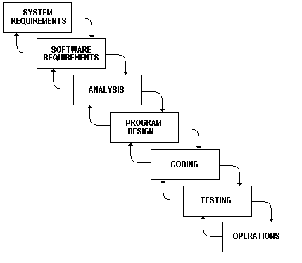

Figure 1 - Modified Waterfall Model

***Reference:*** *Page 63, chapter 5, The Software Life Cycle, MEDICAL DEVICE SOFTWARE VERIFICATION, VALIDATION, AND COMPLIANCE, by David A.Vogel.*

### Roles and Responsibilities

|  |  |  |  |
| --- | --- | --- | --- |
| **No** | **Full name** | **Role in Group** | **Responsibilities** |
| **1** | Lại Đức Hùng | Product Owner | * Specifying user requirements * Controlling the development process * Giving out technique and business analysis support |
| **2** | Trần Nguyễn Quốc Vũ | Team Leader | * Designing database * Clarifying requirements * Preparing documents * Designing GUI * Creating test plans * Coding * Testing |
| **3** | Lều Thị Thu Thảo | Team Member | * Designing database * Clarifying requirements * Preparing documents * Designing GUI * Creating test plans * Coding * Testing |
| **4** | Nguyễn Huy Hoàng | Team Member | * Designing database * Clarifying requirements * Preparing documents * Designing GUI * Creating test plans * Coding * Testing |
| **5** | Vũ Hoàng Nam | Team Member | * Designing database * Clarifying requirements * Preparing documents * Designing GUI * Creating test plans * Coding * Testing |

Table 6 - Role and Responsibilities

### Tools and Techniques

|  |  |  |
| --- | --- | --- |
| **Tools** | | **Name** |
| Developing Tool | | Android Studio  Visual Studio Code 2017 |
| Managing Database | | MySQL, Firebase, SQLite |
| Running services tools | | Ngrok |
| Source Control | | Gitlab, Github |
| Modeling Tool | | StarUML v2.7.0, Draw.io |
| Web Browser | | Chrome v51 |
| **Techniques** | | **Name** |
| Developing tools | Front end/ Mobile Application | Android JetPack  ReactJS, Tailwind CSS |
| Back end | Typescript |
| Web Servers | | Ngrok |
| Database Management System | | MySQL Engine  Firebase  SQLite |

Table 7 - Tools and Techniques

## Project Management Plan

### Software development life cycle

|  |  |  |  |  |  |
| --- | --- | --- | --- | --- | --- |
| **Phase** | **Description** | **Deliverables** | **Resource needed** | **Dependencies and**  **Constrains** | **Risks** |
| **Requirement**  **Analysis** | - Research about requirements from pet owners.  -Identify requirements for the system in common. | -Software requirement specification.  -Introduction of proposed application.  -Project Task scheme  - Prototypes | 20 man- days | N/A | - Uncertain of project's scope  - Lack of experience in collect requirement |
| **Design** | - Architecture design of all the system needed.  - UI, UX design  - Design ERD  - Design Component diagram | - Base source code for back-end and front-end  - Base UI  - ERD  - Component diagram | 30 man- days | All design depend on  “Requirement  Analysis” | - Lack of experience in design UI, UX. |
| **Implementation** | - Build system core functions.  - Build real-time APIs and other APIs.  - Implement mobile application. | - Main user’s functions on the mobile application for Pet Owner. | 40 man-days | All implementation depends on “Design”. | - Human misunderstandings.  - Lack of knowledge and experience. |
| **Testing** | - Test approach  - Test plan  - Test case | - Test document | 20 man-days | Depend on  “Implementation” | - Lack of experience in testing  - Unaccounted for test case |
| **Maintenance** | - Deploy on sever and mobile | -Installation guide.  - User Manual  - User Manual | 20 man- days | Depend on  “Testing” | - Require experience in maintenance. |

Table 8 - Software development life cycle

### Phase Detail

Phase 1: Requirements Analysis

| **Task** | **Description** | **Author** |
| --- | --- | --- |
| **1. Collect requirements** | Find which application currently provide similar service. | VuTNQ, ThaoLTT, CuongPG, HoangNH, NamVH |
| **2. Identify and clarify the main functions** | Define core application functions. | VuTNQ, ThaoLTT, CuongPG, HoangNH, NamVH |
| **3. Create system** **introduction** | Fulfill Introduction Report. | VuTNQ, ThaoLTT, CuongPG, HoangNH, NamVH |
| **4. Software project**  **management plan** | Prepare Project Management scheme. | VuTNQ, ThaoLTT, CuongPG, HoangNH, NamVH |
| **5. Prototype** | Build a prototype of proposed system. | VuTNQ, ThaoLTT, CuongPG, HoangNH, NamVH |
| **6. SRS** | Create SRS document. | VuTNQ, ThaoLTT, CuongPG, HoangNH, NamVH |

Table 9 - Phase 1: Requirements Analysis

Phase 2: Design

|  |  |  |
| --- | --- | --- |
| Task | Description | Author |
| 1. Database design | Based on ERD.  Based on other needs to design. | VuTNQ, ThaoLTT, CuongPG, HoangNH, NamVH |
| 2. Technology research | Study Spring Boot framework and study Angularjs framework. | VuTNQ, ThaoLTT, CuongPG, HoangNH, NamVH |
| 3. Design document | Create software design document. | VuTNQ, ThaoLTT, CuongPG, HoangNH, NamVH |

Table 10 - Phase 2: Design

Phase 3: Implementation

|  |  |  |
| --- | --- | --- |
| **Task** | **Description** | **Author** |
| **1. API functions** | Implement APIs for Pet Care application. | VuTNQ, ThaoLTT, HoangNH, NamVH |
| **2. Web Admin** | Implement a web page for admin. | VuTNQ, ThaoLTT, HoangNH, NamVH |
| **3. Mobile functions** | Implement mobile application. | VuTNQ, ThaoLTT, HoangNH, NamVH |
| **4. Unit testing** | Write test cases and test for web functions. | VuTNQ, ThaoLTT, HoangNH, NamVH |
| Write test cases and testing for mobile functions. | VuTNQ, ThaoLTT, HoangNH, NamVH |

Table 11 - Phase 3: Implementation

Phase 4: Testing

|  |  |  |
| --- | --- | --- |
| **Task** | **Description** | **Author** |
| **1. Integration testing** | Write test case and test systems. | VuTNQ, ThaoLTT, HoangNH, NamVH |
| **2. Testing document** | Write test case documents. | VuTNQ, ThaoLTT, HoangNH, NamVH |
| **3. Acceptance testing** | Let customer test real product to ensure the product meet user’s requirements. | VuTNQ, ThaoLTT, HoangNH, NamVH |

Table 12 - Phase 4: Testing

Phase 5: Operation and Maintenance

|  |  |  |
| --- | --- | --- |
| **Task** | **Description** | **Author** |
| **1. Installation guide** | Write installation guide | VuTNQ, ThaoLTT, HoangNH, NamVH |
| **2. User’s Manual** | Write user manual | VuTNQ, ThaoLTT, HoangNH, NamVH |

Table 13 - Phase 5: Maintenance

### Meeting Minutes

All meeting documents could be found here: <https://drive.google.com/drive/u/2/folders/10XbONt2FmvvYnnUMHLxBt51A2mwIec8t?fbclid=IwAR1vmh_jNzgp1HYOUfbFYmXEXGSewtNRuqsCpr0DizySF7CClPhRiL_5PLI>

(Security: Must be login with FPT University’s email).

## Coding Convention

Our team is using Javato develop web server and using Android Studio to develop a mobile application with the following code convention:

* **Naming Convention**
  + Use Pascal case for class names and method names.
  + Use camel case for method arguments and local variables.
  + Do not use underscores in identifiers. Except: can prefix private static variables with an underscore.
  + Use nouns or noun phrases to name a class.
  + Prefix interfaces with the letter ‘I’.
* **Layout Conventions**
  + Tabs must be set exactly every 4 spaces.
  + Avoid lines longer than 80 characters.
  + Vertically align curly brackets.
  + Write only one statement per line.
  + Write only one declaration per line.
  + Add one blank line between method definitions and property definitions.
* **Declarations Convention**
  + - Tabs must be set exactly every 4 spaces.
    - Avoid lines longer than 80 characters.
    - Vertically align curly brackets.
    - Write only one statement per line.
    - Write only one declaration per line.
    - Add one blank line between method definitions and property definitions.
* **Commenting Conventions**
  + - Place the comment on a separate line.
    - Begin comment text with an uppercase letter and end with a period.
    - Add one space between the comment delimiter (//) and the comment text.

***Reference:*** *Coding Convention for the Java Programming Language - Oracle*

# C. Software Requirement Specification

## User Requirement Specification

### Guest Requirement

Guest is a user who has limited access to the system. The Guest can use the following functions:

* Login
* Register

In our system, the Guest can be able to use some functions associated with the Pet Owner without having to log in to the system. Those functions are:

* Manage Pets
* Manage Pet’s Activity’s Reminders
* Manage Pet’s Activity ‘s Histories
* Search and Get Pet Shops and Services Details

### Authorized User Requirement

Authorized user can be able to use further functions in the system that are specified by each roles. The authorized user can use the following functions:

* Edit Profile
* Logout: after finishing all the activities on the system, the authorized user can log out of the system.

### Admin Requirement

Admin is a user who works directly with the system and has the rights to manage accounts’ and shops’ information that are existed in the system. The Admin can use the following functions:

* Manage Accounts
* Manage and Activate/Deactivate Pet Shops
* Manage Vaccines
* Manage Medicines
* Manage Breeds

### Shop Owner Requirement

Shop Owner is a user who manages all the information of the services and discounts appearing in the shop. The Shop Owner has the following functions:

* Manage Pet Shops
* Manage Services
* Manage Discounts

### Pet Owner Requirement

Pet Owner is a user who manages all the information of the pets, the activity schedules, the medical status of pets and can connect with other pet owners. The Pet Owner has the following functions:

* Manage Pets
* Manage Pet’s Activity’s Reminders
* Manage Pet’s Activity ‘s Histories
* Search and Get Pet Shops and Services Details
* Find other Pet owners
* Contact other Pet Owners

## System Requirement Specification

### External Interface Requirement

#### User Interface

* User interface has to be easy to use and recognizable.
* Website and mobile application must be responsive, suitable with all devices resolution such as: laptop, tablet or smartphone.
* The user interface of mobile and web application is used in English.
* Every feature should be arranged and displayed briefly.

#### Hardware Interface

Smartphone, Laptop, tablet or Desktop’s connection must be available for the Internet.

#### Software Interface

* The website works with Firefox (v57 or above), Chrome (v51 or above) and Safari (v5 or above).
* The mobile app work best on android version 6.0.1+.



#### Communication Protocol

* Use HTTP protocol for communication between mobile application and web service.
* Use HTTP protocol for communication between web browser and web service.

### System Overview Use Case

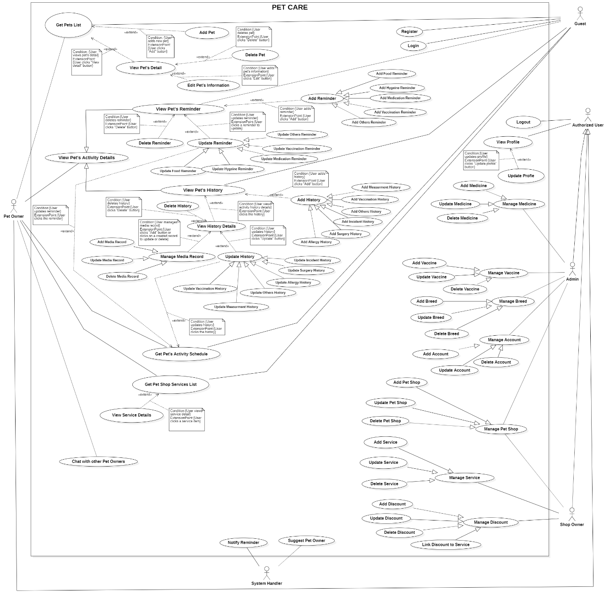

Figure 2-System Overview Use Case

### List of Use Cases

#### <Guest> Overview Use Case

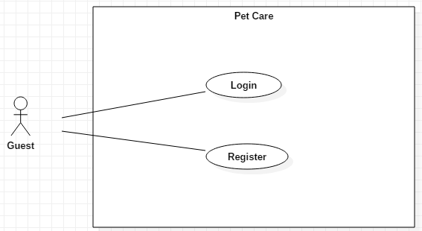

Figure 3-<Guest> Overview Use Case

##### <Guest> Login

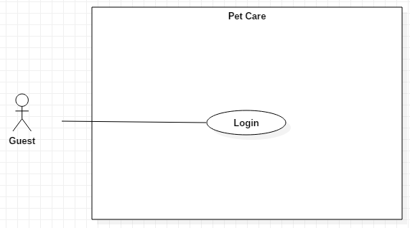

Figure 4-<Guest> Login

|  |  |  |  |
| --- | --- | --- | --- |
| **USE CASE – UC\_01** | | | |
| **Use Case No.** | **01** | **Use Case Version** | 1.0 |
| **Use Case Name** | Login | | |
| **Author** | Vũ Hoàng Nam | | |
| **Date** | 07/10/2019 | **Priority** | Normal |
| **Actor:**   * Guest   **Summary:**   * This use case allows the Guest to log into the system.   **Goal:**   * The Guest logs in of the system successfully with authorized role.   **Triggers:**   * The Guest clicks on “Log in” button.   **Preconditions:**   * Guest launches the application.   **Post conditions:**   * Success: Guest is logged into the system with authorized role. * Fail: System shows error messages.   **Main Success Scenarios:**   |  |  |  | | --- | --- | --- | | **Step** | **Actor Action** | **System Response** | | 1 | Guest fills out data fields to “Login” screen. | “Login” screen is shown with the following labels and fields:   * Email: text; required * Password: text; required. | | 2 | The Guest clicks on “Log In” button. | System validates input data and shows “My Pets” screen.  [Exception 1, 2, 3] |   **Alternative Scenarios:** N/A  **Exceptions:**   |  |  |  | | --- | --- | --- | | **No** | **Actor Action** | **System Response** | | 1 | * Email is empty * Password is empty | System shows error message: “This field is required!” | | 2 | Guest inputs wrong username or password. | System shows error message: “Invalid username or password. Please try again!” | | 3 | Network problem. | System shows error message “Please check your connection”. |   **Relationships:** N/A  **Business Rules:**   * Password is encrypted after clicking the “Log in” button. * After logging in to the system, guest will be redirected to specific screen based on his role on the system: Admin, Shop owner or Pet owner. * If the role is “Admin”: the system will display the screen for Admin. * If the role is “Shop owner”: the system will display the screen for Shop owner. * If the role is “Pet owner”: the system will display the screen for Pet owner. * After logged in, user doesn’t need to log in again until they log out. | | | |

<Guest> Login use case specification

##### <Guest> Register

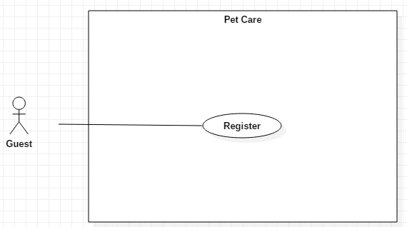

Figure 5-<Guest> Register

|  |  |  |  |
| --- | --- | --- | --- |
| **USE CASE – UC\_02** | | | |
| **Use Case No.** | **02** | **Use Case Version** | 1.0 |
| **Use Case Name** | Register | | |
| **Author** | Vũ Hoàng Nam | | |
| **Date** | 07/10/2019 | **Priority** | Normal |
| **Actor:**   * Guest   **Summary:**   * This use case allows the Guest to register an account with the system.   **Goal:**   * The Guest registers an account with the system successfully.   **Triggers:**   * The Guest clicks on “Register” button.   **Preconditions:**   * Guest launches the application. * Guest is at “Login” screen   **Post conditions:**   * Success: The Guest registers an account successfully. * Fail: System shows error messages.   **Main Success Scenarios:**   |  |  |  | | --- | --- | --- | | **Step** | **Actor Action** | **System Response** | | 1 | Guest clicks the “Sign Up” button. | “Register” screen is shown with the following labels and fields:  - Email: text, required  - Password: Text input, required  - Confirm password: text, required | | 2 | Guest clicks on ”Sign Up” button | System validates input data and shows “Login” screen.  [Exceptions] |   **Alternative Scenarios:** N/A  **Exceptions:**   |  |  |  | | --- | --- | --- | | **No** | **Actor Action** | **System Response** | | 1 | * Email is empty * Password is empty * Confirm password is empty | System shows error message: “This field is required!” | | 2 | Password and Confirm Password is not matched | System shows error message: “Password does not match!” | | 3 | Network problem. | System shows error message “Please check your connection”. |   **Relationships:** N/A  **Business Rules:**   * In this system, only the Guest can register an account. * Register function is available for mobile application. Therefore, after signing up, Guest will be the Pet owner to use the mobile application. * Password is encrypted after clicking the “Sign Up” button. | | | |

<Guest> Register use case specification

#### <Authorized User> Overview Use Case

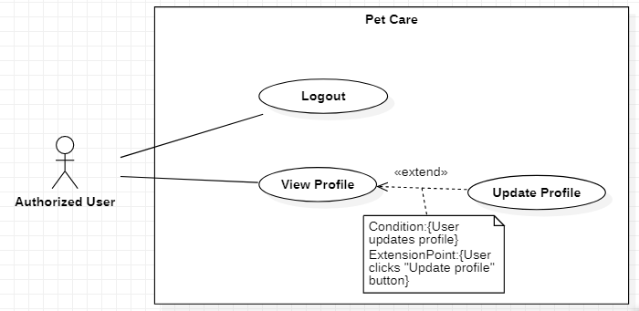

Figure 6-<Authorized User> Overview Use Case

##### <Authorized User> View Profile

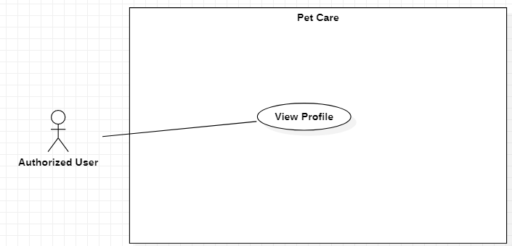

Figure 7-<Authorized User> View Profile

|  |  |  |  |
| --- | --- | --- | --- |
| **USE CASE – UC\_03** | | | |
| **Use Case No.** | **03** | **Use Case Version** | 1.0 |
| **Use Case Name** | View Profile | | |
| **Author** | Vũ Hoàng Nam | | |
| **Date** | 30/09/2019 | **Priority** | Normal |
| **Actor:**   * Authorized User   **Summary:**   * This use case allows the Authorized User to view their profile.   **Goal:**   * The Authorized User edits their profile successfully.   **Triggers:**   * The Authorized User clicks on “Edit profile” button.   **Preconditions:**   * User already logged in the system with the role that has been authorized in the system.   **Post conditions:**   * Success: The Authorized User views their profile successfully. * Fail: System shows error messages.   **Main Success Scenarios:**   |  |  |  | | --- | --- | --- | | **Step** | **Actor Action** | **System Response** | | 1 | Authorized User clicks on “View profile” button. | “Profile” screen is shown with the following information:   * Name * Email * Created date * “Update profile” button   [Exception 1] |   **Alternative Scenarios:** N/A  **Exceptions:**   |  |  |  | | --- | --- | --- | | **No** | **Actor Action** | **System Response** | | 1 | Network problem. | System shows error message “Please check your connection”. |   **Relationships:** N/A  **Business Rules:**   * In this system, only the Authorized User can view their profile. * User’s name, email and created date cannot be null. * Created date field show in dd/mm/yyyy format. * User cannot change the data unless they click on “Update profile” button. | | | |

<Authorized User> View Profile use case specification

##### <Authorized User> Update Profile

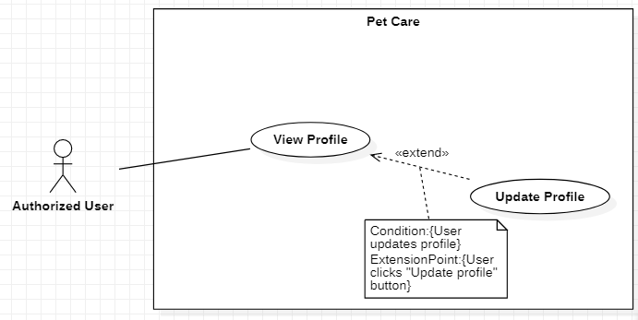

Figure 8-<Authorized User> Update Profile

|  |  |  |  |
| --- | --- | --- | --- |
| **USE CASE – UC\_04** | | | |
| **Use Case No.** | **04** | **Use Case Version** | 1.0 |
| **Use Case Name** | Update Profile | | |
| **Author** | Vũ Hoàng Nam | | |
| **Date** | 30/09/2019 | **Priority** | Normal |
| **Actor:**   * Authorized User   **Summary:**   * This use case allows the Authorized User to update profile.   **Goal:**   * The Authorized User updates profile successfully.   **Triggers:**   * The Authorized User clicks on “Update Profile” button.   **Preconditions:**   * User already logged in the system with the role that has been authorized in the system.   **Post conditions:**   * Success: The Authorized User edits their profile successfully. * Fail: System shows error messages.   **Main Success Scenarios:**   |  |  |  | | --- | --- | --- | | **Step** | **Actor Action** | **System Response** | | 1 | The Authorized User clicks on “Update” button on “Profile” screen. | “Update Account” screen is shown with following labels and fields:   * Email: text, required * Password: text, required * Name: text, required. * Provider: text, required. | | 2 | The Authorized User fills out data fields and clicks on “Confirm” button. | System validates inputted data and shows “Accounts” screen  [Exception 1, 2, 3, 4] |   **Alternative Scenarios:** N/A  **Exceptions:**   |  |  |  | | --- | --- | --- | | **No** | **Actor Action** | **System Response** | | 1 | * Email is empty. * Password is empty. * Name is empty. | System shows error message "This field is required.” and highlights the empty fields. | | 2 | Editing email is used. | System shows error message “Email used!” and highlights the error field. | | 3 | The Authorized User clicks on “Cancel” button. | System shows “Profile” screen. | | 4 | Network problem. | System shows error message: “Please check your connection.” |   **Relationships:** N/A  **Business Rules:**   * In this system, only the Authorized User can edit their profile. * The Authorized User must log in the system before editing the profile. | | | |

<Authorized User> Update Profile use case specification

##### <Authorized User> Logout

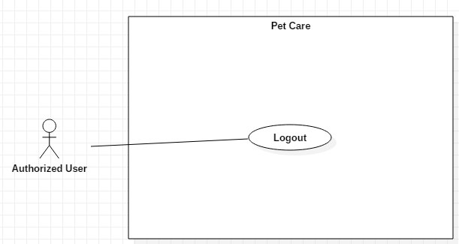

Figure 9-<Authorized User> Logout

|  |  |  |  |
| --- | --- | --- | --- |
| **USE CASE – UC\_09** | | | |
| **Use Case No.** | **09** | **Use Case Version** | 1.0 |
| **Use Case Name** | Logout | | |
| **Author** | Vũ Hoàng Nam | | |
| **Date** | 30/09/2019 | **Priority** | Normal |
| **Actor:**   * Authorized User   **Summary:**   * This use case allows the Authorized User to log out of the system.   **Goal:**   * The Authorized User logs out of the system successfully.   **Triggers:**   * The Authorized User clicks on “Log out” button.   **Preconditions:**   * User already logged in the system with the role that has been authorized in the system.   **Post conditions:**   * Success: The Authorized User logs out of the system successfully. * Fail: System shows error messages.   **Main Success Scenarios:**   |  |  |  | | --- | --- | --- | | **Step** | **Actor Action** | **System Response** | | 1 | The Authorized User clicks on “Log Out” button. | System shows “Login” screen.  [Exception 1] |   **Alternative Scenarios:** N/A  **Exceptions:**   |  |  |  | | --- | --- | --- | | **No** | **Actor Action** | **System Response** | | 1 | Network problem. | System shows error message: “Please check your connection”. |   **Relationships:** Associated with Authorized User actor.  **Business Rules:**   * In this system, only the Authorized User can log out. * The Authorized User must log in the system before logging out. | | | |

<Authorized User> Logout use case specification

#### <Admin> Overview Use Case

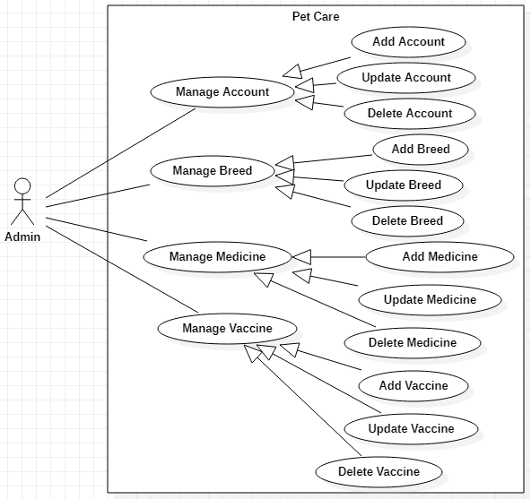

Figure 10-<Admin> Overview Use Case

##### <Admin> Add Account

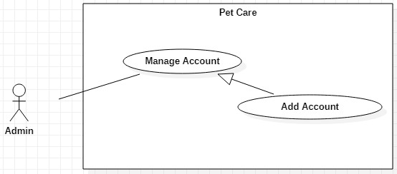

Figure 11-<Admin> Add Account

|  |  |  |  |
| --- | --- | --- | --- |
| **USE CASE – UC\_10** | | | |
| **Use Case No.** | 10 | **Use Case Version** | 1.0 |
| **Use Case Name** | Add Account | | |
| **Author** | Vũ Hoàng Nam, Nguyễn Huy Hoàng | | |
| **Date** | 30/09/2019 | **Priority** | Normal |
| **Actor:**   * Admin   **Summary:**   * This use case allows the Admin to add accounts.   **Goal:**   * The Admin adds accounts successfully.   **Triggers:**   * The Admin clicks on “Create new account” button.   **Preconditions:**   * User must log in the system with the Admin role.   **Post conditions:**   * Success: The account is added. * Fail: System shows error messages.   **Main Success Scenario:**   |  |  |  | | --- | --- | --- | | **Step** | **Actor Action** | **System Response** | | 1 | Admin clicks on “Create new account” button on “Accounts” screen. | “Add Account” screen is shown with following labels and fields:   * Email: text, required * Password: text, required * Name: text, required. * Role: options list: Shop owner; required. | | 2 | Admin fills out data fields and clicks on “Create” button. | System validates inputted data and shows “Accounts” screen  [Exception 1, 2, 3] |   **Alternative Scenarios:** N/A  **Exceptions:**   |  |  |  | | --- | --- | --- | | **No** | **Actor Action** | **System Response** | | 1 | * Email is empty. * Password is empty. * Name is empty. | System shows error message "This field is required.” and highlights the empty fields. | | 2 | Email is already used | System shows error message “Email used!” and highlights the error field. | | 3 | Network problem. | System shows error message: “Please check your connection.” |   **Relationships:**  Generalized from Manage Account use case.  **Business Rules:**   * In this system, only the Admin can add new accounts. * The ID of the medicine is automatically generated. * The Admin can only create new accounts with Shop owner role. The accounts that have Pet owner role are the accounts registered into the system through the mobile application. The Admin cannot create new accounts with Pet owner role. | | | |

<Admin> Activate Account use case specification

##### <Admin> Update Account

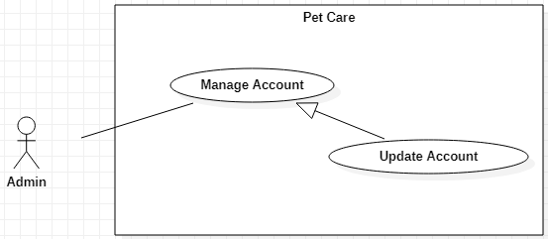

Figure 12-<Admin> Update Account

|  |  |  |  |
| --- | --- | --- | --- |
| **USE CASE – UC\_11** | | | |
| **Use Case No.** | 11 | **Use Case Version** | 1.0 |
| **Use Case Name** | Update Account, Nguyễn Huy Hoàng | | |
| **Author** | Vũ Hoàng Nam | | |
| **Date** | 30/09/2019 | **Priority** | Normal |
| **Actor:**   * Admin   **Summary:**   * This use case allows the Admin to update accounts.   **Goal:**   * The Admin updates accounts successfully.   **Triggers:**   * The Admin clicks on “View Details” button to update.   **Preconditions:**   * User must log in the system with the Admin role.   **Post conditions:**   * Success: The account information is updated. * Fail: System shows error messages.   **Main Success Scenario:**   |  |  |  | | --- | --- | --- | | **Step** | **Actor Action** | **System Response** | | 1 | The Admin selects a virus and clicks on “View Details” button on “Accounts” screen. | “Update Account” screen is shown with following labels and fields:   * Email: text, required * Password: text, required * Name: text, required. * Role: options list: Shop owner; required. | | 2 | Admin fills out data fields and clicks on “Save” button. | System validates inputted data and shows “Accounts” screen  [Exception 1, 2, 3] |   **Alternative Scenarios:** N/A  **Exceptions:**   |  |  |  | | --- | --- | --- | | **No** | **Actor Action** | **System Response** | | 1 | * Email is empty. * Password is empty. * Name is empty. | System shows error message "This field is required.” and highlights the empty fields. | | 2 | Editing email is used. | System shows error message “Email used!” and highlights the error field. | | 3 | Network problem. | System shows error message: “Please check your connection.” |   **Relationships:**  Generalized from Manage Account use case.  **Business Rules:**   * In this system, only the Admin can update accounts. | | | |

##### <Admin> Delete Account

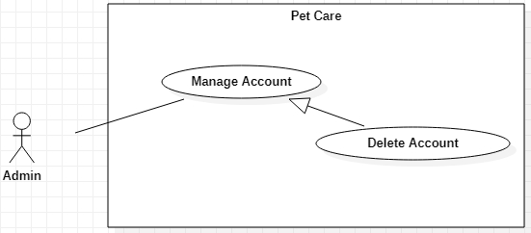

Figure 13-<Admin> Delete Account

|  |  |  |  |
| --- | --- | --- | --- |
| **USE CASE – UC\_12** | | | |
| **Use Case No.** | 12 | **Use Case Version** | 1.0 |
| **Use Case Name** | Delete Account | | |
| **Author** | Vũ Hoàng Nam, Nguyễn Huy Hoàng | | |
| **Date** | 30/09/2019 | **Priority** | Normal |
| **Actor:**   * Admin   **Summary:**   * This use case allows the Admin to delete accounts.   **Goal:**   * The Admin deletes accounts successfully.   **Triggers:**   * The Admin clicks on “Delete” button.   **Preconditions:**   * User must log in the system with the Admin role.   **Post conditions:**   * Success: The account information is updated. * Fail: System shows error messages.   **Main Success Scenario:**   |  |  |  | | --- | --- | --- | | **Step** | **Actor Action** | **System Response** | | 1 | The Admin clicks on “Delete” button on “Account Details” screen. | System shows a message box “Type the account name to confirm” and a text field. | | 2 | The Admin inputs the account name correctly and clicks on “OK” button | The vaccine is deleted and system shows “Accounts” screen.  [Exception 1,2,3] |   **Alternative Scenarios:** N/A  **Exceptions:**   |  |  |  | | --- | --- | --- | | **Step** | **Actor Action** | **System Response** | | 1 | Admin clicks on “Cancel” button. | System shows “Accounts” screen. | | 2 | Network problem. | System shows error message “Please check your connection.” |   **Relationships:**  Generalized from Manage Account use case.  **Business Rules:**   * In this system, only the Admin can delete accounts. * Admin cannot deactivate himself/herself. | | | |

<Admin> Delete Account use case specification

##### <Admin> Add Vaccine

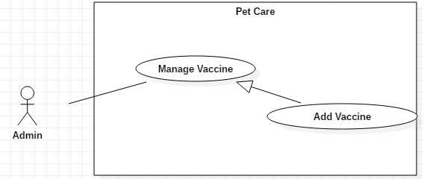

Figure 14-<Admin> Add Vaccine

|  |  |  |  |
| --- | --- | --- | --- |
| **USE CASE – UC\_13** | | | |
| **Use Case No.** | 13 | **Use Case Version** | 1.0 |
| **Use Case Name** | Add Vaccine | | |
| **Author** | Vũ Hoàng Nam, Nguyễn Huy Hoàng | | |
| **Date** | 30/09/2019 | **Priority** | Normal |
| **Actor:**   * Admin   **Summary:**   * This use case allows the Admin to add vaccines’ information.   **Goal:**   * The vaccine is added successfully.   **Triggers:**   * The Admin clicks on “Create new vaccine” button.   **Preconditions:**   * User must log in the system with the Admin role.   **Post conditions:**   * Success: The vaccine is added into the system. * Fail: System shows error messages.   **Main Success Scenario:**   |  |  |  | | --- | --- | --- | | **Step** | **Actor Action** | **System Response** | | 1 | The Admin clicks on “Create new vaccine” button on “Vaccines” screen. | “Add Vaccine” screen is shown with the following labels and fields:   * Vaccine Name: fixed * Vaccine type: options list: Single/Multiple; required * Pet type: options list: Dog/Cat/Other; required * Notes: text, optional * Strong against: viruses list; required | | 2 | The Admin clicks on “Create” button.  [Alternative 1,2] | System validates inputted data and shows “Vaccines” screen.  [Exception 1, 2, 3] |   **Alternative Scenarios:**   |  |  |  | | --- | --- | --- | | **Step** | **Actor Action** | **System Response** | | 1 | The Admin clicks on “Import CSV” button on “Vaccines” screen. | “Import File” screen is shown. | | 2 | Admin chooses file and clicks on “Confirm” button. | System adds list of vaccines from the file, then shows “Vaccines” screen.  [Exception 3] |   **Exceptions:**   |  |  |  | | --- | --- | --- | | **No** | **Actor Action** | **System Response** | | 1 | Vaccine Name is empty | System shows error message "This field is required.” and highlights the empty fields. | | 2 | Vaccine Name is used | System shows error message "Vaccine name is used.” and highlights the empty fields. | | 3 | Network connection problem. | System shows error message: “Please check your connection.” |   **Relationships:**  Generalized from Manage Vaccine use case.  **Business Rules:**   * In this system, only Admin can add new vaccines’ information. * The ID of the medicine is automatically generated. * To create new vaccines, there must be a virus information in the system. * The vaccines information can be imported into the system with an .xls file. | | | |

<Admin> Add Vaccine use case specification

##### <Admin> Update Vaccine

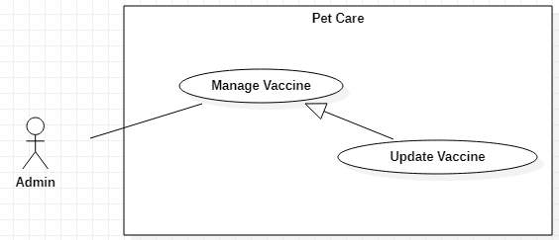

Figure 15-<Admin> Update Vaccine

|  |  |  |  |
| --- | --- | --- | --- |
| **USE CASE – UC\_14** | | | |
| **Use Case No.** | 14 | **Use Case Version** | 1.0 |
| **Use Case Name** | Update Vaccine | | |
| **Author** | Vũ Hoàng Nam, Nguyễn Huy Hoàng | | |
| **Date** | 30/09/2019 | **Priority** | Normal |
| **Actor:**   * Admin   **Summary:**   * This use case allows the Admin to update vaccines’ information.   **Goal:**   * The Admin updates vaccines successfully.   **Triggers:**   * The Admin clicks on “View Details” button to update.   **Preconditions:**   * User must log in the system with the Admin role.   **Post conditions:**   * Success: The account information is updated. * Fail: System shows error messages.   **Main Success Scenario:**   |  |  |  | | --- | --- | --- | | **Step** | **Actor Action** | **System Response** | | 1 | The Admin selects a virus and clicks on “View Details” button on “Viruses” screen. | “Vaccine Details” screen is shown with following labels and fields:   * Vaccine Name: fixed * Vaccine type: options list: Single/Multiple; required * Pet type: options list: Dog/Cat/Other; required * Notes: text, optional * Strong against: viruses list; required | | 2 | Admin fills out data fields and clicks on “Save” button. | System validates inputted data and shows “Vaccines” screen  [Exception 1, 2, 3] |   **Alternative Scenarios:** N/A  **Exceptions:**   |  |  |  | | --- | --- | --- | | **No** | **Actor Action** | **System Response** | | 1 | Vaccine Name is empty | System shows error message "This field is required.” and highlights the empty fields. | | 2 | Editing Vaccine Name is used | System shows error message "Vaccine name is used.” and highlights the empty fields. | | 3 | Network connection problem. | System shows error message: “Please check your connection.” |   **Relationships:**  Generalized from Manage Vaccine use case.  **Business Rules:**   * In this system, only the Admin can update vaccines’ information. | | | |

<Admin> Update Vaccine use case specification

##### <Admin> Delete Vaccine

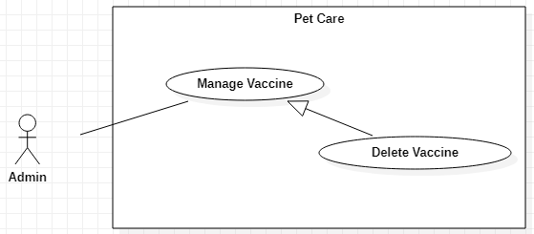

Figure 16-<Admin> Delete Vaccine

|  |  |  |  |
| --- | --- | --- | --- |
| **USE CASE – UC\_15** | | | |
| **Use Case No.** | 15 | **Use Case Version** | 1.0 |
| **Use Case Name** | Delete Vaccine | | |
| **Author** | Vũ Hoàng Nam, Nguyễn Huy Hoàng | | |
| **Date** | 30/09/2019 | **Priority** | Normal |
| **Actor:**   * Admin   **Summary:**   * This use case allows the Admin to delete vaccines.   **Goal:**   * The vaccine is deleted successfully.   **Triggers:**   * The Admin clicks on “Delete” button.   **Preconditions:**   * User must log in the system with the Admin role.   **Post conditions:**   * Success: The vaccine is deleted. * Fail: System shows error messages.   **Main Success Scenario:**   |  |  |  | | --- | --- | --- | | **Step** | **Actor Action** | **System Response** | | 1 | The Admin clicks on “Delete” button on “Vaccine Details” screen. | System shows a message box “Type the vaccine name to confirm” and a text field. | | 2 | The Admin inputs the vaccine name correctly and clicks on “OK” button | The vaccine is deleted and system shows “Vaccines” screen.  [Exception 1,2,3] |   **Alternative Scenarios:** N/A  **Exceptions:**   |  |  |  | | --- | --- | --- | | **Step** | **Actor Action** | **System Response** | | 1 | Admin clicks on “Cancel” button. | System shows “Vaccines” screen. | | 2 | The Admin inputs the vaccine name incorrectly | System shows error message “Mismatched name. Cancelling..” | | 3 | Network problem. | System shows error message “Please check your connection.” |   **Relationships:**  Generalized from Manage Vaccine use case.  **Business Rules:**   * In this system, only Admin can delete vaccines. | | | |

<Admin> Delete Vaccine use case specification

##### <Admin> Add Medicine

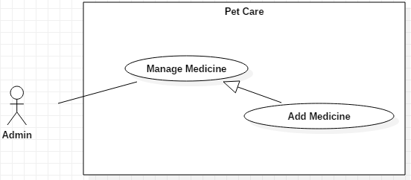

Figure 17-<Admin> Add Medicine

|  |  |  |  |
| --- | --- | --- | --- |
| **USE CASE – UC\_16** | | | |
| **Use Case No.** | 16 | **Use Case Version** | 1.0 |
| **Use Case Name** | Add Medicine | | |
| **Author** | Vũ Hoàng Nam, Nguyễn Huy Hoàng | | |
| **Date** | 30/09/2019 | **Priority** | Normal |
| **Actor:**   * Admin   **Summary:**   * This use case allows the Admin to add medicines’ information.   **Goal:**   * The medicine is added successfully.   **Triggers:**   * The Admin clicks on “Create new medicine” button.   **Preconditions:**   * User must log in the system with the Admin role.   **Post conditions:**   * Success: The medicine is added into the system. * Fail: System shows error messages.   **Main Success Scenario:**   |  |  |  | | --- | --- | --- | | **Step** | **Actor Action** | **System Response** | | 1 | The Admin clicks on “Create new medicine” button on “Medicines” screen. | “Add Medicine” screen is shown with the following labels and fields:   * Medicine name: text, required * Notes: text, optional | | 2 | The Admin clicks on “Create” button.  [Alternative 1,2] | System validates inputted data and shows “Medicines” screen.  [Exception 1, 2, 3] |   **Alternative Scenarios:**   |  |  |  | | --- | --- | --- | | **Step** | **Actor Action** | **System Response** | | 1 | The Admin clicks on “Import CSV” button on “Medicines” screen. | “Import File” screen is shown. | | 2 | Admin chooses file and clicks on “Confirm” button. | System adds list of medicines from the file, then shows “Medicines” screen.  [Exception 3] |   **Exceptions:**   |  |  |  | | --- | --- | --- | | **No** | **Actor Action** | **System Response** | | 1 | Medicine name is empty | System shows error message "This field is required.” and highlights the empty fields. | | 2 | Medicine name is used | System shows error message "Medicine name is used.” and highlights the empty fields. | | 3 | Network problem. | System shows error message: “Please check your connection.” |   **Relationships:**  Generalized from Manage Medicine use case.  **Business Rules:**   * In this system, only Admin can add new medicines’ information. * The ID of the medicine is automatically generated. * The medicines information can be imported into the system with an .xls file. | | | |

<Admin> Add Medicine use case specification

##### <Admin> Update Medicine

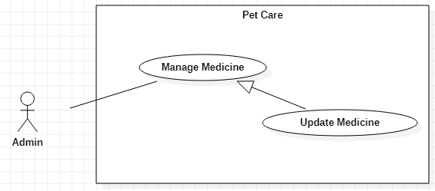

Figure 18-<Admin> Update Medicine

|  |  |  |  |
| --- | --- | --- | --- |
| **USE CASE – UC\_17** | | | |
| **Use Case No.** | 17 | **Use Case Version** | 1.0 |
| **Use Case Name** | Update Medicine | | |
| **Author** | Vũ Hoàng Nam, Nguyễn Huy Hoàng | | |
| **Date** | 30/09/2019 | **Priority** | Normal |
| **Actor:**   * Shop owner   **Summary:**   * This use case allows the Admin to update the medicines’ information.   **Goal:**   * The medicine is updated successfully.   **Triggers:**   * The Admin clicks on “View Details” button to update.   **Preconditions:**   * User must log in the system with the Admin role.   **Post conditions:**   * Success: The selected medicine is updated. * Fail: System shows error messages.   **Main Success Scenarios:**   |  |  |  | | --- | --- | --- | | **Step** | **Actor Action** | **System Response** | | 1 | The Admin selects a medicine and clicks on “View Details” button on “Medicines” screen. | “Medicine Details” screen is shown with following labels and fields:   * Medicine Name: text, required * Notes: text, optional | | 2 | Admin fills out data fields and clicks on “Save” button. | System validates inputted data and shows “Medicines” screen  [Exception 1, 2, 3] |   **Alternative Scenarios:** N/A  **Exceptions:**   |  |  |  | | --- | --- | --- | | **No** | **Actor Action** | **System Response** | | 1 | Medicine name is empty | System shows error message "This field is required.” and highlights the empty fields. | | 2 | Editing Medicine name is used | System shows error message "Medicine name is used.” and highlights the empty fields. | | 3 | Network problem. | System shows error message: “Please check your connection.” |   **Relationships:**  Generalized from Manage Medicine use case.  **Business Rules:**   * In this system, only the Admin can edit information of the medicines. | | | |

<Admin> Edit Medicine use case specification

##### <Admin> Delete Medicine

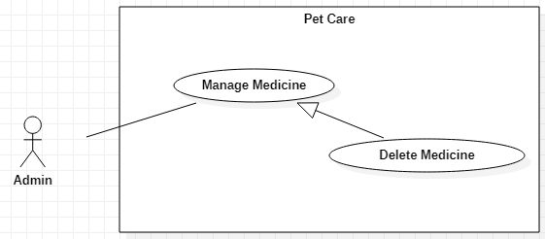

Figure 19-<Admin> Deactivate Medicine

|  |  |  |  |
| --- | --- | --- | --- |
| **USE CASE – UC\_18** | | | |
| **Use Case No.** | 18 | **Use Case Version** | 1.0 |
| **Use Case Name** | Delete Medicine | | |
| **Author** | Vũ Hoàng Nam, Nguyễn Huy Hoàng | | |
| **Date** | 30/09/2019 | **Priority** | Normal |
| **Actor:**   * Admin   **Summary:**   * This use case allows the Admin to delete medicines.   **Goal:**   * The medicine is deleted successfully.   **Triggers:**   * The Admin clicks on “Delete” button.   **Preconditions:**   * User must log in the system with the Admin role.   **Post conditions:**   * Success: The medicine is deleted. * Fail: System shows error messages.   **Main Success Scenario:**   |  |  |  | | --- | --- | --- | | **Step** | **Actor Action** | **System Response** | | 1 | The Admin clicks on “Delete” button on “Medicine Details” screen. | System shows a message box “Type the medicine name to confirm” and a text field. | | 2 | The Admin inputs the medicine name correctly and clicks on “OK” button | The medicine is deleted and system shows “Medicines” screen.  [Exception 1,2,3] |   **Alternative Scenarios:** N/A  **Exceptions:**   |  |  |  | | --- | --- | --- | | **Step** | **Actor Action** | **System Response** | | 1 | Admin clicks on “Cancel” button. | System shows “Medicines” screen. | | 2 | The Admin inputs the medicine name incorrectly | System shows error message “Mismatched name. Cancelling..” | | 3 | Network problem. | System shows error message “Please check your connection.” |   **Relationships:**  Generalized from Manage Medicine use case.  **Business Rules:**   * In this system, only Admin can delete medicines. | | | |

<Admin> Delete Medicine use case specification

##### <Admin> Add Breed

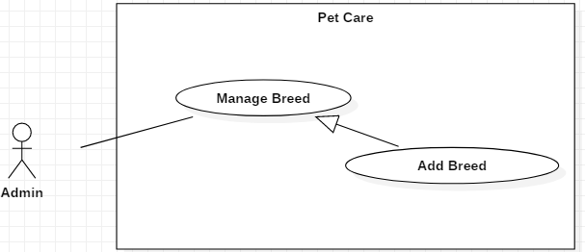

Figure 20-<Admin> Add Breed

|  |  |  |  |
| --- | --- | --- | --- |
| **USE CASE – UC\_19** | | | |
| **Use Case No.** | 19 | **Use Case Version** | 1.0 |
| **Use Case Name** | Add Breed | | |
| **Author** | Vũ Hoàng Nam, Nguyễn Huy Hoàng | | |
| **Date** | 30/09/2019 | **Priority** | Normal |
| **Actor:**   * Admin   **Summary:**   * This use case allows the Admin to add new breed.   **Goal:**   * The breed is added successfully.   **Triggers:**   * The Admin clicks on “Create new breed” button.   **Preconditions:**   * User must log in the system with the Admin role.   **Post conditions:**   * Success: The breed is added into the system. * Fail: System shows error messages.   **Main Success Scenario:**   |  |  |  | | --- | --- | --- | | **Step** | **Actor Action** | **System Response** | | 1 | The Admin clicks on “Create new breed” button on “Breeds” screen. | “Add Breed” screen is shown with the following labels and fields:   * Breed Name: text, required * Pet type: options list: Dog/Cat/Other; required * Notes: text, optional | | 2 | The Admin clicks on “Create” button. | System validates inputted data and shows “Breeds” screen.  [Exception 1, 2, 3] |   **Alternative Scenarios:**   |  |  |  | | --- | --- | --- | | **Step** | **Actor Action** | **System Response** | | 1 | The Admin clicks on “Import CSV” button on “Breeds” screen. | “Import File” screen is shown. | | 2 | Admin chooses file and clicks on “Confirm” button. | System adds list of breeds from the file, then shows “Breeds” screen.  [Exception 3] |   **Exceptions:**   |  |  |  | | --- | --- | --- | | **No** | **Actor Action** | **System Response** | | 1 | Breed Name is empty | System shows error message "This field is required.” and highlights the empty fields. | | 2 | Breed name is used | System shows error message "Breed name is used.” and highlights the empty fields. | | 3 | Network problem. | System shows error message: “Please check your connection.” |   **Relationships:**  Generalized from Manage Breed use case.  **Business Rules:**   * In this system, only Admin can add new breeds. * The ID of the breed is automatically generated. * “Other” pet type option is for the breed that does not belong to Dog or Cat pet type. * The breeds information can be imported into the system with an .xls file. | | | |

<Admin> Add Breed use case specification

##### <Admin> Update Breed

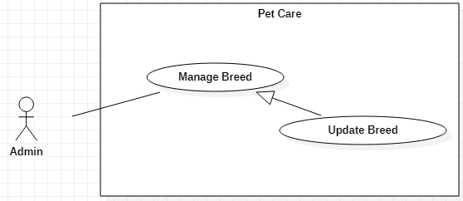

Figure 21-<Admin> Update Breed

|  |  |  |  |
| --- | --- | --- | --- |
| **USE CASE – UC\_20** | | | |
| **Use Case No.** | 20 | **Use Case Version** | 1.0 |
| **Use Case Name** | Update Breed | | |
| **Author** | Vũ Hoàng Nam, Nguyễn Huy Hoàng | | |
| **Date** | 30/09/2019 | **Priority** | Normal |
| **Actor:**   * Admin   **Summary:**   * This use case allows the Admin to update the breed’s information.   **Goal:**   * The breed is updated successfully.   **Triggers:**   * The Admin clicks on “View Details” button to update.   **Preconditions:**   * User must log in the system with the Admin role.   **Post conditions:**   * Success: The selected breed is updated. * Fail: System shows error messages.   **Main Success Scenarios:**   |  |  |  | | --- | --- | --- | | **Step** | **Actor Action** | **System Response** | | 1 | The Admin selects a breed and clicks on “View Details” button on “Breeds” screen. | “Breed Details” screen is shown with following labels and fields:   * Breed Name: text, required * Pet type: options list: Dog/Cat/Other; required * Notes: text, optional | | 2 | Admin fills out data fields and clicks on “Save” button. | System validates inputted data and shows “Breeds” screen  [Exception 1, 2, 3] |   **Alternative Scenarios:** N/A  **Exceptions:**   |  |  |  | | --- | --- | --- | | **No** | **Actor Action** | **System Response** | | 1 | Breed Name is empty | System shows error message "This field is required.” and highlights the empty fields. | | 2 | Editing Breed name is used | System shows error message "Breed name is used.” and highlights the empty fields. | | 3 | Network problem. | System shows error message: “Please check your connection.” |   **Relationships:**  Generalized from Manage Breed use case.  **Business Rules:**   * In this system, only the Admin can update information of the breed. * “Other” pet type option is for the breed that does not belong to Dog or Cat pet type. | | | |

<Admin> Update Breed use case specification

##### <Admin> Delete Breed

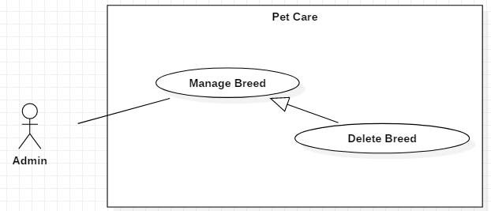

Figure 22-<Admin> Delete Breed

|  |  |  |  |
| --- | --- | --- | --- |
| **USE CASE – UC\_21** | | | |
| **Use Case No.** | 21 | **Use Case Version** | 1.0 |
| **Use Case Name** | Delete Breed | | |
| **Author** | Vũ Hoàng Nam, Nguyễn Huy Hoàng | | |
| **Date** | 30/09/2019 | **Priority** | Normal |
| **Actor:**   * Admin   **Summary:**   * This use case allows the Admin to delete the breed.   **Goal:**   * The breed is deleted successfully.   **Triggers:**   * The Admin clicks on “Delete” button.   **Preconditions:**   * User must log in the system with the Admin role.   **Post conditions:**   * Success: The breed is deleted. * Fail: System shows error messages.   **Main Success Scenarios:**   |  |  |  | | --- | --- | --- | | **Step** | **Actor Action** | **System Response** | | 1 | The Shop owner clicks on “Delete” button on “Breed Details” screen. | System shows a message box “Type the breed name to confirm” and a text field. | | 2 | The Shop owner inputs the breed name correctly and clicks on “OK” button | The breed is deleted and system shows “Breeds” screen.  [Exception 1,2,3] |   **Alternative Scenarios:** N/A  **Exceptions:**   |  |  |  | | --- | --- | --- | | **No** | **Actor Action** | **System Response** | | 1 | The Shop owner clicks on “Cancel” button | System shows “Breeds” screen. | | 2 | The Shop owner inputs the breed name incorrectly | System shows error message “Mismatched name. Cancelling..” | | 3 | Network problem. | System shows error message “Please check your connection.” |   **Relationships:**  Generalized from Manage Breed use case.  **Business Rules:**   * In this system, only the Admin can delete breeds. | | | |

<Admin> Delete Breed use case specification

#### <Admin, Shop owner> Overview Use Case

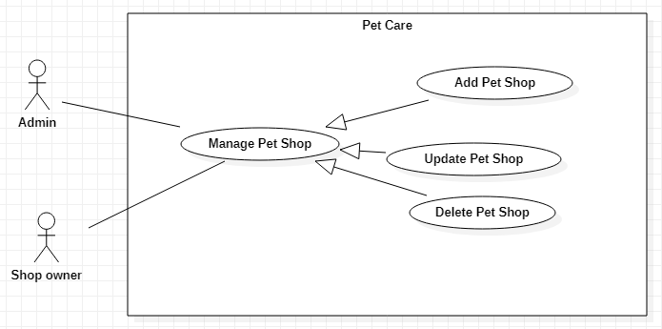

Figure 23-<Admin, Shop owner> Overview Use Case

##### <Admin, Shop owner> Add Pet Shop

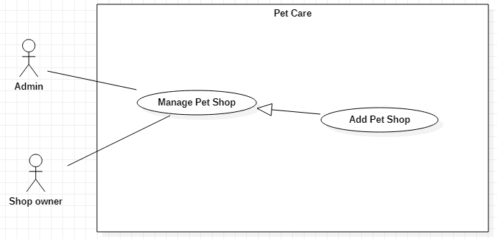

Figure 24-<Admin, Shop owner> Add Pet Shop

|  |  |  |  |
| --- | --- | --- | --- |
| **USE CASE – UC\_22** | | | |
| **Use Case No.** | 22 | **Use Case Version** | 1.0 |
| **Use Case Name** | Add Pet Shop | | |
| **Author** | Trần Nguyễn Quốc Vũ | | |
| **Date** | 30/09/2019 | **Priority** | Normal |
| **Actor:**   * Admin, Shop owner   **Summary:**   * This use case allows the Admin or the Shop owner to add new pet shop.   **Goal:**   * The pet shop is added successfully.   **Triggers:**   * The Admin or the Shop owner clicks on “Add” button.   **Preconditions:**   * User must log in the system with the Admin or Shop owner role.   **Post conditions:**   * Success: The pet shop is created. * Fail: System shows error messages.   **Main Success Scenario:**   |  |  |  | | --- | --- | --- | | **Step** | **Actor Action** | **System Response** | | 1 | The Admin or the Shop owner clicks on “Create new shop” button on “Shops” screen. | If the user logs into the system with Admin role, “Add Shop” screen is shown with the following labels and fields:   * Shop status: options list: Inactive/Active; required * Shop Name: text, required * Image: image; optional * Description: text, optional * Latitude: text, optional * Longtitude: text, optional * Updated at: datetime, fixed * Created at: datetime, fixed   If the user logs into the system with Shop owner role, “Add Shop” screen is shown with the following labels and fields:   * Shop Name: text, required * Image: image; optional * Description: text, optional * Latitude: text, optional * Longtitude: text, optional * Updated at: datetime, fixed * Created at: datetime, fixed | | 2 | The Admin or the Shop owner fills out data fields and clicks on “Create” button. | System validates inputted data and shows “Shops” screen.  [Exception 1, 2, 3] |   **Alternative Scenarios:** N/A  **Exceptions:**   |  |  |  | | --- | --- | --- | | **No** | **Actor Action** | **System Response** | | 1 | Shop Name is empty | System shows error message "This field is required.” and highlights the empty fields. | | 2 | Shop name is used | System shows error message " Shop name is used.” and highlights the empty fields. | | 3 | Network problem. | System shows error message: “Please check your connection.” |   **Relationships:**  Generalized from Manage Pet Shop use case.  **Business Rules:**   * In this system, the Admin and the Shop owner can add new pet shop. * The ID of pet shop is automatically generated. * If the pet shop is created by the Shop owner, it will have inactive status. The Shop owner has no right to set the status for the pet shop. * When the Admin adds a new pet shop, he/she can set status for the pet shop directly. * The information of the activated pet shops will be used on the mobile application. | | | |

<Admin, Shop owner> Add Pet Shop use case specification

##### <Admin, Shop owner> Update Pet Shop

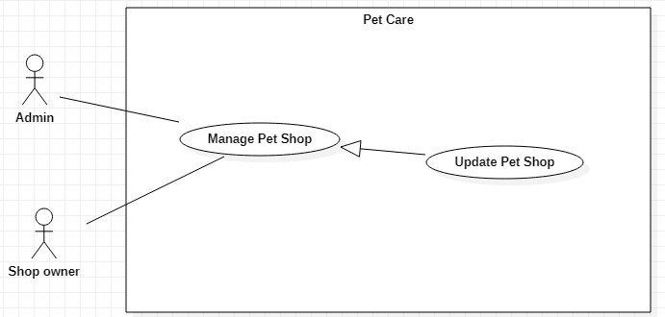

Figure 25-<Admin, Shop owner> Update Pet Shop

|  |  |  |  |
| --- | --- | --- | --- |
| **USE CASE – UC\_23** | | | |
| **Use Case No.** | 23 | **Use Case Version** | 1.0 |
| **Use Case Name** | Update Pet Shop | | |
| **Author** | Trần Nguyễn Quốc Vũ | | |
| **Date** | 30/09/2019 | **Priority** | Normal |
| **Actor:**   * Admin, Shop owner   **Summary:**   * This use case allows the Admin or the Shop owner to update the pet shop information.   **Goal:**   * The pet shop is updated successfully.   **Triggers:**   * The Shop owner clicks on “View Details” button to update.   **Preconditions:**   * User must log in the system with the Admin or Shop owner role.   **Post conditions:**   * Success: The pet shop’s information is updated. * Fail: System shows error messages.   **Main Success Scenarios:**   |  |  |  | | --- | --- | --- | | **Step** | **Actor Action** | **System Response** | | 1 | The Admin or the Shop owner selects a shop and clicks on “View Details” button on “Shops” screen. | If the user logs into the system with Admin role, “Shop Details” screen is shown with the following labels and fields:   * Shop status: options list: Inactive/Active; required * Shop Name: text, required * Image: image; optional * Description: text, optional * Latitude: text, optional * Longtitude: text, optional * Updated at: datetime, fixed * Created at: datetime, fixed   If the user logs into the system with Shop owner role, “Shop Details” screen is shown with the following labels and fields:   * Shop Name: text, required * Image: image; optional * Description: text, optional * Latitude: text, optional * Longtitude: text, optional * Updated at: datetime, fixed * Created at: datetime, fixed | | 2 | The Admin or the Shop owner fills out data fields and clicks on “Create” button. | System validates inputted data and shows “Shops” screen.  [Exception 1, 2, 3] |   **Alternative Scenarios:** N/A  **Exceptions:**   |  |  |  | | --- | --- | --- | | **No** | **Actor Action** | **System Response** | | 1 | Shop Name is empty | System shows error message "This field is required.” and highlights the empty fields. | | 2 | Editing Shop name is used | System shows error message " Shop name is used.” and highlights the empty fields. | | 3 | Network problem. | System shows error message: “Please check your connection.” |   **Relationships:**  Generalized from Manage Pet Shop use case.  **Business Rules:**   * In this system, the Admin and the Shop owner can update information of the pet shop. * The Shop owner has no right to change the status for the pet shop, only the Admin does. * The information of the activated pet shops will be used on the mobile application. | | | |

<Admin, Shop owner> Update Pet Shop use case specification

##### <Admin, Shop owner> Delete Pet Shop

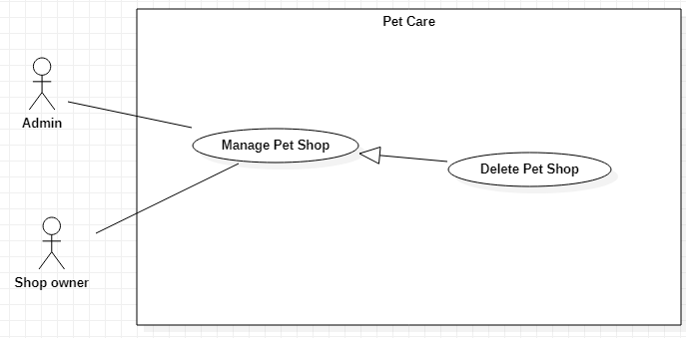

Figure 26-<Admin, Shop owner> Delete Pet Shop

|  |  |  |  |
| --- | --- | --- | --- |
| **USE CASE – UC\_24** | | | |
| **Use Case No.** | 24 | **Use Case Version** | 1.0 |
| **Use Case Name** | Delete Pet Shop | | |
| **Author** | Trần Nguyễn Quốc Vũ | | |
| **Date** | 30/09/2019 | **Priority** | Normal |
| **Actor:**   * Admin, Shop owner   **Summary:**   * This use case allows the Admin or the Shop owner to delete pet shops.   **Goal:**   * The pet shop is deleted successfully.   **Triggers:**   * The Admin clicks on “Delete” button.   **Preconditions:**   * User must log in the system with the Admin or Shop owner role.   **Post conditions:**   * Success: The selected pet shop is deleted. * Fail: System shows error messages.   **Main Success Scenarios:**   |  |  |  | | --- | --- | --- | | **Step** | **Actor Action** | **System Response** | | 1 | The Admin or the Shop owner clicks on “Delete” button on “Shop Details” screen. | System shows a message box “Type the shop name to confirm” and a text field. | | 2 | The Admin or the Shop owner inputs the shop name correctly and clicks on “OK” button | The shop is deleted and system shows “Shops” screen.  [Exception 1,2,3] |   **Alternative Scenarios:** N/A  **Exceptions:**   |  |  |  | | --- | --- | --- | | **No** | **Actor Action** | **System Response** | | 1 | The Admin or the Shop owner clicks on “Cancel” button | System shows “Shops” screen. | | 2 | The Admin or the Shop owner inputs the shop name incorrectly | System shows error message “Mismatched name. Cancelling..” | | 3 | Network problem. | System shows error message “Please check your connection.” |   **Relationships:**  Generalized from Manage Pet Shop use case.  **Business Rules:**   * In this system, the Admin or the Shop owner can delete pet shops. * To delete a pet shop, the Admin or the Shop owner must type the shop’s name to confirm. The input is case-sensitive. | | | |

<Admin, Shop owner> Delete Pet Shop use case specification

#### <Shop owner> Overview Use Case

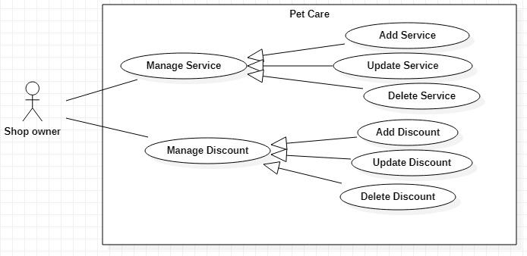

Figure 27-<Shop owner> Overview Use Case

##### <Shop owner> Add Service

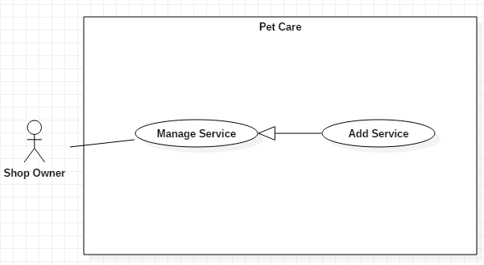

Figure 28-<Shop owner> Add Service

|  |  |  |  |
| --- | --- | --- | --- |
| **USE CASE – UC\_25** | | | |
| **Use Case No.** | 25 | **Use Case Version** | 1.0 |
| **Use Case Name** | Add Service | | |
| **Author** | Trần Nguyễn Quốc Vũ | | |
| **Date** | 30/09/2019 | **Priority** | Normal |
| **Actor:**   * Shop owner   **Summary:**   * This use case allows the Shop owner to add the services of the shop.   **Goal:**   * The service is added successfully.   **Triggers:**   * The Shop owner clicks on “Add” button.   **Preconditions:**   * User must log in the system with the Shop owner role.   **Post conditions:**   * Success: A new service is added. * Fail: System shows error messages.   **Main Success Scenarios:**   |  |  |  | | --- | --- | --- | | **Step** | **Actor Action** | **System Response** | | 1 | The Shop owner clicks on “Create new service” button on “Services” screen. | “Add Service” screen is shown with the following labels and fields:   * Service name: text, required * Unit: fixed (in VND) * Price: integer, required * Description: text, optional * Add Service to Shop section: a text field to add a new shop name and a dropdown list of existed shops for user to choose. * Updated at: datetime, fixed * Created at: datetime, fixed | | 2 | The Shop owner inputs data and clicks on “Save” button. | System validates inputted data and shows “Services” screen.  [Exception 1, 2, 3, 4] |   **Alternative Scenarios:** N/A  **Exceptions:**   |  |  |  | | --- | --- | --- | | **No** | **Actor Action** | **System Response** | | 1 | * Service name is empty * Price is empty * Shop name is not selected | System shows error message "This field is required.” and highlights the empty fields. | | 2 | The Shop owner either chooses a pet shop from the list or enters a new pet shop name. | System shows error message "Please choose a shop or create a new shop.” and highlights the empty fields. | | 3 | Service name is used | System shows error message " Service name is used.” and highlights the empty fields. | | 4 | Network problem. | System shows error message “Please check your connection.” |   **Relationships:**  Generalized from Manage Service use case.  **Business Rules:**   * In this system, only the Shop owner can add services for the shop. * The ID of the service is automatically generated. * The price unit is Vietnam Dong. * The Shop owner must choose a pet shop or add a new pet shop to add the service into. If the user enters a new pet shop name, the new pet shop will be updated in the system. | | | |

<Shop owner> Add Service use case specification

##### <Shop owner> Update Service

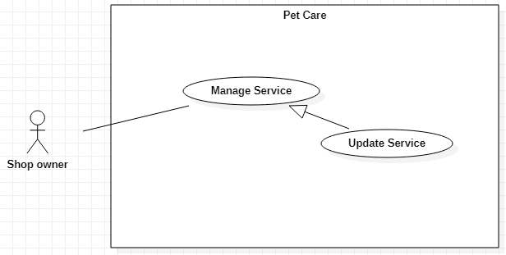

Figure 29-<Shop owner> Update Service

|  |  |  |  |
| --- | --- | --- | --- |
| **USE CASE – UC\_26** | | | |
| **Use Case No.** | 26 | **Use Case Version** | 1.0 |
| **Use Case Name** | Update Service | | |
| **Author** | Lều Thị Thu Thảo | | |
| **Date** | 30/09/2019 | **Priority** | Normal |
| **Actor:**   * Shop owner   **Summary:**   * This use case allows the Shop owner to update the services’ information.   **Goal:**   * The service is updated successfully.   **Triggers:**   * The Shop owner clicks on “View Details” button to update.   **Preconditions:**   * User must log in the system with the Shop owner role.   **Post conditions:**   * Success: The selected service is updated. * Fail: System shows error messages.   **Main Success Scenarios:**   |  |  |  | | --- | --- | --- | | **Step** | **Actor Action** | **System Response** | | 1 | The Shop owner selects a service and clicks on “View Details” button on “Services” screen. | System shows “Shop Details” screen with the following labels and fields:   * Service name: text, required * Unit: fixed (in VND) * Price: integer, required * Description: text, optional * The name of pet shop that has this service. * Updated at: datetime, fixed * Created at: datetime, fixed | | 2 | The Shop owner fills out data fields and clicks on “Save” button. | System validates inputted data and shows “Services” screen.  [Exception 1, 2, 3] |   **Alternative Scenarios:** N/A  **Exceptions:**   |  |  |  | | --- | --- | --- | | **No** | **Actor Action** | **System Response** | | 1 | Service Name is empty | System shows error message "This field is required.” and highlights the empty fields. | | 2 | Editing Service name is used | System shows error message " Service name is used.” and highlights the empty fields. | | 3 | Network problem. | System shows error message “Please check your connection.” |   **Relationships:**  Generalized from Manage Service use case.  **Business Rules:**   * In this system, only the Shop owner can update information of the services. * The price unit is Vietnam Dong. | | | |

<Shop owner> Update Service use case specification

##### <Shop owner> Delete Service

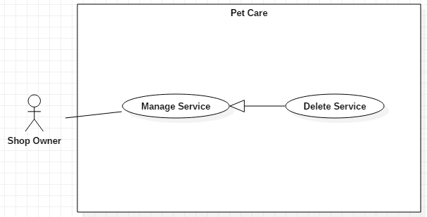

Figure 30-<Shop owner> Delete Service

|  |  |  |  |
| --- | --- | --- | --- |
| **USE CASE – UC\_27** | | | |
| **Use Case No.** | 27 | **Use Case Version** | 1.0 |
| **Use Case Name** | Delete Service | | |
| **Author** | Lều Thị Thu Thảo | | |
| **Date** | 30/09/2019 | **Priority** | Normal |
| **Actor:**   * Shop owner   **Summary:**   * This use case allows the Shop owner to delete services.   **Goal:**   * The service is deleted successfully.   **Triggers:**   * The Shop owner clicks on “Delete” button.   **Preconditions:**   * User must log in the system with the Shop owner role.   **Post conditions:**   * Success: The selected service is deleted. * Fail: System shows error messages.   **Main Success Scenarios:**   |  |  |  | | --- | --- | --- | | **Step** | **Actor Action** | **System Response** | | 1 | The Shop owner clicks on “Delete” button on “Service Details” screen. | System shows a message box “Type the service name to confirm” and a text field. | | 2 | The Shop owner inputs the service name correctly and clicks on “OK” button | The shop is deleted and system shows “Services” screen.  [Exception 1,2,3] |   **Alternative Scenarios:** N/A  **Exceptions:**   |  |  |  | | --- | --- | --- | | **No** | **Actor Action** | **System Response** | | 1 | The Shop owner clicks on “Cancel” button | System shows “Services” screen. | | 2 | The Shop owner inputs the service name incorrectly | System shows error message “Mismatched name. Cancelling..” | | 3 | Network problem. | System shows error message “Please check your connection.” |   **Relationships:**  Generalized from Manage Service use case.  **Business Rules:**   * In this system, the Shop owner can delete services. * To delete a service, the Shop owner must type the service’s name to confirm. The input is case-sensitive. | | | |

<Shop owner> Delete Service use case specification

##### <Shop owner> Add Discount

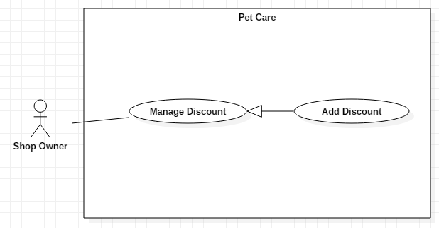

Figure 31-<Shop owner> Add Discount

|  |  |  |  |
| --- | --- | --- | --- |
| **USE CASE – UC\_28** | | | |
| **Use Case No.** | 28 | **Use Case Version** | 1.0 |
| **Use Case Name** | Add Discount | | |
| **Author** | Lều Thị Thu Thảo | | |
| **Date** | 30/09/2019 | **Priority** | Normal |
| **Actor:**   * Shop owner   **Summary:**   * This use case allows the Shop owner to add the discounts.   **Goal:**   * The discount is added successfully.   **Triggers:**   * The Shop owner clicks on “Add” button.   **Preconditions:**   * User must log in the system with the Shop owner role.   **Post conditions:**   * Success: The discount is added. * Fail: System shows error messages.   **Main Success Scenarios:**   |  |  |  | | --- | --- | --- | | **Step** | **Actor Action** | **System Response** | | 1 | The Shop owner clicks on “Create new discount” button on “Discounts” screen. | “Add Discount” screen is shown with the following labels and fields:   * Code: text, required * Type: options list: Percent, Raw value; required * Discount Value: float, required * Unit: fixed (in VND) (will be displayed if the Shop owner select Raw value type option) * Valid from: datetime, fixed * Valid to: datetime, fixed * Add Discount to Shop section: a text field to add a new shop name and a dropdown list of existed shops for user to choose. * Updated at: datetime, fixed * Created at: datetime, fixed | | 2 | The Shop owner inputs data and clicks on “Save” button. | System validates inputted data and shows “Discounts” screen.  [Exception 1,2,3] |   **Alternative Scenarios:** N/A  **Exceptions:**   |  |  |  | | --- | --- | --- | | **No** | **Actor Action** | **System Response** | | 1 | * Code is empty * Discount Value is empty * Shop name is not selected | System shows error message "This field is required.” and highlights the empty fields. | | 2 | The Shop owner either chooses a pet shop from the list or enters a new pet shop name. | System shows error message "Please choose a shop or create a new shop.” and highlights the empty fields. | | 3 | Network problem. | System shows error message “Please check your connection.” |   **Relationships:**  Generalized from Manage Discount use case.  **Business Rules:**   * In this system, only the Shop owner can add discounts for the shop. * The ID of the discount is automatically generated. * “Type” is the type of discount whether the discount is in “%” or “VND”. * The discount code is randomly generated and the Shop owner can edit the code. * The Shop owner must choose a pet shop or add a new pet shop to add the discount into. If the user enters a new pet shop name, the new pet shop will be updated in the system. | | | |

<Shop owner> Add Discount use case specification

##### <Shop owner> Update Discount

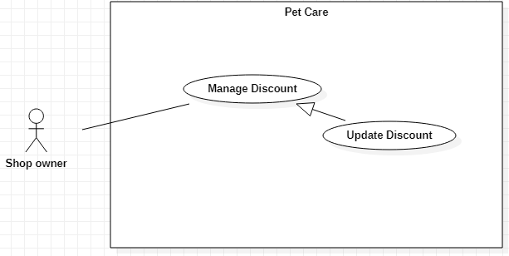

Figure 32-<Shop owner> Update Discount

|  |  |  |  |
| --- | --- | --- | --- |
| **USE CASE – UC\_29** | | | |
| **Use Case No.** | 29 | **Use Case Version** | 1.0 |
| **Use Case Name** | Update Discount | | |
| **Author** | Lều Thị Thu Thảo | | |
| **Date** | 30/09/2019 | **Priority** | Normal |
| **Actor:**   * Shop owner   **Summary:**   * This use case allows the Shop owner to update discounts’ information.   **Goal:**   * The discount is updated successfully.   **Triggers:**   * The Shop owner clicks on “View Details” button to update.   **Preconditions:**   * User must log in the system with the Shop owner role.   **Post conditions:**   * Success: The discount’s information is updated. * Fail: System shows error messages.   **Main Success Scenarios:**   |  |  |  | | --- | --- | --- | | **Step** | **Actor Action** | **System Response** | | 1 | The Shop owner clicks on “Edit” button on “Discounts” screen. | “Edit Discount” screen is shown with following labels and fields whose are the selected service’s information:   * Code: text, required * Type: options list: Percent, Raw value; required * Discount Value: float, required * Unit: fixed (in VND) (will be displayed if the Shop owner select Raw value type option) * Valid from: datetime, fixed * Valid to: datetime, fixed * The name of pet shop that has this discount. * Updated at: datetime, fixed * Created at: datetime, fixed | | 2 | The Shop owner inputs data and clicks on “Confirm” button. | System validates inputted data and shows “Discounts” screen.  [Exception 1, 2, 3] |   **Alternative Scenarios:** N/A  **Exceptions:**   |  |  |  | | --- | --- | --- | | **No** | **Actor Action** | **System Response** | | 1 | * Code is empty * Discount Value is empty * Shop name is not selected | System shows error message "This field is required.” and highlights the empty fields. | | 2 | The Shop owner clicks on “Cancel” button. | System shows “Discounts” screen. | | 3 | Network problem. | System shows error message “Please check your connection.” |   **Relationships:**  Generalized from Manage Service use case.  **Business Rules:**   * In this system, only the Shop owner can updated the information of the discounts. * “Type” is the type of discount whether the discount is in “%” or “VND”. * The discount code is randomly generated and the Shop owner can edit the code. | | | |

<Shop owner> Update Discount use case specification

##### <Shop owner> Delete Discount

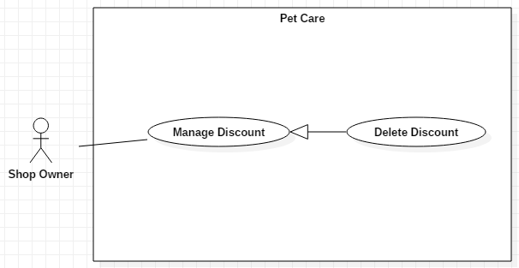

Figure 33-<Shop owner> Delete Discount

|  |  |  |  |
| --- | --- | --- | --- |
| **USE CASE – UC\_30** | | | |
| **Use Case No.** | 30 | **Use Case Version** | 1.0 |
| **Use Case Name** | Delete Discount | | |
| **Author** | Lều Thị Thu Thảo | | |
| **Date** | 30/09/2019 | **Priority** | Normal |
| **Actor:**   * Shop owner   **Summary:**   * This use case allows the Shop owner to delete discounts.   **Goal:**   * The discount is deleted successfully.   **Triggers:**   * The Shop owner clicks on “Delete” button.   **Preconditions:**   * User must log in the system with the Shop owner role.   **Post conditions:**   * Success: The selected discount is deleted. * Fail: System shows error messages.   **Main Success Scenarios:**   |  |  |  | | --- | --- | --- | | **Step** | **Actor Action** | **System Response** | | 1 | The Shop owner clicks on “Delete” button on “Discount Details” screen. | System shows a message box “Type the discount code to confirm” and a text field. | | 2 | The Shop owner inputs the discount code correctly and clicks on “OK” button | The shop is deleted and system shows “Discounts” screen.  [Exception 1,2,3] |   **Alternative Scenarios:** N/A  **Exceptions:**   |  |  |  | | --- | --- | --- | | **No** | **Actor Action** | **System Response** | | 1 | The Shop owner clicks on “Cancel” button | System shows “Services” screen. | | 2 | The Shop owner inputs the discount code incorrectly | System shows error message “Mismatched name. Cancelling..” | | 3 | Network problem. | System shows error message “Please check your connection.” |   **Relationships:**  Generalized from Manage Discount use case.  **Business Rules:**   * In this system, the Shop owner can delete discounts. * To delete a service, the Shop owner must type the discount code to confirm. The input is case-sensitive. | | | |

<Shop owner> Delete Discount use case specification

##### <Shop owner> Link Discount to Service

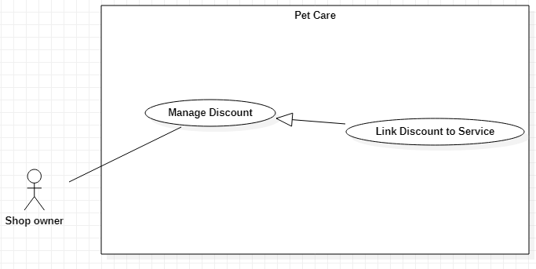

Figure 34-<Shop owner> Link Discount to Service

|  |  |  |  |
| --- | --- | --- | --- |
| **USE CASE – UC\_31** | | | |
| **Use Case No.** | 31 | **Use Case Version** | 1.0 |
| **Use Case Name** | Link Discount to Service | | |
| **Author** | Lều Thị Thu Thảo | | |
| **Date** | 30/09/2019 | **Priority** | Normal |
| **Actor:**   * Shop owner   **Summary:**   * This use case allows the Shop owner to link the discount to the service.   **Goal:**   * The discount is linked to the service successfully.   **Triggers:**   * The Shop owner clicks on “Delete” button.   **Preconditions:**   * User must log in the system with the Shop owner role.   **Post conditions:**   * Success: The selected discount is linked with a service.. * Fail: System shows error messages.   **Main Success Scenarios:**   |  |  |  | | --- | --- | --- | | **Step** | **Actor Action** | **System Response** | | 1 | The Shop owner clicks on “Create new” button on “Link” screen. | “Add Discount” screen is shown with the following labels and fields:   * Shop: options list of existed pet shops * Discount and Service: the list of discounts and services of the selected pet shop * Updated at: datetime, fixed * Created at: datetime, fixed | | 2 | The Shop owner chooses a pet shop from the list | System shows the list of services and discounts of the selected pet shop | | 3 | The Shop owner chooses the service and the discount corresponding selected pet shop. | System shows a discount calculation area and calculates then displays the discount price. | | 4 | The Shop clicks on “Create” button. | System shows “Link” screen.  [Exception 1] |   **Alternative Scenarios:** N/A  **Exceptions:**   |  |  |  | | --- | --- | --- | | **No** | **Actor Action** | **System Response** | | 1 | Network problem. | System shows error message “Please check your connection.” |   **Relationships:**  Generalized from Manage Discount use case.  **Business Rules:**   * In this system, the Shop owner can link discount to services. | | | |

<Shop owner> Link Discount to Service use case specification

#### <Pet owner> Overview Use Case

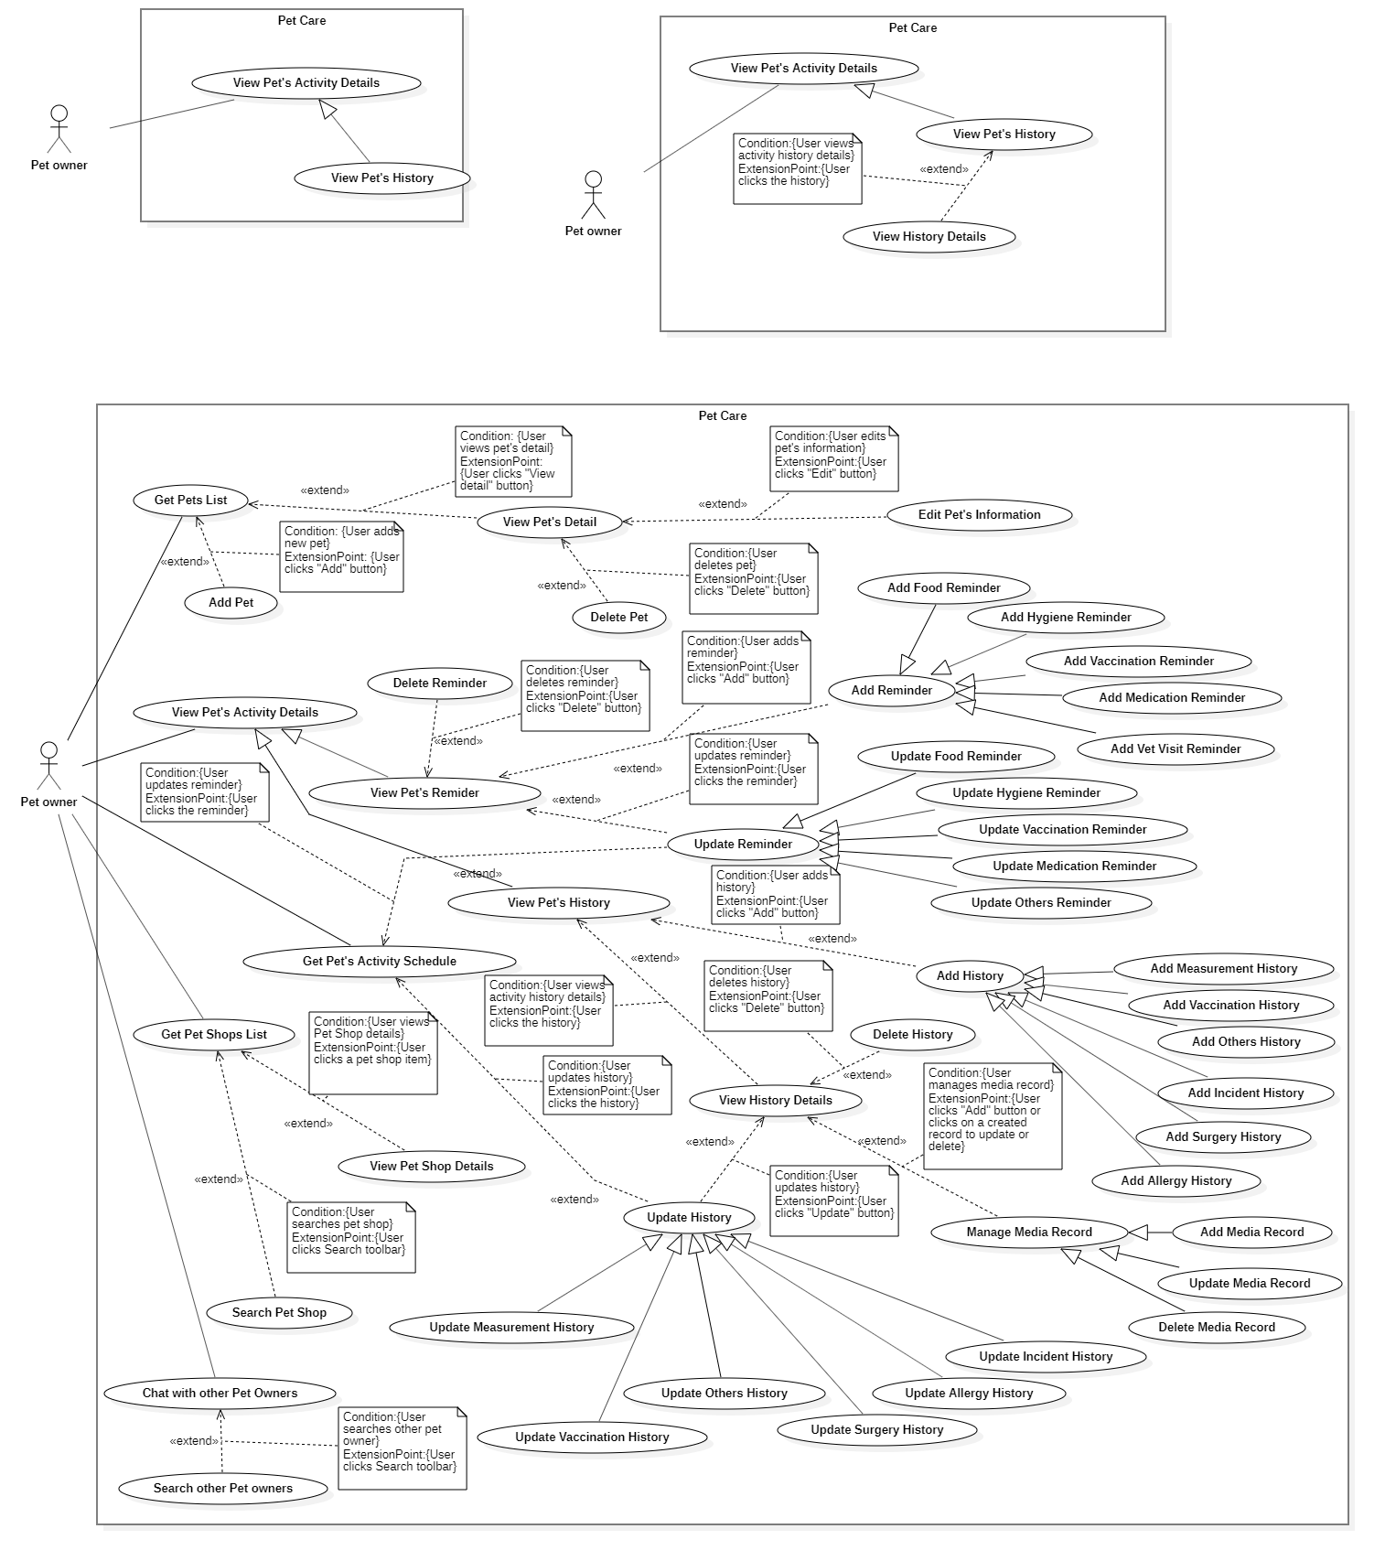

Figure 35-<Pet owner> Overview Use Case

##### <Pet owner> Get Pets List

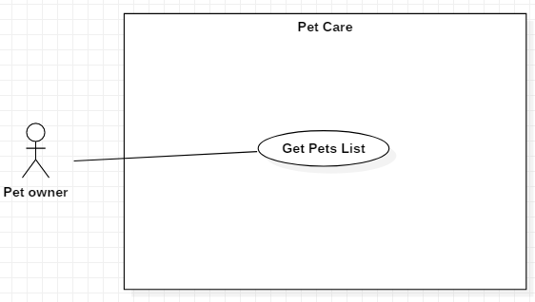

Figure 36-<Pet owner> Get Pets List

|  |  |  |  |
| --- | --- | --- | --- |
| **USE CASE – UC\_32** | | | |
| **Use Case No.** | 32 | **Use Case Version** | 1.0 |
| **Use Case Name** | Get Pets List | | |
| **Author** | Trần Nguyễn Quốc Vũ, Lều Thị Thu Thảo | | |
| **Date** | 30/09/2019 | **Priority** | Normal |
| **Actor:**   * Pet owner   **Summary:**   * This use case allows the Pet owner to get pet list.   **Goal:**   * The Pet owner gets pet list successfully.   **Triggers:**   * The pet owner is at “My Pets” screen   **Preconditions:** User can log in the system with Pet owner role.  **Post conditions:**   * Success: The pet list is shown. * Fail: System displays error message.   **Main Success Scenario:**   |  |  |  | | --- | --- | --- | | **Step** | **Actor Action** | **System Response** | | 1 | The Pet owner clicks on ”My pets” tab on the bottom navigation bar | System displays “My Pets” screen current pet list. |   **Alternative Scenarios:** N/A  **Exceptions:** N/A  **Relationships:**  Associated with Pet Owner actor.  **Business Rules:**   * In this system, the Guest and the Pet owner can get pets list. * If the list is empty, system displays message “Record is empty. Please add a new pet”. | | | |

<Pet owner> Get Pets List use case specification

##### <Pet owner> Add Pet

**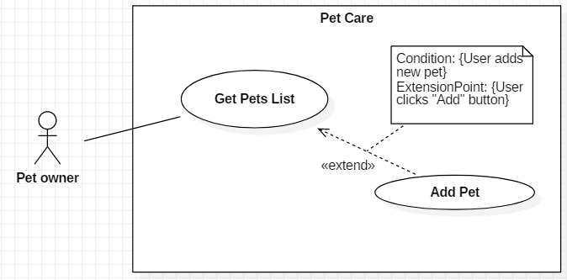**

Figure 37-<Pet owner> Add Pet

|  |  |  |  |
| --- | --- | --- | --- |
| **USE CASE – UC\_33** | | | |
| **Use Case No.** | 33 | **Use Case Version** | 1.0 |
| **Use Case Name** | Add Pet | | |
| **Author** | Trần Nguyễn Quốc Vũ, Lều Thị Thu Thảo | | |
| **Date** | 30/09/2019 | **Priority** | Normal |
| **Actor:**   * Pet owner   **Summary:**   * This use case allows the Pet owner to add new pets.   **Goal:**   * The Pet owner adds a new pet successfully.   **Triggers:**   * The Pet owner clicks on “Add” button on “Pets List” screen.   **Preconditions:** User can log in the system with Pet owner role.  **Post conditions:**   * Success: A new pet is created. * Fail: System shows error messages.   **Main Success Scenarios:**   |  |  |  | | --- | --- | --- | | **Step** | **Actor Action** | **System Response** | | 1 | The Pet owner clicks on “Add” button on “Pets List” screen. | “Add Pet” screen is shown with following labels and fields:   * Pet avatar: image, optional. * Pet name: text, required * Pet type: select option, required * Breed: select option, required * Gender: select option, required * Birthday: date, required * Color: text, optional * Notes, text, optional | | 2 | The Pet owner fills out data fields and clicks “Save” button. | System validates inputted data and shows “View pet list” screen  [Exception 1, 2] |   **Alternative Scenarios:** N/A  **Exceptions:**   |  |  |  | | --- | --- | --- | | **No** | **Actor Action** | **System Response** | | 1 | * Pet name is empty. * Breed is not selected. * Birthday is not selected. | System shows error message "This field is required.” and highlights the empty fields. | | 2 | The Pet owner clicks on “Cancel” button. | System shows “View list pets” screen. |   **Relationships:**  Extended from Get Pets List use case.  **Business Rules:**   * In this system, the Guest and the Pet owner can add new pets. * System only supports Dog and Cat pet type. If the user has another pet type, select “Other” option in “Pet type” field. * Breeds list is loaded from the system. * When the Pet owner chooses a pet type, the breeds of that corresponding pet type will be displayed. * Pet’s birthday must be prior to the current date. | | | |

<Pet owner> Add Pet use case specification

##### <Pet owner> View Pet’s Detail

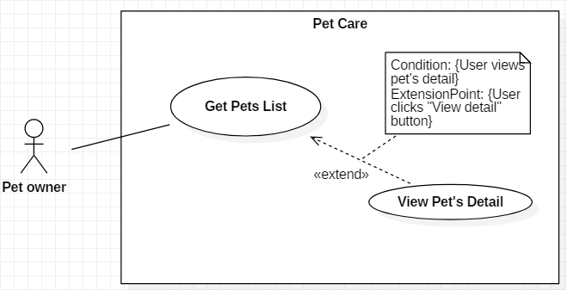

Figure 38-<Pet owner> View Pet’s Detail

|  |  |  |  |
| --- | --- | --- | --- |
| **USE CASE – UC\_34** | | | |
| **Use Case No.** | 34 | **Use Case Version** | 1.0 |
| **Use Case Name** | View Pet’s Detail | | |
| **Author** | Trần Nguyễn Quốc Vũ, Lều Thị Thu Thảo | | |
| **Date** | 30/09/2019 | **Priority** | Normal |
| **Actor:**   * Pet owner   **Summary:**   * This use case allows the Pet owner to view pet’s detail along with the menu of options for the pet caring function that are available in the system (managing activity’s reminder and history for pet).   **Goal:**   * The Pet owner view pet’s detail successfully.   **Triggers:**   * The Pet owner clicks on a pet on “Pets List” screen.   **Preconditions:** User can log in the system with Pet owner role.  **Post conditions:**   * Success: The pet’s detail is shown. * Fail: System shows error message.   **Main Success Scenarios:**   |  |  |  | | --- | --- | --- | | **Step** | **Actor Action** | **System Response** | | 1 | Pet owner clicks on a pet on “Pets List” screen. | “Pets List” screen is shown with following information about the pet: avatar, name, type, breed, age, gender; with the bottom half of the screen is a menu panel of the activities.  The menu panel is divided into 2 tabs: Care and Medical:   * Care tab includes the menu of the caring activities: Food, Bath, Hair, Nails, Teeth, Ears, Internal Deworming, Fleas & Ticks, Measurements * Medical tab includes the menu of the medical activities: Medication, Vaccination, Vet Visit, Surgeries, Allergies, Incident. |   **Alternative Scenarios:** N/A  **Exceptions:** N/A  **Relationships:**  Extended from Get Pets List use case.  **Business Rules:**   * In this system, the Guest and the Pet owner can view pet’s detail. * User can configure the activities list to suitable for the needs of pet. * If an activity that has data is disabled, when being enabled again, the data of the activity still exists. * Pet’s age will be calculated based on its birthday. | | | |

<Pet owner> View Pet’s Detail use case specification

##### <Pet owner> Edit Pet’s Information

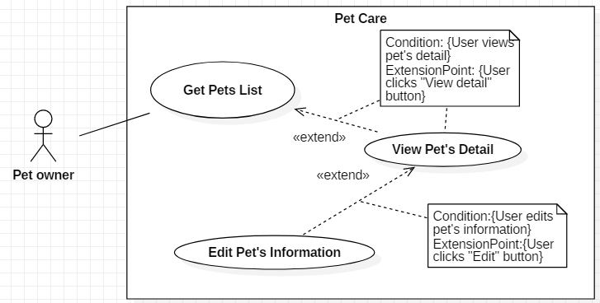

Figure 39-<Pet owner> Edit Pet’s Information

|  |  |  |  |
| --- | --- | --- | --- |
| **USE CASE – UC\_35** | | | |
| **Use Case No.** | 35 | **Use Case Version** | 1.0 |
| **Use Case Name** | Edit Pet’s Information | | |
| **Author** | Trần Nguyễn Quốc Vũ, Lều Thị Thu Thảo | | |
| **Date** | 30/09/2019 | **Priority** | Normal |
| **Actor:**   * Pet owner   **Summary:**   * This use case allows the Pet owner to edit pet’s information.   **Goal:**   * The Pet owner edits pet’s information successfully.   **Triggers:**   * The Pet owner clicks “Edit” button on “Pet’s Detail” screen.   **Preconditions:** User can log in the system with Pet owner role.  **Post conditions:**   * Success: The pet’s information is edited. * Fail: System shows error message.   **Main Success Scenarios:**   |  |  |  | | --- | --- | --- | | **Step** | **Actor Action** | **System Response** | | 1 | The Pet owner clicks on “Edit” button on “Pet’s Detail” screen. | “Edit Pet” screen is shown with following labels and fields:   * Pet avatar: image, optional. * Pet name: text, required * Pet type: select option, required * Breed: select option, required * Gender: select option, required * Birthday: date, required * Color: text, optional * Notes, text, optional | | 2 | The Pet owner fills out data fields and clicks “Save” button. | System validates inputted data and shows “Pet’s Detail” screen  [Exception 1, 2] |   **Alternative Scenarios:** N/A  **Exceptions:**   |  |  |  | | --- | --- | --- | | **No** | **Actor Action** | **System Response** | | 1 | * Pet name is empty. * Breed is empty. * Birthday is empty. | System shows error message "This field is required.” and highlights the empty fields. | | 2 | The Pet owner clicks on “Back” button. | System shows “Pet’s Detail” screen. |   **Relationships:**  Extended from View Pet’s Detail use case.  **Business Rules:**   * In this system, the Guest and the Pet owner can edit pet’s information. * Breeds list is loaded from the system. | | | |

<Pet owner> Edit Pet’s Information use case specification

##### <Pet owner> Delete Pet

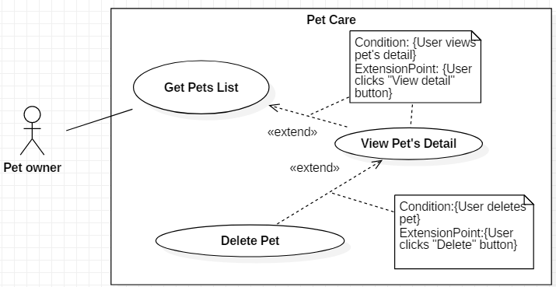

Figure 40-<Pet Owner> Delete Pet

|  |  |  |  |
| --- | --- | --- | --- |
| **USE CASE – UC\_36** | | | |
| **Use Case No.** | 36 | **Use Case Version** | 1.0 |
| **Use Case Name** | Delete Pet | | |
| **Author** | Trần Nguyễn Quốc Vũ, Lều Thị Thu Thảo | | |
| **Date** | 30/09/2019 | **Priority** | Normal |
| **Actor:**   * Pet owner   **Summary:**   * This use case allows the Pet owner to delete pets.   **Goal:**   * The Pet owner deletes pet’s information successfully.   **Triggers:**   * The Pet owner clicks “Delete” button on “Pet’s Detail” screen.   **Preconditions:** User can log in the system with Pet owner role.  **Post conditions:**   * Success: The pet is deleted. * Fail: System shows error message.   **Main Success Scenarios:**   |  |  |  | | --- | --- | --- | | **Step** | **Actor Action** | **System Response** | | 1 | The Shop owner clicks on “Delete” button on “Pet’s Detail” screen. | System shows a confirmation box with the Y/N options: “Delete this pet?” | | 2 | The Shop owner clicks on “Confirm” button. | System shows “Pet’s Detail” screen.  [Exception 1] |   **Alternative Scenarios:** N/A  **Exceptions:**   |  |  |  | | --- | --- | --- | | **No** | **Actor Action** | **System Response** | | 1 | The Pet owner clicks on “Back” button. | System shows “Pet’s Detail” screen. |   **Relationships:**  Extended from View Pet’s Detail use case.  **Business Rules:**   * In this system, the Guest and the Pet owner can delete pets. | | | |

<Pet owner> Delete Pet use case specification

##### <Pet owner> View Pet’s Reminder

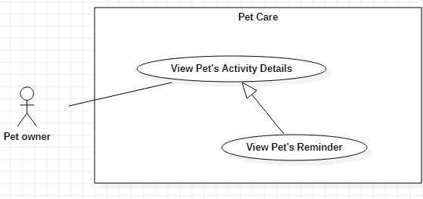

Figure 41-<Pet Owner> View Pet’s Reminder

|  |  |  |  |
| --- | --- | --- | --- |
| **USE CASE – UC\_37** | | | |
| **Use Case No.** | **37** | **Use Case Version** | 1.0 |
| **Use Case Name** | View Pet’s Reminder | | |
| **Author** | Nguyễn Huy Hoàng | | |
| **Date** | 30/09/2019 | **Priority** | Normal |
| **Actor:**   * Pet owner   **Summary:**   * This use case allows the Pet owner to view reminders of pet’s activity.   **Goal:**   * The Pet owner view the reminders successfully.   **Triggers:**   * The Pet owner clicks on the specific Activity icon to view the activity’s reminders list.   **Preconditions:**   * User can log in the system with the Pet owner role. * User is at a Pet’s Detail screen.   **Post conditions:**   * Success: Activity’s reminders is displayed. * Fail: System shows error messages.   **Main Success Scenarios:**   |  |  |  | | --- | --- | --- | | **Step** | **Actor Action** | **System Response** | | 1 | The Pet owner clicks on an Activity icon listed on Pet’s Detail screen | System shows the corresponding Activity screen with the following information:   * Reminder section: contains the upcoming reminder of an activity. * “View more” button: to view the list of reminders. | | 2 | The Pet owner clicks on “View more” button | System shows the list of all reminders of the activity.  [Exception 1] |   **Alternative Scenarios:** N/A  **Exceptions:**   |  |  |  | | --- | --- | --- | | **No** | **Actor Action** | **System Response** | | 1 | No reminders existed. | System shows “Add Reminder” button |   **Relationships:** Generalized from View Pet’s Activity Details use case.  **Business Rules:**   * In this system, the Guest and the Pet owner can view pet’s activity reminders. * The activities that are allowed for the Pet owner to add reminders: Food, Hygiene Activities (Bath, Hair, Nails, Teeth, Ears, Internal Deworming, Fleas & Ticks), Vaccination, Medication, Vet Visits. * The Pet owner can click the information button to read more suggested information about each activity for pets. | | | |

<Pet owner> View Pet’s Reminder use case specification

##### <Pet owner> Add Food Reminder

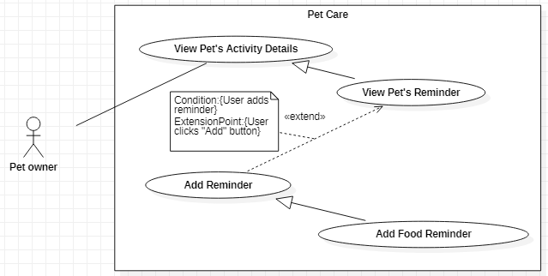

Figure 42-<Pet Owner> Add Food Reminder

|  |  |  |  |
| --- | --- | --- | --- |
| **USE CASE – UC\_38** | | | |
| **Use Case No.** | **38** | **Use Case Version** | 1.0 |
| **Use Case Name** | Add Food Reminder | | |
| **Author** | Nguyễn Huy Hoàng | | |
| **Date** | 30/09/2019 | **Priority** | Normal |
| **Actor:**   * Pet owner   **Summary:**   * This use case allows the Pet owner to add food reminders for the pet.   **Goal:**   * The Pet owner adds new food reminder successfully.   **Triggers:**   * The Pet owner clicks on the “Add” button.   **Preconditions:**   * User can log in the system with the Pet owner role. * User is at Food screen.   **Post conditions:**   * Success: The new reminder is created. * Fail: System shows error messages.   **Main Success Scenarios:**   |  |  |  | | --- | --- | --- | | **Step** | **Actor Action** | **System Response** | | 1 | The Pet owner clicks on “Add” button on the Food screen. | System shows “Add Reminder” screen with the following information:   * Food type: options list: Supplement, Main Food, Treat, Other; required * Food name: text, required. When the Pet owner clicks on the text field, system displays “Add Food” screen with the following information: * “Add New Food Name” button: the Pet owner clicks this button to add new pet food. After the new food is created, the pet owner clicks on the food to choose. * Notes: text, optional * Unit: options list: G/Kg/Ml/L/Units/Other; required * Start date: date, required * Repetition: options list: Does not repeat, Specific days of week, Day(s), Week(s), Month(s), Year(s); required. * If the Pet owner selects Day(s) / Week(s) / Month(s) / Year(s) option, a text field will be displayed for the Pet owner to input the interval value. * If the Pet owner selects Specific days of week option, a list of days in the week will be displayed for the Pet owner to select the days manually. * Duration: options list: No end date, Until date, For X days; required. Duration option will be displayed if the Pet owner selects Day(s) / Week(s) / Month(s) / Year(s) repetition option. * If “Until date” option is selected, system displays a field for the Pet owner to input the date. * If “For X days” option is selected, system displays a field for the Pet owner to input the interval value. * Reminder time: time, required. When the Pet owners clicks the field, a text field will be displayed in-line with the Time text field for inputting food quantity value for each specific time. | | 2 | The Pet owner fills out data fields and clicks “Save” button.  [Alternative 1(1,2,3), 2(1,2,3)] | System validates inputted data and displays the “Food” screen  [Exception 1,2,3,4,5,6] |   **Alternative Scenarios 1:**   |  |  |  | | --- | --- | --- | | **Step** | **Actor Action** | **System Response** | | 1 | When a food reminder is created, the Pet owner clicks the Food’s reminder | System shows “Food’s Schedule” screen with the following information:   * Name of food, food category * A toggle to activate/deactivate food * “Schedule” section contains the reminders of the corresponding food. | | 2 | The Pet owner clicks the Configure icon. | System shows “Configure Food Reminder” screen with the following information:   * Food type: fixed * Food name: fixed * Notes: text, optional * Unit: options list: G/Kg/Ml/L/Units/Other; required * Start date: date, required * Repetition: options list: Does not repeat, Specific days of week, Day(s), Week(s), Month(s), Year(s); required. * If the Pet owner selects Day(s) / Week(s) / Month(s) / Year(s) option, a text field will be displayed for the Pet owner to input the interval value. * If the Pet owner selects Specific days of week option, a list of days in the week will be displayed for the Pet owner to select the days manually. * Duration: options list: No end date, Until date, For X days; required. * If “Until date” option is selected, system displays a field for the Pet owner to input the date. * If “For X days” option is selected, system displays a field for the Pet owner to input the interval value. * Reminder time: time, required. When the Pet owners clicks the field, a text field will be displayed in-line with the Time text field for inputting food quantity value for each specific time. | | 3 | The Pet owner fills out data fields and clicks “Save” button. | System validates inputted data and displays the “Food’s Schedule” screen  [Exception 1,2,3,4,5] |   **Alternative Scenarios 2:**   |  |  |  | | --- | --- | --- | | **Step** | **Actor Action** | **System Response** | | 1 | When a food reminder is created, the Pet owner clicks the Food’s reminder | System shows “Food’s Schedule” screen with the following information:   * Name of food, food category * A toggle to activate/deactivate food * “Schedule” section contains the reminders of the corresponding food. | | 2 | The Pet owner clicks the Add button on “Schedule” section. | System shows “Add Food Schedule” screen with the following information:   * Food name: fixed * Date: date, required * Time: time, required * Quantity: float; required (with the quantity unit has been set before) * Status: options list: Schedule/Skip/Done; required * Notes: text, optional | | 3 | The Pet owner fills out data fields and clicks “Save” button. | System validates inputted data and displays the “Food’s Schedule” screen  [Exception 1,2,3,5] |   **Exceptions:**   |  |  |  | | --- | --- | --- | | **No** | **Actor Action** | **System Response** | | 1 | * Food name is empty * Start date is not selected * Repetition is not selected * Duration is not selected * Interval value is empty (if the Repetition or Duration option requires inputting the value) * Reminder time is not selected * Quantity is empty | System shows error message "This field is required.” and highlights the empty fields. | | 2 | Interval value is 0 | System shows error message "Please input value larger than 0.” and highlights the empty fields. | | 3 | Quantity value is 0. | System shows error message "Please input value larger than 0.” and highlights the empty fields. | | 4 | The Pet owner inputs duplicate reminder time | System shows error message "Time already existed.” and highlights the empty fields. | | 5 | Until date is not after the Start date | System shows error message "Please input another date.” and highlights the empty fields. | | 6 | The Pet owner clicks on “Cancel” button. | System shows “Food” / “Food’s Schedule” screen. |   **Relationships:** Generalized from Add Reminder use case, which is extended from View Pet’s Reminder use case.  **Business Rules:**   * In this system, the Guest and the Pet owner can add food reminders for pet. * If the Pet owner selects Repetition option as Specific days of week / Day(s) / Week(s) / Month(s) / Year(s), the Duration option will be displayed. * The Start date cannot be past date. The Until date must be after the Start date. The interval value for For X Days option must be larger than 0. * The interval value for Day(s), Week(s), Month(s), Year(s) repetition option must be larger than 0. * Food quantity must be larger than 0. * Each food reminder will be listed as each specific time in “Schedule” section. * A reminder after being created will have “Scheduled” status. * The reminders list in “Schedule” section is displayed in descending date order. * When the reminder time reaches the real time, the reminder will have Overdue status and be listed on “Schedule” section. From now on, the reminder has become an activity history. Though this history is still “Unknown” because the system doesn’t know the Pet owner has done the activity or not. So the Pet owner can only update the status of this history later whether it is “Skipped” or “Done”. * If the Pet owner set the reminder time in the past, the reminder will be an Unknown Overdue reminder and will be listed in “Schedule” section. * If the reminder is set having a repetition, when the old reminder time has passed, the system will shift to the next reminder time based on the corresponding repetition, making it become a new reminder. * The Pet owner can create more reminders for existed food by choosing the food and updating more reminder times. * If the pet has an allergy record about food, when adding a food reminder, a warning tab “Allergies warning” will be displayed to let the user know about the kind of food that the pet is allergic to. The pet owner can view the list of food that the pet is allergic to or add a new allergy record about the food. | | | |

<Pet owner> Add Food Reminder use case specification

##### <Pet owner> Add Hygiene Reminder

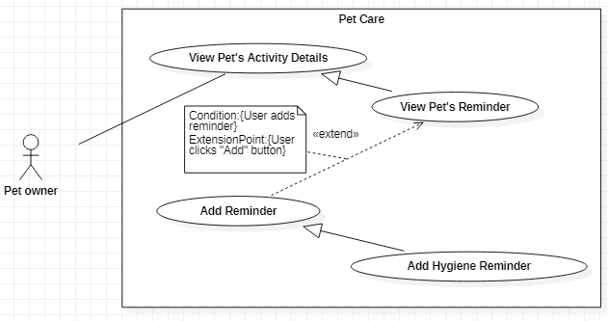

Figure 43-<Pet Owner> Add Hygiene Reminder

|  |  |  |  |
| --- | --- | --- | --- |
| **USE CASE – UC\_39** | | | |
| **Use Case No.** | **39** | **Use Case Version** | 1.0 |
| **Use Case Name** | Add HygieneReminder | | |
| **Author** | Nguyễn Huy Hoàng | | |
| **Date** | 30/09/2019 | **Priority** | Normal |
| **Actor:**   * Pet owner   **Summary:**   * This use case allows the Pet owner to add hygiene activity reminders for the pet (including Bath, Nails, Hair, Teeth, Ears, Internal Deworming, Fleas and Ticks activity).   **Goal:**   * The Pet owner adds new hygiene activity reminder successfully.   **Triggers:**   * The Pet owner clicks on the “Add Reminder” button.   **Preconditions:**   * User can log in the system with the Pet owner role. * User is at specific Hygiene screen: Bath / Nails / Hair / Teeth / Ears / Internal Deworming/ Fleas and Ticks screen.   **Post conditions:**   * Success: The new reminder is created. * Fail: System shows error messages.   **Main Success Scenarios:**   |  |  |  | | --- | --- | --- | | **Step** | **Actor Action** | **System Response** | | 1 | The Pet owner clicks on “Add Reminder” button on the specific Hygiene screen. | System shows “Add Reminder” screen with the following information:   * Date: date, required * Time: time, required * Repetition: options list: Does not repeat, Day(s), Week(s), Month(s), Year(s); required. If the Pet owner selects Day(s) / Week(s) / Month(s) / Year(s), a value input field will be displayed for the Pet owner to input the interval value. * Cared at: options list: At home/At shop; required * Notes: text, optional | | 2 | The Pet owner fills out data fields and clicks “Save” button. | System validates inputted data and shows the specific Hygiene screen.  [Exception 1,2,3] |   **Alternative Scenarios:** N/A  **Exceptions:**   |  |  |  | | --- | --- | --- | | **No** | **Actor Action** | **System Response** | | 1 | * Date is not selected * Time is not selected * Interval value is empty (if the Repetition option requires inputting the value) | System shows error message "This field is required.” and highlights the empty fields. | | 2 | Interval value is 0. | System shows error message " Please input value larger than 0.” and highlights the empty fields. | | 3 | Time is in the past | System shows error message "Cannot select past time.” and highlights the empty fields. | | 4 | The Pet owner clicks on “Cancel” button. | System shows the specific Hygiene screen. |   **Relationships:** Generalized from Add Reminder use case, which is extended from View Pet’s Reminder use case.  **Business Rules:**   * In this system, the Guest and the Pet owner can add hygiene activity reminders for pet. * Reminder time cannot be set in past time. * The date cannot be past date. * The interval value for Day(s), Week(s), Month(s), Year(s) repetition option must be larger than 0. * A reminder after being created will have “Scheduled” status. * When the reminder time reaches the real time, the reminder will have Overdue status and be listed on “History” section. From now on, the reminder has become an activity history. Though this history is still “Unknown” because the system doesn’t know the Pet owner has done the activity or not. The Pet owner can update the status of this history later whether it is “Skipped” or “Done”. * If the reminder is set having a repetition, when the old reminder time has passed, the system will shift to the next reminder time based on the corresponding repetition, making it become a new reminder. * If the Pet owner selects At shop option in “Cared at” field, a suggesting dialog box will be shown to display the information of the shop that provides the corresponding hygiene activity. The pet owner can view details of the shop, then selects the shop to add shop address into the reminder. | | | |

<Pet owner> Add Hygiene Reminder use case specification

##### <Pet owner> Add Vaccination Reminder

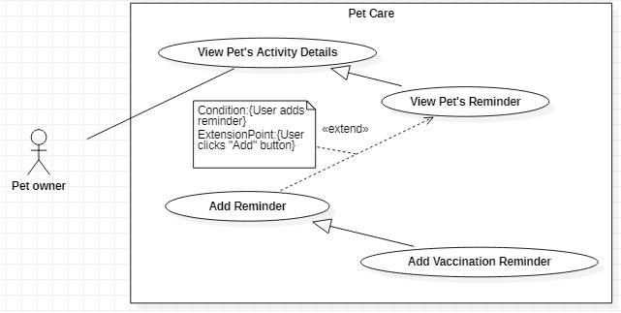

Figure 44-<Pet Owner> Add Vaccination Reminder

|  |  |  |  |
| --- | --- | --- | --- |
| **USE CASE – UC\_40** | | | |
| **Use Case No.** | **40** | **Use Case Version** | 1.0 |
| **Use Case Name** | Add VaccinationReminder | | |
| **Author** | Nguyễn Huy Hoàng | | |
| **Date** | 30/09/2019 | **Priority** | Normal |
| **Actor:**   * Pet owner   **Summary:**   * This use case allows the Pet owner to add vaccinationreminders for the pet.   **Goal:**   * The Pet owner adds new vaccinationreminder successfully.   **Triggers:**   * The Pet owner clicks on the “Add Reminder” button.   **Preconditions:**   * User can log in the system with the Pet owner role. * User is at Vaccinationsscreen.   **Post conditions:**   * Success: The new reminder is created. * Fail: System shows error messages.   **Main Success Scenarios:**   |  |  |  | | --- | --- | --- | | **Step** | **Actor Action** | **System Response** | | 1 | The Pet owner clicks on “Add Reminder” button on Vaccinationsscreen. | System shows “Add Reminder” screen with the following information:   * Vaccine name: text, required. When the Pet owner clicks on the text field, system displays “Vaccines List” screen for the Pet owner to select. * Date: date, required * Time: time, required * Repetition: options list: Does not repeat, Day(s), Week(s), Month(s), Year(s); required. If the Pet owner selects Day(s) / Week(s) / Month(s) / Year(s), a value input field will be displayed for the Pet owner to input the value. * End date: options list: No end date, Until date; required. If “Until date” option is selected, the system displays a field for the Pet owner to input the date. End date option will be displayed if the Pet owner selects Day(s) / Week(s) / Month(s) / Year(s) repetition option. * Notes: text, optional | | 2 | The Pet owner fills out data fields and clicks “Save” button. | System validates inputted data and shows Vaccinationsscreen.  [Exception 1,2,3,4,5] |   **Alternative Scenarios:** N/A  **Exceptions:**   |  |  |  | | --- | --- | --- | | **No** | **Actor Action** | **System Response** | | 1 | * Vaccine name is empty * Date is not selected * Time is not selected * Repetition is not selected * End date is not selected | System shows error message "This field is required.” and highlights the empty fields. | | 2 | Interval value is 0 | System shows error message "Please input value larger than 0.” and highlights the empty fields. | | 3 | Until date is not after the Start date | System shows error message "Please input another date.” and highlights the empty fields. | | 4 | The Pet owner selects one of the Combined Vaccines and also selects one of the Individual Vaccines, | System shows error message with Y/N options "Your selected vaccine is conflicted. Do you want to select this vaccine?” | | 5 | The Pet owner clicks on “Cancel” button. | System shows the Vaccinationsscreen. |   **Relationships:** Generalized from Add Reminder use case, which is extended from View Pet’s Reminder use case.  **Business Rules:**   * In this system, the Guest and the Pet owner can add vaccinationreminders for pet. * Reminder time cannot be set in past time and cannot be duplicated. * If the Pet owner selects Repetition option as Day(s) / Week(s) / Month(s) / Year(s), the End date option will be displayed. * The Date cannot be past date. * The interval value for Day(s), Week(s), Month(s), Year(s) repetition option must be larger than 0. * The date cannot be past date. The Until date must be after the Start date. * A reminder after being created will have “Scheduled” status. * Vaccines List has Combined Vaccines and Individual Vaccines. If the Pet owner selects one of the Combined Vaccines and also selects one of the Individual Vaccines, the system will display a warning to let the user know the selection is conflicted. * The vaccines list is loaded from the system. * The vaccines are specified for specific pet types: dogs, cats. * When the reminder time reaches the real time, the reminder will have Overdue status. The Pet owner can update the status of the reminder later whether it is “Skipped” or “Done”. After being updated the status, the reminder becomes an activity history and be listed in “History” section. * If the reminder is set having a repetition, when the old reminder time has passed, the system will shift the reminder time based on the corresponding repetition, making it become a new reminder. The next reminder time will be set, based on the moment the Pet owner presses “Skipped” or “Done” on the reminder. | | | |

<Pet owner> Add Vaccination Reminder use case specification

##### <Pet owner> Add Medication Reminder

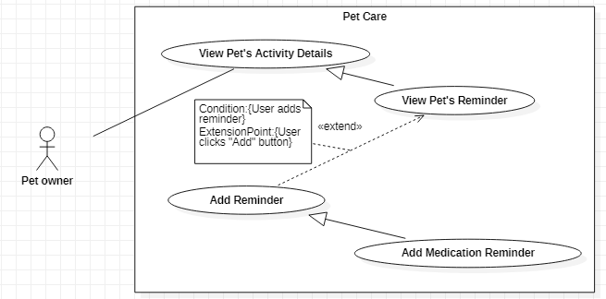

Figure 45-<Pet Owner> Add Medication Reminder

|  |  |  |  |
| --- | --- | --- | --- |
| **USE CASE – UC\_41** | | | |
| **Use Case No.** | **41** | **Use Case Version** | 1.0 |
| **Use Case Name** | Add MedicationReminder | | |
| **Author** | Nguyễn Huy Hoàng | | |
| **Date** | 30/09/2019 | **Priority** | Normal |
| **Actor:**   * Pet owner   **Summary:**   * This use case allows the Pet owner to add medication reminders for the pet.   **Goal:**   * The Pet owner adds new medication reminder successfully.   **Triggers:**   * The Pet owner clicks on the “Add Reminder” button.   **Preconditions:**   * User can log in the system with the Pet owner role. * User is at Medications screen.   **Post conditions:**   * Success: The new reminder is created. * Fail: System shows error messages.   **Main Success Scenarios:**   |  |  |  | | --- | --- | --- | | **Step** | **Actor Action** | **System Response** | | 1 | The Pet owner clicks on “Add Reminder” button on Medications screen. | System shows “Add Reminder” screen with the following information:   * Medicine name: text, required. When the Pet owner clicks on the text field, system displays “Medicines List” screen for the Pet owner to select. * Notes: text, optional * Unit: options list: Pill(s), Ampoule(s), Capsule(s), Drop(s), Injection(s), Milligram(s), Milliliter(s), Piece(s), Other; required * Start date: date, required * Repetition: options list: Does not repeat, Day(s), Week(s), Month(s), Year(s); required. If the Pet owner selects Day(s) / Week(s) / Month(s) / Year(s), a value input field will be displayed for the Pet owner to input the interval value. * Duration: options list: No end date, Until date, For X days; required. Duration option will be displayed if the Pet owner selects Day(s) / Week(s) / Month(s) / Year(s) repetition option. * If “Until date” option is selected, system displays a field for the Pet owner to input the date. * If “For X days” option is selected, system displays a field for the Pet owner to input the interval value. * Reminder time: time, required. When the Pet owners clicks the field, a text field will be displayed in-line with the Time text field for inputting dosage value for each specific time. | | 2 | The Pet owner fills out data fields and clicks “Save” button.  [Alternative 1(1,2,3), 2(1,2,3)] | System validates inputted data and shows Medications screen.  [Exception 1,2,3,4,5] |   **Alternative Scenarios 1:**   |  |  |  | | --- | --- | --- | | **Step** | **Actor Action** | **System Response** | | 1 | When a medicine reminder is created, the Pet owner clicks the Medicine’s reminder | System shows “Medicine’s Schedule” screen with the following information:   * Name of medicine * A toggle to activate/deactivate medicine * “Schedule” section contains the reminders of the corresponding medicine. | | 2 | The Pet owner clicks the Configure icon. | System shows “Configure Medicine Reminder” screen with the following information:   * Medicine name: fixed * Notes: text, optional * Unit: options list: Pill(s), Ampoule(s), Capsule(s), Drop(s), Injection(s), Milligram(s), Milliliter(s), Piece(s), Other; required * Start date: date, required * Repetition: options list: Does not repeat, Specific days of week, Day(s), Week(s), Month(s), Year(s); required. * If the Pet owner selects Day(s) / Week(s) / Month(s) / Year(s) option, a text field will be displayed for the Pet owner to input the interval value. * If the Pet owner selects Specific days of week option, a list of days in the week will be displayed for the Pet owner to select the days manually. * Duration: options list: No end date, Until date, For X days; required. * If “Until date” option is selected, system displays a field for the Pet owner to input the date. * If “For X days” option is selected, system displays a field for the Pet owner to input the interval value. * Reminder time: time, required. When the Pet owners clicks the field, a text field will be displayed in-line with the Time text field for inputting medicine dosage value for each specific time. | | 3 | The Pet owner fills out data fields and clicks “Save” button. | System validates inputted data and displays the “Medicine’s Schedule” screen  [Exception 1,2,3,4,5] |   **Alternative Scenarios 2:**   |  |  |  | | --- | --- | --- | | **Step** | **Actor Action** | **System Response** | | 1 | When a food reminder is created, the Pet owner clicks the Food’s reminder | System shows “Food’s Schedule” screen with the following information:   * Name of food, food category * A toggle to activate/deactivate food * “Schedule” section contains the reminders of the corresponding food. | | 2 | The Pet owner clicks the Add button on “Schedule” section. | System shows “Add Food Schedule” screen with the following information:   * Food name: fixed * Date: date, required * Time: time, required * Dosage: float; required (with the quantity unit has been set before) * Status: options list: Schedule/Skip/Done; required * Notes: text, optional | | 3 | The Pet owner fills out data fields and clicks “Save” button. | System validates inputted data and displays the “Food’s Schedule” screen  [Exception 1,2,3,5] |   **Exceptions:**   |  |  |  | | --- | --- | --- | | **No** | **Actor Action** | **System Response** | | 1 | * Medicine name is empty * Unit is not selected * Start date is not selected * Repetition is not selected * Duration is not selected * Interval value is empty (if the Repetition or Duration option requires inputting the value) * Dosage is empty * Reminder time is not selected | System shows error message "This field is required.” and highlights the empty fields. | | 2 | Interval value is 0 | System shows error message "Please input value larger than 0.” and highlights the empty fields. | | 3 | Dosage value is 0. | System shows error message "Please input value larger than 0.” and highlights the empty fields. | | 4 | The Pet owner inputs duplicate reminder time | System shows error message "Time already existed.” and highlights the empty fields. | | 5 | Until date is not after the Start date | System shows error message "Please input another date.” and highlights the empty fields. | | 6 | The Pet owner clicks on “Cancel” button. | System shows Medications / Medication’s Schedule screen. |   **Relationships:** Generalized from Add Reminder use case, which is extended from View Pet’s Reminder use case.  **Business Rules:**   * In this system, the Guest and the Pet owner can add medication reminders for pet. * If the Pet owner selects Repetition option as Specific days of week / Day(s) / Week(s) / Month(s) / Year(s), the Duration option will be displayed. * Each medication reminder will be listed as each specific time in “Schedule” section. * The medicines list is loaded from the system. * A reminder after being created will have “Scheduled” status. * The reminders list in “Schedule” section is displayed in descending date order. * Dosage value must be larger than 0. * The Start date cannot be past date. The Until date must be after the Start date. The interval value for “For X Days” option must be larger than 0. * When the reminder time reaches the real time, the reminder will have Overdue status and be listed on “Schedule” section. From now on, the reminder has become an activity history. Though this history is still “Unknown” because the system doesn’t know the Pet owner has done the activity or not. So the Pet owner can update the status of this history later whether it is “Skipped” or “Done”. * If the Pet owner set the reminder time in the past, the reminder will be an Unknown Overdue reminder and will be listed in “Schedule” section. * If the reminder is set having a repetition, when the old reminder time has passed, the system will shift to the next reminder time based on the corresponding repetition, making it become a new reminder. The next reminder time will be set, based on the moment the Pet owner presses “Skipped” or “Done” on the reminder. | | | |

<Pet owner> Add Medication Reminder use case specification

##### <Pet owner> Add Others Reminder

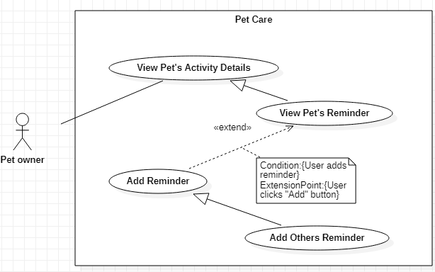

Figure 46-<Pet Owner> Add Others Reminder

|  |  |  |  |
| --- | --- | --- | --- |
| **USE CASE – UC\_42** | | | |
| **Use Case No.** | **42** | **Use Case Version** | 1.0 |
| **Use Case Name** | Add OthersReminder | | |
| **Author** | Nguyễn Huy Hoàng | | |
| **Date** | 30/09/2019 | **Priority** | Normal |
| **Actor:**   * Pet owner   **Summary:**   * This use case allows the Pet owner to add other types of activityreminders for the pet.   **Goal:**   * The Pet owner adds new other types of activityreminder successfully.   **Triggers:**   * The Pet owner clicks on the “Add Reminder” button.   **Preconditions:**   * User can log in the system with the Pet owner role. * User is at Othersscreen.   **Post conditions:**   * Success: The new reminder is created. * Fail: System shows error messages.   **Main Success Scenarios:**   |  |  |  | | --- | --- | --- | | **Step** | **Actor Action** | **System Response** | | 1 | The Pet owner clicks on “Add Reminder” button on Othersscreen. | System shows “Add Reminder” screen with the following information:   * Description: text, required * Date: date, required * Time: time, required * Repetition: options list: Does not repeat, Day(s), Week(s), Month(s), Year(s); required. If the Pet owner selects Day(s) / Week(s) / Month(s) / Year(s), a value input field will be displayed for the Pet owner to input the value. * End date: options list: No end date, Until date; required. If “Until date” option is selected, system displays a field for the Pet owner to input the date. End date option will be displayed if the Pet owner selects Day(s) / Week(s) / Month(s) / Year(s) repetition option. * Notes: text, optional | | 2 | The Pet owner fills out data fields and clicks “Save” button. | System validates inputted data and shows Others screen.  [Exception 1,2,3,4,5] |   **Alternative Scenarios:** N/A  **Exceptions:**   |  |  |  | | --- | --- | --- | | **No** | **Actor Action** | **System Response** | | 1 | * Description is empty * Date is not selected * Time is not selected * End date is not selected | System shows error message "This field is required.” and highlights the empty fields. | | 2 | Time is in the past | System shows error message "Cannot select past time.” and highlights the empty fields. | | 3 | Interval value is 0 | System shows error message "Please input value larger than 0.” and highlights the empty fields. | | 4 | Until date is not after the Start date | System shows error message "Please input another date.” and highlights the empty fields. | | 5 | The Pet owner clicks on “Cancel” button. | System shows Others screen. |   **Relationships:** Generalized from Add Reminder use case, which is extended from View Pet’s Reminder use case.  **Business Rules:**   * In this system, the Guest and the Pet owner can add other types of activityreminders for pet. * Reminder time cannot be set in past time and cannot be duplicated. * If the Pet owner selects Repetition option as Day(s) / Week(s) / Month(s) / Year(s), the End date option will be displayed. * The date cannot be past date. The Until date must be after the Start date. * A reminder after being created will have “Scheduled” status. * When the reminder time reaches the real time, the reminder will have Overdue status and be listed on “History” section. From now on, the reminder has become an activity history. Though this history is still “Unknown” because the system doesn’t know the Pet owner has done the activity or not. So the Pet owner can update the status of this history later whether it is “Skipped” or “Done”. * If the reminder is set having a repetition, when the old reminder time has passed, the system will shift the reminder time based on the corresponding repetition, making it become a new reminder. | | | |

<Pet owner> Add Others Reminder use case specification

##### <Pet owner> Update Food Reminder

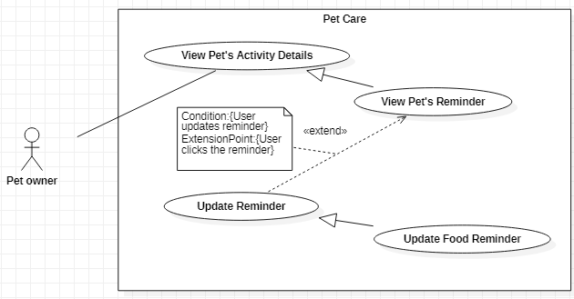

Figure 47-<Pet Owner> Update Food Reminder

|  |  |  |  |
| --- | --- | --- | --- |
| **USE CASE – UC\_43** | | | |
| **Use Case No.** | **43** | **Use Case Version** | 1.0 |
| **Use Case Name** | Update Food Reminder | | |
| **Author** | Nguyễn Huy Hoàng | | |
| **Date** | 30/09/2019 | **Priority** | Normal |
| **Actor:**   * Pet owner   **Summary:**   * This use case allows the Pet owner to update food reminder’s information, change reminder’s status or deactivate reminders.   **Goal:**   * The Pet owner updates reminder successfully.   **Triggers:**   * The Pet owner clicks on a reminder.   **Preconditions:**   * User can log in the system with the Pet owner role. * User is at “Food” screen.   **Post conditions:**   * Success: The information of the pet is shared to other user. * Fail: System shows error messages.   **Main Success Scenarios:**   |  |  |  | | --- | --- | --- | | **Step** | **Actor Action** | **System Response** | | 1 | The Pet owner clicks on a reminder on Food screen. | If the reminder is still in “Schedule” status, system shows “Reminder’s Detail” screen with the following information:   * Food name: fixed * Date and time: fixed * Quantity: float, required * Notes: text, optional   If the reminder is overdue and still has Unknown status, system shows “Reminder’s Detail” screen with the following information:   * Food name: fixed * Date and time: fixed * Quantity: fixed * Notes: fixed * “Skip” and “Done” button   If the reminder has “Skipped” or “Done” status, system shows “Reminder’s Detail” screen with the following information:   * Food name: fixed * Date: date, required * Time: time, required * Quantity: float, required * Status: options list: Skipped/Done; required * Notes: text, optional   [Alternative 1,2,3] | | 2 | The Pet owner updates the information or status of the reminder and clicks “Save” to update reminder’s information; or clicks “Skip” or “Done” to change the reminder’s status  [Alternative 1,2,3] | System validated inputted data and shows “Food” screen with the updated reminder.  [Exception 1,2,3,4,5] |   **Alternative Scenarios:**   |  |  |  | | --- | --- | --- | | **Step** | **Actor Action** | **System Response** | | 1 | When a food reminder is created, the Pet owner clicks the Food’s reminder | System shows “Food’s Schedule” screen with the following information:   * Name of food, food category * A toggle to activate/deactivate food * “Schedule” section contains the reminders of the corresponding food. | | 2 | The Pet owner clicks on a reminder on “Schedule” section. | If the reminder is still in “Schedule” status, system shows “Reminder’s Detail” screen with the following information:   * Food name: fixed * Date and time: fixed * Quantity: float, required * Notes: text: optional   If the reminder is overdue and still has Unknown status, system shows “Reminder’s Detail” screen with the following information:   * Food name: fixed * Date and time: fixed * Quantity: fixed * Notes: text: fixed * “Skip” and “Done” button   If the reminder has “Skipped” or “Done” status, system shows “Reminder’s Detail” screen with the following information:   * Food name: fixed * Date: date, required * Time: time, required * Quantity: float, required * Status: options list: Skipped/Done; required * Notes: text, optional | | 3 | The Pet owner updates the information or status of the reminder. | System validates inputted data and shows “Food’s Schedule” screen with the updated reminder [Exception 1,2,3,4] |   **Exceptions:**   |  |  |  | | --- | --- | --- | | **No** | **Actor Action** | **System Response** | | 1 | * Food name is empty * Start date is not selected * Repetition is not selected * Duration is not selected * Reminder time is not selected | System shows error message "This field is required.” and highlights the empty fields. | | 2 | Interval value is 0 | System shows error message "Please input value larger than 0.” and highlights the empty fields. | | 3 | Quantity value is 0. | System shows error message "Please input value larger than 0.” and highlights the empty fields. | | 4 | The Pet owner clicks on “Cancel” button. | System shows “Food” / “Food’s Schedule” screen. |   **Relationships:** Generalized from Update Reminder use case, which is extended from View Pet’s Reminder use case.  **Business Rules:**   * In this system, the Guest and the Pet owner can update food’s reminders. * When the reminder has “Scheduled” status, only Quantity can be updated. Food quantity must be larger than 0. * Reminder time cannot be updated in past time. * When the reminder has “Overdue” status, it still stays on “Unknown” because the system doesn’t know the Pet owner has done the activity or not. So the Pet owner can only update the status whether it is “Skipped” or “Done”. * Once the food is deactivated, all of the reminders related to that food will be disabled. The Pet owner can archive the food’s information for later usage. When the food is activated, the schedules related to the food will be generated, based on the reminders of the food. * When the reminder has “Skipped” or “Done” status, it is considered as a schedule history. Therefore the Pet owner can update the date and time in the past. | | | |

<Pet owner> Update Food Reminder use case specification

##### <Pet owner> Update Hygiene Reminder

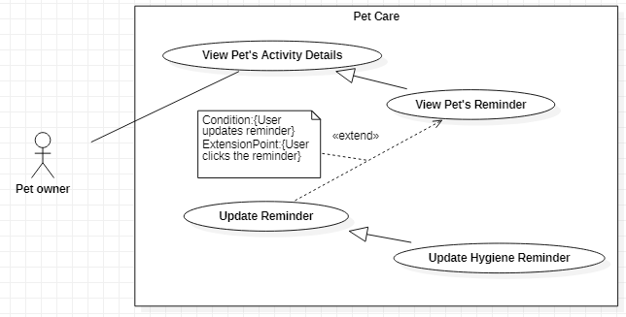

Figure 48-<Pet Owner> Update Hygiene Reminder

|  |  |  |  |
| --- | --- | --- | --- |
| **USE CASE – UC\_44** | | | |
| **Use Case No.** | **44** | **Use Case Version** | 1.0 |
| **Use Case Name** | Update Hygiene Reminder | | |
| **Author** | Nguyễn Huy Hoàng | | |
| **Date** | 30/09/2019 | **Priority** | Normal |
| **Actor:**   * Pet owner   **Summary:**   * This use case allows the Pet owner to update hygiene activities reminder’s information or change reminder’s status.   **Goal:**   * The Pet owner updates reminder successfully.   **Triggers:**   * The Pet owner clicks on a reminder.   **Preconditions:**   * User can log in the system with the Pet owner role. * User is at specific Hygiene screen: Bath / Nails / Hair / Teeth / Ears / Internal Deworming/ Fleas and Ticks screen.   **Post conditions:**   * Success: The information of the pet is shared to other user. * Fail: System shows error messages.   **Main Success Scenarios:**   |  |  |  | | --- | --- | --- | | **Step** | **Actor Action** | **System Response** | | 1 | The Pet owner clicks on a reminder on the specific Hygiene screen. | System shows “Reminder’s Detail” screen with the following information:   * Date: date, required * Time: time, required * Repetition: options list: Does not repeat, Day(s), Week(s), Month(s), Year(s); required. If the Pet owner selects Day(s) / Week(s) / Month(s) / Year(s), a value input field will be displayed for the Pet owner to input the value. * Notes: text, optional | | 2 | The Pet owner fills out data fields and clicks “Save” button. | System validates inputted data and shows the specific Hygiene screen with the updated reminder.  [Exception 1,2,3,4] |   **Alternative Scenarios:** N/A  **Exceptions:**   |  |  |  | | --- | --- | --- | | **No** | **Actor Action** | **System Response** | | 1 | * Date is not selected * Time is not selected | System shows error message "This field is required.” and highlights the empty fields. | | 2 | Interval value is 0. | System shows error message " Please input value larger than 0.” and highlights the empty fields. | | 3 | Time is in the past | System shows error message "Cannot select past time.” and highlights the empty fields. | | 4 | The Pet owner clicks on “Cancel” button. | System shows the specific Hygiene screen. |   **Relationships:** Generalized from Update Reminder use case, which is extended from View Pet’s Reminder use case.  **Business Rules:**   * In this system, the Guest and the Pet owner can update hygiene activities’ reminders. * Reminder time cannot be updated in past time. * The date cannot be past date. * The interval value for Day(s), Week(s), Month(s), Year(s) repetition option must be larger than 0. * When the reminder has “Overdue” status, it still stays on “Unknown” because the system doesn’t know the Pet owner has done the activity or not. So the Pet owner can update the status whether it is “Skipped” or “Done”. * Once the reminder is “Done” or “Skipped”, its time and status can be re- updated later. | | | |

<Pet owner> Update Hygiene Reminder use case specification

##### <Pet owner> Update Vaccination Reminder

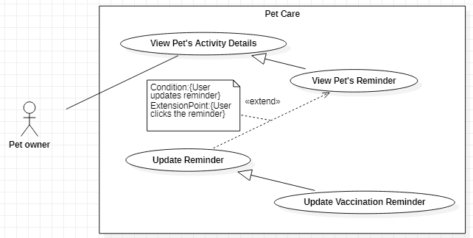

Figure 49-<Pet Owner> Update Vaccination Reminder

|  |  |  |  |
| --- | --- | --- | --- |
| **USE CASE – UC\_45** | | | |
| **Use Case No.** | **45** | **Use Case Version** | 1.0 |
| **Use Case Name** | Update Vaccination Reminder | | |
| **Author** | Nguyễn Huy Hoàng | | |
| **Date** | 30/09/2019 | **Priority** | Normal |
| **Actor:**   * Pet owner   **Summary:**   * This use case allows the Pet owner to update vaccination reminder’s information or change reminder’s status.   **Goal:**   * The Pet owner updates reminder successfully.   **Triggers:**   * The Pet owner clicks on a reminder.   **Preconditions:**   * User can log in the system with the Pet owner role. * User is at “Vaccination” screen.   **Post conditions:**   * Success: The information of the pet is shared to other user. * Fail: System shows error messages.   **Main Success Scenarios:**   |  |  |  | | --- | --- | --- | | **Step** | **Actor Action** | **System Response** | | 1 | The Pet owner clicks on a reminder on Vaccinationsscreen. | System shows “Reminder’s Detail” screen with the following information:   * Vaccine name: fixed * Date: date, required * Time: time, required * Repetition: options list: Does not repeat, Day(s), Week(s), Month(s), Year(s); required. If the Pet owner selects Day(s) / Week(s) / Month(s) / Year(s), a value input field will be displayed for the Pet owner to input the value. * End date: options list: No end date, Until date; required. If “Until date” option is selected, the system displays a field for the Pet owner to input the date. End date option will be displayed if the Pet owner selects Day(s) / Week(s) / Month(s) / Year(s) repetition option. * Notes: text, optional | | 2 | The Pet owner fills out data fields and clicks “Save” button. | System validates inputted data and shows Vaccinationsscreen with the updated reminder.  [Exception] |   **Alternative Scenarios:** N/A  **Exceptions:**   |  |  |  | | --- | --- | --- | | **No** | **Actor Action** | **System Response** | | 1 | * Vaccine name is empty * Date is not selected * Time is not selected * Repetition is not selected * End date is not selected | System shows error message "This field is required.” and highlights the empty fields. | | 2 | Interval value is 0 | System shows error message "Please input value larger than 0.” and highlights the empty fields. | | 3 | Until date is not after the Start date | System shows error message "Please input another date.” and highlights the empty fields. | | 4 | The Pet owner selects one of the Combined Vaccines and also selects one of the Individual Vaccines, | System shows error message with Y/N options "Your selected vaccine is conflicted. Do you want to select this vaccine?” | | 5 | The Pet owner clicks on “Cancel” button. | System shows the Vaccinationsscreen. |   **Relationships:** Generalized from Update Reminder use case, which is extended from View Pet’s Reminder use case.  **Business Rules:**   * In this system, the Guest and the Pet owner can update vaccination reminders. * When the reminder has “Scheduled” status, the selected vaccine cannot be updated. * Reminder time cannot be updated in past time. * If the Pet owner selects Repetition option as Day(s) / Week(s) / Month(s) / Year(s), the End date option will be displayed. * The Date cannot be past date. * The interval value for Day(s), Week(s), Month(s), Year(s) repetition option must be larger than 0. * The Pet owner can update the status of the reminder later whether it is “Skipped” or “Done”. After being updated the status, the reminder becomes an activity history and be listed in “History” section. * If the reminder is set having a repetition, when the old reminder time has passed, the system will shift the reminder time based on the corresponding repetition, making it become a new reminder. The next reminder time will be set, based on the moment the Pet owner presses “Skipped” or “Done” on the reminder. * Once reminder has “Skipped” or “Done” status, only its status can be re-updated later. | | | |

<Pet owner> Update Vaccination Reminder use case specification

##### <Pet owner> Update Medication Reminder

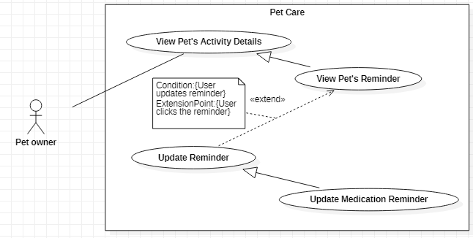

Figure 50-<Pet Owner> Update Medication Reminder

|  |  |  |  |
| --- | --- | --- | --- |
| **USE CASE – UC\_46** | | | |
| **Use Case No.** | **46** | **Use Case Version** | 1.0 |
| **Use Case Name** | Update Medication Reminder | | |
| **Author** | Nguyễn Huy Hoàng | | |
| **Date** | 30/09/2019 | **Priority** | Normal |
| **Actor:**   * Pet owner   **Summary:**   * This use case allows the Pet owner to update medication reminder’s information, change reminder’s status or deactivate reminders.   **Goal:**   * The Pet owner updates reminder successfully.   **Triggers:**   * The Pet owner clicks on a reminder.   **Preconditions:**   * User can log in the system with the Pet owner role. * User is at “Medication” screen.   **Post conditions:**   * Success: The information of the pet is shared to other user. * Fail: System shows error messages.   **Main Success Scenarios:**   |  |  |  | | --- | --- | --- | | **Step** | **Actor Action** | **System Response** | | 1 | The Pet owner clicks on a reminder on Medication screen. | If the reminder is still in “Schedule” status, system shows “Reminder’s Detail” screen with the following information:   * Medication name: fixed * Date and time: fixed * Dosage: text, required * Notes: text: optional   If the reminder is overdue and still has Unknown status, system shows “Reminder’s Detail” screen with the following information:   * Medication name: fixed * Date and time: fixed * Dosage: fixed * Notes: text: fixed * “Skip” and “Done” button   If the reminder has “Skipped” or “Done” status, system shows “Reminder’s Detail” screen with the following information:   * Medication name: fixed * Date: date, required * Time: time, required * Dosage: float, required * Status: options list: Skipped/Done; required * Notes: text, optional   [Alternative 1,2,3] | | 2 | The Pet owner updates the information or status of the reminder and clicks “Save” to update reminder’s information; or clicks “Skip” or “Done” to change the reminder’s status.  [Alternative 1,2,3] | System validated inputted data and shows “Medications” screen with the updated reminder.  [Exception 1,2,3,4,5] |   **Alternative Scenarios:**   |  |  |  | | --- | --- | --- | | **Step** | **Actor Action** | **System Response** | | 1 | When a medication reminder is created, the Pet owner clicks the Medication’s reminder | System shows “Medication’s Schedule” screen with the following information:   * Name of medicine * A toggle to activate/deactivate medicine * “Schedule” section contains the reminders of the corresponding medicine. | | 2 | The Pet owner clicks on a reminder on “Schedule” section. | If the reminder is still in “Schedule” status, system shows “Reminder’s Detail” screen with the following information:   * Medicine name: fixed * Date and time: fixed * Dosage: float, required * Notes: text: optional   If the reminder is overdue and still has Unknown status, system shows “Reminder’s Detail” screen with the following information:   * Medicine name: fixed * Date and time: fixed * Dosage: fixed * Notes: text: fixed * “Skip” and “Done” button   If the reminder has “Skipped” or “Done” status, system shows “Reminder’s Detail” screen with the following information:   * Medicine name: fixed * Date: date, required * Time: time, required * Dosage: float, required * Status: options list: Skipped/Done; required * Notes: text, optional | | 3 | The Pet owner updates the information or status of the reminder. | System validates inputted data and shows “Medication’s Schedule” screen with the updated reminder [Exception 1,2,3,4,5] |   **Exceptions:**   |  |  |  | | --- | --- | --- | | **No** | **Actor Action** | **System Response** | | 1 | * Medicine name is empty * Unit is not selected * Start date is not selected * Repetition is not selected * Duration is not selected * Reminder time is not selected | System shows error message "This field is required.” and highlights the empty fields. | | 2 | Interval value is 0 | System shows error message "Please input value larger than 0.” and highlights the empty fields. | | 3 | Dosage value is 0. | System shows error message "Please input value larger than 0.” and highlights the empty fields. | | 4 | The Pet owner clicks on “Cancel” button. | System shows Medications / Medication’s Schedule screen. |   **Relationships:** Generalized from Update Reminder use case, which is extended from View Pet’s Reminder use case.  **Business Rules:**   * In this system, the Guest and the Pet owner can update medicine reminders. * When the reminder has “Scheduled” status, Medicine name cannot be updated. * Reminder time cannot be updated in past time. * Dosage value must be larger than 0. * The Start date cannot be past date. The Until date must be after the Start date. The interval value for “For X Days” option must be larger than 0. * When the reminder has “Overdue” status, it still stays on “Unknown” because the system doesn’t know the Pet owner has done the activity or not. So the Pet owner can only update the status whether it is “Skipped” or “Done”. * The Pet owner can create more reminders for existed medicine by choosing the medicine and updating more reminder times. * Once the medicine is deactivated, all of the reminders related to that medicine will be disabled. The Pet owner can archive the medicine’s information for later usage. * When the reminder has “Skipped” or “Done” status, it is considered as a schedule history. Therefore the Pet owner can update the date and time in the past. | | | |

<Pet owner> Update Medication Reminder use case specification

##### <Pet owner> Update Others Reminder

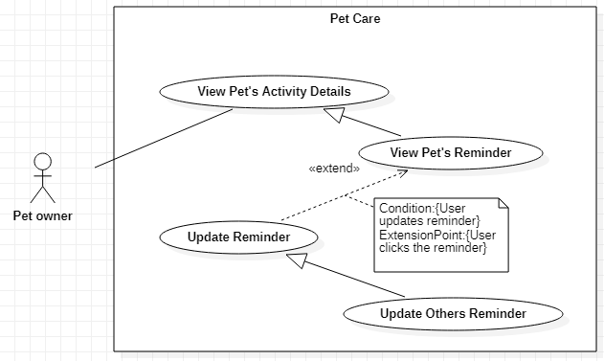

Figure 51-<Pet Owner> Update Others Reminder

|  |  |  |  |
| --- | --- | --- | --- |
| **USE CASE – UC\_47** | | | |
| **Use Case No.** | **47** | **Use Case Version** | 1.0 |
| **Use Case Name** | Update Vet Visit Reminder | | |
| **Author** | Nguyễn Huy Hoàng | | |
| **Date** | 30/09/2019 | **Priority** | Normal |
| **Actor:**   * Pet owner   **Summary:**   * This use case allows the Pet owner to update food reminder’s information, change reminder’s status or deactivate reminders.   **Goal:**   * The Pet owner updates reminder successfully.   **Triggers:**   * The Pet owner clicks on a reminder.   **Preconditions:**   * User can log in the system with the Pet owner role. * User is at “Vet Visit” screen.   **Post conditions:**   * Success: The information of the pet is shared to other user. * Fail: System shows error messages.   **Main Success Scenarios:**   |  |  |  | | --- | --- | --- | | **Step** | **Actor Action** | **System Response** | | 1 | The Pet owner clicks on a reminder on Vet Visitsscreen. | System shows “Add Reminder” screen with the following information:   * Description: text, required * Date: date, required * Time: time, required * Repetition: options list: Does not repeat, Day(s), Week(s), Month(s), Year(s); required. If the Pet owner selects Day(s) / Week(s) / Month(s) / Year(s), a value input field will be displayed for the Pet owner to input the value. * End date: options list: No end date, Until date; required. If “Until date” option is selected, system displays a field for the Pet owner to input the date. End date option will be displayed if the Pet owner selects Day(s) / Week(s) / Month(s) / Year(s) repetition option. * Notes: text, optional | | 2 | The Pet owner fills out data fields and clicks “Save” button. | System validates inputted data and shows Vet Visits screen with the updated reminder.  [Exception 1,2,3,4,5] |   **Alternative Scenarios:** N/A  **Exceptions:**   |  |  |  | | --- | --- | --- | | **No** | **Actor Action** | **System Response** | | 1 | * Description is empty * Date is not selected * Time is not selected * End date is not selected | System shows error message "This field is required.” and highlights the empty fields. | | 2 | Time is in the past | System shows error message "Cannot select past time.” and highlights the empty fields. | | 3 | Interval value is 0 | System shows error message "Please input value larger than 0.” and highlights the empty fields. | | 4 | Until date is not after the Start date | System shows error message "Please input another date.” and highlights the empty fields. | | 5 | The Pet owner clicks on “Cancel” button. | System shows Vet Visits screen. |   **Relationships:** Generalized from Update Reminder use case, which is extended from View Pet’s Reminder use case.  **Business Rules:**   * In this system, the Guest and the Pet owner can update vet visit reminders. * Reminder time cannot be updated in past time. * The date cannot be past date. The Until date must be after the Start date. * The interval value for Day(s), Week(s), Month(s), Year(s) repetition option must be larger than 0. * When the reminder has “Overdue” status, it still stays on “Unknown” because the system doesn’t know the Pet owner has done the activity or not. So the Pet owner can update the status whether it is “Skipped” or “Done”. | | | |

<Pet owner> Update Others Reminder use case specification

##### <Pet owner> Delete Reminder

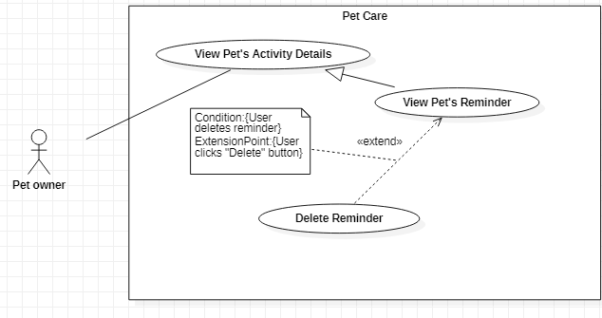

Figure 52-<Pet Owner> Delete Reminder

|  |  |  |  |
| --- | --- | --- | --- |
| **USE CASE – UC\_48** | | | |
| **Use Case No.** | **48** | **Use Case Version** | 1.0 |
| **Use Case Name** | Delete Reminder | | |
| **Author** | Nguyễn Huy Hoàng | | |
| **Date** | 30/09/2019 | **Priority** | Normal |
| **Actor:**   * Pet owner   **Summary:**   * This use case allows the Pet owner to delete reminders of pet’s activity.   **Goal:**   * The Pet owner deletes the reminders successfully.   **Triggers:**   * The Pet owner clicks on “Delete” button.   **Preconditions:**   * User can log in the system with the Pet owner role. * User is at a Reminder’s Detail screen of a specific Activity   **Post conditions:**   * Success: Activity’s reminder is deleted. * Fail: System shows error messages.   **Main Success Scenarios:**   |  |  |  | | --- | --- | --- | | **Step** | **Actor Action** | **System Response** | | 1 | The Pet owner clicks on “Delete” button | System shows the message dialog with Y/N options: “Do you want to delete this reminder?” | | 2 | The Pet owner clicks on “Confirm” button | System redirects to the specific Activity screen.  [Exception 1] |   **Alternative Scenarios:** N/A  **Exceptions:**   |  |  |  | | --- | --- | --- | | **No** | **Actor Action** | **System Response** | | 1 | The Pet owner clicks on “Cancel” button. | System redirects to the specific Activity screen. |   **Relationships:** Extended from View History Details.  **Business Rules:**   * In this system, the Guest and the Pet owner can delete pet’s activity reminders. * The activities that are allowed for the Pet owner to delete reminders: Hygiene Activities (Bath, Hair, Nails, Teeth, Ears, Internal Deworming, Fleas & Ticks), Vaccination, Vet Visits. * For Food and Medications, the Pet owner can only be able to disable the reminders. | | | |

<Pet owner> Delete Reminder use case specification

##### <Pet owner> View Pet’s History

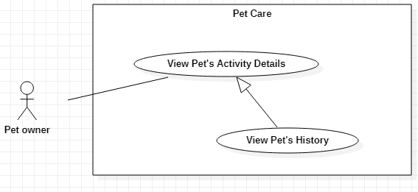

Figure 53-<Pet Owner> View Pet’s History

|  |  |  |  |
| --- | --- | --- | --- |
| **USE CASE – UC\_49** | | | |
| **Use Case No.** | **49** | **Use Case Version** | 1.0 |
| **Use Case Name** | View Pet’s History | | |
| **Author** | Vũ Hoàng Nam | | |
| **Date** | 30/09/2019 | **Priority** | Normal |
| **Actor:**   * Pet owner   **Summary:**   * This use case allows the Pet owner to view histories of pet’s activity.   **Goal:**   * The Pet owner view the histories successfully.   **Triggers:**   * The Pet owner clicks on the specific Activity icon to view the activity’s histories list.   **Preconditions:**   * User can log in the system with the Pet owner role. * User is at a Pet’s Detail screen.   **Post conditions:**   * Success: Activity’s history is displayed. * Fail: System shows error messages.   **Main Success Scenarios:**   |  |  |  | | --- | --- | --- | | **Step** | **Actor Action** | **System Response** | | 1 | The Pet owner clicks on an Activity icon listed on Pet’s Detail screen | System shows the corresponding Activity screen with the following information:   * History section: contains the upcoming reminder of an activity.   [Exception 1] |   **Alternative Scenarios:** N/A  **Exceptions:**   |  |  |  | | --- | --- | --- | | **No** | **Actor Action** | **System Response** | | 1 | No histories existed. | System shows “No entries found” message. |   **Relationships:** Generalized from View Pet’s Activity Details use case.  **Business Rules:**   * In this system, the Guest and the Pet owner can view pet’s activity histories. * The activities that are allowed for the Pet owner to add histories: Measurements, Hygiene Activities (Bath, Hair, Nails, Teeth, Ears, Internal Deworming, Fleas & Ticks), Vaccination, Medication, Vet Visits, Incidents, Allergies, Surgeries. * The Pet owner can click the information button to read more suggested information about each activity for pets. * For Vaccination histories, the Pet owner can view the histories list by vaccine name or by history’s date. | | | |

<Pet owner> View Pet’s History use case specification

##### <Pet owner> Add Measurement History

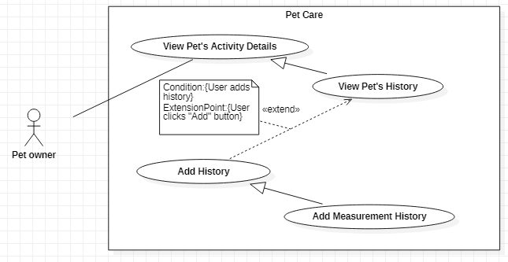

Figure 54-<Pet Owner> Add Measurement History

|  |  |  |  |
| --- | --- | --- | --- |
| **USE CASE – UC\_50** | | | |
| **Use Case No.** | **50** | **Use Case Version** | 1.0 |
| **Use Case Name** | Add Measurement History | | |
| **Author** | Vũ Hoàng Nam | | |
| **Date** | 30/09/2019 | **Priority** | Normal |
| **Actor:**   * Pet owner   **Summary:**   * This use case allows the Pet owner to add measurement histories for the pet.   **Goal:**   * The Pet owner adds new histories successfully.   **Triggers:**   * The Pet owner clicks on the “Add History” button   **Preconditions:**   * User can log in the system with the Pet owner role. * User is at Measurements screen.   **Post conditions:**   * Success: The new history is created. * Fail: System shows error messages.   **Main Success Scenarios:**   |  |  |  | | --- | --- | --- | | **Step** | **Actor Action** | **System Response** | | 1 | The Pet owner clicks on “Add History” button on the Measurements screen. | System shows “Add History” screen with the following information:   * **Weight:** * Date: date, required * Value: integer, required * Unit: options list: gr/kg; required * Notes: text, optional * **Height:** * Date: date, required * Value: integer, required (with centimeter as fixed unit) * Notes: text, optional | | 2 | The Pet owner fills out data fields and clicks “Save” button. | System validates inputted data and shows Measurements screen with the measurement histories and a graph to display the changes of the pet’s measurements.  [Exception 1,2] |   **Alternative Scenarios:** N/A  **Exceptions:**   |  |  |  | | --- | --- | --- | | **No** | **Actor Action** | **System Response** | | 1 | * **Weight:** * Date is not selected * Value is not selected * Unit is not selected * **Height:** * Date is not selected * Value is not selected | System shows error message "This field is required.” and highlights the empty fields. | | 2 | The Pet owner clicks on “Cancel” button. | System shows Measurements screen. |   **Relationships:** Generalized from Add History use case, which is extended from View Pet’s History use case.  **Business Rules:**   * In this system, the Guest and the Pet owner can add measurement histories for the pet. * Weight unit is measured in gram kilogram. Height unit is measured in centimeter. * The measurement date can only be set in the past and cannot be prior to the pet’s birthdate. | | | |

<Pet owner> Add Measurement History use case specification

##### <Pet owner> Add Vaccination History

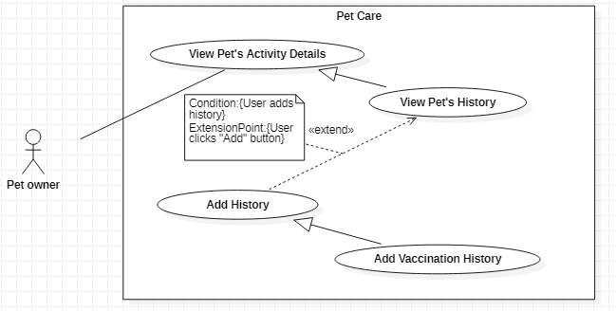

Figure 55-<Pet Owner> Add Vaccination History

|  |  |  |  |
| --- | --- | --- | --- |
| **USE CASE – UC\_51** | | | |
| **Use Case No.** | **51** | **Use Case Version** | 1.0 |
| **Use Case Name** | Add Vaccination History | | |
| **Author** | Vũ Hoàng Nam | | |
| **Date** | 30/09/2019 | **Priority** | Normal |
| **Actor:**   * Pet owner   **Summary:**   * This use case allows the Pet owner to add vaccination histories for the pet.   **Goal:**   * The Pet owner adds new histories successfully.   **Triggers:**   * The Pet owner clicks on the “Add History” button   **Preconditions:**   * User can log in the system with the Pet owner role. * User is at Vaccinations screen.   **Post conditions:**   * Success: The new history is created. * Fail: System shows error messages.   **Main Success Scenarios:**   |  |  |  | | --- | --- | --- | | **Step** | **Actor Action** | **System Response** | | 1 | The Pet owner clicks on “Add History” button on the Vaccinations screen. | System shows “Add History” screen with the following information:   * Vaccine name: text, required. When the Pet owner clicks on the text field, system displays “Vaccines List” screen for the Pet owner to select. * Date: date, required * Notes: text, optional | | 2 | The Pet owner fills out data fields and clicks “Save” button. | System validates inputted data and Vaccinations screen.  [Exception 1,2,3] |   **Alternative Scenarios:** N/A  **Exceptions:**   |  |  |  | | --- | --- | --- | | **No** | **Actor Action** | **System Response** | | 1 | * Vaccine name is empty * Date is not selected | System shows error message "This field is required.” and highlights the empty fields. | | 4 | The Pet owner selects one of the Combined Vaccines and also selects one of the Individual Vaccines, | System shows error message with Y/N options "Your selected vaccine is conflicted. Do you want to select this vaccine?” | | 3 | The Pet owner clicks on “Cancel” button. | System shows Vaccinations screen. |   **Relationships:** Generalized from Add History use case, which is extended from View Pet’s History use case.  **Business Rules:**   * In this system, the Guest and the Pet owner can add vaccination histories for the pet. * Vaccine List has Combined Vaccines and Individual Vaccines. If the Pet owner selects one of the Combined Vaccines and also selects one of the Individual Vaccines, the system will display a warning to let the user know the selection is conflicted. * The activity’s history date can only be set in the past and cannot be prior to pet’s birthdate. * The history after being created will have “Done” status. The Pet owner can update the status of the history later. * The Pet owner can view vaccination histories by date or by vaccine name. * When an activity reminder has Overdue status, it becomes an activity history and is listed in “History” section. | | | |

<Pet owner> Add Vaccination History use case specification

##### <Pet owner> Add Others History

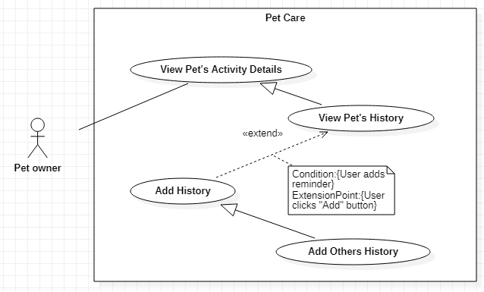

Figure 56-<Pet Owner> Add Others History

|  |  |  |  |
| --- | --- | --- | --- |
| **USE CASE – UC\_52** | | | |
| **Use Case No.** | **52** | **Use Case Version** | 1.0 |
| **Use Case Name** | Add Others History | | |
| **Author** | Vũ Hoàng Nam | | |
| **Date** | 30/09/2019 | **Priority** | Normal |
| **Actor:**   * Pet owner   **Summary:**   * This use case allows the Pet owner to add other types of activity histories for the pet.   **Goal:**   * The Pet owner adds new histories successfully.   **Triggers:**   * The Pet owner clicks on the “Add History” button   **Preconditions:**   * User can log in the system with the Pet owner role. * User is at Others screen.   **Post conditions:**   * Success: The new history is created. * Fail: System shows error messages.   **Main Success Scenarios:**   |  |  |  | | --- | --- | --- | | **Step** | **Actor Action** | **System Response** | | 1 | The Pet owner clicks on “Add History” button on the Others screen. | System shows “Add History” screen with the following information:   * Description: text, required * Date: date, required * Time: time, required * Notes: text, optional | | 2 | The Pet owner fills out data fields and clicks “Save” button. | System validates inputted data and Others screen.  [Exception 1,2] |   **Alternative Scenarios:** N/A  **Exceptions:**   |  |  |  | | --- | --- | --- | | **No** | **Actor Action** | **System Response** | | 1 | * Description is empty * Date is not selected * Time is not selected | System shows error message "This field is required.” and highlights the empty fields. | | 2 | The Pet owner clicks on “Cancel” button. | System shows Others screen. |   **Relationships:** Generalized from Add History use case, which is extended from View Pet’s History use case.  **Business Rules:**   * In this system, the Guest and the Pet owner can add other types of activity histories for the pet. * The activity’s history date and time can only be set in the past and cannot be prior to pet’s birthdate. * The history after being created will have “Done” status. * The Pet owner can update the status of the history later. When an activity reminder has Overdue status, it becomes an activity history and is listed in “History” section. | | | |

<Pet owner> Add Others History use case specification

##### <Pet owner> Add Incident History

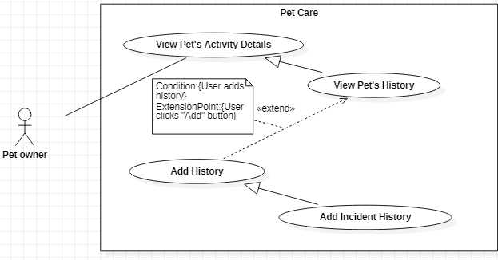

Figure 57-<Pet Owner> Add Incident History

|  |  |  |  |
| --- | --- | --- | --- |
| **USE CASE – UC\_53** | | | |
| **Use Case No.** | **53** | **Use Case Version** | 1.0 |
| **Use Case Name** | Add Incident History | | |
| **Author** | Vũ Hoàng Nam | | |
| **Date** | 30/09/2019 | **Priority** | Normal |
| **Actor:**   * Pet owner   **Summary:**   * This use case allows the Pet owner to add incident histories for the pet.   **Goal:**   * The Pet owner adds new histories successfully.   **Triggers:**   * The Pet owner clicks on the “Add History” button   **Preconditions:**   * User can log in the system with the Pet owner role. * User is at Incidents screen.   **Post conditions:**   * Success: The new history is created. * Fail: System shows error messages.   **Main Success Scenarios:**   |  |  |  | | --- | --- | --- | | **Step** | **Actor Action** | **System Response** | | 1 | The Pet owner clicks on “Add History” button on the Incidents screen. | System shows “Add History” screen with the following information:   * Description: text, required * Severity: options list: Minor / Medium / Moderate / Major / Critical; required * Dare occurred: date, required * Actions Taken: text, optional * Notes: text, optional | | 2 | The Pet owner fills out data fields and clicks “Save” button. | System validates inputted data and Incidents screen.  [Exception 1,2] |   **Alternative Scenarios:** N/A  **Exceptions:**   |  |  |  | | --- | --- | --- | | **No** | **Actor Action** | **System Response** | | 1 | * Description is empty * Severity is not selected * Dare occurred is not selected | System shows error message "This field is required.” and highlights the empty fields. | | 2 | The Pet owner clicks on “Cancel” button. | System shows Incidents screen. |   **Relationships:** Generalized from Add History use case, which is extended from View Pet’s History use case.  **Business Rules:**   * In this system, the Guest and the Pet owner can add incident histories for the pet. * The activity’s history date can only be set in the past and cannot be prior to pet’s birthdate. | | | |

<Pet owner> Add Incident History use case specification

##### <Pet owner> Add Allergy History

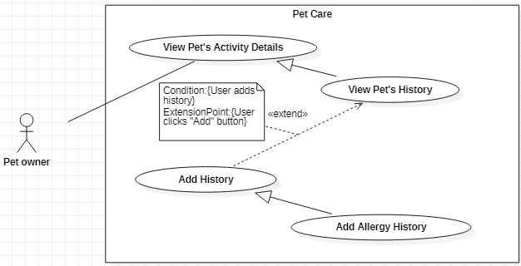

Figure 58-<Pet Owner> Add Allergy History

|  |  |  |  |
| --- | --- | --- | --- |
| **USE CASE – UC\_54** | | | |
| **Use Case No.** | **54** | **Use Case Version** | 1.0 |
| **Use Case Name** | Add Allergy History | | |
| **Author** | Vũ Hoàng Nam | | |
| **Date** | 30/09/2019 | **Priority** | Normal |
| **Actor:**   * Pet owner   **Summary:**   * This use case allows the Pet owner to add allergy histories for the pet.   **Goal:**   * The Pet owner adds new histories successfully.   **Triggers:**   * The Pet owner clicks on the “Add History” button   **Preconditions:**   * User can log in the system with the Pet owner role. * User is at Allergies screen.   **Post conditions:**   * Success: The new history is created. * Fail: System shows error messages.   **Main Success Scenarios:**   |  |  |  | | --- | --- | --- | | **Step** | **Actor Action** | **System Response** | | 1 | The Pet owner clicks on “Add History” button on the Allergies screen. | System shows “Add History” screen with the following information:   * Name: text, required * Date diagnosed: date, required * Severity: options list: RAST 0 – Undetectable / RAST 1 – Low / RAST 2 – Moderate / RAST 3 – High / RAST 4 – Very High / RAST 5 – Ultra High / RAST 6 – Extremely High; required * Category: options list: Food / Environment / Other; required * Actions Taken: text, optional * Notes: text, optional | | 2 | The Pet owner fills out data fields and clicks “Save” button. | System validates inputted data and Allergies screen.  [Exception 1,2] |   **Alternative Scenarios:** N/A  **Exceptions:**   |  |  |  | | --- | --- | --- | | **No** | **Actor Action** | **System Response** | | 1 | * Name is empty * Date diagnosed is not selected * Severity is not selected | System shows error message "This field is required.” and highlights the empty fields. | | 2 | The Pet owner clicks on “Cancel” button. | System shows Allergies screen. |   **Relationships:** Generalized from Add History use case, which is extended from View Pet’s History use case.  **Business Rules:**   * In this system, the Guest and the Pet owner can add allergy histories for the pet. * The activity’s history date can only be set in the past and cannot be prior to pet’s birthdate. | | | |

<Pet owner> Add Allergy History use case specification

##### <Pet owner> Add Surgery History

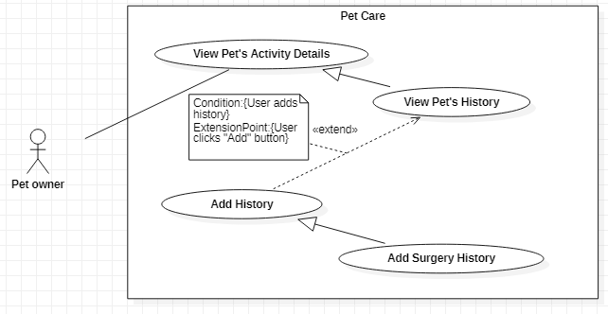

Figure 59-<Pet Owner> Add Surgery History

|  |  |  |  |
| --- | --- | --- | --- |
| **USE CASE – UC\_55** | | | |
| **Use Case No.** | **55** | **Use Case Version** | 1.0 |
| **Use Case Name** | Add Surgery History | | |
| **Author** | Vũ Hoàng Nam | | |
| **Date** | 30/09/2019 | **Priority** | Normal |
| **Actor:**   * Pet owner   **Summary:**   * This use case allows the Pet owner to add surgery histories for the pet.   **Goal:**   * The Pet owner adds new histories successfully.   **Triggers:**   * The Pet owner clicks on the “Add History” button   **Preconditions:**   * User can log in the system with the Pet owner role. * User is at Surgeries screen.   **Post conditions:**   * Success: The new history is created. * Fail: System shows error messages.   **Main Success Scenarios:**   |  |  |  | | --- | --- | --- | | **Step** | **Actor Action** | **System Response** | | 1 | The Pet owner clicks on “Add History” button on the Surgeries screen. | System shows “Add History” screen with the following information:   * Type of surgery: text, required * Date: date, required * Medical Remarks: text, optional * Notes: text, optional | | 2 | The Pet owner fills out data fields and clicks “Save” button. | System validates inputted data and Surgeries screen.  [Exception 1,2] |   **Alternative Scenarios:** N/A  **Exceptions:**   |  |  |  | | --- | --- | --- | | **No** | **Actor Action** | **System Response** | | 1 | * Type of surgery is empty * Date is not selected | System shows error message "This field is required.” and highlights the empty fields. | | 2 | The Pet owner clicks on “Cancel” button. | System shows Surgeries screen. |   **Relationships:** Generalized from Add History use case, which is extended from View Pet’s History use case.  **Business Rules:**   * In this system, the Guest and the Pet owner can add surgery histories for the pet. * The activity’s history date can only be set in the past and cannot be prior to pet’s birthdate. | | | |

<Pet owner> Add Surgery History use case specification

##### <Pet owner> View History Details

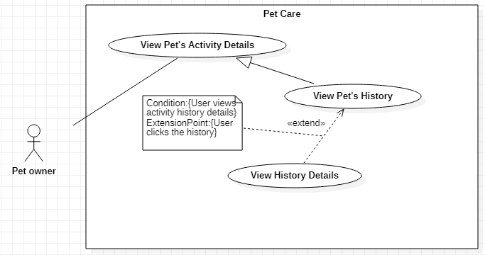

Figure 60-<Pet Owner> View History Details

|  |  |  |  |
| --- | --- | --- | --- |
| **USE CASE – UC\_56** | | | |
| **Use Case No.** | **56** | **Use Case Version** | 1.0 |
| **Use Case Name** | View History Details | | |
| **Author** | Vũ Hoàng Nam | | |
| **Date** | 30/09/2019 | **Priority** | Normal |
| **Actor:**   * Pet owner   **Summary:**   * This use case allows the Pet owner to view the detail of pet activity’s histories.   **Goal:**   * The Pet owner view the history details successfully.   **Triggers:**   * The Pet owner clicks on an activity’s history to view the history details.   **Preconditions:**   * User can log in the system with the Pet owner role. * User is at a specific Activity screen.   **Post conditions:**   * Success: Activity’s history detail is displayed. * Fail: System shows error messages.   **Main Success Scenarios:**   |  |  |  | | --- | --- | --- | | **Step** | **Actor Action** | **System Response** | | 1 | The Pet owner clicks on a activity history on a specific Activity’s Detail screen | System shows the History Details screen with the following information:   * History Details section: contains the information of the activity’s history: * Date and time, Status, Notes * Edit and Delete button * Media Records section: contains the list of additional records for the activity history. |   **Alternative Scenarios:** N/A  **Exceptions:** N/A  **Relationships:** Extended from View Pet’s History use case.  **Business Rules:**   * In this system, the Guest and the Pet owner can view pet’s activity histories. * The activities that are allowed for the Pet owner to view history’s details: Measurements, Hygiene Activities (Bath, Hair, Nails, Teeth, Ears, Internal Deworming, Fleas & Ticks), Vaccination, Medication, Vet Visits, Incidents, Allergies, Surgeries. * Media Records section allows the Pet owner to add and update more additional information (image, date, time, notes) for a specific activity’s history. This helps the user have logged information to keep track of the pet’s health. | | | |

<Pet owner> View History Details use case specification

##### <Pet owner> Update Hygiene History

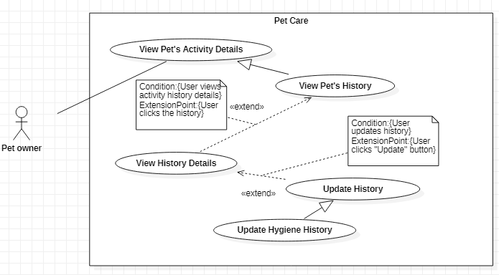

Figure 61-<Pet Owner> Update Hygiene History

|  |  |  |  |
| --- | --- | --- | --- |
| **USE CASE – UC\_57** | | | |
| **Use Case No.** | **57** | **Use Case Version** | 1.0 |
| **Use Case Name** | Update Hygiene History | | |
| **Author** | Vũ Hoàng Nam | | |
| **Date** | 30/09/2019 | **Priority** | Normal |
| **Actor:**   * Pet owner   **Summary:**   * This use case allows the Pet owner to update hygiene activity’s histories.   **Goal:**   * The Pet owner updates hygiene activity’s histories successfully.   **Triggers:**   * The Pet owner clicks on a history.   **Preconditions:**   * User can log in the system with the Pet owner role. * User is at specific Hygiene screen: Bath / Nails / Hair / Teeth / Ears / Internal Deworming/ Fleas and Ticks screen.   **Post conditions:**   * Success: The history is updated. * Fail: System shows error messages.   **Main Success Scenarios:**   |  |  |  | | --- | --- | --- | | **Step** | **Actor Action** | **System Response** | | 1 | The Pet owner clicks on a history on the specific Hygiene screen. | If the history is overdue and still has Unknown status, system shows “History’s Detail” screen with the following information:   * Food name: fixed * Date and time: fixed * Notes: fixed * “Skip” and “Done” button   If the history has “Skipped” or “Done” status, system shows “History’s Detail” screen with the following information:   * Date: date, required * Time: time, required * Notes: text, optional | | 2 | The Pet owner fills out data fields and clicks “Save” button. | System validates inputted data and shows the specific Hygiene screen with the updated history.  [Exception 1,2] |   **Alternative Scenarios:** N/A  **Exceptions:**   |  |  |  | | --- | --- | --- | | **No** | **Actor Action** | **System Response** | | 1 | * Date is not selected * Time is not selected | System shows error message "This field is required.” and highlights the empty fields. | | 2 | The Pet owner clicks on “Cancel” button. | System shows the specific Hygiene screen. |   **Relationships:** Generalized from Update History use case, which is extended from View History Details use case.  **Business Rules:**   * In this system, the Guest and the Pet owner update hygiene activity’s histories. * A reminder will be considered as a history when it is overdue. * The activity’s history date and time can only be updated in the past and cannot be prior to pet’s birthdate. | | | |

<Pet owner> Update Hygiene History use case specification

##### <Pet owner> Update Measurement History

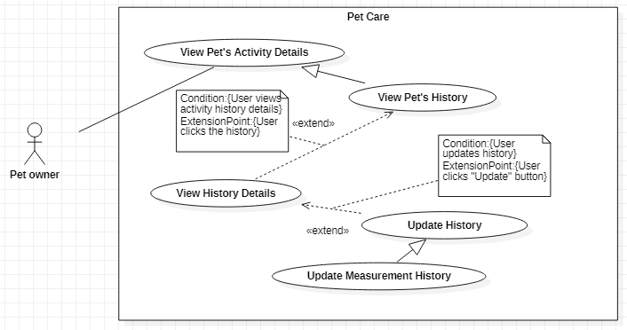

Figure 62-<Pet Owner> Update Measurement History

|  |  |  |  |
| --- | --- | --- | --- |
| **USE CASE – UC\_58** | | | |
| **Use Case No.** | **58** | **Use Case Version** | 1.0 |
| **Use Case Name** | Update Measurement History | | |
| **Author** | Vũ Hoàng Nam | | |
| **Date** | 30/09/2019 | **Priority** | Normal |
| **Actor:**   * Pet owner   **Summary:**   * This use case allows the Pet owner to update measurement histories.   **Goal:**   * The Pet owner updates measurement histories successfully.   **Triggers:**   * The Pet owner clicks on a history.   **Preconditions:**   * User can log in the system with the Pet owner role. * User is at Measurements screen.   **Post conditions:**   * Success: The history is updated. * Fail: System shows error messages.   **Main Success Scenarios:**   |  |  |  | | --- | --- | --- | | **Step** | **Actor Action** | **System Response** | | 1 | The Pet owner clicks on a history button on the Measurements screen. | System shows “History’s Detail” screen with the following information:   * **Weight:** * Date: date, required * Value: integer, required * Unit: options list: gr/kg; required * Notes: text, optional * **Height:** * Date: date, required * Value: integer, required (with centimeter as fixed unit) * Notes: text, optional | | 2 | The Pet owner fills out data fields and clicks “Save” button. | System validates inputted data and shows Measurements screen with the updated histories and a graph to display the changes of the pet’s measurements.  [Exception 1,2] |   **Alternative Scenarios:** N/A  **Exceptions:**   |  |  |  | | --- | --- | --- | | **No** | **Actor Action** | **System Response** | | 1 | * **Weight:** * Date is not selected * Value is not selected * Unit is not selected * **Height:** * Date is not selected * Value is not selected | System shows error message "This field is required.” and highlights the empty fields. | | 2 | The Pet owner clicks on “Cancel” button. | System shows Measurements screen. |   **Relationships:** Generalized from Update History use case, which is extended from View History Details use case.  **Business Rules:**   * In this system, the Guest and the Pet owner update measurement histories. * Weight unit is measured in gram kilogram. Height unit is measured in centimeter. * The measurement date can only be updated in the past and cannot be prior to the pet’s birthdate. | | | |

<Pet owner> Update Measurement History use case specification

##### <Pet owner> Update Vaccination History

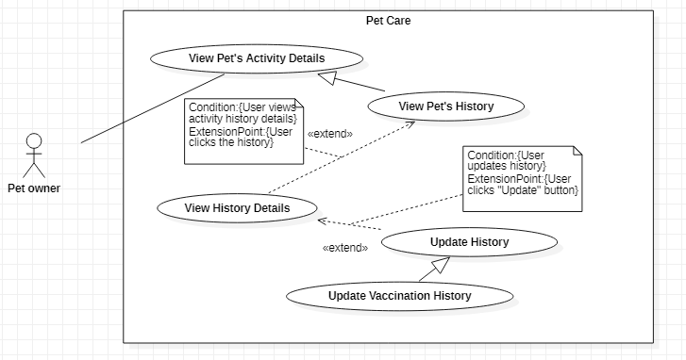

Figure 63-<Pet Owner> Update Vaccination History

|  |  |  |  |
| --- | --- | --- | --- |
| **USE CASE – UC\_59** | | | |
| **Use Case No.** | **59** | **Use Case Version** | 1.0 |
| **Use Case Name** | Update Vaccination History | | |
| **Author** | Vũ Hoàng Nam | | |
| **Date** | 30/09/2019 | **Priority** | Normal |
| **Actor:**   * Pet owner   **Summary:**   * This use case allows the Pet owner to update vaccination histories.   **Goal:**   * The Pet owner updates vaccination histories successfully.   **Triggers:**   * The Pet owner clicks on a history.   **Preconditions:**   * User can log in the system with the Pet owner role. * User is at Vaccinations screen.   **Post conditions:**   * Success: The history is updated. * Fail: System shows error messages.   **Main Success Scenarios:**   |  |  |  | | --- | --- | --- | | **Step** | **Actor Action** | **System Response** | | 1 | The Pet owner clicks on a history on the Vaccinations screen and click a vaccine name. | System shows “History’s Detail” screen with the following information:   * Vaccine name: fixed * Date: fixed * Status: options list: Skipped/Done; required * Notes: text, optional | | 2 | The Pet owner fills out data fields and clicks “Save” button. | System validates inputted data and shows the Vaccinations screen with the updated history.  [Exception 1] |   **Alternative Scenarios:** N/A  **Exceptions:**   |  |  |  | | --- | --- | --- | | **No** | **Actor Action** | **System Response** | | 1 | The Pet owner clicks on “Cancel” button. | System shows the specific Hygiene screen. |   **Relationships:** Generalized from Update History use case, which is extended from View History Details use case.  **Business Rules:**   * In this system, the Guest and the Pet owner update vaccination histories. * The activity’s history date and vaccine name cannot be updated. * A reminder will be considered as a history when it is overdue and the Pet owner has clicked “Skip” or “Done” button to change the status. | | | |

<Pet owner> Update Vaccination History use case specification

##### <Pet owner> Update Others History

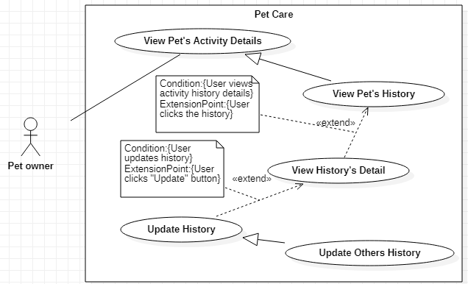

Figure 64-<Pet Owner> Update Others History

|  |  |  |  |
| --- | --- | --- | --- |
| **USE CASE – UC\_60** | | | |
| **Use Case No.** | **60** | **Use Case Version** | 1.0 |
| **Use Case Name** | Update Others History | | |
| **Author** | Vũ Hoàng Nam | | |
| **Date** | 30/09/2019 | **Priority** | Normal |
| **Actor:**   * Pet owner   **Summary:**   * This use case allows the Pet owner to update other type of activity histories.   **Goal:**   * The Pet owner updates other types of activity histories successfully.   **Triggers:**   * The Pet owner clicks on a history.   **Preconditions:**   * User can log in the system with the Pet owner role. * User is at Others screen.   **Post conditions:**   * Success: The history is updated. * Fail: System shows error messages.   **Main Success Scenarios:**   |  |  |  | | --- | --- | --- | | **Step** | **Actor Action** | **System Response** | | 1 | The Pet owner clicks on a history on the Others screen. | If the history is overdue and still has Unknown status, system shows “History’s Detail” screen with the following information:   * Description: fixed * Date and time: fixed * Notes: fixed * “Skip” and “Done” button   If the history has “Skipped” or “Done” status, system shows “History’s Detail” screen with the following information:   * Description: fixed * Date: date, required * Time: time, required * Status: options list: Skipped/Done; required * Notes: text, optional | | 2 | The Pet owner fills out data fields and clicks “Save” button. | System validates inputted data and shows the Others screen with the updated history.  [Exception 1,2] |   **Alternative Scenarios:** N/A  **Exceptions:**   |  |  |  | | --- | --- | --- | | **No** | **Actor Action** | **System Response** | | 1 | * Date is empty * Time is empty | System shows error message "This field is required.” and highlights the empty fields. | | 2 | The Pet owner clicks on “Cancel” button. | System shows the Others screen. |   **Relationships:** Generalized from Update History use case, which is extended from View History Details use case.  **Business Rules:**   * In this system, the Guest and the Pet owner update other types of activity histories. * The activity’s history date and time can only be updated in the past date and cannot be prior to pet’s birthdate. | | | |

<Pet owner> Update Others History use case specification

##### <Pet owner> Update Incident History

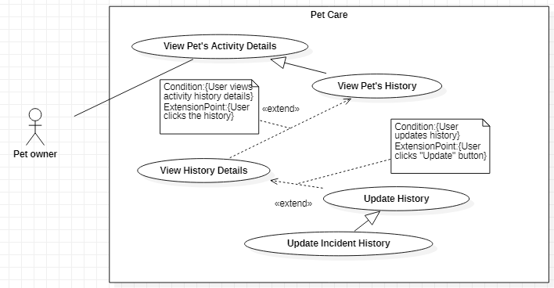

Figure 65-<Pet Owner> Update Incident History

|  |  |  |  |
| --- | --- | --- | --- |
| **USE CASE – UC\_61** | | | |
| **Use Case No.** | **61** | **Use Case Version** | 1.0 |
| **Use Case Name** | Update Incident History | | |
| **Author** | Vũ Hoàng Nam | | |
| **Date** | 30/09/2019 | **Priority** | Normal |
| **Actor:**   * Pet owner   **Summary:**   * This use case allows the Pet owner to update incident histories.   **Goal:**   * The Pet owner updates incident histories successfully.   **Triggers:**   * The Pet owner clicks on a history.   **Preconditions:**   * User can log in the system with the Pet owner role. * User is at Incidents screen.   **Post conditions:**   * Success: The history is updated. * Fail: System shows error messages.   **Main Success Scenarios:**   |  |  |  | | --- | --- | --- | | **Step** | **Actor Action** | **System Response** | | 1 | The Pet owner clicks on a history on the Incidents screen. | System shows “History’s Detail” screen with the following information:   * Description: text, required * Severity: options list: Minor / Medium / Moderate / Major / Critical; required * Dare occurred: date, required * Actions Taken: text, optional * Notes: text, optional | | 2 | The Pet owner fills out data fields and clicks “Save” button. | System validates inputted data and shows the Incidents screen with the updated history.  [Exception 1,2] |   **Alternative Scenarios:** N/A  **Exceptions:**   |  |  |  | | --- | --- | --- | | **No** | **Actor Action** | **System Response** | | 1 | * Description is empty * Severity is not selected * Dare occurred is not selected | System shows error message "This field is required.” and highlights the empty fields. | | 2 | The Pet owner clicks on “Cancel” button. | System shows Incidents screen. |   **Relationships:** Generalized from Update History use case, which is extended from View History Details use case.  **Business Rules:**   * In this system, the Guest and the Pet owner update incidents activity’s histories. * The activity’s history date and time can only be updated in the past date cannot be prior to pet’s birthdate. | | | |

<Pet owner> Update Incident History use case specification

##### <Pet owner> Update Allergy History

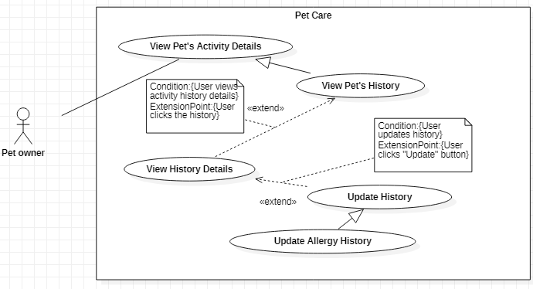

Figure 66-<Pet Owner> Update Allergy History

|  |  |  |  |
| --- | --- | --- | --- |
| **USE CASE – UC\_62** | | | |
| **Use Case No.** | **62** | **Use Case Version** | 1.0 |
| **Use Case Name** | Update Allergy History | | |
| **Author** | Vũ Hoàng Nam | | |
| **Date** | 30/09/2019 | **Priority** | Normal |
| **Actor:**   * Pet owner   **Summary:**   * This use case allows the Pet owner to update allergy histories.   **Goal:**   * The Pet owner updates allergy histories successfully.   **Triggers:**   * The Pet owner clicks on a history.   **Preconditions:**   * User can log in the system with the Pet owner role. * User is at Allergies screen.   **Post conditions:**   * Success: The history is updated. * Fail: System shows error messages.   **Main Success Scenarios:**   |  |  |  | | --- | --- | --- | | **Step** | **Actor Action** | **System Response** | | 1 | The Pet owner clicks on a history on the Allergies screen. | System shows “History’s Detail” screen with the following information:   * Name: text, required * Date diagnosed: date, required * Severity: options list: RAST 0 – Undetectable / RAST 1 – Low / RAST 2 – Moderate / RAST 3 – High / RAST 4 – Very High / RAST 5 – Ultra High / RAST 6 – Extremely High; required * Category: options list: Food / Environment / Other; required * Actions Taken: text, optional * Notes: text, optional | | 2 | The Pet owner fills out data fields and clicks “Save” button. | System validates inputted data and shows the Allergies screen with the updated history.  [Exception 1,2] |   **Alternative Scenarios:** N/A  **Exceptions:**   |  |  |  | | --- | --- | --- | | **No** | **Actor Action** | **System Response** | | 1 | * Name is empty * Date diagnosed is not selected * Severity is not selected | System shows error message "This field is required.” and highlights the empty fields. | | 2 | The Pet owner clicks on “Cancel” button. | System shows Allergies screen. |   **Relationships:** Generalized from Update History use case, which is extended from View History Details use case.  **Business Rules:**   * In this system, the Guest and the Pet owner update allergy activity’s histories. * The activity’s history date and time can only be updated in the past date cannot be prior to pet’s birthdate. | | | |

<Pet owner> Update Allergy History use case specification

##### <Pet owner> Update Surgery History

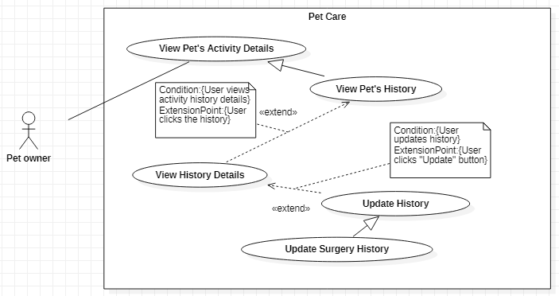

Figure 67-<Pet Owner> Update Surgery History

|  |  |  |  |
| --- | --- | --- | --- |
| **USE CASE – UC\_63** | | | |
| **Use Case No.** | **63** | **Use Case Version** | 1.0 |
| **Use Case Name** | Update Surgery History | | |
| **Author** | Vũ Hoàng Nam | | |
| **Date** | 30/09/2019 | **Priority** | Normal |
| **Actor:**   * Pet owner   **Summary:**   * This use case allows the Pet owner to update surgery histories.   **Goal:**   * The Pet owner updates surgery histories successfully.   **Triggers:**   * The Pet owner clicks on a history.   **Preconditions:**   * User can log in the system with the Pet owner role. * User is at Surgeries screen.   **Post conditions:**   * Success: The history is updated. * Fail: System shows error messages.   **Main Success Scenarios:**   |  |  |  | | --- | --- | --- | | **Step** | **Actor Action** | **System Response** | | 1 | The Pet owner clicks on a history on the Surgeries screen. | System shows “History’s Detail” screen with the following information:   * Name: text, required * Date: date, required * Medical Remarks: text, optional * Notes: text, optional | | 2 | The Pet owner fills out data fields and clicks “Save” button. | System validates inputted data and shows the Surgeries screen with the updated history.  [Exception 1,2] |   **Alternative Scenarios:** N/A  **Exceptions:**   |  |  |  | | --- | --- | --- | | **No** | **Actor Action** | **System Response** | | 1 | * Type of surgery is empty * Date is not selected | System shows error message "This field is required.” and highlights the empty fields. | | 2 | The Pet owner clicks on “Cancel” button. | System shows Surgeries screen. |   **Relationships:** Generalized from Update History use case, which is extended from View History Details use case.  **Business Rules:**   * In this system, the Guest and the Pet owner update surgery activity’s histories. * The activity’s history date and time can only be updated in the past date cannot be prior to pet’s birthdate. | | | |

<Pet owner> Update Surgery History use case specification

##### <Pet owner> Add Media Record

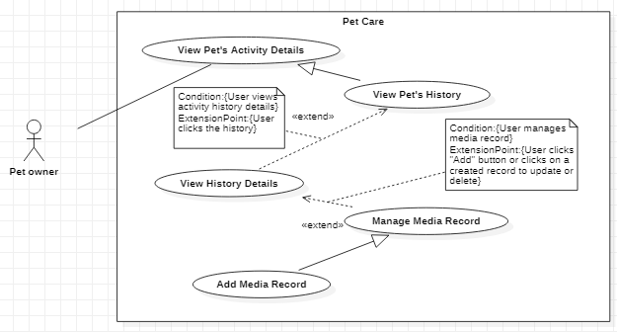

Figure 68-<Pet Owner> Add Media Record

|  |  |  |  |
| --- | --- | --- | --- |
| **USE CASE – UC\_64** | | | |
| **Use Case No.** | **64** | **Use Case Version** | 1.0 |
| **Use Case Name** | Add Media Record | | |
| **Author** | Vũ Hoàng Nam | | |
| **Date** | 30/09/2019 | **Priority** | Normal |
| **Actor:**   * Pet owner   **Summary:**   * This use case allows the Pet owner to add media records for the activity’s history.   **Goal:**   * The Pet owner adds media record successfully.   **Triggers:**   * The Pet owner clicks on a history to show History’s Detail screen * The Pet owner clicks “Add” button on “Media Records” section.   **Preconditions:**   * User can log in the system with the Pet owner role. * User is at specific Activity screen that allows to add media records: Hygiene (Bath / Nails / Hair / Teeth / Ears / Internal Deworming/ Fleas and Ticks), Vaccinations, Surgeries, Incidents, Allergies, Vet Visits   **Post conditions:**   * Success: The media record is created. * Fail: System shows error messages.   **Main Success Scenarios:**   |  |  |  | | --- | --- | --- | | **Step** | **Actor Action** | **System Response** | | 1 | The Pet owner clicks “Add” button on “Media Records” section. | System shows “Add Media Record” screen with the following information:   * Add Image: image; optional/required * Date: date, required * Time: time, required * Notes: text, optional/required | | 2 | The Pet owner fills out data fields and clicks “Save” button. | System validates inputted data and shows the History’s Detail screen.  [Exception 1,2,3] |   **Alternative Scenarios:** N/A  **Exceptions:**   |  |  |  | | --- | --- | --- | | **No** | **Actor Action** | **System Response** | | 1 | * Date is not selected * Time is not selected | System shows error message "This field is required.” and highlights the empty fields. | | 2 | Either the image or the notes is not added. | System shows error message "Please add image or notes.” and highlights the empty fields. | | 3 | The Pet owner clicks on “Cancel” button. | System shows History’s Detail screen. |   **Relationships:** Generalized from Manage Media Record use case, which is extended from View History Details use case.  **Business Rules:**   * In this system, the Guest and the Pet owner can add media records for activity’s histories. * The activities that are allowed for the Pet owner to add media records: Hygiene (Bath / Nails / Hair / Teeth / Ears / Internal Deworming/ Fleas and Ticks), Vaccinations, Surgeries, Incidents, Allergies, Vet Visits. * The activity’s history date and time can only be set in the past date cannot be prior to pet’s birthdate. * When adding media records, the Pet owner must either add an image or add notes to complete. | | | |

<Pet owner> Add Media Record use case specification

##### <Pet owner> Update Media Record

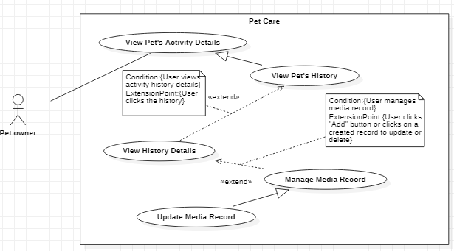

Figure 69-<Pet Owner> Update Media Record

|  |  |  |  |
| --- | --- | --- | --- |
| **USE CASE – UC\_65** | | | |
| **Use Case No.** | **65** | **Use Case Version** | 1.0 |
| **Use Case Name** | Update Media Record | | |
| **Author** | Vũ Hoàng Nam | | |
| **Date** | 30/09/2019 | **Priority** | Normal |
| **Actor:**   * Pet owner   **Summary:**   * This use case allows the Pet owner to update the information of the media record for the activity’s history.   **Goal:**   * The Pet owner updates the media record successfully.   **Triggers:**   * The Pet owner clicks on a history to show History’s Detail screen * The Pet owner clicks on a media record.   **Preconditions:**   * User can log in the system with the Pet owner role. * User is at specific Activity screen that allows to update media record: Hygiene (Bath / Nails / Hair / Teeth / Ears / Internal Deworming/ Fleas and Ticks), Vaccinations, Surgeries, Incidents, Allergies, Vet Visits   **Post conditions:**   * Success: The media record is updated. * Fail: System shows error messages.   **Main Success Scenarios:**   |  |  |  | | --- | --- | --- | | **Step** | **Actor Action** | **System Response** | | 1 | The Pet owner clicks on a media record | System shows “Media Record Details” screen with the following information:   * Add Image: image; optional/required * Date: date, required * Time: time, required * Notes: text, optional/required | | 2 | The Pet owner fills out data fields and clicks “Save” button. | System validates inputted data and shows the History’s Detail screen.  [Exception 1,2,3] |   **Alternative Scenarios:** N/A  **Exceptions:**   |  |  |  | | --- | --- | --- | | **No** | **Actor Action** | **System Response** | | 1 | * Date is not selected * Time is not selected | System shows error message "This field is required.” and highlights the empty fields. | | 2 | Either the image or the notes is not added. | System shows error message "Please add image or notes.” and highlights the empty fields. | | 3 | The Pet owner clicks on “Cancel” button. | System shows Surgeries screen. |   **Relationships:** Generalized from Manage Media Record use case, which is extended from View History Details use case.  **Business Rules:**   * In this system, the Guest and the Pet owner can update media records for activity’s histories. * The activity’s history date and time can only be set in the past date cannot be prior to pet’s birthdate. * When updating media record, the Pet owner must either add an image or add notes to complete. | | | |

<Pet owner> Update Additional Info use case specification

##### <Pet owner> Delete Media Record

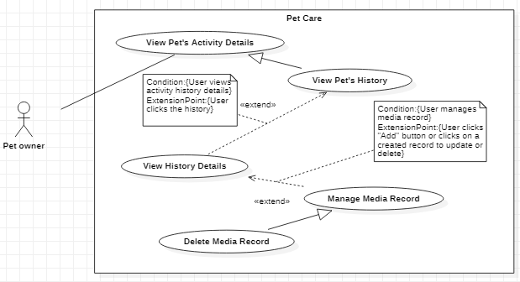

Figure 70-<Pet Owner> Delete Media Record

|  |  |  |  |
| --- | --- | --- | --- |
| **USE CASE – UC\_66** | | | |
| **Use Case No.** | **66** | **Use Case Version** | 1.0 |
| **Use Case Name** | Delete Media Record | | |
| **Author** | Vũ Hoàng Nam | | |
| **Date** | 30/09/2019 | **Priority** | Normal |
| **Actor:**   * Pet owner   **Summary:**   * This use case allows the Pet owner to delete the media record.   **Goal:**   * The Pet owner deletes the media record successfully.   **Triggers:**   * The Pet owner clicks on a history to show History’s Detail screen * The Pet owner clicks on a media record and clicks Delete button   **Preconditions:**   * User can log in the system with the Pet owner role. * User is at specific Activity screen that allows to update media record: Hygiene (Bath / Nails / Hair / Teeth / Ears / Internal Deworming/ Fleas and Ticks), Vaccinations, Surgeries, Incidents, Allergies, Vet Visits   **Post conditions:**   * Success: The media record is deleted. * Fail: System shows error messages.   **Main Success Scenarios:**   |  |  |  | | --- | --- | --- | | **Step** | **Actor Action** | **System Response** | | 1 | The Pet owner clicks on Delete button | System shows the message dialog with Y/N options: “Do you want to delete this record?” | | 2 | The Pet owner clicks on “Confirm” button | System shows History Details screen. |   **Alternative Scenarios:** N/A  **Exceptions:**   |  |  |  | | --- | --- | --- | | **No** | **Actor Action** | **System Response** | | 1 | The Pet owner clicks on “Back” button. | System redirects to the History Details screen. |   **Relationships:** Generalized from Manage Media Record use case, which is extended from View History Details use case.  **Business Rules:**   * In this system, the Guest and the Pet owner can delete media records for activity’s histories. | | | |

<Pet owner> Delete Media Record use case specification

##### <Pet owner> Delete History

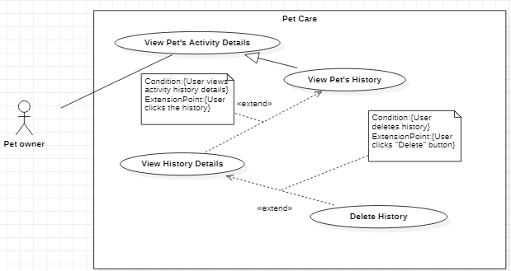

Figure 71-<Pet Owner> Delete History

|  |  |  |  |
| --- | --- | --- | --- |
| **USE CASE – UC\_67** | | | |
| **Use Case No.** | **67** | **Use Case Version** | 1.0 |
| **Use Case Name** | Delete History | | |
| **Author** | Vũ Hoàng Nam | | |
| **Date** | 30/09/2019 | **Priority** | Normal |
| **Actor:**   * Pet owner   **Summary:**   * This use case allows the Pet owner to delete histories of pet’s activity.   **Goal:**   * The Pet owner deletes the histories successfully.   **Triggers:**   * The Pet owner clicks on “Delete” button.   **Preconditions:**   * User can log in the system with the Pet owner role. * User is at a History’s Detail screen of a specific Activity.   **Post conditions:**   * Success: Activity’s history is deleted. * Fail: System shows error messages.   **Main Success Scenarios:**   |  |  |  | | --- | --- | --- | | **Step** | **Actor Action** | **System Response** | | 1 | The Pet owner clicks on “Delete” button | System shows the message dialog with Y/N options: “Do you want to delete this reminder?” | | 2 | The Pet owner clicks on “Confirm” button | System redirects to the specific Activity screen.  [Exception 1] |   **Alternative Scenarios:** N/A  **Exceptions:**   |  |  |  | | --- | --- | --- | | **No** | **Actor Action** | **System Response** | | 1 | The Pet owner clicks on “Back” button. | System redirects to the specific Activity screen. |   **Relationships:** Generalized from Update History use case, which is extended from View History Details use case.  **Business Rules:**   * In this system, the Guest and the Pet owner can delete pet’s activity histories. * The activities that are allowed for the Pet owner to delete histories: Measurements, Hygiene Activities (Bath, Hair, Nails, Teeth, Ears, Internal Deworming, Fleas & Ticks), Vaccination, Medication, Vet Visits, Incidents, Allergies, Surgeries. | | | |

<Pet owner> Delete History use case specification

##### <Pet owner> Get Pet’s Activity Schedule

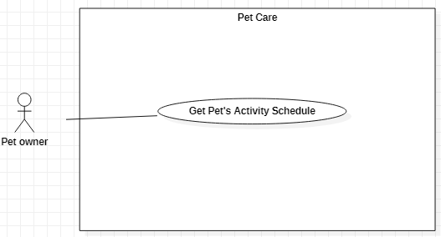

Figure 72-<Pet Owner> Get Pet’s Activity Schedule

|  |  |  |  |
| --- | --- | --- | --- |
| **USE CASE – 68** | | | |
| **Use Case No.** | 68 | **Use Case Version** | 1.0 |
| **Use Case Name** | Get Pet’s Activity Schedule | | |
| **Author** | Nguyễn Huy Hoàng | | |
| **Date** | 29/09/2019 | **Priority** | Normal |
| **Actor**:   * Pet Owner   **Summary**:   * This use case describes how the Pet owner get pet’s activity schedule.   **Goal**:   * The Pet owner gets pet’s activity schedules successfully.   **Triggers**:   * The Pet owner clicks “Schedule” tab of the bottom navigation tab in mobile application.   **Preconditions**: User can log in the system with Pet owner role.  **Post Conditions:**   * Success: The pet’s activity schedule is shown. * Fail: System displays error message.   **Main Success Scenario**:   |  |  |  | | --- | --- | --- | | **Step** | **Actor Action** | **System Response** | | 1 | The Pet owner clicks “Schedule” tab. | System displays list of pet’s activity schedules. |   **Alternative Scenarios**: N/A  **Exceptions**: N/A  **Relationships**: Associated with Pet Owner actor.  **Business Rules**:   * In this system, the Guest and the Pet owner can get pet’s activity schedule. * The activity schedule is displayed in calendar mode * The schedule displays activity with some basic information: pet’s name, activity, time, date. * The Pet owner can update the schedule through this Schedule section directly, by clicking an activity schedule displayed on the calendar to go to the update screen. | | | |

##### <Pet owner> Get Pet Shop Services List

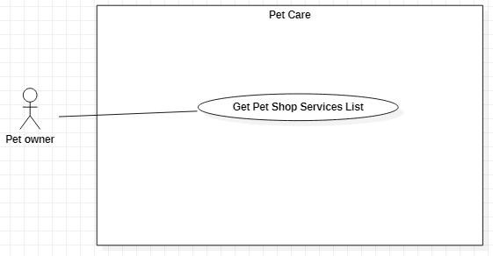

Figure 73-<Pet owner> Get Pet Shop Services List

|  |  |  |  |  |  |  |  |  |  |  |  |  |  |  |  |  |  |  |  |  |  |  |  |  |  |  |  |  |  |  |  |  |  |  |  |  |
| --- | --- | --- | --- | --- | --- | --- | --- | --- | --- | --- | --- | --- | --- | --- | --- | --- | --- | --- | --- | --- | --- | --- | --- | --- | --- | --- | --- | --- | --- | --- | --- | --- | --- | --- | --- | --- |
| |  |  |  |  | | --- | --- | --- | --- | | **USE CASE – UC\_69** | | | | | **Use Case No.** | 69 | **Use Case Version** | 1.0 | | **Use Case Name** | Get Pet Shop Services List | | | | **Author** | Nguyễn Huy Hoàng | | | | **Date** | 30/09/2019 | **Priority** | Normal | | **Actor:**   * Pet owner   **Summary:**   * This use case allows the Pet owner to get the pet shop services list.   **Goal:**   * The Pet owner gets the pet shop services list successfully.   **Triggers:**   * The Pet owner clicks “Shops” tab on the navigation bar.   **Preconditions:**   * User can log in the system with Pet owner role. * User is at “Shops” screen.   **Post conditions:**   * Success: The services list is shown. * Fail: N/A.   **Main Success Scenarios:**   |  |  |  | | --- | --- | --- | | **Step** | **Actor Action** | **System Response** | | 1 | The Pet owner clicks “Shops” tab on the navigation bar. | “Shops” screen is shown with the pet shop services list displayed in tab sections:   * “Nearby” tab * “Discount” tab   [Exception 1] |   **Alternative Scenarios:** N/A  **Exceptions:**   |  |  |  | | --- | --- | --- | | **Step** | **Actor Action** | **System Response** | | 1 | Network connection problem. | System shows error message: “Please check your network connection.” |   **Relationships:**  Associated with Pet owner and Guest actor.  **Business Rules:**   * In this system, the Guest and the Pet owner can get pet shop services list. * The internet connection is required to use this function. * The “Nearby” tab displays the information card of the pet shop service which are nearby the Pet owner’s location. * The “Discount” tab displays the information card of the pet shop service which have the high rate of discount’s price. * The information card shows the following information of the service: image, shop’s name, shop’s address, discount rate. | | | | |

<Pet owner> Get Pet Shop Services List use case specification

##### <Pet owner> View Service Details

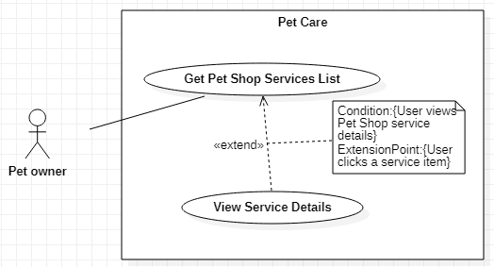

Figure 74-<Pet owner> View Service Details

|  |  |  |  |
| --- | --- | --- | --- |
| **USE CASE – UC\_70** | | | |
| **Use Case No.** | 70 | **Use Case Version** | 1.0 |
| **Use Case Name** | View Service Details | | |
| **Author** | Nguyễn Huy Hoàng | | |
| **Date** | 30/09/2019 | **Priority** | Normal |
| **Actor:**   * Pet owner   **Summary:**   * This use case allows the Pet owner to view service’s detail.   **Goal:**   * The Pet owner views service’s detail successfully.   **Triggers:**   * The Pet owner clicks on the service information card.   **Preconditions:**   * User can log in the system with Pet owner role. * User is at “Shops” screen.   **Post conditions:**   * Success: The shop’s detail screen that includes the service is shown. * Fail: N/A.   **Main Success Scenarios:**   |  |  |  | | --- | --- | --- | | **Step** | **Actor Action** | **System Response** | | 1 | The Pet owner clicks on the service information card to see the shop’s information detail. | “Pet Shop Details” screen is shown with the following information of the shop that includes the service:   * Image * Name * Address * Description * Services that the shop provides (including service’s price and discount price)   [Exception 1] |   **Alternative Scenarios:** N/A  **Exceptions:**   |  |  |  | | --- | --- | --- | | **Step** | **Actor Action** | **System Response** | | 1 | Network connection problem. | System shows error message: “Please check your network connection.” |   **Relationships:** Extended from Get Pet Shop Services List use case.  **Business Rules:**   * In this system, the Guest and the Pet owner can view service’s detail. * The internet connection is required to use this function. | | | |

<Pet owner> View Service Details use case specification

##### <Pet owner> Chat with other Pet Owners

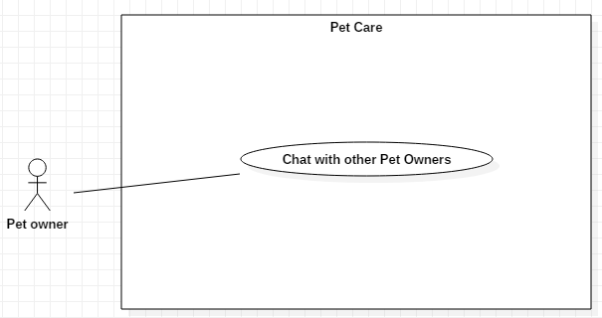

Figure 75-<Pet owner> Chat with other Pet Owners

|  |  |  |  |
| --- | --- | --- | --- |
| **USE CASE – UC\_71** | | | |
| **Use Case No.** | **71** | **Use Case Version** | 1.0 |
| **Use Case Name** | Chat with other Pet owners | | |
| **Author** | Nguyễn Huy Hoàng | | |
| **Date** | 30/09/2019 | **Priority** | Normal |
| **Actor:**   * Pet owner   **Summary:**   * This use case allows the Pet owner to chat with other Pet owner.   **Goal:**   * The Pet owner chats with other Pet owner successfully.   **Triggers:**   * The Pet owner clicks on the “Social” tab on the navigation bar and clicks to choose a user to chat.   **Preconditions:**   * User must log in the system with the Pet owner role. * User is at “Social” screen.   **Post conditions:**   * Success: The Pet owner chats with the other Pet owner. * Fail: System shows error messages.   **Main Success Scenarios:**   |  |  |  | | --- | --- | --- | | **Step** | **Actor Action** | **System Response** | | 1 | The Pet owner clicks on a user that appears in “Suggested for you” section (or in the conversations list section) | System shows “Chat” screen. | | 2 | The Pet owner inputs text and clicks “Send” button to send the message. | System sends message and displays the conversation.  [Exception 1] |   **Alternative Scenarios:** N/A  **Exceptions:**   |  |  |  | | --- | --- | --- | | **No** | **Actor Action** | **System Response** | | 1 | Network connection problem. | System shows error message: “Please check your network connection.” |   **Relationships:** Associated with Pet Owner actor.  **Business Rules:**   * In this system, only the Pet owner can chat with other pet owners. * The internet connection is required to use this function. | | | |

<Pet owner> Chat with other Pet owners use case specification

#### <System Handler> Overview Use Case

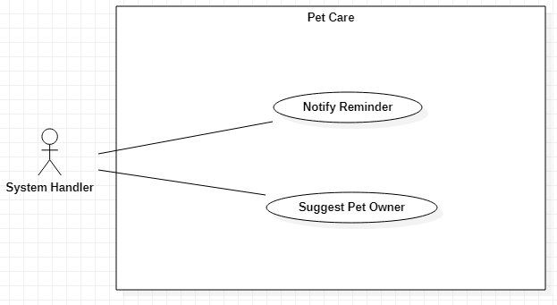

Figure 76-<System Handler> Overview Use Case

##### <System Handler> Notify Reminder

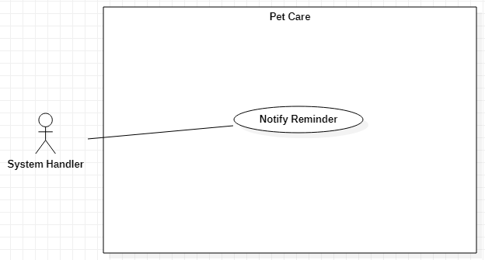

Figure 77-<System Handler> Notify Reminder

|  |  |  |  |
| --- | --- | --- | --- |
| **USE CASE – UC\_72** | | | |
| **Use Case No.** | 72 | **Use Case Version** | 1.0 |
| **Use Case Name** | Notify Reminder | | |
| **Author** | Trần Nguyễn Quốc Vũ | | |
| **Date** | 30/09/2019 | **Priority** | Normal |
| **Actor:**   * System handle   **Summary:**   * This use case describes the system notifying activity’s reminder to the user.   **Goal:**   * The reminder is notified successfully.   **Triggers:**   * N/A   **Preconditions:** The reminder reaches the setting time.  **Post conditions:**   * Success: The reminder is notified to the user. * Fail: N/A   **Main Success Scenarios:**   |  |  |  | | --- | --- | --- | | **Step** | **Actor Action** | **System Response** | | 1 | The user sets the reminder time and the reminder reaches the time | System notifies the reminder in the notification area. |   **Alternative Scenarios:** N/A  **Exceptions:** N/A  **Relationships:** N/A  **Business Rules:**   * The reminder has to reach to the setting time. | | | |

<System Handler> Notify Reminder use case specification

##### <System Handler> Suggest Pet Owner

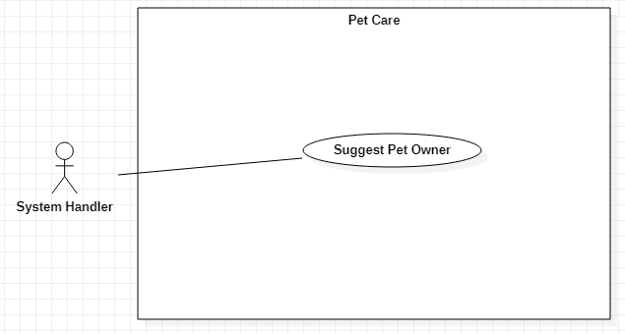

Figure 78-<System Handler> Suggest Pet Owner

|  |  |  |  |
| --- | --- | --- | --- |
| **USE CASE – UC\_73** | | | |
| **Use Case No.** | 73 | **Use Case Version** | 1.0 |
| **Use Case Name** | Suggest Pet Owner | | |
| **Author** | Trần Nguyễn Quốc Vũ | | |
| **Date** | 30/09/2019 | **Priority** | Normal |
| **Actor:**   * System handle   **Summary:**   * This use case describes the system suggesting the list of pet owners to the user when the user uses “Social” function.   **Goal:**   * The list of suggested pet owners is displayed successfully.   **Triggers:** N/A  **Preconditions:** The user has the data about the pet in the system.  **Post conditions:**   * Success: The suggested pet owners list is displayed. * Fail: System shows error messages.   **Main Success Scenarios:**   |  |  |  | | --- | --- | --- | | **Step** | **Actor Action** | **System Response** | | 1 | The Pet owner clicks on Social tab on the navigation bar | System shows Social screen with the list of suggested pet owners.  [Exception 1] |   **Alternative Scenarios:** N/A  **Exceptions:**   |  |  |  | | --- | --- | --- | | **No** | **Actor Action** | **System Response** | | 1 | Network connection problem. | System shows error message: “Please check your network connection.” |   **Relationships:**  N/A  **Business Rules:**   * The list of suggested pet owners is based on the similarity of the pet type and pet breed between the owners. * The internet connection is required to run this function. | | | |

<System Handler> Suggest Pet owner use case specification

## Software System Attribute

### Usability

* The system is easy to use that needs less than 2 hour of training to use the system.
* User interface is clear, simple and easy to use.
* Users don’t need to have any knowledge in any field of computer still understand what system UI’s meaning.

### Reliability

* Exception rate is at minimum 1% over all working time

### Availability

The system must be available 24/7, except for some system maintenances time.

### Security

* Privacy: Each role of user has a specific permission to interact with system.
* System always checks authorization and authenticated before doing function of admin and user
* Only admin can grant permission to other roles.
* The password of user have been encrypted in database.

### Maintainability

* The system is distributed to many separated services and instances.
* Maintain the whole system every month.
* The code is based on popular design patterns in order to easy to maintain and upgrade.

### Portability

* The website is running on Windows 7 or above.
* Easy installation from APK for Android version.
* The mobile application is running on Android 5.1 or above.

### Performance

* All requests are handling in maximum time of 5 seconds.
* All real-time requests must be handled in maximum time of 2 milliseconds.

## Conceptual Diagram

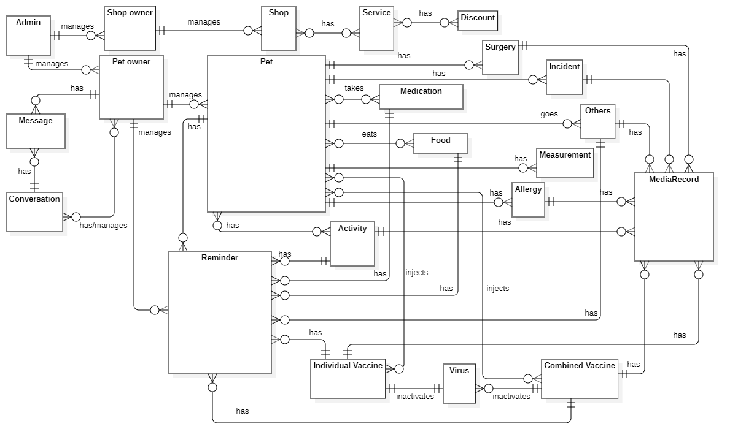

Figure 79-Conceptual Diagram

|  |  |
| --- | --- |
| **ENTITY DATA DICTIONARY: DESCRIBE ALL CONTENT OF ALL ENTITIES** | |
| **Entity name** | **Description** |
| **Admin** | Contains the admin information |
| **Shop owner** | Contains the shop owner information |
| **Pet owner** | Contains the pet owner information |
| **Pet** | Contains the pet information |
| **Reminder** | Contains the reminder information |
| **Food** | Contains the food information |
| **Medication** | Contains the medication information |
| **Individual Vaccine** | Contains the individual vaccine information |
| **Combined Vaccine** | Contains the combined vaccine information |
| **Virus** | Contains the virus information |
| **Surgery** | Contains the surgery’s history information of the pet |
| **Allergy** | Contains the allergy’s history information of the pet |
| **Incident** | Contains the incident’s history information of the pet |
| **Measurement** | Contains the measurement’s history information of the pet |
| **Activity** | Contains the hygiene activity information |
| **Others** | Contains the other activities information |
| **Message** | Contains the message information |
| **Conversation** | Contains the conversation information |
| **Shop** | Contains the shop information |
| **Service** | Contains the service information |
| **Discount** | Contains the discount information |

Table 14 - Conceptual Diagram Data Dictionary

# D. Software Design Description

## Design Overview

* This document describes the technical and user interface design of Pet Care system. It includes the architectural design, the detailed design of common functions and business functions and the design of database model.
* The architectural design describes the overall architecture of the system and the architecture of each main component and subsystem.
* The detailed design describes static and dynamic structure for each component and functions. It includes class diagrams, class explanations and sequence diagrams for each use cases.
* The database design describes the relationships between entities and details of each entity.
* Document overview:
  + Section 2: gives an overall description of the system architecture design.
  + Section 3: gives component diagram that describes the connection and integration of the system.
  + Section 4: gives the detail design description, which includes class diagram, class explanation and sequence diagram to detail the application functions.
  + Section 5: describes a fully attributed Entity Relationship Diagram.

## System Architectural Design

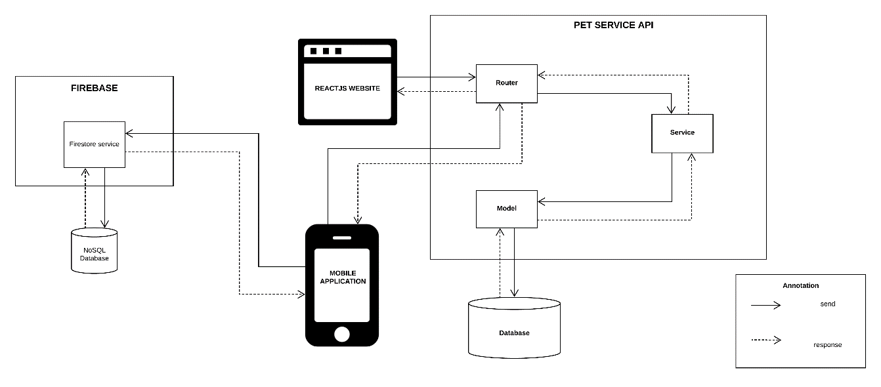

Figure 80 - System Architectural Design

### Web Application Architecture Description

For web application, our system is developed with ReactJS. We decide to choose this architect for web application because of following advantages:

* ReactJS is an efficient framework that can create Rich Internet Applications (RIA).
* ReactJS provides developers an options to write client side applications using JavaScript in a clean Model View Controller (MVC) way and model–view–view model (MVVM) architectures.
* Applications written in ReactJS are cross-browser compliant. ReactJS automatically handles JavaScript code suitable for each browser.
* ReactJS is open source, completely free, and used by thousands of developers around the world. It is licensed under the Apache license version 2.0.

The MVC pattern (Model-View-Controller) separates application into 3 main components: Model-View-Controller. MVC patter helps you to build application more testable and easier. MVC-based app contains:

* Controller: is a part of application like a handler browser to handle and response user interaction and input. Controller handles route data and call repository’s method to get business data for handling business logic. Then select view to render to web browser for user.
* View: is a part of application for displaying the app’s user interface. It get data from model and specifies how that data should be presented. It updates UI when model changes.
* Model: is a part of application for represents the business data. The model classes use validation logic to enforce business data. The model notifies views when it changes and lets view query the model.

### Mobile Application Architecture Description

The mobile application of Pet Care system is built based on Android jetpack from Google development team. Android jetpack components are a collection of libraries that make it easier to build a fast, robust, testable, and maintainable app.

Based on these components, we are using MVVM model to construct high quality Android app and to help us develop the app faster than the original one.

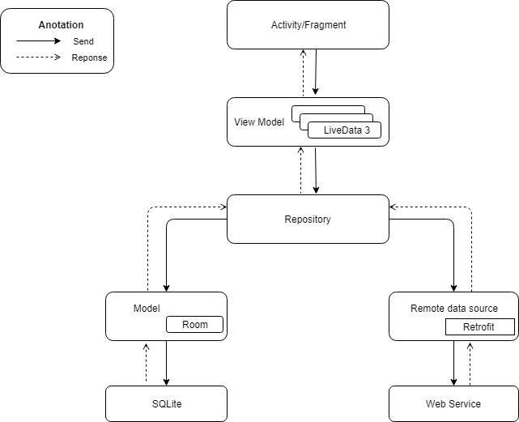

Figure 81-Mobile Application Architectural Design

There are three main parts in this architecture:

* Model: This part is mainly used to represent the business logic from our backend service.
* View: This part displays our data information to the user
* ViewModel: This part works as a bridge between Model and View. When the new data is coming from the backend, the model will receive then pass to the ViewModel to process and send to the View for consuming.

## Component Diagram

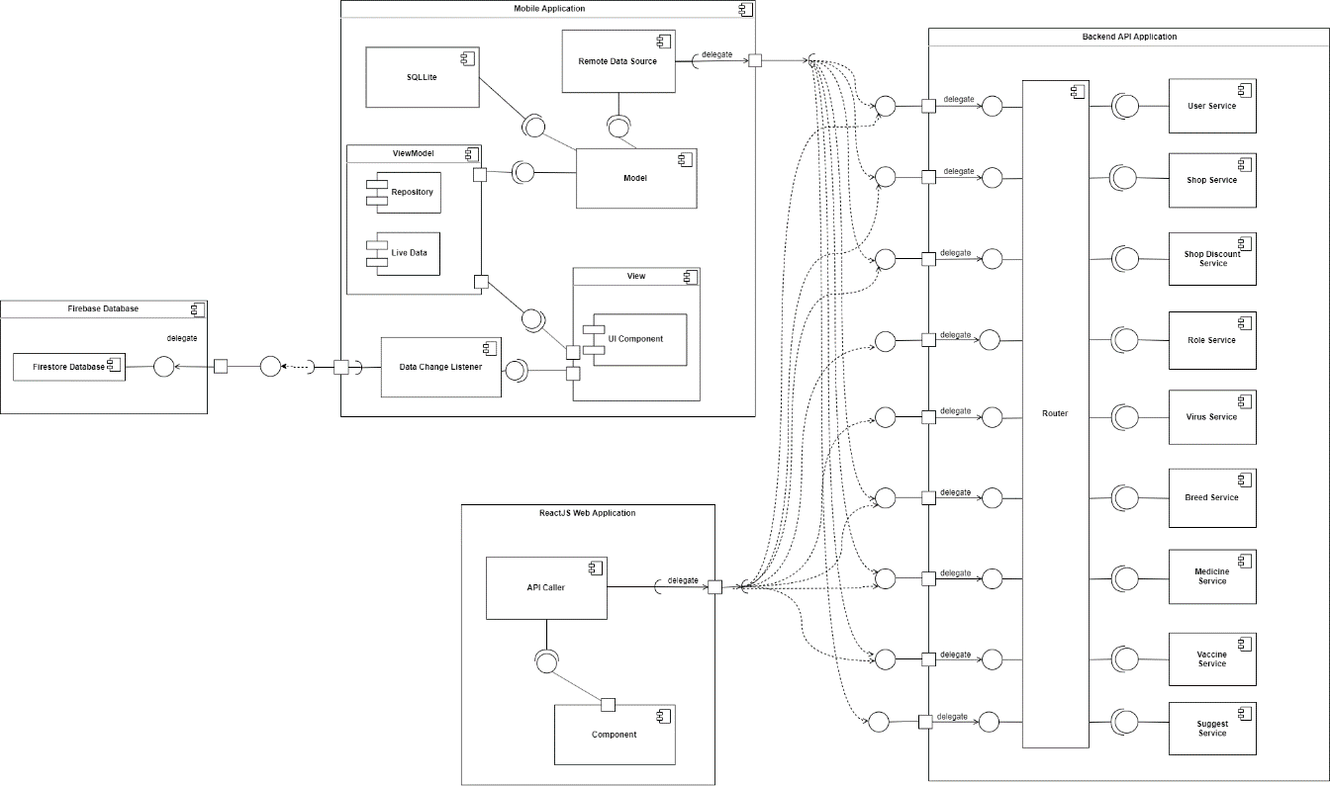

Figure 82-Component Diagram

|  |  |
| --- | --- |
| COMPONENT DICTIONARY: DESCRIBES COMPONENTS | |
| Component name | **Description** |
| Backend API Application | Component which contains core flow of Pet Care system |
| ReactJS Web Application | Component to handle HTTP requests from client to the specific service (use cases) |
| Firebase Database | Component with file storage |
| Mobile Application | Component to help pet owner implement activities in the system through UI components |
| Table 15-Component Dictionary | |

## Detail Description

### Class Diagram

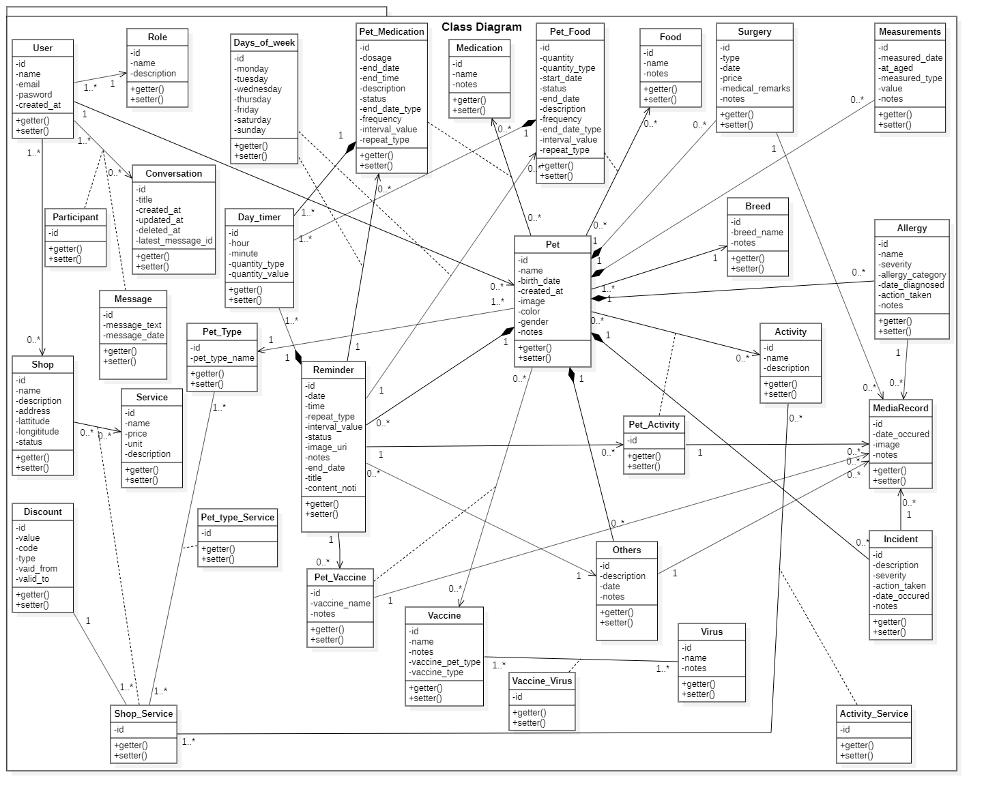

Figure 83-Class Diagram

|  |  |  |
| --- | --- | --- |
| **CLASS DICTIONARY: DESCRIBE CLASS** | | |
| ***Class Name*** | ***Mapping column with Conceptual diagram*** | ***Description*** |
| **User** | N/A | Does not exist in conceptual diagram, but needed in class diagram to contain the user information in general. |
| **Role** | N/A | Does not exist in conceptual diagram, but needed in class diagram to contain the role information in general. |
| **Pet** | Pet | Contains the pet information. |
| **Reminder** | Reminder | Contains the reminder information. |
| **Others** | Others | Contains the other activities information. |
| **Surgery** | N/A | Contains the surgery information of the pet. |
| **Allergy** | N/A | Contains the allergy information of the pet. |
| **Incident** | N/A | Contains the incident information of the pet. |
| **Food** | Food | Contains the food information. |
| **Medication** | Medication | Contains the medication information. |
| **Vaccine** | N/A | Contains the vaccine information in general. |
| **Virus** | Virus | Contains the virus information. |
| **Activity** | Activity | Contains the pet caring activity information. |
| **Measurements** | N/A | Contains the measurement information of the pet. |
| **Pet\_Food** | N/A | Does not exist in conceptual diagram, but needed in class diagram to contain the attributes to define many to many relationship between the pet and the food. |
| **Pet\_Medication** | N/A | Does not exist in conceptual diagram, but needed in class diagram to contain the attributes to define many to many relationship between the pet and the medication. |
| **Pet\_ Vaccine** | N/A | Does not exist in conceptual diagram, but needed in class diagram to contain the attributes to define many to many relationship between the pet and the vaccine. |
| **Pet\_ Activity** | N/A | Does not exist in conceptual diagram, but needed in class diagram to contain the attributes to define many to many relationship between the pet and the activity. |
| **MediaRecord** | Media Record | Contains the media records information |
| **Shop** | Shop | Contains the pet shop information. |
| **Service** | Service | Contains the service information of the shop. |
| **Shop\_Service** | N/A | Does not exist in conceptual diagram, but needed in class diagram to contain to contain the attributes to define many to many relationship between the shop and the service. |
| **Discount** | Discount | Contains the discount information. |
| **Message** | Message | Contains the message information. |
| **Conversation** | Conversation | Contains the conversation information of the group chat. |
| **Participant** | N/A | Does not exist in conceptual diagram, but needed in class diagram to contain the participant information in the group chat conversation. |

Table 16 - Class Dictionary

### Class Diagram Explanation

#### User

* **Attributes**

|  |  |  |  |
| --- | --- | --- | --- |
| **Attribute** | **Type** | **Visibility** | **Description** |
| id | string | private | Unique identifier of user |
| name | string | private | Name of user |
| email | string | private | Email of user |
| password | string | private | Password of user |
| created\_at | datetime | private | User created date |

Table 17 - <Class Diagram> User Attributes

* **Methods**

|  |  |  |  |
| --- | --- | --- | --- |
| **Method** | **Return Type** | **Visibility** | **Description** |
| getter() | attribute type | public | Get user attributes |
| setter() | void | public | Set value of user attributes |

Table 18 - <Class Diagram> User Methods

#### Role

* **Attributes**

|  |  |  |  |
| --- | --- | --- | --- |
| **Attribute** | **Type** | **Visibility** | **Description** |
| id | string | private | Unique identifier of role |
| name | string | private | Name of role |
| description | string | private | Description of role |

Table 19 - <Class Diagram> Admin Attributes

* **Methods**

|  |  |  |  |
| --- | --- | --- | --- |
| **Method** | **Return Type** | **Visibility** | **Description** |
| getter() | attribute type | public | Get role attributes |
| setter() | void | public | Set value of role attributes |

Table 20 - <Class Diagram> Admin Methods

#### Pet

* **Attributes**

|  |  |  |  |
| --- | --- | --- | --- |
| **Attribute** | **Type** | **Visibility** | **Description** |
| id | string | private | Unique identifier of pet |
| name | string | private | Name of pet |
| birthdate | date | private | Birth date of pet |
| created\_at | datetime | private | Pet created time |
| image | string | private | Image of pet |
| color | string | private | Color of pet |
| note | string | private | Note of pet |
| gender | string | private | Gender of pet |
| pet\_type | string | private | Pet type |
| breed | string | private | Breed of pet |

Table 21- <Class Diagram> Pet Attributes

* **Methods**

|  |  |  |  |
| --- | --- | --- | --- |
| **Method** | **Return Type** | **Visibility** | **Description** |
| getter() | attribute type | public | Get pet attributes |
| setter() | void | public | Set value of pet attributes |

Table 22- <Class Diagram> Pet Methods

#### Pet type

* **Attributes**

|  |  |  |  |
| --- | --- | --- | --- |
| **Attribute** | **Type** | **Visibility** | **Description** |
| id | string | private | Unique identifier of pet type |
| pet\_type\_name | string | private | Name of pet type |

Table 23- <Class Diagram> Pet Type Attributes

* **Methods**

|  |  |  |  |
| --- | --- | --- | --- |
| **Method** | **Return Type** | **Visibility** | **Description** |
| getter() | attribute type | public | Get Pet Type attributes |
| setter() | void | public | Set value of Pet Type attributes |

Table 24- <Class Diagram> Pet Type Methods

#### Breed

* **Attributes**

|  |  |  |  |
| --- | --- | --- | --- |
| **Attribute** | **Type** | **Visibility** | **Description** |
| id | int | private | Unique identifier of pet breed |
| breed\_name | string | private | Name of pet breed |
| notes | String | private | Notes of pet breed |

Table 25- <Class Diagram> Breed Attributes

* **Methods**

|  |  |  |  |
| --- | --- | --- | --- |
| **Method** | **Return Type** | **Visibility** | **Description** |
| getter() | attribute type | public | Get Breed attributes |
| setter() | void | public | Set value of Breed attributes |

Table 26- <Class Diagram> Breed Methods

#### Reminder

* **Attributes**

|  |  |  |  |
| --- | --- | --- | --- |
| **Attribute** | **Type** | **Visibility** | **Description** |
| id | int | private | Unique identifier of reminder |
| date | date | private | Date on reminder |
| time | time | private | Time on reminder |
| repeat\_type | string | private | Repeat type on reminder (by days, weeks, etc) |
| interval\_value | integer | private | Interval value on reminder |
| status | boolean | private | Status of reminder |
| image\_uri | string | private | Image on reminder |
| notes | string | private | Notes on reminder |

Table 27- <Class Diagram> Reminder Attributes

* **Methods**

|  |  |  |  |
| --- | --- | --- | --- |
| **Method** | **Return Type** | **Visibility** | **Description** |
| getter() | attribute type | public | Get reminder attributes |
| setter() | void | public | Set value of reminder attributes |

Table 28- <Class Diagram> Reminder Methods

#### Days\_of\_Week

* **Attributes**

|  |  |  |  |
| --- | --- | --- | --- |
| **Attribute** | **Type** | **Visibility** | **Description** |
| id | string | private | Unique identifier of days of week |
| monday | string | private | Description of Monday |
| tuesday | string | private | Date of other Tuesday |
| wednesday | string | private | Description of Wednesday |
| thursday | string | private | Date of other Thursday |
| friday | string | private | Description of Friday |
| saturday | string | private | Date of other Saturday |
| sunday | string | private | Description of Sunday |

Table 29- <Class Diagram> Days of week Attribute

* **Methods**

|  |  |  |  |
| --- | --- | --- | --- |
| **Method** | **Return Type** | **Visibility** | **Description** |
| getter() | attribute type | public | Get Days of week attributes |
| setter() | void | public | Set value of Days of week attributes |

Table 30- <Class Diagram> Days of week Methods

#### Day\_timer

* **Attributes**

|  |  |  |  |
| --- | --- | --- | --- |
| **Attribute** | **Type** | **Visibility** | **Description** |
| id | string | private | Unique identifier of day timer |
| hour | interger | private | Hour of day timer |
| minute | interger | private | Minute of day timer |
| quantity\_type | interger | private | Quantity\_type of day timer |
| quantity\_value | float | private | Quantity value of day timer |

Table 31- <Class Diagram> Day timer Attributes

* **Methods**

|  |  |  |  |
| --- | --- | --- | --- |
| **Method** | **Return Type** | **Visibility** | **Description** |
| getter() | attribute type | public | Get Day timer attributes |
| setter() | void | public | Set value of Day timer attributes |

Table 32- <Class Diagram> Day timer Methods

#### Others

* **Attributes**

|  |  |  |  |
| --- | --- | --- | --- |
| **Attribute** | **Type** | **Visibility** | **Description** |
| id | int | private | Unique identifier of other activities |
| description | string | private | Description of other activities |
| date | datetime | private | Date of other activities |
| notes | string | private | Notes of the other activities |

Table 33- <Class Diagram> Others Attribute

* **Methods**

|  |  |  |  |
| --- | --- | --- | --- |
| **Method** | **Return Type** | **Visibility** | **Description** |
| getter() | attribute type | public | Get other activities attributes |
| setter() | void | public | Set value of other activities attributes |

Table 34- <Class Diagram> Others Methods

#### Measurements

* **Attributes**

|  |  |  |  |
| --- | --- | --- | --- |
| **Attribute** | **Type** | **Visibility** | **Description** |
| id | int | private | Unique identifier of measurements note |
| measured\_date | date | private | Date of measurements |
| at\_aged | boolean | private | Age of pet at the date of measurements |
| type | string | private | Measurements type |
| value | string | private | Measurements value |
| notes | string | private | Measurements notes |

Table 35- <Class Diagram>Measurements Attributes

* **Methods**

|  |  |  |  |
| --- | --- | --- | --- |
| **Method** | **Return Type** | **Visibility** | **Description** |
| getter() | attribute type | public | Get measurements attributes |
| setter() | void | public | Set value of measurements attributes |

Table 36- <Class Diagram> Measurements Methods

#### Surgery

* **Attributes**

|  |  |  |  |
| --- | --- | --- | --- |
| **Attribute** | **Type** | **Visibility** | **Description** |
| id | int | private | Unique identifier of surgery note |
| type | string | private | Type of surgery |
| date | date | private | Date of surgery |
| price | float | private | Surgery price |
| medical\_remarks | string | private | Medical remarks of pet surgery |
| notes | string | private | Surgery notes |

Table 37- <Class Diagram> Surgery Attribute

* **Methods**

|  |  |  |  |
| --- | --- | --- | --- |
| **Method** | **Return Type** | **Visibility** | **Description** |
| getter() | attribute type | public | Get surgery attributes |
| setter() | void | public | Set value of surgery attributes |

Table 38- <Class Diagram> Surgery Methods

#### Allergy

* **Attributes**

|  |  |  |  |
| --- | --- | --- | --- |
| **Attribute** | **Type** | **Visibility** | **Description** |
| id | int | private | Unique identifier of allergy note |
| name | string | private | Name of allergy |
| severity | string | private | Severity level of allergy |
| allergy\_category | string | private | Type of allergy |
| date\_diagnosed | date | private | Date that the pet had allergy |
| action\_taken | string | private | Actions that pet owner does to take care of pet |
| notes | string | private | Allergy notes |

Table 39- <Class Diagram> Allergy Attributes

* **Methods**

|  |  |  |  |
| --- | --- | --- | --- |
| **Method** | **Return Type** | **Visibility** | **Description** |
| getter() | attribute type | public | Get allergy attributes |
| setter() | void | public | Set value of allergy attributes |

Table 40- <Class Diagram> Allergy Methods

#### Incident

* **Attributes**

|  |  |  |  |
| --- | --- | --- | --- |
| **Attribute** | **Type** | **Visibility** | **Description** |
| id | int | private | Unique identifier of incident note |
| description | string | private | Description of incident |
| severity | string | private | Severity level of incident |
| action\_taken | string | private | Actions that pet owner does to take care of pet |
| date\_occured | date | private | Date that pet had incident |
| notes | string | private | Incident notes |

Table 41- <Class Diagram>Incident Attributes

* **Methods**

|  |  |  |  |
| --- | --- | --- | --- |
| **Method** | **Return Type** | **Visibility** | **Description** |
| getter() | attribute type | public | Get incident attributes |
| setter() | void | public | Set value of incident attributes |

Table 42- <Class Diagram> Incident Method

#### Food

* **Attributes**

|  |  |  |  |
| --- | --- | --- | --- |
| **Attribute** | **Type** | **Visibility** | **Description** |
| id | int | private | Unique identifier of food |
| name | string | private | Name of food |
| notes | string | private | Notes about food |

Table 43- <Class Diagram> Food Attributes

* **Methods**

|  |  |  |  |
| --- | --- | --- | --- |
| **Method** | **Return Type** | **Visibility** | **Description** |
| getter() | attribute type | public | Get food attributes |
| setter() | void | public | Set value of food attributes |

Table 44- <Class Diagram> Food Methods

#### Medication

* **Attributes**

|  |  |  |  |
| --- | --- | --- | --- |
| **Attribute** | **Type** | **Visibility** | **Description** |
| id | int | private | Unique identifier of medication |
| name | string | private | Name of medication |
| notes | string | private | Notes about medication |

Table 45- <Class Diagram> Medication Attributes

* **Methods**

|  |  |  |  |
| --- | --- | --- | --- |
| **Method** | **Return Type** | **Visibility** | **Description** |
| getter() | attribute type | public | Get medication attributes |
| setter() | void | public | Set value of medication attributes |

Table 46- <Class Diagram> Medication Methods

#### Vaccine

* **Attributes**

|  |  |  |  |
| --- | --- | --- | --- |
| **Attribute** | **Type** | **Visibility** | **Description** |
| id | int | private | Unique identifier of vaccine |
| name | string | private | Name of vaccine |
| vaccine\_pet\_type | int | Private | Type of pet that has the vaccine |
| notes | string | private | Notes about vaccine |
| is\_defined | int | private | To define the vaccine is created by the system or the user |

Table 47- <Class Diagram> Vaccine Attributes

* **Methods**

|  |  |  |  |
| --- | --- | --- | --- |
| **Method** | **Return Type** | **Visibility** | **Description** |
| getter() | attribute type | public | Get vaccine attributes |
| setter() | void | public | Set value of vaccine attributes |

Table 48- <Class Diagram> Vaccine Methods

#### Virus

* **Attributes**

|  |  |  |  |
| --- | --- | --- | --- |
| **Attribute** | **Type** | **Visibility** | **Description** |
| id | int | private | Unique identifier of virus |
| name | string | private | Name of virus |
| notes | string | private | Notes about virus |
| is\_defined | int | private | To define the virus is created by the system or the user |

Table 49- <Class Diagram> Virus Attributes

* **Methods**

|  |  |  |  |
| --- | --- | --- | --- |
| **Method** | **Return Type** | **Visibility** | **Description** |
| getter() | attribute type | public | Get virus attributes |
| setter() | void | public | Set value of virus attributes |

Table 50- <Class Diagram> Virus Methods

#### Vaccine\_Virus

* **Attributes**

|  |  |  |  |
| --- | --- | --- | --- |
| **Attribute** | **Type** | **Visibility** | **Description** |
| id | string | private | Unique identifier of the relationship between vaccine and virus |

Table 51- <Class Diagram> Vaccine\_Virus Attributes

* **Methods**

|  |  |  |  |
| --- | --- | --- | --- |
| **Method** | **Return Type** | **Visibility** | **Description** |
| getter() | attribute type | public | Get Vaccine\_Virus attributes |
| setter() | void | public | Set value of Vaccine\_Virus attributes |

Table 52- <Class Diagram> Vaccine\_Virus Methods

#### Activity

* **Attributes**

|  |  |  |  |
| --- | --- | --- | --- |
| **Attribute** | **Type** | **Visibility** | **Description** |
| id | int | private | Unique identifier of activity |
| name | string | private | Name of activity |
| description | string | private | Description about activity |

Table 53- <Class Diagram> Activity Attributes

* **Methods**

|  |  |  |  |
| --- | --- | --- | --- |
| **Method** | **Return Type** | **Visibility** | **Description** |
| getter() | attribute type | public | Get activity attributes |
| setter() | void | public | Set value of activity attributes |

Table 54- <Class Diagram> Activity Methods

#### Pet\_Food

* **Attributes**

|  |  |  |  |
| --- | --- | --- | --- |
| **Attribute** | **Type** | **Visibility** | **Description** |
| id | int | private | Unique identifier of pet\_food note |
| quantity | float | private | Quantity of food for the pet |
| quantity\_type | string | private | Quantity type of food for the pet |
| taste | string | private | Taste of food for the pet |
| status | int | private | Status of pet\_food note |
| end\_date | date | private | Date that the pet stop having food |
| end\_time | time | private | Time that the pet stop having food |
| description | string | private | Description of pet\_food note |

Table 55- <Class Diagram>Pet\_Food Attributes

* **Methods**

|  |  |  |  |
| --- | --- | --- | --- |
| **Method** | **Return Type** | **Visibility** | **Description** |
| getter() | attribute type | public | Get pet\_food attributes |
| setter() | void | public | Set value of pet\_food attributes |

Table 56- <Class Diagram> Pet\_Food Methods

#### Pet\_Medication

* **Attributes**

|  |  |  |  |
| --- | --- | --- | --- |
| **Attribute** | **Type** | **Visibility** | **Description** |
| id | int | private | Unique identifier of pet\_ medication note |
| dosage | float | private | Dosage of medication |
| end\_date | date | private | Date that the pet stop having medication |
| end\_time | time | private | Time that the pet stop having medication |
| description | string | private | Description of pet\_ medication note |
| status | int | private | Status of pet\_ medication note |

Table 57- <Class Diagram> Pet\_Medication Attributes

* **Methods**

|  |  |  |  |
| --- | --- | --- | --- |
| **Method** | **Return Type** | **Visibility** | **Description** |
| getter() | attribute type | public | Get pet\_ medication attributes |
| setter() | void | public | Set value of pet\_ medication attributes |

Table 58- <Class Diagram> Pet\_Medication Methods

#### Pet\_Vaccine

* **Attributes**

|  |  |  |  |
| --- | --- | --- | --- |
| **Attribute** | **Type** | **Visibility** | **Description** |
| id | int | private | Unique identifier of pet\_ vaccine note |
| vaccinated\_date | date | private | Name of vaccine for pet |
| vaccinated\_by | string |  | The person who vaccinated the pet |
| notes | string | private | Notes about vaccine for pet |
| status | int | private | Status of pet\_vaccine note |

Table 59- <Class Diagram> Pet\_Vaccine Attributes

* **Methods**

|  |  |  |  |
| --- | --- | --- | --- |
| **Method** | **Return Type** | **Visibility** | **Description** |
| getter() | attribute type | public | Get pet\_ vaccine attributes |
| setter() | void | public | Set value of pet\_ vaccine attributes |

Table 60- <Class Diagram> Pet\_ Vaccine Methods

#### Pet\_Activity

* **Attributes**

|  |  |  |  |
| --- | --- | --- | --- |
| **Attribute** | **Type** | **Visibility** | **Description** |
| id | int | private | Unique identifier of pet\_ activity note |
| status | int | private | Status of pet\_activity note |

Table 61- <Class Diagram> Pet\_Activity Attributes

* **Methods**

|  |  |  |  |
| --- | --- | --- | --- |
| **Method** | **Return Type** | **Visibility** | **Description** |
| getter() | attribute type | public | Get pet\_ activity attributes |
| setter() | void | public | Set value of pet\_ activity attributes |

Table 62- <Class Diagram> Pet\_Activity Methods

#### Pet\_type\_Service

* **Attributes**

|  |  |  |  |
| --- | --- | --- | --- |
| **Attribute** | **Type** | **Visibility** | **Description** |
| id | string | private | Unique identifier of the relationship between pet type and shop service |

Table 63- <Class Diagram> Pet\_type\_Service Attributes

* **Methods**

|  |  |  |  |
| --- | --- | --- | --- |
| **Method** | **Return Type** | **Visibility** | **Description** |
| getter() | attribute type | public | Get Pet\_type\_Service attributes |
| setter() | void | public | Set value of Pet\_type\_Service attributes |

Table 64- <Class Diagram> Pet\_type\_Service Methods

#### Activity\_Service

* **Attributes**

|  |  |  |  |
| --- | --- | --- | --- |
| **Attribute** | **Type** | **Visibility** | **Description** |
| id | string | private | Unique identifier of the relationship between activity and shop service |

Table 65- <Class Diagram> Activity\_Service Attributes

* **Methods**

|  |  |  |  |
| --- | --- | --- | --- |
| **Method** | **Return Type** | **Visibility** | **Description** |
| getter() | attribute type | public | Get Activity\_Service attributes |
| setter() | void | public | Set value of Activity\_Service attributes |

Table 66- <Class Diagram> Activity\_Service Methods

#### Shop

* **Attributes**

|  |  |  |  |
| --- | --- | --- | --- |
| **Attribute** | **Type** | **Visibility** | **Description** |
| id | string | private | Unique identifier of pet shop |
| name | int | private | Name of pet shop |
| description | string | private | Description of pet shop |
| address | string | private | Address of pet shop |
| lattitude | string | private | Lattitude of pet shop |
| longititude | string | private | Longititude of pet shop |
| status | boolean | private | Status of pet shop |

Table 67- <Class Diagram> Shop Attributes

* **Methods**

|  |  |  |  |
| --- | --- | --- | --- |
| **Method** | **Return Type** | **Visibility** | **Description** |
| getter() | attribute type | public | Get shop attributes |
| setter() | void | public | Set value of shop attributes |

Table 68- <Class Diagram> Shop Methods

#### Service

* **Attributes**

|  |  |  |  |
| --- | --- | --- | --- |
| **Attribute** | **Type** | **Visibility** | **Description** |
| id | int | private | Unique identifier of service |
| name | string | private | Name of service |
| price | float | private | Price of service |
| unit | int | private | Unit of service |
| description | string | private | Description of service |

Table 69- <Class Diagram> Service Attributes

* **Methods**

|  |  |  |  |
| --- | --- | --- | --- |
| **Method** | **Return Type** | **Visibility** | **Description** |
| getter() | attribute type | public | Get service attributes |
| setter() | void | public | Set value of service attributes |

Table 70- <Class Diagram> Service Methods

#### Shop\_Service

* **Attributes**

|  |  |  |  |
| --- | --- | --- | --- |
| **Attribute** | **Type** | **Visibility** | **Description** |
| id | int | private | Unique identifier of shop\_service |

Table 71- <Class Diagram> Shop\_Service Attributes

* **Methods**

|  |  |  |  |
| --- | --- | --- | --- |
| **Method** | **Return Type** | **Visibility** | **Description** |
| getter() | attribute type | public | Get shop\_service attributes |
| setter() | void | public | Set value of shop\_service attributes |

Table 72- <Class Diagram> Shop\_Service Methods

#### Discount

* **Attributes**

|  |  |  |  |
| --- | --- | --- | --- |
| **Attribute** | **Type** | **Visibility** | **Description** |
| id | string | private | Unique identifier of discount |
| value | string | private | Value of discount |
| code | string | private | Code of discount |
| type | int | private | Type of discount |
| valid\_from | datetime | private | Discount valid from date |
| valid\_to | datetime | private | Discount valid to date |

Table 73- <Class Diagram> Discount Attributes

* **Methods**

|  |  |  |  |
| --- | --- | --- | --- |
| **Method** | **Return Type** | **Visibility** | **Description** |
| getter() | attribute type | public | Get message attributes |
| setter() | void | public | Set value of message attributes |

Table 74- <Class Diagram> Discount Methods

#### Message

* **Attributes**

|  |  |  |  |
| --- | --- | --- | --- |
| **Attribute** | **Type** | **Visibility** | **Description** |
| id | int | private | Unique identifier of message |
| text | string | private | Message text |
| type | int | private | Type of message |
| date | datetime | private | Message date |

Table 75- <Class Diagram> Message Attributes

* **Methods**

|  |  |  |  |
| --- | --- | --- | --- |
| **Method** | **Return Type** | **Visibility** | **Description** |
| getter() | attribute type | public | Get message attributes |
| setter() | void | public | Set value of message attributes |

Table 76- <Class Diagram> Message Methods

#### Conversation

* **Attributes**

|  |  |  |  |
| --- | --- | --- | --- |
| **Attribute** | **Type** | **Visibility** | **Description** |
| id | int | private | Unique identifier of chat conversation |
| title | string | private | Title of chat conversation |
| channel\_id | string | private | Channel of chat conversation |
| created\_at | datetime | private | Time that chat conversation is created |
| updated\_at | datetime | private | Time that chat conversation’s information is updated |
| deleted\_at | datetime | private | Time that chat conversation is deleted |
| latest\_message\_id | string | private | Latest message in the chat conversation |
| is\_group | boolean | private | Determine whether the conversation is between 2 people or is a group chat (with more than 3 people) |

Table 77- <Class Diagram> Conversation Attributes

* **Methods**

|  |  |  |  |
| --- | --- | --- | --- |
| **Method** | **Return Type** | **Visibility** | **Description** |
| getter() | attribute type | public | Get chat conversation attributes |
| setter() | void | public | Set value of chat conversation attributes |

Table 78- <Class Diagram> Conversation Methods

#### Participant

* **Attributes**

|  |  |  |  |
| --- | --- | --- | --- |
| **Attribute** | **Type** | **Visibility** | **Description** |
| id | string | private | Unique identifier of the participant |

Table 79- <Class Diagram> Participant Attributes

* **Methods**

|  |  |  |  |
| --- | --- | --- | --- |
| **Method** | **Return Type** | **Visibility** | **Description** |
| getter() | attribute type | public | Get participant attributes |
| setter() | void | public | Set value of participant attributes |

Table 80- <Class Diagram> Participant Methods

### Sequence Diagram

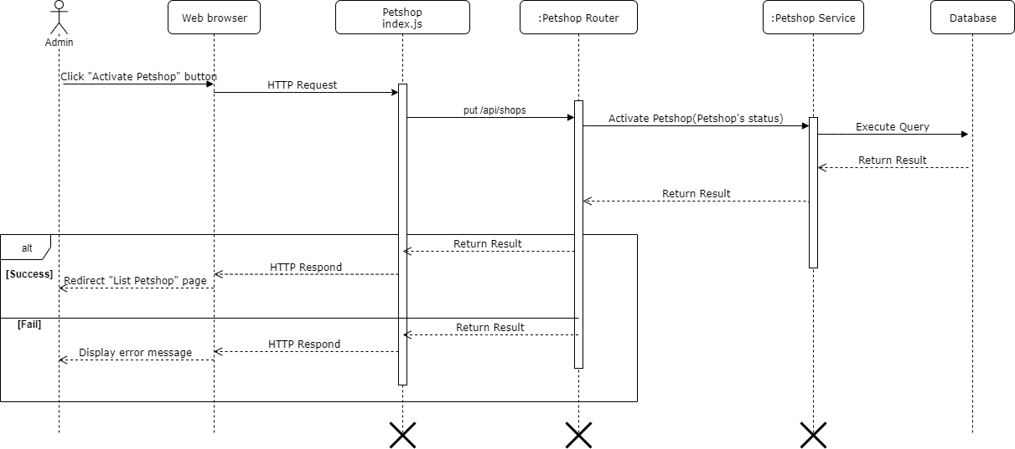

Figure 84 - <Sequence Diagram> Activate Pet Shop

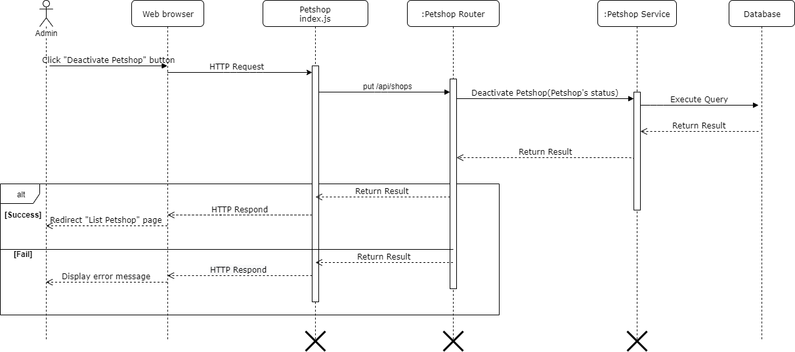

Figure 85-<Sequence Diagram> Deactivate Pet Shop

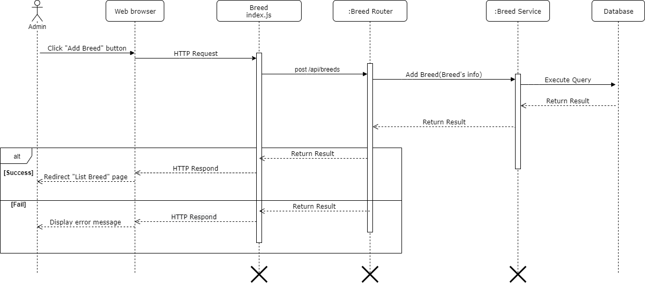

Figure 86-<Sequence Diagram> Add Breed

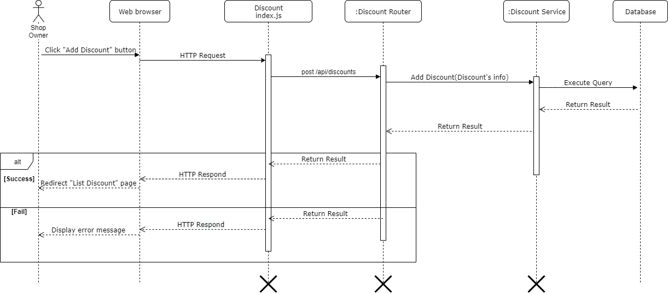

Figure 87-<Sequence Diagram> Add Discount

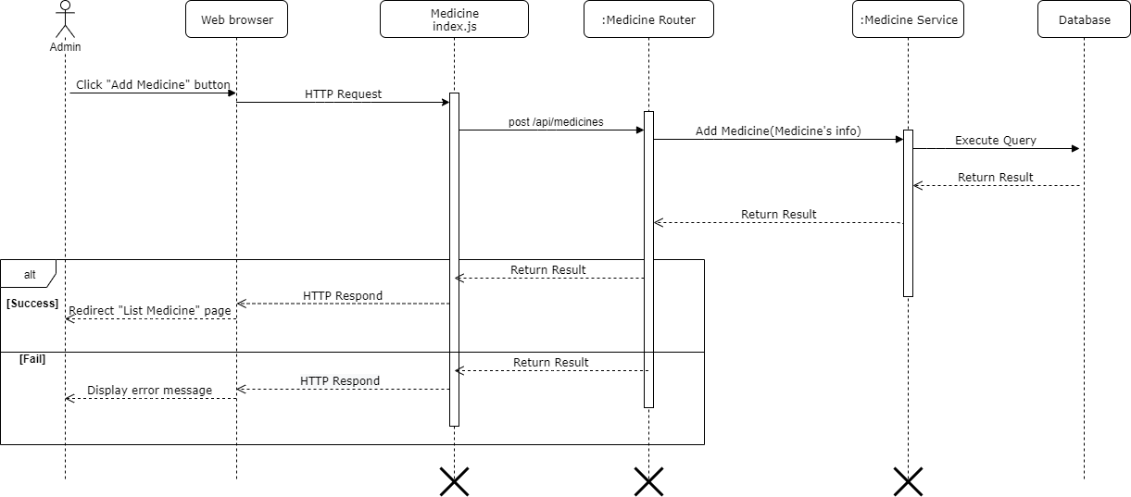

Figure 88-<Sequence Diagram> Add Medicine

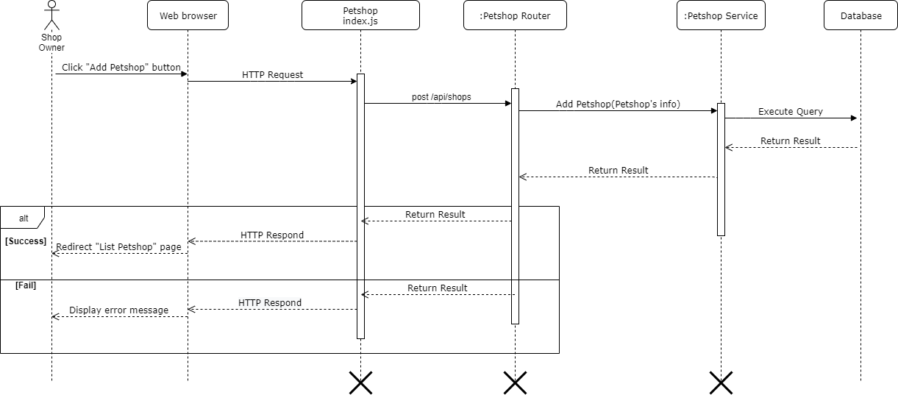

Figure 89-<Sequence Diagram> Add Pet Shop

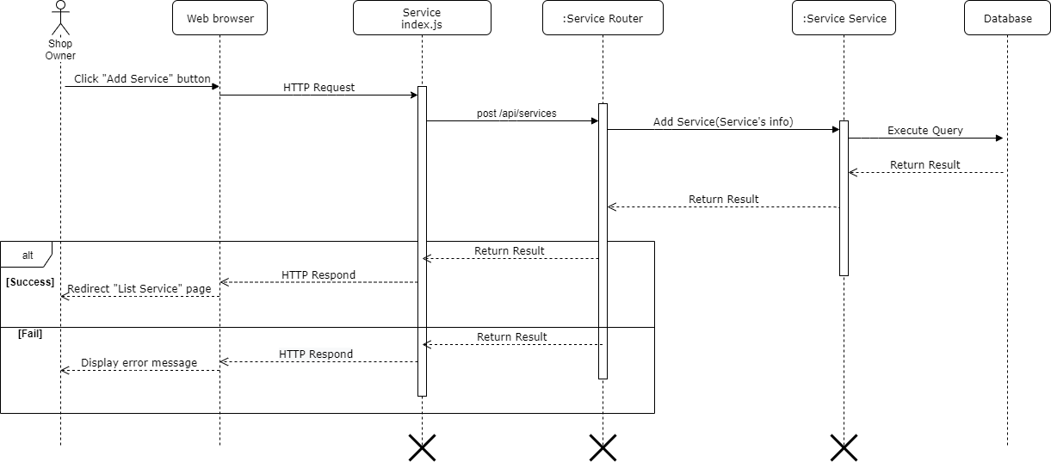

Figure 90-<Sequence Diagram> Add Service

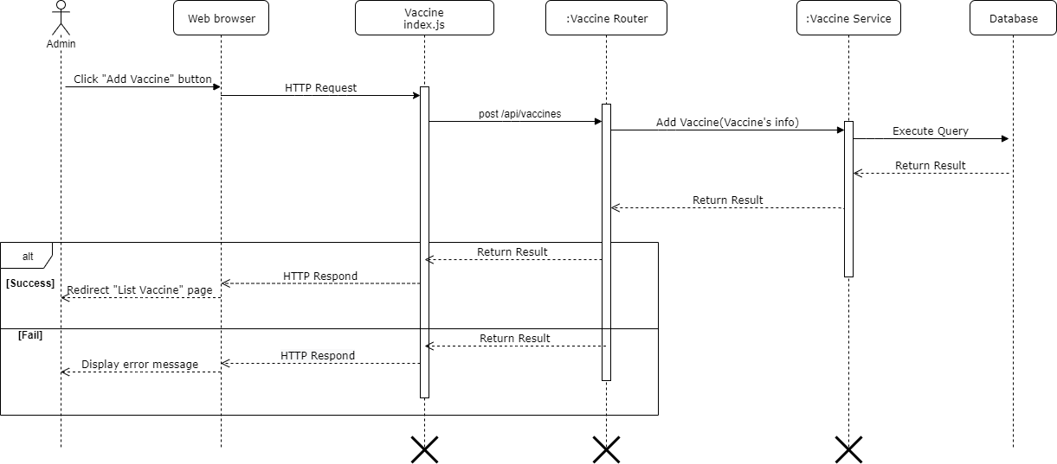

Figure 91-<Sequence Diagram> Add Vaccine

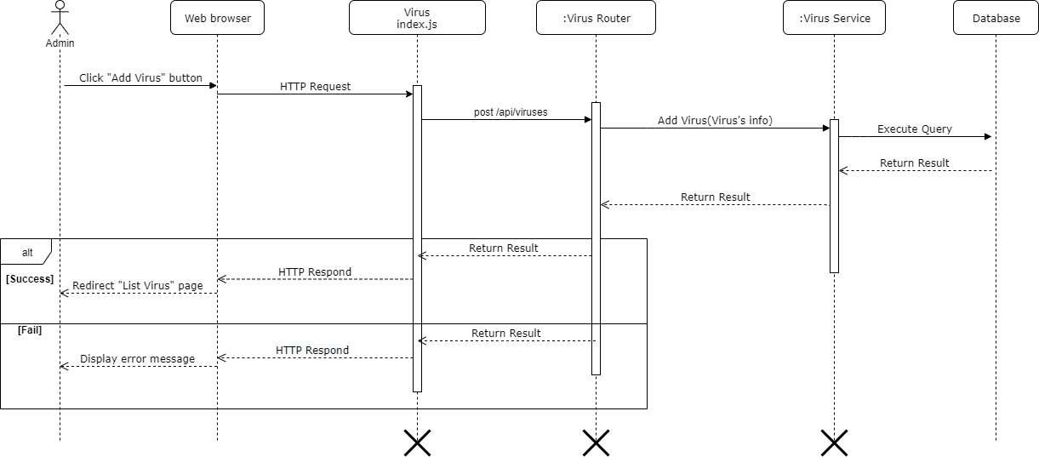

Figure 92-<Sequence Diagram> Add Virus

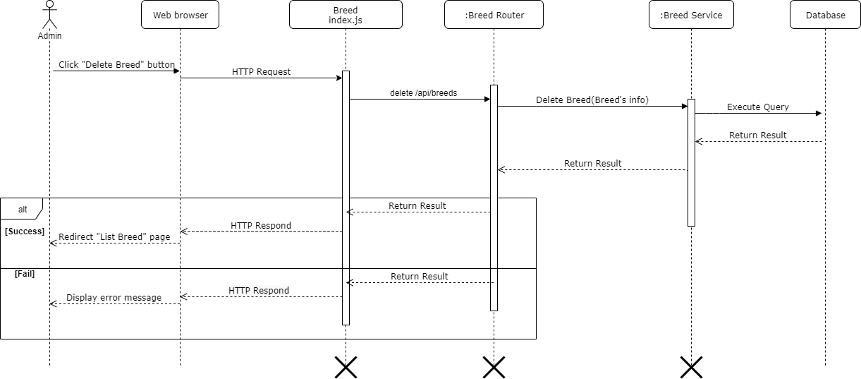

Figure 93-<Sequence Diagram> Delete Breed

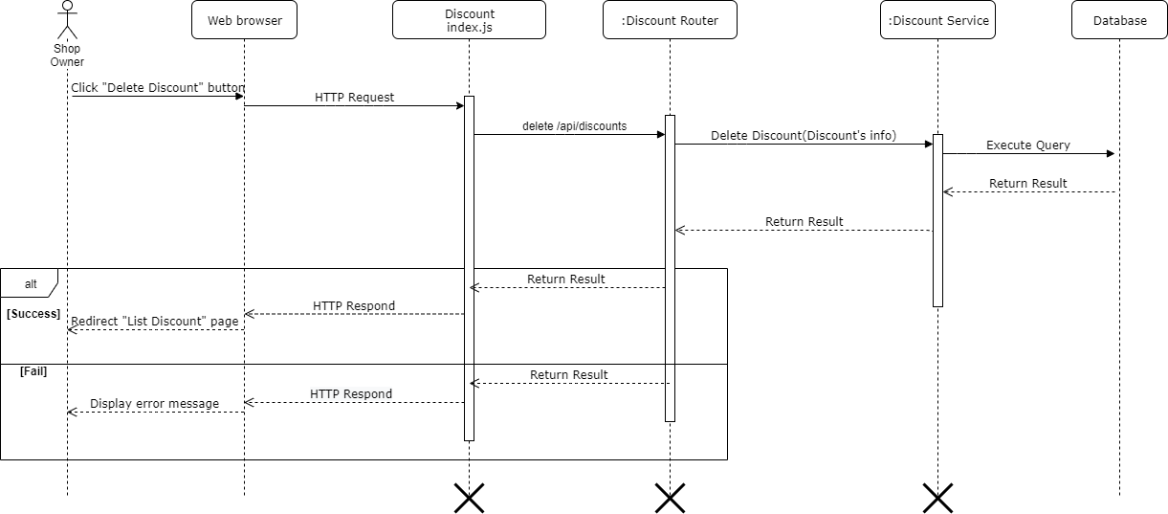

Figure 94-<Sequence Diagram> Delete Discount

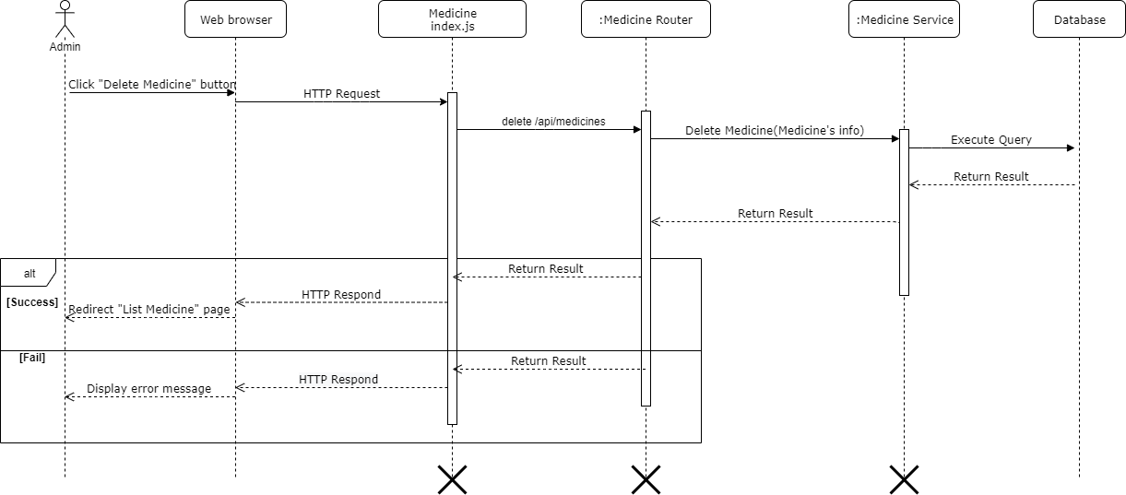

Figure 95-<Sequence Diagram> Delete Medicine

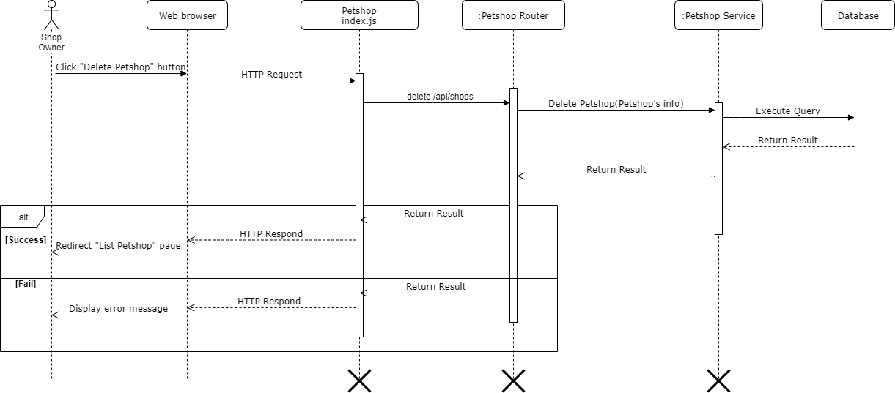

Figure 96-<Sequence Diagram> Delete Pet Shop

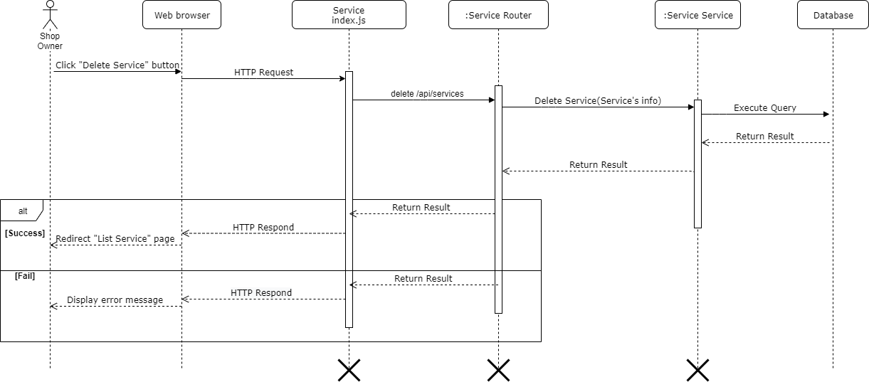

Figure 97-<Sequence Diagram> Delete Service

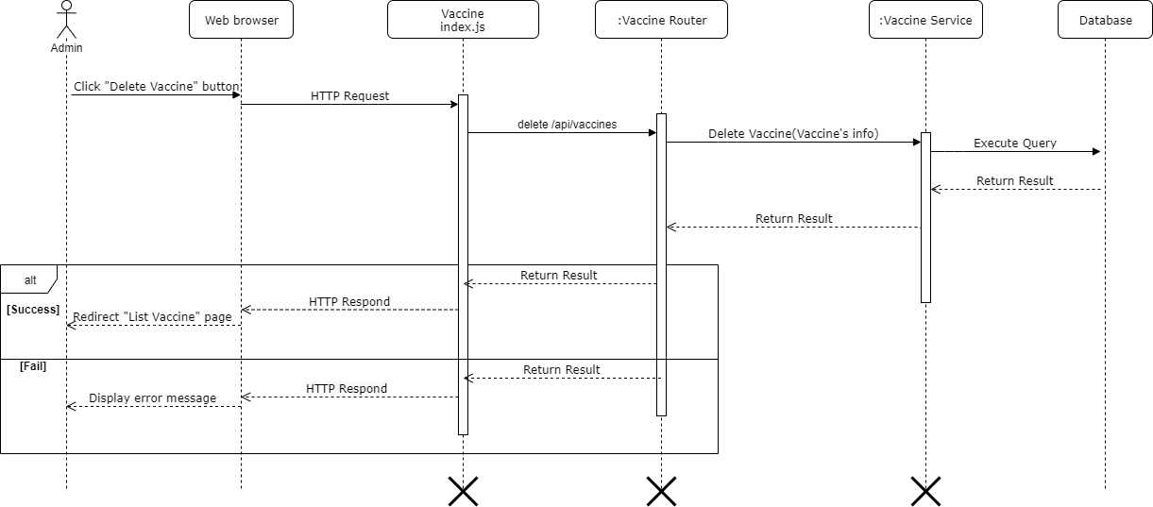

Figure 98-<Sequence Diagram> Delete Vaccine

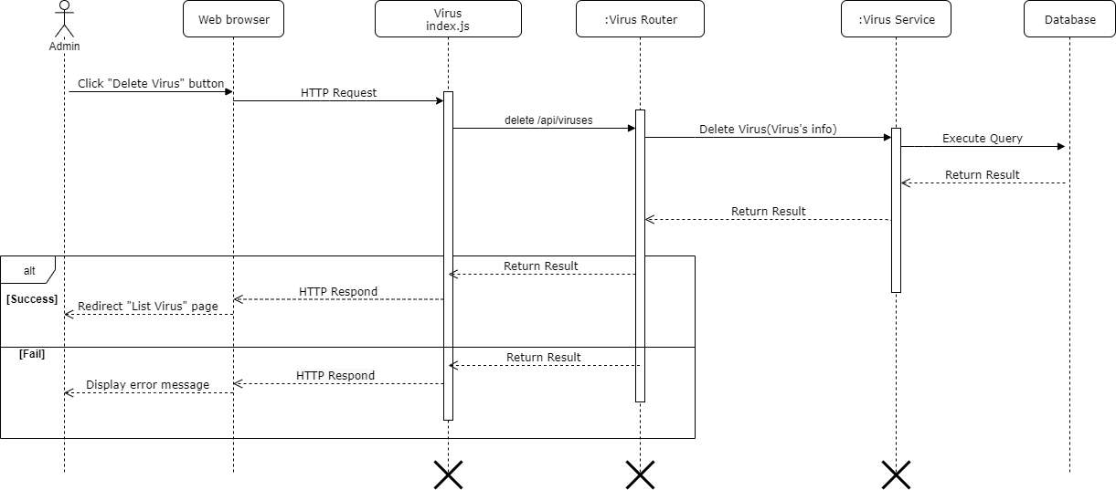

Figure 99-<Sequence Diagram> Delete Virus

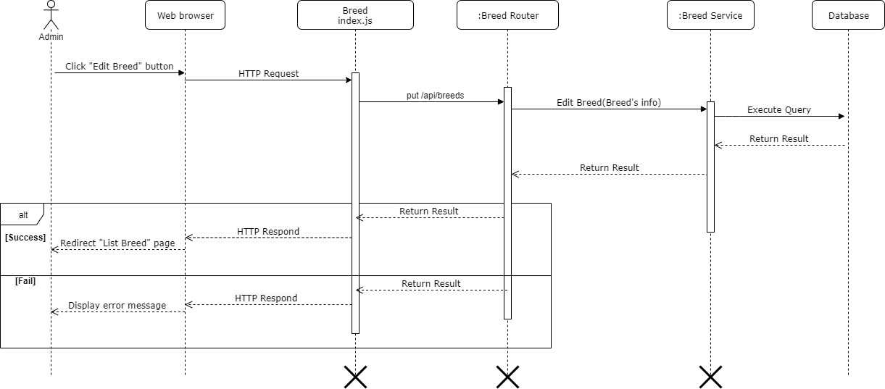

Figure 100-<Sequence Diagram> Edit Breed

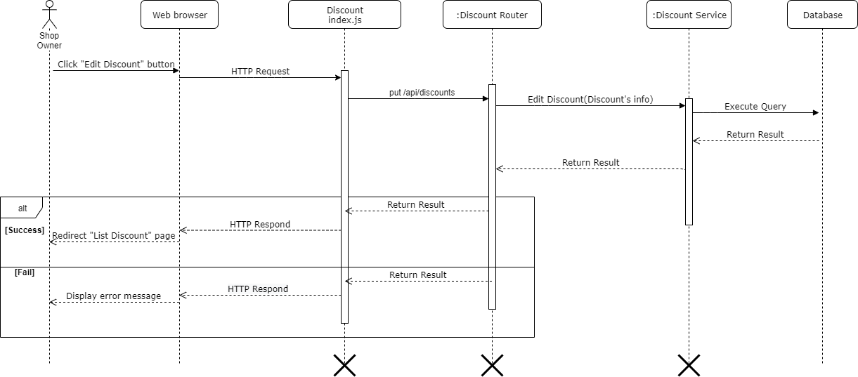

Figure 101-<Sequence Diagram> Edit Discount

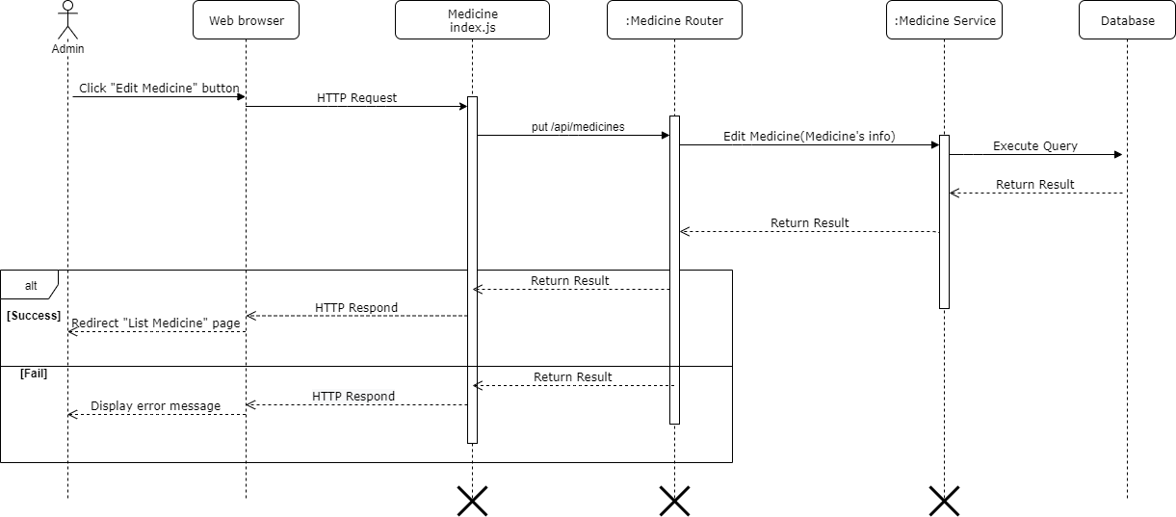

Figure 102-<Sequence Diagram> Edit Medicine

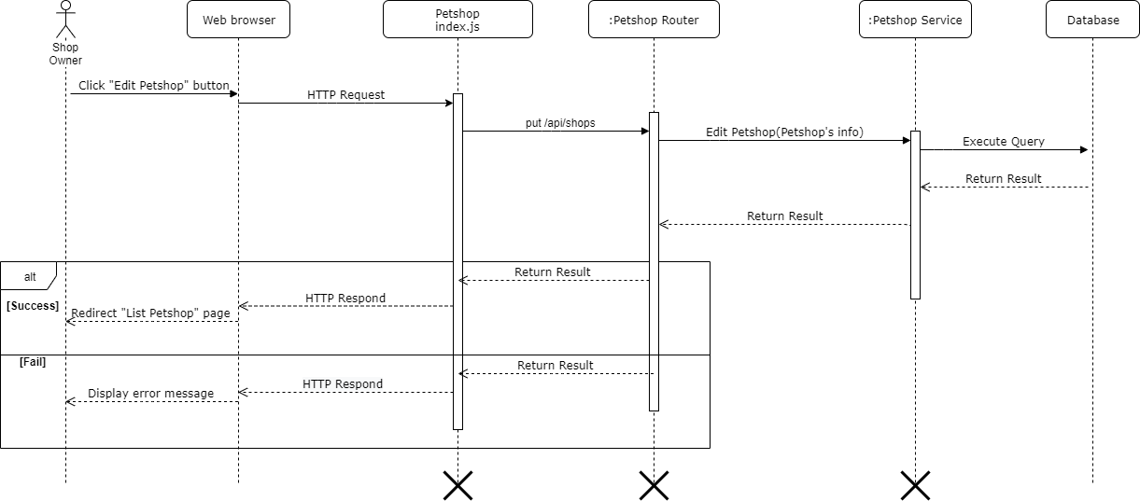

Figure 103-<Sequence Diagram> Edit Pet shop

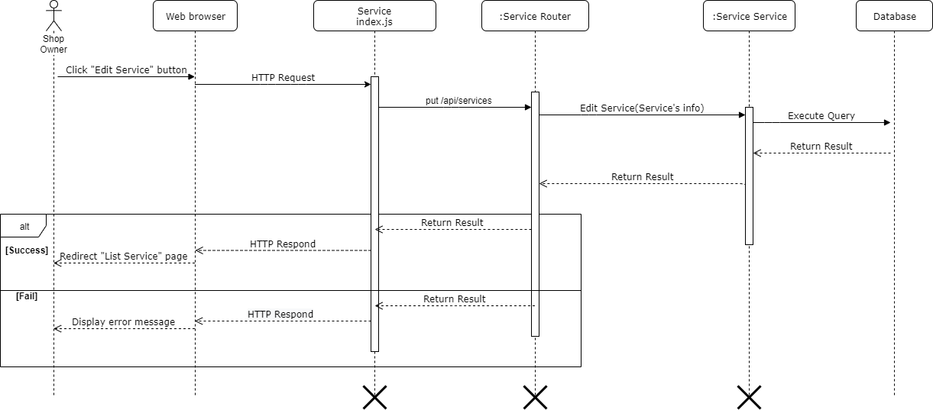

Figure 104-<Sequence Diagram> Edit Service

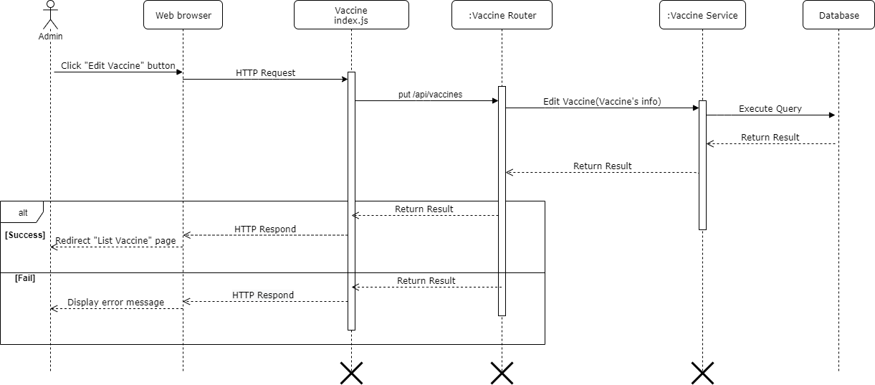

Figure 105-<Sequence Diagram> Edit Vaccine

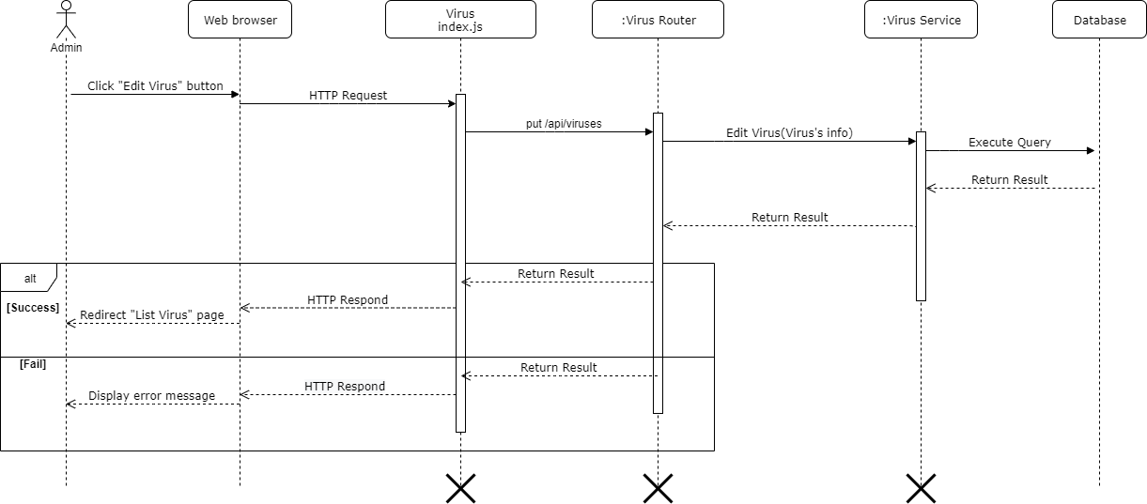

Figure 106 - <Sequence Diagram> Edit Virus

### Activity Diagram

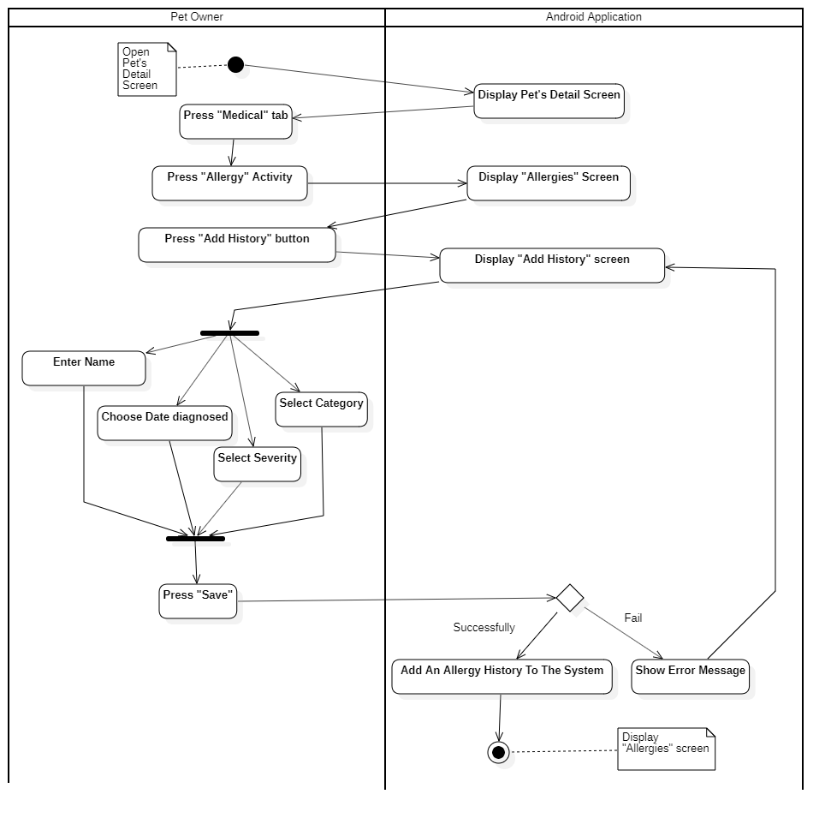

Figure 107- <Activity Diagram> Add Allergy History

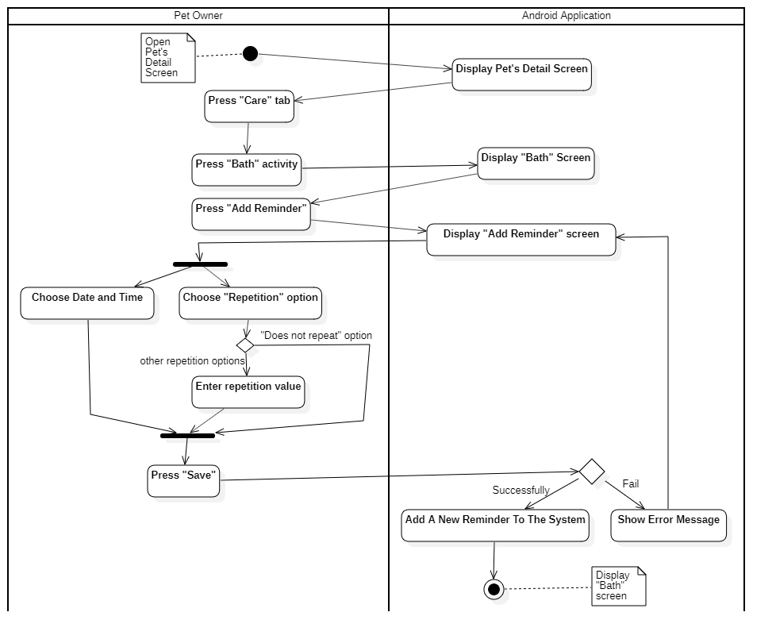

Figure 108- <Activity Diagram> Add Bath Reminder

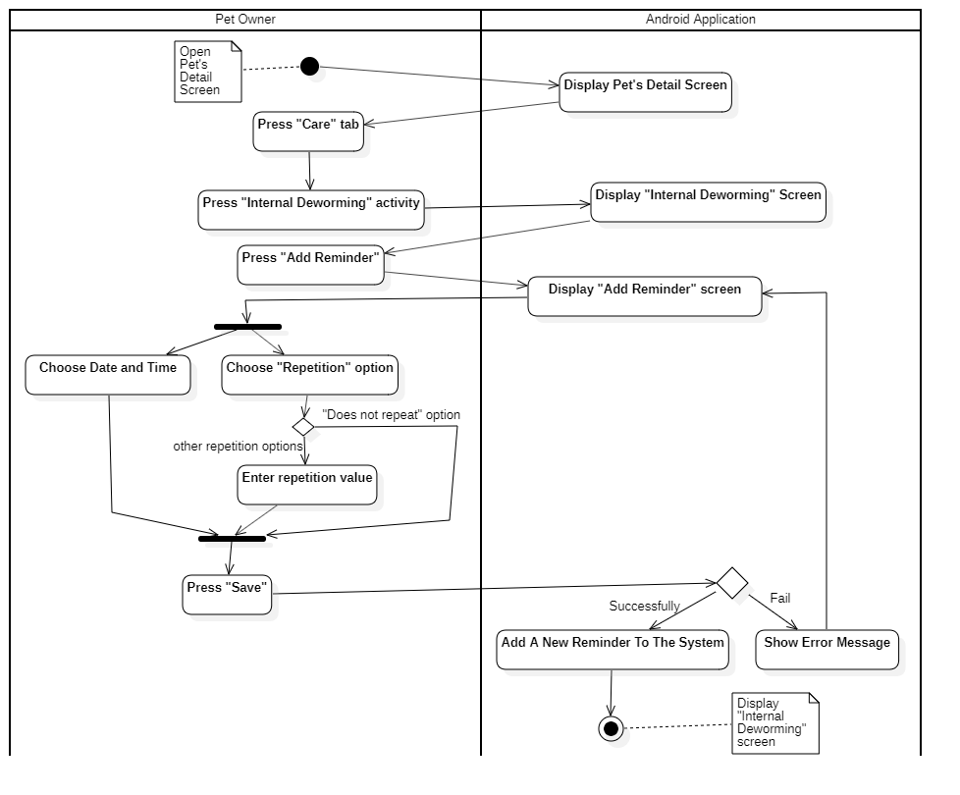

Figure 109- <Activity Diagram> Add Internal Deworming Reminder

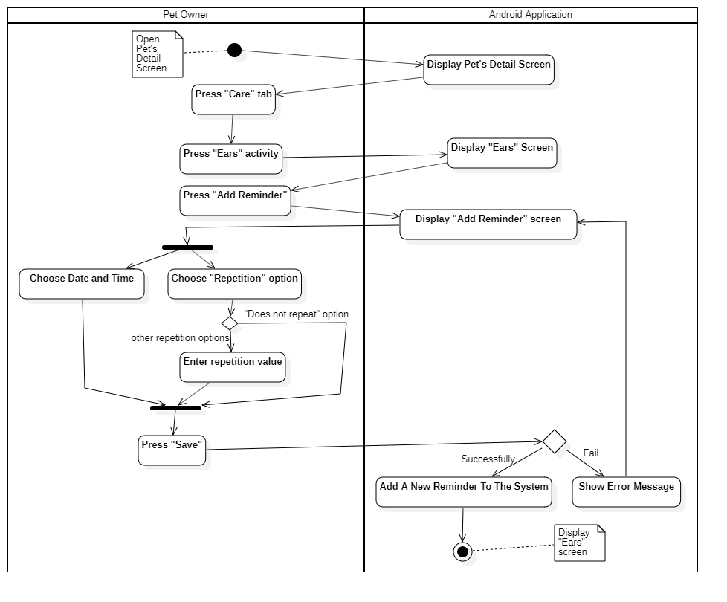

Figure 110- <Activity Diagram> Add Ears Reminder

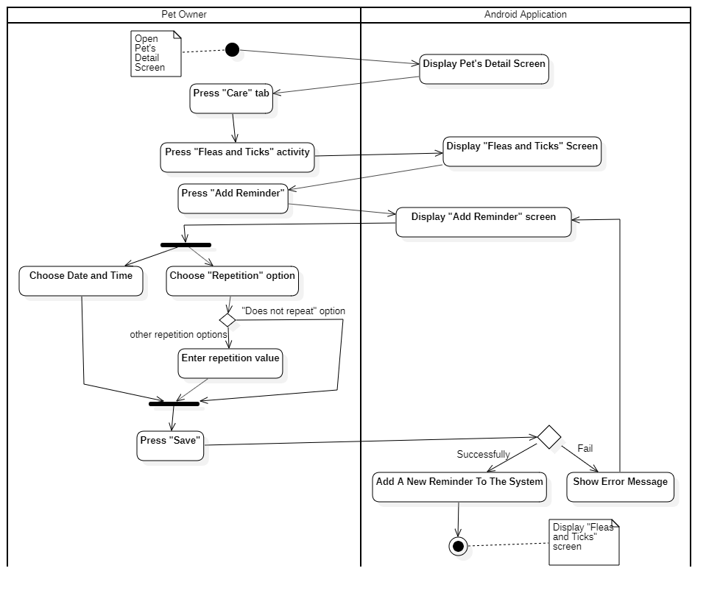

Figure 111- <Activity Diagram> Add Fleas and Ticks Reminder

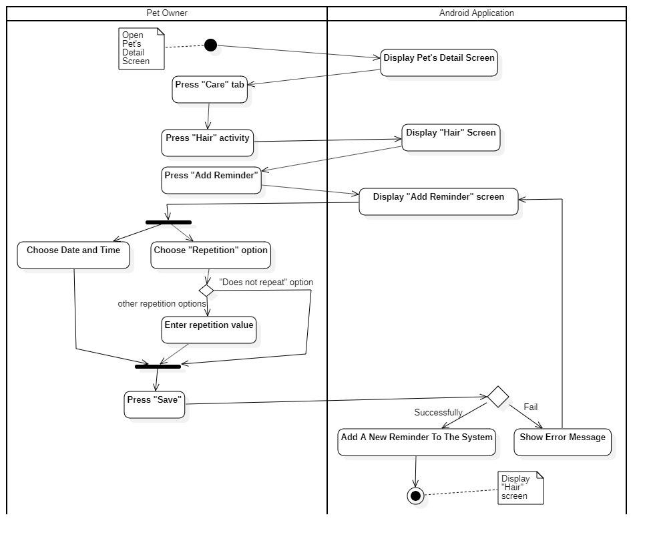

Figure 112- <Activity Diagram> Add Hair Reminder

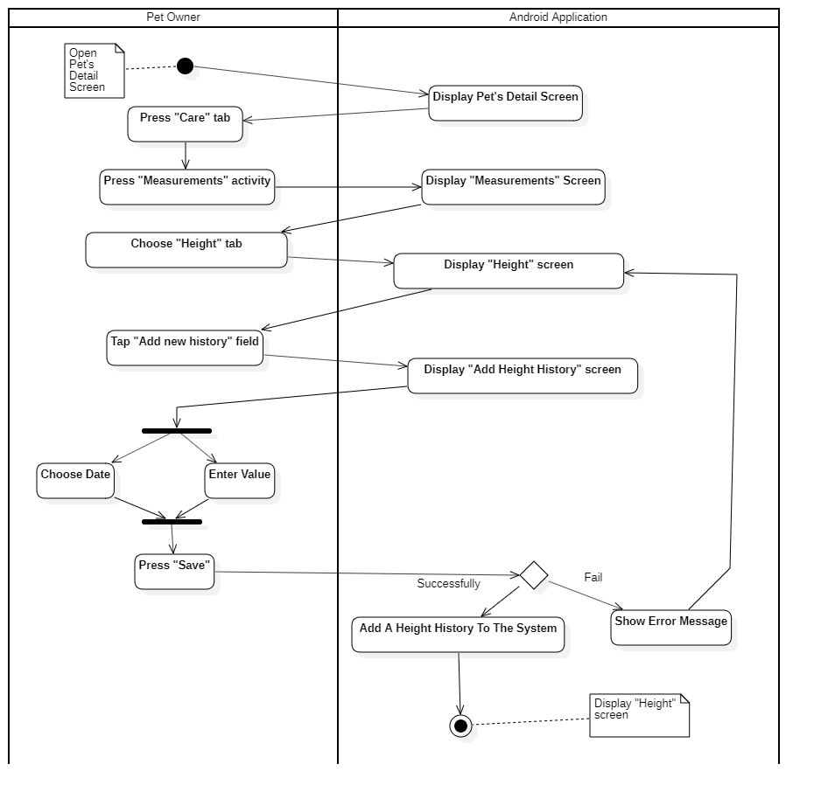

Figure 113- <Activity Diagram> Add Height Measurements History

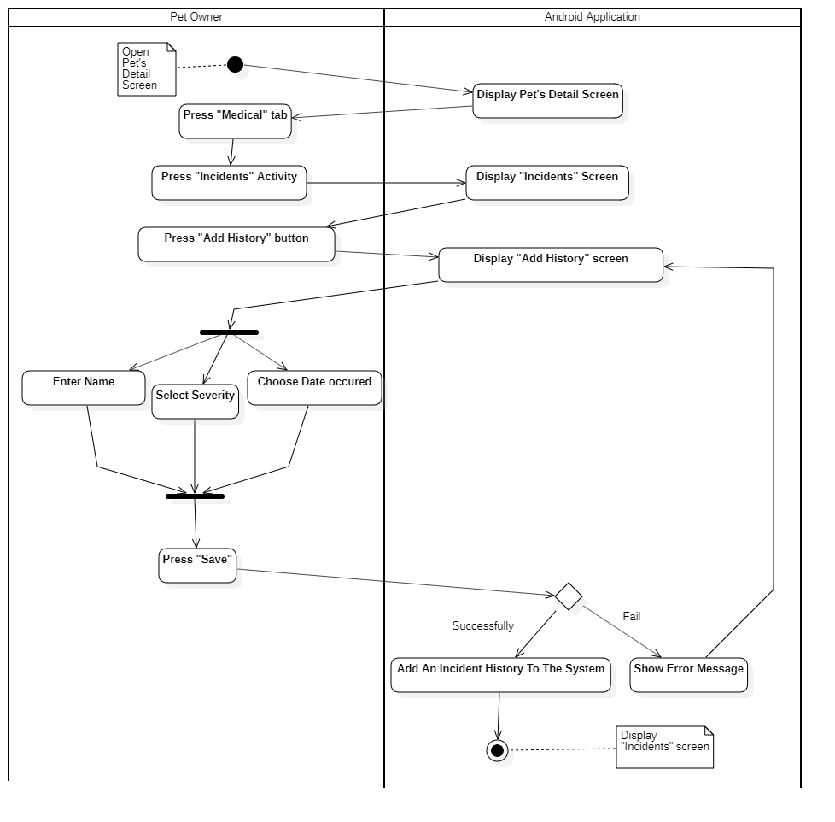

Figure 114- <Activity Diagram> Add Incident History

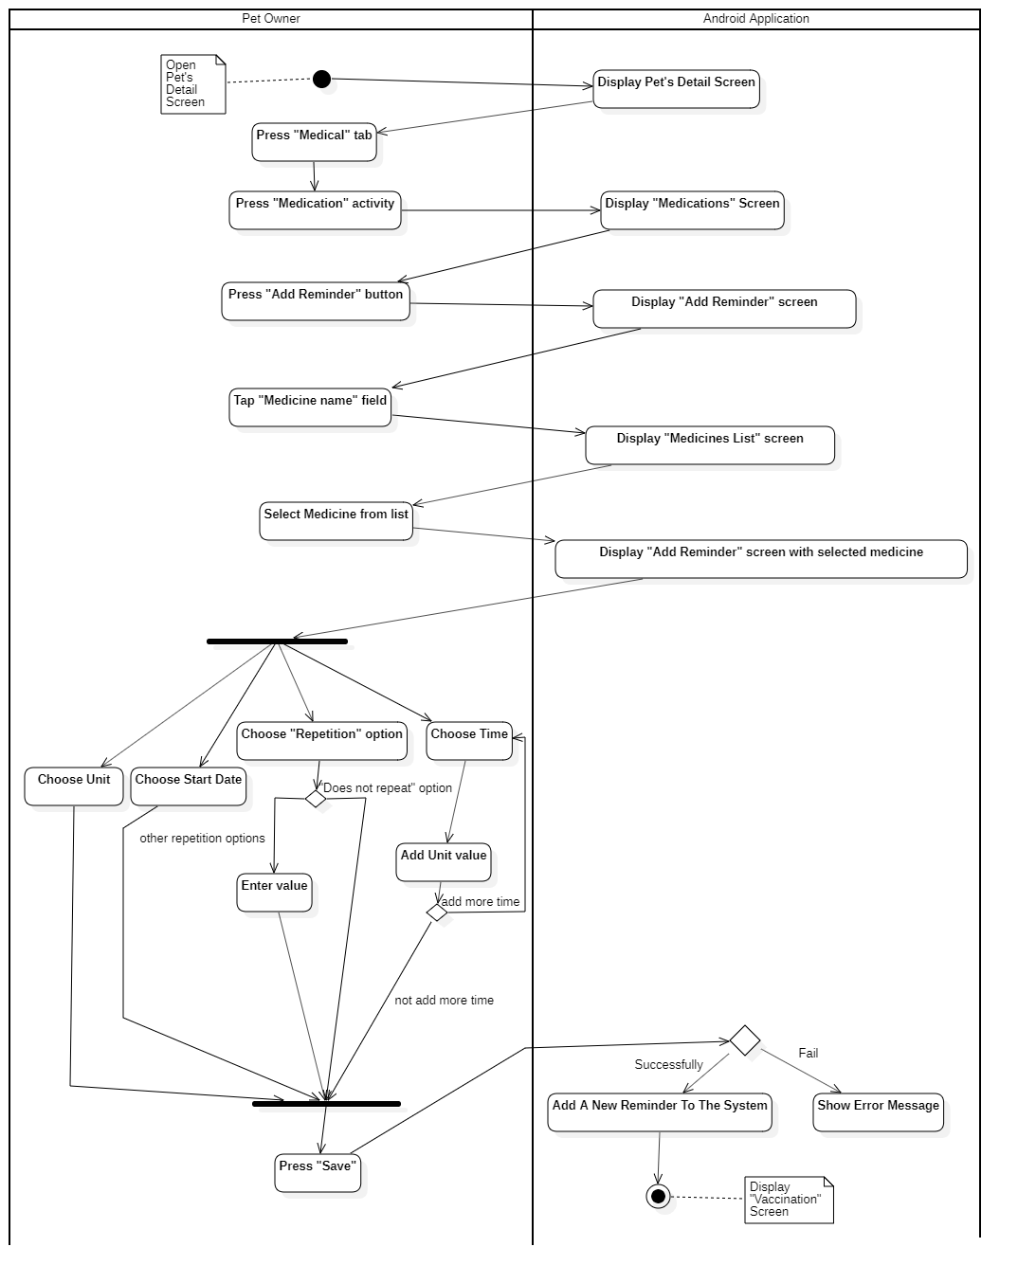

Figure 115- <Activity Diagram> Add Medication Reminder

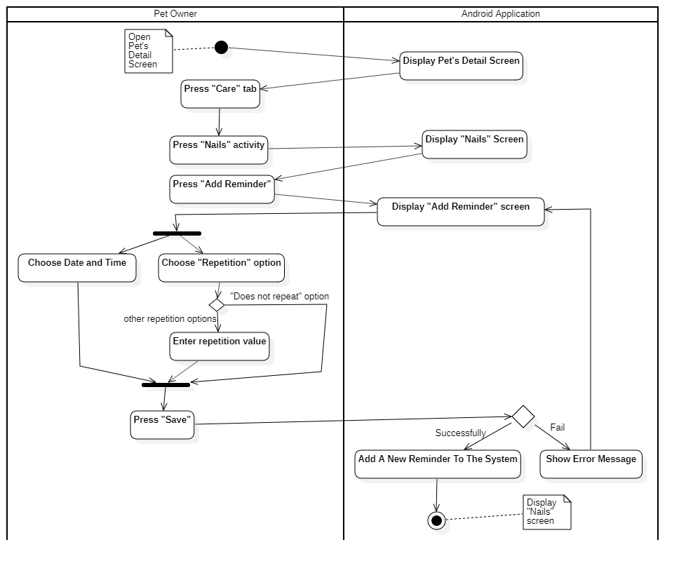

Figure 116- <Activity Diagram> Add Nails Reminder

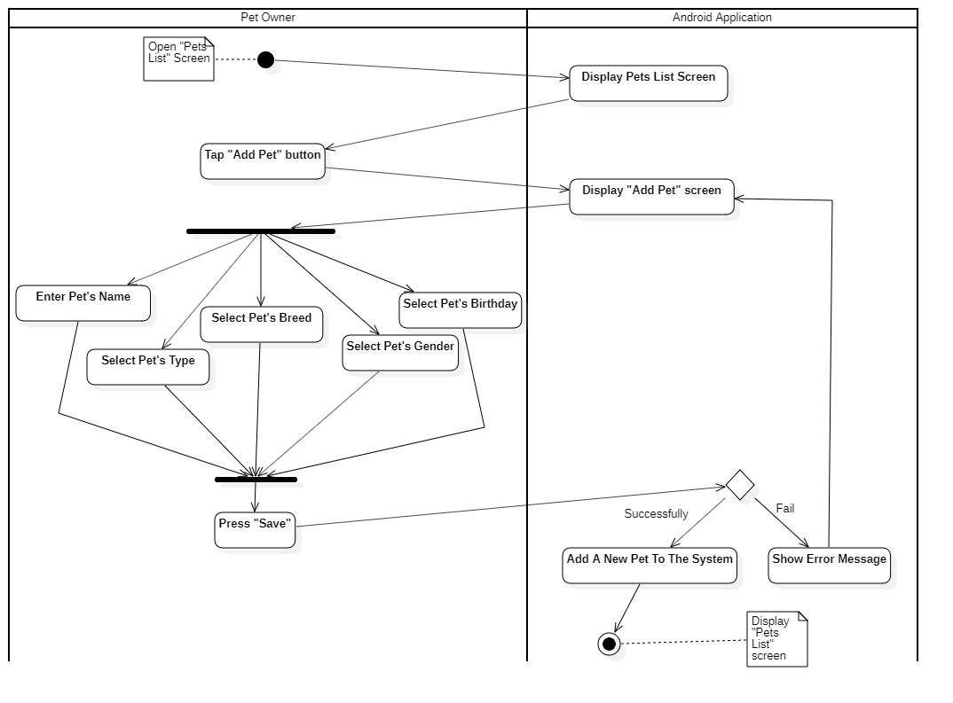

Figure 117- <Activity Diagram> Add Pet

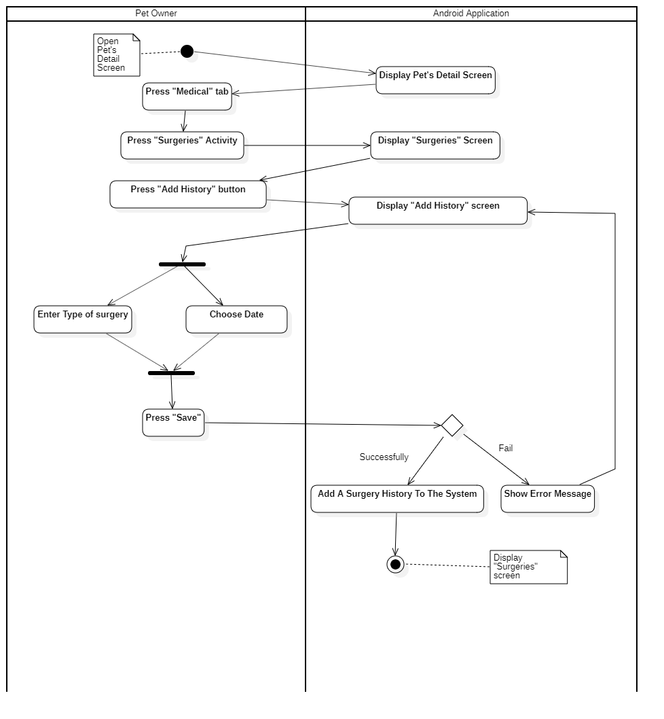

Figure 118- <Activity Diagram> Add Surgery History

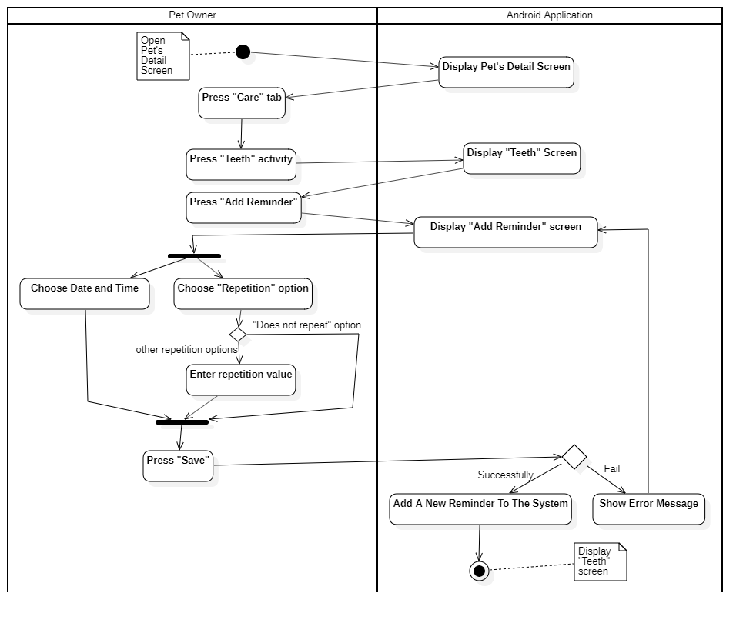

Figure 119- <Activity Diagram> Add Teeth Reminder

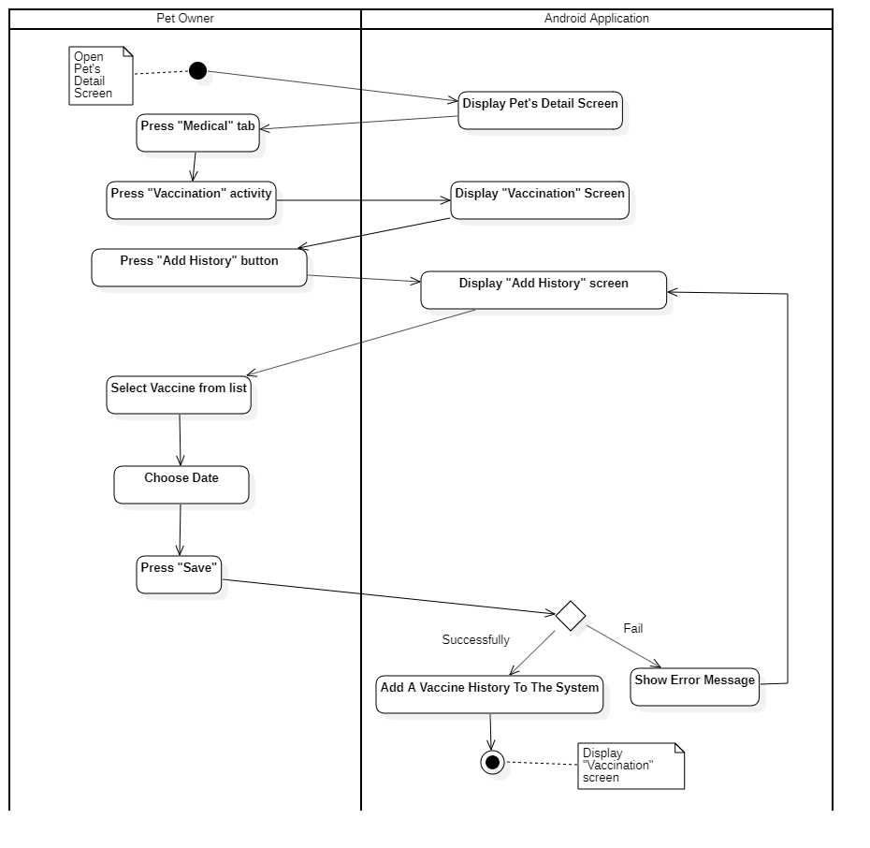

Figure 120- <Activity Diagram> Add Vaccination History

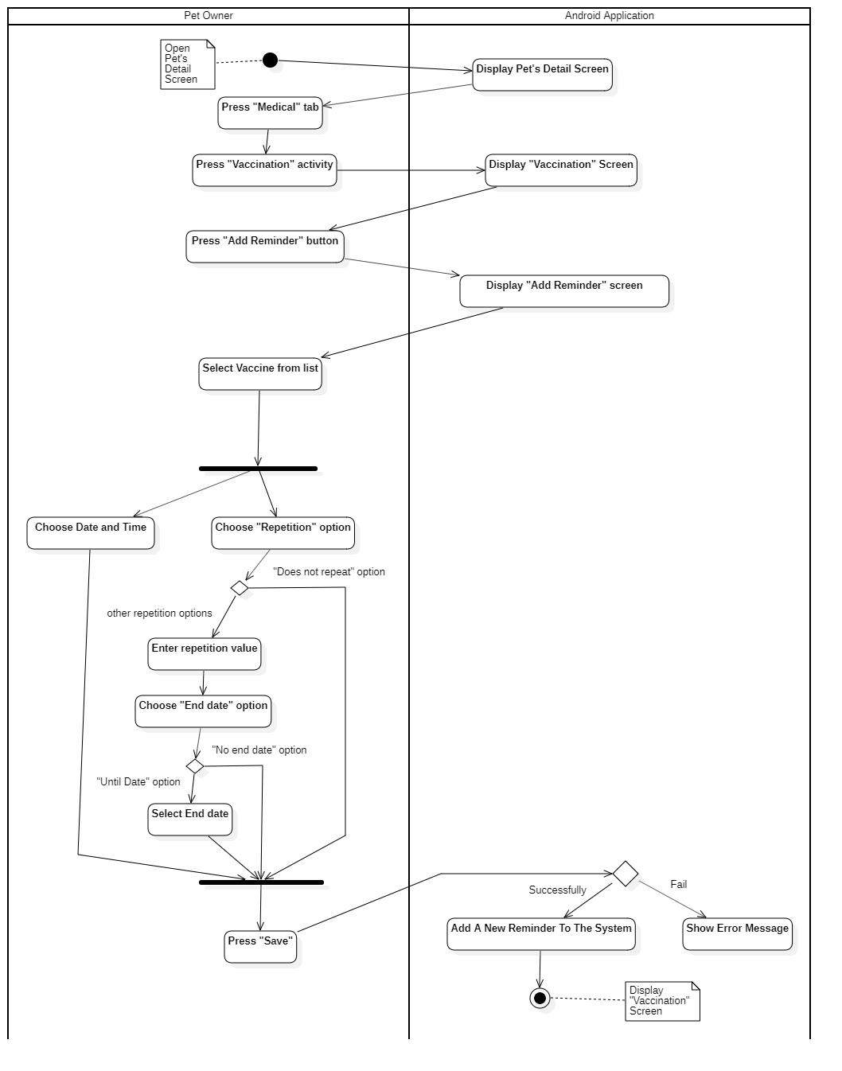

Figure 121- <Activity Diagram> Add Vaccination Reminder

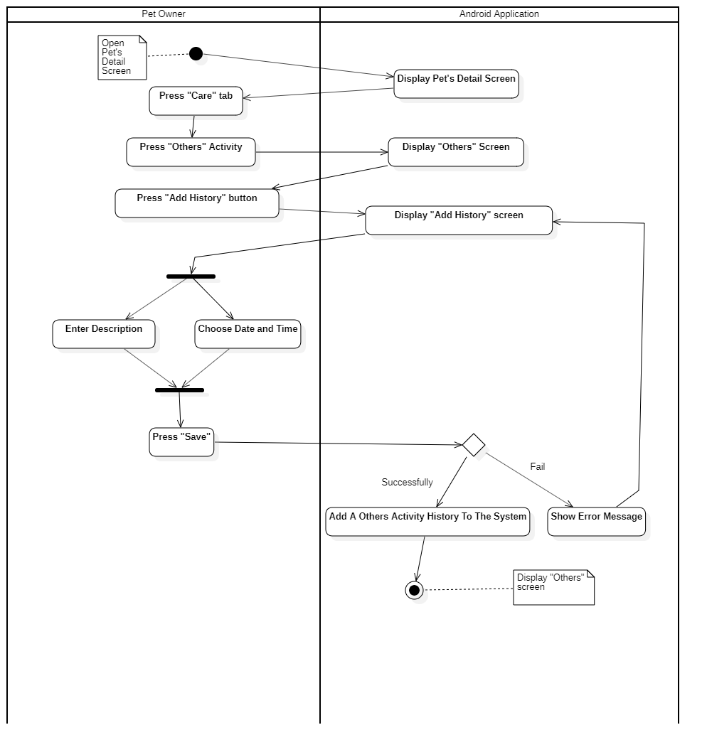

Figure 122- <Activity Diagram> Add Others Activity History

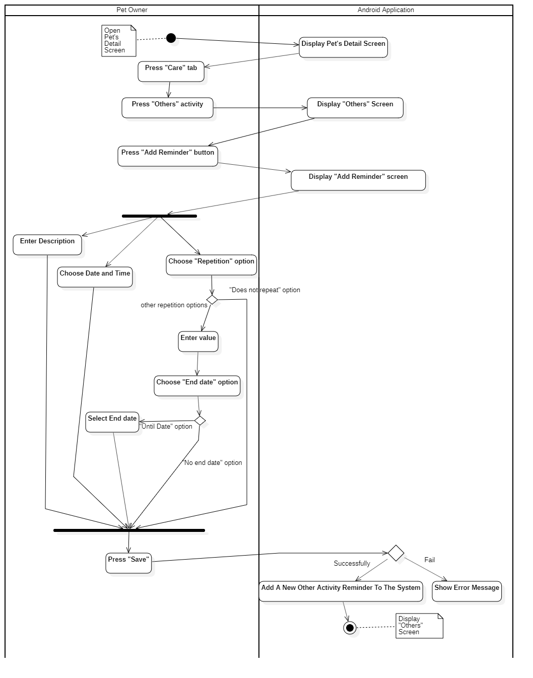

Figure 123- <Activity Diagram> Add Others Activity Reminder

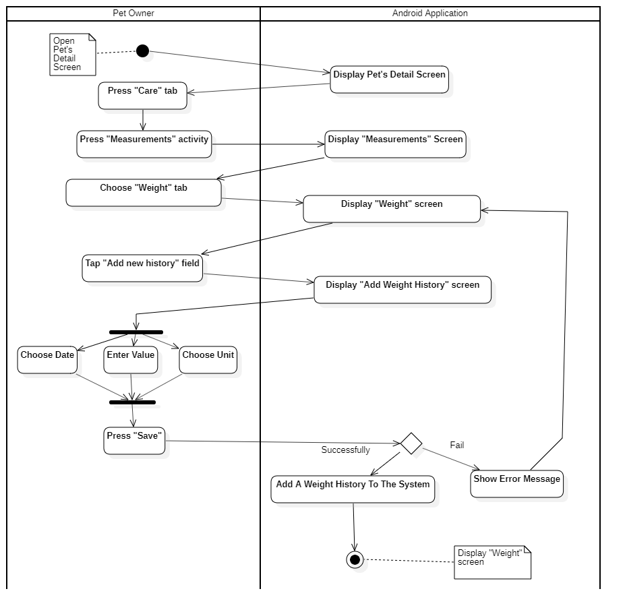

Figure 124- <Activity Diagram> Add Weight Measurement History

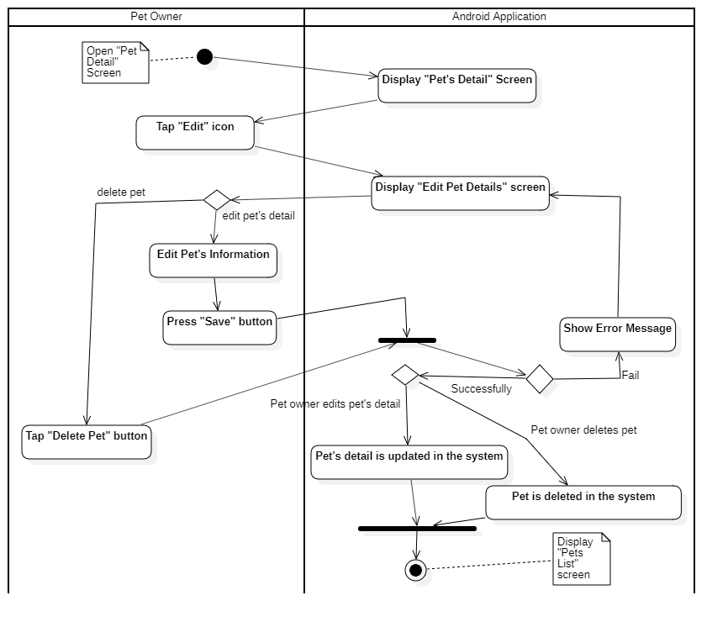

Figure 125- <Activity Diagram> Update/Delete Pet

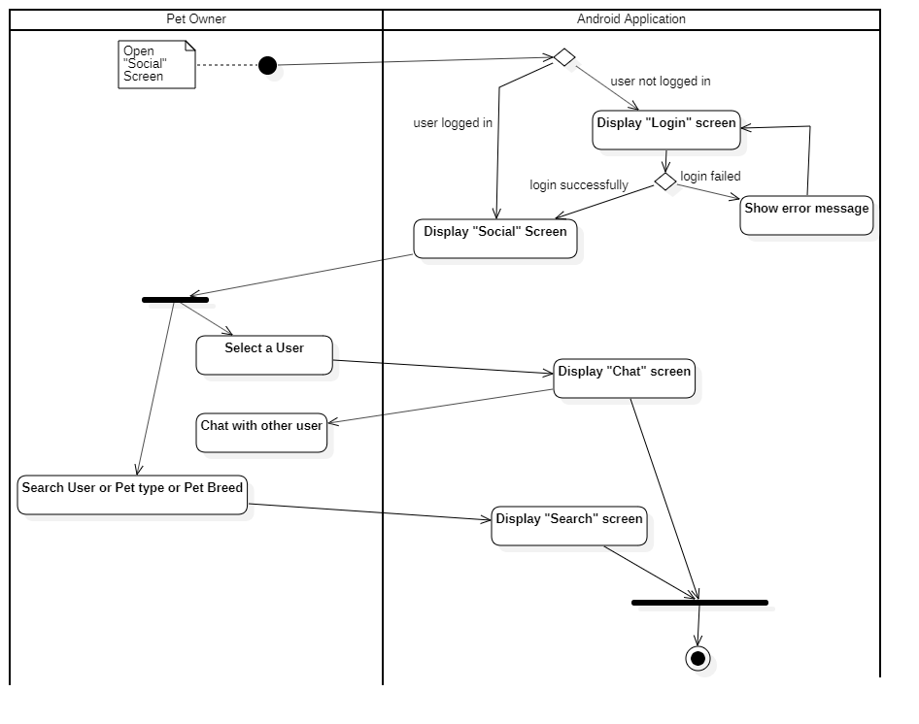

Figure 126- <Activity Diagram> Chat with other Pet owner

## User Interface Design

### Mobile Application

#### Pets List

Figure 127<UI Design> Pets List

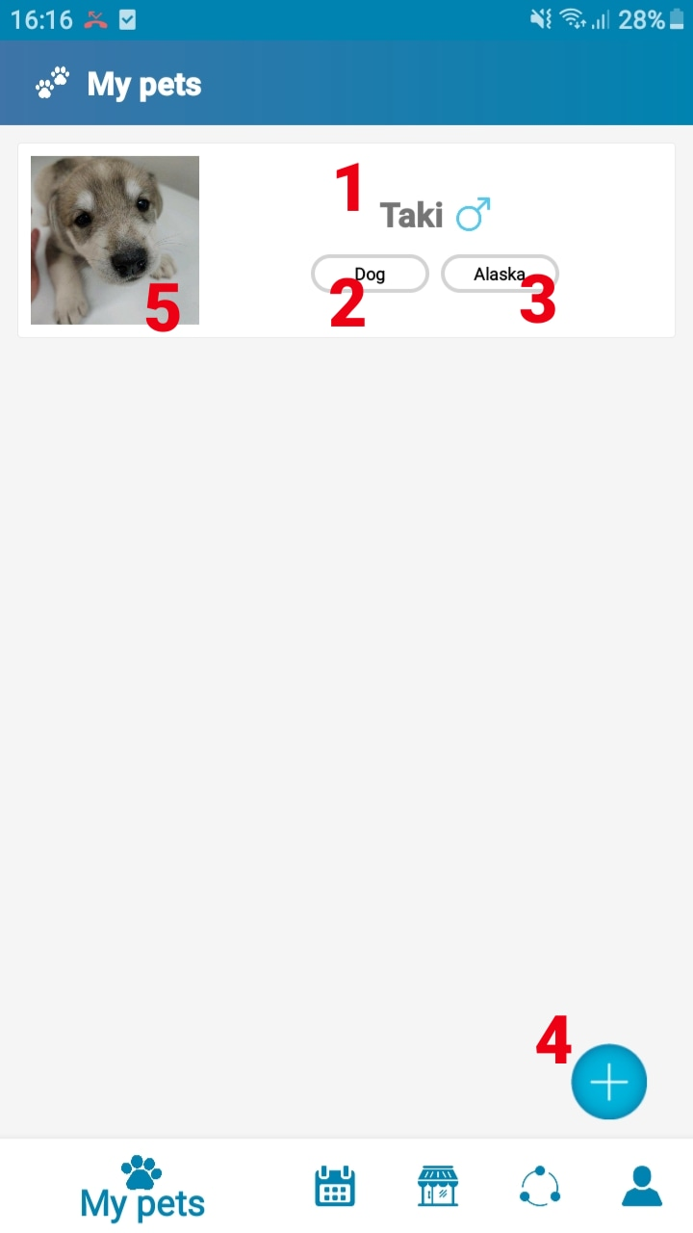

* **Field**

|  |  |  |  |  |  |  |
| --- | --- | --- | --- | --- | --- | --- |
| **No** | **Field Name** | **Description** | **Read-only** | **Mandatory** | **Control Type** | **Data Type** |
| 1 | Name | Show pet’s name | Yes | Yes | TextView | String |
| 2 | Pet type | Show type of pet | Yes | Yes | TextView | String |
| 3 | Breed | Show pet’s breed | Yes | Yes | TextView | String |

* **Button**

|  |  |  |  |  |
| --- | --- | --- | --- | --- |
| **No** | **Function** | **Description** | **Validation** | **Outcome** |
| 4 | Add New Pet | Add a new pet into system | N/A | Transfer to Add New Pet Screen |
| 5 | Pet | Pet’s detail and activity list | N/A | Transfer to Pet’s detail Screen |

Table 81- <UI Design>Pet List Button

#### Add New Pet

Figure 128- <UI Design> Add New Pet

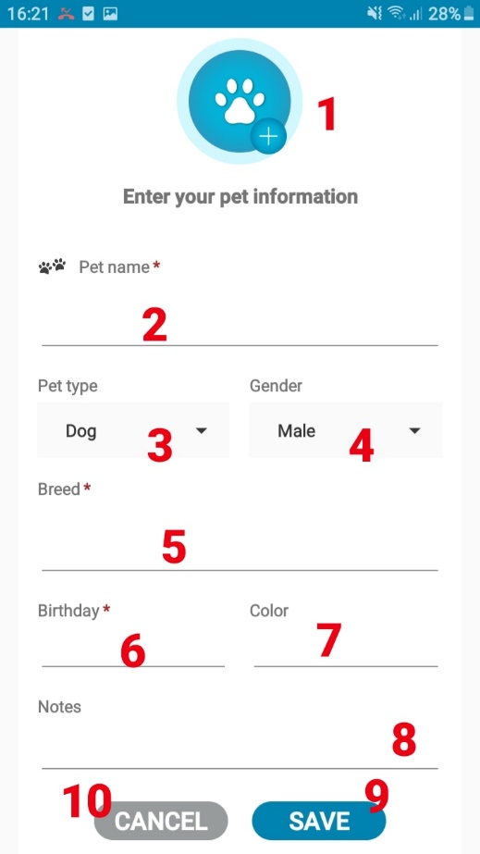

* **Fields**

|  |  |  |  |  |  |  |
| --- | --- | --- | --- | --- | --- | --- |
| **No** | **Field Name** | **Description** | **Read-only** | **Mandatory** | **Control Type** | **Data Type** |
| 1 | Image | Add image of pet | No | No | Spinner | Image |
| 2 | Pet name | Fill name of pet | No | Yes | Textview | String |
| 3 | Pet type | Fill pet’s type | Yes | Yes | Spinner | String |
| 4 | Gender | Fill pet’s gender | Yes | Yes | Spinner | String |
| 5 | Breed | Fill breed | No | Yes | Textview | String |
| 6 | Birthday | Fill pet’s birthday | Yes | Yes | Date | Date |
| 7 | Color | Fill pet’s Color | No | No | Textview | String |
| 8 | Notes | Fill pet’s note | No | No | Textview | String |

Table 82- <UI Design> Add New Pet Fields

* **Button**

|  |  |  |  |  |
| --- | --- | --- | --- | --- |
| **No** | **Function** | **Description** | **Validation** | **Outcome** |
| 9 | Save | Add New Pet into system | N/A | Message from system |
| 10 | Cancel | Exit Add New Pet screen | N/A | Transfer to Pet List |

Table 83- <UI Design>Add New Pet Buttons

#### Pet’s Detail and Activities List

Figure 129- <UI Design>Pet’s Detail and Activities List

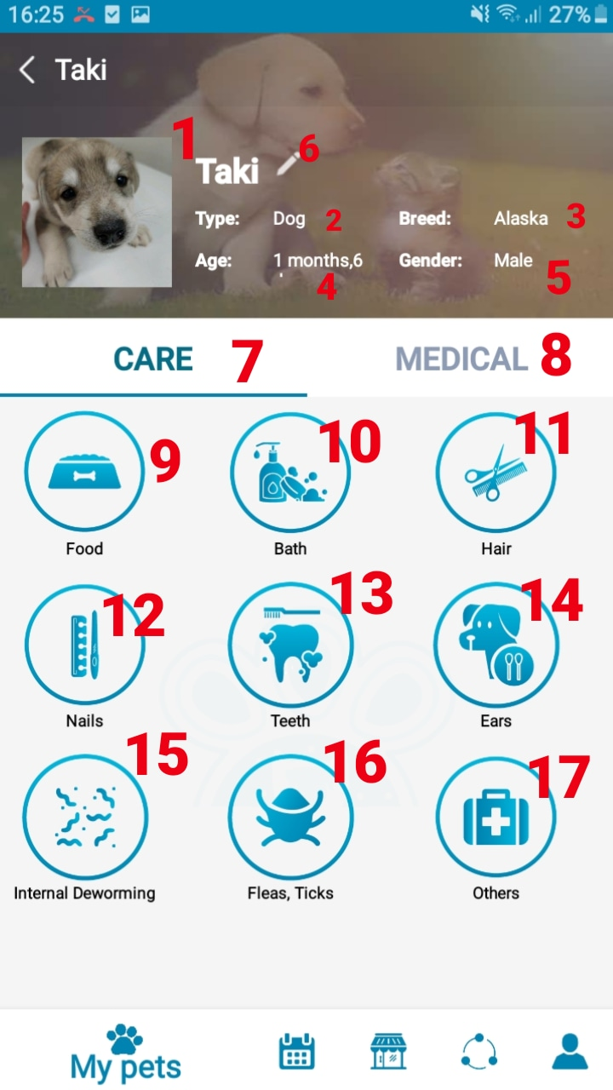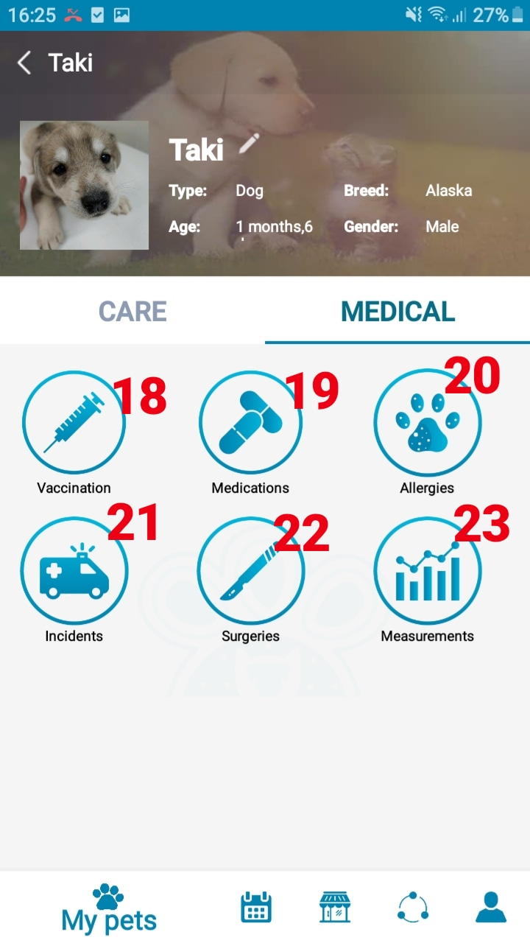

* **Fields**

|  |  |  |  |  |  |  |
| --- | --- | --- | --- | --- | --- | --- |
| **No** | **Field Name** | **Description** | **Read-only** | **Mandatory** | **Control Type** | **Data Type** |
| 1 | Pet name | Show Name of pet | Yes | Yes | TextView | String |
| 2 | Pet type | Show Type of pet | Yes | Yes | TextView | String |
| 3 | Breed | Show Pet’s breed | Yes | Yes | TextView | String |
| 4 | Age | Show Pet’s age | Yes | Yes | TextView | String |
| 5 | Gender | Show Pet’s gender | Yes | Yes | TextView | String |

Table 84- <UI Design> Pet’s Detail Fields

* **Button**

|  |  |  |  |  |
| --- | --- | --- | --- | --- |
| **No** | **Function** | **Description** | **Validation** | **Outcome** |
| 6 | Edit | Edit Pet’s Information | N/A | Transfer to Edit Pet’s Information Screen |
| 7 | Care | Group of activity in Care | N/A | Display activities in group Care |
| 8 | Medical | Group of activity in Medical | N/A | Display activities in group Medical |
| 9 | Food | Food activity | N/A | Transfer to Food screen |
| 10 | Bath | Bath activity | N/A | Transfer to Bath screen |
| 11 | Hair | Hair activity | N/A | Transfer to Hair screen |
| 12 | Nails | Nails activity | N/A | Transfer to Nails screen |
| 13 | Teeth | Teeth activity | N/A | Transfer to Teeth screen |
| 14 | Ears | Ears activity | N/A | Transfer to Ears screen |
| 15 | Internal Deworming | Internal Deworming activity | N/A | Transfer to Internal Deworming screen |
| 16 | Fleas, Ticks | Fleas, Ticks activity | N/A | Transfer to Fleas, Ticks screen |
| 17 | Others | Other types of activity | N/A | Transfer to Others screen |
| 18 | Vaccination | Vaccination activity | N/A | Transfer to Vaccination screen |
| 19 | Medication | Medication activity | N/A | Transfer to Medication screen |
| 20 | Allergies | Allergies activity | N/A | Transfer to Allergies screen |
| 21 | Incidents | Incidents activity | N/A | Transfer to Incidents screen |
| 22 | Surgeries | Surgeries activity | N/A | Transfer to Surgeries screen |
| 23 | Measurements | Measurements activity | N/A | Transfer to Measurements screen |

Table 85- <UI Design> Pet’s Detail Button

#### Edit Pet’s Information

Figure 130- <UI Design>Edit Pet’s Information

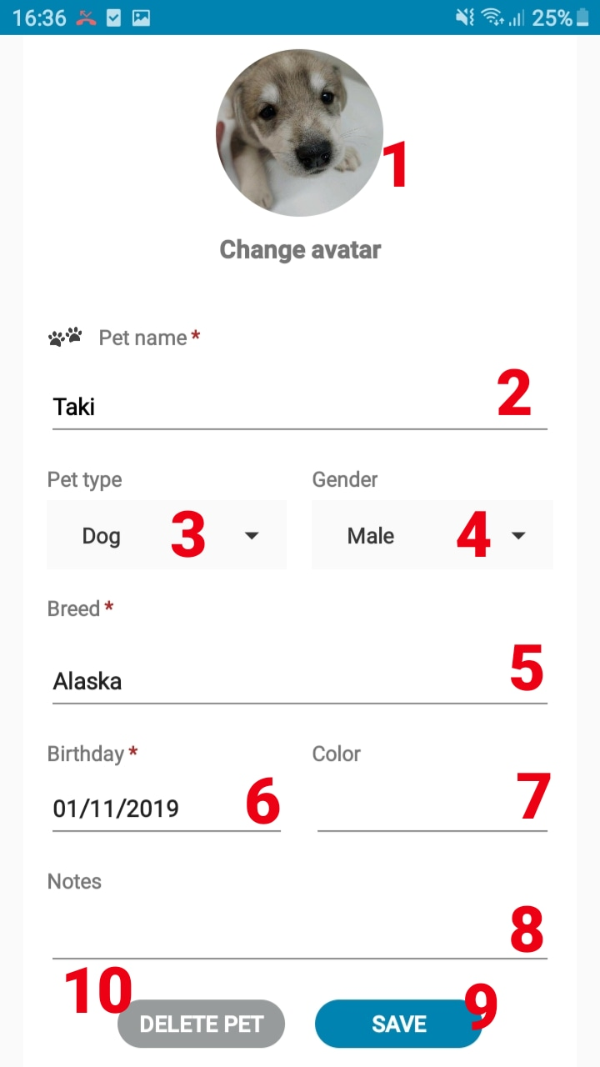

* **Fields**

|  |  |  |  |  |  |  |
| --- | --- | --- | --- | --- | --- | --- |
| **No** | **Field Name** | **Description** | **Read-only** | **Mandatory** | **Control Type** | **Data Type** |
| 1 | Image | Add image of pet | No | No |  | Image |
| 2 | Pet name | Fill name of pet | No | Yes | Textview | String |
| 3 | Pet type | Fill pet’s type | Yes | Yes | Spinner | String |
| 4 | Gender | Fill pet’s gender | Yes | Yes | Spinner | String |
| 5 | Breed | Fill breed | Yes | Yes | Textview | String |
| 6 | Birthday | Fill pet’s birthday | Yes | Yes | Date | String |
| 7 | Color | Fill pet’s Color | No | No | Textview | String |
| 8 | Notes | Fill pet’s note | No | No | Textview | String |

Table 86- <UI Design> Edit Pet’s Information Fields

* **Button**

|  |  |  |  |  |
| --- | --- | --- | --- | --- |
| **No** | **Function** | **Description** | **Validation** | **Outcome** |
| 9 | Save | Edit new info of pet | N/A | Transfer to Pet’s Detail screen |
| 10 | Delete Pet | Delete pet | N/A | Pet information is deleted |

Table 87- <UI Design> Edit Pet’s Information Button

#### Vaccination

Figure 131- <UI Design>Vaccination

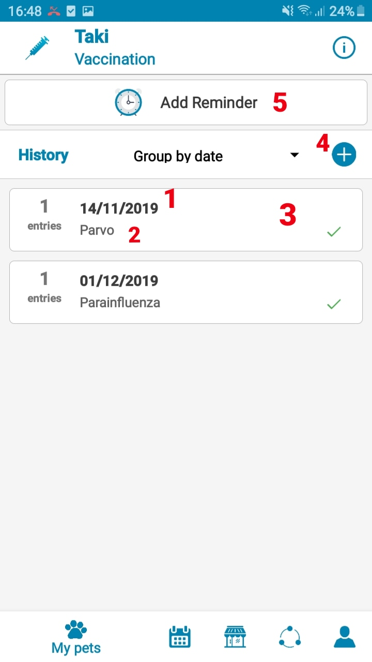

* **Fields**

|  |  |  |  |  |  |  |
| --- | --- | --- | --- | --- | --- | --- |
| **No** | **Field Name** | **Description** | **Read-only** | **Mandatory** | **Control Type** | **Data Type** |
| 1 | Date | The day vaccine was taken | Yes | Yes | TextView | String |
| 2 | Vaccine name | Vaccine that was taken | Yes | Yes | TextView | String |

Table 88- <UI Design> Vaccination Fields

* **Button**

|  |  |  |  |  |
| --- | --- | --- | --- | --- |
| **No** | **Function** | **Description** | **Validation** | **Outcome** |
| 3 | Edit | Edit the infor of vaccine history | N/A | Transfer to Vaccine history edit screen |
| 4 | Add new vaccine history | Add new vaccine history | N/A | Transfer to Add new vaccine history screen |
| 5 | Vaccine Reminders | Go to Vaccine reminder screen |  | Transfer to Vaccine reminder screen |

Table 89- <UI Design>Vaccination Buttons

#### Add Vaccination History

Figure 132- <UI Design> Add New Vaccine History

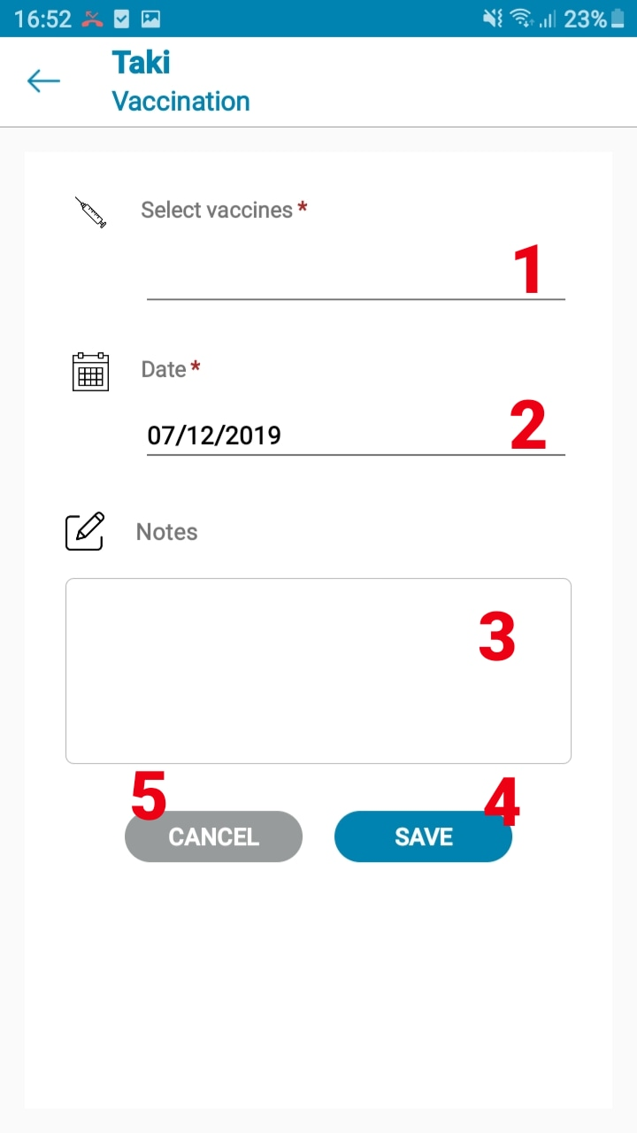

* **Fields**

|  |  |  |  |  |  |  |
| --- | --- | --- | --- | --- | --- | --- |
| **No** | **Field Name** | **Description** | **Read-only** | **Mandatory** | **Control Type** | **Data Type** |
| 1 | Select vaccines | Choose or add new vaccine to list | No | Yes | TextView | String |
| 2 | Date | Fill date taken the vaccine | Yes | Yes | Date | Date |
| 3 | Notes | Fill additional notes | No | No | TextView | String |

Table 90- <UI Design> Add New Vaccine History Fields

* **Button**

|  |  |  |  |  |
| --- | --- | --- | --- | --- |
| **No** | **Function** | **Description** | **Validation** | **Outcome** |
| 4 | Save | Save new vaccine history to the system | N/A | Transfer to Vaccine history screen |
| 5 | Cancel | Exit add new vaccine history screen | N/A | Transfer to Vaccine history screen |

Table 91- <UI Design> Add New Vaccine History Buttons

#### Add Vaccination Reminder

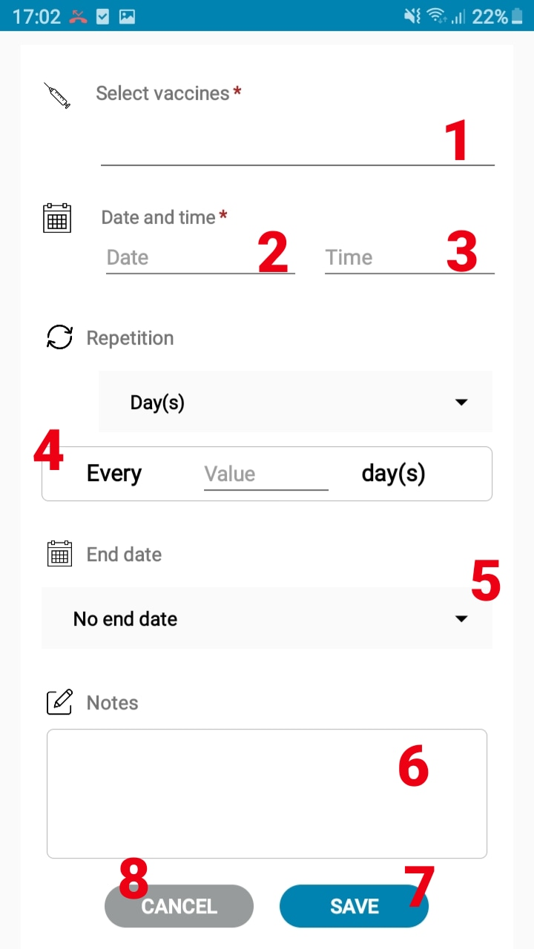

Figure 133- <UI Design> Add New Vaccine Reminder

* **Fields**

|  |  |  |  |  |  |  |
| --- | --- | --- | --- | --- | --- | --- |
| **No** | **Field Name** | **Description** | **Read-only** | **Mandatory** | **Control Type** | **Data Type** |
| 1 | Select vaccines | Select vaccines form the list | No | Yes | TextView | String |
| 2 | Date | Fill date the vaccine will be taken | Yes | Yes | Date | Date |
| 3 | Time | Fill time the vaccine will be taken | Yes | Yes | Time | Time |
| 4 | Repetition | Fill frequency of repetition | Yes | Yes | TextView | String |
| 5 | End date | Fill day stop taking vaccines | Yes | No | TextView | String |
| 6 | Notes | Fill additional notes | No | No | TextView | String |

Table 92- <UI Design> Add New Vaccine Reminder Fields

* **Button**

|  |  |  |  |  |
| --- | --- | --- | --- | --- |
| **No** | **Function** | **Description** | **Validation** | **Outcome** |
| 7 | Save | Add new vaccine reminder to the system | N/A | Message from system |
| 8 | Cancel | Exit add new vaccine reminder screen |  | Transfer to Vaccine reminder screen |

Table 93- <UI Design> Add New Vaccine Reminder Button

#### Food

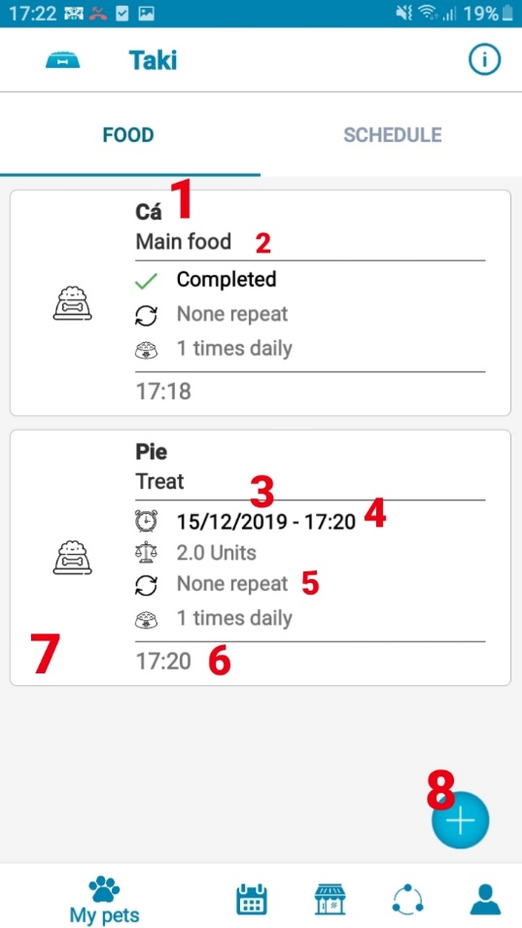

Figure 134- <UI Design> Food

* **Fields**

|  |  |  |  |  |  |  |
| --- | --- | --- | --- | --- | --- | --- |
| **No** | **Field Name** | **Description** | **Read-only** | **Mandatory** | **Control Type** | **Data Type** |
| 1 | Food name | Show name of food | No | Yes | TextView | String |
| 2 | Food type | Show the type of food | Yes | Yes | TextView | String |
| 3 | Date | Show the date of the schedule | Yes | Yes | Date | Date |
| 4 | Time | Show the time of the schedule | Yes | Yes | Time | Time |
| 5 | Frequency | Show the frequency of the schedule | Yes | Yes | TextView | String |
| 6 | Reminder Time | Show the time that was set for the schedule | Yes | Yes | Time | Time |

Table 94- <UI Design> Food Fields

* **Button**

|  |  |  |  |  |
| --- | --- | --- | --- | --- |
| **No** | **Function** | **Description** | **Validation** | **Outcome** |
| 7 | Edit | Edit the information of food reminder | N/A | Transfer to food reminder edit screen |
| 8 | Add new food reminder | Add a new food reminder to the system | N/A | Transfer to add new food reminder screen |

Table 95- <UI Design>Food Button

#### Food Schedule

**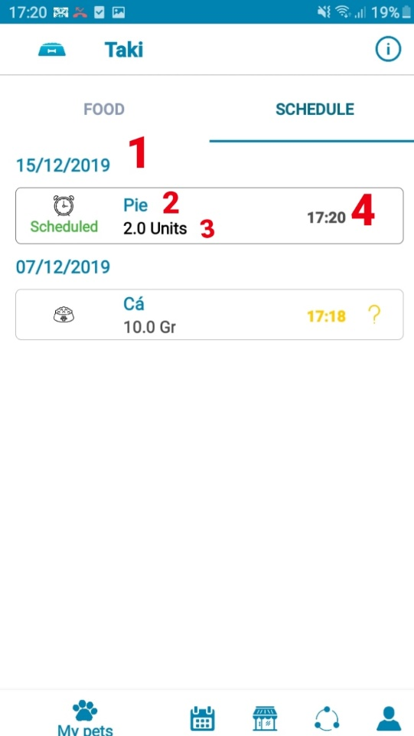**

Figure 135-<UI Design> Food Schedule

* **Fields**

|  |  |  |  |  |  |  |
| --- | --- | --- | --- | --- | --- | --- |
| **No** | **Field Name** | **Description** | **Read-only** | **Mandatory** | **Control Type** | **Data Type** |
| 1 | Date | Show the scheduled date | Yes | Yes | Date | Date |
| 2 | Food name | Show the name of food | Yes | Yes | TextView | String |
| 3 | Quantity | Show the quantity of food | Yes | Yes | TextView | String |
| 4 | Scheduled time | Show the scheduled time | Yes | Yes | Time | Time |

Table 96- <UI Design> Food Schedule Fields

#### Add Food Reminder

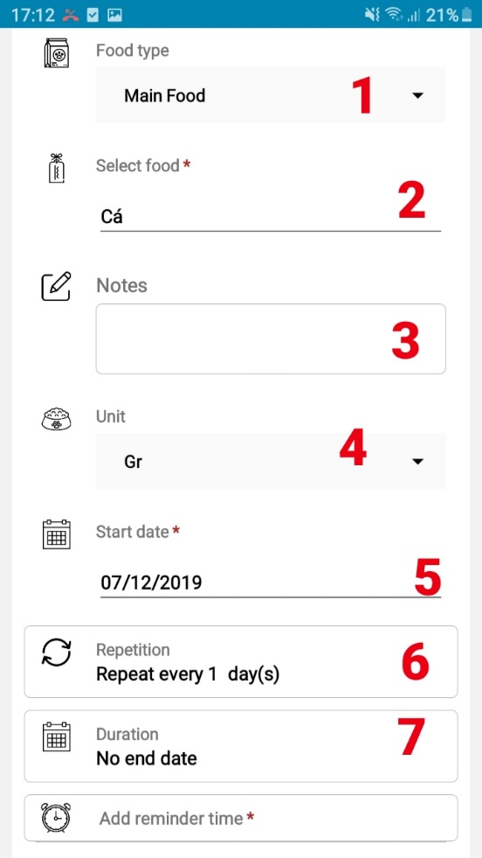 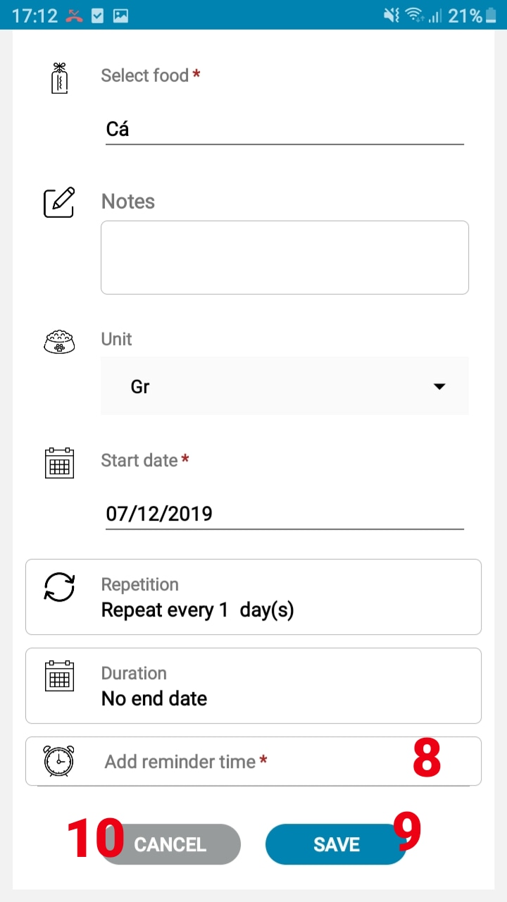

Figure 136- <UI Design> Add New Food Reminder

* **Fields**

|  |  |  |  |  |  |  |
| --- | --- | --- | --- | --- | --- | --- |
| **No** | **Field Name** | **Description** | **Read-only** | **Mandatory** | **Control Type** | **Data Type** |
| 1 | Type | Choose type of food | Yes | Yes | TextView | String |
| 2 | Food name | Fill food name | No | Yes | TextView | String |
| 3 | Notes | Fill additional notes | No | No | TextView | String |
| 4 | Unit | Choose unit of food | Yes | Yes | TextView | String |
| 5 | Start date | Choose start date | Yes | Yes | Date | Date |
| 6 | Repetition | Choose reminder’s repetition value | Yes | Yes | Textview | Integer |
| 7 | Duration | Choose end date | Yes | Yes | Date | Date |

Table 97- <UI Design> Add New Food Reminder Fields

* **Button**

|  |  |  |  |  |
| --- | --- | --- | --- | --- |
| **No** | **Function** | **Description** | **Validation** | **Outcome** |
| 8 | Add reminder time | Add a new reminder time | N/A | A new field to add time and quantity is shown |
| 9 | Save | Add new reminder to the system | N/A | Message from system |
| 10 | Cancel | Exit the Add new reminder screen | N/A | Transfer to to Food screen |

Table 98- <UI Design> Add New Food Reminder Buttons

#### Hygiene Activity (Bath)

Figure 137- <UI Design> Bath

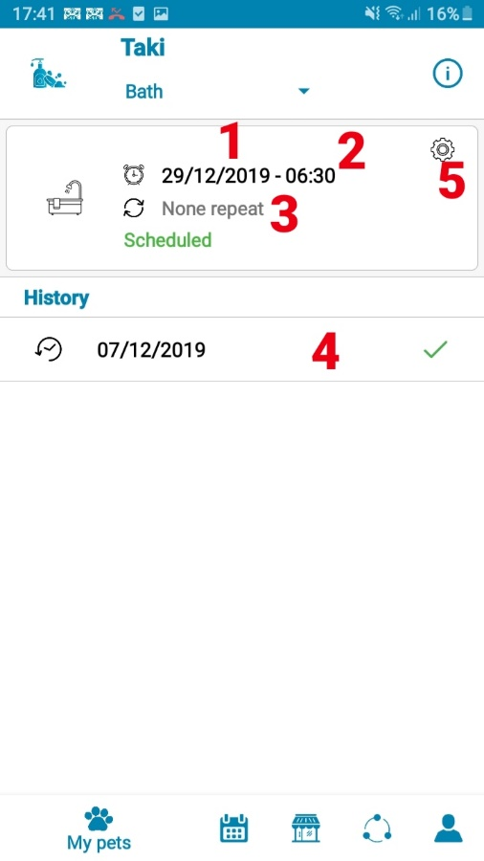

* **Fields**

|  |  |  |  |  |  |  |
| --- | --- | --- | --- | --- | --- | --- |
| **No** | **Field Name** | **Description** | **Read-only** | **Mandatory** | **Control Type** | **Data Type** |
| 1 | Date | Show scheduled date | Yes | Yes | Date | Date |
| 2 | Time | Show scheduled time | Yes | Yes | Time | Time |
| 3 | Frequency | Show frequency of repetition | Yes | Yes | TextView | String |
| 4 | History | Show done schedule | Yes | Yes | DateTime | DateTime |

Table 99- <UI Design> Bath Fields

* **Button**

|  |  |  |  |  |
| --- | --- | --- | --- | --- |
| **No** | **Function** | **Description** | **Validation** | **Outcome** |
| 5 | Edit | Edit the information fo the schedule | N/A | Transfer to Edit bath reminder screen |

Table 100- <UI Design> Bath Buttons

#### Add Hygiene Reminder (Bath)

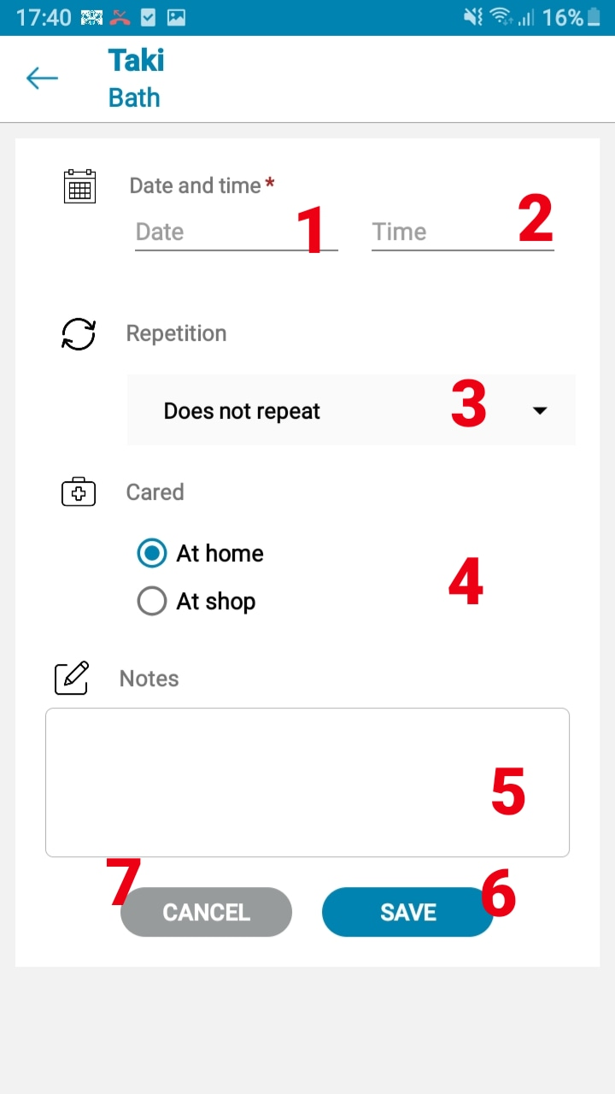

Figure 138- <UI Design> Add New Bath Reminder

* **Fields**

|  |  |  |  |  |  |  |
| --- | --- | --- | --- | --- | --- | --- |
| **No** | **Field Name** | **Description** | **Read-only** | **Mandatory** | **Control Type** | **Data Type** |
| 1 | Date | Fill date | Yes | Yes | Date | Date |
| 2 | Time | Fill time | Yes | Yes | Time | Time |
| 3 | Repetition | Choose the rate of repetition and value | Yes | Yes | TextView | String |
| 4 | Care | Choose where to take care of pet | Yes | Yes | TextView | String |
| 5 | Notes | Fill additional notes | No | No | TextView | String |

Table 101- <UI Design> Add New Bath Reminder Fields

* **Button**

|  |  |  |  |  |
| --- | --- | --- | --- | --- |
| **No** | **Function** | **Description** | **Validation** | **Outcome** |
| 6 | Save | Add new reminder to the system | N/A | Message from system |
| 7 | Cancel | Exit the Add new reminder screen | N/A | Transfer to to Bath screen |

Table 102- <UI Design> Add New Bath Reminder Buttons

#### Measurement (Weight)

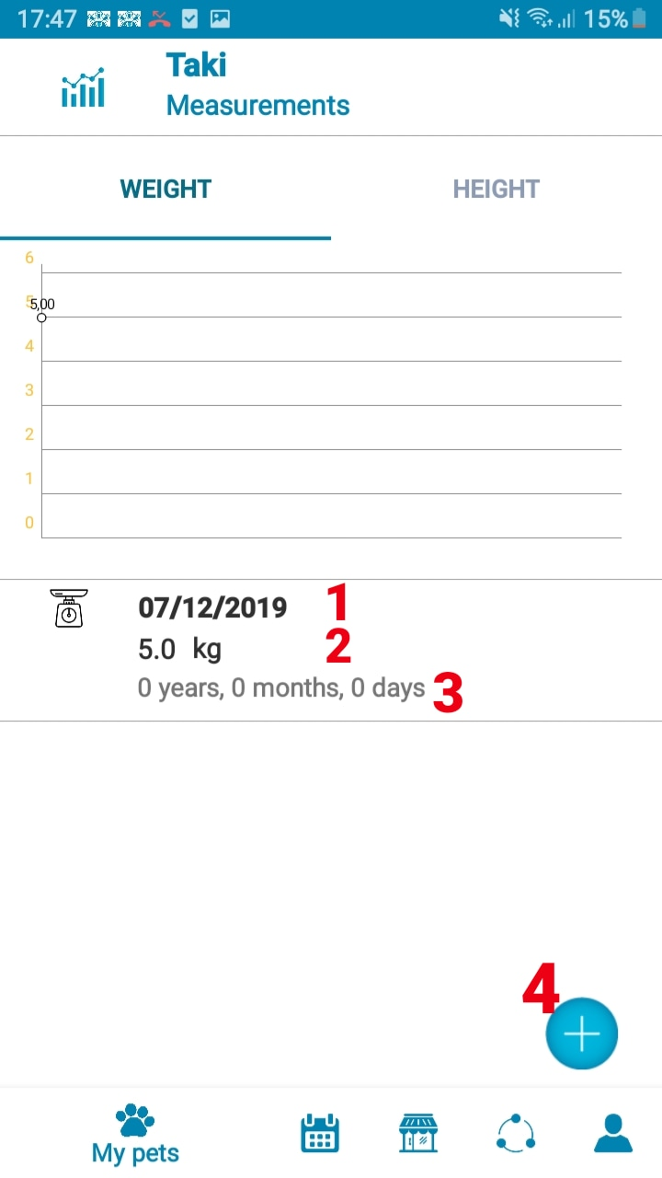

* **Fields**

Figure 139- <UI Design> Measurement Weight

|  |  |  |  |  |  |  |
| --- | --- | --- | --- | --- | --- | --- |
| **No** | **Field Name** | **Description** | **Read-only** | **Mandatory** | **Control Type** | **Data Type** |
| 1 | Date | Show increased weight date | Yes | Yes | Date | Date |
| 2 | Weight | Show pet’s weight | Yes | Yes | TextView | String |
| 3 | Age | Show age when weight increased | Yes | Yes | TextView | String |

Table 103- <UI Design> Measurement Weight Fields

* **Button**

|  |  |  |  |  |
| --- | --- | --- | --- | --- |
| **No** | **Function** | **Description** | **Validation** | **Outcome** |
| 4 | Add new weight | Add a new weight value to the system | N/A | Transfer to Measurement Weight screen |

Table 104- <UI Design> Measurement Weight Buttons

#### Measurement (Height)

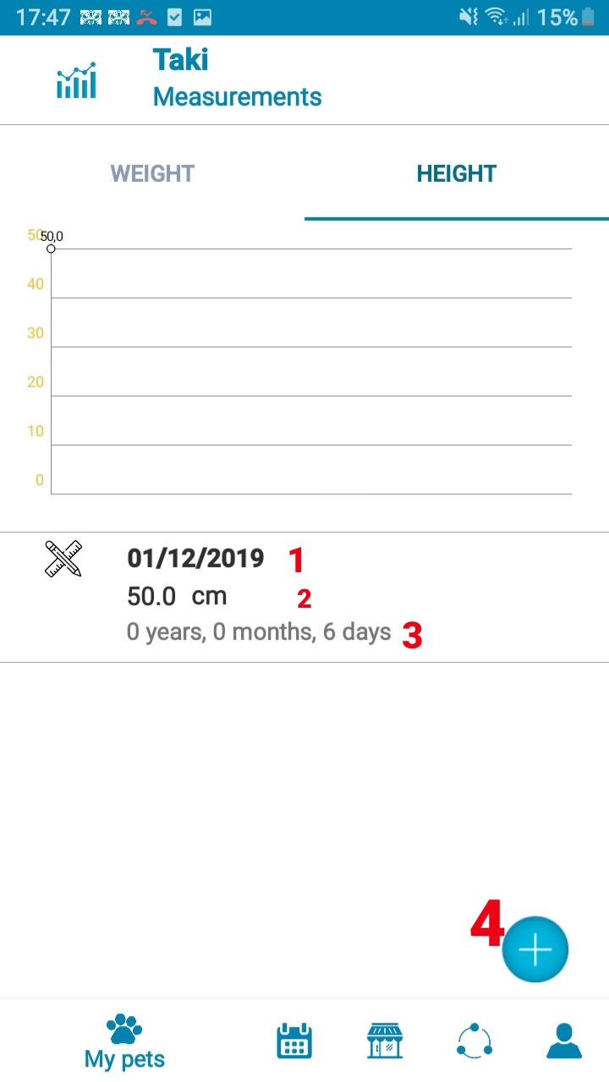

Figure 140- <UI Design> Measurement Height

* **Fields**

|  |  |  |  |  |  |  |
| --- | --- | --- | --- | --- | --- | --- |
| **No** | **Field Name** | **Description** | **Read-only** | **Mandatory** | **Control Type** | **Data Type** |
| 1 | Date | Show increased height date | Yes | Yes | Time | Time |
| 2 | Height | Show pet’s height | Yes | Yes | Date | Date |
| 3 | Age | Show age when height increased | Yes | Yes | TextView | String |

Table 105- <UI Design> Measurement Height Fields

* **Button**

|  |  |  |  |  |
| --- | --- | --- | --- | --- |
| **No** | **Function** | **Description** | **Validation** | **Outcome** |
| 4 | Add new height | Add a new weight value to the system | N/A | Transfer to Measurement Height screen |

Table 106- <UI Design> Measurement Height Buttons

#### Add New Weight Measurement

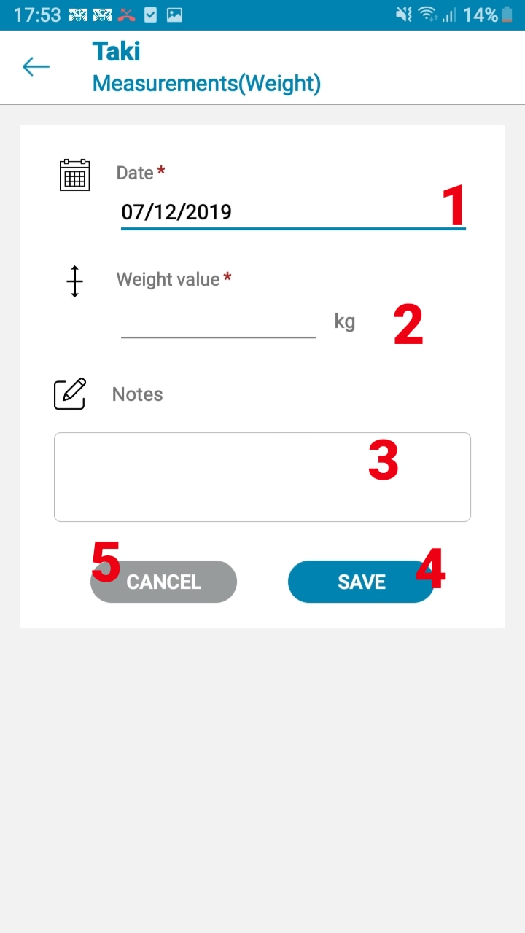

Figure 141- <UI Design> Add New Weight

* **Fields**

|  |  |  |  |  |  |  |
| --- | --- | --- | --- | --- | --- | --- |
| **No** | **Field Name** | **Description** | **Read-only** | **Mandatory** | **Control Type** | **Data Type** |
| 1 | Date | Fill date | Yes | Yes | Date | Date |
| 2 | Value | Fill value | No | Yes | TextView | String |
| 3 | Notes | Fill additional notes | No | No | TextView | String |

Table 107- <UI Design> Add New Weight Fields

* **Button**

|  |  |  |  |  |
| --- | --- | --- | --- | --- |
| **No** | **Function** | **Description** | **Validation** | **Outcome** |
| 4 | Save | Add new reminder to the system | N/A | Message from system |
| 5 | Cancel | Exit the Add new reminder screen | N/A | Transfer to to Weight screen |

Table 108- <UI Design> Add New Weight Buttons

#### Add New Height Measurement

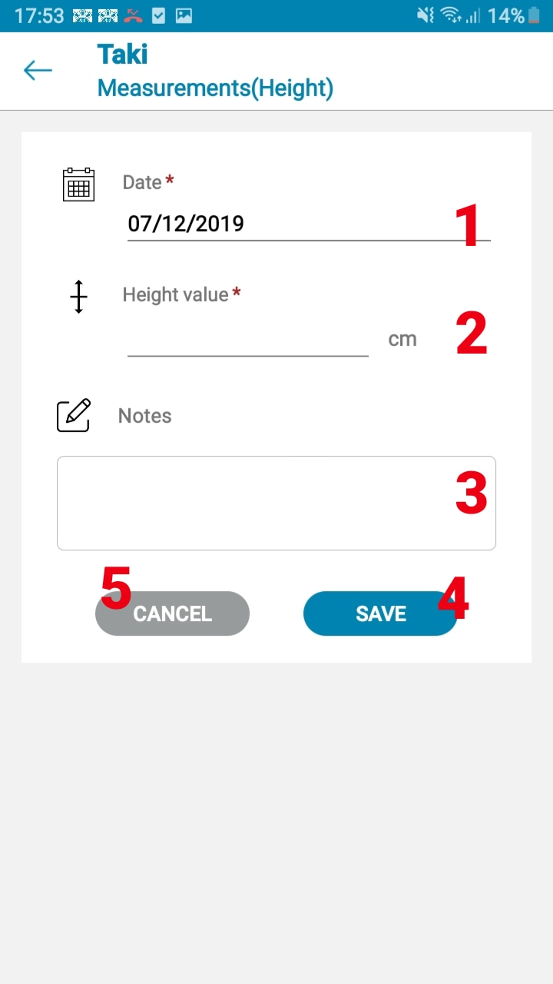

* **Fields**

Figure 142- <UI Design> Add New Height

|  |  |  |  |  |  |  |
| --- | --- | --- | --- | --- | --- | --- |
| **No** | **Field Name** | **Description** | **Read-only** | **Mandatory** | **Control Type** | **Data Type** |
| 1 | Date | Fill date | Yes | Yes | Date | Date |
| 2 | Value | Fill value | No | Yes | TextView | String |
| 3 | Notes | Fill additional notes | No | No | TextView | String |

Table 109- <UI Design> Add New Height Fields

* **Button**

|  |  |  |  |  |
| --- | --- | --- | --- | --- |
| **No** | **Function** | **Description** | **Validation** | **Outcome** |
| 4 | Save | Add new reminder to the system | N/A | Message from system |
| 5 | Cancel | Exit the Add new reminder screen | N/A | Transfer to to Height screen |

Table 110- <UI Design> Add New Height Buttons

#### D:\Games\Screenshots\Screenshots\2019-10\qemu-system-x86_64_2019_10_19_00_10_14.pngqemu-system-x86_64_2019_10_19_00_10_14Medication

Figure 145- <UI Design> Medication

* **Fields**

|  |  |  |  |  |  |  |
| --- | --- | --- | --- | --- | --- | --- |
| **No** | **Field Name** | **Description** | **Read-only** | **Mandatory** | **Control Type** | **Data Type** |
| 1 | Medication name | Show name of medication | No | Yes | TextView | String |
| 2 | Date | Show the date of the schedule | Yes | Yes | Date | Date |
| 3 | Time | Show the time of the schedule | Yes | Yes | Time | Time |
| 4 | Frequency | Show the frequency of the schedule | Yes | Yes | TextView | String |
| 5 | Reminder Time | Show the time that was set for the schedule | Yes | Yes | Time | Time |

Table 111- <UI Design> Medication Fields

* **Button**

|  |  |  |  |  |
| --- | --- | --- | --- | --- |
| **No** | **Function** | **Description** | **Validation** | **Outcome** |
| 6 | Edit | Edit the information of medication reminder | N/A | Transfer to medication reminder edit screen |
| 7 | Add new medication reminder | Add a new medication reminder to the system | N/A | Transfer to add new medication reminder screen |

#### Add Medication Reminder

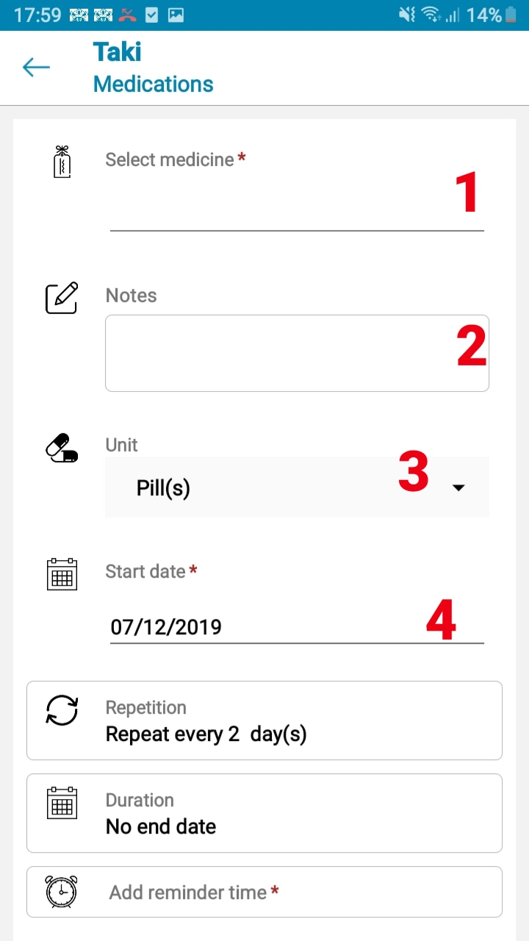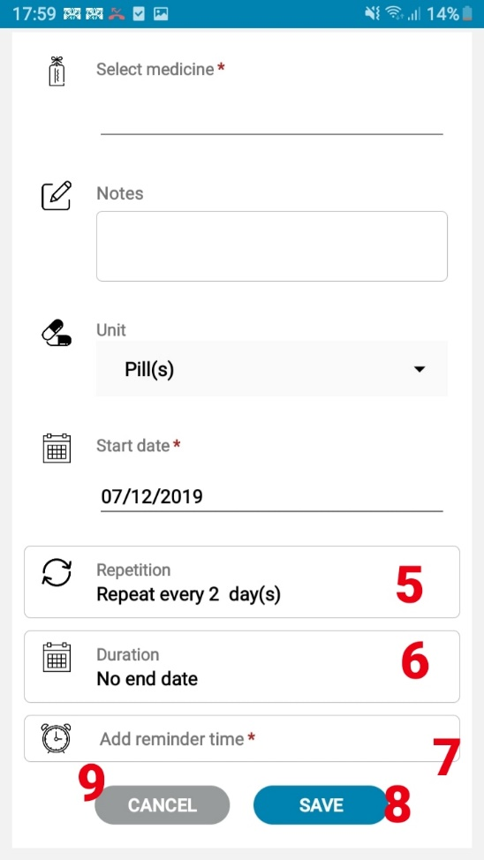

Figure 146- <UI Design> Add New Medication Reminder

* **Fields**

|  |  |  |  |  |  |  |
| --- | --- | --- | --- | --- | --- | --- |
| **No** | **Field Name** | **Description** | **Read-only** | **Mandatory** | **Control Type** | **Data Type** |
| 1 | Medication name | Fill food name | No | Yes | TextView | String |
| 2 | Notes | Fill additional notes | No | No | TextView | String |
| 3 | Unit | Choose unit of food | Yes | Yes | TextView | String |
| 4 | Start date | Choose start date | Yes | Yes | Date | Date |
| 5 | Repetition | Choose reminder’s repetition value | Yes | Yes | Textview | Integer |
| 6 | Duration | Choose end date | Yes | Yes | Date | Date |

Table 112- <UI Design> Add New Medication Reminder Fields

* **Button**

|  |  |  |  |  |
| --- | --- | --- | --- | --- |
| **No** | **Function** | **Description** | **Validation** | **Outcome** |
| 7 | Add reminder time | Add a new reminder time | N/A | A new field to add time and quantity is shown |
| 8 | Save | Add new reminder to the system | N/A | Message from system |
| 9 | Cancel | Exit the Add new reminder screen | N/A | Transfer to to Medication screen |

Table 113- <UI Design> Add New Medication Reminder Buttons

#### Surgeries

* 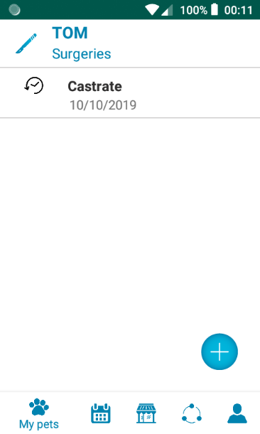**Fields**

Figure 147- <UI Design> Surgeries

|  |  |  |  |  |  |  |
| --- | --- | --- | --- | --- | --- | --- |
| **No** | **Field Name** | **Description** | **Read-only** | **Mandatory** | **Control Type** | **Data Type** |
| 1 | Surgeries name | Show name of medication | Yes | Yes | TextView | String |
|  | Date | Show the date of the schedule | Yes | Yes | Date | Date |

Table 114- <UI Design> Surgeries Fields

* **Button**

|  |  |  |  |  |
| --- | --- | --- | --- | --- |
| **No** | **Function** | **Description** | **Validation** | **Outcome** |
| 5 | Edit | Edit the information of surgeries record | N/A | Transfer to surgeries record edit screen |
| 6 | Add new surgeries record | Add a new surgeries record to the system | N/A | Transfer to add new surgeries record screen |

#### D:\Games\Screenshots\Screenshots\2019-10\qemu-system-x86_64_2019_10_19_00_11_18.pngqemu-system-x86_64_2019_10_19_00_11_18Add Surgeries Record

Figure 148- <UI Design> Add New Surgeries Record

* **Fields**

|  |  |  |  |  |  |  |
| --- | --- | --- | --- | --- | --- | --- |
| **No** | **Field Name** | **Description** | **Read-only** | **Mandatory** | **Control Type** | **Data Type** |
| 1 | Type of surgeries | Fill surgery name | No | Yes | TextView | String |
| 2 | Date | Choose date that pet had surgery | Yes | Yes | Date | Date |
| 3 | Medical Remarks | Fill medical remarks from the vet | No | No | TextView | String |
| 4 | Notes | Fill additional notes | No | No | TextView | String |

Table 115- <UI Design> Add New Surgeries Record Fields

* **Button**

|  |  |  |  |  |
| --- | --- | --- | --- | --- |
| **No** | **Function** | **Description** | **Validation** | **Outcome** |
| 5 | Save | Add new record to the system | N/A | Message from system |
| 6 | Cancel | Exit the Add new record screen | N/A | Transfer to to Surgeries screen |

Table 116- <UI Design> Add New Surgeries Record Buttons

#### D:\Games\Screenshots\Screenshots\2019-10\qemu-system-x86_64_2019_10_19_00_12_15.pngqemu-system-x86_64_2019_10_19_00_12_15Allergies

* **Fields**

Figure 149- <UI Design> Allergies

|  |  |  |  |  |  |  |
| --- | --- | --- | --- | --- | --- | --- |
| **No** | **Field Name** | **Description** | **Read-only** | **Mandatory** | **Control Type** | **Data Type** |
| 1 | Allergies name | Show name of medication | Yes | Yes | TextView | String |
| 2 | Date | Show the date of the schedule | Yes | Yes | Date | Date |
| 3 | Severity | Show the serverity of the allergy | Yes | Yes | TextView | String |

Table 117- <UI Design> Allergies Fields

* **Button**

|  |  |  |  |  |
| --- | --- | --- | --- | --- |
| **No** | **Function** | **Description** | **Validation** | **Outcome** |
| 4 | Edit | Edit the information of allergies record | N/A | Transfer to allergies record edit screen |
| 5 | Add new allergies record | Add a new allergies record to the system | N/A | Transfer to add new allergies record screen |

#### D:\Games\Screenshots\Screenshots\2019-10\qemu-system-x86_64_2019_10_19_00_12_33.pngqemu-system-x86_64_2019_10_19_00_12_33Add Allergies Record

Figure 150- <UI Design> Add New Allergies Record

* **Fields**

|  |  |  |  |  |  |  |
| --- | --- | --- | --- | --- | --- | --- |
| **No** | **Field Name** | **Description** | **Read-only** | **Mandatory** | **Control Type** | **Data Type** |
| 1 | Allergy | Fill allergy name | No | Yes | TextView | String |
| 2 | Date diagnosed | Choose date that pet was diagnosed | Yes | Yes | Date | Date |
| 3 | Severity | Choose the severity of the allergy | Yes | Yes | TextView | String |
| 4 | Category | Choose the allergy category | Yes | Yes | TextView | String |
| 5 | Action taken | Fill action taken | No | No | TextView | String |
| 6 | Notes | Fill additional notes | No | No | TextView | String |

Table 118- <UI Design> Add New Allergies Record Fields

* **Button**

|  |  |  |  |  |
| --- | --- | --- | --- | --- |
| **No** | **Function** | **Description** | **Validation** | **Outcome** |
| 7 | Save | Add new record to the system | N/A | Message from system |
| 8 | Cancel | Exit the Add new record screen | N/A | Transfer to to Allergies screen |

Table 119- <UI Design> Add New Allergies Record Buttons

#### D:\Games\Screenshots\Screenshots\2019-10\qemu-system-x86_64_2019_10_19_00_12_58.pngqemu-system-x86_64_2019_10_19_00_12_58Vet Visit History

Figure 151- <UI Design>Vet Visit History

* **Fields**

|  |  |  |  |  |  |  |
| --- | --- | --- | --- | --- | --- | --- |
| **No** | **Field Name** | **Description** | **Read-only** | **Mandatory** | **Control Type** | **Data Type** |
| 1 | Description | Reason for vet visit | Yes | Yes | TextView | String |
| 2 | Date | Date visited the vet | Yes | Yes | Date | Date |

Table 120- <UI Design> Vet Visit History Fields

* **Button**

|  |  |  |  |  |
| --- | --- | --- | --- | --- |
| **No** | **Function** | **Description** | **Validation** | **Outcome** |
| 3 | Edit | Edit the infor of vet visit history | N/A | Transfer to vet visit history edit screen |
| 4 | Add new vet visit history | Add new vet visit history | N/A | Transfer to Add new vet visit history screen |

Table 121- <UI Design>Vet Visit History Buttons

#### Add Vet Visit History

Figure 152- <UI Design> Add New Vet Visit History

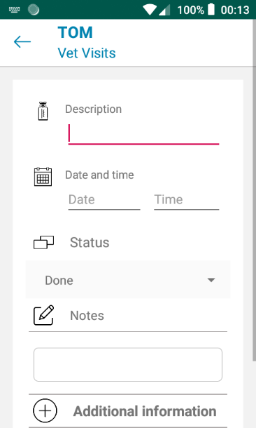

* **Fields**

|  |  |  |  |  |  |  |
| --- | --- | --- | --- | --- | --- | --- |
| **No** | **Field Name** | **Description** | **Read-only** | **Mandatory** | **Control Type** | **Data Type** |
| 1 | Description | Fill vet visit desctiption | No | Yes | TextView | String |
| 2 | Date | Choose date visited the vet | Yes | Yes | Date | Date |
| 3 | Time | Choose time visited the vet |  |  |  |  |
| 4 | Status | Choose where was the vaccine taken | Yes | No | RadioButton | String |
| 5 | Notes | Fill additional notes | No | No | TextView | String |

Table 122- <UI Design> Add New Vet Visit History Fields

* **Button**

|  |  |  |  |  |
| --- | --- | --- | --- | --- |
| **No** | **Function** | **Description** | **Validation** | **Outcome** |
| 6 | Save | Save new vet visit history to the system | N/A | Transfer to Vet Visit history screen |
| 7 | Cancel | Exit add new vet visit history screen | N/A | Transfer to Vet visit history screen |

Table 123- <UI Design> Add New Vet Visit History Buttons

#### Vet VisitD:\Games\Screenshots\Screenshots\2019-10\qemu-system-x86_64_2019_10_19_00_13_27.pngqemu-system-x86_64_2019_10_19_00_13_27 Reminder

Figure 153- <UI Design> Vet Visit Reminder

* **Fields**

|  |  |  |  |  |  |  |
| --- | --- | --- | --- | --- | --- | --- |
| **No** | **Field Name** | **Description** | **Read-only** | **Mandatory** | **Control Type** | **Data Type** |
| 1 | Description | Show description | Yes | Yes | TextView | String |
| 2 | Time | Show Vaccine time | Yes | Yes | DateTime | DateTime |
| 3 | Frequency | Show frequency | Yes | Yes | TextView | String |

Table 124- <UI Design>Vet Visit Reminder Fields

* **Button**

|  |  |  |  |  |
| --- | --- | --- | --- | --- |
| **No** | **Function** | **Description** | **Validation** | **Outcome** |
| 4 | Edit | Edit vet visit reminder | N/A | Transfer to edit vet visit screen |
| 5 | Skip | Change the status of reminder to Skipped |  | Reminder status change to Skipped |
| 6 | Done | Change the status of reminder to Done |  | Reminder status change to Done |
| 7 | Add new vet visit reminder | Add a new vet visit reminder to the system |  | Transfer to Add new vet visit reminder screen |

Table 125- <UI Design>Vet Visit Reminder Button

#### D:\Games\Screenshots\Screenshots\2019-10\qemu-system-x86_64_2019_10_19_00_13_40.pngqemu-system-x86_64_2019_10_19_00_13_40Add Vet Visit Reminder

Figure 154- <UI Design> Add New Vaccine Reminder

* **Fields**

|  |  |  |  |  |  |  |
| --- | --- | --- | --- | --- | --- | --- |
| **No** | **Field Name** | **Description** | **Read-only** | **Mandatory** | **Control Type** | **Data Type** |
| 1 | Description | Fill vet visit desctiption | No | Yes | TextView | String |
| 2 | Date | Fill date visiting the vet | Yes | Yes | Date | Date |
| 3 | Time | Fill time visiting the vet | Yes | Yes | Time | Time |
| 4 | Repetition | Fill frequency of repetition | Yes | Yes | TextView | String |
| 5 | End date | Fill day stop visiting the vet | Yes | No | TextView | String |
| 6 | Notes | Fill additional notes | No | No | TextView | String |

Table 126- <UI Design> Add New Vaccine Reminder Fields

* **Button**

|  |  |  |  |  |
| --- | --- | --- | --- | --- |
| **No** | **Function** | **Description** | **Validation** | **Outcome** |
| 7 | Save | Add new vet visit reminder to the system | N/A | Message from system |
| 8 | Cancel | Exit add new vet visit reminder screen |  | Transfer to Vet visit reminder screen |

Table 127- <UI Design> Add New Vaccine Reminder Button

#### Incidents

Figure 155- <UI Design> Incidents

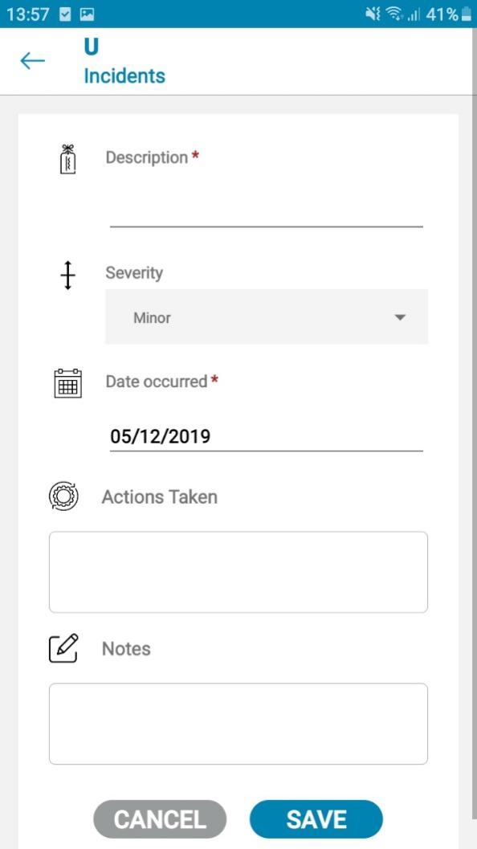

* **Fields**

|  |  |  |  |  |  |  |
| --- | --- | --- | --- | --- | --- | --- |
| **No** | **Field Name** | **Description** | **Read-only** | **Mandatory** | **Control Type** | **Data Type** |
| 1 | Description | Show description of incident | Yes | Yes | TextView | String |
| 2 | Date | Show the date of the incident | Yes | Yes | Date | Date |
| 3 | Severity | Show the serverity of the incident | Yes | Yes | TextView | String |

Table 128- <UI Design> Incidents Fields

* **Button**

|  |  |  |  |  |
| --- | --- | --- | --- | --- |
| **No** | **Function** | **Description** | **Validation** | **Outcome** |
| 4 | Edit | Edit the information of incident record | N/A | Transfer to incident record edit screen |
| 5 | Add new incident record | Add a new incident record to the system | N/A | Transfer to add new incident record screen |

#### D:\Games\Screenshots\Screenshots\2019-10\qemu-system-x86_64_2019_10_19_00_14_05.pngqemu-system-x86_64_2019_10_19_00_14_05Add Incidents Record

Figure 156- <UI Design> Add New Incidents Record

* **Fields**

|  |  |  |  |  |  |  |
| --- | --- | --- | --- | --- | --- | --- |
| **No** | **Field Name** | **Description** | **Read-only** | **Mandatory** | **Control Type** | **Data Type** |
| 1 | Description | Fill description of the incident | No | Yes | TextView | String |
| 2 | Severity | Choose the severity of the incident | Yes | Yes | TextView | String |
| 3 | Date occured | Choose date the incident occured | Yes | Yes | Date | Date |
| 4 | Action taken | Fill action taken | No | No | TextView | String |
| 5 | Notes | Fill additional notes | No | No | TextView | String |

Table 129- <UI Design> Add New Incidents Record Fields

* **Button**

|  |  |  |  |  |
| --- | --- | --- | --- | --- |
| **No** | **Function** | **Description** | **Validation** | **Outcome** |
| 6 | Save | Add new record to the system | N/A | Message from system |
| 7 | Cancel | Exit the Add new record screen | N/A | Transfer to to Incident screen |

Table 130- <UI Design> Add New Incidents Record Buttons

#### Shop

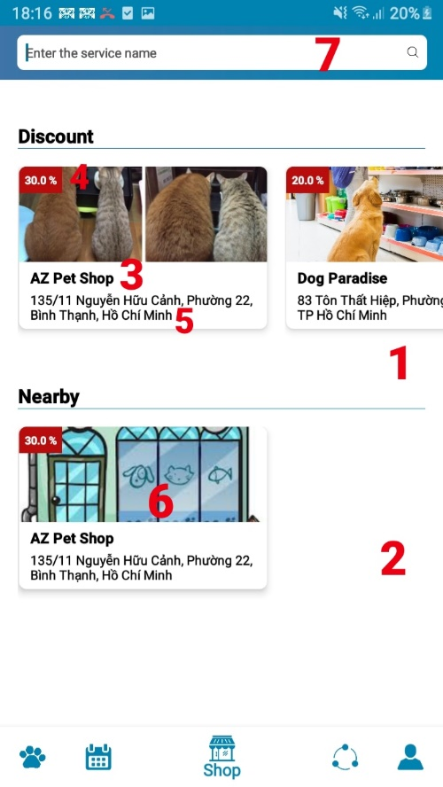

Figure 157- <UI Design> Shop

* **Fields**

|  |  |  |  |  |  |  |
| --- | --- | --- | --- | --- | --- | --- |
| **No** | **Field Name** | **Description** | **Read-only** | **Mandatory** | **Control Type** | **Data Type** |
| 1 | Discount section | Display shops with discounts | Yes | Yes | TextView | String |
| 2 | Nearby section | Displays shops nearby the user | Yes | Yes | TextView | String |
| 3 | Shop name | Shop’s name | Yes | Yes | TextView | String |
| 4 | Discount | Discount that shop has | Yes | Yes | TextView | String |
| 5 | Address | Address of shop | Yes | Yes | TextView | String |

Table 131- <UI Design> Shop Fields

* **Button**

|  |  |  |  |  |
| --- | --- | --- | --- | --- |
| **No** | **Function** | **Description** | **Validation** | **Outcome** |
| 6 | Shop item | Displays shop’s general information | N/A | Transfer to shop’s detail screen |
| 7 | Search | Search shop and service | N/A | Transfer to search screen |

Table 132- <UI Design> Shop Buttons

#### D:\Games\Screenshots\Screenshots\2019-10\qemu-system-x86_64_2019_10_19_00_38_44.pngqemu-system-x86_64_2019_10_19_00_38_44Social

Figure 157- <UI Design> Social

* **Fields**

|  |  |  |  |  |  |  |
| --- | --- | --- | --- | --- | --- | --- |
| **No** | **Field Name** | **Description** | **Read-only** | **Mandatory** | **Control Type** | **Data Type** |
| 1 | Group name | Show name of group currently in | Yes | Yes | TextView | String |
| 2 | User name | Show name of user currently chatting with | Yes | Yes | TextView | String |
| 3 | Chat | Show line of recent chat | Yes | Yes | TextView | String |

Table 133- <UI Design> Social Fields

* **Button**

|  |  |  |  |  |
| --- | --- | --- | --- | --- |
| **No** | **Function** | **Description** | **Validation** | **Outcome** |
| 4 | Create new group | Add new chat group to the system | N/A | Transfer to create group chat screen |
| 5 | Group chat | Chatting in group with many people | N/A | Transfer to group screen |
| 6 | Private chat | Chatting with only one user |  | Transfer to private chat screen |

Table 134- <UI Design> Social Buttons

#### D:\Games\Screenshots\Screenshots\2019-10\qemu-system-x86_64_2019_10_19_00_39_44.pngqemu-system-x86_64_2019_10_19_00_39_44Chat

Figure 158- <UI Design> Private Chat

* **Fields**

|  |  |  |  |  |  |  |
| --- | --- | --- | --- | --- | --- | --- |
| **No** | **Field Name** | **Description** | **Read-only** | **Mandatory** | **Control Type** | **Data Type** |
| 1 | User name | Show name of user currently chatting with | Yes | Yes | TextView | String |
| 2 | Chat history | Show line of recent chat | Yes | Yes | TextView | String |
| 3 | Chat | Fill chat conversation | No | Yes | TextView | String |
| 4 | Time | Show time the chat line was sent | Yes | Yes | Time | Time |

Table 135- <UI Design> Private Chat Fields

* **Button**

|  |  |  |  |  |
| --- | --- | --- | --- | --- |
| **No** | **Function** | **Description** | **Validation** | **Outcome** |
| 5 | Send | Send a new chat line to the conversation | N/A | The new chat line is shown in the conversation |

Table 136- <UI Design> Private Chat Buttons

#### D:\Games\Screenshots\Screenshots\2019-10\qemu-system-x86_64_2019_10_19_00_43_57.pngqemu-system-x86_64_2019_10_19_00_43_57Profile

Figure 159- <UI Design> Profile

* **Fields**

|  |  |  |  |  |  |  |
| --- | --- | --- | --- | --- | --- | --- |
| **No** | **Field Name** | **Description** | **Read-only** | **Mandatory** | **Control Type** | **Data Type** |
| 1 | Image | Show image of user | Yes | Yes | TextView | String |
| 2 | Username | Show username of user | Yes | Yes | TextView | String |
| 3 | Email | Show email of user | Yes | Yes | TextView | String |
| 4 | Phone number | Show phone number of user | Yes | Yes | TextView | String |
| 5 | Address | Show address of user | Yes | Yes | TextView | String |
| 6 | Date created | Show date the account was created | Yes | Yes | Date | Date |

Table 137- <UI Design> Profile Fields

* **Button**

|  |  |  |  |  |
| --- | --- | --- | --- | --- |
| **No** | **Function** | **Description** | **Validation** | **Outcome** |
| 7 | Update profile | Update profile of user | N/A | Transfer to update profile screen |
| 8 | Logout | Log user oit of the system | N/A | System show message |

Table 138- <UI Design> Profile Buttons

### Web Application

#### Login

Figure 160- <UI Design> Login

* **Fields**

|  |  |  |  |  |  |  |
| --- | --- | --- | --- | --- | --- | --- |
| **No** | **Field Name** | **Description** | **Read-only** | **Mandatory** | **Control Type** | **Data Type** |
| 1 | Username | Fill username | No | Yes | TextView | String |
| 2 | Password | Fill password | No | Yes | TextView | String |

Table 139- <UI Design> Login Fields

* **Button**

|  |  |  |  |  |
| --- | --- | --- | --- | --- |
| **No** | **Function** | **Description** | **Validation** | **Outcome** |
| 3 | Login | Login into the application | Required | Transfer to Home page |

Table 140- <UI Design> Login Button

#### View Shops List

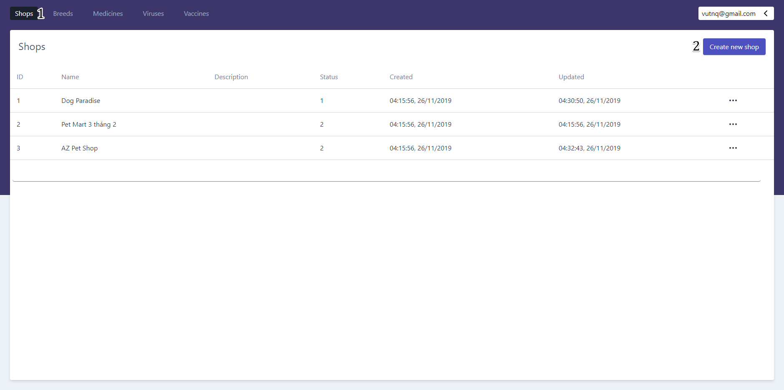

Figure 161- <UI Design> View Shops List

* **Fields**

|  |  |  |  |  |  |  |
| --- | --- | --- | --- | --- | --- | --- |
| **No** | **Field Name** | **Description** | **Read-only** | **Mandatory** | **Control Type** | **Data Type** |
| 1 | ID | ID of shop | Yes | Yes | Text | String |
| 2 | Name | Name of shop | Yes | Yes | Text | String |
| 3 | Description | Description of shop | Yes | Yes | Text | String |
| 4 | Status | Status of shop | Yes | Yes | Text | Integer |
| 5 | Created | Date created of shop | Yes | No | Text | Datetime |
| 6 | Updated | Date updated of shop | Yes | Yes | Text | Datetime |

Table 141- <UI Design> View Shops List Fields

* **Button**

|  |  |  |  |  |
| --- | --- | --- | --- | --- |
| **No** | **Function** | **Description** | **Validation** | **Outcome** |
| 7 | View details | View details and update shop’s information | N/A | Transfer to shop’s detail screen |
| 8 | Create new shop | Create new shop | N/A | Transfer to create new shop’s screen |

Table 142- <UI Design> View Shops List Buttons

#### View Accounts List

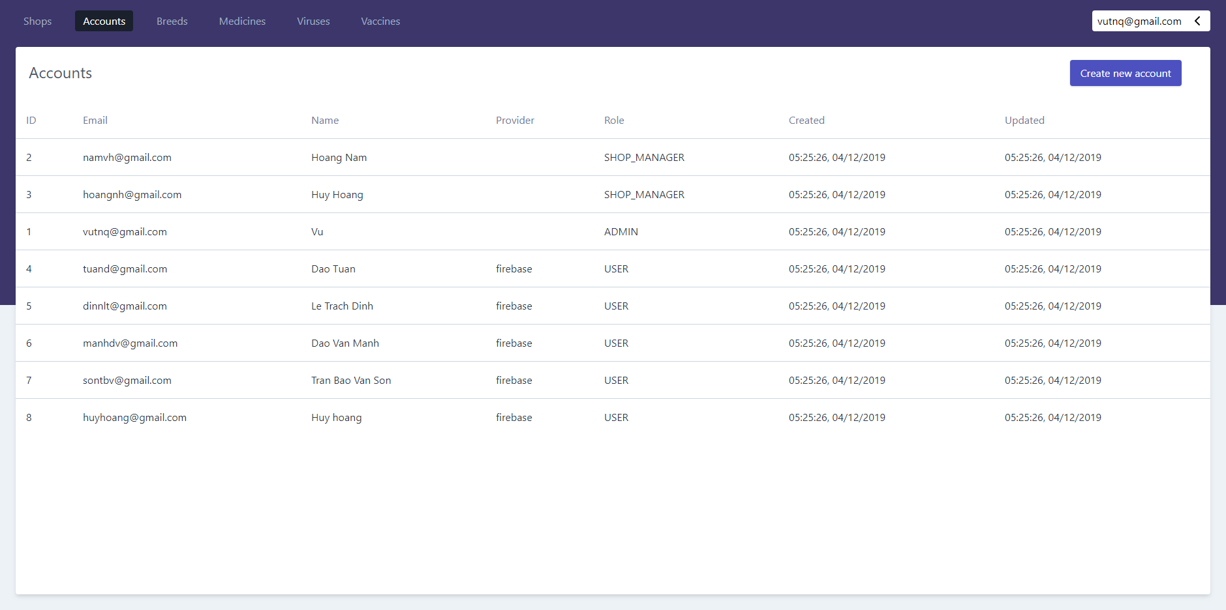

Figure 162- <UI Design> View Accounts List

* **Fields**

|  |  |  |  |  |  |  |
| --- | --- | --- | --- | --- | --- | --- |
| **No** | **Field Name** | **Description** | **Read-only** | **Mandatory** | **Control Type** | **Data Type** |
| 1 | ID | ID of account | Yes | Yes | Text | String |
| 2 | Email | Email of account | Yes | Yes | Text | String |
| 3 | Name | Name of account | Yes | Yes | Text | String |
| 4 | Provider | The server that creates the account | Yes | Yes | Text | String |
| 5 | Role | Role of account | Yes | No | Text | String |
| 6 | Created | Date created of account | Yes | Yes | Text | Datetime |
| 7 | Updated | Date updated of account | Yes | Yes | Text | Datetime |

Table 143- <UI Design> View All Accounts Fields

* **Button**

|  |  |  |  |  |
| --- | --- | --- | --- | --- |
| **No** | **Function** | **Description** | **Validation** | **Outcome** |
| 8 | Create new account | Create new account | N/A | Transfer to create new account’s screen |

Table 144- <UI Design>View All Accounts Buttons

#### View Breeds List

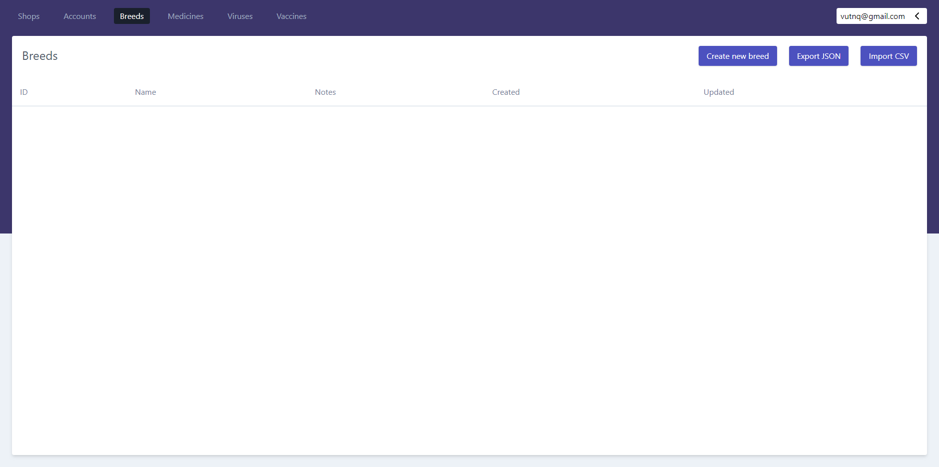

Figure 163- <UI Design> View Breeds List

* **Fields**

|  |  |  |  |  |  |  |
| --- | --- | --- | --- | --- | --- | --- |
| **No** | **Field Name** | **Description** | **Read-only** | **Mandatory** | **Control Type** | **Data Type** |
| 1 | ID | ID of breed | Yes | Yes | Text | String |
| 2 | Name | Name of breed | Yes | Yes | Text | String |
| 3 | Notes | Notes of breed | Yes | Yes | Text | String |
| 4 | Created | Date created of breed | Yes | No | Text | Datetime |
| 5 | Updated | Date updated of breed | Yes | Yes | Text | Datetime |

Table 145- <UI Design>View Breeds List Fields

* **Button**

|  |  |  |  |  |
| --- | --- | --- | --- | --- |
| **No** | **Function** | **Description** | **Validation** | **Outcome** |
| 6 | Create new breed | Create new breed | N/A | Transfer to create new breed’s screen |
| 7 | Export JSON | Export information of breed into JSON file | N/A | Show export JSON dialog |
| 8 | Import CSV | Import CSV file | N/A | Show import file dialog |

Table 146- <UI Design>View Breeds List Buttons

#### View Medicines List

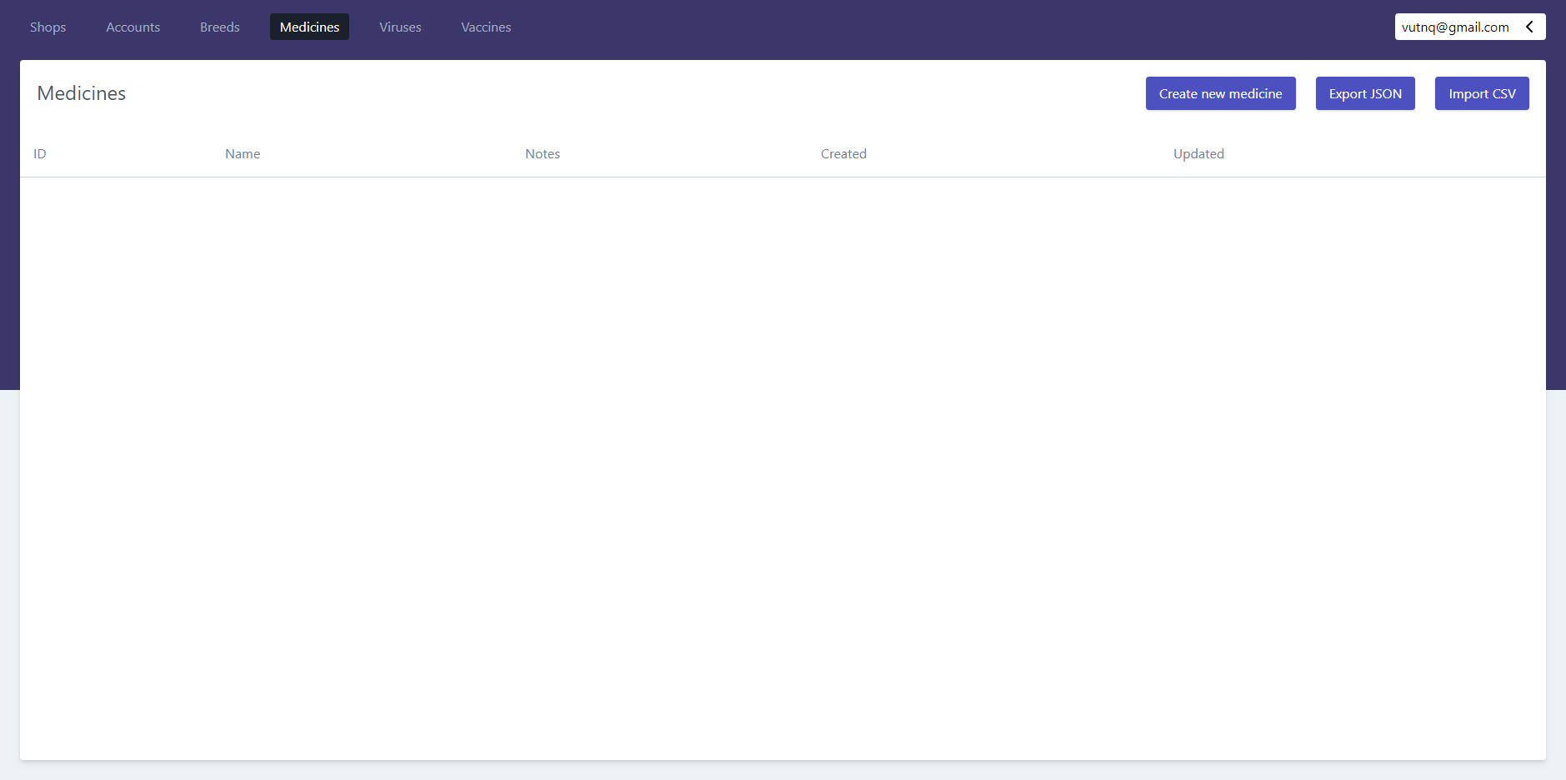

Figure 164- <UI Design> View Medicines List

* **Fields**

|  |  |  |  |  |  |  |
| --- | --- | --- | --- | --- | --- | --- |
| **No** | **Field Name** | **Description** | **Read-only** | **Mandatory** | **Control Type** | **Data Type** |
| 1 | ID | ID of medicine | Yes | Yes | Text | String |
| 2 | Name | Name of medicine | Yes | Yes | Text | String |
| 3 | Notes | Notes of medicine | Yes | Yes | Text | String |
| 4 | Created | Date created of medicine | Yes | No | Text | Datetime |
| 5 | Updated | Date updated of medicine | Yes | Yes | Text | Datetime |

Table 147- <UI Design>View Medicines List Fields

* **Button**

|  |  |  |  |  |
| --- | --- | --- | --- | --- |
| **No** | **Function** | **Description** | **Validation** | **Outcome** |
| 6 | Create new medicine | Create new medicine | N/A | Transfer to create new medicine’s screen |
| 7 | Export JSON | Export information of medicine into JSON file | N/A | Show export JSON dialog |
| 8 | Import CSV | Import CSV file | N/A | Show import file dialog |

Table 148- <UI Design>View Medicines List Buttons

#### View Vaccines List

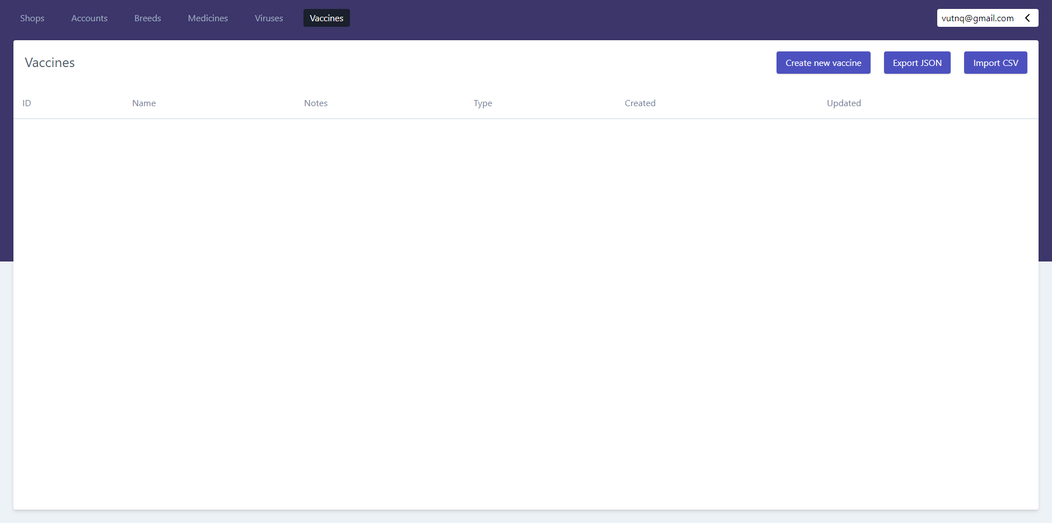

Figure 166- <UI Design> View Vaccines List

* **Fields**

|  |  |  |  |  |  |  |
| --- | --- | --- | --- | --- | --- | --- |
| **No** | **Field Name** | **Description** | **Read-only** | **Mandatory** | **Control Type** | **Data Type** |
| 1 | ID | ID of vaccine | Yes | Yes | Text | String |
| 2 | Name | Name of vaccine | Yes | Yes | Text | String |
| 3 | Notes | Notes of vaccine | Yes | Yes | Text | String |
| 4 | Type | Type of vaccine | Yes | Yes | Text | Integer |
| 5 | Created | Date created of vaccine | Yes | No | Text | Datetime |
| 6 | Updated | Date updated of vaccine | Yes | Yes | Text | Datetime |

Table 149- <UI Design>View Vaccines List Fields

* **Button**

|  |  |  |  |  |
| --- | --- | --- | --- | --- |
| **No** | **Function** | **Description** | **Validation** | **Outcome** |
| 7 | Create new vaccine | Create new vaccine | N/A | Transfer to create new vaccine’s screen |
| 8 | Import CSV | Import CSV file | N/A | Show import file dialog |

Table 150- <UI Design>View Vaccines List Buttons

#### Create Shop (for Admin)

**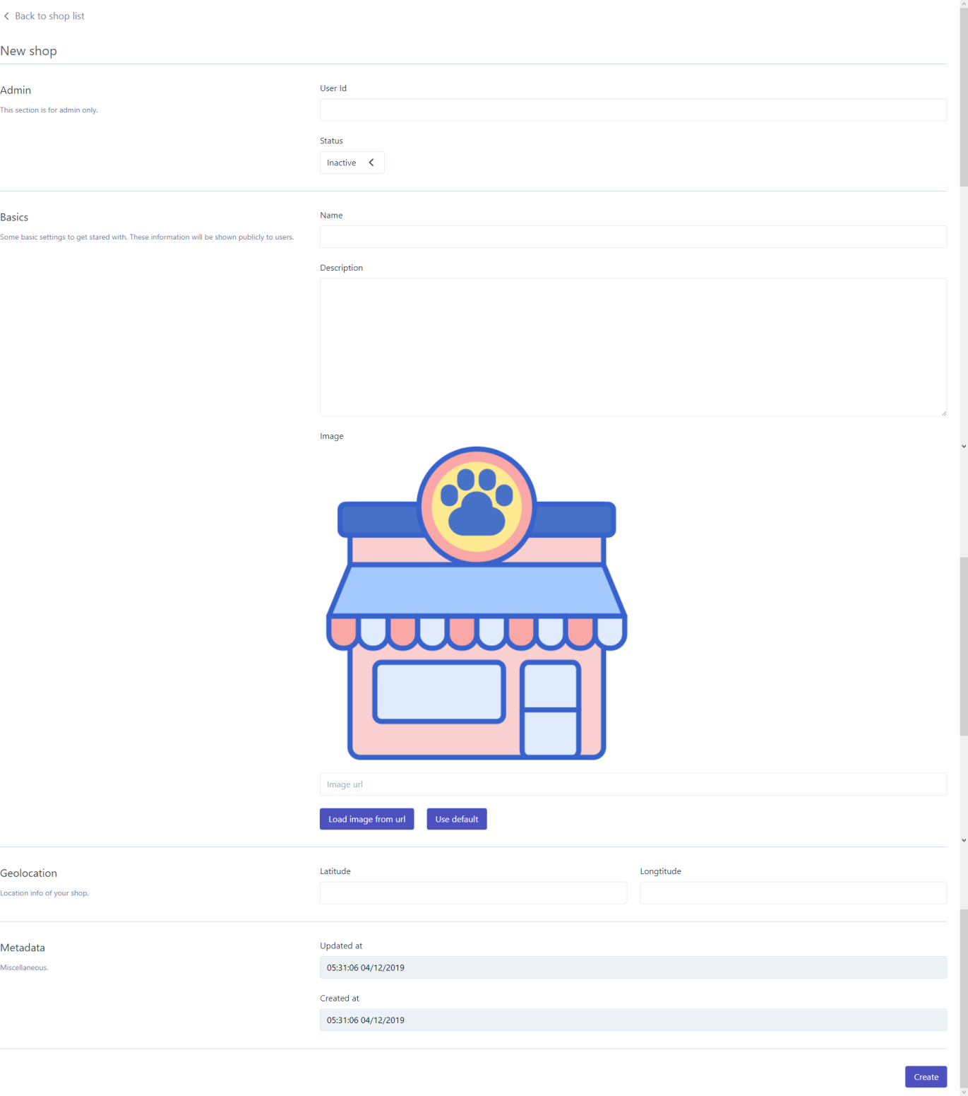**

Figure 165- <UI Design> Create Shop

* **Fields**

|  |  |  |  |  |  |  |
| --- | --- | --- | --- | --- | --- | --- |
| **No** | **Field Name** | **Description** | **Read only** | **Mandatory** | **Control Type** | **Data Type** |
| 1 | User ID | ID of user that manages the shop | No | Yes | Text | String |
| 2 | Status | Status of shop | No | Yes | Select | String |
| 3 | Name | Name of shop | No | Yes | Text | String |
| 4 | Description | Description of shop | No | No | Text | String |
| 5 | Image (Image URL) | Image URL of shop | No | No | Text | String |
| 6 | Lattitude | Latitude of shop | No | Yes | Text | String |
| 7 | Longtitude | Longtitude of shop | No | Yes | Text | String |
| 8 | Update at | Date updated of shop | Yes | Yes | Text | Datetime |
| 9 | Created at | Date created of shop | Yes | Yes | Text | Date |

Table 151- <UI Design>Create Shop Fields

* **Button**

|  |  |  |  |  |
| --- | --- | --- | --- | --- |
| **No** | **Function** | **Description** | **Validation** | **Outcome** |
| 10 | Load image from URL | Load the image by the URL | N/A | Shows the image on the screen |
| 11 | Use default | Load the default image | N/A | Shows the default image on the screen |
| 12 | Create | Create new shop successfully | Required | Redirects to shops list’s screen with new created shop |

Table 152- <UI Design>Create Shop Buttons

#### Create Account

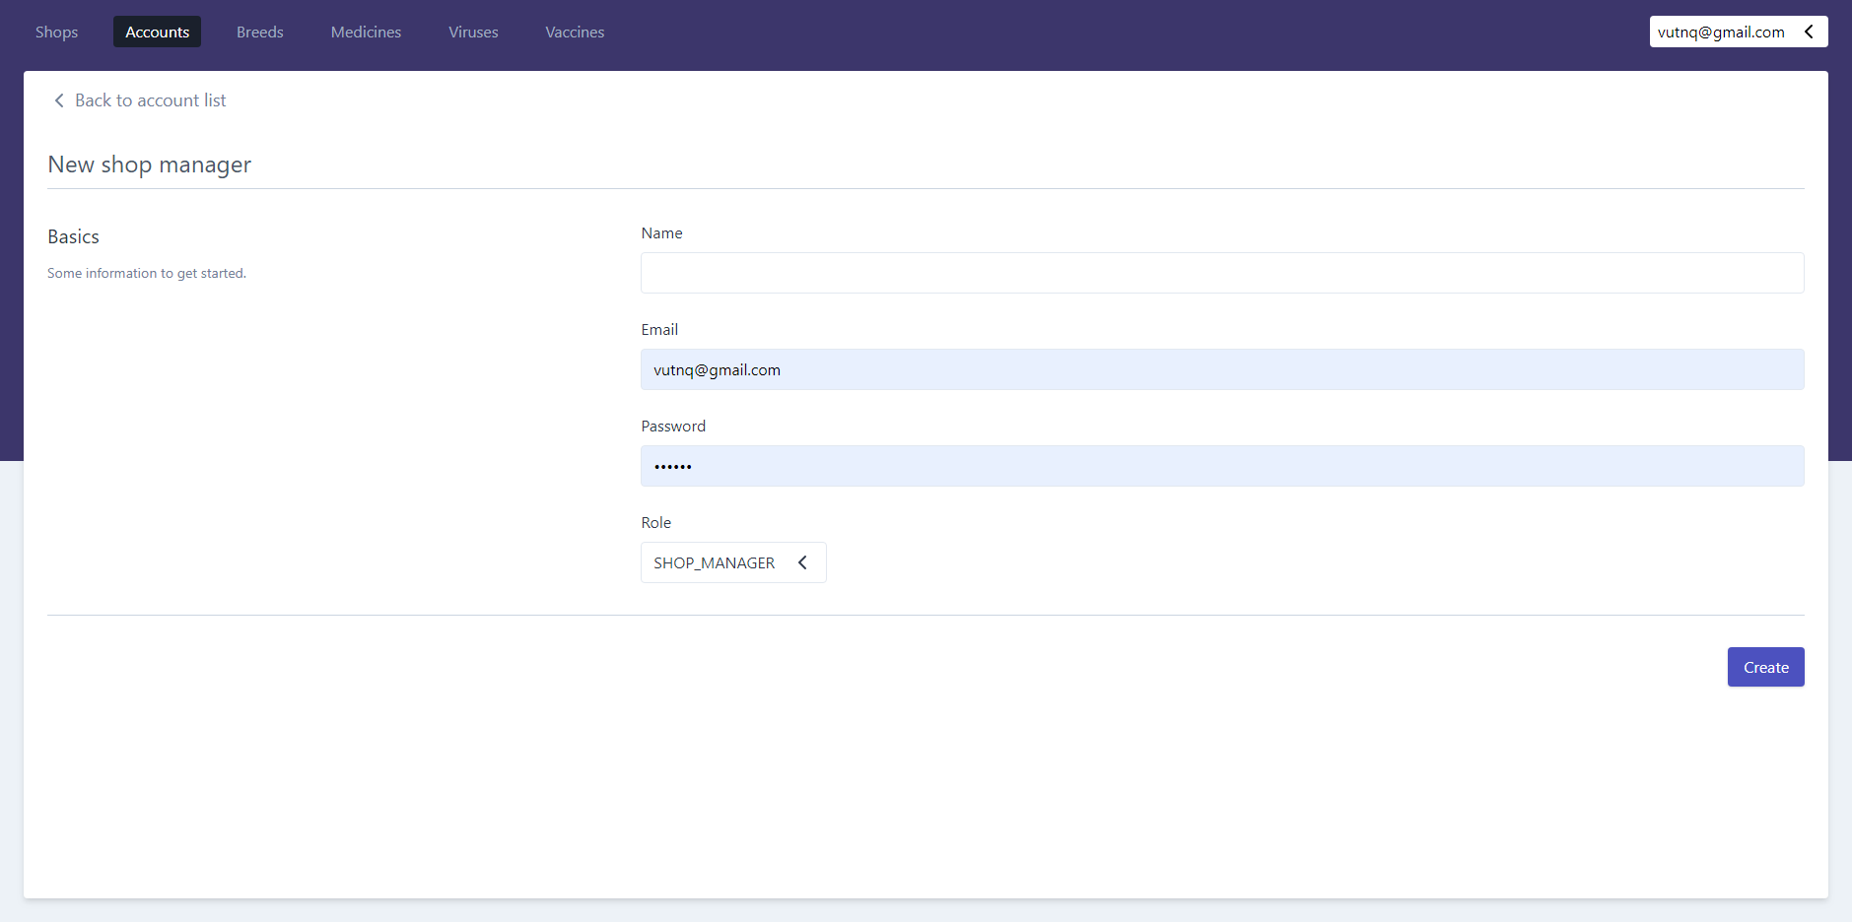

Figure 166- <UI Design> Create Account

* **Fields**

|  |  |  |  |  |  |  |
| --- | --- | --- | --- | --- | --- | --- |
| **No** | **Field Name** | **Description** | **Read only** | **Mandatory** | **Control Type** | **Data Type** |
| 1 | Name | Name of account | No | Yes | Text | String |
| 2 | Email | Email of account | No | Yes | Select | String |
| 3 | Password | Password of account | No | Yes | Text | String |
| 4 | Role | Role of account | No | Yes | Select | String |

Table 153- <UI Design>Create Account Fields

* **Button**

|  |  |  |  |  |
| --- | --- | --- | --- | --- |
| **No** | **Function** | **Description** | **Validation** | **Outcome** |
| 5 | Create | Create new account successfully | Required | Redirects to accounts list’s screen with new created account |

Table 154- <UI Design>Create Account Buttons

#### Create Breed

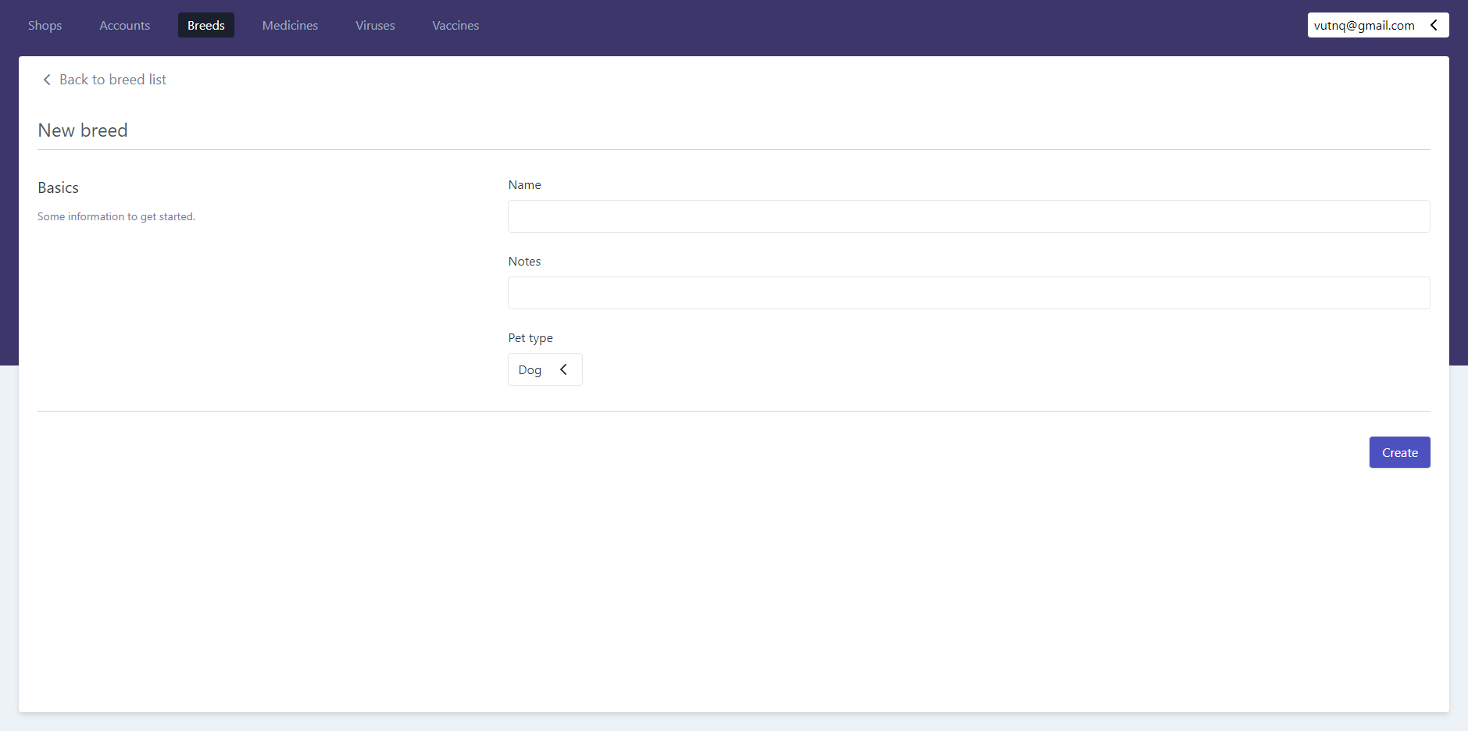

Figure 167- <UI Design> Create Breed

* **Fields**

|  |  |  |  |  |  |  |
| --- | --- | --- | --- | --- | --- | --- |
| **No** | **Field Name** | **Description** | **Read only** | **Mandatory** | **Control Type** | **Data Type** |
| 1 | Name | Name of breed | No | Yes | Text | String |
| 2 | Notes | Notes of breed | No | No | Text | String |
| 3 | Pet type | Pet type of breed | No | Yes | Select | String |

Table 155- <UI Design>Create Breed Fields

* **Button**

|  |  |  |  |  |
| --- | --- | --- | --- | --- |
| **No** | **Function** | **Description** | **Validation** | **Outcome** |
| 4 | Create | Create new breed successfully | Required | Redirects to breeds list’s screen with new created breed |

Table 156- <UI Design>Create Breed Button

#### Create Medicine

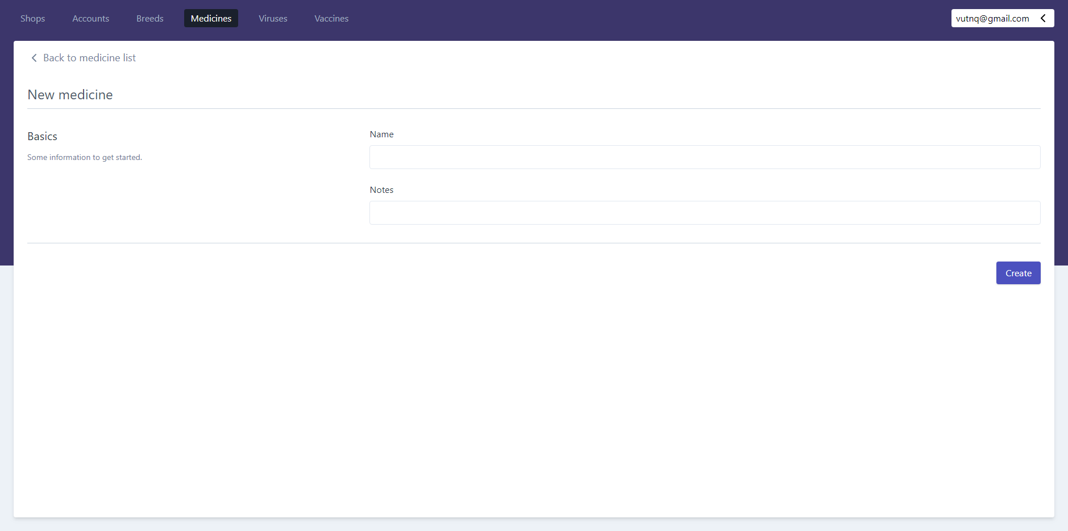

Figure 168- <UI Design> Create Medicine

* **Fields**

|  |  |  |  |  |  |  |
| --- | --- | --- | --- | --- | --- | --- |
| **No** | **Field Name** | **Description** | **Read only** | **Mandatory** | **Control Type** | **Data Type** |
| 1 | Name | Name of medicine | No | Yes | Text | String |
| 2 | Notes | Notes of medicine | No | No | Text | String |

Table 157- <UI Design>Create Medicine Fields

* **Button**

|  |  |  |  |  |
| --- | --- | --- | --- | --- |
| **No** | **Function** | **Description** | **Validation** | **Outcome** |
| 3 | Create | Create new medicine successfully | Required | Redirects to medicines list’s screen with new created medicine |

Table 158- <UI Design>Create Medicine Button

#### Create Vaccine

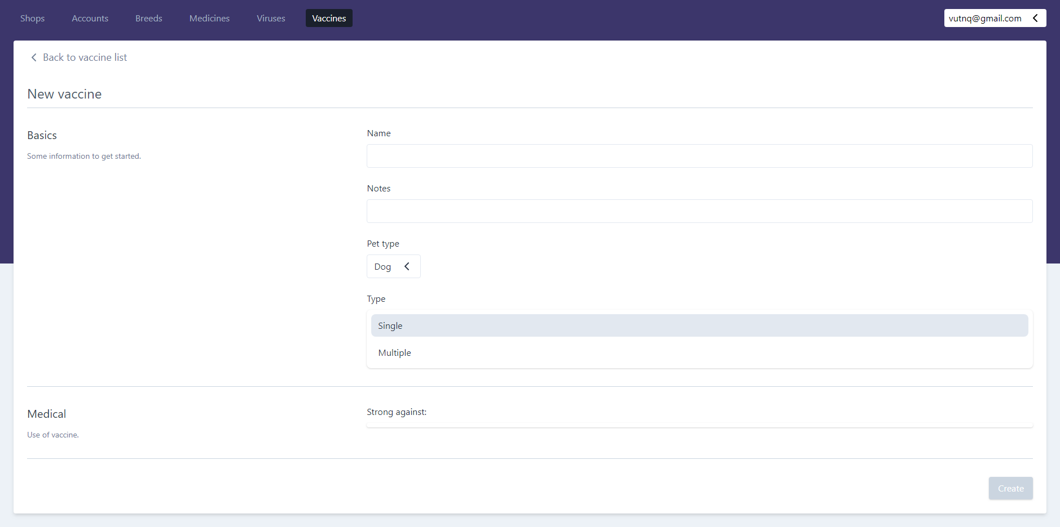

Figure 169- <UI Design> Create Vaccine

* **Fields**

|  |  |  |  |  |  |  |
| --- | --- | --- | --- | --- | --- | --- |
| **No** | **Field Name** | **Description** | **Read only** | **Mandatory** | **Control Type** | **Data Type** |
| 1 | Name | Name of vaccine | No | Yes | Text | String |
| 2 | Notes | Notes of vaccine | No | No | Text | String |
| 3 | Pet type | Pet type of vaccine | No | Yes | Select | String |
| 4 | Type | Type of vaccine | No | Yes | Select | String |
| 5 | Strong against | Virus that vaccine is against | No | Yes | Select | String |

Table 159- <UI Design>Create Vaccine Fields

* **Button**

|  |  |  |  |  |
| --- | --- | --- | --- | --- |
| **No** | **Function** | **Description** | **Validation** | **Outcome** |
| 6 | Create | Create new vaccine successfully | Required | Redirects to vaccines list’s screen with new created vaccines |

Table 160- <UI Design>Create Vaccine Button

#### View Services List

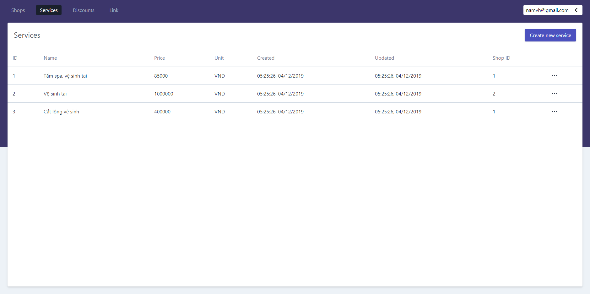

Figure 170 - <UI Design> View Services List

* **Fields**

|  |  |  |  |  |  |  |
| --- | --- | --- | --- | --- | --- | --- |
| **No** | **Field Name** | **Description** | **Read-only** | **Mandatory** | **Control Type** | **Data Type** |
| 1 | ID | ID of service | Yes | Yes | Text | String |
| 2 | Name | Name of service | Yes | Yes | Text | String |
| 3 | Price | Price of service | Yes | Yes | Text | Integer |
| 4 | Unit | Unit price of service | Yes | Yes | Text | String |
| 5 | Created | Date created of service | Yes | No | Text | Datetime |
| 6 | Updated | Date updated of service | Yes | Yes | Text | Datetime |
| 7 | Shop ID | ID of shop that service belongs to | Yes | Yes | Text | String |

Table 161- <UI Design> View Services List Fields

* **Button**

|  |  |  |  |  |
| --- | --- | --- | --- | --- |
| **No** | **Function** | **Description** | **Validation** | **Outcome** |
| 8 | View details | View details and update service’s information | N/A | Transfer to service’s detail screen |
| 9 | Create new service | Create new service | N/A | Transfer to create new service’s screen |

Table 162- <UI Design> View Services List Buttons

#### View Discounts List

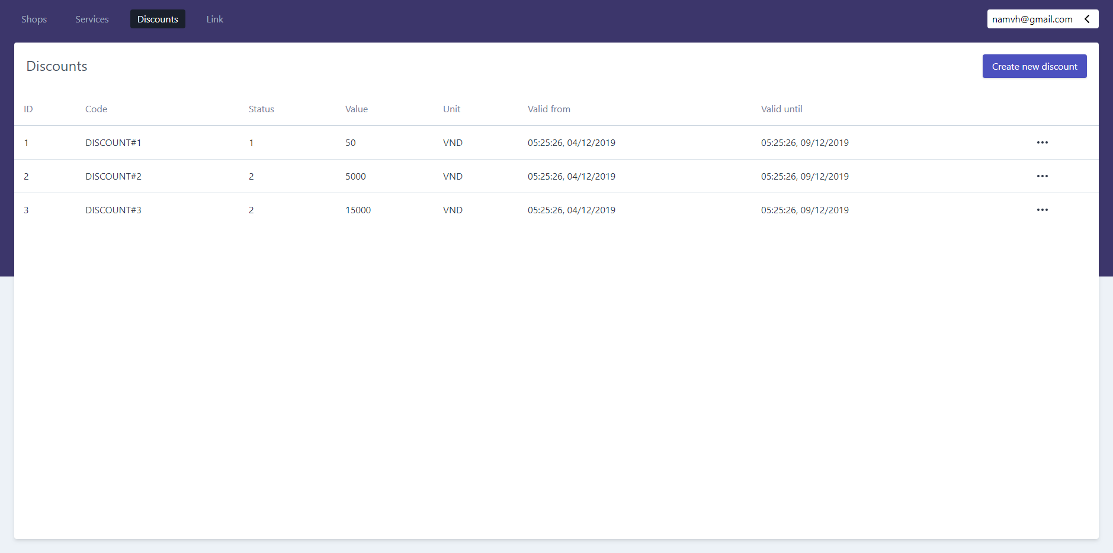

Figure 171 - <UI Design> View Discounts List

* **Fields**

|  |  |  |  |  |  |  |
| --- | --- | --- | --- | --- | --- | --- |
| **No** | **Field Name** | **Description** | **Read-only** | **Mandatory** | **Control Type** | **Data Type** |
| 1 | ID | ID of discount | Yes | Yes | Text | String |
| 2 | Code | Code of discount | Yes | Yes | Text | String |
| 3 | Status | Status of service | Yes | Yes | Text | Integer |
| 4 | Value | Value of discount | Yes | Yes | Text | Integer |
| 5 | Unit | Unit value of discount | Yes | Yes | Text | String |
| 6 | Valid from | Date that discount is valid from | Yes | No | Text | Datetime |
| 7 | Valid until | Date that discount is valid to | Yes | Yes | Text | Datetime |

Table 163- <UI Design> View Discounts List Fields

* **Button**

|  |  |  |  |  |
| --- | --- | --- | --- | --- |
| **No** | **Function** | **Description** | **Validation** | **Outcome** |
| 8 | View details | View details and update discount’s information | N/A | Transfer to discount’s detail screen |
| 9 | Create new discount | Create new discount | N/A | Transfer to create new discount’s screen |

Table 164- <UI Design> View Discounts List Buttons

#### View Link Discounts List

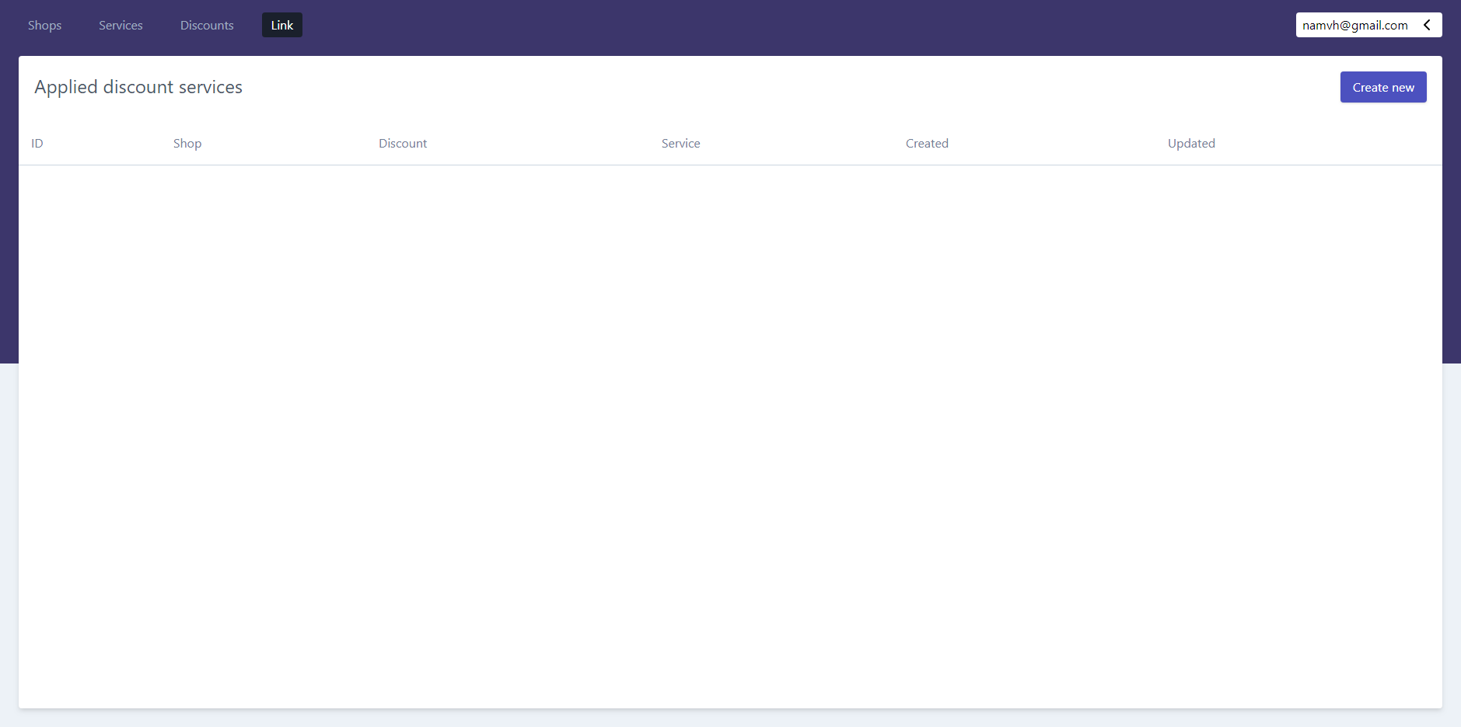

Figure 172 - <UI Design> View Link Discounts List

* **Fields**

|  |  |  |  |  |  |  |
| --- | --- | --- | --- | --- | --- | --- |
| **No** | **Field Name** | **Description** | **Read-only** | **Mandatory** | **Control Type** | **Data Type** |
| 1 | ID | ID of applied discount | Yes | Yes | Text | String |
| 2 | Shop | Name of shop | Yes | Yes | Text | String |
| 3 | Discount | Code of discount | Yes | Yes | Text | String |
| 4 | Service | Service that applies the discount | Yes | Yes | Text | String |
| 5 | Created | Date created of service | Yes | No | Text | Datetime |
| 6 | Update | Date updated of service | Yes | Yes | Text | Datetime |

Table 165- <UI Design> View Link Discounts List Fields

* **Button**

|  |  |  |  |  |
| --- | --- | --- | --- | --- |
| **No** | **Function** | **Description** | **Validation** | **Outcome** |
| 7 | Create new | Create new | N/A | Transfer to create new link discount’s screen |

Table 166- <UI Design> View Link Discounts List Buttons

#### Create Shop (for Shop owner)

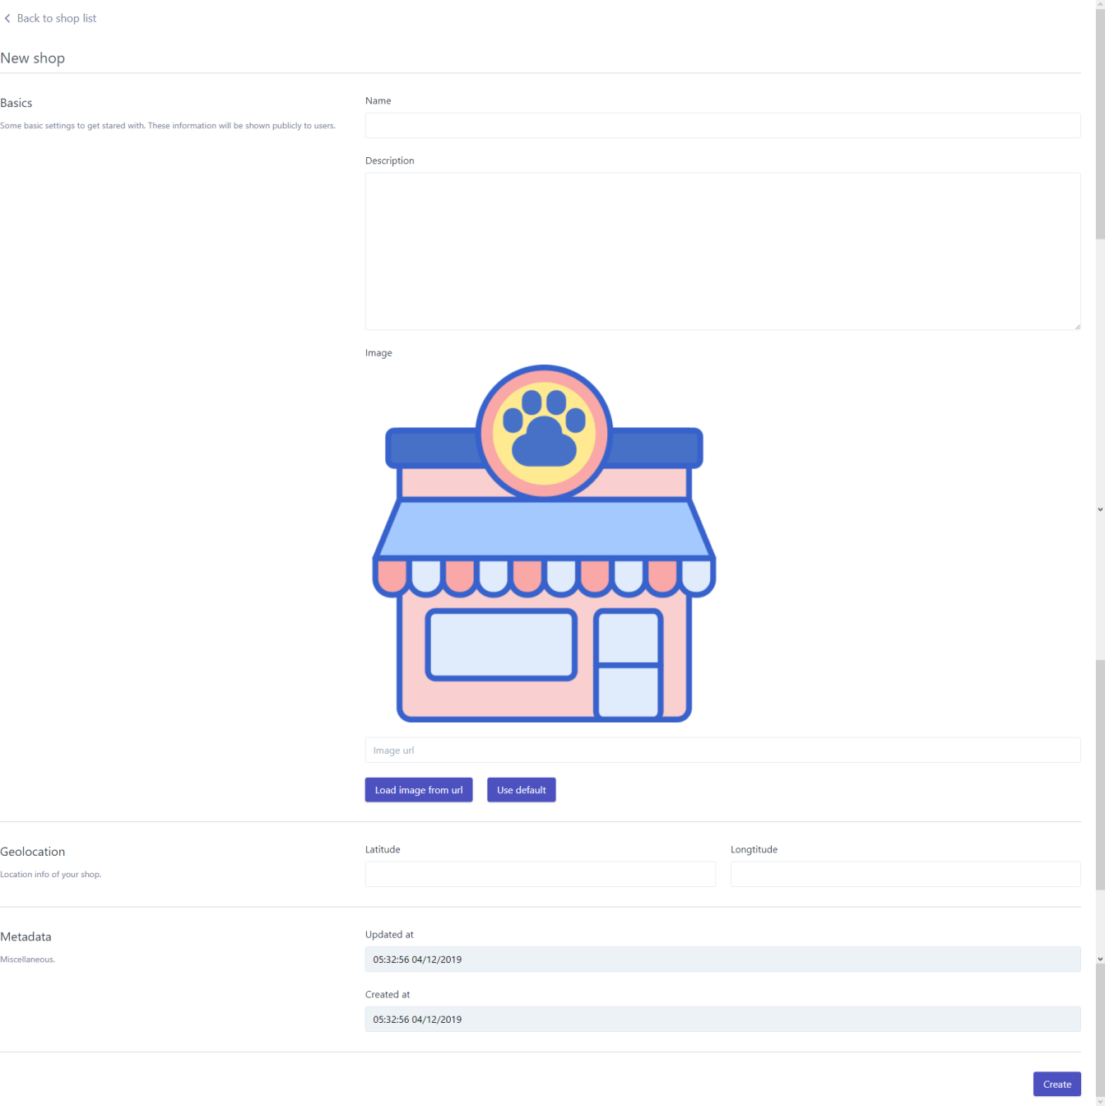

Figure 173- <UI Design> Create Shop (for Shop owner)

* **Fields**

|  |  |  |  |  |  |  |
| --- | --- | --- | --- | --- | --- | --- |
| **No** | **Field Name** | **Description** | **Read only** | **Mandatory** | **Control Type** | **Data Type** |
| 1 | Name | Name of shop | No | Yes | Text | String |
| 2 | Description | Description of shop | No | No | Text | String |
| 3 | Image (Image URL) | Image URL of shop | No | No | Text | String |
| 4 | Lattitude | Latitude of shop | No | Yes | Text | String |
| 5 | Longtitude | Longtitude of shop | No | Yes | Text | String |
| 6 | Update at | Date updated of shop | Yes | Yes | Text | Datetime |
| 7 | Created at | Date created of shop | Yes | Yes | Text | Date |

Table 167- <UI Design> Create Shop (for Shop owner)

* **Button**

|  |  |  |  |  |
| --- | --- | --- | --- | --- |
| **No** | **Function** | **Description** | **Validation** | **Outcome** |
| 8 | Load image from URL | Load the image by the URL | N/A | Shows the image on the screen |
| 9 | Use default | Load the default image | N/A | Shows the default image on the screen |
| 10 | Create | Create new shop successfully | Required | Redirects to shops list’s screen with new created shop |

Table 168- <UI Design> Create Shop (for Shop owner)

#### Create Service

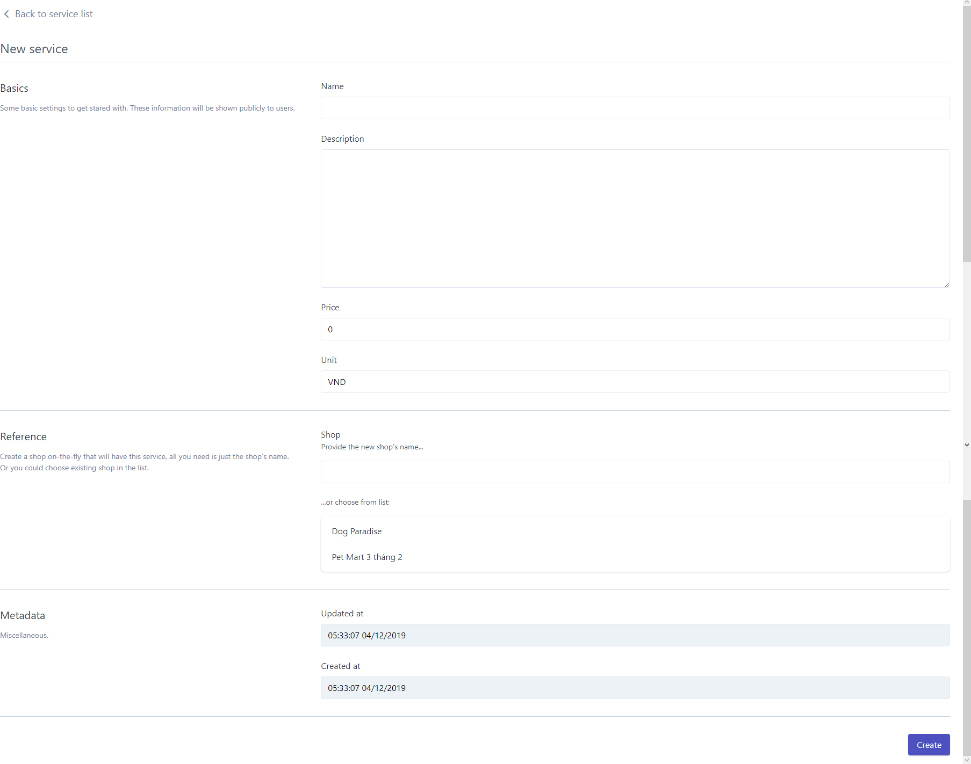

Figure 174- <UI Design> Create Service

* **Fields**

|  |  |  |  |  |  |  |
| --- | --- | --- | --- | --- | --- | --- |
| **No** | **Field Name** | **Description** | **Read only** | **Mandatory** | **Control Type** | **Data Type** |
| 1 | Name | Name of service | No | Yes | Text | String |
| 2 | Description | Description of service | No | No | Text | String |
| 3 | Price | Price of service | No | Yes | Text | Int |
| 4 | Unit | Unit price of service | No | Yes | Text | String |
| 5 | Shop name | New shop name to add service into | No | Yes | Text | String |
| 6 | Shop list | List of existed shops to add service into | No | Yes | Select | String |
| 7 | Updated at | Updated time of service | Yes | Yes | Text | Datetime |
| 8 | Created at | Created time of service | Yes | Yes | Text | Datetime |

Table 169- <UI Design>Create Service Fields

* **Button**

|  |  |  |  |  |
| --- | --- | --- | --- | --- |
| **No** | **Function** | **Description** | **Validation** | **Outcome** |
| 3 | Create | Create new service successfully | Required | Redirects to services list’s screen with new created service |

Table 170- <UI Design>Create Service Button

#### Create Discount

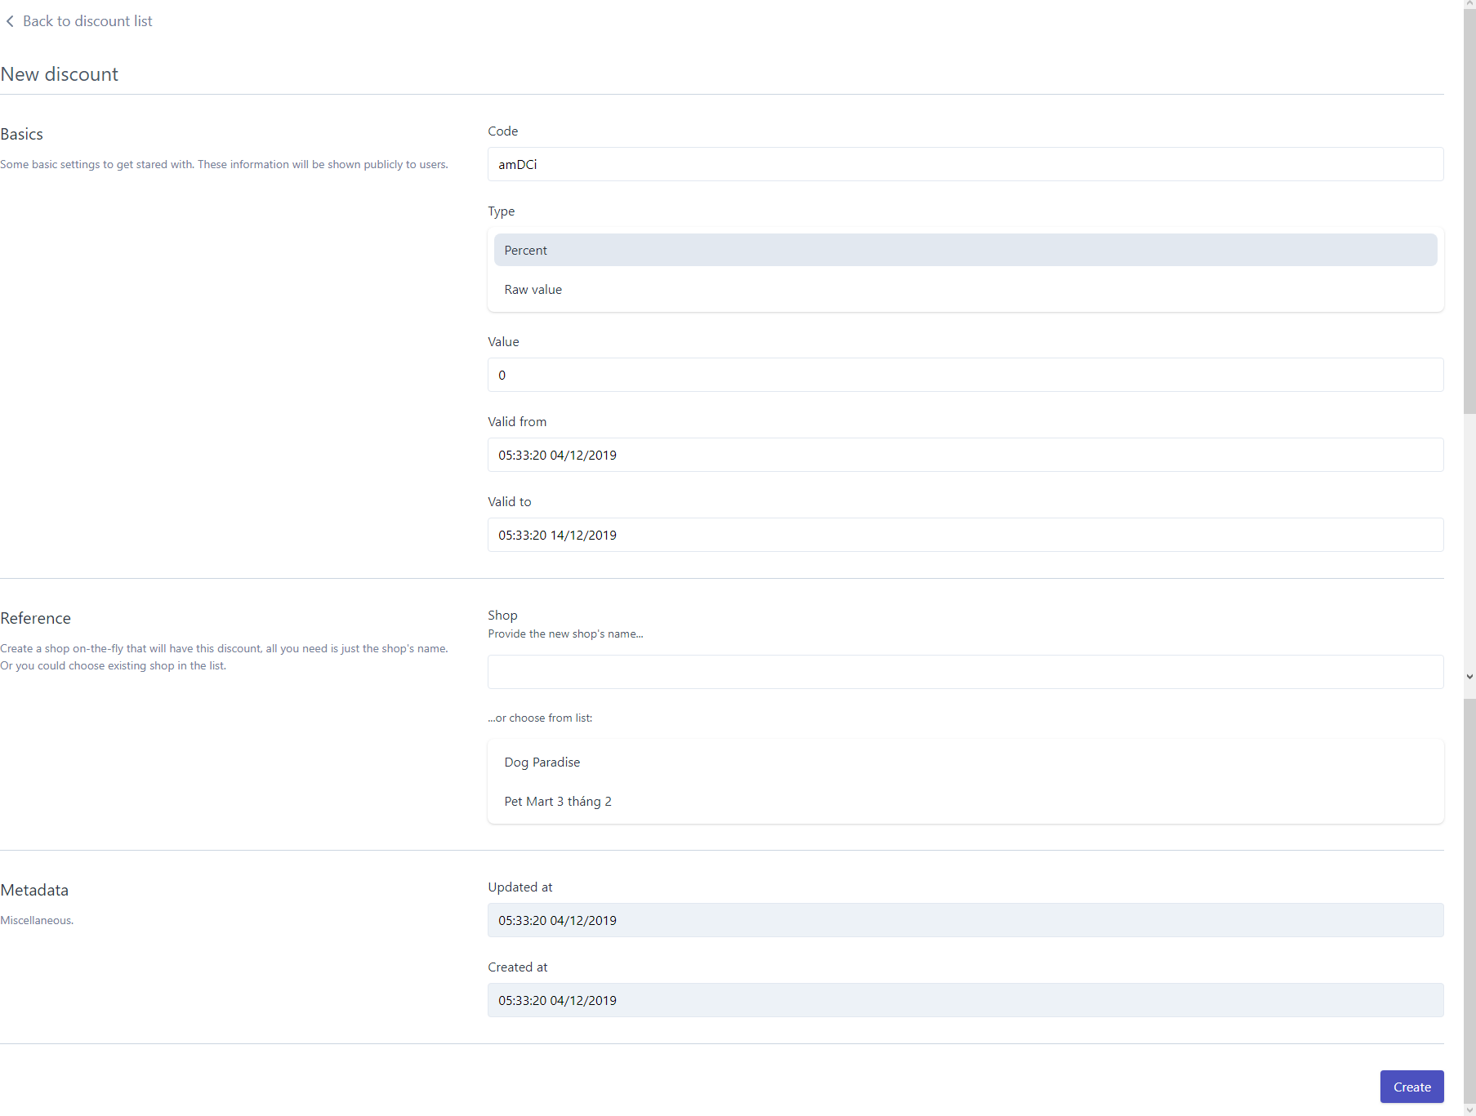

Figure 175- <UI Design> Create Discount

* **Fields**

|  |  |  |  |  |  |  |
| --- | --- | --- | --- | --- | --- | --- |
| **No** | **Field Name** | **Description** | **Read only** | **Mandatory** | **Control Type** | **Data Type** |
| 1 | Code | Code of discount | No | Yes | Text | String |
| 2 | Type | Type of discount | No | Yes | Text | String |
| 3 | Value | Price of discount | No | Yes | Text | Int |
| 3.1 | Unit (if Raw value type is selected) | Unit price of discount | No | Yes | Text | String |
| 4 | Valid from | Date that discount is valid from | Yes | Yes | Text | Datetime |
| 5 | Valid until | Date that discount is valid to | Yes | Yes | Text | Datetime |
| 6 | Shop name | New shop name to add discount into | No | Yes | Text | String |
| 7 | Shop list | List of existed shops to add discount into | No | Yes | Select | String |
| 8 | Updated at | Updated time of discount | Yes | Yes | Text | Datetime |
| 9 | Created at | Created time of discount | Yes | Yes | Text | Datetime |

Table 171- <UI Design>Create Discount Fields

* **Button**

|  |  |  |  |  |
| --- | --- | --- | --- | --- |
| **No** | **Function** | **Description** | **Validation** | **Outcome** |
| 3 | Create | Create new discount successfully | Required | Redirects to discounts list’s screen with new created discount |

Table 172- <UI Design>Create Discount Button

#### Create Link Discounts List

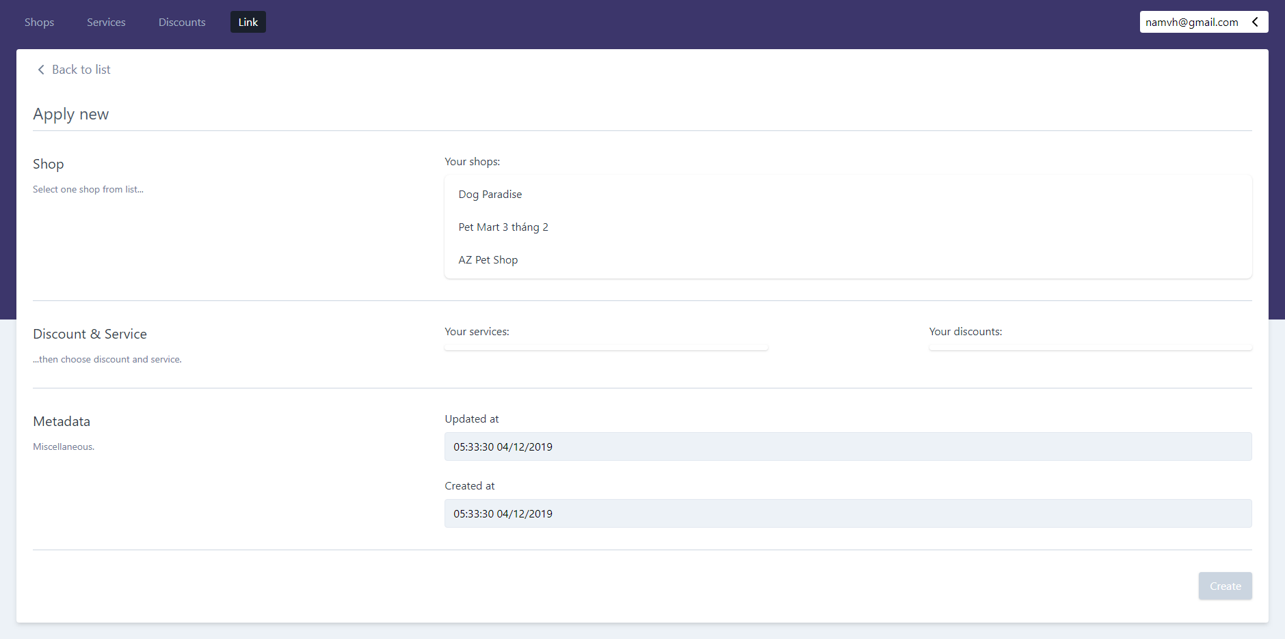

Figure 176 - <UI Design> Create Link Discounts List

* **Fields**

|  |  |  |  |  |  |  |
| --- | --- | --- | --- | --- | --- | --- |
| **No** | **Field Name** | **Description** | **Read-only** | **Mandatory** | **Control Type** | **Data Type** |
| 1 | Your shop | List of shops | No | Yes | Select | String |
| 2 | Your services | List of services of the shop | No | Yes | Select | String |
| 3 | Your discount | List of existed discount | No | Yes | Select | String |
| 4 | Created at | Date created of applied discount | Yes | Yes | Text | Datetime |
| 5 | Update at | Date updated of applied discount | Yes | Yes | Text | Datetime |

Table 173- <UI Design> Create Link Discounts List Fields

* **Button**

|  |  |  |  |  |
| --- | --- | --- | --- | --- |
| **No** | **Function** | **Description** | **Validation** | **Outcome** |
| 3 | Create | Create new link discount successfully | Required | Redirects to link discounts list’s screen with new created link discount |

Table 174- <UI Design>Create Link Discount Button

## Database Design

### Entity Relationship Diagram (ERD)

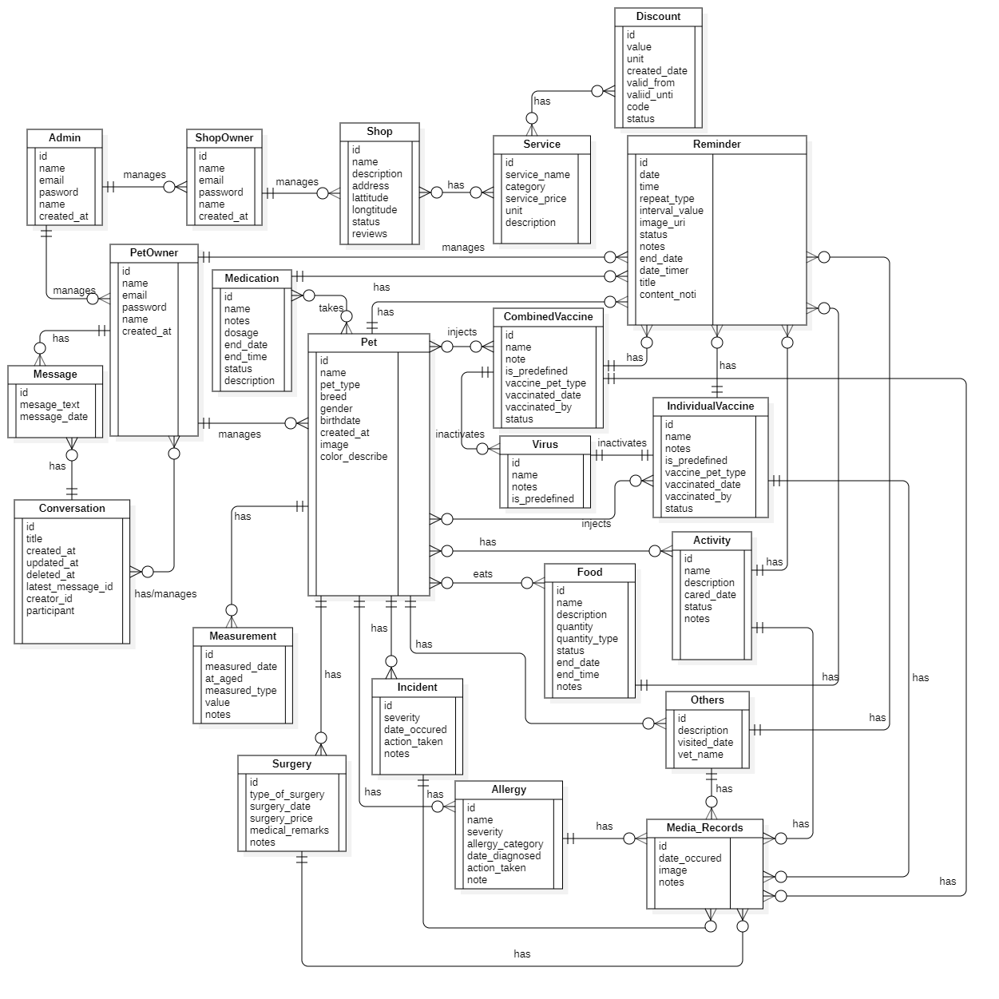

Figure - Entity Relationship Diagram

### Entity Dictionary

| **Entity Data Dictionary: Describe content of all entities** | | |
| --- | --- | --- |
| **Entity Name** | **Mapping entity with conceptual diagram** | **Description** |
| Admin | Admin | Contains information of admin. |
| ShopOwner | Shop owner | Contains information of shop owner. |
| PetOwner | Pet owner | Contains information of pet owner. |
| Pet | Pet | Contains information of pet and the relevant attributes. |
| Food | Food | Contains information of the food. |
|  |  |  |
| Medication | Medication | Contains information of the medication. |
| IndividualVaccine | Individual Vaccine | Contains information of the individual vaccine. |
| CombinedVaccine | CombinedVaccine | Contains information of the combined vaccine. |
| Virus | Virus | Contains information of the virus. |
| Activity | Activity | Contains information of the activity. |
| Incident | Incident | Contains information of the incident. |
| Surgery | Surgery | Contains information of the surgery. |
| Allergy | Allergy | Contains information of the allergy. |
| Others | Others | Contains information of the other activities. |
| Measurement | Measurement | Contains information of the measurements. |
| Media\_Records | Media\_Records | Contains information of the activity. |
| Reminder | Reminder | Contains information of reminder and the relevant attributes. |
| Shop | Shop | Contains information of pet shop. |
| Service | Service | Contains information of services of the pet shop and the relevant attributes. |
| Discount | Discount | Contains information of discount. |
| Message | Message | Contains information of message in the chat box and the relevant attributes. |
| Conversation | Conversation | Contains information of the group chat conversation and the relevant attributes. |

Table 175 - Entity Data Dictionary

## Algorithms

### Suggesting users the other owners that have the similar pet types and pet breeds

#### Definition

This purpose of this algorithm is to help the user find the other pet owners which have the similar pet types or breeds by suggesting in the “Social” tab. This will also help the users contact with the other pet owners through the chat system and have conversation about their pets.

#### Problem

The users using our system are prone to be informed of other pet owners which have the similar pet types, so that they can make acquaintances to discuss and talk about the pet. By acquiring the information on the pets that the user has inputted into the application, the algorithm will then provide the method to help the user find other appropriate interested partners.

#### Solution

The Jaccard’s coefficient is used to measure the similarity between users. By considering two factors: the pet type and the pet breed, the algorithm will base on the information of the pets that the pet owners has input into the application. We will then calculate and through the results, will then sort and display the suggestions to the users on the top list of the system screen.

To suggest the appropriate pet owner, we use the formula:

Where:

p: the number of similarities that are positive between two considered pet owner

q: the number of pets that the ith pet owner has but the jth pet owner doesn’t have

r: the number of pets that the jth pet owner has but the ithpet owner doesn’t have

v: the Jaccard’s coefficient value between the ith pet owner and the jth pet owner

#### Example

First, we have list of pet owners with the information of the pet they have. The information is displayed in the matrix:

|  |  |  |
| --- | --- | --- |
| **Factor**  **Pet owner** | **Dog** | **Cat** |
| A | 1 | 0 |
| B | 1 | 0 |
| C | 1 | 0 |
| D | 1 | 0 |
| E | 0 | 1 |

|  |  |  |  |  |
| --- | --- | --- | --- | --- |
| **Factor**  **Pet owner** | **Akita** | **Pug** | **Husky** | **Egyptian Cat** |
| A | 1 | 1 | 1 | 0 |
| B | 1 | 1 | 0 | 0 |
| C | 1 | 0 | 0 | 0 |
| D | 0 | 0 | 1 | 0 |
| E | 0 | 0 | 0 | 1 |

Table 176 – The matrix information of the pet type and breed each user has

We consider the pet owner A is the main user of our system in this scenario. The remaining pet owners are the users that are on the list of suggestion to the main user.

The factors are divided into 2 categories: pet type and pet breed.

For Dog pet type, we list out the following breeds: Akita, Pug, Husky.

For Cat pet type, we have Egyptian breed.

We use the binary values to denote whether the pet owner has the pet type or pet breed that is similar with the other pet owners. 1 is denoted as the pet owner having the pet type/breed in the application, 0 is denoted as the pet owner not having the pet with that type/breed.

Based on the data on the matrix, we have the coordinates of each pet owner:

By Type:

Pet owner A coordinate = {1, 0}

Pet owner B coordinate = {1, 0}

Pet owner C coordinate = {1, 0}

Pet owner D coordinate = {1, 0}

Pet owner E coordinate = {0, 1}

By Breed:

Pet owner A coordinate = {1, 1, 1, 0}

Pet owner B coordinate = {1, 1, 0, 0}

Pet owner C coordinate = {1, 0, 0, 0}

Pet owner D coordinate = {0, 0, 1, 0}

Pet owner E coordinate = {0, 0, 0, 1}

We calculate the similarity of pet owner A with the other pet owner B by:

First we define p, q, r for pet type:

With p = 1

A = {1, 0}

B = {1, 0}

With q = 0

A = {1, 0}

B = {1, 0}

With r = 0

A = {1, 0}

B = {1, 0}

After that, we calculated the v value of pet type by the Jaccard’s formula:

Similarly, we have:

And then, we define p, q, r for pet breed:

With p = 2:

A = {1, 1, 1, 0}

B = {1, 1, 0, 0}

With q = 1:

A = {1, 1, 1, 0}

B = {1, 1, 0, 0}

With r = 0:

A = {1, 1, 1, 0}

B = {1, 1, 0, 0}

Secondly, we calculate the v value of pet breed by the Jaccard’s formula:

Similarly, we have:

The result value of the pet owner A and pet owner B is the highest of all, therefore the similarity of these two pet owners is the closest. The system will first calculate the v value of pet type and then list out the users with value greater than 0, then the system will continue to calculate the v value of pet breed by the list of users from the calculation of pet type and sort by descending the list of suggesting users with v value greater than 0.

#### Complexity

In total, the complexity of this algorithm is O[Mx(N-1)].

With:

* M is the column of the matrix.
* N is the row of the matrix.
* Actual complexity is O(n2-n).

#### Flowchart

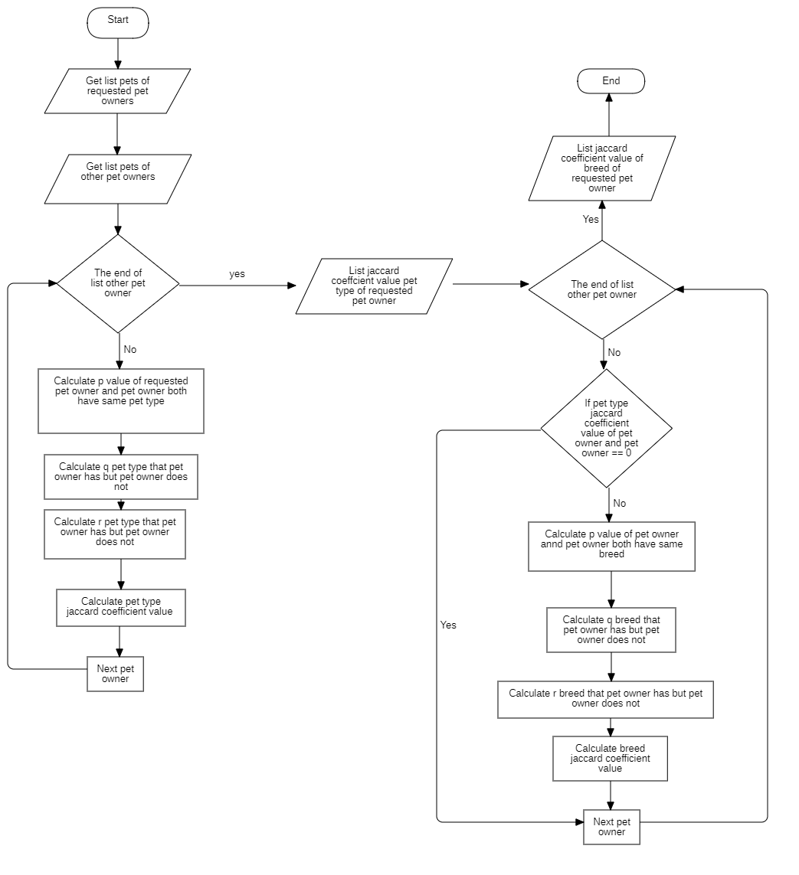

Figure 177-Suggesting pet owner algorithm

# E. System Implementation & Testing

Introduction

### Overview

This section describes the conducts on complete integrate system to evaluate our **Pet Care** system process.

It adds up all necessary information about implementation and testing phase of Pet Care system with test cases/plans, test results with pass/fail criteria also the steps to fulfill all possible cases.

### Test Approach

* **Goal:** Test the core flow of the Pet Care system with an mobile application and a web-admin application.
* **Method:** Black-box testing

## 

## Database Relationship Diagram

### Physical Diagram

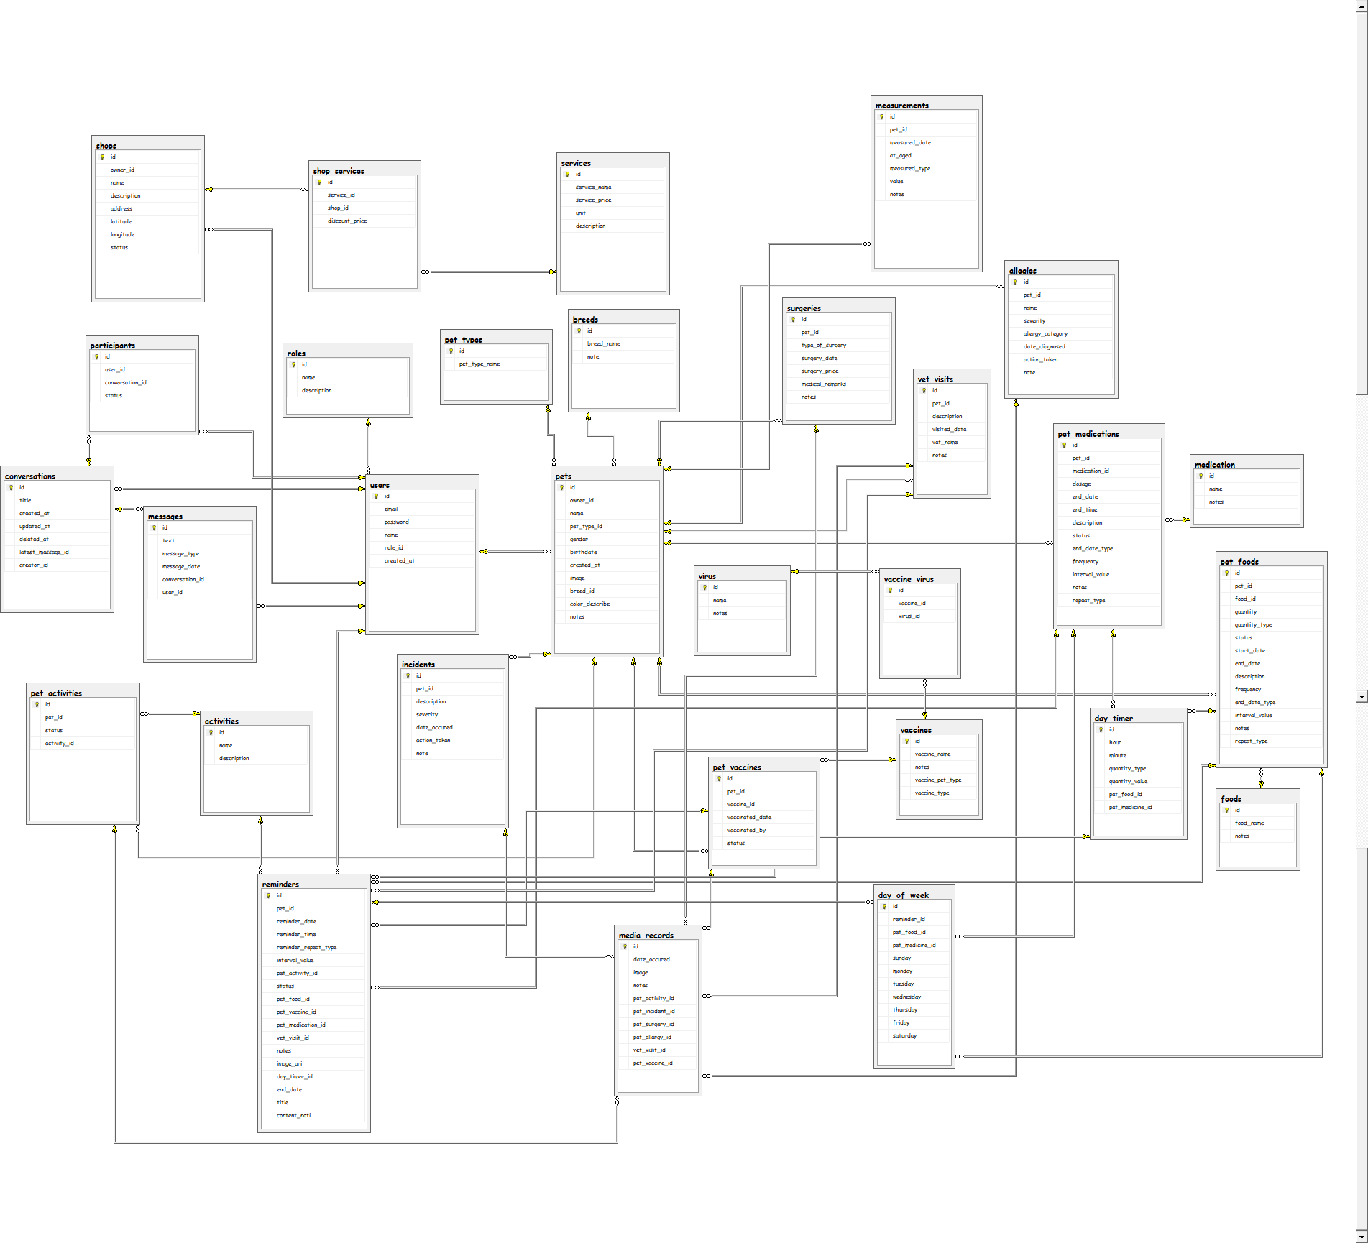

Database Diagram

### Data Dictionary

| **Entity Data Dictionary: Describe content of all entities** | | |
| --- | --- | --- |
| **Entity Name** | **Mapping table with class diagram** | **Description** |
| **Users** | User | Contains the information of user |
| **Roles** | N/A | Contains the information of user’s role |
| **Pets** | Pet | Contains the information of pet |
| **Breeds** | N/A | Contains the information of pet breed |
| **Pet\_Types** | N/A | Contains the information of pet type |
| **Foods** | Foods | Contains the information of food |
| **Vaccines** | Vaccines | Contains the information of vaccine |
| **Medications** | Medications | Contains the information of medication |
| **Measurements** | Measurements | Contains the information of pet’s measurement record |
| **Surgeries** | Surgeries | Contains the information of pet’s surgeries record |
| **Allergies** | Allergies | Contains the information of pet’s allergies record |
| **Incidents** | Incidents | Contains the information of pet’s incidents record |
| **VetVisits** | VetVisits | Contains the information of pet vet visitings record |
| **Activities** | Activities | Contains the information of pet caring activitiy |
| **Reminders** | Reminders | Contains the information of reminder |
| **Viruses** | Viruses | Contains the information of virus |
| **Pet\_Foods** | Pet\_Foods | Contains the information of food for specified pet |
| **Pet\_Vaccines** | Pet\_Vaccines | Contains the information of vaccnine for specified pet |
| **Pet\_Medications** | Pet\_Medications | Contains the information of medication for specified pet |
| **Pet\_Activities** | Pet\_Activities | Contains the information of activity for specified pet |
| **Pet\_Activity\_Histories** | Pet\_Activity\_Histories | Contains the information of activity history for specified pet |
| **Vaccines\_Virurses** | Vaccines\_Virurses | Contains the information of vaccines for specified virus treatment |
| **Particitpants** | Particitpants | Contains the information of participant of the group chat conversation |
| **Messages** | Messages | Contains the information of message |
| **Conversations** | Conversations | Contains the information of the group chat conversation |
| **Shops** | Shops | Contains the information of pet shop |
| **Services** | Services | Contains the information of service of the pet shop |
| **Shop\_Services** | Shop\_Services | Contains the information of service for specified pet shop |

Table 177 Physical Diagram Data Dictionary

| **Table Name** | **Attributes** | **Description** | **Domain** | **Allow Null** |
| --- | --- | --- | --- | --- |
| Activities | Id | Unique identifier of activity | Integer | No |
| Name | Name of activity | String | No |
| Description | Description of activity | String | Yes |
| Allergies | Id | Unique identifier of allergy | Integer | No |
| Pet\_id | Unique identifier of pet | Integer | No |
| Name | Name of allergy | String | No |
| Severity | Severity of allergy | Integer | No |
| Allergy\_category | Category of allergy | Interger | No |
| Date\_diagnosed | Date the allergy is diagnosed | Date | No |
| Action\_taken | Action taken when happened | String | No |
| Note | Note of allergy | String | Yes |
| Breeds | Id | Unique identifier of breed | Integer | No |
| Breed\_name | Name of breed | String | No |
| Note | Note of breed | String | Yes |
| Name | Name of category | String | No |
| City | Name of city | String | No |
| Conversations | Id | Unique identifier of conversation | Integer | No |
| Title | Title of conversation | Integer | No |
| Channel\_id | Unique identifier of conversation |  | No |
| Created\_at | Date and time conversation was created | DateTime | No |
| Updated\_at | Date and time conversation was updated | DateTime | No |
| Deleted\_at | Date and time conversation was deleted | DateTime | No |
| Latest\_message\_id | Unique identifier of latest message | Integer | No |
| Is\_group | Conversation is a group or individual | Integer | No |
| Creator\_id | Unique identifier of creator | Integer | No |
| District | Name of district | String | No |
| City\_id | Unique identifier of city | Integer | No |
| Foods | Id | Unique identifier of food | Integer | No |
| Food\_name | Name of food | String | No |
| Notes | Note of food | String | Yes |
| Incidents | Id | Unique identifier of incident | Integer | No |
| Pet\_id | Unique identifier of pet | Integer | No |
| Description | Description of incident | String | No |
| Severity | Severity of incident | Integer | No |
| Date\_occured | Date the incident occured | Date | No |
| Action\_taken | Action taken when incident happened | String | No |
| Note | Note of incident | String | Yes |
| Measurements | Id | Unique identifier of measurement | Integer | No |
| Pet\_id | Unique identifier of pet | Integer | No |
| Measured\_date | Date the measurement was taken | Date | No |
| At\_age | Age of pet the measurement was taken | Date | No |
| Measured\_type | Type of measurement | Integer | No |
| Value | Value of measurement | Integer | No |
| Notes | Note of measurement | String | Yes |
| Medication | Id | Unique identifier of medication | Integer | No |
| Name | Name of medication | String | No |
| Notes | Note of medication | String | Yes |
| Messages | Id | Unique identifier of message | Integer | No |
| Text | Text of message | String | No |
| Message\_type | Type of message | Integer | No |
| Message\_date | Date and time the message was sent | DateTime | No |
| Conversation\_id | Unique identifier of conversation | Integer | No |
| User\_id | Unique identifier of user | Integer | No |
| Participants | Id | Unique identifier of participant | Integer | No |
| Conversation\_id | Unique identifier of conversation | Integer | No |
| User\_id | Unique identifier of user | Integer | No |
| Status | Status of participant | String | No |
| Pet\_activities | Id | Unique identifier of pet activity | Integer | No |
| Pet\_id | Unique identifier of pet | Integer | No |
| Activity\_id | Unique identifier of activity | Integer | No |
| Status | Status of pet activity | Integer | No |
| Pet\_activity\_histories | Id | Unique identifier of pet activity history | Integer | No |
| Pet\_id | Unique identifier of pet | Integer | No |
| Care\_activity\_id | Unique identifier of care activity | Integer | No |
| Care\_by | Who took care of the pet | Integer | No |
| Status | Status of the pet activity history | Integer | No |
| Professional\_name | Name of the professional took care of the pet | String | No |
| Cared\_date | Date the pet was cared | Date | No |
| Notes | Note of pet activity history | String | Yes |
| Pet\_foods | Id | Unique identifier of pet food | Integer | No |
| Pet\_id | Unique identifier of pet | Integer | No |
| Food\_id | Unique identifier of food | Integer | No |
| Quantity | Quantity of food | Integer | No |
| Quantity\_type | Type of quantity | Integer | No |
| Status | Status of pet food | Integer | No |
| Taste | Taste of pet food | Integer | No |
| End\_date | Date stop reminding | Date | No |
| End\_time | Time stop reminder | Time | No |
| Description | Description of pet food | String | No |
| Pet\_medications | Id | Unique identifier of pet medication | Integer | No |
| Pet\_id | Unique identifier of pet | Integer | No |
| Medication\_id | Unique identifier of medication | Integer | No |
| Dosage | Dosage of medication | String | No |
| End\_date | Date stop using medication | Date | No |
| End\_time | Time stop using medication | Time | No |
| Description | Description of pet medication | String | No |
| Status | Status of pet medication | Integer | No |
| Pet\_types | Id | Unique identifier of pet type | Integer | No |
| Pet\_type\_name | Name of pet type | String | No |
| Pet\_vaccines | Id | Unique identifier of pet vaccine | Integer | No |
| Pet\_id | Unique identifier of | Integer | No |
| Vaccine\_id | Unique identifier of | Integer | No |
| Vaccinated\_date | Date the pet was vaccinated | Date | No |
| Vaccinated\_by | Who vaccinated the pet | String | No |
| Status | Status of the pet vaccine | String | No |
| Pets | Id | Unique identifier of pet | Integer | No |
| Owner\_id | Unique identifier of owner | Integer | No |
| Name | Name of pet | String | No |
| Pet\_type\_id | Unique identifier of pet type | Integer | No |
| Gender | Gender of pet | Integer | No |
| Birthdate | Birthdate of pet | Date | No |
| Created\_at | Date the pet was added | String | No |
| Image | Image of pet | String | No |
| Breed\_id | Unique identifier of breed | Integer | No |
| Color\_describe | Color of pet | String | Yes |
| Notes | Note of pet | String |  |
| Reminders | Id | Unique identifier of reminder | Integer | No |
| Pet\_id | Unique identifier of pet | Integer | No |
| Reminder\_date | Date of the reminder | Date | No |
| Reminder\_time | Time of the reminder | Time | No |
| Reminder\_repeat\_type | Type of repetition of the reminder | Integer | No |
| Interval\_value | Interval value of repetition | Integer | No |
| Pet\_activity\_id | Unique identifier of pet activity | Integer | No |
| Status | Status of reminder | Integer | No |
| Pet\_food\_id | Unique identifier of pet food | Integer | No |
| Pet\_vaccine\_id | Unique identifier of pet vaccine | Integer | No |
| Pet\_medication\_id | Unique identifier of pet medication | Integer | No |
| Vet\_visit\_id | Unique identifier of vet visit | Integer | No |
| Notes | Note of reminder | String | Yes |
| Image\_uri | Image of reminder | String | Yes |
| Pet\_activity\_history\_id | Unique identifier of pet activity history | Integer | No |
| Roles | Id | Unique identifier of role | Integer | No |
| Name | Name of role | String | No |
| Description | Description of role | String | No |
| Services | Id | Unique identifier of service | Integer | No |
| Service\_name | Name of service | String | No |
| Service\_price | Price of service | Float | No |
| Category\_id | Unique identifier of category | Integer | No |
| Unit | Unit of service | String | No |
| Description | Description of service | String | No |
| Shop\_services | Id | Unique identifier of shop service | Integer | No |
| Service\_id | Unique identifier of service | Integer | No |
| Shop\_id | Unique identifier of shop | Integer | No |
| Discount\_price | Discount price of shop service | Float | No |
| Shops | Id | Unique identifier of shop | Integer | No |
| Owner\_id | Unique identifier of owner | Integer | No |
| Name | Name of shop | String | No |
| Description | Description of shop | String | No |
| Address | Address of shop | String | No |
| District\_id | Unique identifier of disctrict | Integer | No |
| Latitude | Latitude of shop | Integer | No |
| Longtitude | Longtitude of shop | Integer | No |
| Status | Status of shop | Integer | No |
| Place\_id | Unique identifier of place | String | No |
| Surgeries | Id | Unique identifier of surgery | Integer | No |
| Pet\_id | Unique identifier of pet | Integer | No |
| Type\_of\_surgery | Type of surgery | String | No |
| Surgery\_date | Date of surgery | Date | No |
| Surgery\_price | Price of surgery | String | No |
| Medical\_remarks | Medical remarks from doctor | String | Yes |
| Notes | Note of surgery | String | Yes |
| Tags | Id | Unique identifier of tag | Integer | No |
| Tag\_name | Name of tag | String | No |
| Users | Id | Unique identifier of user | Integer | No |
| Email | Email of user | String | No |
| Password | Password of user | String | No |
| Name | Name of user | String | No |
| Role\_id | Unique identifier of role | Integer | No |
| Created\_at | Date the user registered | String | No |
| Vaccines | Id | Unique identifier of vaccine | Integer | No |
| Vaccine\_name | Name of vaccine | String | No |
| Notes | Note of vaccine | String | No |
| Vaccine\_type | Type of vaccine | Integer | No |
| Vaccine\_pet\_type | Type of vaccine pet | Integer | No |
| Vaccines\_viruses | Vaccine\_id | Unique identifier of vaccine | Integer | No |
| Virus\_id | Unique identifier of virus | Integer | No |
| Id | Unique identifier of vaccine virus | Integer | No |
| Vet\_visits | Id | Unique identifier of vet visit | Integer | No |
| Pet\_id | Unique identifier of pet | Integer | No |
| Description | Description of vet visit | String | No |
| Visited\_date | Date of vet visit | Date | No |
| Vet\_name | Name of vet | String | No |
| Notes | Note of vet visit | String | Yes |
| Viruses | Id | Unique identifier of virus | Integer | No |
| Virus\_name | Name of virus | String | No |
| Notes | Virus | String | Yes |

Table 178 Database Data Dictionary

## 

## Test Plan

The overall purpose of testing is to ensure Pet Care system meets its entire technical, functional and business requirement. The purpose of this document is to describe the test plan and strategy for testing the Pet Care system. The following part will describe which features to be tested and which will not.

### Feature to be tested

* **Guest**: Login
* **Admin**: Create Account, Deactivate Account, Create Shop, Deactivate Shop, Create Breed, Edit Breed, Create Virus, Edit Virus, Create Medicine, Edit Medicine, Create Vaccine, Edit Vaccine
* **Shop Owner**: Create Shop, Edit Shop, Create Service, Edit Service, Create Discount, Edit Discount, Create Link, Edit Link
* **Pet Owner**: Login, Register, Add Pet, Edit Pet, Add Hygenic Reminder, Add Food Reminder, Add Medication Reminder, Add Periodic Maintenance Reminder, Add Vaccination Reminder, Update Hygenic Reminder, Update Food Reminder, Update Medication Reminder, Update Periodic Maintenance Reminder, Update Vaccination Reminder, Add Others Reminder, Update Others Reminder, Add Vaccination History, Add Surgery History, Add Allergy History, Add Incidents History, Update Vaccination History, Update Surgery History, Update Allergy History, Update Incidents History

### Features not to be tested

Shop, Social

## System Testing Test Case

### Test Case

#### Web System Test Cases

##### <Guest> Login

|  |  |  |  |  |  |  |  |
| --- | --- | --- | --- | --- | --- | --- | --- |
| ID | Test Case Description | Precondition | Test case procedure | Expected output | Inner-test case dependence | Result | Test Date |
| LI\_1 | Login successfully | Guest is at “Login” screen | 1. Enter Email  2. Enter Password  3. Tap “Sign in” | System shows message “Login successfully!” | N/A | Passed | 12/11/2019 |
| LI\_2 | Inputted data is blank | Guest is at “Login” screen | 1. Not enter Email  2. Enter Password  3. Tap “Sign in” | System shows error message “This field is required!” | N/A | Passed | 12/11/2019 |
| LI\_3 | Check wrong format inputted data | Guest is at “Login” screen | 1. Enter Email “12345”  2. Enter Password  3. Tap “Sign in” | System shows error message “Please input correct format.” | N/A | Passed | 12/11/2019 |

Table 179 - Login

##### <Admin>Create New Shop

|  |  |  |  |  |  |  |  |
| --- | --- | --- | --- | --- | --- | --- | --- |
| ID | Test Case Description | Precondition | Test case procedure | Expected output | Inner-test case dependence | Result | Test Date |
| SH\_1 | Create new shop successfully | Admin is at “Create new shop” screen | 1. Enter user ID  2. Choose status  3. Enter name  4. Enter description (optional)  5. Choose image (optional)  6. Enter geolocation  7. Tap “Create” | System shows list of shops with newly created shop | N/A | Passed | 12/11/2019 |
| SH\_2 | Inputted data is blank | Admin is at “Create new shop” screen | 1. Leave user ID blank  2. Choose status  3. Leave name blank  4. Enter description (optional)  5. Choose image (optional)  6. Enter geolocation (optional)  7. Tap “Create” | System shows error message “This field is required!” | N/A | Passed | 12/11/2019 |
| SH\_3 | Check wrong format inputted data | Admin is at “Create new shop” screen | 1. Enter user ID with wrong format  2. Choose status  3. Enter name with wrong format  4. Enter description (optional)  5. Choose image (optional)  6. Enter geolocation  7. Tap “Create” | System shows error message “Please input correct format.” | N/A | Passed | 12/11/2019 |
| SH\_4 | Create new duplicate shop | Admin is at “Create new shop” screen | 1. Enter user ID  2. Choose status  3. Enter name of shop this user already has  4. Enter description (optional)  5. Choose image (optional)  6. Enter geolocation  7. Tap “Create” | System shows error message “This shop already existed.” | N/A | Passed | 15/11/2019 |

Table 180- Create New Shop

##### <Admin>*Edit Shop*

|  |  |  |  |  |  |  |  |
| --- | --- | --- | --- | --- | --- | --- | --- |
| ID | Test Case Description | Precondition | Test case procedure | Expected output | Inner-test case dependence | Result | Test Date |
| SH\_1 | Edit shop successfully | Admin is at “Edit shop” screen | 1. Enter user ID  2. Choose status  3. Enter name  4. Enter description (optional)  5. Choose image (optional)  6. Enter geolocation  7. Tap “Create” | System shows list of shops with newly edited shop | N/A | Passed | 12/11/2019 |
| SH\_2 | Inputted data is blank | Admin is at “Edit shop” screen | 1. Leave user ID blank  2. Choose status  3. Leave name blank  4. Enter description (optional)  5. Choose image (optional)  6. Enter geolocation (optional)  7. Tap “Create” | System shows error message “This field is required!” | N/A | Passed | 12/11/2019 |
| SH\_3 | Check wrong format inputted data | Admin is at “Edit shop” screen | 1. Enter user ID with wrong format  2. Choose status  3. Enter name with wrong format  4. Enter description (optional)  5. Choose image (optional)  6. Enter geolocation  7. Tap “Create” | System shows error message “Please input correct format.” | N/A | Passed | 12/11/2019 |
| SH\_4 | Edit shop into duplicate shop | Admin is at “Edit shop” screen | 1. Enter user ID  2. Choose status  3. Enter name of shop this user already has  4. Enter description (optional)  5. Choose image (optional)  6. Enter geolocation  7. Tap “Create” | System shows error message “This shop already existed.” | N/A | Passed | 15/11/2019 |

Table 181- Edit Shop

##### <Admin>*Create New Account*

|  |  |  |  |  |  |  |  |
| --- | --- | --- | --- | --- | --- | --- | --- |
| ID | Test Case Description | Precondition | Test case procedure | Expected output | Inner-test case dependence | Result | Test Date |
| AC\_1 | Create new account successfully | Admin is at “Create new account” screen | 1. Enter name  2. Enter email  3. Enter Password  4. Choose role  5. Tap “Create” | System shows list of accounts with newly created account | N/A | Passed | 12/11/2019 |
| AC\_2 | Inputted data is blank | Admin is at “Create new account” screen | 1. Leave name blank  2. Leave email blank  3. Leave Password blank  4. Choose role  5. Tap “Create” | System shows error message “This field is required!” | N/A | Passed | 12/11/2019 |
| AC\_3 | Check wrong format inputted data | Admin is at “Create new account” screen | 1. Enter name with wrong format  2. Enter email with wrong format  3. Enter Password with wrong format  4. Choose role  5. Tap “Create” | System shows error message “Please input correct format.” | N/A | Passed | 12/11/2019 |
| AC\_4 | Create new duplicate account | Admin is at “Create new account” screen | 1. Enter name  2. Enter email that already existed  3. Enter Password  4. Choose role  5. Tap “Create” | System shows error message “This account already existed.” | N/A | Passed | 15/11/2019 |

Table 182- Create new account

##### <Admin>*Create New Breed*

|  |  |  |  |  |  |  |  |
| --- | --- | --- | --- | --- | --- | --- | --- |
| ID | Test Case Description | Precondition | Test case procedure | Expected output | Inner-test case dependence | Result | Test Date |
| BR\_1 | Create new breed successfully | Admin is at “Create new breed” screen | 1. Enter name  2. Enter notes(optional)  3. Choose pet type  4. Tap “Create” | System shows list of breeds with newly created breed | N/A | Passed | 12/11/2019 |
| BR\_2 | Inputted data is blank | Admin is at “Create new breed” screen | 1. Leave name blank  2. Enter notes(optional)  3. Choose pet type  4. Tap “Create” | System shows error message “This field is required!” | N/A | Passed | 12/11/2019 |
| BR\_3 | Check wrong format inputted data | Admin is at “Create new breed” screen | 1. Enter name with wrong format  2. Enter notes(optional)  3. Choose pet type  4. Tap “Create” | System shows error message “Please input correct format.” | N/A | Passed | 12/11/2019 |
| BR\_4 | Create new duplicate breed | Admin is at “Create new breed” screen | 1. Enter name of pet that already existed  2. Enter notes(optional)  3. Choose pet type  4. Tap “Create” | System shows error message “This breed already existed.” | N/A | Passed | 15/11/2019 |

Table 183- Create new breed

##### <Admin>*Edit Breed*

|  |  |  |  |  |  |  |  |
| --- | --- | --- | --- | --- | --- | --- | --- |
| ID | Test Case Description | Precondition | Test case procedure | Expected output | Inner-test case dependence | Result | Test Date |
| BR\_1 | Edit breed successfully | Admin is at “Edit breed” screen | 1. Enter name  2. Enter notes(optional)  3. Choose pet type  4. Tap “Create” | System shows list of breeds with newly created breed | N/A | Passed | 12/11/2019 |
| BR\_2 | Inputted data is blank | Admin is at “Edit breed” screen | 1. Leave name blank  2. Enter notes(optional)  3. Choose pet type  4. Tap “Create” | System shows error message “This field is required!” | N/A | Passed | 12/11/2019 |
| BR\_3 | Check wrong format inputted data | Admin is at “Edit breed” screen | 1. Enter name with wrong format  2. Enter notes(optional)  3. Choose pet type  4. Tap “Create” | System shows error message “Please input correct format.” | N/A | Passed | 12/11/2019 |
| BR\_4 | Edit duplicate breed | Admin is at “Edit breed” screen | 1. Enter name of pet that already existed  2. Enter notes(optional)  3. Choose pet type  4. Tap “Create” | System shows error message “This breed already existed.” | N/A | Passed | 15/11/2019 |

Table 184- Edit breed

##### <Admin>*Create New Medicine*

|  |  |  |  |  |  |  |  |
| --- | --- | --- | --- | --- | --- | --- | --- |
| ID | Test Case Description | Precondition | Test case procedure | Expected output | Inner-test case dependence | Result | Test Date |
| MD\_1 | Create new medicine successfully | Admin is at “Create new medicine” screen | 1. Enter name  2. Enter notes(optional)  3. Tap “Create” | System shows list of medicines with newly created medicine | N/A | Passed | 12/11/2019 |
| MD\_2 | Inputted data is blank | Admin is at “Create new medicine” screen | 1. Leave name blank  2. Enter notes(optional)  3. Tap “Create” | System shows error message “This field is required!” | N/A | Passed | 12/11/2019 |
| MD\_3 | Check wrong format inputted data | Admin is at “Create new medicine” screen | 1. Enter name with wrong format  2. Enter notes(optional)  3. Tap “Create” | System shows error message “Please input correct format.” | N/A | Passed | 12/11/2019 |
| MD\_4 | Create new duplicate medicine | Admin is at “Create new medicine” screen | 1. Enter name of pet that already existed  2. Enter notes(optional)  3. Tap “Create” | System shows error message “This medicine already existed.” | N/A | Passed | 15/11/2019 |

Table 185- Create new medicine

##### <Admin>*Edit Medicine*

|  |  |  |  |  |  |  |  |
| --- | --- | --- | --- | --- | --- | --- | --- |
| ID | Test Case Description | Precondition | Test case procedure | Expected output | Inner-test case dependence | Result | Test Date |
| MD\_1 | Edit medicine successfully | Admin is at “Edit medicine” screen | 1. Enter name  2. Enter notes(optional)  3. Tap “Create” | System shows list of medicines with newly created medicine | N/A | Passed | 12/11/2019 |
| MD\_2 | Inputted data is blank | Admin is at “Edit medicine” screen | 1. Leave name blank  2. Enter notes(optional)  3. Tap “Create” | System shows error message “This field is required!” | N/A | Passed | 12/11/2019 |
| MD\_3 | Check wrong format inputted data | Admin is at “Edit medicine” screen | 1. Enter name with wrong format  2. Enter notes(optional)  3. Tap “Create” | System shows error message “Please input correct format.” | N/A | Passed | 12/11/2019 |
| MD\_4 | Edit duplicate medicine | Admin is at “Edit medicine” screen | 1. Enter name of pet that already existed  2. Enter notes(optional)  3. Tap “Create” | System shows error message “This medicine already existed.” | N/A | Passed | 15/11/2019 |

Table 186 - Edit medicine

##### <Admin>*Create New Virus*

|  |  |  |  |  |  |  |  |
| --- | --- | --- | --- | --- | --- | --- | --- |
| ID | Test Case Description | Precondition | Test case procedure | Expected output | Inner-test case dependence | Result | Test Date |
| VR\_1 | Create new virus successfully | Admin is at “Create new virus” screen | 1. Enter name  2. Enter notes(optional)  3. Tap “Create” | System shows list of viruss with newly created virus | N/A | Passed | 12/11/2019 |
| VR\_2 | Inputted data is blank | Admin is at “Create new virus” screen | 1. Leave name blank  2. Enter notes(optional)  3. Tap “Create” | System shows error message “This field is required!” | N/A | Passed | 12/11/2019 |
| VR\_3 | Check wrong format inputted data | Admin is at “Create new virus” screen | 1. Enter name with wrong format  2. Enter notes(optional)  3. Tap “Create” | System shows error message “Please input correct format.” | N/A | Passed | 12/11/2019 |
| VR\_4 | Create new duplicate virus | Admin is at “Create new virus” screen | 1. Enter name of pet that already existed  2. Enter notes(optional)  3. Tap “Create” | System shows error message “This virus already existed.” | N/A | Passed | 15/11/2019 |

Table 187- Create new virus

##### <Admin>*Edit Virus*

|  |  |  |  |  |  |  |  |
| --- | --- | --- | --- | --- | --- | --- | --- |
| ID | Test Case Description | Precondition | Test case procedure | Expected output | Inner-test case dependence | Result | Test Date |
| VR\_1 | Edit virus successfully | Admin is at “Edit virus” screen | 1. Enter name  2. Enter notes(optional)  3. Tap “Create” | System shows list of viruss with newly created virus | N/A | Passed | 12/11/2019 |
| VR\_2 | Inputted data is blank | Admin is at “Edit virus” screen | 1. Leave name blank  2. Enter notes(optional)  3. Tap “Create” | System shows error message “This field is required!” | N/A | Passed | 12/11/2019 |
| VR\_3 | Check wrong format inputted data | Admin is at “Edit virus” screen | 1. Enter name with wrong format  2. Enter notes(optional)  3. Tap “Create” | System shows error message “Please input correct format.” | N/A | Passed | 12/11/2019 |
| VR\_4 | Edit duplicate virus | Admin is at “Edit virus” screen | 1. Enter name of pet that already existed  2. Enter notes(optional)  3. Tap “Create” | System shows error message “This virus already existed.” | N/A | Passed | 15/11/2019 |

Table 188- Edit virus

##### <Admin>*Create New Vaccine*

|  |  |  |  |  |  |  |  |
| --- | --- | --- | --- | --- | --- | --- | --- |
| ID | Test Case Description | Precondition | Test case procedure | Expected output | Inner-test case dependence | Result | Test Date |
| VC\_1 | Create new vaccine successfully | Admin is at “Create new vaccine” screen | 1. Enter name  2. Enter notes (optional)  3. Choose pet type  4. Choose vaccine type  5. Choose virus strong agaisnt  6. Tap “Create” | System shows list of vaccines with newly created vaccine | N/A | Passed | 12/11/2019 |
| VC\_2 | Inputted data is blank | Admin is at “Create new vaccine” screen | 1. Leave name blank  2. Enter notes (optional)  3. Choose pet type  4. Choose vaccine type  5. Choose virus strong agaisnt  6. Tap “Create” | System shows error message “This field is required!” | N/A | Passed | 12/11/2019 |
| VC\_3 | Check wrong format inputted data | Admin is at “Create new vaccine” screen | 1. Enter name with wrong format  2. Enter notes (optional)  3. Choose pet type  4. Choose vaccine type  5. Choose virus strong agaisnt  6. Tap “Create” | System shows error message “Please input correct format.” | N/A | Passed | 12/11/2019 |
| VC\_4 | Create new duplicate vaccine | Admin is at “Create new vaccine” screen | 1. Enter name  2. Enter notes (optional)  3. Choose pet type  4. Choose vaccine type  5. Choose virus strong agaisnt  6. Tap “Create” | System shows error message “This vaccine already existed.” | N/A | Passed | 15/11/2019 |

Table 189- Create new vaccine

##### <Admin>*Edit Vaccine*

|  |  |  |  |  |  |  |  |
| --- | --- | --- | --- | --- | --- | --- | --- |
| ID | Test Case Description | Precondition | Test case procedure | Expected output | Inner-test case dependence | Result | Test Date |
| VC\_1 | Edit vaccine successfully | Admin is at “Edit vaccine” screen | 1. Enter name  2. Enter notes (optional)  3. Choose pet type  4. Choose vaccine type  5. Choose virus strong agaisnt  6. Tap “Create” | System shows list of vaccines with newly created vaccine | N/A | Passed | 12/11/2019 |
| VC\_2 | Inputted data is blank | Admin is at “Edit vaccine” screen | 1. Leave name blank  2. Enter notes (optional)  3. Choose pet type  4. Choose vaccine type  5. Choose virus strong agaisnt  6. Tap “Create” | System shows error message “This field is required!” | N/A | Passed | 12/11/2019 |
| VC\_3 | Check wrong format inputted data | Admin is at “Edit vaccine” screen | 1. Enter name with wrong format  2. Enter notes (optional)  3. Choose pet type  4. Choose vaccine type  5. Choose virus strong agaisnt  6. Tap “Create” | System shows error message “Please input correct format.” | N/A | Passed | 12/11/2019 |
| VC\_4 | Edit duplicate vaccine | Admin is at “Edit vaccine” screen | 1. Enter name  2. Enter notes (optional)  3. Choose pet type  4. Choose vaccine type  5. Choose virus strong agaisnt  6. Tap “Create” | System shows error message “This vaccine already existed.” | N/A | Passed | 15/11/2019 |

Table 190- Edit vaccine

##### <Shop Owner>Create New Shop

|  |  |  |  |  |  |  |  |
| --- | --- | --- | --- | --- | --- | --- | --- |
| ID | Test Case Description | Precondition | Test case procedure | Expected output | Inner-test case dependence | Result | Test Date |
| SH\_1 | Create new shop successfully | Admin is at “Create new shop” screen | 1. Enter name  2. Enter description (optional)  3. Choose image (optional)  4. Enter geolocation  5. Tap “Create” | System shows list of shops with newly created shop | N/A | Passed | 12/11/2019 |
| SH\_2 | Inputted data is blank | Admin is at “Create new shop” screen | 1. Leave name blank  2. Enter description (optional)  3. Choose image (optional)  4. Enter geolocation  5. Tap “Create” | System shows error message “This field is required!” | N/A | Passed | 12/11/2019 |
| SH\_3 | Check wrong format inputted data | Admin is at “Create new shop” screen | 1. Enter name with wrong format  2. Enter description (optional)  3. Choose image (optional)  4. Enter geolocation  5. Tap “Create” | System shows error message “Please input correct format.” | N/A | Passed | 12/11/2019 |
| SH\_4 | Create new duplicate shop | Admin is at “Create new shop” screen | 1. Enter name of shop already existed  2. Enter description (optional)  3. Choose image (optional)  4. Enter geolocation  5. Tap “Create” | System shows error message “This shop already existed.” | N/A | Passed | 15/11/2019 |

Table 191- Create new shop

##### <Shop Owner>*Edit Shop*

|  |  |  |  |  |  |  |  |
| --- | --- | --- | --- | --- | --- | --- | --- |
| ID | Test Case Description | Precondition | Test case procedure | Expected output | Inner-test case dependence | Result | Test Date |
| SH\_1 | Edit shop successfully | Admin is at “Edit shop” screen | 1. Enter name  2. Enter description (optional)  3. Choose image (optional)  4. Enter geolocation  5. Tap “Create” | System shows list of shops with newly created shop | N/A | Passed | 12/11/2019 |
| SH\_2 | Inputted data is blank | Admin is at “Edit shop” screen | 1. Leave name blank  2. Enter description (optional)  3. Choose image (optional)  4. Enter geolocation  5. Tap “Create” | System shows error message “This field is required!” | N/A | Passed | 12/11/2019 |
| SH\_3 | Check wrong format inputted data | Admin is at “Edit shop” screen | 1. Enter name with wrong format  2. Enter description (optional)  3. Choose image (optional)  4. Enter geolocation  5. Tap “Create” | System shows error message “Please input correct format.” | N/A | Passed | 12/11/2019 |
| SH\_4 | Edit duplicate shop | Admin is at “Edit shop” screen | 1. Enter name of shop already existed  2. Enter description (optional)  3. Choose image (optional)  4. Enter geolocation  5. Tap “Create” | System shows error message “This shop already existed.” | N/A | Passed | 15/11/2019 |

Table 192- Edit shop

##### <Shop Owner>*Create New Service*

|  |  |  |  |  |  |  |  |
| --- | --- | --- | --- | --- | --- | --- | --- |
| ID | Test Case Description | Precondition | Test case procedure | Expected output | Inner-test case dependence | Result | Test Date |
| SR\_1 | Create new service successfully | Admin is at “Create new service” screen | 1. Enter name  2. Enter description (optional)  3. Enter price  4. Enter unit  5. Choose shop  6. Tap “Create” | System shows list of services with newly created service | N/A | Passed | 12/11/2019 |
| SR\_2 | Inputted data is blank | Admin is at “Create new service” screen | 1. Leave name blank  2. Enter description (optional)  3. Enter price  4. Enter unit  5. Choose shop  6. Tap “Create” | System shows error message “This field is required!” | N/A | Passed | 12/11/2019 |
| SR\_3 | Check wrong format inputted data | Admin is at “Create new service” screen | 1. Enter name with wrong format  2. Enter description (optional)  3. Enter price  4. Enter unit  5. Choose shop  6. Tap “Create” | System shows error message “Please input correct format.” | N/A | Passed | 12/11/2019 |
| SR\_4 | Create new duplicate service | Admin is at “Create new service” screen | 1. Enter name of service already existed  2. Enter description (optional)  3. Enter price  4. Enter unit  5. Choose shop  6. Tap “Create” | System shows error message “This service already existed.” | N/A | Passed | 15/11/2019 |

Table 193- Create new service

##### <Shop Owner>*Edit Service*

|  |  |  |  |  |  |  |  |
| --- | --- | --- | --- | --- | --- | --- | --- |
| ID | Test Case Description | Precondition | Test case procedure | Expected output | Inner-test case dependence | Result | Test Date |
| SR\_1 | Edit service successfully | Admin is at “Edit service” screen | 1. Enter name  2. Enter description (optional)  3. Enter price  4. Enter unit  5. Choose shop  6. Tap “Create” | System shows list of services with newly created service | N/A | Passed | 12/11/2019 |
| SR\_2 | Inputted data is blank | Admin is at “Edit service” screen | 1. Leave name blank  2. Enter description (optional)  3. Enter price  4. Enter unit  5. Choose shop  6. Tap “Create” | System shows error message “This field is required!” | N/A | Passed | 12/11/2019 |
| SR\_3 | Check wrong format inputted data | Admin is at “Edit service” screen | 1. Enter name with wrong format  2. Enter description (optional)  3. Enter price  4. Enter unit  5. Choose shop  6. Tap “Create” | System shows error message “Please input correct format.” | N/A | Passed | 12/11/2019 |
| SR\_4 | Edit duplicate service | Admin is at “Edit service” screen | 1. Enter name of service already existed  2. Enter description (optional)  3. Enter price  4. Enter unit  5. Choose shop  6. Tap “Create” | System shows error message “This service already existed.” | N/A | Passed | 15/11/2019 |

Table 194- Edit service

##### <Shop Owner>*Create New Discount*

|  |  |  |  |  |  |  |  |
| --- | --- | --- | --- | --- | --- | --- | --- |
| ID | Test Case Description | Precondition | Test case procedure | Expected output | Inner-test case dependence | Result | Test Date |
| DS\_1 | Create new discount successfully | Admin is at “Create new discount” screen | 1. Enter code  2. Choose discount type(optional)  3. Enter value  4. Enter valid duration  5. Choose shop  6. Tap “Create” | System shows list of discounts with newly created discount | N/A | Passed | 12/11/2019 |
| DS\_2 | Inputted data is blank | Admin is at “Create new discount” screen | 1. Leave code blank  2. Choose discount type(optional)  3. Enter value  4. Enter valid duration  5. Choose shop  6. Tap “Create” | System shows error message “This field is required!” | N/A | Passed | 12/11/2019 |
| DS\_3 | Check wrong format inputted data | Admin is at “Create new discount” screen | 1. Enter code with wrong format  2. Choose discount type(optional)  3. Enter value  4. Enter valid duration  5. Choose shop  6. Tap “Create” | System shows error message “Please input correct format.” | N/A | Passed | 12/11/2019 |
| DS\_4 | Create new duplicate discount | Admin is at “Create new discount” screen | 1. Enter code of discount already existed  2. Choose discount type(optional)  3. Enter value  4. Enter valid duration  5. Choose shop  6. Tap “Create” | System shows error message “This discount already existed.” | N/A | Passed | 15/11/2019 |

Table 195- Create new discount

##### <Shop Owner>*Edit Discount*

|  |  |  |  |  |  |  |  |
| --- | --- | --- | --- | --- | --- | --- | --- |
| ID | Test Case Description | Precondition | Test case procedure | Expected output | Inner-test case dependence | Result | Test Date |
| DS\_1 | Edit discount successfully | Admin is at “Edit discount” screen | 1. Enter code  2. Choose discount type(optional)  3. Enter value  4. Enter valid duration  5. Choose shop  6. Tap “Create” | System shows list of discounts with newly created discount | N/A | Passed | 12/11/2019 |
| DS\_2 | Inputted data is blank | Admin is at “Edit discount” screen | 1. Leave code blank  2. Choose discount type(optional)  3. Enter value  4. Enter valid duration  5. Choose shop  6. Tap “Create” | System shows error message “This field is required!” | N/A | Passed | 12/11/2019 |
| DS\_3 | Check wrong format inputted data | Admin is at “Edit discount” screen | 1. Enter code with wrong format  2. Choose discount type(optional)  3. Enter value  4. Enter valid duration  5. Choose shop  6. Tap “Create” | System shows error message “Please input correct format.” | N/A | Passed | 12/11/2019 |
| DS\_4 | Edit duplicate discount | Admin is at “Edit discount” screen | 1. Enter code of discount already existed  2. Choose discount type(optional)  3. Enter value  4. Enter valid duration  5. Choose shop  6. Tap “Create” | System shows error message “This discount already existed.” | N/A | Passed | 15/11/2019 |

Table 196- Edit discount

##### <Shop Owner>*Create New Link*

|  |  |  |  |  |  |  |  |
| --- | --- | --- | --- | --- | --- | --- | --- |
| ID | Test Case Description | Precondition | Test case procedure | Expected output | Inner-test case dependence | Result | Test Date |
| LK\_1 | Create new link successfully | Admin is at “Create new link” screen | 1. Choose shop  2. Choose service  3. Choose discount  4. Tap “Create” | System shows list of links with newly created link | N/A | Passed | 12/11/2019 |
| LK\_2 | Create new duplicate link | Admin is at “Create new link” screen | 1. Choose shop, serviceand discount that already linked  4. Tap “Create” | System shows error message “This link already existed.” | N/A | Passed | 15/11/2019 |

Table 197- Create new link

##### <Shop Owner>*Edit Link*

|  |  |  |  |  |  |  |  |
| --- | --- | --- | --- | --- | --- | --- | --- |
| ID | Test Case Description | Precondition | Test case procedure | Expected output | Inner-test case dependence | Result | Test Date |
| LK\_1 | Edit link successfully | Admin is at “Edit link” screen | 1. Choose shop  2. Choose service  3. Choose discount  4. Tap “Create” | System shows list of links with newly created link | N/A | Passed | 12/11/2019 |
| LK\_2 | Edit duplicate link | Admin is at “Edit link” screen | 1. Choose shop, serviceand discount that already linked  4. Tap “Create” | System shows error message “This link already existed.” | N/A | Passed | 15/11/2019 |

Table 198- Edit link

#### Mobile Application Test Cases

##### <Guest> Login

|  |  |  |  |  |  |  |  |
| --- | --- | --- | --- | --- | --- | --- | --- |
| ID | Test Case Description | Precondition | Test case procedure | Expected output | Inner-test case dependence | Result | Test Date |
| LI\_1 | Login successfully | Guest is at “Login” screen | 1. Enter Email  2. Enter Password  3. Tap “Sign in” | System shows message “Login successfully!” | N/A | Passed | 12/11/2019 |
| LI\_2 | Inputted data is blank | Guest is at “Login” screen | 1. Not enter Email  2. Enter Password  3. Tap “Sign in” | System shows error message “This field is required!” | N/A | Passed | 12/11/2019 |
| LI\_3 | Check wrong format inputted data | Guest is at “Login” screen | 1. Enter Email “12345”  2. Enter Password  3. Tap “Sign in” | System shows error message “Please input correct format.” | N/A | Passed | 12/11/2019 |

Table 199 - <Test Case> Login

##### <Guest> Register

|  |  |  |  |  |  |  |  |
| --- | --- | --- | --- | --- | --- | --- | --- |
| ID | Test Case Description | Precondition | Test case procedure | Expected output | Inner-test case dependence | Result | Test Date |
| REG\_1 | Register successfully | Guest is at “Sign Up” screen | 1. Enter Email  2. Enter Password  3. Enter Confirm Password  4. Tap “Sign up” | System shows message “Register successfully!” | N/A | Passed | 12/11/2019 |
| REG\_2 | Inputted data is blank | Guest is at “Sign Up” screen | 1. Not enter Email  2. Enter Password  3. Enter Confirm Password  4. Tap “Sign up” | System shows error message “This field is required!” | N/A | Passed | 12/11/2019 |
| REG\_3 | Check wrong format inputted data | Guest is at “Sign Up” screen | 1. Enter Email “12345”  2. Enter Password  3. Enter Confirm Password  4. Tap “Sign up” | System shows error message “Please input correct format.” | N/A | Passed | 12/11/2019 |
| REG\_4 | Register with an existed email | Guest is at “Sign Up” screen  System already has an account with email “Nguyenhuyhoang397@gmail.com” | 1. Enter Email “Nguyenhuyhoang397@gmail.com”  2. Enter Password  3. Enter Confirm Password  4. Tap “Sign up” | System shows error message “Email has been used.” | N/A | Passed | 15/11/2019 |

Table 200 - <Test Case> Register

##### <Pet Owner> Add Pet

|  |  |  |  |  |  |  |  |
| --- | --- | --- | --- | --- | --- | --- | --- |
| ID | Test Case Description | Precondition | Test case procedure | Expected output | Inner-test case dependence | Result | Test Date |
| AP\_1 | Add a pet successfully | User/Pet Owner is at “My Pets” screen and taps on “Add” button | 1. Choose avatar (optional)  2. Enter pet name “Lu”  3. Select pet type “Dog”  4. Select gender “Male”  5. Choose breed “Akita”  6. Select birthday “1-10-2019”  7. Enter color (optional)  8. Enter notes (optional)  9. Tap “Save” | System shows message “Add pet successfully!” | N/A | Passed | 12/11/2019 |
| AP\_2 | Enter wrong format input for pet name | User/Pet Owner is at “My Pets” screen and taps on “Add” button | 1. Choose avatar (optional)  2. Enter pet name “Lu@123”  3. Select pet type “Dog”  4. Select gender “Male”  5. Choose breed  6. Select birthday “1-10-2019”  7. Enter color (optional)  8. Enter notes (optional)  9. Tap “Save” | System shows error message “Pet name must not contain special characters.” | N/A | Passed | 12/11/2019 |
| AP\_3 | Check if inputted required data is blank | User/Pet Owner is at “My Pets” screen and taps on “Add” button | 1. Choose avatar (optional)  2. Leave pet name blank  3. Select pet type “Dog”  4. Select gender “Male”  5. Choose breed  6. Select birthday “1-10-2019”  7. Enter color (optional)  8. Enter notes (optional)  9. Tap “Save” | System shows error message “This field cannot be blank.” | N/A | Passed | 12/11/2019 |
| AP\_4 | Check if adding a new pet that has all of the information be the same as the existed pet in the system | User/Pet Owner is at “My Pets” screen and taps on “Add” button  The pet “Lu” was created in the system (Dog, male, Akita, birthday 1-10-2019) | 1. Choose avatar (optional)  2. Enter pet name “Lu”  3. Select pet type “Dog”  4. Select gender “Male”  5. Choose breed “Akita”  6. Select birthday “1-10-2019”  7. Enter color (optional)  8. Enter notes (optional)  9. Tap “Save” | System shows message “You already had the same pet. Wish to proceed?” | N/A | Passed | 12/11/2019 |
| AP\_5 | Check constraint between Pet type and Breed | User/Pet Owner is at “My Pets” screen and taps on “Add” button | 1. Input information normally  2. Choose pet type “Dog” then choose “Breed” / Choose pet type “Cat” then choose “Breed”  3. Tap “Save” | System shows the specified Breeds based on the selected Pet type respectively | N/A | Passed | 12/11/2019 |
| AP\_6 | Check when a breed defined by user is deleted | User/Pet Owner is at “My Pets” screen, taps on “Add” button, and is at “Breed” screen | 1. Add “Becgie” breed.  2. Tap “Save”  3. Delete “Becgie” breed | System shows message “Are you sure? Won’t be able to recover this breed!” | N/A | Passed | 12/11/2019 |
| AP\_7 | Add new duplicated breed | User/Pet Owner is at “My Pets” screen, taps on “Add” button, and is at “Breed” screen  “Becgie” breed is existed | 1. Add “Becgie” breed.  2. Tap “Save” | System shows error message “Duplicated breed.” | N/A | Passed | 12/11/2019 |
| AP\_8 | Check if pet doesn’t have breed information when the breed is deleted | User/Pet Owner is at “My Pets” screen, taps on “Add” button  “Becgie” breed is added manually then deleted | 1. Input information normally  2. Tap “Save” | System removes the “Becgie” out of input fields and forces user to choose another breed | N/A | Passed | 12/11/2019 |

Table 201 - <Test Case> Add Pet

##### <Pet Owner> Edit Pet

|  |  |  |  |  |  |  |  |
| --- | --- | --- | --- | --- | --- | --- | --- |
| ID | Test Case Description | Precondition | Test case procedure | Expected output | Inner-test case dependence | Result | Test Date |
| EP\_1 | Edit pet successfully | User/Pet Owner is at “Pet’s Activity” screen and taps on “Edit” button | 1. Choose avatar (optional)  2. Enter pet name “Ki”  3. Select pet type “Dog”  4. Select gender “Male”  5. Choose breed “Corgi”  6. Select birthday “1-09-2019”  7. Enter color (optional)  8. Enter notes (optional)  9. Tap “Save” | System shows message “Edit pet successfully!” | N/A | Passed | 16/11/2019 |
| EP\_2 | Enter wrong format input for pet name | User/Pet Owner is at “Pet’s Activity” screen and taps on “Edit” button | 1. Choose avatar (optional)  2. Enter pet name “Ki@123”  3. Select pet type “Dog”  4. Select gender “Corgi”  5. Choose breed  6. Select birthday “1-09-2019”  7. Enter color (optional)  8. Enter notes (optional)  9. Tap “Save” | System shows error message “Pet name must not contain special characters.” | N/A | Passed | 16/11/2019 |
| EP\_3 | Inputted required data is blank | User/Pet Owner is at “Pet’s Activity” screen and taps on “Edit” button | 1. Choose avatar (optional)  2. Leave pet name blank  3. Select pet type “Dog”  4. Select gender “Male”  5. Choose breed “Corgi”  6. Select birthday “1-09-2019”  7. Enter color (optional)  8. Enter notes (optional)  9. Tap “Save” | System shows error message “This field cannot be blank.” | N/A | Passed | 16/11/2019 |
| EP\_4 | Check if editing a pet that has all of the information be the same as the existed pet in the system | User/Pet Owner is at “Pet’s Activity” screen and taps on “Edit” button  The pet “Ki” was created in the system (Dog, male, Corgi, birthday 1-09-2019) | 1. Choose avatar (optional)  2. Enter pet name “Ki”  3. Select pet type “Dog”  4. Select gender “Male”  5. Choose breed “Corgi”  6. Select birthday “1-09-2019”  7. Enter color (optional)  8. Enter notes (optional)  9. Tap “Save” | System shows message “You already had the same pet. Wish to proceed?” | N/A | Passed | 16/11/2019 |
| EP\_5 | Check if pet doesn’t have breed information when the breed is deleted | User/Pet Owner is at “Pet’s Activity” screen and taps on “Edit” button  “Becgie” breed is added manually then deleted | 1. Input information normally  2. Tap “Save” | System removes the “Becgie” out of input fields and forces user to choose another breed | N/A | Passed | 16/11/2019 |
| EP\_6 | changing pet type | User/Pet Owner is at “Pet’s Activity” screen and taps on “Edit” button  The pet “Ki” was created in the system (Dog, male, Corgi, birthday 1-09-2019) | 1. Input information normally  2. changing pet type into “Cat”  3. Tap “Save” | System changes the pet type for pet. When user is at the “Edit” screen again, “Cat” type is shown | N/A | Passed | 16/11/2019 |

Table 202 - <Test Case> Edit Pet

##### <Pet Owner> Add Food Reminder

|  |  |  |  |  |  |  |  |
| --- | --- | --- | --- | --- | --- | --- | --- |
| ID | Test Case Description | Precondition | Test case procedure | Expected output | Inner-test case dependence | Result | Test Date |
| CR\_FO\_RD\_1 | Create a food reminder successfully | Login with Pet Owner role  Pet Owner is at “Food” screen and Tap on “Add reminder” button | 1. Entering food’s name  2. Enter notes (optional)  3. Select unit from “Unit” dropdown  4. Choosing start date  5. Choose repeat frequency in “Repetition” (optional)  6. adding reminder time and unit value  7. Tap “Save” button | System shows message “Reminder created successfully!” | N/A | Passed | 16/11/2019 |
| CR\_FO\_RD\_2 | Inputted required data is blank | Login with Pet Owner role  Pet Owner is at “Food” screen and Tap on “Add reminder” button | 1. Not Entering food’s name  2. Enter notes (optional)  3. Select unit from “Unit” dropdown  4. Not Choosing start date  5. Choose repeat frequency in “Repetition” (optional)  6. Not adding reminder time in “Add reminder time”  7. Tap “Save” button | System shows error message "This field is required” | N/A | Passed | 16/11/2019 |
| CR\_FO\_RD\_3 | Check interval value is 0 | User/Pet Owner is at “Food” screen and taps on “Add reminder” button | 1. Input information normally  2. Input interval value“0”  3. Tap “Save” button | System shows error message “Cannot input value 0.” | N/A | Passed | 16/11/2019 |
| CR\_FO\_RD\_4 | Set time of reminder in the past | User/Pet Owner is at “Food” screen and taps on “Add reminder” button | 1. Input information normally  2. Select time in the past  3. Tap “Save” button | System shows error message “Reminder can’t be set in the past” | N/A | Passed | 16/11/2019 |
| CR\_FO\_RD\_5 | Create a food reminder time that is the same of the bath reminder time | Login with Pet Owner role  Pet Owner is at “Food” screen and Tap on “Add reminder” button  System has a reminder of bath set at the time of 9am | 1. Entering food’s name  2. Enter notes (optional)  3. Select unit from “Unit” dropdown  4. Choosing start date  5. Choose repeat frequency in “Repetition” (optional)  6. adding reminder time at the same time as bath reminder time and unit value  7. Tap “Save” button | System shows error message “There’s a reminder that existing in this time.” | N/A | Passed | 16/11/2019 |
| CR\_FO\_RD\_6 | Create a food reminder time that is the same of the vaccine reminder time | Login with Pet Owner role  Pet Owner is at “Food” screen and Tap on “Add reminder” button  System has a reminder of vaccine set at the time of 9am | 1. Entering food’s name  2. Enter notes (optional)  3. Select unit from “Unit” dropdown  4. Choosing start date  5. Choose repeat frequency in “Repetition” (optional)  6. adding reminder time at the same time as vaccine reminder time and unit value  7. Tap “Save” button | System shows error message “There’s a reminder that existing in this time.” | N/A | Passed | 16/11/2019 |

Table 203- <Test Case> Add Food Reminder

##### <Pet Owner> Update Food Reminder

|  |  |  |  |  |  |  |  |
| --- | --- | --- | --- | --- | --- | --- | --- |
| ID | Test Case Description | Precondition | Test case procedure | Expected output | Inner-test case dependence | Result | Test Date |
| UP\_B\_R\_1 | Edit Time to an past time | User/Pet Owner is at “Food” screen and taps on a “Configure” button of the reminder | 1. Input information normally  2. Set Time to a past time  3. Tap “Save” | System changes the status of reminder from “Scheduled” to “Overdue” | N/A | Passed | 16/11/2019 |
| UP\_B\_R\_2 | “Skip” or “Done” an Overdue reminder | User/Pet Owner is at “Food” screen | 1. Tap “Skip” or “Done” | System moves the reminder to the reminders history list | N/A | Passed | 14/11/2019 |

Table 204- <Test Case> Update Food Reminder

##### <Pet Owner> Add Hygenic Reminder

|  |  |  |  |  |  |  |  |
| --- | --- | --- | --- | --- | --- | --- | --- |
| ID | Test Case Description | Precondition | Test case procedure | Expected output | Inner-test case dependence | Result | Test Date |
| CR\_BA\_RD\_1 | Create a bath reminder successfully | User/ Pet Owner is at “Hygenic” screen and taps on “Add reminder” button | 1. Select Date and Time  3. Select Repetition  4. Select Interval Value if have Repetition  5. Enter Notes (optional)  6. Tap “Save” button | System shows message “Reminder created successfully!” | N/A | Passed | 14/11/2019 |
| CR\_BA\_RD\_2 | Inputted required data is blank | User/ Pet Owner is at “Hygenic” screen and taps on “Add reminder” button | 1. Not select Date and Time  2. Tap “Save” button | System shows error message “This field is required.” | N/A | Passed | 14/11/2019 |
| CR\_BA\_RD\_3 | Set time in the past | User/ Pet Owner is at “Hygenic” screen and taps on “Add reminder” button | 1. Select Date and Time which time is in the past  3. Select Repetition  4. Select Interval Value if have Repetition  5. Enter Notes (optional)  6. Tap “Save” button | System shows error message “Cannot input past time.” | N/A | Passed | 14/11/2019 |
| CR\_BA\_RD\_4 | Check duplicated reminder | User/ Pet Owner is at “Hygenic” screen and taps on “Add reminder” button  User/Pet owner has created a reminder in the system | 1. Input information normally, the data is the same as the existed reminder in the system.  2. Tap “Save” button | System shows message “You had the same reminder. Wish to proceed?” | N/A | Passed | 14/11/2019 |
| CR\_BA\_RD\_5 | Create a bath reminder time that is the same of the food reminder time | User/ Pet Owner is at “Hygenic” screen and taps on “Add reminder” button  System has a reminder of food set at the time of 9am | 1. Enter a date in “Date”  2. Choose where the pet will get a bath in “Cared”  3. Enter notes in “Notes”  4. Tap “Additional information”  5. Add an image  6. Add 9am in “Date and time”  7. Add notes in “Notes”  8. Tap “Save” button to go back to main add reminder screen  9. Tap “Save” button | System shows error message “There’s a reminder that existing in this time.” | N/A | Passed | 16/11/2019 |
| CR\_BA\_RD\_6 | Create a bath reminder time that is the same of the vaccine reminder time | User/ Pet Owner is at “Hygenic” screen and taps on “Add reminder” button  System has a reminder of vaccine set at the time of 9am | 1. Enter a date in “Date”  2. Choose where the pet will get a bath in “Cared”  3. Enter notes in “Notes”  4. Tap “Additional information”  5. Add an image  6. Add 9am in “Date and time”  7. Add notes in “Notes”  8. Tap “Save” button to go back to main add reminder screen  9. Tap “Save” button | System shows error message “There’s a reminder that existing in this time.” | N/A | Passed | 16/11/2019 |
| CR\_BA\_RD\_7 | Create a bath reminder time that is the same of the medication reminder time | User/ Pet Owner is at “Hygenic” screen and taps on “Add reminder” button  System has a reminder of medication set at the time of 9am | 1. Enter a date in “Date”  2. Choose where the pet will get a bath in “Cared”  3. Enter notes in “Notes”  4. Tap “Additional information”  5. Add an image  6. Add 9am in “Date and time”  7. Add notes in “Notes”  8. Tap “Save” button to go back to main add reminder screen  9. Tap “Save” button | System shows error message “There’s a reminder that existing in this time.” | N/A | Passed | 16/11/2019 |

Table 205- <Test Case> Add Bath Reminder

##### <Pet Owner> Update Hygenic Reminder

|  |  |  |  |  |  |  |  |
| --- | --- | --- | --- | --- | --- | --- | --- |
| ID | Test Case Description | Precondition | Test case procedure | Expected output | Inner-test case dependence | Result | Test Date |
| UP\_B\_R\_1 | Edit Time to an past time | User/Pet Owner is at “Hygenic” screen and taps on a “Configure” button of the reminder | 1. Input information normally  2. Set Time to a past time  3. Tap “Save” | System changes the status of reminder from “Scheduled” to “Overdue” | N/A | Passed | 16/11/2019 |
| UP\_B\_R\_2 | “Skip” or “Done” an Overdue reminder | User/Pet Owner is at “Hygenic” screen | 1. Tap “Skip” or “Done” | System moves the reminder to the reminders history list | N/A | Passed | 14/11/2019 |

Table 206<Test Case> Update Bath Reminder

##### <Pet Owner> Add Pediodic Maintenance Reminder

|  |  |  |  |  |  |  |  |
| --- | --- | --- | --- | --- | --- | --- | --- |
| ID | Test Case Description | Precondition | Test case procedure | Expected output | Inner-test case dependence | Result | Test Date |
| CR\_ID\_RD\_1 | Create a Internal Deworming reminder successfully | User/ Pet Owner is at “Pediodic Maintenance” screen and taps on “Add reminder” button | 1. Select Date and Time  3. Select Repetition  4. Select Interval Value if have Repetition  5. Enter Notes (optional)  6. Tap “Save” button | System shows message “Reminder created successfully!” | N/A | Passed | 14/11/2019 |
| CR\_ID\_RD\_2 | Inputted required data is blank | User/ Pet Owner is at “Pediodic Maintenance” screen and taps on “Add reminder” button | 1. Not select Date and Time  2. Tap “Save” button | System shows error message “This field is required.” | N/A | Passed | 14/11/2019 |
| CR\_ID\_RD\_3 | Set time in the past | User/ Pet Owner is at “Pediodic Maintenance” screen and taps on “Add reminder” button | 1. Select Date and Time which time is in the past  3. Select Repetition  4. Select Interval Value if have Repetition  5. Enter Notes (optional)  6. Tap “Save” button | System shows error message “Cannot input past time.” | N/A | Passed | 14/11/2019 |
| CR\_ID\_RD\_4 | Check duplicated reminder | User/ Pet Owner is at “Pediodic Maintenance” screen and taps on “Add reminder” button  User/Pet owner has created a reminder in the system | 1. Input information normally, the data is the same as the existed reminder in the system.  2. Tap “Save” button | System shows message “You had the same reminder. Wish to proceed?” | N/A | Passed | 14/11/2019 |
| CR\_ID\_RD\_5 | Create a Internal Deworming reminder time that is the same of the food reminder time | User/ Pet Owner is at “Pediodic Maintenance” screen and taps on “Add reminder” button  System has a reminder of food set at the time of 9am | 1. Enter a date in “Date”  2. Choose where the pet will get a Internal Deworming in “Cared”  3. Enter notes in “Notes”  4. Tap “Additional information”  5. Add an image  6. Add 9am in “Date and time”  7. Add notes in “Notes”  8. Tap “Save” button to go back to main add reminder screen  9. Tap “Save” button | System shows error message “There’s a reminder that existing in this time.” | N/A | Passed | 16/11/2019 |
| CR\_ID\_RD\_6 | Create a Internal Deworming reminder time that is the same of the vaccine reminder time | User/ Pet Owner is at “Pediodic Maintenance” screen and taps on “Add reminder” button  System has a reminder of vaccine set at the time of 9am | 1. Enter a date in “Date”  2. Choose where the pet will get a Internal Deworming in “Cared”  3. Enter notes in “Notes”  4. Tap “Additional information”  5. Add an image  6. Add 9am in “Date and time”  7. Add notes in “Notes”  8. Tap “Save” button to go back to main add reminder screen  9. Tap “Save” button | System shows error message “There’s a reminder that existing in this time.” | N/A | Passed | 16/11/2019 |
| CR\_ID\_RD\_7 | Create a Internal Deworming reminder time that is the same of the medication reminder time | User/ Pet Owner is at “Pediodic Maintenance” screen and taps on “Add reminder” button  System has a reminder of medication set at the time of 9am | 1. Enter a date in “Date”  2. Choose where the pet will get a Internal Deworming in “Cared”  3. Enter notes in “Notes”  4. Tap “Additional information”  5. Add an image  6. Add 9am in “Date and time”  7. Add notes in “Notes”  8. Tap “Save” button to go back to main add reminder screen  9. Tap “Save” button | System shows error message “There’s a reminder that existing in this time.” | N/A | Passed | 16/11/2019 |

Table 207 - <Test Case> Add Internal Deworming Reminder

##### <Pet Owner> Update Pediodic Maintenance Reminder

|  |  |  |  |  |  |  |  |
| --- | --- | --- | --- | --- | --- | --- | --- |
| ID | Test Case Description | Precondition | Test case procedure | Expected output | Inner-test case dependence | Result | Test Date |
| UP\_ID\_R\_1 | Edit Time to an past time | User/Pet Owner is at “Pediodic Maintenance” screen and taps on a “Configure” button of the reminder | 1. Input information normally  2. Set Time to a past time  3. Tap “Save” | System changes the status of reminder from “Scheduled” to “Overdue” | N/A | Passed | 16/11/2019 |
| UP\_ID\_R\_2 | “Skip” or “Done” an Overdue reminder | User/Pet Owner is at “Pediodic Maintenance” screen | 1. Tap “Skip” or “Done” | System moves the reminder to the reminders history list | N/A | Passed | 14/11/2019 |

Table 208 - <Test Case> Update Internal Deworming Reminder

##### <Pet Owner> Add Measurements History

|  |  |  |  |  |  |  |  |
| --- | --- | --- | --- | --- | --- | --- | --- |
| ID | Test Case Description | Precondition | Test case procedure | Expected output | Inner-test case dependence | Result | Test Date |
| CR\_MEA\_H\_1 | Create a weight history successfully | User/Pet Owner is at “Measurements” screen and “Weight” tab and taps on “Add history” button | 1. Select Date  2. Enter Value  3. Select Unit  4. Enter Notes (optional)  5. Tap “Save” | System shows message “History created successfully!” | N/A | Passed | 16/11/2019 |
| CR\_MEA\_H\_2 | Create a height history successfully | User/Pet Owner is at “Measurements” screen and “Height” tab and taps on “Add history” button | 1. Select Date  2. Enter Value  3. Enter Notes (optional)  4. Tap “Save” | System shows message “History created successfully!” | N/A | Passed | 16/11/2019 |
| CR\_MEA\_H\_3 | Input value 0 | User/Pet Owner is at “Measurements” screen and “Weight” tab and taps on “Add history” button | 1. Input other information normally  2. Enter Value “0”  3. Tap “Save” | System shows error message “Cannot input value 0.” | N/A | Passed | 16/11/2019 |
| CR\_MEA\_H\_4 | Check wrong format inputted value | User/Pet Owner is at “Measurements” screen and “Weight” tab and taps on “Add history” button | 1. Input other information normally  2. Enter Value “abc”  3. Tap “Save” | System shows error message “Value must be a number.” | N/A | Passed | 16/11/2019 |
| CR\_MEA\_H\_5 | Check date of measurement is prior to pet’s birthday | User/Pet Owner is at “Measurements” screen and “Weight” tab and taps on “Add history” button  Pet’s birthday is “1-10-2019” | 1. Input other information normally  2. Select Date “1-9-2019”  3. Tap “Save” | System shows error message “History can’t be prior to birthday” | N/A | Passed | 16/11/2019 |
| CR\_MEA\_H\_6 | Check if the height of the later measurement is lower than the height of the previous measurement | User/Pet Owner is at “Measurements” screen and “Height” tab and taps on “Add history” button  The previous Height existed in the system is “30cm”, whose Date is “1-9-2019” | 1. Input other information normally  2. Select Date “20-9-2019”  3. Enter Value “20”  3. Tap “Save” | System shows error message “New height can’t be lower than old height” | N/A | Passed | 16/11/2019 |

Table 209 - <Test Case> Add Measurements History

##### <Pet Owner> Add Vaccination Reminder

|  |  |  |  |  |  |  |  |
| --- | --- | --- | --- | --- | --- | --- | --- |
| ID | Test Case Description | Precondition | Test case procedure | Expected output | Inner-test case dependence | Result | Test Date |
| CR\_VA\_R\_1 | Create a vaccine reminder successfully | User/Pet Owner is at “Vaccination” screen and taps on “Add reminder” button | 1. Choose a vaccine from list in “Select vaccine”  2. Choose a date and time  3. Select Repetition value  4. Select End date if have Repetition value  5. Enter Notes (optional)  6. Tap “Save” button | System shows message “Reminder created successfully!” | N/A | Passed | 13/11/2019 |
| CR\_VA\_R\_2 | Inputted required data is blank | User/Pet Owner is at “Vaccination” screen and taps on “Add reminder” button | 1. Not select vaccine  2. Not choose date and time  3. Select Repetition value  4. Select End date if have Repetition value  3. Enter Notes (optional)  5. Tap “Save” button | System shows error message “This field is required.” | N/A | Passed | 13/11/2019 |
| CR\_VA\_R\_3 | Check duplicated reminder | User/Pet Owner is at “Vaccination” screen and taps on “Add reminder” button  User/Pet owner has created a reminder in the system | 1. Input information normally, the data is the same as the existed reminder in the system.  2. Tap “Save” button | System shows message “You had the same reminder. Wish to proceed?” | N/A | Passed | 13/11/2019 |
| CR\_VA\_R\_4 | Check interval value is 0 | User/Pet Owner is at “Vaccination” screen and taps on “Add reminder” button | 1. Input information normally  2. Input interval value“0”  3. Tap “Save” button | System shows error message “Cannot input value 0.” | N/A | Passed | 13/11/2019 |
| CR\_VA\_R\_5 | Check End date is prior to Date | User/Pet Owner is at “Vaccination” screen and taps on “Add reminder” button | 1. Input information normally  2. Input Date “1-10-2019”  3. Input End date “1-9-2019”  4. Tap “Save” button | System shows error message “End date can’t be older than today”. | N/A | Passed | 13/11/2019 |
| CR\_VA\_R\_6 | Check constraints between Repetition and End date | User/Pet Owner is at “Vaccination” screen and taps on “Add reminder” button | 1. Input information normally  2. Input Date “1-10-2019”  3. Input Repetition “Every 2 weeks”  4. Input End date “5-10-2019”  5. Tap “Save” button | Stop repetition | N/A | Passed | 13/11/2019 |
| CR\_VA\_R\_7 | Set time of reminder in the past | User/Pet Owner is at “Vaccination” screen and taps on “Add reminder” button | 1. Input information normally  2. Select time in the past  3. Tap “Save” button | System shows error message “Reminder can’t be set in the past” | N/A | Passed | 13/11/2019 |
| CR\_VA\_R\_8 | Create a vaccine reminder time that is the same of the food reminder time | Login with Pet Owner role Pet Owner is at “Vaccine” screen and tap on “Vaccine Reminder” button Pet owner tap on "Add Reminder" button | 1. Choose a vaccine from list in “Select vaccines” 2. Choose date and time that already has a reminder for in "Food" 3. Choose to repeat or not in "Frequency" 4. If "Repeat every" is selected, choose the frequency for the repetition 5. Add additional notes 6. Tap "Save" button to go back to "Vaccine Reminder" screen | System shows error message “There’s a reminder that existing in this time.” | N/A | Passed | 16/11/2019 |
| CR\_VA\_R\_9 | Create a vaccine reminder time that is the same of the caring activity (Bath, Hair, Nails, Teeth, Ears, Internal Deworming, Fleas & Ticks) reminder time | Login with Pet Owner role Pet Owner is at “Vaccine” screen and tap on “Vaccine Reminder” button Pet owner tap on "Add Reminder" button | 1. Choose a vaccine from list in “Select vaccines” 2. Choose date and time that already has a reminder for in "Bath" 3. Choose to repeat or not in "Frequency" 4. If "Repeat every" is selected, choose the frequency for the repetition 5. Add additional notes 6. Tap "Save" button to go back to "Vaccine Reminder" screen | System shows error message “There’s a reminder that existing in this time.” | N/A | Passed | 16/11/2019 |
| CR\_VA\_R\_10 | Create a vaccine reminder time that is the same of the medication reminder time | Login with Pet Owner role Pet Owner is at “Vaccine” screen and tap on “Vaccine Reminder” button Pet owner tap on "Add Reminder" button | 1. Choose a vaccine from list in “Select vaccines” 2. Choose date and time that already has a reminder for in "Medication" 3. Choose to repeat or not in "Frequency" 4. If "Repeat every" is selected, choose the frequency for the repetition 5. Add additional notes 6. Tap "Save" button to go back to "Vaccine Reminder" screen | System shows error message “There’s a reminder that existing in this time.” | N/A | Passed | 16/11/2019 |

Table 210 - <Test Case> Add Vaccination Reminder

##### <Pet Owner> Update Vaccination Reminder

|  |  |  |  |  |  |  |  |
| --- | --- | --- | --- | --- | --- | --- | --- |
| ID | Test Case Description | Precondition | Test case procedure | Expected output | Inner-test case dependence | Result | Test Date |
| UP\_VA\_R\_1 | Disable reminder | User/Pet Owner is at “Vaccination” screen and taps on a “Configure” button of the reminder | 1. Turn off the toggle  2. Tap “Save” | System removes the reminder form the reminders list | N/A | Passed | 16/11/2019 |
| UP\_VA\_R\_2 | “Skip” or “Done” an Overdue reminder | User/Pet Owner is at “Vaccination” screen and has an Overdue reminder | 1. Tap “Skip” or “Done” | System moves the reminder to the reminders history list | N/A | Passed | 16/11/2019 |

Table 211 - <Test Case> Update Vaccination Reminder

##### <Pet Owner> Add Vaccination History

|  |  |  |  |  |  |  |  |
| --- | --- | --- | --- | --- | --- | --- | --- |
| ID | Test Case Description | Precondition | Test case procedure | Expected output | Inner-test case dependence | Result | Test Date |
| CR\_VA\_H\_1 | Create a vaccine history successfully | User/Pet Owner is at “Vaccination” screen and taps on “Add history” button | 1. Choose a vaccine from list in “Select vaccine”  2. Choose a date in “Date”  3. Choose where the pet will get a vaccine shot from in “Cared”  4. Add notes in “Notes” (optional)  5. Tap “Save” button | System shows message “History created successfully!” | N/A | Passed | 13/11/2019 |
| CR\_VA\_H\_2 | Inputted required data is blank | User/Pet Owner is at “Vaccination” screen and taps on “Add history” button | 1. Not select vaccine  2. Not choose a Date  3. Choose where the pet will get a vaccine shot from in “Cared”  4. Add notes in “Notes” (optional)  5. Tap “Save” button | System shows error message “This field is required.” | N/A | Passed | 13/11/2019 |
| CR\_VA\_H\_3 | Check duplicated history | User/Pet Owner is at “Vaccination” screen and taps on “Add history” button  User/Pet owner has created a history in the system | 1. Input information normally, the data is the same as the existed history in the system.  2. Tap “Save” button | System shows message “You had the same history. Wish to proceed?” | N/A | Passed | 13/11/2019 |
| CR\_VA\_H\_4 | Date of history is prior to pet’s birthday | User/Pet Owner is at “Vaccination” screen and taps on “Add history” button  Pet’s birthday is “1-10-2019” | 1. Input information normally  2. Select Date “1-9-2019”  2. Tap “Save” button | System shows error message “History can’t be prior to birthday” | N/A | Passed | 13/11/2019 |

Table 212- <Test Case> Add Vaccination History

##### <Pet Owner> Update Vaccination History

|  |  |  |  |  |  |  |  |
| --- | --- | --- | --- | --- | --- | --- | --- |
| ID | Test Case Description | Precondition | Test case procedure | Expected output | Inner-test case dependence | Result | Test Date |
| UP\_VA\_H\_1 | changing history status from Done to Skip | User/Pet Owner is at “Vaccination” screen and taps on a history  The history status is Done | 1. changing the status to Skip  2. Tap “Save” | System changes the number of entries from 1 to 0 | N/A | Passed | 16/11/2019 |
| UP\_VA\_H\_2 | changing history status from Skip to Done | User/Pet Owner is at “Vaccination” screen and taps on a history  The history status is Skip | 1. changing the status to Done  2. Tap “Save” | System changes the number of entries from 0 to 1 | N/A | Passed | 16/11/2019 |
| UP\_VA\_H\_3 | changing history date | User/Pet Owner is at “Vaccination” screen and taps on a history | 1. changing the date of history  2. Tap “Save” | System changes the date of history | N/A | Passed | 13/11/2019 |
| UP\_VA\_H\_4 | Delete a history | User/Pet Owner is at “Vaccination” screen and taps on a history | 1. Tap “Delete” | System shows message “Delete? Won’t be able to recover data.” | N/A | Passed | 13/11/2019 |

Table 213 - <Test Case> Update Vaccination History

##### <Pet Owner> Add Medication Reminder

|  |  |  |  |  |  |  |  |
| --- | --- | --- | --- | --- | --- | --- | --- |
| ID | Test Case Description | Precondition | Test case procedure | Expected output | Inner-test case dependence | Result | Test Date |
| CR\_ME\_RD\_1 | Create a medication reminder successfully | Login with Pet Owner role  Pet Owner is at “Medication” screen and Tap on “Add reminder” button | 1. Choose medication name  2. Enter “Notes” (optional)  3. Select unit from “Unit” dropdown  4. Enter start date  5. Select “Repetition”  6. Tap “Add reminder time” then enter the time and number of unit  7. Tap “Save” button | System shows message “Reminder created successfully!” | N/A | Passed | 16/11/2019 |
| CR\_ME\_RD\_2 | Inputted required data is blank | Login with Pet Owner role  Pet Owner is at “Medication” screen and Tap on “Add reminder” button | 1. Not Choosing a name  2. Enter “Notes” (optional)  3. Select unit from “Unit” dropdown  4. Not Choosing a start date  5. Choose repeat frequency in “Frequency”  6. Not adding a reminder time  7. Tap “Save” button | System shows error message “This field is required.” | N/A | Passed | 16/11/2019 |
| CR\_ME\_RD\_3 | Create a medication reminder time that is the same of the bath reminder time | Login with Pet Owner role Pet Owner is at “Medication” screen and tap on "Add Reminder" button | 1. Choose a medication from list in “Name” 2. Add notes 3. Choose unit of medication 4. Choose start date in "Duration" 5. Choose in "End date" 6. Choose type of repeat in "Frequency" 7. Tap "Add reminder time" then choose time that already has a reminder in "Bath" and amount of unit of medication  8. Tap "Save" button to go back to "Medication" screen | System shows error message “There’s a reminder that existing in this time.” | N/A | Passed | 16/11/2019 |
| CR\_ME\_RD\_4 | Create a medication reminder time that is the same of the hair reminder time | Login with Pet Owner role Pet Owner is at “Medication” screen and tap on "Add Reminder" button | 1. Choose a medication from list in “Name” 2. Add notes 3. Choose unit of medication 4. Choose start date in "Duration" 5. Choose in "End date" 6. Choose type of repeat in "Frequency" 7. Tap "Add reminder time" then choose time that already has a reminder in "Hair" and amount of unit of medication  8. Tap "Save" button to go back to "Medication" screen | System shows error message “There’s a reminder that existing in this time.” | N/A | Passed | 16/11/2019 |
| CR\_ME\_RD\_5 | Create a medication reminder time that is the same of the ear reminder time | Login with Pet Owner role Pet Owner is at “Medication” screen and tap on "Add Reminder" button | 1. Choose a medication from list in “Name” 2. Add notes 3. Choose unit of medication 4. Choose start date in "Duration" 5. Choose in "End date" 6. Choose type of repeat in "Frequency" 7. Tap "Add reminder time" then choose time that already has a reminder in "Ears" and amount of unit of medication  8. Tap "Save" button to go back to "Medication" screen | System shows error message “There’s a reminder that existing in this time.” | N/A | Passed | 16/11/2019 |
| CR\_ME\_RD\_6 | Create a medication reminder time that is the same of the nail reminder time | Login with Pet Owner role Pet Owner is at “Medication” screen and tap on "Add Reminder" button | 1. Choose a medication from list in “Name” 2. Add notes 3. Choose unit of medication 4. Choose start date in "Duration" 5. Choose in "End date" 6. Choose type of repeat in "Frequency" 7. Tap "Add reminder time" then choose time that already has a reminder in "Nail" and amount of unit of medication  8. Tap "Save" button to go back to "Medication" screen | System shows error message “There’s a reminder that existing in this time.” | N/A | Passed | 16/11/2019 |
| CR\_ME\_RD\_7 | Create a medication reminder time that is the same of the teeth reminder time | Login with Pet Owner role Pet Owner is at “Medication” screen and tap on "Add Reminder" button | 1. Choose a medication from list in “Name” 2. Add notes 3. Choose unit of medication 4. Choose start date in "Duration" 5. Choose in "End date" 6. Choose type of repeat in "Frequency" 7. Tap "Add reminder time" then choose time that already has a reminder in "Teeth" and amount of unit of medication  8. Tap "Save" button to go back to "Medication" screen | System shows error message “There’s a reminder that existing in this time.” | N/A | Passed | 16/11/2019 |
| CR\_ME\_RD\_8 | Create a medication reminder time that is the same of the flea, tick reminder time | Login with Pet Owner role Pet Owner is at “Medication” screen and tap on "Add Reminder" button | 1. Choose a medication from list in “Name” 2. Add notes 3. Choose unit of medication 4. Choose start date in "Duration" 5. Choose in "End date" 6. Choose type of repeat in "Frequency" 7. Tap "Add reminder time" then choose time that already has a reminder in "Fleas, Ticks" and amount of unit of medication  8. Tap "Save" button to go back to "Medication" screen | System shows error message “There’s a reminder that existing in this time.” | N/A | Passed | 16/11/2019 |
| CR\_ME\_RD\_9 | Create a medication reminder time that is the same of the vaccination reminder time | Login with Pet Owner role Pet Owner is at “Medication” screen and tap on "Add Reminder" button | 1. Choose a medication from list in “Name” 2. Add notes 3. Choose unit of medication 4. Choose start date in "Duration" 5. Choose in "End date" 6. Choose type of repeat in "Frequency" 7. Tap "Add reminder time" then choose time that already has a reminder in "Vaccination" and amount of unit of medication  8. Tap "Save" button to go back to "Medication" screen | System shows error message “There’s a reminder that existing in this time.” | N/A | Passed | 16/11/2019 |
| CR\_ME\_RD\_10 | Check interval value is 0 | User/Pet Owner is at “Medication” screen and taps on “Add reminder” button | 1. Input information normally  2. Input interval value“0”  3. Tap “Save” button | System shows error message “Cannot input value 0.” | N/A | Passed | 16/11/2019 |
| CR\_ME\_RD\_11 | Check End date is prior to Date | User/Pet Owner is at “Medication” screen and taps on “Add reminder” button | 1. Input information normally  2. Input Date “1-10-2019”  3. Input End date “1-9-2019”  4. Tap “Save” button | System shows error message “End date can’t be older than today”. | N/A | Passed | 16/11/2019 |
| CR\_ME\_RD\_12 | Check constraints between Repetition and End date | User/Pet Owner is at “Medication” screen and taps on “Add reminder” button | 1. Input information normally  2. Input Date “1-10-2019”  3. Input Repetition “Every 2 weeks”  4. Input End date “5-10-2019”  5. Tap “Save” button | Stop repetition | N/A | Passed | 16/11/2019 |
| CR\_ME\_RD\_13 | Set time of reminder in the past | User/Pet Owner is at “Medication” screen and taps on “Add reminder” button | 1. Input information normally  2. Select time in the past  3. Tap “Save” button | System shows error message “Reminder can’t be set in the past” | N/A | Passed | 16/11/2019 |
| CR\_ME\_RD\_14 | Set end date before start date | User/Pet Owner is at “Medication” screen and taps on “Add reminder” button | 1. Input information normally  2. Select end date before start date  3. Tap “Save” button | System shows error message “End date can’t be before start date” | N/A | Passed | 16/11/2019 |

Table 214 - <Test Case> Add Medication Reminder

##### <Pet Owner> Add Others Reminder

|  |  |  |  |  |  |  |  |
| --- | --- | --- | --- | --- | --- | --- | --- |
| ID | Test Case Description | Precondition | Test case procedure | Expected output | Inner-test case dependence | Result | Test Date |
| CR\_VV\_R\_1 | Create a Others reminder successfully | User/Pet Owner is at “Others” screen and taps on “Add reminder” button | 1. Enter Description  2. Choose Date and Time  3. Select Repetition value  4. Select End date if have Repetition value  3. Enter Notes (optional)  5. Tap “Save” button | System shows message “Reminder created successfully!” | N/A | Passed | 29/11/2019 |
| CR\_VV\_R\_2 | Inputted required data is blank | User/Pet Owner is at “Others” screen and taps on “Add reminder” button | 1. Not select vaccine  2. Not choose date and time  3. Select Repetition value  4. Select End date if have Repetition value  3. Enter Notes (optional)  5. Tap “Save” button | System shows error message “This field is required.” | N/A | Passed | 29/11/2019 |
| CR\_VA\_R\_3 | Check duplicated reminder | User/Pet Owner is at “Others” screen and taps on “Add reminder” button  User/Pet owner has created a reminder in the system | 1. Input information normally, the data is the same as the existed reminder in the system.  2. Tap “Save” button | System shows message “You had the same reminder. Wish to proceed?” | N/A | Passed | 29/11/2019 |
| CR\_VV\_R\_4 | Check interval value is 0 | User/Pet Owner is at “Others” screen and taps on “Add reminder” button | 1. Input information normally  2. Input interval value“0”  3. Tap “Save” button | System shows error message “Cannot input value 0.” | N/A | Passed | 29/11/2019 |
| CR\_VV\_R\_5 | Check End date is prior to Date | User/Pet Owner is at “Others” screen and taps on “Add reminder” button | 1. Input information normally  2. Input Date “1-10-2019”  3. Input End date “1-9-2019”  4. Tap “Save” button | System shows error message “End date can’t be prior to birthday”. | N/A | Passed | 29/11/2019 |
| CR\_VV\_R\_6 | Check constraints between Repetition and End date | User/Pet Owner is at “Others” screen and taps on “Add reminder” button | 1. Input information normally  2. Input Date “1-10-2019”  3. Input Repetition “Every 2 weeks”  4. Input End date “5-10-2019”  5. Tap “Save” button | Stop repetition | N/A | Passed | 29/11/2019 |
| CR\_VV\_R\_7 | Set time of reminder in the past | User/Pet Owner is at “Vaccination” screen and taps on “Add reminder” button | 1. Enter Description  2. Choose Date and Time prior to current date  3. Select Repetition value  4. Select End date if have Repetition value  3. Enter Notes (optional)  5. Tap “Save” button | System shows error message “Reminder can’t be in the past” | N/A | Passed | 29/11/2019 |

Table 215 - <Test Case> Add Others Reminder

##### <Pet Owner> Update Others Reminder

|  |  |  |  |  |  |  |  |
| --- | --- | --- | --- | --- | --- | --- | --- |
| ID | Test Case Description | Precondition | Test case procedure | Expected output | Inner-test case dependence | Result | Test Date |
| UP\_VV\_R\_1 | Disable reminder | User/Pet Owner is at “Others” screen and taps on a “Configure” button of the reminder | 1. Turn off the toggle  2. Tap “Save” | System removes the reminder form the reminders list | N/A | Passed | 29/11/2019 |
| UP\_VV\_R\_2 | “Skip” or “Done” an Overdue reminder | User/Pet Owner is at “Others” screen and has an Overdue reminder | 1. Tap “Skip” or “Done” | System moves the reminder to the reminders history list | N/A | Passed | 29/11/2019 |

Table 216 - <Test Case> Update Others Reminder

##### <Pet Owner> Add Others History

|  |  |  |  |  |  |  |  |
| --- | --- | --- | --- | --- | --- | --- | --- |
| ID | Test Case Description | Precondition | Test case procedure | Expected output | Inner-test case dependence | Result | Test Date |
| CR\_VE\_H\_1 | Create a vet visit history successfully | User/Pet Owner is at “Others” screen and taps on “Add history” button | 1. Enter Description  2. Select Date and Time  3. Select status “Done”  4. Add notes in “Notes” (optional)  5. Tap “Add Additional Information” button  6. Add image (optional)  7. Add Date and Time and Notes for Additional Information  8. Tap “Save” | System shows message “History created successfully!” | N/A | Passed | 29/11/2019 |
| CR\_VA\_H\_2 | Inputted required data is blank | User/Pet Owner is at “Others” screen and taps on “Add history” button | 1. Input other information normally  2. Not select Date and Time  3. Ta p “Save” | System shows error message “This field is required.” | N/A | Passed | 29/11/2019 |
| CR\_VA\_H\_3 | Check duplicated history | User/Pet Owner is at “Others” screen and taps on “Add history” button  User/Pet owner has created a history in the system | 1. Input information normally, the data is the same as the existed history in the system.  2. Tap “Save” button | System shows message “You had the same history. Wish to proceed?” | N/A | Passed | 29/11/2019 |
| CR\_VA\_H\_4 | Date of history is prior to pet’s birthday | User/Pet Owner is at “Others” screen and taps on “Add history” button  Pet’s birthday is “1-10-2019” | 1. Input information normally  2. Select Date “1-9-2019”  2. Tap “Save” button | System shows error message “History can’t be prior to birthday” | N/A | Passed | 29/11/2019 |

Table 217 - <Test Case> Add Others History

##### <Pet Owner> Update Others History

|  |  |  |  |  |  |  |  |
| --- | --- | --- | --- | --- | --- | --- | --- |
| ID | Test Case Description | Precondition | Test case procedure | Expected output | Inner-test case dependence | Result | Test Date |
| UP\_VV\_H\_1 | changing history status from Done to Skip | User/Pet Owner is at “Others” screen and taps on a history  The history status is Done | 1. changing the status to Skip  2. Tap “Save” | System changes the status of history from Done to Skip | N/A | Passed | 29/11/2019 |
| UP\_VV\_H\_2 | changing history status from Skip to Done | User/Pet Owner is at “Others” screen and taps on a history  The history status is Skip | 1. changing the status to Done  2. Tap “Save” | System changes the status of history from Skip to Done | N/A | Passed | 29/11/2019 |
| UP\_VV\_H\_3 | Delete a history | User/Pet Owner is at “Others” screen and taps on a history | 1. Tap “Delete” | System shows message “Delete? Won’t be able to recover data.” | N/A | Passed | 29/11/2019 |

Table 218 - <Test Case> Update Others History

##### <Pet Owner> Add Surgery History

|  |  |  |  |  |  |  |  |
| --- | --- | --- | --- | --- | --- | --- | --- |
| ID | Test Case Description | Precondition | Test case procedure | Expected output | Inner-test case dependence | Result | Test Date |
| CR\_SU\_H\_1 | Create a surgery history successfully | User/Pet Owner is at “Surgeries” screen and taps on “Add history” button | 1. Enter Type of surgery  2. Select Date  3. Enter Medical Remarks (optional)  4. Enter Notes (optional)  5. Tap “Save” | System shows message “History created successfully!” | N/A | Passed | 29/11/2019 |
| CR\_SU\_H\_2 | Inputted required data is blank | User/Pet Owner is at “Surgeries” screen and taps on “Add history” button | 1. Not enter Type of surgery  2. Not select Date  3. Input other information normally  4. Tap “Save” | System shows error message “This field is required.” | N/A | Passed | 29/11/2019 |
| CR\_SU\_H\_3 | Check duplicated history with the same date | User/Pet Owner is at “Surgeries” screen and taps on “Add history” button  User/Pet owner has created a history in the system that has date “1-10-2019” | 1. Input information normally  2. Select Date “1-10-2019” is the same as the existed history in the system.  3. Tap “Save” button | System shows message “You had the same history. Wish to proceed?” | N/A | Passed | 29/11/2019 |
| CR\_SU\_H\_4 | Date of history is prior to pet’s birthday | User/Pet Owner is at “Surgeries” screen and taps on “Add history” button  Pet’s birthday is “1-10-2019” | 1. Input information normally  2. Select Date “1-9-2019”  2. Tap “Save” button | System shows error message “History can’t be prior to birthday” | N/A | Passed | 29/11/2019 |

Table 219 - <Test Case> Add Surgery History

##### <Pet Owner> Update Surgery History

|  |  |  |  |  |  |  |  |
| --- | --- | --- | --- | --- | --- | --- | --- |
| ID | Test Case Description | Precondition | Test case procedure | Expected output | Inner-test case dependence | Result | Test Date |
| CR\_SU\_H\_1 | Inputted required data is blank | User/Pet Owner is at “Surgeries” screen and taps on “Update history” button | 1. Not enter Type of surgery  2. Not select Date  3. Input other information normally  4. Tap “Save” | System shows error message “This field is required.” | N/A | Passed | 29/11/2019 |
| CR\_SU\_H\_2 | Date of history is prior to pet’s birthday | User/Pet Owner is at “Surgeries” screen and taps on “Update history” button  Pet’s birthday is “1-10-2019” | 1. Input information normally  2. Select Date “1-9-2019”  2. Tap “Save” button | System shows error message “History can’t be prior to birthday” | N/A | Passed | 29/11/2019 |

Table 220 - <Test Case> Update Surgery History

##### <Pet Owner> Add Allergy History

|  |  |  |  |  |  |  |  |
| --- | --- | --- | --- | --- | --- | --- | --- |
| ID | Test Case Description | Precondition | Test case procedure | Expected output | Inner-test case dependence | Result | Test Date |
| CR\_SU\_H\_1 | Create a Allergy history successfully | User/Pet Owner is at “Allergy” screen and taps on “Add history” button | 1. Enter Type of Allergy  2. Choose “Severity”  3. Choose “Date”  4. Enter “Action taken” (optional)  5. Enter Notes (optional)  6. Tap “Save” | System shows message “History created successfully!” | N/A | Passed | 29/11/2019 |
| CR\_SU\_H\_2 | Inputted required data is blank | User/Pet Owner is at “Allergy” screen and taps on “Add history” button | 1. Enter Type of Allergy  2. Choose “Severity”  3. Choose “Date”  4. Enter “Action taken” (optional)  5. Enter Notes (optional)  6. Tap “Save” | System shows error message “This field is required.” | N/A | Passed | 29/11/2019 |
| CR\_SU\_H\_3 | Check duplicated history with the same date | User/Pet Owner is at “Allergy” screen and taps on “Add history” button  User/Pet owner has created a history in the system that has date “1-10-2019” | 1. Enter Type of Allergy  2. Choose “Severity”  3. Choose “Date” at “1-10-2019”  4. Enter “Action taken” (optional)  5. Enter Notes (optional)  6. Tap “Save” | System shows message “You had the same history. Wish to proceed?” | N/A | Passed | 29/11/2019 |
| CR\_SU\_H\_4 | Date of history is prior to pet’s birthday | User/Pet Owner is at “Allergy” screen and taps on “Add history” button  Pet’s birthday is “1-10-2019” | 1. Enter Type of Allergy  2. Choose “Severity”  3. Choose “Date” at “1-9-2019”  4. Enter “Action taken” (optional)  5. Enter Notes (optional)  6. Tap “Save” | System shows error message “History can’t be prior to birthday” | N/A | Passed | 29/11/2019 |

Table 221 - <Test Case> Add Allergy History

##### <Pet Owner> Update Allergy History

|  |  |  |  |  |  |  |  |
| --- | --- | --- | --- | --- | --- | --- | --- |
| ID | Test Case Description | Precondition | Test case procedure | Expected output | Inner-test case dependence | Result | Test Date |
| CR\_SU\_H\_1 | Inputted required data is blank | User/Pet Owner is at “Allergy” screen and taps on “Update history” button | 1. Enter Type of Allergy  2. Choose “Severity”  3. Choose “Date”  4. Enter “Action taken” (optional)  5. Enter Notes (optional)  6. Tap “Save” | System shows error message “This field is required.” | N/A | Passed | 29/11/2019 |
| CR\_SU\_H\_2 | Date of history is prior to pet’s birthday | User/Pet Owner is at “Allergy” screen and taps on “Update history” button  Pet’s birthday is “1-10-2019” | 1. Enter Type of Allergy  2. Choose “Severity”  3. Choose “Date” at “1-9-2019”  4. Enter “Action taken” (optional)  5. Enter Notes (optional)  6. Tap “Save” | System shows error message “History can’t be prior to birthday” | N/A | Passed | 29/11/2019 |

Table 222 - <Test Case> Update Allergy History

##### <Pet Owner> Add Incidents History

|  |  |  |  |  |  |  |  |
| --- | --- | --- | --- | --- | --- | --- | --- |
| ID | Test Case Description | Precondition | Test case procedure | Expected output | Inner-test case dependence | Result | Test Date |
| CR\_SU\_H\_1 | Create a Incidents history successfully | User/Pet Owner is at “Incidents” screen and taps on “Add history” button | 1. Enter Type of Incidents  2. Choose “Severity”  3. Choose “Date”  4. Enter “Action taken” (optional)  5. Enter Notes (optional)  6. Tap “Save” | System shows message “History created successfully!” | N/A | Passed | 29/11/2019 |
| CR\_SU\_H\_2 | Inputted required data is blank | User/Pet Owner is at “Incidents” screen and taps on “Add history” button | 1. Enter Type of Incidents  2. Choose “Severity”  3. Choose “Date”  4. Enter “Action taken” (optional)  5. Enter Notes (optional)  6. Tap “Save” | System shows error message “This field is required.” | N/A | Passed | 29/11/2019 |
| CR\_SU\_H\_3 | Check duplicated history with the same date | User/Pet Owner is at “Incidents” screen and taps on “Add history” button  User/Pet owner has created a history in the system that has date “1-10-2019” | 1. Enter Type of Incidents  2. Choose “Severity”  3. Choose “Date” at “1-10-2019”  4. Enter “Action taken” (optional)  5. Enter Notes (optional)  6. Tap “Save” | System shows message “You had the same history. Wish to proceed?” | N/A | Passed | 29/11/2019 |
| CR\_SU\_H\_4 | Date of history is prior to pet’s birthday | User/Pet Owner is at “Incidents” screen and taps on “Add history” button  Pet’s birthday is “1-10-2019” | 1. Enter Type of Incidents  2. Choose “Severity”  3. Choose “Date” at “1-9-2019”  4. Enter “Action taken” (optional)  5. Enter Notes (optional)  6. Tap “Save” | System shows error message “History can’t be prior to birthday” | N/A | Passed | 29/11/2019 |

Table 223 - <Test Case> Add Incidents History

##### <Pet Owner> Update Incidents History

|  |  |  |  |  |  |  |  |
| --- | --- | --- | --- | --- | --- | --- | --- |
| ID | Test Case Description | Precondition | Test case procedure | Expected output | Inner-test case dependence | Result | Test Date |
| CR\_SU\_H\_1 | Inputted required data is blank | User/Pet Owner is at “Incidents” screen and taps on “Update history” button | 1. Enter Type of Incidents  2. Choose “Severity”  3. Choose “Date”  4. Enter “Action taken” (optional)  5. Enter Notes (optional)  6. Tap “Save” | System shows error message “This field is required.” | N/A | Passed | 29/11/2019 |
| CR\_SU\_H\_2 | Date of history is prior to pet’s birthday | User/Pet Owner is at “Incidents” screen and taps on “Update history” button  Pet’s birthday is “1-10-2019” | 1. Enter Type of Incidents  2. Choose “Severity”  3. Choose “Date” at “1-9-2019”  4. Enter “Action taken” (optional)  5. Enter Notes (optional)  6. Tap “Save” | System shows error message “History can’t be prior to birthday” | N/A | Passed | 29/11/2019 |

Table 224 - <Test Case> Update Incidents History

### テストケース

#### Webシステムのテストケース

##### <ゲスト>ログイン

|  |  |  |  |  |  |  |  |
| --- | --- | --- | --- | --- | --- | --- | --- |
| **ID** | **テストケースの説明** | **前提条件** | **テストケース手順** | **期待される出力** | **内部テストケース依存** | **結果** | **試験日** |
| **LI\_1** | 正常にログイン | ゲストは「ログイン」画面にいます | 1.メールアドレスを入力してください  2.パスワードを入力してください  3.「サインイン」をタップします | システムに「ログインに成功しました！」 | N/A | 合格 | 12/11/2019 |
| **LI\_2** | 入力されたデータは空白です | ゲストは「ログイン」画面にいます | 1.メールを入力しない  2.パスワードを入力してください  3.「サインイン」をタップします | システムにエラーメッセージ「このフィールドは必須です！」 | N/A | 合格 | 12/11/2019 |
| **LI\_3** | 間違った形式の入力データを確認する | ゲストは「ログイン」画面にいます | 1.メール「12345」を入力します  2.パスワードを入力してください  3.「サインイン」をタップします | システムは「正しいフォームを入力してください」というエラーメッセージを表示します。 | N/A | 合格 | 12/11/2019 |

Table 3- ログイン

##### <管理者> 新規ショップの作成

|  |  |  |  |  |  |  |  |
| --- | --- | --- | --- | --- | --- | --- | --- |
| **ID** | **テストケースの説明** | **前提条件** | **テストケース手順** | **期待される出力** | **内部テストケース依存** | **結果** | **試験日** |
| **SH\_1** | 新しいショップを作成しました | 管理者は「新規ショップの作成」画面にいます | 1. ユーザーIDを入力します  2. ステータスを選択  3. 名前を入力してください  4.説明を入力します（オプション）  5.画像を選択します（オプション）  6.位置情報を入力します  7.「作成」をタップします | システムは、新しく作成されたショップのあるショップのリストを表示します | N/A | 合格 | 12/11/2019 |
| **SH\_2** | 入力されたデータは空白です | 管理者は「新規ショップの作成」画面にいます | 1. ユーザーIDを空白のままにします  2. ステータスを選択  3. 名前を空白のままにします  4.説明を入力します（オプション）  5.画像を選択します（オプション）  6.位置情報の入力（オプション）  7.「作成」をタップします | システムにエラーメッセージ「このフィールドは必須です！」 | N/A | 合格 | 12/11/2019 |
| **SH\_3** | 間違った形式の入力データを確認する | 管理者は「新規ショップの作成」画面にいます | 1. 間違った形式のユーザーIDを入力します  2. ステータスを選択  3. 間違った形式で名前を入力してください  4.説明を入力します（オプション）  5.画像を選択します（オプション）  6.位置情報を入力します  7.「作成」をタップします | システムは「正しいフォームを入力してください」というエラーメッセージを表示します。 | N/A | 合格 | 16/11/2019 |
| **SH\_4** | 新しい複製ショップを作成 | 管理者は「新規ショップの作成」画面にいます | 1. ユーザーIDを入力します  2. ステータスを選択  3. このユーザーが既に持っているお店の名前を入力してください  4.説明を入力します（オプション）  5.画像を選択します（オプション）  6.位置情報を入力します  7.「作成」をタップします | 「このショップは既に存在します。」というエラーメッセージが表示されます。 | N/A | 合格 | 16/11/2019 |

Table 4- 新規ショップの作成

##### <管理者> *ショップの編集*

|  |  |  |  |  |  |  |  |
| --- | --- | --- | --- | --- | --- | --- | --- |
| **ID** | **テストケースの説明** | **前提条件** | **テストケース手順** | **期待される出力** | **内部テストケース依存** | **結果** | **試験日** |
| **SH\_1** | ショップを正常に編集します | 管理者は「ショップの編集」画面にいます | 1. ユーザーIDを入力します  2. ステータスを選択  3. 名前を入力してください  4.説明を入力します（オプション）  5.画像を選択します（オプション）  6.位置情報を入力します  7.「作成」をタップします | システムは、新しく編集されたショップのあるショップのリストを表示します | N/A | 合格 | 12/11/2019 |
| **SH\_2** | 入力されたデータは空白です | 管理者は「ショップの編集」画面にいます | 1. ユーザーIDを空白のままにします  2. ステータスを選択  3. 名前を空白のままにします  4.説明を入力します（オプション）  5.画像を選択します（オプション）  6.位置情報の入力（オプション）  7.「作成」をタップします | システムにエラーメッセージ「このフィールドは必須です！」 | N/A | 合格 | 12/11/2019 |
| **SH\_3** | 間違った形式の入力データを確認する | 管理者は「ショップの編集」画面にいます | 1. 間違った形式のユーザーIDを入力します  2. ステータスを選択  3. 間違った形式で名前を入力してください  4.説明を入力します（オプション）  5.画像を選択します（オプション）  6.位置情報を入力します  7.「作成」をタップします | システムは「正しいフォームを入力してください」というエラーメッセージを表示します。 | N/A | 合格 | 12/11/2019 |
| **SH\_4** | ショップを編集して重複するショップに | 管理者は「ショップの編集」画面にいます | 1. ユーザーIDを入力します  2. ステータスを選択  3. このユーザーが既に持っているお店の名前を入力してください  4.説明を入力します（オプション）  5.画像を選択します（オプション）  6.位置情報を入力します  7.「作成」をタップします | 「このショップは既に存在します。」というエラーメッセージが表示されます。 | N/A | 合格 | 16/11/2019 |

Table 5- ショップの編集

##### <管理者> *新しいアカウントを作成*

|  |  |  |  |  |  |  |  |
| --- | --- | --- | --- | --- | --- | --- | --- |
| **ID** | **テストケースの説明** | **前提条件** | **テストケース手順** | **期待される出力** | **内部テストケース依存** | **結果** | **試験日** |
| **AC\_1** | 新しいアカウントを正常に作成します | 管理者は「新規アカウントの作成」画面にいます | 1. 名前を入力してください  2. メールアドレスを入力してください  3. パスワードを入力してください  4.役割を選択する  5.「作成」をタップします | システムは、新しく作成されたアカウントでアカウントのリストを表示します | N/A | 合格 | 12/11/2019 |
| **AC\_2** | 入力されたデータは空白です | 管理者は「新規アカウントの作成」画面にいます | 1. 名前を空白のままにします  2. メールを空白のままにします  3. パスワードを空白のままにします  4.役割を選択する  5.「作成」をタップします | システムにエラーメッセージ「このフィールドは必須です！」 | N/A | 合格 | 12/11/2019 |
| **AC\_3** | 間違った形式の入力データを確認する | 管理者は「新規アカウントの作成」画面にいます | 1. 間違った形式で名前を入力してください  2. 間違った形式のメールを入力してください  3. 間違った形式でパスワードを入力してください  4.役割を選択する  5.「作成」をタップします | システムは「正しいフォームを入力してください」というエラーメッセージを表示します。 | N/A | 合格 | 12/11/2019 |
| **AC\_4** | 新しい複製アカウントを作成 | 管理者は「新規アカウントの作成」画面にいます | 1. 名前を入力してください  2. すでに存在するメールアドレスを入力してください  3. パスワードを入力してください  4.役割を選択する  5.「作成」をタップします | 「このアカウントは既に存在しました。」というエラーメッセージが表示されます。 | N/A | 合格 | 16/11/2019 |

Table 6- 新しいアカウントの作成

##### <管理者> *新しい品種の作成*

|  |  |  |  |  |  |  |  |
| --- | --- | --- | --- | --- | --- | --- | --- |
| **ID** | **テストケースの説明** | **前提条件** | **テストケース手順** | **期待される出力** | **内部テストケース依存** | **結果** | **試験日** |
| **BR\_1** | 新しい品種を作成する | 管理者は「新しい品種の作成」画面にいます | 1. 名前を入力してください  2.メモを入力します（オプション）  3.ペットの種類を選択してください  4.「作成」をタップします | システムは、新しく作成された品種を持つ品種のリストを表示します | N/A | 合格 | 12/11/2019 |
| **BR\_2** | 入力されたデータは空白です | 管理者は「新しい品種の作成」画面にいます | 1. 名前を空白のままにします  2.メモを入力します（オプション）  3.ペットの種類を選択してください  4.「作成」をタップします | システムにエラーメッセージ「このフィールドは必須です！」 | N/A | 合格 | 12/11/2019 |
| **BR\_3** | 間違った形式の入力データを確認する | 管理者は「新しい品種の作成」画面にいます | 1. 間違った形式で名前を入力してください  2.メモを入力します（オプション）  3.ペットの種類を選択してください  4.「作成」をタップします | システムは「正しいフォームを入力してください」というエラーメッセージを表示します。 | N/A | 合格 | 12/11/2019 |
| **BR\_4** | 新しい複製品種を作成する | 管理者は「新しい品種の作成」画面にいます | 1. すでに存在するペットの名前を入力してください  2.メモを入力します（オプション）  3.ペットの種類を選択してください  4.「作成」をタップします | システムは「この品種は既に存在しました。」というエラーメッセージを表示します。 | N/A | 合格 | 16/11/2019 |

Table 7- 新しい品種の作成

##### <管理者> *品種の編集*

|  |  |  |  |  |  |  |  |
| --- | --- | --- | --- | --- | --- | --- | --- |
| **ID** | **テストケースの説明** | **前提条件** | **テストケース手順** | **期待される出力** | **内部テストケース依存** | **結果** | **試験日** |
| **BR\_1** | 品種を正常に編集する | 管理者は「品種の編集」画面にいます | 1. 名前を入力してください  2.メモを入力します（オプション）  3.ペットの種類を選択してください  4.「作成」をタップします | システムは、新しく作成された品種を持つ品種のリストを表示します | N/A | 合格 | 12/11/2019 |
| **BR\_2** | 入力されたデータは空白です | 管理者は「品種の編集」画面にいます | 1. 名前を空白のままにします  2.メモを入力します（オプション）  3.ペットの種類を選択してください  4.「作成」をタップします | システムにエラーメッセージ「このフィールドは必須です！」 | N/A | 合格 | 12/11/2019 |
| **BR\_3** | 間違った形式の入力データを確認する | 管理者は「品種の編集」画面にいます | 1. 間違った形式で名前を入力してください  2.メモを入力します（オプション）  3.ペットの種類を選択してください  4.「作成」をタップします | システムは「正しいフォームを入力してください」というエラーメッセージを表示します。 | N/A | 合格 | 12/11/2019 |
| **BR\_4** | 複製品種を編集 | 管理者は「品種の編集」画面にいます | 1. すでに存在するペットの名前を入力してください  2.メモを入力します（オプション）  3.ペットの種類を選択してください  4.「作成」をタップします | システムは「この品種は既に存在しました。」というエラーメッセージを表示します。 | N/A | 合格 | 16/11/2019 |

Table 8- 品種の編集

##### <管理者> *新しい薬を作成する*

|  |  |  |  |  |  |  |  |
| --- | --- | --- | --- | --- | --- | --- | --- |
| **ID** | **テストケースの説明** | **前提条件** | **テストケース手順** | **期待される出力** | **内部テストケース依存** | **結果** | **試験日** |
| **MD\_1** | 新薬を作成する | 管理者は「新しい薬の作成」画面にいます | 1. 名前を入力してください  2.メモを入力します（オプション）  3.「作成」をタップします | システムは、新しく作成された薬を含む薬のリストを表示します | N/A | 合格 | 12/11/2019 |
| **MD\_2** | 入力されたデータは空白です | 管理者は「新しい薬の作成」画面にいます | 1. 名前を空白のままにします  2.メモを入力します（オプション）  3.「作成」をタップします | システムにエラーメッセージ「このフィールドは必須です！」 | N/A | 合格 | 12/11/2019 |
| **MD\_3** | 間違った形式の入力データを確認する | 管理者は「新しい薬の作成」画面にいます | 1. 間違った形式で名前を入力してください  2.メモを入力します（オプション）  3.「作成」をタップします | システムは「正しいフォームを入力してください」というエラーメッセージを表示します。 | N/A | 合格 | 12/11/2019 |
| **MD\_4** | 新しい複製薬を作成する | 管理者は「新しい薬の作成」画面にいます | 1. すでに存在するペットの名前を入力してください  2.メモを入力します（オプション）  3.「作成」をタップします | システムは「この薬はすでに存在しました。」というエラーメッセージを表示します。 | N/A | 合格 | 16/11/2019 |

Table 9- 作成された新薬

##### <管理者> *医学の編集*

|  |  |  |  |  |  |  |  |
| --- | --- | --- | --- | --- | --- | --- | --- |
| **ID** | **テストケースの説明** | **前提条件** | **テストケース手順** | **期待される出力** | **内部テストケース依存** | **結果** | **試験日** |
| **MD\_1** | 薬を正常に編集する | 管理者は「薬の編集」画面にいます | 1. 名前を入力してください  2.メモを入力します（オプション）  3.「作成」をタップします | システムは、新しく作成された薬を含む薬のリストを表示します | N/A | 合格 | 12/11/2019 |
| **MD\_2** | 入力されたデータは空白です | 管理者は「薬の編集」画面にいます | 1. 名前を空白のままにします  2.メモを入力します（オプション）  3.「作成」をタップします | システムにエラーメッセージ「このフィールドは必須です！」 | N/A | 合格 | 12/11/2019 |
| **MD\_3** | 間違った形式の入力データを確認する | 管理者は「薬の編集」画面にいます | 1. 間違った形式で名前を入力してください  2.メモを入力します（オプション）  3.「作成」をタップします | システムは「正しいフォームを入力してください」というエラーメッセージを表示します。 | N/A | 合格 | 12/11/2019 |
| **MD\_4** | 重複した薬を編集する | 管理者は「薬の編集」画面にいます | 1. すでに存在するペットの名前を入力してください  2.メモを入力します（オプション）  3.「作成」をタップします | システムは「この薬はすでに存在しました。」というエラーメッセージを表示します。 | N/A | 合格 | 16/11/2019 |

Table 10- 薬の編集

##### <管理者> *新しいウイルスの作成*

|  |  |  |  |  |  |  |  |
| --- | --- | --- | --- | --- | --- | --- | --- |
| **ID** | **テストケースの説明** | **前提条件** | **テストケース手順** | **期待される出力** | **内部テストケース依存** | **結果** | **試験日** |
| **VR\_1** | 新しいウイルスを正常に作成する | 管理者は「新しいウイルスの作成」画面にいます | 1. 名前を入力してください  2.メモを入力します（オプション）  3.「作成」をタップします | システムは、新しく作成されたウイルスを含むウイルスのリストを表示します | N/A | 合格 | 12/11/2019 |
| **VR\_2** | 入力されたデータは空白です | 管理者は「新しいウイルスの作成」画面にいます | 1. 名前を空白のままにします  2.メモを入力します（オプション）  3.「作成」をタップします | システムにエラーメッセージ「このフィールドは必須です！」 | N/A | 合格 | 12/11/2019 |
| **VR\_3** | 間違った形式の入力データを確認する | 管理者は「新しいウイルスの作成」画面にいます | 1. 間違った形式で名前を入力してください  2.メモを入力します（オプション）  3.「作成」をタップします | システムは「正しいフォームを入力してください」というエラーメッセージを表示します。 | N/A | 合格 | 12/11/2019 |
| **VR\_4** | 新しい複製ウイルスを作成する | 管理者は「新しいウイルスの作成」画面にいます | 1. すでに存在するペットの名前を入力してください  2.メモを入力します（オプション）  3.「作成」をタップします | 「このウイルスは既に存在しました。」というエラーメッセージが表示されます。 | N/A | 合格 | 16/11/2019 |

Table 11- 新しいウイルスの作成

##### <管理者> *ウイルスの編集*

|  |  |  |  |  |  |  |  |
| --- | --- | --- | --- | --- | --- | --- | --- |
| **ID** | **テストケースの説明** | **前提条件** | **テストケース手順** | **期待される出力** | **内部テストケース依存** | **結果** | **試験日** |
| **VR\_1** | ウイルスを正常に編集する | 管理者は「ウイルスの編集」画面にいます | 1. 名前を入力してください  2.メモを入力します（オプション）  3.「作成」をタップします | システムは、新しく作成されたウイルスを含むウイルスのリストを表示します | N/A | 合格 | 12/11/2019 |
| **VR\_2** | 入力されたデータは空白です | 管理者は「ウイルスの編集」画面にいます | 1. 名前を空白のままにします  2.メモを入力します（オプション）  3.「作成」をタップします | システムにエラーメッセージ「このフィールドは必須です！」 | N/A | 合格 | 12/11/2019 |
| **VR\_3** | 間違った形式の入力データを確認する | 管理者は「ウイルスの編集」画面にいます | 1. 間違った形式で名前を入力してください  2.メモを入力します（オプション）  3.「作成」をタップします | システムは「正しいフォームを入力してください」というエラーメッセージを表示します。 | N/A | 合格 | 12/11/2019 |
| **VR\_4** | 重複ウイルスを編集する | 管理者は「ウイルスの編集」画面にいます | 1. すでに存在するペットの名前を入力してください  2.メモを入力します（オプション）  3.「作成」をタップします | 「このウイルスは既に存在しました。」というエラーメッセージが表示されます。 | N/A | 合格 | 16/11/2019 |

Table 12- ウイルスの編集

##### <管理者> *新しいワクチンの作成*

|  |  |  |  |  |  |  |  |
| --- | --- | --- | --- | --- | --- | --- | --- |
| **ID** | **テストケースの説明** | **前提条件** | **テストケース手順** | **期待される出力** | **内部テストケース依存** | **結果** | **試験日** |
| **VC\_1** | 新しいワクチンを作成する | 管理者は「新しいワクチンの作成」画面にいます | 1. 名前を入力してください  2. メモを入力します（オプション）  3.ペットの種類を選択してください  4.ワクチンの種類を選択する  5.強力なウイルスに対する選択  6.「作成」をタップします | システムは、新しく作成されたワクチンを含むワクチンのリストを表示します | N/A | 合格 | 12/11/2019 |
| **VC\_2** | 入力されたデータは空白です | 管理者は「新しいワクチンの作成」画面にいます | 1. 残す名を空白  2. メモを入力します（オプション）  3.ペットの種類を選択してください  4.ワクチンの種類を選択する  5.強力なウイルスに対する選択  6.「作成」をタップします | システムにエラーメッセージ「このフィールドは必須です！」 | N/A | 合格 | 12/11/2019 |
| **VC\_3** | 間違った形式の入力データを確認する | 管理者は「新しいワクチンの作成」画面にいます | 1. 間違った形式で名前を入力してください  2. メモを入力します（オプション）  3.ペットの種類を選択してください  4.ワクチンの種類を選択する  5.強力なウイルスに対する選択  6.「作成」をタップします | システムは「正しいフォームを入力してください」というエラーメッセージを表示します。 | N/A | 合格 | 12/11/2019 |
| **VC\_4** | 新しい複製ワクチンを作成する | 管理者は「新しいワクチンの作成」画面にいます | 1. 名前を入力してください  2. メモを入力します（オプション）  3.ペットの種類を選択してください  4.ワクチンの種類を選択する  5.強力なウイルスに対する選択  6.「作成」をタップします | システムは、「このワクチンは既に存在しました。」というエラーメッセージを表示します。 | N/A | 合格 | 16/11/2019 |

Table 13- 新しいワクチンの作成

##### <管理者> *ワクチンの編集*

|  |  |  |  |  |  |  |  |
| --- | --- | --- | --- | --- | --- | --- | --- |
| **ID** | **テストケースの説明** | **前提条件** | **テストケース手順** | **期待される出力** | **内部テストケース依存** | **結果** | **試験日** |
| **VC\_1** | ワクチンを正常に編集する | 管理者は「ワクチンの編集」画面にいます | 1. 名前を入力してください  2. メモを入力します（オプション）  3.ペットの種類を選択してください  4.ワクチンの種類を選択する  5.強力なウイルスに対する選択  6.「作成」をタップします | システムは、新しく作成されたワクチンを含むワクチンのリストを表示します | N/A | 合格 | 12/11/2019 |
| **VC\_2** | 入力されたデータは空白です | 管理者は「ワクチンの編集」画面にいます | 1. 残す名を空白  2. メモを入力します（オプション）  3.ペットの種類を選択してください  4.ワクチンの種類を選択する  5.強力なウイルスに対する選択  6.「作成」をタップします | システムにエラーメッセージ「このフィールドは必須です！」 | N/A | 合格 | 12/11/2019 |
| **VC\_3** | 間違った形式の入力データを確認する | 管理者は「ワクチンの編集」画面にいます | 1. 間違った形式で名前を入力してください  2. メモを入力します（オプション）  3.ペットの種類を選択してください  4.ワクチンの種類を選択する  5.強力なウイルスに対する選択  6.「作成」をタップします | システムは「正しいフォームを入力してください」というエラーメッセージを表示します。 | N/A | 合格 | 12/11/2019 |
| **VC\_4** | 重複ワクチンの編集 | 管理者は「ワクチンの編集」画面にいます | 1. 名前を入力してください  2. メモを入力します（オプション）  3.ペットの種類を選択してください  4.ワクチンの種類を選択する  5.強力なウイルスに対する選択  6.「作成」をタップします | システムは、「このワクチンは既に存在しました。」というエラーメッセージを表示します。 | N/A | 合格 | 16/11/2019 |

Table 14 -編集ワクチン

##### <ショップオーナー> 新規ショップを作成

|  |  |  |  |  |  |  |  |
| --- | --- | --- | --- | --- | --- | --- | --- |
| **ID** | **テストケースの説明** | **前提条件** | **テストケース手順** | **期待される出力** | **内部テストケース依存** | **結果** | **試験日** |
| **SH\_1** | 新しいショップを作成しました | 管理者は「新規ショップの作成」画面にいます | 1. 名前を入力してください  2.説明を入力します（オプション）  3.画像を選択します（オプション）  4.位置情報を入力します  5.「作成」をタップします | システムは、新しく作成されたショップのあるショップのリストを表示します | N/A | 合格 | 12/11/2019 |
| **SH\_2** | 入力されたデータは空白です | 管理者は「新規ショップの作成」画面にいます | 1. 名前を空白のままにします  2.説明を入力します（オプション）  3.画像を選択します（オプション）  4.位置情報を入力します  5.「作成」をタップします | システムにエラーメッセージ「このフィールドは必須です！」 | N/A | 合格 | 12/11/2019 |
| **SH\_3** | 間違った形式の入力データを確認する | 管理者は「新規ショップの作成」画面にいます | 1. 間違った形式で名前を入力してください  2.説明を入力します（オプション）  3.画像を選択します（オプション）  4.位置情報を入力します  5.「作成」をタップします | システムは「正しいフォームを入力してください」というエラーメッセージを表示します。 | N/A | 合格 | 12/11/2019 |
| **SH\_4** | 新しい複製ショップを作成 | 管理者は「新規ショップの作成」画面にいます | 1. 既に存在するお店の名前を入力してください  2.説明を入力します（オプション）  3.画像を選択します（オプション）  4.位置情報を入力します  5.「作成」をタップします | 「このショップは既に存在します。」というエラーメッセージが表示されます。 | N/A | 合格 | 16/11/2019 |

Table 15- 新しいショップの作成

##### <ショップオーナー> *ショップの編集*

|  |  |  |  |  |  |  |  |
| --- | --- | --- | --- | --- | --- | --- | --- |
| **ID** | **テストケースの説明** | **前提条件** | **テストケース手順** | **期待される出力** | **内部テストケース依存** | **結果** | **試験日** |
| **SH\_1** | ショップを正常に編集します | 管理者は「ショップの編集」画面にいます | 1. 名前を入力してください  2.説明を入力します（オプション）  3.画像を選択します（オプション）  4.位置情報を入力します  5.「作成」をタップします | システムは、新しく作成されたショップのあるショップのリストを表示します | N/A | 合格 | 12/11/2019 |
| **SH\_2** | 入力されたデータは空白です | 管理者は「ショップの編集」画面にいます | 1. 名前を空白のままにします  2.説明を入力します（オプション）  3.画像を選択します（オプション）  4.位置情報を入力します  5.「作成」をタップします | システムにエラーメッセージ「このフィールドは必須です！」 | N/A | 合格 | 12/11/2019 |
| **SH\_3** | 間違った形式の入力データを確認する | 管理者は「ショップの編集」画面にいます | 1. 間違った形式で名前を入力してください  2.説明を入力します（オプション）  3.画像を選択します（オプション）  4.位置情報を入力します  5.「作成」をタップします | システムは「正しいフォームを入力してください」というエラーメッセージを表示します。 | N/A | 合格 | 12/11/2019 |
| **SH\_4** | 複製ショップを編集 | 管理者は「ショップの編集」画面にいます | 1. 既に存在するお店の名前を入力してください  2.説明を入力します（オプション）  3.画像を選択します（オプション）  4.位置情報を入力します  5.「作成」をタップします | 「このショップは既に存在します。」というエラーメッセージが表示されます。 | N/A | 合格 | 16/11/2019 |

Table 16- ショップの編集

##### <店主> *新規サービスの作成*

|  |  |  |  |  |  |  |  |
| --- | --- | --- | --- | --- | --- | --- | --- |
| **ID** | **テストケースの説明** | **前提条件** | **テストケース手順** | **期待される出力** | **内部テストケース依存** | **結果** | **試験日** |
| **SR\_1** | 新しいサービスを正常に作成します | 管理者は「新規サービスの作成」画面にいます | 1. 名前を入力してください  2.説明を入力します（オプション）  3.価格を入力してください  4.単位を入力してください  5.ショップを選択  6.「作成」をタップします | システムは、新しく作成されたサービスとともにサービスのリストを表示します | N/A | 合格 | 12/11/2019 |
| **SR\_2** | 入力されたデータは空白です | 管理者は「新規サービスの作成」画面にいます | 1. 名前を空白のままにします  2.説明を入力します（オプション）  3.価格を入力してください  4.単位を入力してください  5.ショップを選択  6.「作成」をタップします | システムにエラーメッセージ「このフィールドは必須です！」 | N/A | 合格 | 12/11/2019 |
| **SR\_3** | 間違った形式の入力データを確認する | 管理者は「新規サービスの作成」画面にいます | 1. 間違った形式で名前を入力してください  2.説明を入力します（オプション）  3.価格を入力してください  4.単位を入力してください  5.ショップを選択  6.「作成」をタップします | システムは「正しいフォームを入力してください」というエラーメッセージを表示します。 | N/A | 合格 | 12/11/2019 |
| **SR\_4** | 新しい複製サービスを作成する | 管理者は「新規サービスの作成」画面にいます | 1. すでに存在するサービスの名前を入力してください  2.説明を入力します（オプション）  3.価格を入力してください  4.単位を入力してください  5.ショップを選択  6.「作成」をタップします | 「このサービスは既に存在します。」というエラーメッセージが表示されます。 | N/A | 合格 | 16/11/2019 |

Table 17- 新しいサービスの作成

##### <店主> *編集サービス*

|  |  |  |  |  |  |  |  |
| --- | --- | --- | --- | --- | --- | --- | --- |
| **ID** | **テストケースの説明** | **前提条件** | **テストケース手順** | **期待される出力** | **内部テストケース依存** | **結果** | **試験日** |
| **SR\_1** | サービスを正常に編集します | 管理者は「サービスの編集」画面にいます | 1. 名前を入力してください  2.説明を入力します（オプション）  3.価格を入力してください  4.単位を入力してください  5.ショップを選択  6.「作成」をタップします | システムは、新しく作成されたサービスとともにサービスのリストを表示します | N/A | 合格 | 12/11/2019 |
| **SR\_2** | 入力されたデータは空白です | 管理者は「サービスの編集」画面にいます | 1. 名前を空白のままにします  2.説明を入力します（オプション）  3.価格を入力してください  4.単位を入力してください  5.ショップを選択  6.「作成」をタップします | システムにエラーメッセージ「このフィールドは必須です！」 | N/A | 合格 | 12/11/2019 |
| **SR\_3** | 間違った形式の入力データを確認する | 管理者は「サービスの編集」画面にいます | 1. 間違った形式で名前を入力してください  2.説明を入力します（オプション）  3.価格を入力してください  4.単位を入力してください  5.ショップを選択  6.「作成」をタップします | システムは「正しいフォームを入力してください」というエラーメッセージを表示します。 | N/A | 合格 | 12/11/2019 |
| **SR\_4** | 重複サービスを編集 | 管理者は「サービスの編集」画面にいます | 1. すでに存在するサービスの名前を入力してください  2.説明を入力します（オプション）  3.価格を入力してください  4.単位を入力してください  5.ショップを選択  6.「作成」をタップします | 「このサービスは既に存在します。」というエラーメッセージが表示されます。 | N/A | 合格 | 16/11/2019 |

Table 18- サービスの編集

##### <店主> *新規割引の作成*

|  |  |  |  |  |  |  |  |
| --- | --- | --- | --- | --- | --- | --- | --- |
| **ID** | **テストケースの説明** | **前提条件** | **テストケース手順** | **期待される出力** | **内部テストケース依存** | **結果** | **試験日** |
| **DS\_1** | 新しい割引を正常に作成する | 管理者は「新規割引の作成」画面にいます | 1. コードを入力してください  2.割引タイプを選択します（オプション）  3.値を入力  4.有効な期間を入力してください  5.ショップを選択  6.「作成」をタップします | システムは、新しく作成された割引とともに割引のリストを表示します | N/A | 合格 | 12/11/2019 |
| **DS\_2** | 入力されたデータは空白です | 管理者は「新規割引の作成」画面にいます | 1. コードを空白のままにします  2.割引タイプを選択します（オプション）  3.値を入力  4.有効な期間を入力してください  5.ショップを選択  6.「作成」をタップします | システムにエラーメッセージ「このフィールドは必須です！」 | N/A | 合格 | 12/11/2019 |
| **DS\_3** | 間違った形式の入力データを確認する | 管理者は「新規割引の作成」画面にいます | 1. 間違った形式のコードを入力してください  2.割引タイプを選択します（オプション）  3.値を入力  4.有効な期間を入力してください  5.ショップを選択  6.「作成」をタップします | システムは「正しいフォームを入力してください」というエラーメッセージを表示します。 | N/A | 合格 | 12/11/2019 |
| **DS\_4** | 新しい重複割引を作成する | 管理者は「新規割引の作成」画面にいます | 1. 既に存在する割引コードを入力してください  2.割引タイプを選択します（オプション）  3.値を入力  4.有効な期間を入力してください  5.ショップを選択  6.「作成」をタップします | 「この割引は既に存在します。」というエラーメッセージが表示されます。 | N/A | 合格 | 16/11/2019 |

Table 19 -新しい割引を作成します。

##### <店主> *割引の編集*

|  |  |  |  |  |  |  |  |
| --- | --- | --- | --- | --- | --- | --- | --- |
| **ID** | **テストケースの説明** | **前提条件** | **テストケース手順** | **期待される出力** | **内部テストケース依存** | **結果** | **試験日** |
| **DS\_1** | 割引を正常に編集します | 管理者は「割引の編集」画面にいます | 1. コードを入力してください  2.割引タイプを選択します（オプション）  3.値を入力  4.有効な期間を入力してください  5.ショップを選択  6.「作成」をタップします | システムは、新しく作成された割引とともに割引のリストを表示します | N/A | 合格 | 12/11/2019 |
| **DS\_2** | 入力されたデータは空白です | 管理者は「割引の編集」画面にいます | 1. コードを空白のままにします  2.割引タイプを選択します（オプション）  3.値を入力  4.有効な期間を入力してください  5.ショップを選択  6.「作成」をタップします | システムにエラーメッセージ「このフィールドは必須です！」 | N/A | 合格 | 12/11/2019 |
| **DS\_3** | 間違った形式の入力データを確認する | 管理者は「割引の編集」画面にいます | 1. 間違った形式のコードを入力してください  2.割引タイプを選択します（オプション）  3.値を入力  4.有効な期間を入力してください  5.ショップを選択  6.「作成」をタップします | システムは「正しいフォームを入力してください」というエラーメッセージを表示します。 | N/A | 合格 | 12/11/2019 |
| **DS\_4** | 重複割引を編集 | 管理者は「割引の編集」画面にいます | 1. 既に存在する割引コードを入力してください  2.割引タイプを選択します（オプション）  3.値を入力  4.有効な期間を入力してください  5.ショップを選択  6.「作成」をタップします | 「この割引は既に存在します。」というエラーメッセージが表示されます。 | N/A | 合格 | 16/11/2019 |

Table 20- 割引の編集

##### <店主> *新しいリンクを作成*

|  |  |  |  |  |  |  |  |
| --- | --- | --- | --- | --- | --- | --- | --- |
| **ID** | **テストケースの説明** | **前提条件** | **テストケース手順** | **期待される出力** | **内部テストケース依存** | **結果** | **試験日** |
| **LK\_1** | 新しいリンクを正常に作成します | 管理者は「新規リンクの作成」画面にいます | 1. ショップを選択  2.サービスを選択してください  3.割引を選択します  4.「作成」をタップします | システムは、新しく作成されたリンクを含むリンクのリストを表示します | N/A | 合格 | 12/11/2019 |
| **LK\_2** | 新しい複製リンクを作成 | 管理者は「新規リンクの作成」画面にいます | 1. すでにリンクされているショップ、サービス、割引を選択します  4.「作成」をタップします | 「このリンクは既に存在しました。」というエラーメッセージが表示されます。 | N/A | 合格 | 16/11/2019 |

Table 21- 新しいリンクの作成

##### <店主> *リンクの編集*

|  |  |  |  |  |  |  |  |
| --- | --- | --- | --- | --- | --- | --- | --- |
| **ID** | **テストケースの説明** | **前提条件** | **テストケース手順** | **期待される出力** | **内部テストケース依存** | **結果** | **試験日** |
| **LK\_1** | リンクを正常に編集します | 管理者は「リンクの編集」画面にいます | 1. ショップを選択  2.サービスを選択してください  3.割引を選択します  4.「作成」をタップします | システムは、新しく作成されたリンクを含むリンクのリストを表示します | N/A | 合格 | 12/11/2019 |
| **LK\_2** | 重複リンクを編集 | 管理者は「リンクの編集」画面にいます | 1. すでにリンクされているショップ、サービス、割引を選択します  4.「作成」をタップします | 「このリンクは既に存在しました。」というエラーメッセージが表示されます。 | N/A | 合格 | 16/11/2019 |

Table 22 -編集リンク

#### モバイルアプリケーションのテストケース

##### <ゲスト>ログイン

|  |  |  |  |  |  |  |  |
| --- | --- | --- | --- | --- | --- | --- | --- |
| **ID** | **テストケースの説明** | **前提条件** | **テストケース手順** | **期待される出力** | **内部テストケース依存** | **結果** | **試験日** |
| **LI\_1** | 正常にログイン | ゲストは「ログイン」画面にいます | 1.メールアドレスを入力してください  2.パスワードを入力してください  3.「サインイン」をタップします | システムに「ログインに成功しました！」 | N/A | 合格 | 12/11/2019 |
| **LI\_2** | 入力されたデータは空白です | ゲストは「ログイン」画面にいます | 1.メールを入力しない  2.パスワードを入力してください  3.「サインイン」をタップします | システムにエラーメッセージ「このフィールドは必須です！」 | N/A | 合格 | 12/11/2019 |
| **LI\_3** | 間違った形式の入力データを確認する | ゲストは「ログイン」画面にいます | 1.メール「12345」を入力します  2.パスワードを入力してください  3.「サインイン」をタップします | システムは「正しいフォームを入力してください」というエラーメッセージを表示します。 | N/A | 合格 | 12/11/2019 |

Table 23- <テストケース>ログイン

##### <ゲスト>登録

|  |  |  |  |  |  |  |  |
| --- | --- | --- | --- | --- | --- | --- | --- |
| **ID** | **テストケースの説明** | **前提条件** | **テストケース手順** | **期待される出力** | **内部テストケース依存** | **結果** | **試験日** |
| **REG\_1** | 正常に登録する | ゲストは「サインアップ」画面にいます | 1.メールアドレスを入力してください  2.パスワードを入力してください  3.パスワードの確認入力  4.「サインアップ」をタップします | システムに「正常に登録しました！」 | N/A | 合格 | 12/11/2019 |
| **REG\_2** | 入力されたデータは空白です | ゲストは「サインアップ」画面にいます | 1.メールを入力しない  2.パスワードを入力してください  3.パスワードの確認入力  4.「サインアップ」をタップします | システムにエラーメッセージ「このフィールドは必須です！」 | N/A | 合格 | 12/11/2019 |
| **REG\_3** | 間違った形式の入力データを確認する | ゲストは「サインアップ」画面にいます | 1.メール「12345」を入力します  2.パスワードを入力してください  3.パスワードの確認入力  4.「サインアップ」をタップします | システムは「正しいフォームを入力してください」というエラーメッセージを表示します。 | N/A | 合格 | 12/11/2019 |
| **REG\_4** | 既存のメールで登録する | ゲストは「サインアップ」画面にいます    システムにはすでにメール「Nguyenhuyhoang397@gmail.com」のアカウントがあります | 1.メール「Nguyenhuyhoang397@gmail.com 」を入力します  2.パスワードを入力してください  3.パスワードの確認入力  4.「サインアップ」をタップします | システムは「電子メールが使用されました」というエラーメッセージを表示します | N/A | 合格 | 16/11/2019 |

Table 24- <テストケース>レジスタ

##### < ペット所有者> ペットを追加

|  |  |  |  |  |  |  |  |
| --- | --- | --- | --- | --- | --- | --- | --- |
| **ID** | **テストケースの説明** | **前提条件** | **テストケース手順** | **期待される出力** | **内部テストケース依存** | **結果** | **試験日** |
| **AP\_1** | ペットを正常に追加します | ユーザー/ペット所有者は、「マイペット」の画面であるとトンAP の「追加」ボタンを | 1.アバターを選択します（オプション）  2.ペット名「Lu」を入力します  3.ペットの種類「犬」を選択します  4.性別「男性」を選択します  5.品種「秋田」を選ぶ  6.誕生日「2019年1月10日」を選択します  7.色を入力します（オプション）  8.メモを入力します（オプション）  9.「保存」をタップします | システムは「ペットを正常に追加します！」 | なし | 合格 | 12/11/2019 |
| **AP\_2** | ペット名に間違った形式の入力を入力してください | ユーザー/ペット所有者は、「マイペット」の画面であるとトンAP の「追加」ボタンを | 1.アバターを選択します（オプション）  2.ペット名「Lu @ 123」を入力します  3.ペットの種類「犬」を選択します  4.性別「男性」を選択します  5.品種を選ぶ  6.誕生日「2019年1月10日」を選択します  7.色を入力します（オプション）  8.メモを入力します（オプション）  9.「保存」をタップします | システムは、「ペット名に特殊文字を含めることはできません」というエラーメッセージを表示します。 | なし | 合格 | 12/11/2019 |
| **AP\_3** | 入力した必須データが空白かどうかを確認します | ユーザー/ペット所有者は、「マイペット」の画面であるとトンAP の「追加」ボタンを | 1.アバターを選択します（オプション）  2.ペット名を空白のままにします  3.ペットの種類「犬」を選択します  4.性別「男性」を選択します  5.品種を選ぶ  6.誕生日「2019年1月10日」を選択します  7.色を入力します（オプション）  8.メモを入力します（オプション）  9.「保存」をタップします | システムは「このフィールドを空白にすることはできません。」というエラーメッセージを表示します。 | なし | 合格 | 12/11/2019 |
| **AP\_4** | すべての情報を含む新しいペットをシステムに存在するペットと同じものに追加するかどうかを確認します | ユーザー/ペット所有者は、「マイペット」の画面であるとトンAP の「追加」ボタンを    ペット「Lu」はシステムで作成されました（犬、男性、秋田、誕生日1-10-2019） | 1.アバターを選択します（オプション）  2.ペット名「Lu」を入力します  3.ペットの種類「犬」を選択します  4.性別「男性」を選択します  5.品種「秋田」を選ぶ  6.誕生日「2019年1月10日」を選択します  7.色を入力します（オプション）  8.メモを入力します（オプション）  9.「保存」をタップします | システムには、「同じペットを飼っています。続行したいですか？」 | なし | 合格 | 12/11/2019 |
| **AP\_5** | ペットの種類と品種間の制約を確認してください | ユーザー/ペット所有者は、「マイペット」の画面であるとトンAP の「追加」ボタンを | 1.通常の情報入力  2. ペットタイプ「犬」を選択し、「飼育」を選択/ ペットタイプ「猫」を選択し、「飼育」を選択  3.「保存」をタップします | システムは、選択されたペットの種類に基づいて、指定された品種をそれぞれ表示します | なし | 合格 | 12/11/2019 |
| **AP\_6** | ユーザーが定義した品種がいつ削除されるかを確認する | ユーザー/ペット所有者は、「マイペット」の画面であり、タップ のボタンを「追加」に、そして「繁殖」の画面であります | 1.「Becgie」品種を追加します。  2.「保存」をタップします  3.「Becgie」品種を削除する | システムに「本当によろしいですか？」というメッセージが表示されます この品種を回復することはできません！」 | なし | 合格 | 12/11/2019 |
| **AP\_7** | 新しい複製品種を追加 | ユーザー/ペット所有者は、「マイペット」の画面であり、タップ のボタンを「追加」に、そして「繁殖」の画面であります    「ベジー」品種が存在する | 1.「Becgie」品種を追加します。  2.「保存」をタップします | システムは「重複品種」というエラーメッセージを表示します。 | なし | 合格 | 12/11/2019 |
| **AP\_8** | 品種が削除されたときにペットに品種情報がないかどうかを確認します | ユーザー/ペット所有者は、「マイペット」画面にある、トンのAP の「追加」ボタンを    「Becgie」品種は手動で追加してから削除します | 1.通常の情報入力  2.「保存」をタップします | システムは入力フィールドから「Becgie」を削除し、ユーザーに別の品種を選択させる | なし | 合格 | 12/11/2019 |

Table 25- <テストケース>ペットの追加

##### < ペットの所有者> ペットの編集

|  |  |  |  |  |  |  |  |
| --- | --- | --- | --- | --- | --- | --- | --- |
| **ID** | **テストケースの説明** | **前提条件** | **テストケース手順** | **期待される出力** | **内部テストケース依存** | **結果** | **試験日** |
| **EP\_1** | ペットを正常に編集します | ユーザー/ペット所有者は、「ペットの活動」の画面であるとトンのAP の「編集」のボタン | 1.アバターを選択します（オプション）  2.ペット名「Ki」を入力します  3.ペットの種類「犬」を選択します  4.性別「男性」を選択します  5.品種「コーギー」を選択  6.誕生日「1-09-2019」を選択します  7.色を入力します（オプション）  8.メモを入力します（オプション）  9.「保存」をタップします | システムは「ペットの編集に成功しました！」 | なし | 合格 | 16/11/2019 |
| **EP\_2** | ペット名に間違った形式の入力を入力してください | ユーザー/ペット所有者は、「ペットの活動」の画面であるとトンのAP の「編集」のボタン | 1.アバターを選択します（オプション）  2.ペット名「Ki @ 123」を入力します  3.ペットの種類「犬」を選択します  4.性別「コーギー」を選択します  5.品種を選ぶ  6.誕生日「1-09-2019」を選択します  7.色を入力します（オプション）  8.メモを入力します（オプション）  9.「保存」をタップします | システムは、「ペット名に特殊文字を含めることはできません」というエラーメッセージを表示します。 | なし | 合格 | 16/11/2019 |
| **EP\_3** | 入力した必須データは空白です | ユーザー/ペット所有者は、「ペットの活動」の画面であるとトンのAP の「編集」のボタン | 1.アバターを選択します（オプション）  2.ペット名を空白のままにします  3.ペットの種類「犬」を選択します  4.性別「男性」を選択します  5.品種「コーギー」を選択  6.誕生日「1-09-2019」を選択します  7.色を入力します（オプション）  8.メモを入力します（オプション）  9.「保存」をタップします | システムは「このフィールドを空白にすることはできません。」というエラーメッセージを表示します。 | なし | 合格 | 16/11/2019 |
| **EP\_4** | すべての情報を含むペットを編集して、システム内に存在するペットと同じかどうかを確認します | ユーザー/ペット所有者は、「ペットの活動」の画面であるとトンのAP の「編集」のボタン    ペット「Ki」はシステムで作成されました（犬、男性、コーギー、誕生日1-09-2019） | 1.アバターを選択します（オプション）  2.ペット名「Ki」を入力します  3.ペットの種類「犬」を選択します  4.性別「男性」を選択します  5.品種「コーギー」を選択  6.誕生日「1-09-2019」を選択します  7.色を入力します（オプション）  8.メモを入力します（オプション）  9.「保存」をタップします | システムには、「同じペットを飼っています。続行したいですか？」 | なし | 合格 | 16/11/2019 |
| **EP\_5** | 品種が削除されたときにペットに品種情報がないかどうかを確認します | ユーザー/ペット所有者は、「ペットの活動」の画面であるとトンのAP の「編集」のボタン    「Becgie」品種は手動で追加してから削除します | 1.通常の情報入力  2.「保存」をタップします | システムは入力フィールドから「Becgie」を削除し、ユーザーに別の品種を選択させる | なし | 合格 | 16/11/2019 |
| **EP\_6** | ペットタイプの変更 | ユーザー/ペット所有者は、「ペットの活動」の画面であるとトンのAP の「編集」のボタン    ペット「Ki」はシステムで作成されました（犬、男性、コーギー、誕生日1-09-2019） | 1.通常の情報入力  2.ペットの種類を「猫」に変更する  3.「保存」をタップします | システム変更がペットのペットタイプを渡しました。ユーザーが再び「編集」画面にいるとき、「猫」タイプが表示されます | なし | 合格 | 16/11/2019 |

Table 26- <テストケース>ペットの編集

##### < ペットオーナー> フードリマインダーの追加

|  |  |  |  |  |  |  |  |
| --- | --- | --- | --- | --- | --- | --- | --- |
| **ID** | **テストケースの説明** | **前提条件** | **テストケース手順** | **期待される出力** | **内部テストケース依存** | **結果** | **試験日** |
| **CR \_ FO \_RD \_1** | 食品リマインダーを正常に作成する | ペット所有者の役割でログイン    ペットオーナーは「フード」画面にあり、「リマインダーを追加」ボタンをタップします | 1. 入る食品の名前  2.メモを入力します（オプション）  3.「ユニット」ドロップダウンからユニットを選択します  4. 選ぶの開始日  「の繰り返し周波数を選択してください。5. 繰り返し」（オプション）  6. リマインダー時間と単位値の追加  7.「保存」ボタンをタップします | システムに「リマインダーが正常に作成されました！」というメッセージが表示されます | なし | 合格 | 16/11/2019 |
| **CR \_ FO \_RD \_2** | 入力した必須データは空白です | ペット所有者の役割でログイン    ペットオーナーは「フード」画面にあり、「リマインダーを追加」ボタンをタップします | 1. 渡されない食品の名前  2.メモを入力します（オプション）  3.「ユニット」ドロップダウンからユニットを選択します  4. 開始日が選択されていません  「の繰り返し周波数を選択してください。5. 繰り返し」（オプション）  6. 「リマインダー時間の追加」でリマインダー時間を追加しない  7.「保存」ボタンをタップします | システムにエラーメッセージ「このフィールドは必須です」が表示されます | なし | 合格 | 16/11/2019 |
| **CR \_ FO \_RD \_ 3** | チェック間隔値は0です | ユーザー/ ペットの所有者は「食品」画面にあり、「リマインダーを追加」ボタンでs をタップします | 1. 通常の情報入力  2.入力間隔値「0」  3.「保存」ボタンをタップします | システムは、「値0を入力できません」というエラーメッセージを表示します | なし | 合格 | 16/11/2019 |
| **CR \_ FO \_RD \_ 4** | 過去のリマインダーの時間を設定する | ユーザー/ ペットの所有者は「食品」画面にあり、「リマインダーを追加」ボタンでs をタップします | 1. 通常の情報入力  2.過去の時間を選択します  3.「保存」ボタンをタップします | システムショーのエラーメッセージ「リマインダーが過去に設定することはできません」 | なし | 合格 | 16/11/2019 |
| **CR \_ FO \_RD \_ 5** | 入浴リマインダー時間と同じ食品リマインダー時間を作成します | ペット所有者の役割でログイン    ペットオーナーは「フード」画面にあり、「リマインダーを追加」ボタンをタップします    システムには、午前9時に設定されたバスのリマインダーがあります。 | 1. 入る食品の名前  2.メモを入力します（オプション）  3.「ユニット」ドロップダウンからユニットを選択します  4. 選ぶの開始日  「の繰り返し周波数を選択してください。5. 繰り返し」（オプション）  6. バスリマインダー時間と単位値と同時にリマインダー時間を追加  7.「保存」ボタンをタップします | システムは、「この時間に合格したという通知があります。」というエラーメッセージを表示します。 | なし | 合格 | 16/11/2019 |
| **CR \_ FO \_RD \_ 6** | ワクチンのリマインダー時間と同じ食品のリマインダー時間を作成します | ペット所有者の役割でログイン    ペットオーナーは「フード」画面にあり、「リマインダーを追加」ボタンをタップします    システムには、午前9時に設定されたワクチンのリマインダーがあります。 | 1. 入る食品の名前  2.メモを入力します（オプション）  3.「ユニット」ドロップダウンからユニットを選択します  4. 選ぶの開始日  「の繰り返し周波数を選択してください。5. 繰り返し」（オプション）  6. ワクチンのリマインダー時間と単位値と同時にリマインダー時間を追加する  7.「保存」ボタンをタップします | システムは、「この時間に合格したという通知があります。」というエラーメッセージを表示します。 | なし | 合格 | 16/11/2019 |

Table 28 - <テストケース> フードリマインダーを追加

##### <ペット所有者>フードリマインダーを更新

|  |  |  |  |  |  |  |  |
| --- | --- | --- | --- | --- | --- | --- | --- |
| **ID** | **テストケースの説明** | **前提条件** | **テストケース手順** | **期待される出力** | **内部テストケース依存** | **結果** | **試験日** |
| **UP \_ B \_R \_1** | 時間を過去の時間に編集する | ユーザー/ ペットの所有者は「フード」画面にあり、リマインダーの「設定」ボタンでs をタップします | 1.通常の情報入力  2.時間を過去の時間に設定します  3.「保存」をタップします | システム変更がリマインダのステータスを「スケジュール済み」から「期限切れ」に渡しました | なし | 合格 | 16/11/2019 |
| **UP \_ B \_R \_2** | 期限切れのリマインダーを「スキップ」または「完了」 | ユーザー/ ペットの所有者は「食品」画面にいます | 1.「スキップ」または「完了」をタップします | システムはリマインダーをリマインダー履歴リストに移動します | なし | 合格 | 1 4 /11分の2019 |

Table 29 - <テストケース>アップデート食品リマインダー

##### < ペット所有者> 衛生リマインダーを追加

|  |  |  |  |  |  |  |  |
| --- | --- | --- | --- | --- | --- | --- | --- |
| **ID** | **テストケースの説明** | **前提条件** | **テストケース手順** | **期待される出力** | **内部テストケース依存** | **結果** | **試験日** |
| **CR \_ BA \_RD \_1** | 入浴リマインダーを正常に作成する | ユーザー/ ペット所有者は「衛生」画面にあり、「リマインダーの追加」ボタンでs をタップします | 1. セレクのトン日付と時刻  3. 繰り返しを選択します  4. 繰り返しがある場合は、間隔値を選択します  5. メモを入力します（オプション）  6 。「保存」ボタンをタップします | システムに「リマインダーが正常に作成されました！」というメッセージが表示されます | なし | 合格 | 1 4 /11分の2019 |
| **CR \_ BA \_RD \_ 2** | 入力した必須データは空白です | ユーザー/ ペット所有者は「衛生」画面にあり、「リマインダーの追加」ボタンでs をタップします | 1. 日付と時刻を選択しない  2 。「保存」ボタンをタップします | システムは「このフィールドは必須です」というエラーメッセージを表示します。 | なし | 合格 | 1 4 /11分の2019 |
| **CR \_ BA \_RD \_ 3** | 過去の時間を設定する | ユーザー/ ペット所有者は「衛生」画面にあり、「リマインダーの追加」ボタンでs をタップします | 1. セレク過去のある時点トン日付と時刻  3. 繰り返しを選択します  4. 繰り返しがある場合は、間隔値を選択します  5. メモを入力します（オプション）  6 。「保存」ボタンをタップします | システムは「過去の時間を入力できません」というエラーメッセージを表示します。 | なし | 合格 | 1 4 /11分の2019 |
| **CR \_ BA \_RD \_ 4** | 重複するリマインダーを確認する | ユーザー/ ペット所有者は「衛生」画面にあり、「リマインダーの追加」ボタンでs をタップします    ユーザー/ペットの所有者がシステムにリマインダーを作成しました | 1. 通常、情報を入力します。データはシステムに存在するリマインダーと同じです。  2.「保存」ボタンをタップします | システムに「同じリマインダーがありました。続行したいですか？」 | なし | 合格 | 1 4 /11分の2019 |
| **CR \_BA \_RD \_ 5** | 食事のリマインダー時間と同じ入浴リマインダー時間を作成します | ユーザー/ ペット所有者は「衛生」画面にあり、「リマインダーの追加」ボタンでs をタップします    システムには午前9時に設定された食品のリマインダーがあります | 1. 「日付」に日付を入力します  2.「お世話」でペットが入浴する場所を選択します  3.「メモ」にメモを入力します  4.「追加情報」をタップします  5.画像を追加します  6. 「日付と時刻」に午前9時を追加します  7.「メモ」にメモを追加します  8.「保存」ボタンをタップして、メインの追加リマインダー画面に戻ります  9.「保存」ボタンをタップします | システムは、「この時間に合格したという通知があります。」というエラーメッセージを表示します。 | なし | 合格 | 16/11/2019 |
| **CR \_BA \_RD \_ 6** | ワクチンのリマインダー時間と同じ入浴リマインダー時間を作成します | ユーザー/ ペット所有者は「衛生」画面にあり、「リマインダーの追加」ボタンでs をタップします    システムには、午前9時に設定されたワクチンのリマインダーがあります。 | 1. 「日付」に日付を入力します  2.「お世話」でペットが入浴する場所を選択します  3.「メモ」にメモを入力します  4.「追加情報」をタップします  5.画像を追加します  6. 「日付と時刻」に午前9時を追加します  7.「メモ」にメモを追加します  8.「保存」ボタンをタップして、メインの追加リマインダー画面に戻ります  9.「保存」ボタンをタップします | システムは、「この時間に合格したという通知があります。」というエラーメッセージを表示します。 | なし | 合格 | 16/11/2019 |
| **CR \_BA \_RD \_ 7** | 薬物リマインダー時間と同じ入浴リマインダー時間を作成します | ユーザー/ ペット所有者は「衛生」画面にあり、「リマインダーの追加」ボタンでs をタップします    システムには午前9時に設定された薬剤のリマインダーがあります | 1. 「日付」に日付を入力します  2.「お世話」でペットが入浴する場所を選択します  3.「メモ」にメモを入力します  4.「追加情報」をタップします  5.画像を追加します  6. 「日付と時刻」に午前9時を追加します  7.「メモ」にメモを追加します  8.「保存」ボタンをタップして、メインの追加リマインダー画面に戻ります  9.「保存」ボタンをタップします | システムは、「この時間に合格したという通知があります。」というエラーメッセージを表示します。 | なし | 合格 | 16/11/2019 |

Table 30- <テストケース> バスリマインダーの追加

##### < ペット所有者> 衛生上の注意を更新

|  |  |  |  |  |  |  |  |
| --- | --- | --- | --- | --- | --- | --- | --- |
| **ID** | **テストケースの説明** | **前提条件** | **テストケース手順** | **期待される出力** | **内部テストケース依存** | **結果** | **試験日** |
| **UP \_ B \_R \_1** | 時間を過去の時間に編集する | ユーザー/ ペットの所有者は「衛生」画面にあり、リマインダーの「構成する」ボタンでs をタップします | 1.通常の情報入力  2.時間を過去の時間に設定します  3.「保存」をタップします | システム変更がリマインダのステータスを「スケジュール済み」から「期限切れ」に渡しました | なし | 合格 | 16/11/2019 |
| **UP \_ B \_R \_2** | 期限切れのリマインダーを「スキップ」または「完了」 | ユーザー/ ペットの所有者は「衛生」画面にいます | 1.「スキップ」または「完了」をタップします | システムはリマインダーをリマインダー履歴リストに移動します | なし | 合格 | 1 4 /11分の2019 |

Table 31 <テストケース>アップデートバスリマインダー

##### <ペット所有者>定期メンテナンスアラームの追加

|  |  |  |  |  |  |  |  |
| --- | --- | --- | --- | --- | --- | --- | --- |
| **ID** | **テストケースの説明** | **前提条件** | **テストケース手順** | **期待される出力** | **内部テストケース依存** | **結果** | **試験日** |
| **CR\_ID\_RD \_1** | 内部駆虫リマインダーを正常に作成する | ユーザー/ ペットの所有者は「定期メンテナンス」画面にあり、「リマインダーの追加」ボタンでs をタップします | 1. セレクのトン日付と時刻  3. 繰り返しを選択します  4. 繰り返しがある場合は、間隔値を選択します  5. メモを入力します（オプション）  6 。「保存」ボタンをタップします | システムに「リマインダーが正常に作成されました！」というメッセージが表示されます | なし | 合格 | 1 4 /11分の2019 |
| **CR\_ID\_RD \_ 2** | 入力した必須データは空白です | ユーザー/ ペットの所有者は「定期メンテナンス」画面にあり、「リマインダーの追加」ボタンでs をタップします | 1. 日付と時刻を選択しない  2 。「保存」ボタンをタップします | システムは「このフィールドは必須です」というエラーメッセージを表示します。 | なし | 合格 | 1 4 /11分の2019 |
| **CR\_ID\_RD \_ 3** | 過去の時間を設定する | ユーザー/ ペットの所有者は「定期メンテナンス」画面にあり、「リマインダーの追加」ボタンでs をタップします | 1. セレク過去のある時点トン日付と時刻  3. 繰り返しを選択します  4. 繰り返しがある場合は、間隔値を選択します  5. メモを入力します（オプション）  6 。「保存」ボタンをタップします | システムは「過去の時間を入力できません」というエラーメッセージを表示します。 | なし | 合格 | 1 4 /11分の2019 |
| **CR\_ID\_RD \_ 4** | 重複するリマインダーを確認する | ユーザー/ ペットの所有者は「定期メンテナンス」画面にあり、「リマインダーの追加」ボタンでs をタップします    ユーザー/ペットの所有者がシステムにリマインダーを作成しました | 1. 通常、情報を入力します。データはシステムに存在するリマインダーと同じです。  2.「保存」ボタンをタップします | システムに「同じリマインダーがありました。続行したいですか？」 | なし | 合格 | 1 4 /11分の2019 |
| **CR\_ID\_RD \_ 5** | 食物リマインダー時間と同じ内部駆虫リマインダー時間を作成します | ユーザー/ ペットの所有者は「定期メンテナンス」画面にあり、「リマインダーの追加」ボタンでs をタップします    システムには午前9時に設定された食品のリマインダーがあります | 1. 「日付」に日付を入力します  2.ペットが「手入れ」で内部駆虫を取得する場所を選択します  3.「メモ」にメモを入力します  4.「追加情報」をタップします  5.画像を追加します  6. 「日付と時刻」に午前9時を追加します  7.「メモ」にメモを追加します  8.「保存」ボタンをタップして、メインの追加リマインダー画面に戻ります  9.「保存」ボタンをタップします | システムは、「この時間に合格したという通知があります。」というエラーメッセージを表示します。 | なし | 合格 | 16/11/2019 |
| **CR\_ID\_RD \_ 6** | ワクチンのリマインダー時間と同じ内部駆虫リマインダー時間を作成します | ユーザー/ ペットの所有者は「定期メンテナンス」画面にあり、「リマインダーの追加」ボタンでs をタップします    システムには、午前9時に設定されたワクチンのリマインダーがあります。 | 1. 「日付」に日付を入力します  2.ペットが「手入れ」で内部駆虫を取得する場所を選択します  3.「メモ」にメモを入力します  4.「追加情報」をタップします  5.画像を追加します  6. 「日付と時刻」に午前9時を追加します  7.「メモ」にメモを追加します  8.「保存」ボタンをタップして、メインの追加リマインダー画面に戻ります  9.「保存」ボタンをタップします | システムは、「この時間に合格したという通知があります。」というエラーメッセージを表示します。 | なし | 合格 | 16/11/2019 |
| **CR\_ID\_RD \_ 7** | 薬物リマインダー時間と同じ内部駆虫リマインダー時間を作成します | ユーザー/ ペットの所有者は「定期メンテナンス」画面にあり、「リマインダーの追加」ボタンでs をタップします    システムには午前9時に設定された薬剤のリマインダーがあります | 1. 「日付」に日付を入力します  2.ペットが「手入れ」で内部駆虫を取得する場所を選択します  3.「メモ」にメモを入力します  4.「追加情報」をタップします  5.画像を追加します  6. 「日付と時刻」に午前9時を追加します  7.「メモ」にメモを追加します  8.「保存」ボタンをタップして、メインの追加リマインダー画面に戻ります  9.「保存」ボタンをタップします | システムは、「この時間に合格したという通知があります。」というエラーメッセージを表示します。 | なし | 合格 | 16/11/2019 |

Table 32- <テストケース>内部駆虫アラームの追加

##### <ペット所有者>定期メンテナンスアラームの更新

|  |  |  |  |  |  |  |  |
| --- | --- | --- | --- | --- | --- | --- | --- |
| **ID** | **テストケースの説明** | **前提条件** | **テストケース手順** | **期待される出力** | **内部テストケース依存** | **結果** | **試験日** |
| **UP\_ID\_R \_1** | 時間を過去の時間に編集する | ユーザー/ ペットの所有者は「定期メンテナンス」画面にあり、リマインダーの「設定」ボタンでs をタップします | 1.通常の情報入力  2.時間を過去の時間に設定します  3.「保存」をタップします | システム変更がリマインダのステータスを「スケジュール済み」から「期限切れ」に渡しました | なし | 合格 | 16/11/2019 |
| **UP\_ID\_R \_2** | 期限切れのリマインダーを「スキップ」または「完了」 | ユーザー/ ペット所有者は「定期メンテナンス」画面にいます | 1.「スキップ」または「完了」をタップします | システムはリマインダーをリマインダー履歴リストに移動します | なし | 合格 | 1 4 /11分の2019 |

Table 33- <テストケース>更新の内部ワームリマインダー

##### <ペット所有者> 測定履歴の追加

|  |  |  |  |  |  |  |  |
| --- | --- | --- | --- | --- | --- | --- | --- |
| **ID** | **テストケースの説明** | **前提条件** | **テストケース手順** | **期待される出力** | **内部テストケース依存** | **結果** | **試験日** |
| **CR \_MEA \_H \_1** | 体重履歴を正常に作成する | ユーザー/ ペットの所有者は「測定」画面と「体重」タブにあり、「履歴を追加」ボタンでs をタップします | 1. 日付を選択  2.値を入力  3.ユニットを選択  4.メモを入力します（オプション）  5.「保存」をタップします | システムに「履歴が正常に作成されました！」というメッセージが表示されます | なし | 合格 | 16/11/2019 |
| **CR \_MEA \_H \_2** | 高さ履歴を正常に作成する | ユーザー/ ペットの所有者は「測定」画面と「高さ」タブにあり、「履歴を追加」ボタンでs をタップします | 1. 日付を選択  2.値を入力  3.メモを入力します（オプション）  4.「保存」をタップします | システムに「履歴が正常に作成されました！」というメッセージが表示されます | なし | 合格 | 16/11/2019 |
| **CR \_MEA \_H \_3** | 入力値0 | ユーザー/ ペットの所有者は「測定」画面と「体重」タブにあり、「履歴を追加」ボタンでs をタップします | 1. 他の情報を通常どおり入力します  2.値「0」を入力します  3.「保存」をタップします | システムは、「値0を入力できません」というエラーメッセージを表示します | なし | 合格 | 16/11/2019 |
| **CR \_MEA \_H \_4** | 間違った形式の入力値を確認してください | ユーザー/ ペットの所有者は「測定」画面と「体重」タブにあり、「履歴を追加」ボタンでs をタップします | 1. 他の情報を通常どおり入力します  2.値「abc」を入力します  3.「保存」をタップします | システムは「値は数値でなければなりません」というエラーメッセージを表示します。 | なし | 合格 | 16/11/2019 |
| **CR \_MEA \_H \_5** | 測定日がペットの誕生日より前であることを確認してください | ユーザー/ ペットの所有者は「測定」画面と「体重」タブにあり、「履歴を追加」ボタンでs をタップします    ペットの誕生日は「1-10-2019」です | 1. 他の情報を通常どおり入力します  2.日付「1-9-2019」を選択します  3.「保存」をタップします | システムショーのエラーメッセージは、「歴史は誕生日前にすることはできません」 | なし | 合格 | 16/11/2019 |
| **CR \_MEA \_H \_6** | 後の測定の高さが前の測定の高さより低いかどうかを確認します | ユーザー/ ペットの所有者は「測定」画面と「高さ」タブにあり、「履歴を追加」ボタンでs をタップします    システムに存在していた以前の高さは「30cm」で、その日付は「1-9-2019」です | 1. 他の情報を通常どおり入力します  2.日付「20-9-2019」を選択します  3.値「20」を入力します  3.「保存」をタップします | システムショーのエラーメッセージは、「新しいの高さは、古い高さよりも低くすることはできません」 | なし | 合格 | 16/11/2019 |

Table 34- <テストケース>測定履歴の追加

##### < ペット所有者> ワクチン接種リマインダーを追加

|  |  |  |  |  |  |  |  |
| --- | --- | --- | --- | --- | --- | --- | --- |
| **ID** | **テストケースの説明** | **前提条件** | **テストケース手順** | **期待される出力** | **内部テストケース依存** | **結果** | **試験日** |
| **CR \_ VA \_R\_1** | ワクチンリマインダーを正常に作成する | ユーザー/ ペットの所有者は「予防接種」画面にあり、「リマインダーの追加」ボタンでs をタップします | 1.「ワクチンの選択」のリストからワクチンを選択します  2.日付と時刻を選択します  3. 繰り返し値を選択します  4. 繰り返し値がある場合は、終了日を選択します  5.メモを入力します（オプション）  6.「保存」ボタンをタップします | システムに「リマインダーが正常に作成されました！」というメッセージが表示されます | なし | 合格 | 1 3 /11分の2019 |
| **CR \_ VA \_R\_2** | 入力した必須データは空白です | ユーザー/ ペットの所有者は「予防接種」画面にあり、「リマインダーの追加」ボタンでs をタップします | 1. ワクチンを選択しない  2. 日付と時刻を選択しない  3. 繰り返し値を選択します  4. 繰り返し値がある場合は、終了日を選択します  3.メモを入力します（オプション）  5.「保存」ボタンをタップします | システムは「このフィールドは必須です」というエラーメッセージを表示します。 | なし | 合格 | 1 3 /11分の2019 |
| **CR \_ VA \_R\_3** | 重複するリマインダーを確認する | ユーザー/ ペットの所有者は「予防接種」画面にあり、「リマインダーの追加」ボタンでs をタップします    ユーザー/ペットの所有者がシステムにリマインダーを作成しました | 1. 通常、情報を入力します。データはシステムに存在するリマインダーと同じです。  2.「保存」ボタンをタップします | システムに「同じリマインダーがありました。続行したいですか？」 | なし | 合格 | 1 3 /11分の2019 |
| **CR \_ VA \_R\_4** | チェック間隔値は0です | ユーザー/ ペットの所有者は「予防接種」画面にあり、「リマインダーの追加」ボタンでs をタップします | 1. 通常の情報入力  2.入力間隔値「0」  3.「保存」ボタンをタップします | システムは、「値0を入力できません」というエラーメッセージを表示します | なし | 合格 | 1 3 /11分の2019 |
| **CR \_ VA \_R\_5** | チェック終了日が日付より前です | ユーザー/ ペットの所有者は「予防接種」画面にあり、「リマインダーの追加」ボタンでs をタップします | 1. 通常の情報入力  2.入力日付「1-10-2019」  3.入力終了日「1-9-2019」  4.「保存」ボタンをタップします | システムは、「終了日は今日より古いことはできません」というエラーメッセージを表示します。 | なし | 合格 | 1 3 /11分の2019 |
| **CR \_ VA \_R\_6** | 繰り返しと終了日の間の制約を確認する | ユーザー/ ペットの所有者は「予防接種」画面にあり、「リマインダーの追加」ボタンでs をタップします | 1. 通常の情報入力  2.入力日付「1-10-2019」  3.入力の繰り返し「2週間ごと」  4.入力終了日「5-10-2019」  5.「保存」ボタンをタップします | 繰り返しを停止 | なし | 合格 | 1 3 /11分の2019 |
| **CR \_ VA \_R\_7** | 過去のリマインダーの時間を設定する | ユーザー/ ペットの所有者は「予防接種」画面にあり、「リマインダーの追加」ボタンでs をタップします | 1. 通常の情報入力  2.過去の時間を選択します  3.「保存」ボタンをタップします | システムショーのエラーメッセージ「リマインダーが過去に設定することはできません」 | なし | 合格 | 1 3 /11分の2019 |
| **CR \_ VA \_R\_8** | 食品リマインダー時間と同じワクチンリマインダー時間を作成します | ペットオーナーの役割でログインペットオーナーは「ワクチン」画面にあり、「ワクチンリマインダー」ボタンをタップしますペットオーナーは「リマインダーを追加」ボタンをタップします | 1.「ワクチンの選択」のリストからワクチンを 選択します2.「食品」でリマインダーが既にある日時を選択します 3.「頻度」で繰り返すかしないかを選択します 4.「繰り返し」が選択されている場合、選択します繰り返しの頻度 5.追加のメモを追加 6.「保存」ボタンをタップして「ワクチンリマインダー」画面に戻ります | システムは、「この時間に合格したという通知があります。」というエラーメッセージを表示します。 | なし | 合格 | 16/11/2019 |
| **CR \_ VA \_R \_ 9** | カリ合格アクティビティ（お風呂、髪、爪、歯、耳、内部駆虫合格、ノミおよびダニ）のリマインダ時間と同じワクチンのリマインダ時間を作成します。 | ペットオーナーの役割でログインペットオーナーは「ワクチン」画面にあり、「ワクチンリマインダー」ボタンをタップしますペットオーナーは「リマインダーを追加」ボタンをタップします | 1.「ワクチンの選択」のリストからワクチンを 選択します2.「バス」でリマインダーを既に設定している日付を選択します 3.「頻度」で繰り返すかしないかを選択します 4.「繰り返し」が選択されている場合、選択します繰り返しの頻度 5.追加のメモを追加 6.「保存」ボタンをタップして「ワクチンリマインダー」画面に戻ります | システムは、「この時間に合格したという通知があります。」というエラーメッセージを表示します。 | なし | 合格 | 16/11/2019 |
| **CR \_ VA \_R \_ 10** | 薬物リマインダー時間と同じワクチンリマインダー時間を作成します | ペットオーナーの役割でログインペットオーナーは「ワクチン」画面にあり、「ワクチンリマインダー」ボタンをタップしますペットオーナーは「リマインダーを追加」ボタンをタップします | 1.「ワクチンの選択」のリストからワクチンを 選択します2.「薬物」でリマインダーが既にある日時を選択します 3.「頻度」で繰り返すかしないかを選択します 4.「毎回繰り返す」が選択されている場合、選択します繰り返しの頻度 5.追加のメモを追加 6.「保存」ボタンをタップして「ワクチンリマインダー」画面に戻ります | システムは、「この時間に合格したという通知があります。」というエラーメッセージを表示します。 | なし | 合格 | 16/11/2019 |

Table 35- <テストケース>予防接種リマインダーの追加

##### < ペットの飼い主> 予防接種リマインダーの更新

|  |  |  |  |  |  |  |  |
| --- | --- | --- | --- | --- | --- | --- | --- |
| **ID** | **テストケースの説明** | **前提条件** | **テストケース手順** | **期待される出力** | **内部テストケース依存** | **結果** | **試験日** |
| **UP \_ VA \_R \_1** | リマインダーを無効にする | ユーザー/ ペットの所有者は「予防接種」画面にあり、リマインダーの「構成」ボタンでs をタップします | 1.トグルをオフにします  2.「保存」をタップします | システムはリマインダーリストからリマインダーを削除します | なし | 合格 | 16/11/2019 |
| **UP \_ VA \_R \_2** | 期限切れのリマインダーを「スキップ」または「完了」 | ユーザー/ ペットの所有者は「ワクチン接種」画面にあり、期限切れのリマインダーを持っています | 1.「スキップ」または「完了」をタップします | システムはリマインダーをリマインダー履歴リストに移動します | なし | 合格 | 16/11/2019 |

Table 36- <テストケース>予防接種リマインダーの更新

##### < ペット所有者> 予防接種歴の追加

|  |  |  |  |  |  |  |  |
| --- | --- | --- | --- | --- | --- | --- | --- |
| **ID** | **テストケースの説明** | **前提条件** | **テストケース手順** | **期待される出力** | **内部テストケース依存** | **結果** | **試験日** |
| **CR \_ VA \_H \_1** | ワクチンの歴史を正しく作成する | ユーザー/ ペットの所有者は「予防接種」画面にあり、「履歴を追加」ボタンでs をタップします | 1.「ワクチンの選択」のリストからワクチンを選択します  2.「日付」で日付を選択します  3.ペットが「手入れ」でワクチンの接種を受ける場所を選択する  4.「メモ」にメモを追加します（オプション）  5.「保存」ボタンをタップします | システムに「履歴が正常に作成されました！」というメッセージが表示されます | なし | 合格 | 1 3 /11分の2019 |
| **CR \_ VA \_H\_2** | 入力した必須データは空白です | ユーザー/ ペットの所有者は「予防接種」画面にあり、「履歴を追加」ボタンでs をタップします | 1. ワクチンを選択しない  2. 日付を選択しない  3.ペットが「手入れ」でワクチンの接種を受ける場所を選択する  4.「メモ」にメモを追加します（オプション）  5.「保存」ボタンをタップします | システムは「このフィールドは必須です」というエラーメッセージを表示します。 | なし | 合格 | 1 3 /11分の2019 |
| **CR \_ VA \_H\_3** | 重複した履歴を確認する | ユーザー/ ペットの所有者は「予防接種」画面にあり、「履歴を追加」ボタンでs をタップします    ユーザー/ペットの所有者がシステムに履歴を作成しました | 1. 通常、情報を入力します。データはシステムに存在する履歴と同じです。  2.「保存」ボタンをタップします | システムには、「同じ履歴があります。続行したいですか？」 | なし | 合格 | 1 3 /11分の2019 |
| **CR \_ VA \_H\_4** | 歴史の日付はペットの誕生日より前です | ユーザー/ ペットの所有者は「予防接種」画面にあり、「履歴を追加」ボタンでs をタップします    ペットの誕生日は「1-10-2019」です | 1. 通常の情報入力  2.日付「1-9-2019」を選択します  2.「保存」ボタンをタップします | システムショーのエラーメッセージは、「歴史は誕生日前にすることはできません」 | なし | 合格 | 1 3 /11分の2019 |

Table 37- <テストケース> 予防接種履歴の追加

##### < ペット所有者> 予防接種履歴の更新

|  |  |  |  |  |  |  |  |
| --- | --- | --- | --- | --- | --- | --- | --- |
| **ID** | **テストケースの説明** | **前提条件** | **テストケース手順** | **期待される出力** | **内部テストケース依存** | **結果** | **試験日** |
| **UP \_ VA \_H \_1** | 履歴ステータスを完了からスキップに変更する | ユーザー/ ペット所有者は「予防接種」画面にあり、履歴でs をタップします    履歴ステータスは完了です | 1. ステータスをスキップに変更  2.「保存」をタップします | システム変更 1から0のエントリ数 | なし | 合格 | 16/11/2019 |
| **UP \_ VA \_H \_2** | 履歴ステータスをスキップから完了に変更する | ユーザー/ ペット所有者は「予防接種」画面にあり、履歴でs をタップします    履歴ステータスはスキップです | 1. ステータスを完了に変更する  2.「保存」をタップします | システム変更 0から1のエントリ数 | なし | 合格 | 16/11/2019 |
| **UP \_ VA \_H \_ 3** | 履歴日付の変更 | ユーザー/ ペット所有者は「予防接種」画面にあり、履歴でs をタップします | 1. 履歴の日付を変更する  2.「保存」をタップします | システムが履歴の日付を渡しました | なし | 合格 | 1 3 /11分の2019 |
| **UP \_ VA \_H \_ 4** | 履歴を削除する | ユーザー/ ペット所有者は「予防接種」画面にあり、履歴でs をタップします | 1.「削除」をタップします | システムに「削除しますか？データを回復することはできません。」 | なし | 合格 | 1 3 /11分の2019 |

Table 38- <テストケース>予防接種履歴の更新

##### < ペット所有者> 投薬リマインダーを追加

|  |  |  |  |  |  |  |  |
| --- | --- | --- | --- | --- | --- | --- | --- |
| **ID** | **テストケースの説明** | **前提条件** | **テストケース手順** | **期待される出力** | **内部テストケース依存** | **結果** | **試験日** |
| **CR \_ ME\_RD \_1** | 薬物リマインダーを正常に作成する | ペット所有者の役割でログイン    ペットの飼い主は「医薬品」画面にあり、「リマインダーを追加」ボタンをタップします | 1. 薬の名前を選択してください  2.「メモ」と入力します（オプション）  3.「ユニット」ドロップダウンからユニットを選択します  4.開始日を入力してください  5. 「繰り返し」を選択します  6. [リマインダー時間の追加]をタップし、時間とユニット数を入力します  ７。「保存」ボタンをタップします | システムに「リマインダーが正常に作成されました！」というメッセージが表示されます | なし | 合格 | 16/11/2019 |
| **CR \_ ME\_RD \_2** | 入力した必須データは空白です | ペット所有者の役割でログイン    ペットの飼い主は「医薬品」画面にあり、「リマインダーを追加」ボタンをタップします | 1. 名前を渡さなかった  2.「メモ」と入力します（オプション）  3.「ユニット」ドロップダウンからユニットを選択します  4. 開始日を過ぎていない  5.「頻度」で繰り返し頻度を選択します  6. リマインダー時間を追加しない  ７。「保存」ボタンをタップします | システムは「このフィールドは必須です」というエラーメッセージを表示します。 | なし | 合格 | 16/11/2019 |
| **CR \_ ME\_RD \_3** | 入浴リマインダー時間と同じ薬リマインダー時間を作成します | ペット所有者の役割でログインペット所有者は「薬」画面にあり、「リマインダーの追加」ボタンをタップします | 1.「名前」のリストから薬を選択します 。2。メモを追加します 。3 。薬の単位を選択します。4。「期間」で開始日を 選択します。5。「終了日」で 選択し ます。 「リマインダー時間を追加」をタップし、「バス」にリマインダーが既にある時間と投薬単位を選択します 8.「保存」ボタンをタップして「薬」画面に戻ります | システムは、「この時間に合格したという通知があります。」というエラーメッセージを表示します。 | なし | 合格 | 16/11/2019 |
| **CR \_ ME\_RD \_4** | 髪のリマインダー時間と同じ薬のリマインダー時間を作成します | ペット所有者の役割でログインペット所有者は「薬」画面にあり、「リマインダーの追加」ボタンをタップします | 1.「名前」のリストから薬を選択します 。2。メモを追加します 。3 。薬の単位を選択します。4。「期間」で開始日を 選択します。5。「終了日」で 選択し ます。 「リマインダー時間を追加」をタップしてから、「髪」とリマインダーの単位で既にリマインダーが設定されている時間を選択します 8.「保存」ボタンをタップして「薬」画面に戻ります | システムは、「この時間に合格したという通知があります。」というエラーメッセージを表示します。 | なし | 合格 | 16/11/2019 |
| **CR \_ ME\_RD \_ 5** | 耳リマインダー時間と同じ薬リマインダー時間を作成します | ペット所有者の役割でログインペット所有者は「薬」画面にあり、「リマインダーの追加」ボタンをタップします | 1.「名前」のリストから薬を選択します 。2。メモを追加します 。3 。薬の単位を選択します。4。「期間」で開始日を 選択します。5。「終了日」で 選択し ます。 「リマインダー時間を追加」をタップし、「耳」にリマインダーが既にある時間と投薬単位を選択します 8.「保存」ボタンをタップして「薬」画面に戻ります | システムは、「この時間に合格したという通知があります。」というエラーメッセージを表示します。 | なし | 合格 | 16/11/2019 |
| **CR \_ ME\_RD \_ 6** | 爪のリマインダー時間と同じ薬のリマインダー時間を作成します | ペット所有者の役割でログインペット所有者は「薬」画面にあり、「リマインダーの追加」ボタンをタップします | 1.「名前」のリストから薬を選択します 。2。メモを追加します 。3 。薬の単位を選択します。4。「期間」で開始日を 選択します。5。「終了日」で 選択し ます。 「リマインダー時間を追加」をタップし、「ネイル」にリマインダーが既にある時間と投薬単位を選択します 8.「保存」ボタンをタップして「薬」画面に戻ります | システムは、「この時間に合格したという通知があります。」というエラーメッセージを表示します。 | なし | 合格 | 16/11/2019 |
| **CR \_ ME\_RD \_ 7** | 歯のリマインダー時間と同じ薬リマインダー時間を作成します | ペット所有者の役割でログインペット所有者は「薬」画面にあり、「リマインダーの追加」ボタンをタップします | 1.「名前」のリストから薬を選択します 。2。メモを追加します 。3 。薬の単位を選択します。4。「期間」で開始日を 選択します。5。「終了日」で 選択し ます。 「リマインダー時間を追加」をタップし、「歯」にリマインダーが既にある時間と投薬単位を選択します 。「保存」ボタンをタップして「薬」画面に戻ります。 | システムは、「この時間に合格したという通知があります。」というエラーメッセージを表示します。 | なし | 合格 | 16/11/2019 |
| **CR \_ ME\_RD \_ 8** | ノミ、ダニのリマインダー時間と同じ薬のリマインダー時間を作成します | ペット所有者の役割でログインペット所有者は「薬」画面にあり、「リマインダーの追加」ボタンをタップします | 1.「名前」のリストから薬を選択します 。2。メモを追加します 。3 。薬の単位を選択します。4。「期間」で開始日を 選択します。5。「終了日」で 選択し ます。 「リマインダー時間を追加」をタップし、「ノミ、ダニ」でリマインダーが既にある時間と投薬単位を選択します 8.「保存」ボタンをタップして「薬」画面に戻ります | システムは、「この時間に合格したという通知があります。」というエラーメッセージを表示します。 | なし | 合格 | 16/11/2019 |
| **CR \_ ME\_RD \_ 9** | 予防接種リマインダー時間と同じ薬リマインダー時間を作成します | ペット所有者の役割でログインペット所有者は「薬」画面にあり、「リマインダーの追加」ボタンをタップします | 1.「名前」のリストから薬を選択します 。2。メモを追加します 。3 。薬の単位を選択します。4。「期間」で開始日を 選択します。5。「終了日」で 選択し ます。 「リマインダー時間を追加」をタップしてから、「ワクチン接種」にリマインダーが既に設定されている時間と投薬単位を選択します 。「保存」ボタンをタップして「薬」画面に戻ります。 | システムは、「この時間に合格したという通知があります。」というエラーメッセージを表示します。 | なし | 合格 | 16/11/2019 |
| **CR \_ ME\_RD \_ 10** | チェック間隔値は0です | ユーザー/ ペットの所有者は「医薬品」画面にあり、「リマインダーの追加」ボタンでs をタップします | 1. 通常の情報入力  2.入力間隔値「0」  3.「保存」ボタンをタップします | システムは、「値0を入力できません」というエラーメッセージを表示します | なし | 合格 | 16/11/2019 |
| **CR \_ ME\_RD \_ 11** | チェック終了日が日付より前です | ユーザー/ ペットの所有者は「医薬品」画面にあり、「リマインダーの追加」ボタンでs をタップします | 1. 通常の情報入力  2.入力日付「1-10-2019」  3.入力終了日「1-9-2019」  4.「保存」ボタンをタップします | システムは、「終了日は今日より古いことはできません」というエラーメッセージを表示します。 | なし | 合格 | 16/11/2019 |
| **CR \_ ME\_RD \_ 12** | 繰り返しと終了日の間の制約を確認する | ユーザー/ ペットの所有者は「医薬品」画面にあり、「リマインダーの追加」ボタンでs をタップします | 1. 通常の情報入力  2.入力日付「1-10-2019」  3.入力の繰り返し「2週間ごと」  4.入力終了日「5-10-2019」  5.「保存」ボタンをタップします | 繰り返しを停止 | なし | 合格 | 16/11/2019 |
| **CR \_ ME\_RD \_ 13** | 過去のリマインダーの時間を設定する | ユーザー/ ペットの所有者は「医薬品」画面にあり、「リマインダーの追加」ボタンでs をタップします | 1. 通常の情報入力  2.過去の時間を選択します  3.「保存」ボタンをタップします | システムショーのエラーメッセージ「リマインダーが過去に設定することはできません」 | なし | 合格 | 16/11/2019 |
| **CR \_ ME\_RD \_ 14** | 開始日より前に終了日を設定 | ユーザー/ ペットの所有者は「医薬品」画面にあり、「リマインダーの追加」ボタンでs をタップします | 1. 通常の情報入力  2. 開始日より前の終了日を選択します  3.「保存」ボタンをタップします | システムを示し、エラーメッセージ「終了日は、開始日の前にすることはできません」 | なし | 合格 | 16/11/2019 |

Table 39 - <テストケース>薬リマインダーを追加

##### < ペット所有者> その他のリマインダーを追加

|  |  |  |  |  |  |  |  |
| --- | --- | --- | --- | --- | --- | --- | --- |
| **ID** | **テストケースの説明** | **前提条件** | **テストケース手順** | **期待される出力** | **内部テストケース依存** | **結果** | **試験日** |
| **CR \_ V V \_R\_1** | その他のリマインダーを正常に作成する | ユーザー/ ペットの所有者は「その他」画面にあり、「リマインダーの追加」ボタンでs をタップします | 1. 説明を入力  2. 日付と時刻を選択します  3. 繰り返し値を選択します  4. 繰り返し値がある場合は、終了日を選択します  3.メモを入力します（オプション）  5.「保存」ボタンをタップします | システムに「リマインダーが正常に作成されました！」というメッセージが表示されます | なし | 合格 | 29/11/2019 |
| **CR \_ V V \_R\_2** | 入力した必須データは空白です | ユーザー/ ペットの所有者は「その他」画面にあり、「リマインダーの追加」ボタンでs をタップします | 1. ワクチンを選択しない  2. 日付と時刻を選択しない  3. 繰り返し値を選択します  4. 繰り返し値がある場合は、終了日を選択します  3.メモを入力します（オプション）  5.「保存」ボタンをタップします | システムは「このフィールドは必須です」というエラーメッセージを表示します。 | なし | 合格 | 29/11/2019 |
| **CR \_ VA \_R\_3** | 重複するリマインダーを確認する | ユーザー/ ペットの所有者は「その他」画面にあり、「リマインダーの追加」ボタンでs をタップします    ユーザー/ペットの所有者がシステムにリマインダーを作成しました | 1. 通常、情報を入力します。データはシステムに存在するリマインダーと同じです。  2.「保存」ボタンをタップします | システムに「同じリマインダーがありました。続行したいですか？」 | なし | 合格 | 29/11/2019 |
| **CR \_ VV \_R\_4** | チェック間隔値は0です | ユーザー/ ペットの所有者は「その他」画面にあり、「リマインダーの追加」ボタンでs をタップします | 1. 通常の情報入力  2.入力間隔値「0」  3.「保存」ボタンをタップします | システムは、「値0を入力できません」というエラーメッセージを表示します | なし | 合格 | 29/11/2019 |
| **CR \_ VV \_R\_5** | チェック終了日が日付より前です | ユーザー/ ペットの所有者は「その他」画面にあり、「リマインダーの追加」ボタンでs をタップします | 1. 通常の情報入力  2.入力日付「1-10-2019」  3.入力終了日「1-9-2019」  4.「保存」ボタンをタップします | システムは、「終了日を誕生日より前にすることはできません」というエラーメッセージを表示します。 | なし | 合格 | 29/11/2019 |
| **CR \_ VV \_R\_6** | 繰り返しと終了日の間の制約を確認する | ユーザー/ ペットの所有者は「その他」画面にあり、「リマインダーの追加」ボタンでs をタップします | 1. 通常の情報入力  2.入力日付「1-10-2019」  3.入力の繰り返し「2週間ごと」  4.入力終了日「5-10-2019」  5.「保存」ボタンをタップします | 繰り返しを停止 | なし | 合格 | 29/11/2019 |
| **CR \_ VV \_R\_7** | 過去のリマインダーの時間を設定する | ユーザー/ ペットの所有者は「予防接種」画面にあり、「リマインダーの追加」ボタンでs をタップします | 1. 説明を入力  2. 現在の日付より前の日付と時刻を選択します  3. 繰り返し値を選択します  4. 繰り返し値がある場合は、終了日を選択します  3.メモを入力します（オプション）  5.「保存」ボタンをタップします | システムはエラーメッセージ「リマインダーは過去には存在できません」を表示します | なし | 合格 | 29/11/2019 |

Table 40- <テストケース> その他のリマインダーの追加

##### < ペット所有者> その他のリマインダーを更新

|  |  |  |  |  |  |  |  |
| --- | --- | --- | --- | --- | --- | --- | --- |
| **ID** | **テストケースの説明** | **前提条件** | **テストケース手順** | **期待される出力** | **内部テストケース依存** | **結果** | **試験日** |
| **UP \_ VV \_R \_1** | リマインダーを無効にする | ユーザー/ ペットの所有者は「その他」画面にあり、リマインダーの「構成」ボタンでs をタップします | 1.トグルをオフにします  2.「保存」をタップします | システムはリマインダーリストからリマインダーを削除します | なし | 合格 | 29/11/2019 |
| **UP \_ VV \_R \_2** | 期限切れのリマインダーを「スキップ」または「完了」 | ユーザー/ ペットの所有者は「その他」画面にあり、期限切れのリマインダーがあります | 1.「スキップ」または「完了」をタップします | システムはリマインダーをリマインダー履歴リストに移動します | なし | 合格 | 29/11/2019 |

Table 41 - <テストケース>アップデートその他リマインダー

##### < ペット所有者> その他の履歴を追加

|  |  |  |  |  |  |  |  |
| --- | --- | --- | --- | --- | --- | --- | --- |
| **ID** | **テストケースの説明** | **前提条件** | **テストケース手順** | **期待される出力** | **内部テストケース依存** | **結果** | **試験日** |
| **CR \_ V E \_H \_1** | 獣医の訪問履歴を正常に作成する | ユーザー/ ペットの所有者は「その他」画面にあり、「履歴を追加」ボタンでs をタップします | 1. 説明を入力  2. 日付と時刻を選択します  3. ステータス「完了」を選択します  4.「メモ」にメモを追加します（オプション）  5.「追加情報を追加」ボタンをタップします  6.画像の追加（オプション）  7.追加情報の日付と時刻とメモを追加する  8.「保存」をタップします | システムに「履歴が正常に作成されました！」というメッセージが表示されます | なし | 合格 | 29/11/2019 |
| **CR \_ VA \_H\_2** | 入力した必須データは空白です | ユーザー/ ペットの所有者は「その他」画面にあり、「履歴を追加」ボタンでs をタップします | 1. 他の情報を通常どおり入力します  2. 日付と時刻を選択しない  3.「保存」をタップします | システムは「このフィールドは必須です」というエラーメッセージを表示します。 | なし | 合格 | 29/11/2019 |
| **CR \_ VA \_H\_3** | 重複した履歴を確認する | ユーザー/ ペットの所有者は「その他」画面にあり、「履歴を追加」ボタンでs をタップします    ユーザー/ペットの所有者がシステムに履歴を作成しました | 1. 通常、情報を入力します。データはシステムに存在する履歴と同じです。  2.「保存」ボタンをタップします | システムには、「同じ履歴があります。続行したいですか？」 | なし | 合格 | 29/11/2019 |
| **CR \_ VA \_H\_4** | 歴史の日付はペットの誕生日より前です | ユーザー/ ペットの所有者は「その他」画面にあり、「履歴を追加」ボタンでs をタップします    ペットの誕生日は「1-10-2019」です | 1. 通常の情報入力  2.日付「1-9-2019」を選択します  2.「保存」ボタンをタップします | システムショーのエラーメッセージは、「歴史は誕生日前にすることはできません」 | なし | 合格 | 29/11/2019 |

Table 42 - <テストケース>追加その他の歴史

##### < ペット所有者> その他の履歴を更新

|  |  |  |  |  |  |  |  |
| --- | --- | --- | --- | --- | --- | --- | --- |
| **ID** | **テストケースの説明** | **前提条件** | **テストケース手順** | **期待される出力** | **内部テストケース依存** | **結果** | **試験日** |
| **UP \_ VV \_H \_1** | 履歴ステータスを完了からスキップに変更する | ユーザー/ ペットの所有者は「その他」画面にあり、履歴でs をタップします    履歴ステータスは完了です | 1. ステータスをスキップに変更  2.「保存」をタップします | システム変更は、完了からスキップまでの履歴のステータスを渡しました | なし | 合格 | 29/11/2019 |
| **UP \_ VV \_H \_2** | 履歴ステータスをスキップから完了に変更する | ユーザー/ ペットの所有者は「その他」画面にあり、履歴でs をタップします    履歴ステータスはスキップです | 1. ステータスを完了に変更する  2.「保存」をタップします | システム変更は、スキップから完了までの履歴のステータスを渡します。 | なし | 合格 | 29/11/2019 |
| **UP \_ VV \_H \_3** | 履歴を削除する | ユーザー/ ペットの所有者は「その他」画面にあり、履歴でs をタップします | 1.「削除」をタップします | システムに「削除しますか？データを回復することはできません。」 | なし | 合格 | 29/11/2019 |

Table 43- <テストケース> その他の更新履歴

##### <ペット所有者> 手術履歴の追加

|  |  |  |  |  |  |  |  |
| --- | --- | --- | --- | --- | --- | --- | --- |
| **ID** | **テストケースの説明** | **前提条件** | **テストケース手順** | **期待される出力** | **内部テストケース依存** | **結果** | **試験日** |
| **CR \_ SU \_H \_1** | 手術履歴を正常に作成する | ユーザー/ ペット所有者は、「手術」の画面であるとタップS 「歴史を追加」のボタン | 1. 手術の種類を入力してください  2.日付を選択  3.医学的注意事項を入力してください（オプション）  4.メモを入力します（オプション）  5.「保存」をタップします | システムに「履歴が正常に作成されました！」というメッセージが表示されます | なし | 合格 | 29/11/2019 |
| **CR \_ SU \_H \_2** | 入力した必須データは空白です | ユーザー/ ペット所有者は、「手術」の画面であるとタップS 「歴史を追加」のボタン | 1. 手術の種類を入力しない  2. 日付を選択しない  3. 他の情報を通常どおり入力します  4.「保存」をタップします | システムは「このフィールドは必須です」というエラーメッセージを表示します。 | なし | 合格 | 29/11/2019 |
| **CR \_ SU \_H \_3** | 同じ日付の重複した履歴を確認する | ユーザー/ ペット所有者は、「手術」の画面であるとタップS 「歴史を追加」のボタン    ユーザー/ペットの所有者がシステムに「1-10-2019」の日付の履歴を作成しました | 1. 通常の情報入力  2.日付「1-10-2019」を選択すると、システムに存在する履歴と同じになります。  3.「保存」ボタンをタップします | システムには、「同じ履歴があります。続行したいですか？」 | なし | 合格 | 29/11/2019 |
| **CR \_ SU \_H \_4** | 歴史の日付はペットの誕生日より前です | ユーザー/ ペット所有者は、「手術」の画面であるとタップS 「歴史を追加」のボタン    ペットの誕生日は「1-10-2019」です | 1. 通常の情報入力  2.日付「1-9-2019」を選択します  2.「保存」ボタンをタップします | システムショーのエラーメッセージは、「歴史は誕生日前にすることはできません」 | なし | 合格 | 29/11/2019 |

Table 44- <テストケース>手術履歴の追加

##### <ペット所有者> 手術履歴の更新

|  |  |  |  |  |  |  |  |
| --- | --- | --- | --- | --- | --- | --- | --- |
| **ID** | **テストケースの説明** | **前提条件** | **テストケース手順** | **期待される出力** | **内部テストケース依存** | **結果** | **試験日** |
| **CR \_ SU \_H \_1** | 入力した必須データは空白です | ユーザー/ ペット所有者は、「手術」の画面であるとタップS 「更新履歴」のボタン | 1. 手術の種類を入力しない  2. 日付を選択しない  3. 他の情報を通常どおり入力します  4.「保存」をタップします | システムは「このフィールドは必須です」というエラーメッセージを表示します。 | なし | 合格 | 29/11/2019 |
| **CR \_ SU \_H \_2** | 歴史の日付はペットの誕生日より前です | ユーザー/ ペット所有者は、「手術」の画面であるとタップS 「更新履歴」のボタン    ペットの誕生日は「1-10-2019」です | 1. 通常の情報入力  2.日付「1-9-2019」を選択します  2.「保存」ボタンをタップします | システムショーのエラーメッセージは、「歴史は誕生日前にすることはできません」 | なし | 合格 | 29/11/2019 |

Table 45- <テストケース>更新手術履歴

##### <ペット所有者> アレルギー履歴の追加

|  |  |  |  |  |  |  |  |
| --- | --- | --- | --- | --- | --- | --- | --- |
| **ID** | **テストケースの説明** | **前提条件** | **テストケース手順** | **期待される出力** | **内部テストケース依存** | **結果** | **試験日** |
| **CR \_ SU \_H \_1** | アレルギー履歴を正常に作成する | ユーザー/ ペットの所有者は「アレルギー」画面にあり、「履歴を追加」ボタンでs をタップします | 1. アレルギーの種類を入力してください  2.「重大度」を選択します  3.「日付」を選択します  4.「実行されたアクション」を入力します（オプション）  5 。メモを入力（オプション）  6 。「保存」をタップします | システムに「履歴が正常に作成されました！」というメッセージが表示されます | なし | 合格 | 29/11/2019 |
| **CR \_ SU \_H \_2** | 入力した必須データは空白です | ユーザー/ ペットの所有者は「アレルギー」画面にあり、「履歴を追加」ボタンでs をタップします | 1. アレルギーの種類を入力してください  2.「重大度」を選択します  3.「日付」を選択します  4.「実行されたアクション」を入力します（オプション）  5 。メモを入力（オプション）  6 。「保存」をタップします | システムは「このフィールドは必須です」というエラーメッセージを表示します。 | なし | 合格 | 29/11/2019 |
| **CR \_ SU \_H \_3** | 同じ日付の重複した履歴を確認する | ユーザー/ ペットの所有者は「アレルギー」画面にあり、「履歴を追加」ボタンでs をタップします    ユーザー/ペットの所有者がシステムに「1-10-2019」の日付の履歴を作成しました | 1. アレルギーの種類を入力してください  2.「重大度」を選択します  3.「1-10-2019」で「Date」を選択します  4.「実行されたアクション」を入力します（オプション）  5 。メモを入力（オプション）  6 。「保存」をタップします | システムには、「同じ履歴があります。続行したいですか？」 | なし | 合格 | 29/11/2019 |
| **CR \_ SU \_H \_4** | 歴史の日付はペットの誕生日より前です | ユーザー/ ペットの所有者は「アレルギー」画面にあり、「履歴を追加」ボタンでs をタップします    ペットの誕生日は「1-10-2019」です | 1. アレルギーの種類を入力してください  2.「重大度」を選択します  3.「1-9-2019」で「Date」を選択します  4.「実行されたアクション」を入力します（オプション）  5 。メモを入力（オプション）  6 。「保存」をタップします | システムショーのエラーメッセージは、「歴史は誕生日前にすることはできません」 | なし | 合格 | 29/11/2019 |

Table 46- <テストケース>アレルギー履歴の追加

##### <ペット所有者> アレルギー履歴の更新

|  |  |  |  |  |  |  |  |
| --- | --- | --- | --- | --- | --- | --- | --- |
| **ID** | **テストケースの説明** | **前提条件** | **テストケース手順** | **期待される出力** | **内部テストケース依存** | **結果** | **試験日** |
| **CR \_ SU \_H \_1** | 入力した必須データは空白です | ユーザー/ ペットの所有者は「アレルギー」画面にあり、「更新履歴」ボタンでs をタップします | 1. アレルギーの種類を入力してください  2.「重大度」を選択します  3.「日付」を選択します  4.「実行されたアクション」を入力します（オプション）  5 。メモを入力（オプション）  6 。「保存」をタップします | システムは「このフィールドは必須です」というエラーメッセージを表示します。 | なし | 合格 | 29/11/2019 |
| **CR \_ SU \_H \_2** | 歴史の日付はペットの誕生日より前です | ユーザー/ ペットの所有者は「アレルギー」画面にあり、「更新履歴」ボタンでs をタップします    ペットの誕生日は「1-10-2019」です | 1. アレルギーの種類を入力してください  2.「重大度」を選択します  3.「1-9-2019」で「Date」を選択します  4.「実行されたアクション」を入力します（オプション）  5 。メモを入力（オプション）  6 。「保存」をタップします | システムショーのエラーメッセージは、「歴史は誕生日前にすることはできません」 | なし | 合格 | 29/11/2019 |

Table 47- <テストケース>アレルギー履歴の更新

##### <ペット所有者> インシデント履歴の追加

|  |  |  |  |  |  |  |  |
| --- | --- | --- | --- | --- | --- | --- | --- |
| **ID** | **テストケースの説明** | **前提条件** | **テストケース手順** | **期待される出力** | **内部テストケース依存** | **結果** | **試験日** |
| **CR \_ SU \_H \_1** | インシデント履歴を正常に作成します | ユーザー/ ペットの所有者は「インシデント」画面にあり、「履歴を追加」ボタンでs をタップします | 1. インシデントのタイプを入力してください  2.「重大度」を選択します  3.「日付」を選択します  4.「実行されたアクション」を入力します（オプション）  5 。メモを入力（オプション）  6 。「保存」をタップします | システムに「履歴が正常に作成されました！」というメッセージが表示されます | なし | 合格 | 29/11/2019 |
| **CR \_ SU \_H \_2** | 入力した必須データは空白です | ユーザー/ ペットの所有者は「インシデント」画面にあり、「履歴を追加」ボタンでs をタップします | 1. インシデントのタイプを入力してください  2.「重大度」を選択します  3.「日付」を選択します  4.「実行されたアクション」を入力します（オプション）  5 。メモを入力（オプション）  6 。「保存」をタップします | システムは「このフィールドは必須です」というエラーメッセージを表示します。 | なし | 合格 | 29/11/2019 |
| **CR \_ SU \_H \_3** | 同じ日付の重複した履歴を確認する | ユーザー/ ペットの所有者は「インシデント」画面にあり、「履歴を追加」ボタンでs をタップします    ユーザー/ペットの所有者がシステムに「1-10-2019」の日付の履歴を作成しました | 1. インシデントのタイプを入力してください  2.「重大度」を選択します  3.「1-10-2019」で「Date」を選択します  4.「実行されたアクション」を入力します（オプション）  5 。メモを入力（オプション）  6 。「保存」をタップします | システムには、「同じ履歴があります。続行したいですか？」 | なし | 合格 | 29/11/2019 |
| **CR \_ SU \_H \_4** | 歴史の日付はペットの誕生日より前です | ユーザー/ ペットの所有者は「インシデント」画面にあり、「履歴を追加」ボタンでs をタップします    ペットの誕生日は「1-10-2019」です | 1. インシデントのタイプを入力してください  2.「重大度」を選択します  3.「1-9-2019」で「Date」を選択します  4.「実行されたアクション」を入力します（オプション）  5 。メモを入力（オプション）  6 。「保存」をタップします | システムショーのエラーメッセージは、「歴史は誕生日前にすることはできません」 | なし | 合格 | 29/11/2019 |

Table 48- <テストケース>インシデント履歴の追加

##### <ペット所有者> インシデント履歴の更新

|  |  |  |  |  |  |  |  |
| --- | --- | --- | --- | --- | --- | --- | --- |
| **ID** | **テストケースの説明** | **前提条件** | **テストケース手順** | **期待される出力** | **内部テストケース依存** | **結果** | **試験日** |
| **CR \_ SU \_H \_1** | 入力した必須データは空白です | ユーザー/ ペットの所有者は「インシデント」画面にあり、「更新履歴」ボタンでs をタップします | 1. インシデントのタイプを入力してください  2.「重大度」を選択します  3.「日付」を選択します  4.「実行されたアクション」を入力します（オプション）  5 。メモを入力（オプション）  6 。「保存」をタップします | システムは「このフィールドは必須です」というエラーメッセージを表示します。 | なし | 合格 | 29/11/2019 |
| **CR \_ SU \_H \_2** | 歴史の日付はペットの誕生日より前です | ユーザー/ ペットの所有者は「インシデント」画面にあり、「更新履歴」ボタンでs をタップします    ペットの誕生日は「1-10-2019」です | 1. インシデントのタイプを入力してください  2.「重大度」を選択します  3.「1-9-2019」で「Date」を選択します  4.「実行されたアクション」を入力します（オプション）  5 。メモを入力（オプション）  6 。「保存」をタップします | システムショーのエラーメッセージは、「歴史は誕生日前にすることはできません」 | なし | 合格 | 29/11/2019 |

Table 49- <テストケース>更新インシデントの履歴

# F. Software User’s Manual

## Installation Guide

### Setting up environment at server side

#### Hardware requirements

* **For server**

|  |  |  |
| --- | --- | --- |
| **Hardware** | **Minimum Requirement** | **Recommended** |
| **Internet Connection** | Cable, Wi-Fi (4 Mbps) | Cable, Wi-Fi (8 Mbps or more) |
| **Operation System** | XP, Vista, 7, 10, Window Server 2008 | 10, Window server 2008 |
| **Computer Processor** | Intel® Xeon ® 1.4GHz | Intel® Xeon ® Quad Core (12M Cache, 2.50 GHz) |
| **Computer memory** | 4GB RAM | 32 GB RAM or more |
| **Storage space** | 1GB | 5GB or more |

Table 225 - Hardware requirements for Server

* **For PC**

|  |  |  |
| --- | --- | --- |
| **PC** | **Minimum Requirements** | **Recommended** |
| **Internet Connection** | Cable, Wi-Fi (4 Mbps) | Cable, Wi-Fi (8 Mbps) |
| **Operating System** | Window 7 | Window 7 or more. |
| **Computer Processor** | Intel® Core i3 1.4GHz | Intel® Core i5 2.50GHz |
| **Computer Memory** | 1GB RAM | 2GB RAM or more |
| **Web Browser** | Chromes (v42 or higher) | Chrome latest stable version |

Table 226 - Hardware requirements for PC

* **For Mobile**

|  |  |  |
| --- | --- | --- |
| **Mobile** | **Minimum Requirements** | **Recommended** |
| **Internet Connection** | Wi-Fi (4 Mbps) | Wi-Fi (8 Mbps) |
| **Operating System** | Android 6.0 | Android 7.1.1 |
| **Mobile Processor** | SnapDragon 625 | SnapDragon 625 |
| **Mobile Memory** | 2GB RAM | 4GB RAM or more |

Table 227 - Hardware requirements for Mobile

#### Software requirements

|  |  |  |
| --- | --- | --- |
| **Software** | **Name / Version** | **Description** |
| **Operation System** | Window Server 2012 | Operating system and platform for development |
| **Environment** | .NET Framework, Java, C, C#, Typescript, ReactJS | Specification for developing web application |
| **Modeling tool** | StarUML | Designing diagram |
| **IDE** | Android Studio 3.4.1, Visual Studio 2017, IntelliJ 2019.1.3, Visual Studio Code 1.40.2 | Programming tools |
| **DBMS** | SQL Server 2017, MySQL | Creating & managing the database for system |
| **Source control** | Git on IDE (Sourcetree) | Controlling the source code |
| **Web browser** | Chrome 69 or above | Testing system on browser |

Table 228 – Software Requirement

### Deployment at server side

#### Prepare deployment package

* Prepare backend folder for web server and \*.apk file for android device

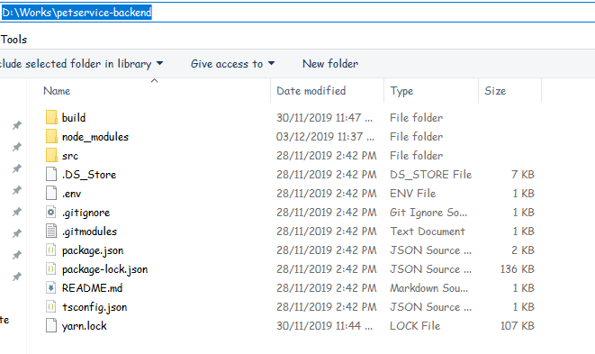

Figure 178 – Prepare deployment package

#### Configure Server before deploy

* Open Command Promt in the backend folder

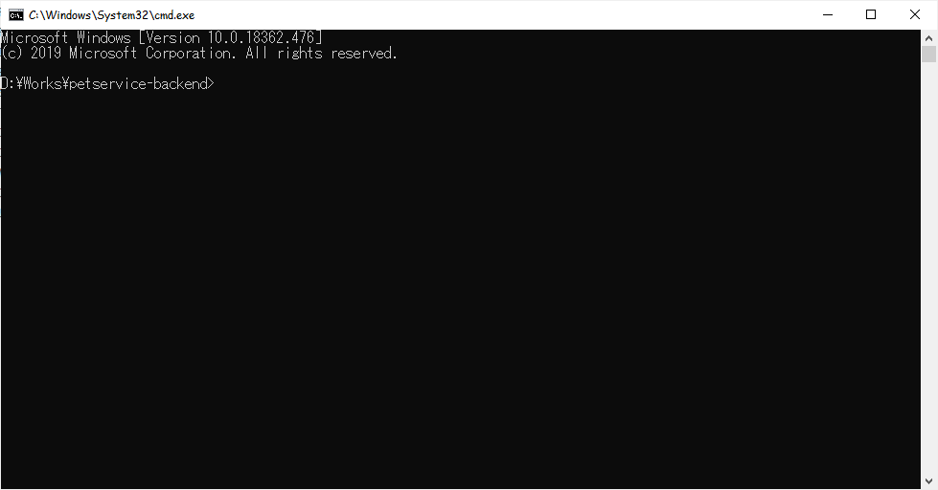

Figure 179 – Open CMD in backend folder

* Run npm install to create node\_module folder

Npm install

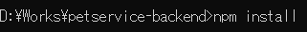

tsc



* Copy folder “public” from folder “src” into folder “build”

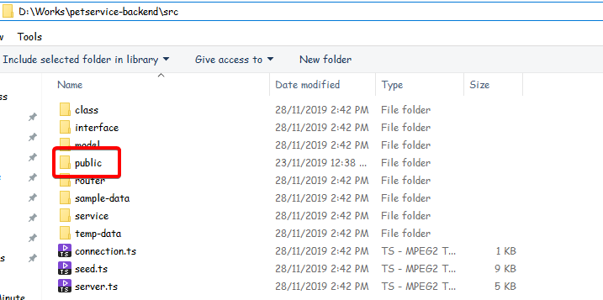

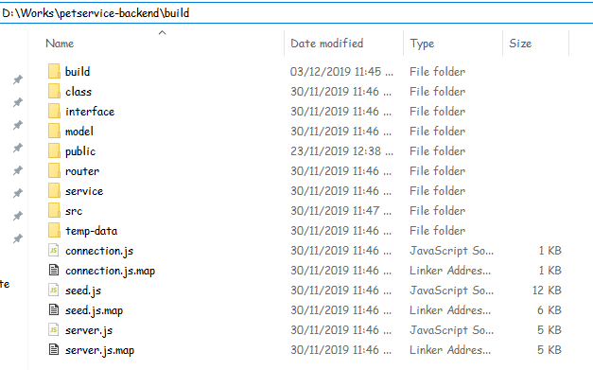

Figure 180 – Copy folder public

* Run XAMPP and Start Apache and MySQL

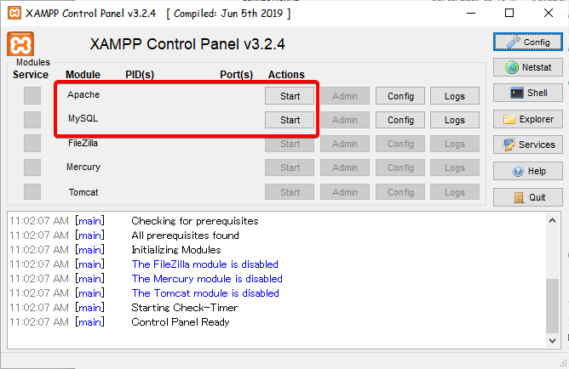

* Run server by using command

node build/server.js



### Setting up the environment at client side

* Copy installation file into android device

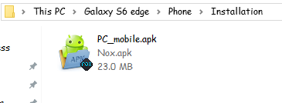

Figure 181 – Copy installation file to device

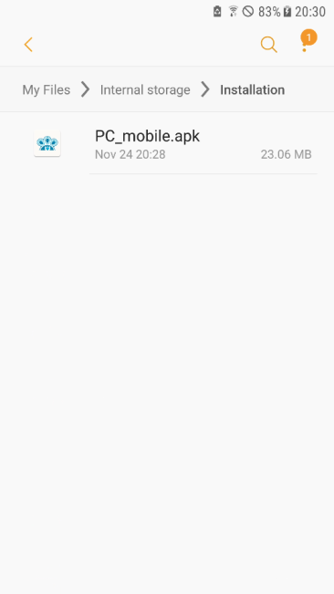

* Open file manage on android device

Figure 5 – Open file manage

* Open installation file then install

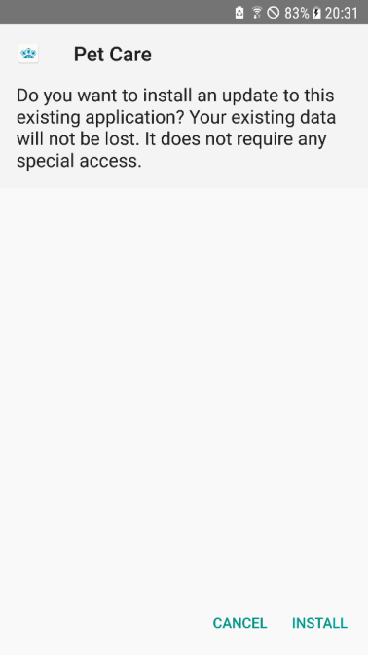

Figure 6 - Install

## User Guide

### Web System

#### Login

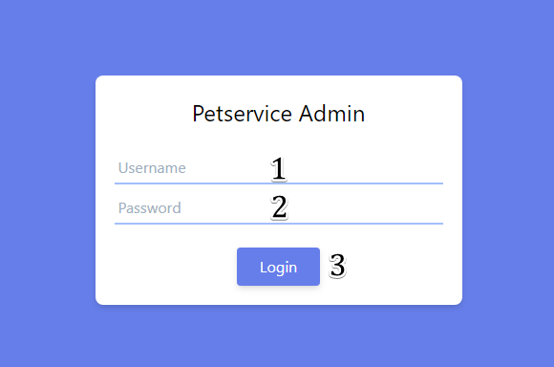

Figure 184 – <User Guide> Login

|  |  |
| --- | --- |
| Step | Description |
| 1 | Fill in field “Username” |
| 2 | Fill in field “Password” |
| 3 | Tap on “Login” button |

Table 229 – <User Guide> Login

#### Admin

##### Create New Shops



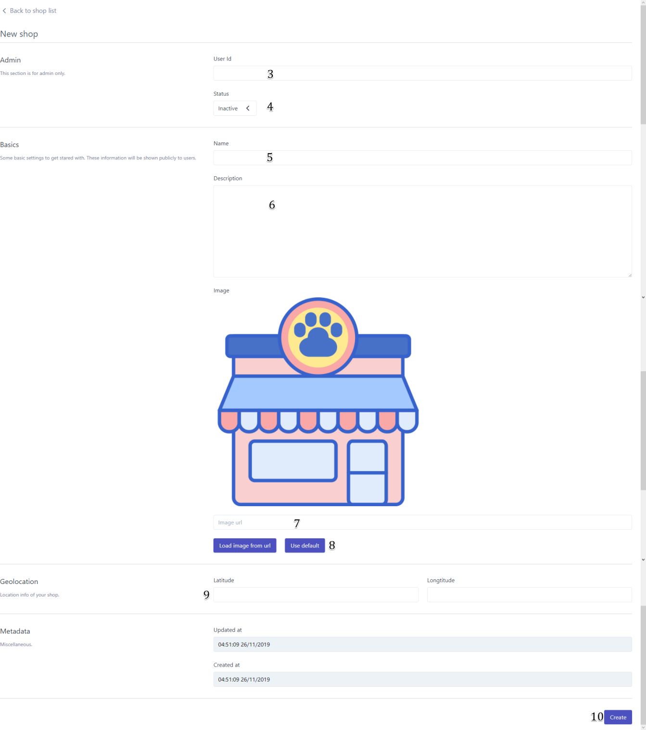

Figure 185 – <User Guide> Create New Shop

|  |  |
| --- | --- |
| Step | Description |
| 1 | Tap “Shops” tab |
| 2 | Tap “Create new shop” button |
| 3 | Enter User id |
| 4 | Choose status |
| 5 | Enter shop’s name |
| 6 | Enter description (Optional) |
| 7 | Enter image url (Optional) |
| 8 | Tap “Load image from url” or “Use default” button |
| 9 | Enter Latitude and Longtitude (optional) |
| 10 | Tap “Create” button |

Table 230 – <User Guide> Create New Shop

##### Edit Shop

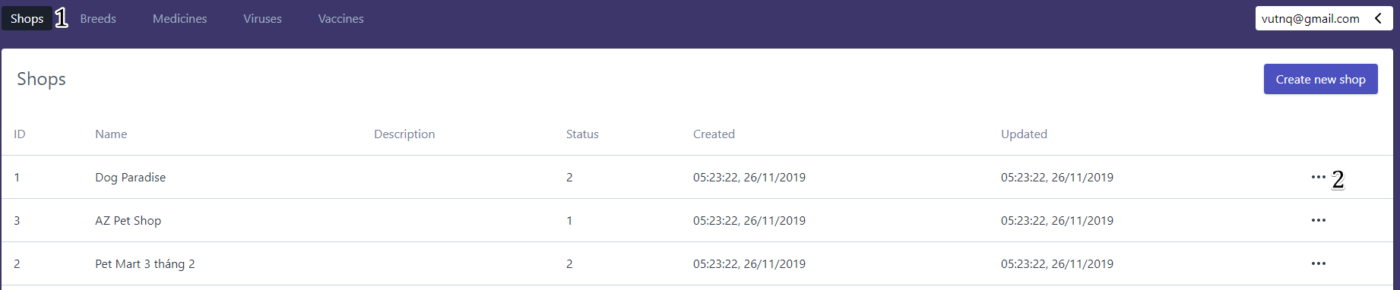

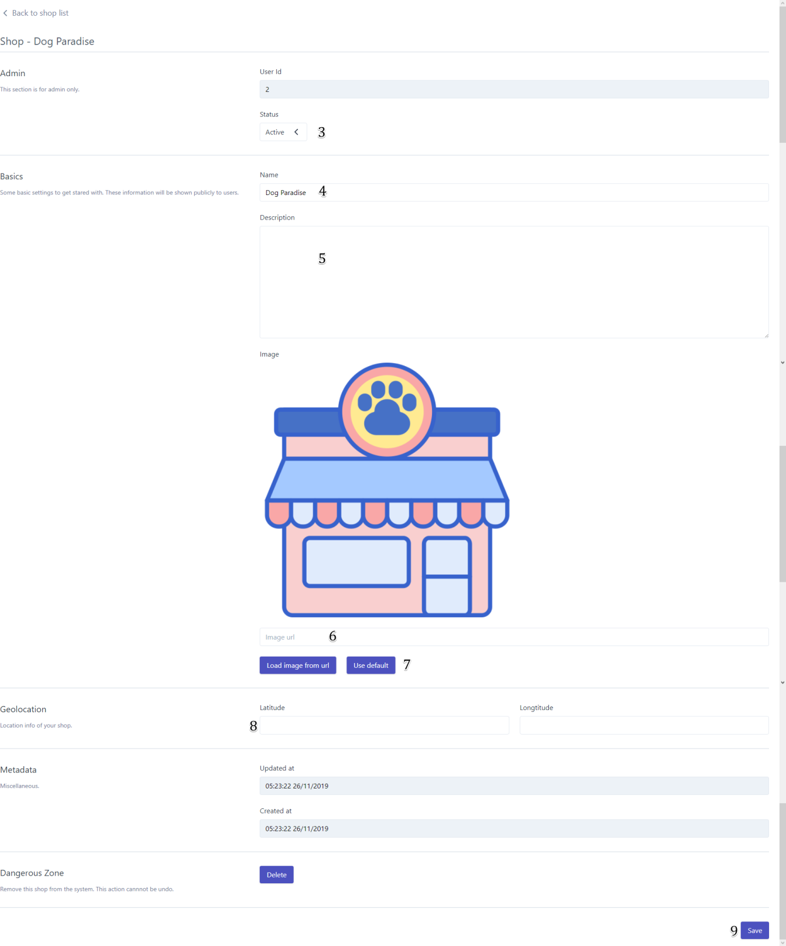

Figure 186 – <User Guide> Edit Shop

|  |  |
| --- | --- |
| Step | Description |
| 1 | Tap “Shops” tab |
| 2 | Tap “Edit shop” button |
| 3 | Choose status |
| 4 | Enter shop’s name |
| 5 | Enter description (Optional) |
| 6 | Enter image url (Optional) |
| 7 | Tap “Load image from url” or “Use default” button |
| 8 | Enter Latitude and Longtitude (optional) |
| 9 | Tap “Save” button |

Table 231 – <User Guide> Edit Shop

##### Create New Account

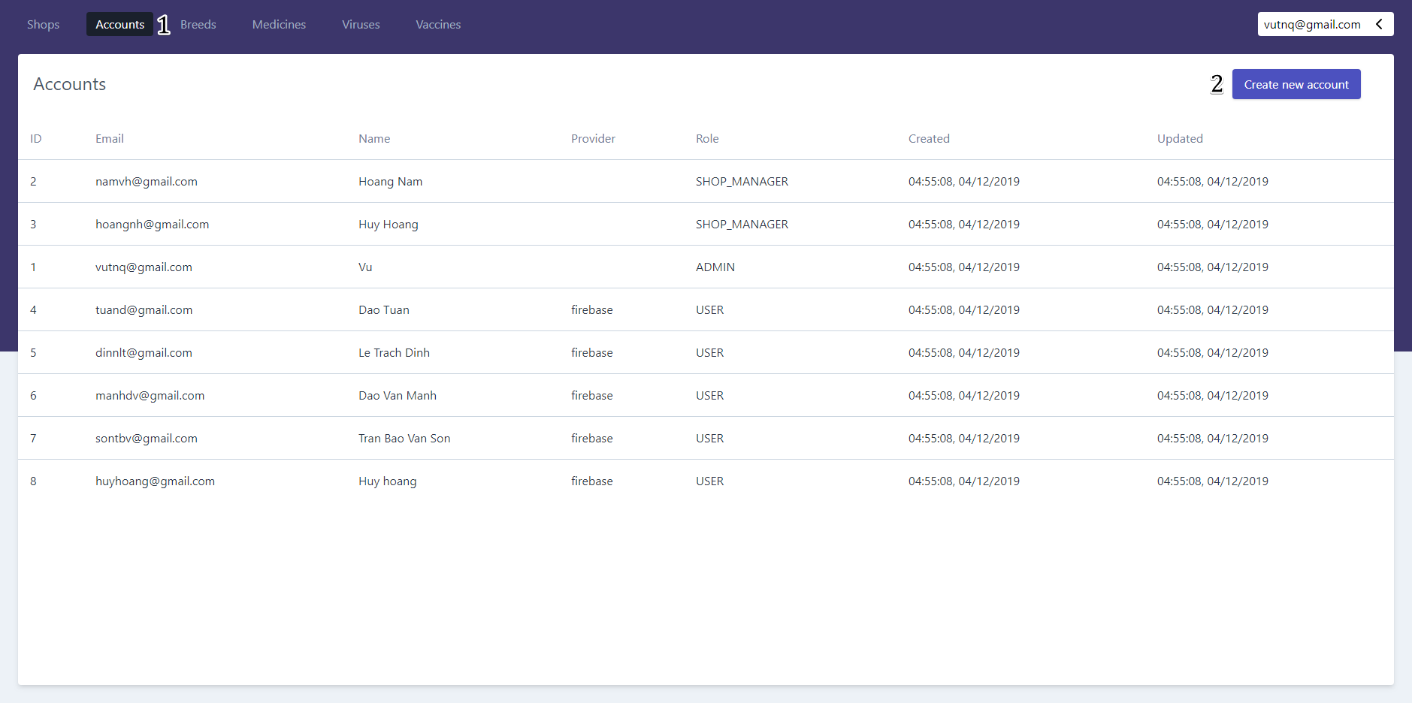

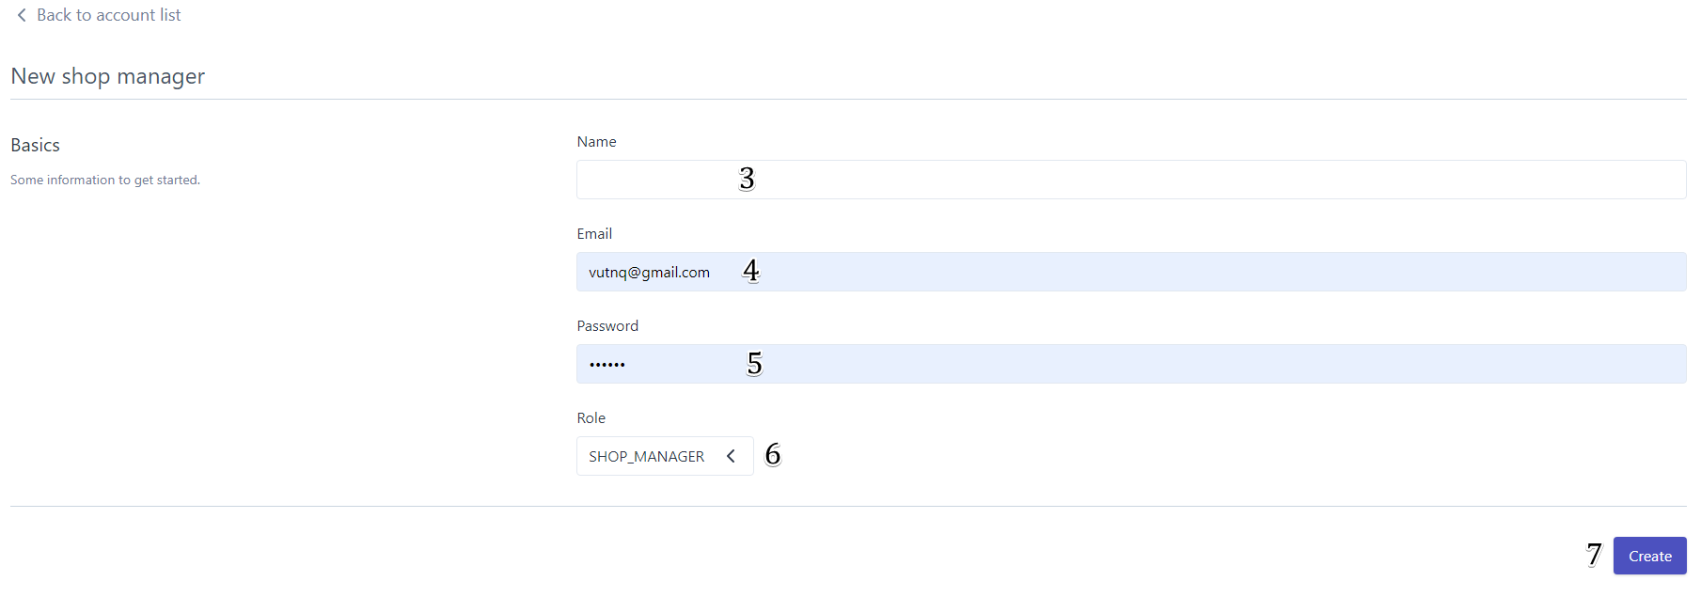

Figure 187 – <User Guide> Create New Account

|  |  |
| --- | --- |
| Step | Description |
| 1 | Tap “Accounts” tab |
| 2 | Tap “Create new account” button |
| 3 | Enter “Name” |
| 4 | Enter “Email” |
| 5 | Enter “Password” |
| 6 | Choose “Role” |
| 7 | Tap “Create” button |

Table 232 – <User Guide> Create New Account

##### Create New Breed

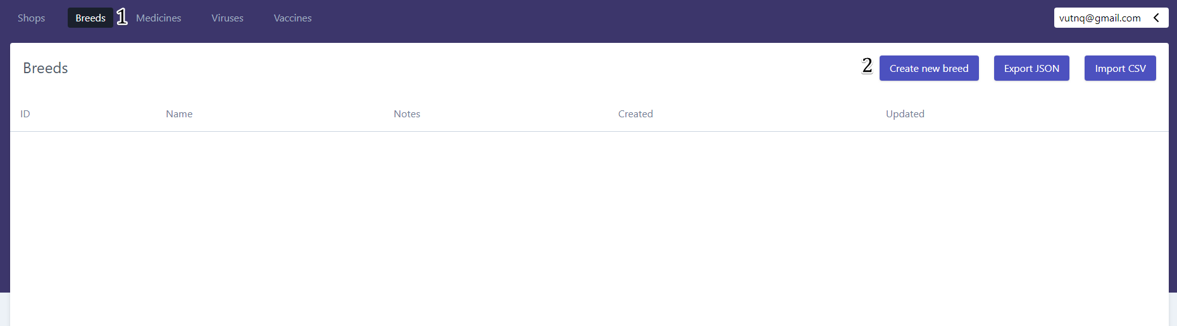

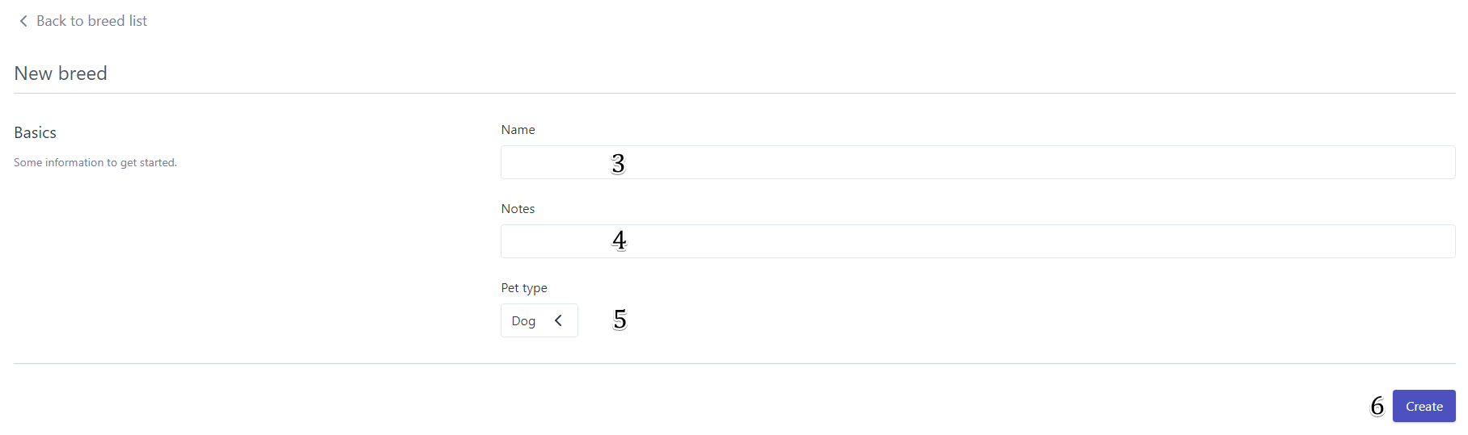

Figure 188 – <User Guide> Create New Breed

|  |  |
| --- | --- |
| Step | Description |
| 1 | Tap “Breeds” tab |
| 2 | Tap “Create new breed” button |
| 3 | Enter “Name” |
| 4 | Enter “Notes” (Optional) |
| 5 | Choose “Pet type” |
| 6 | Tap “Create” button |

Table 233 – <User Guide> Create New Breed

##### Edit Breed

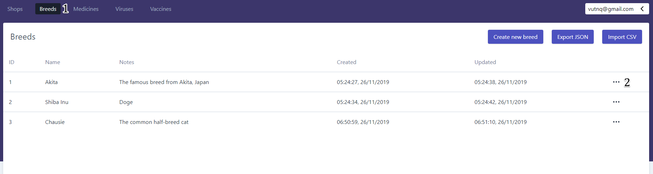

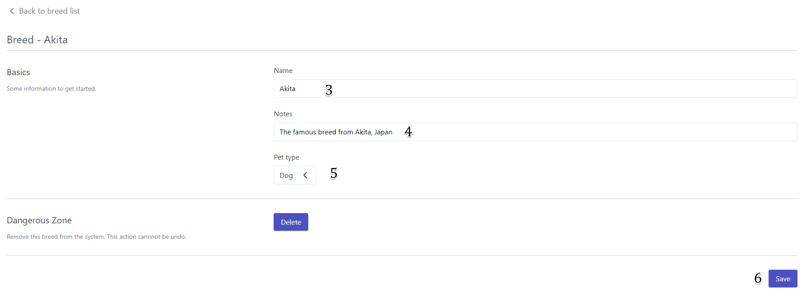

Figure 189 – <User Guide> Edit Breed

|  |  |
| --- | --- |
| Step | Description |
| 1 | Tap “Breeds” tab |
| 2 | Tap “Edit breed” button |
| 3 | Enter “Name” |
| 4 | Enter “Notes” (Optional) |
| 5 | Choose “Pet type” |
| 6 | Tap “Save” button |

Table 234 – <User Guide> Edit Breed

##### Create New Medicine

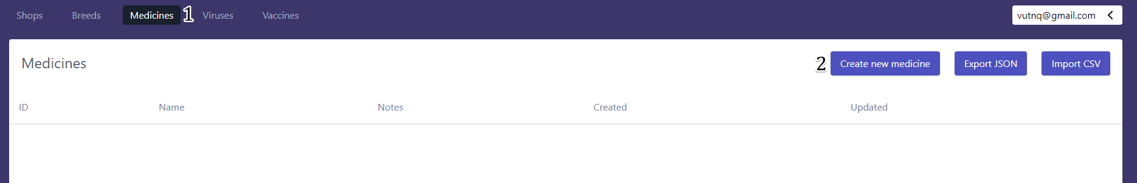

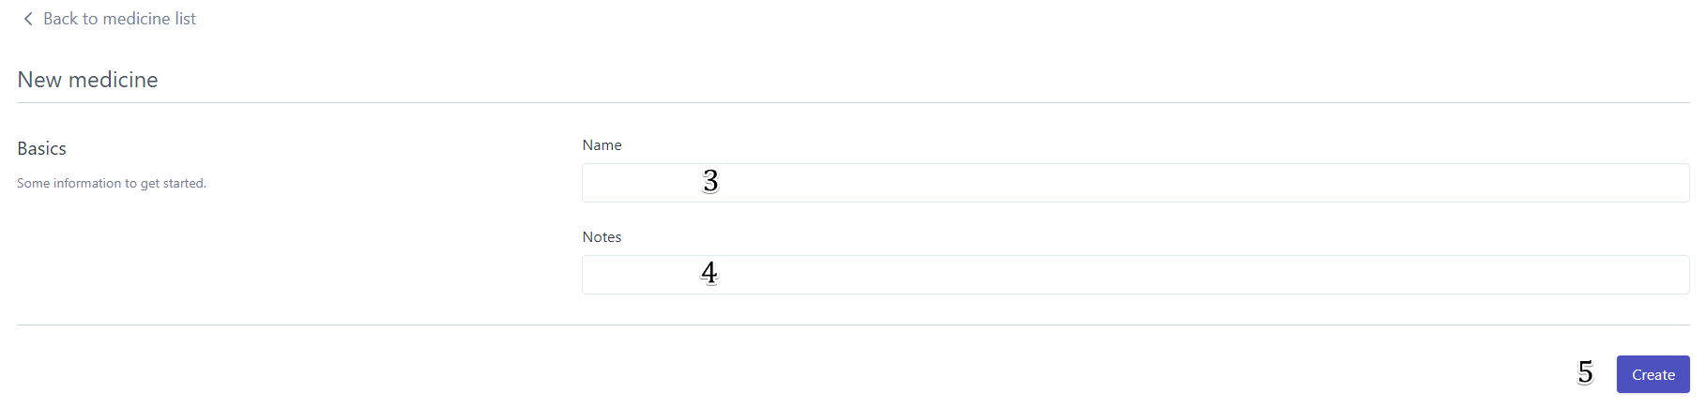

Figure 190 – <User Guide> Create New Medicine

|  |  |
| --- | --- |
| Step | Description |
| 1 | Tap “Medicines” tab |
| 2 | Tap “Create new medicine” button |
| 3 | Enter “Name” |
| 4 | Enter “Notes” (Optional) |
| 5 | Tap “Create” button |

Table 235 – <User Guide> Create New Medicine

##### Edit Medicine

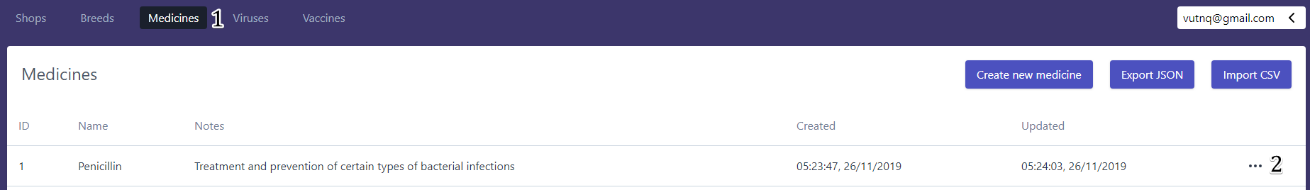

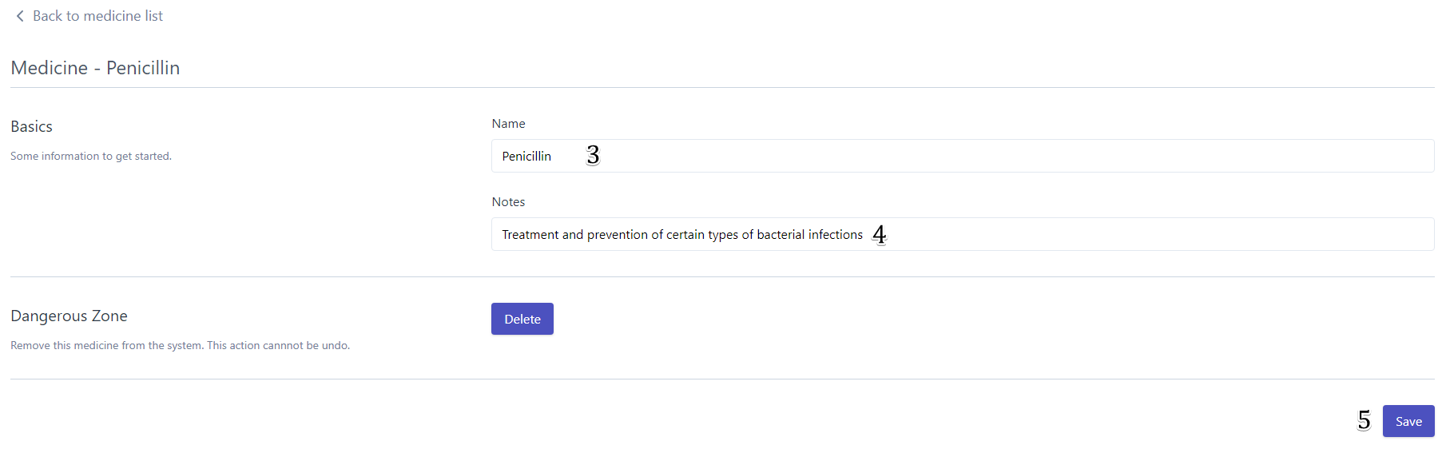

Figure 191 – <User Guide> Edit Medicine

|  |  |
| --- | --- |
| Step | Description |
| 1 | Tap “Medicines” tab |
| 2 | Tap “Edit medicine” button |
| 3 | Enter “Name” |
| 4 | Enter “Notes” (Optional) |
| 5 | Tap “Save” button |

Table 236 – <User Guide> Edit Medicine

##### Create New Viruses

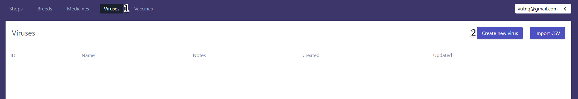

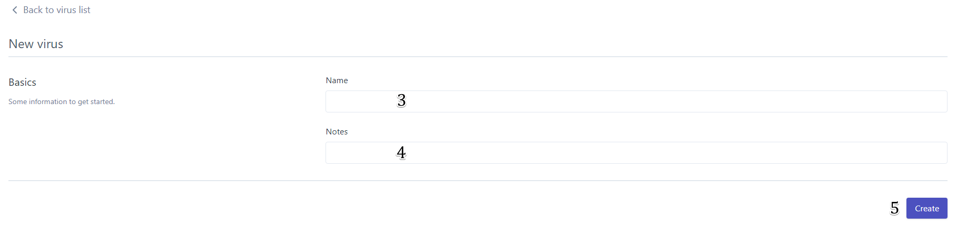

Figure 192 – <User Guide> Create New Virus

|  |  |
| --- | --- |
| Step | Description |
| 1 | Tap “Viruses” tab |
| 2 | Tap “Create new virus” button |
| 3 | Enter “Name” |
| 4 | Enter “Notes” (Optional) |
| 5 | Tap “Create” button |

Table 237 – <User Guide> Create New Virus

##### Edit Virus

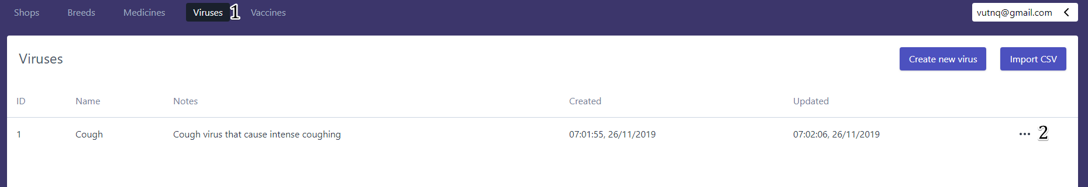

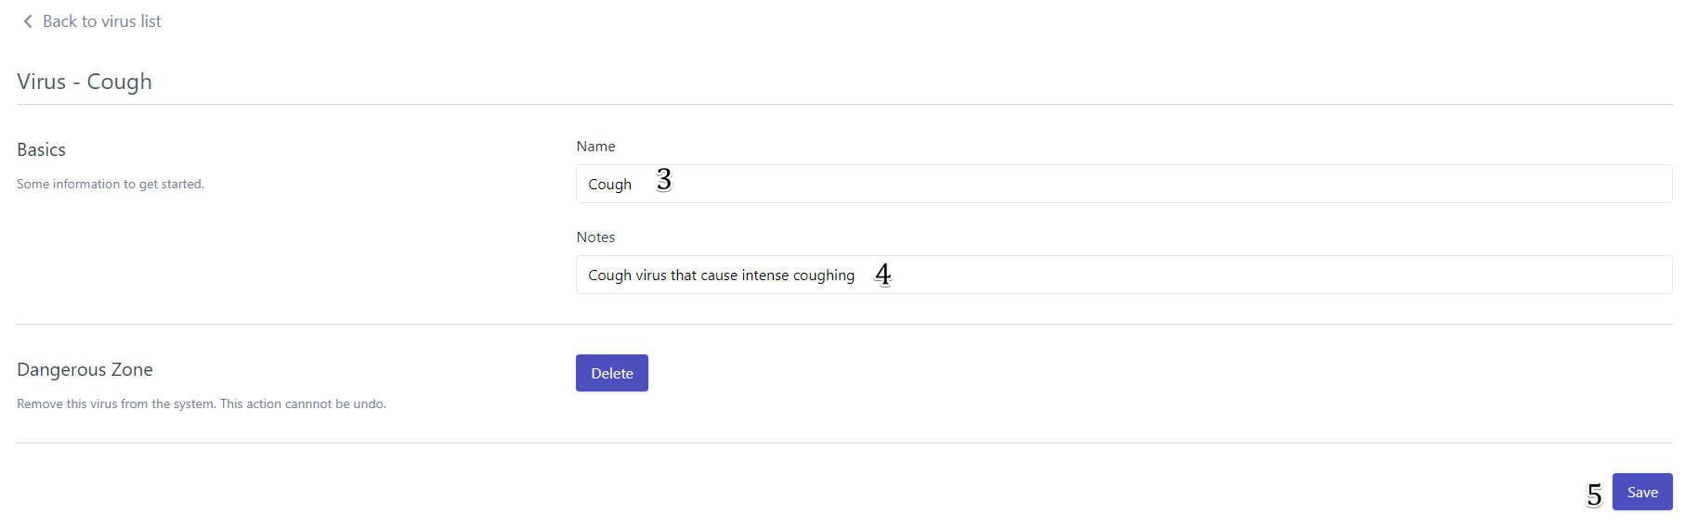

Figure 193 – <User Guide> Edit Virus

|  |  |
| --- | --- |
| Step | Description |
| 1 | Tap “Viruses” tab |
| 2 | Tap “Edit virus” button |
| 3 | Enter “Name” |
| 4 | Enter “Notes” (Optional) |
| 5 | Tap “Save” button |

Table 238 – <User Guide> Edit Virus

##### Create New Vaccines

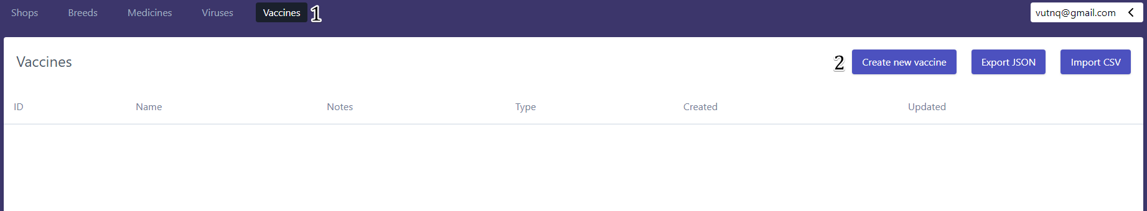

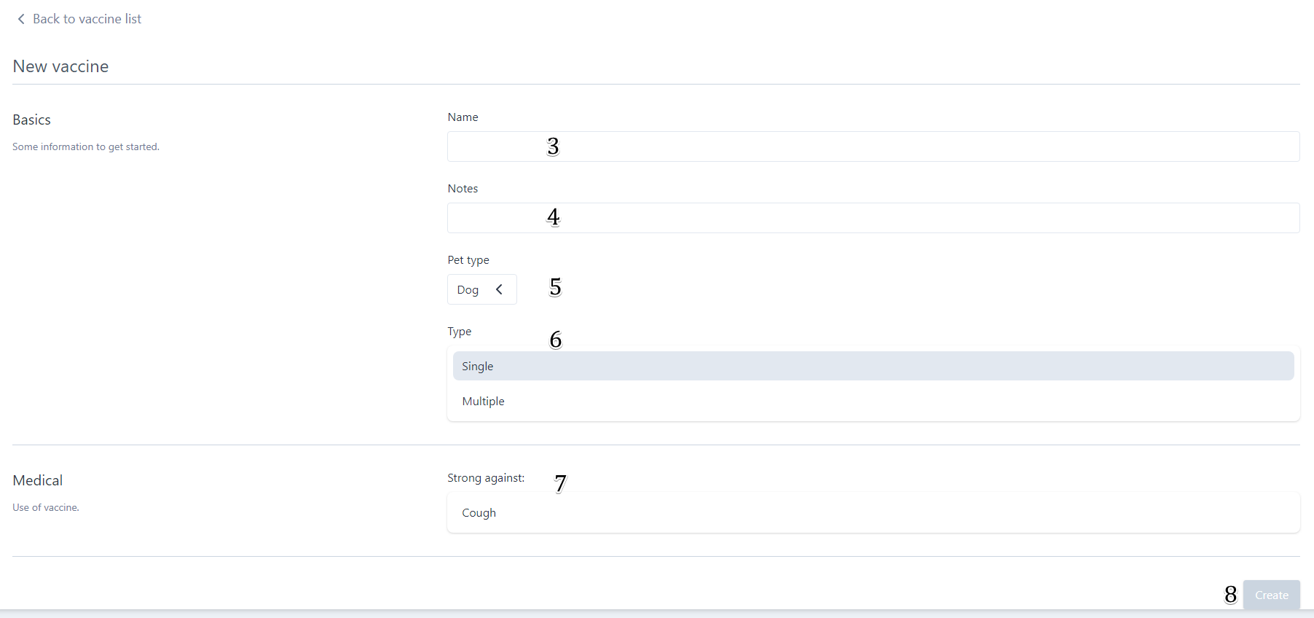

Figure 194 – <User Guide> Create New Vaccine

|  |  |
| --- | --- |
| Step | Description |
| 1 | Tap “Vaccines” tab |
| 2 | Tap “Edit dvaccine” button |
| 3 | Enter “Name” |
| 4 | Enter “Notes” (Optional) |
| 5 | Choose “Pet type” |
| 6 | Choose “Type” |
| 7 | Choose “Strong agaisnt” virus |
| 8 | Tap “Edit” button |

Table 239 – <User Guide> Create New Vaccine

##### Edit Vaccine

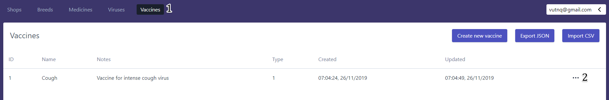

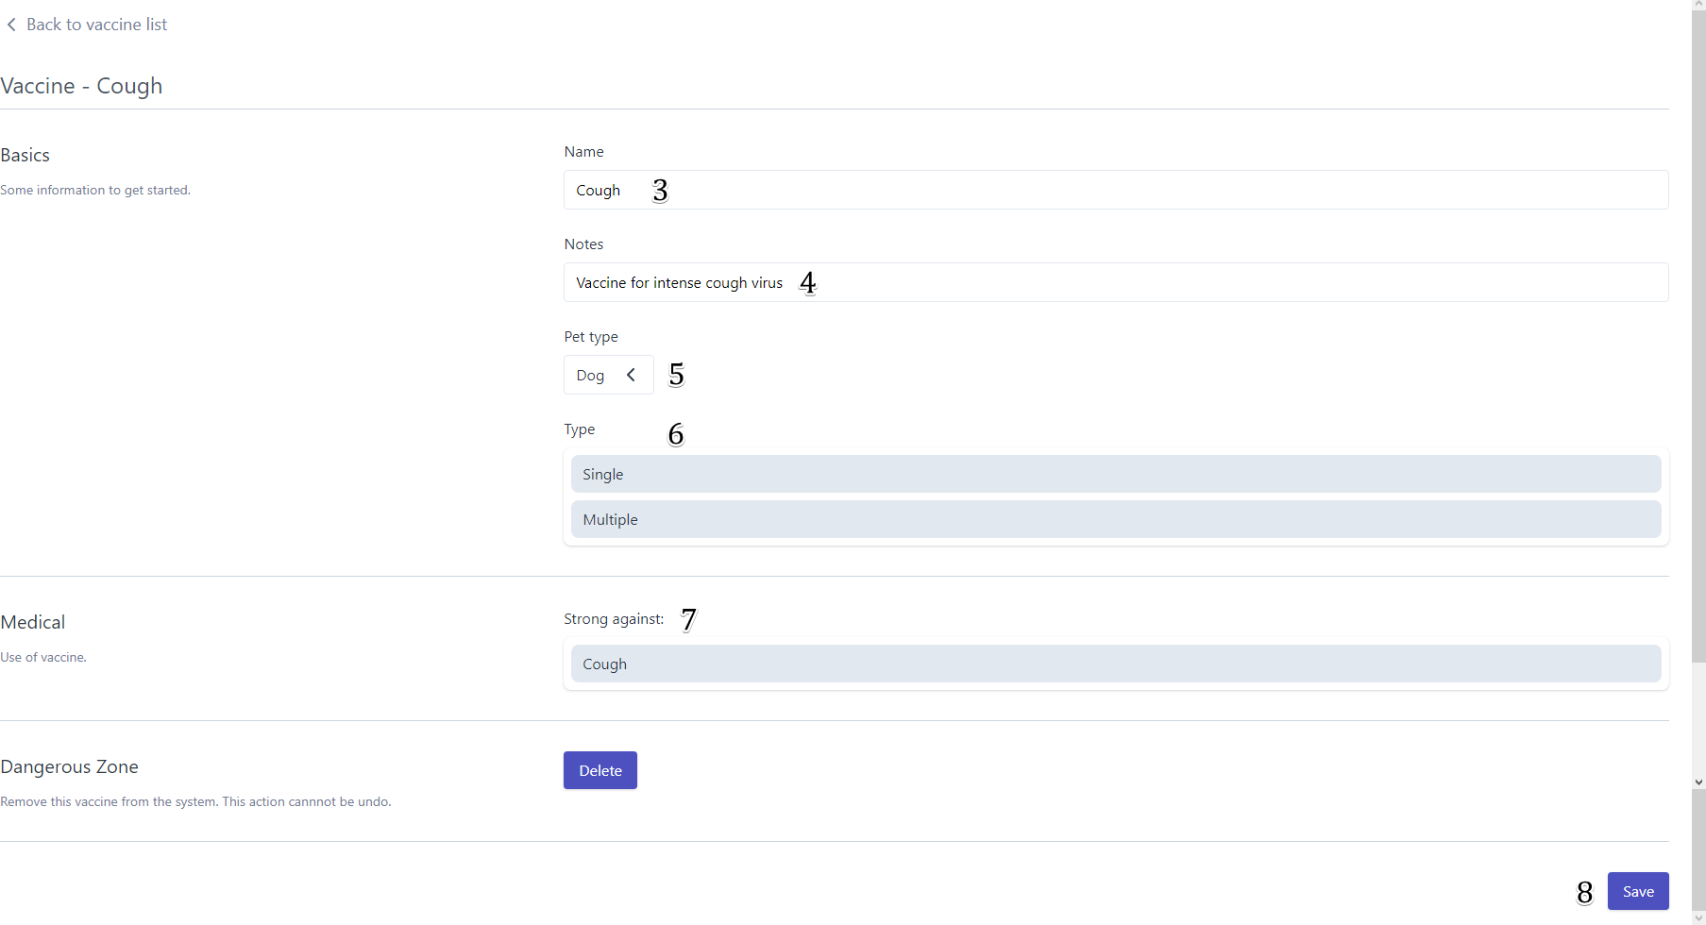

Figure 195 – <User Guide> Edit Vaccine

|  |  |
| --- | --- |
| Step | Description |
| 1 | Tap “Vaccines” tab |
| 2 | Tap “Edit vaccine” button |
| 3 | Enter “Name” |
| 4 | Enter “Notes” (Optional) |
| 5 | Choose “Pet type” |
| 6 | Choose “Type” |
| 7 | Choose “Strong agaisnt” virus |
| 8 | Tap “Save” button |

Table 240 – <User Guide> Edit Vaccine

#### Shop Owner

##### Create New Shop

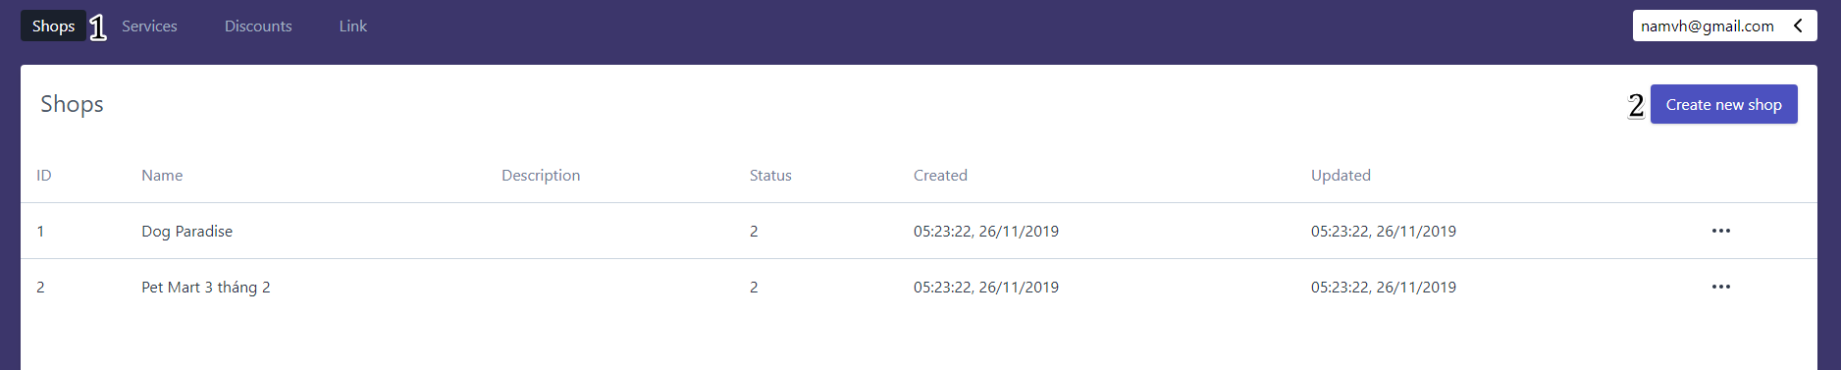

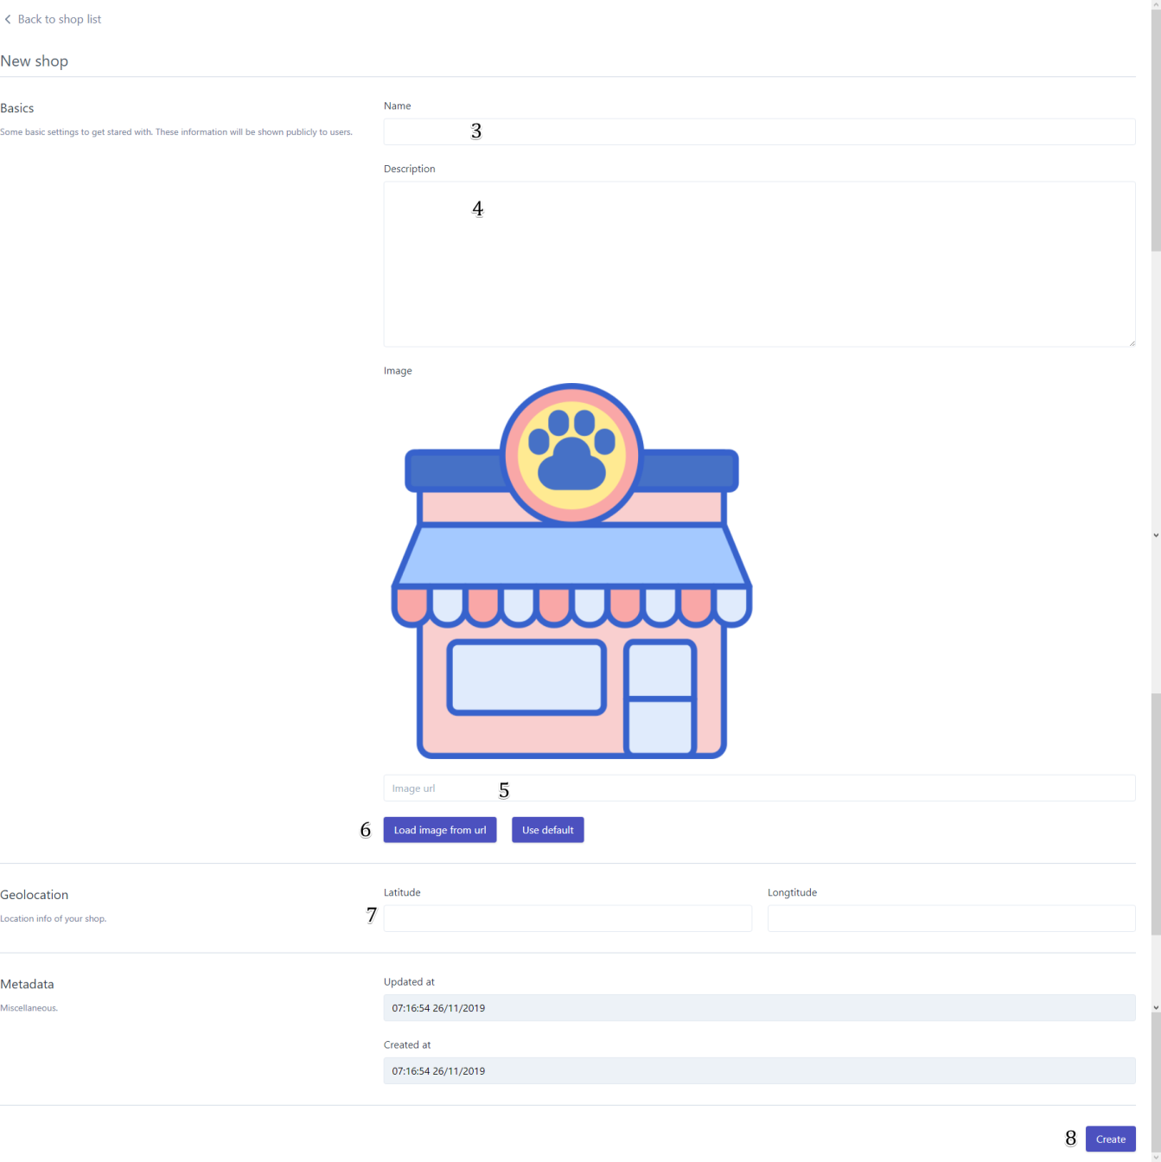

Figure 196 – <User Guide> Create New Shop

|  |  |
| --- | --- |
| Step | Description |
| 1 | Tap “Shops” tab |
| 2 | Tap “Create new shop” button |
| 3 | Enter shop’s name |
| 4 | Enter description (Optional) |
| 5 | Enter image url (Optional) |
| 6 | Tap “Load image from url” or “Use default” button |
| 7 | Enter Latitude and Longtitude (optional) |
| 8 | Tap “Create” button |

Table 241 – <User Guide> Create New Shop

##### Edit Shop

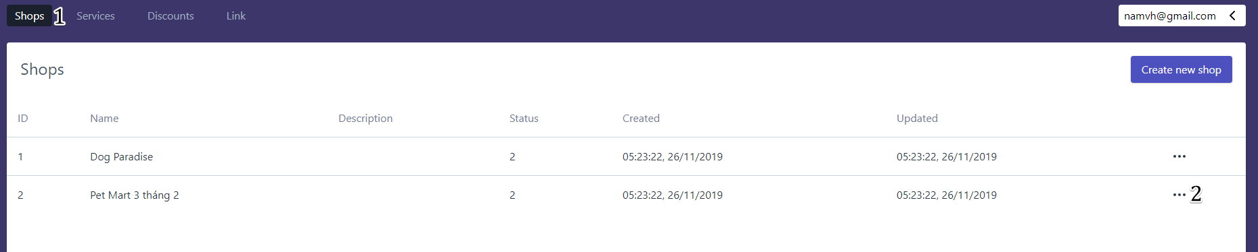

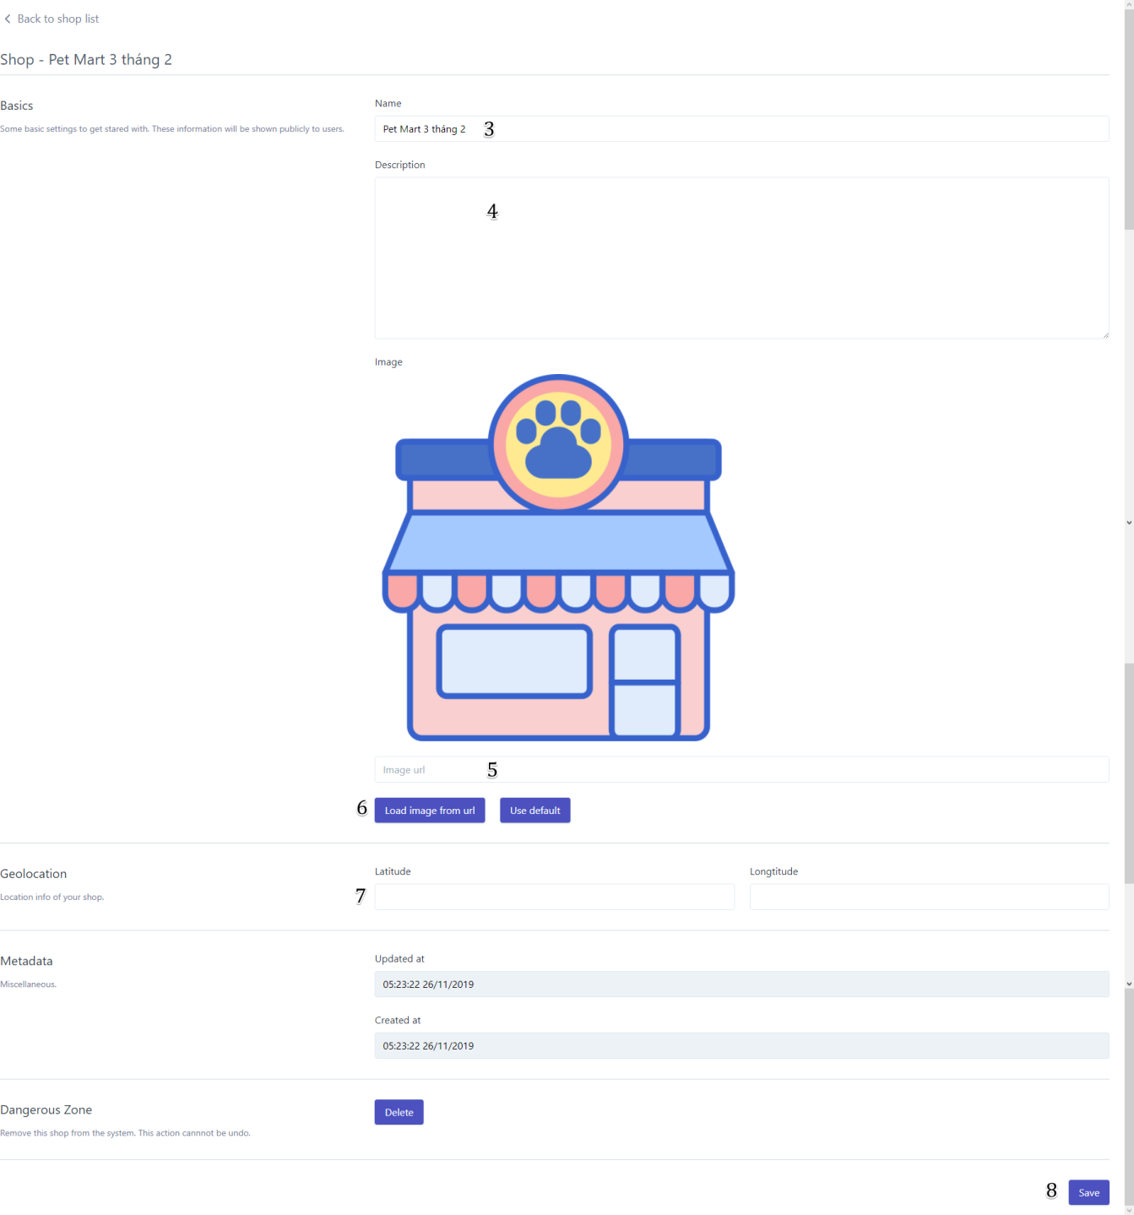

Figure 197 – <User Guide> Edit Shop

|  |  |
| --- | --- |
| Step | Description |
| 1 | Tap “Shops” tab |
| 2 | Tap “Edit shop” button |
| 3 | Enter shop’s name |
| 4 | Enter description (Optional) |
| 5 | Enter image url (Optional) |
| 6 | Tap “Load image from url” or “Use default” button |
| 7 | Enter Latitude and Longtitude (optional) |
| 8 | Tap “Save” button |

Table 242 – <User Guide> Edit Shop

##### Create New Service

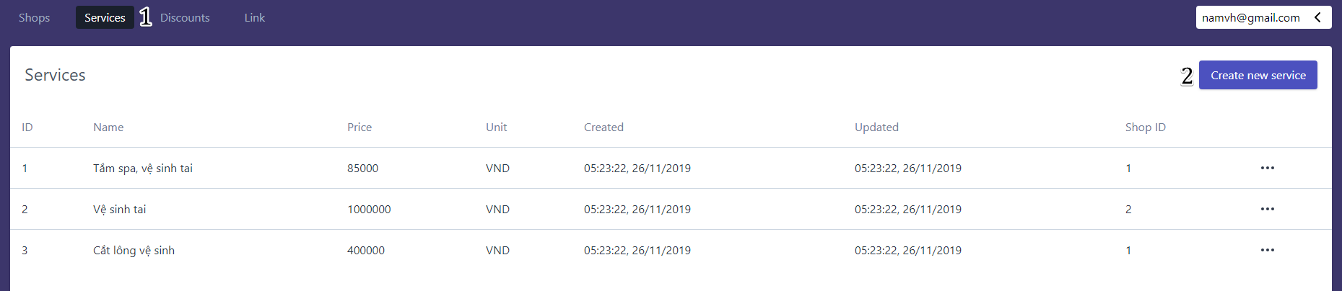

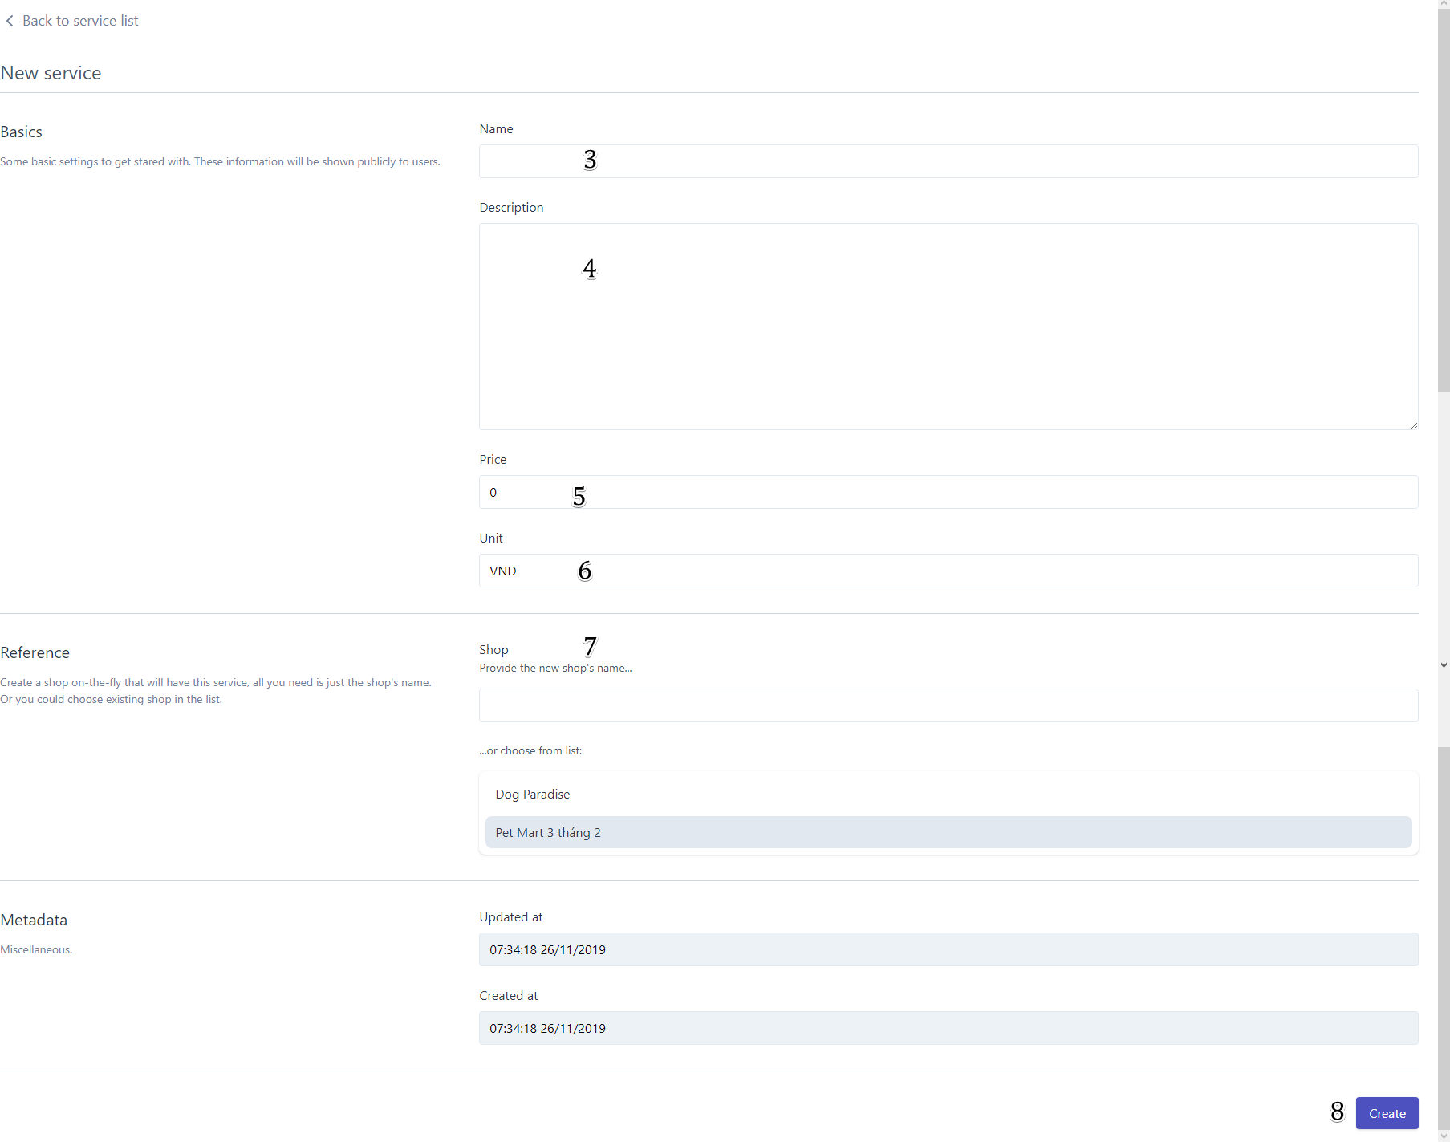

Figure 198 – <User Guide> Create New Service

|  |  |
| --- | --- |
| Step | Description |
| 1 | Tap “Services” tab |
| 2 | Tap “Create new service” button |
| 3 | Enter Service’s name |
| 4 | Enter description (Optional) |
| 5 | Enter price |
| 6 | Enter Unit |
| 7 | Choose shop |
| 8 | Tap “Create” button |

Table 243 – <User Guide> Create New Service

##### Edit Service

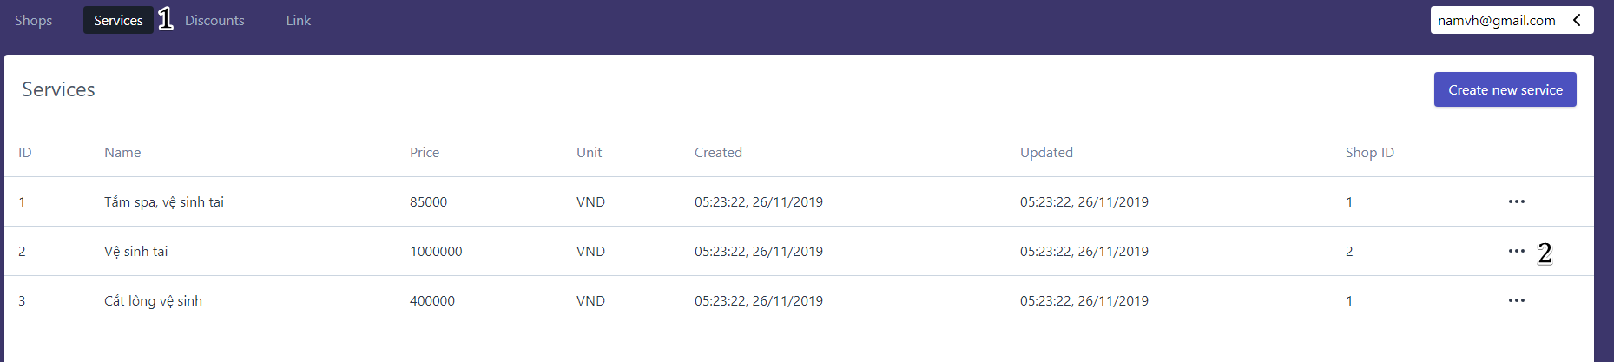

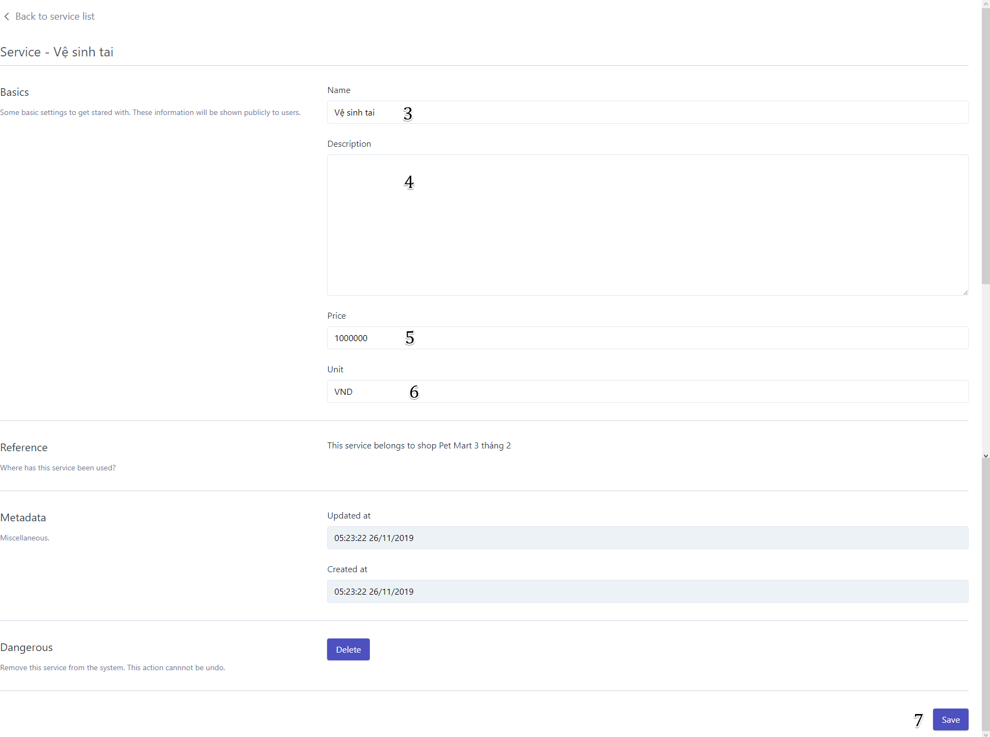

Figure 199 – <User Guide> Edit Service

|  |  |
| --- | --- |
| Step | Description |
| 1 | Tap “Services” tab |
| 2 | Tap “Edit service” button |
| 3 | Enter Service’s name |
| 4 | Enter description (Optional) |
| 5 | Enter price |
| 6 | Enter Unit |
| 7 | Tap “Save” button |

Table 244 – <User Guide> Edit Service

##### Create New Discount

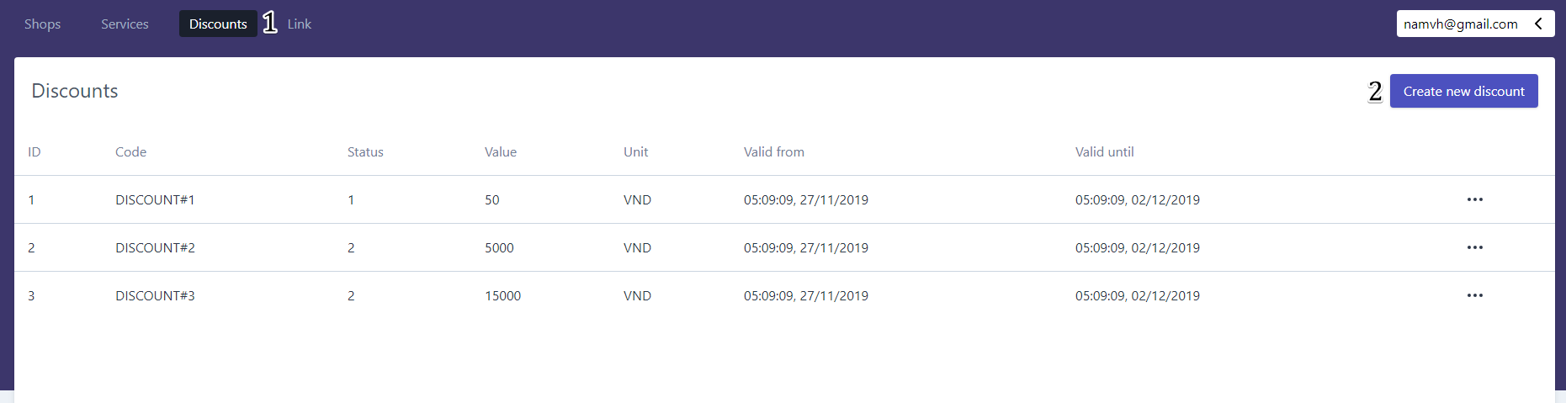

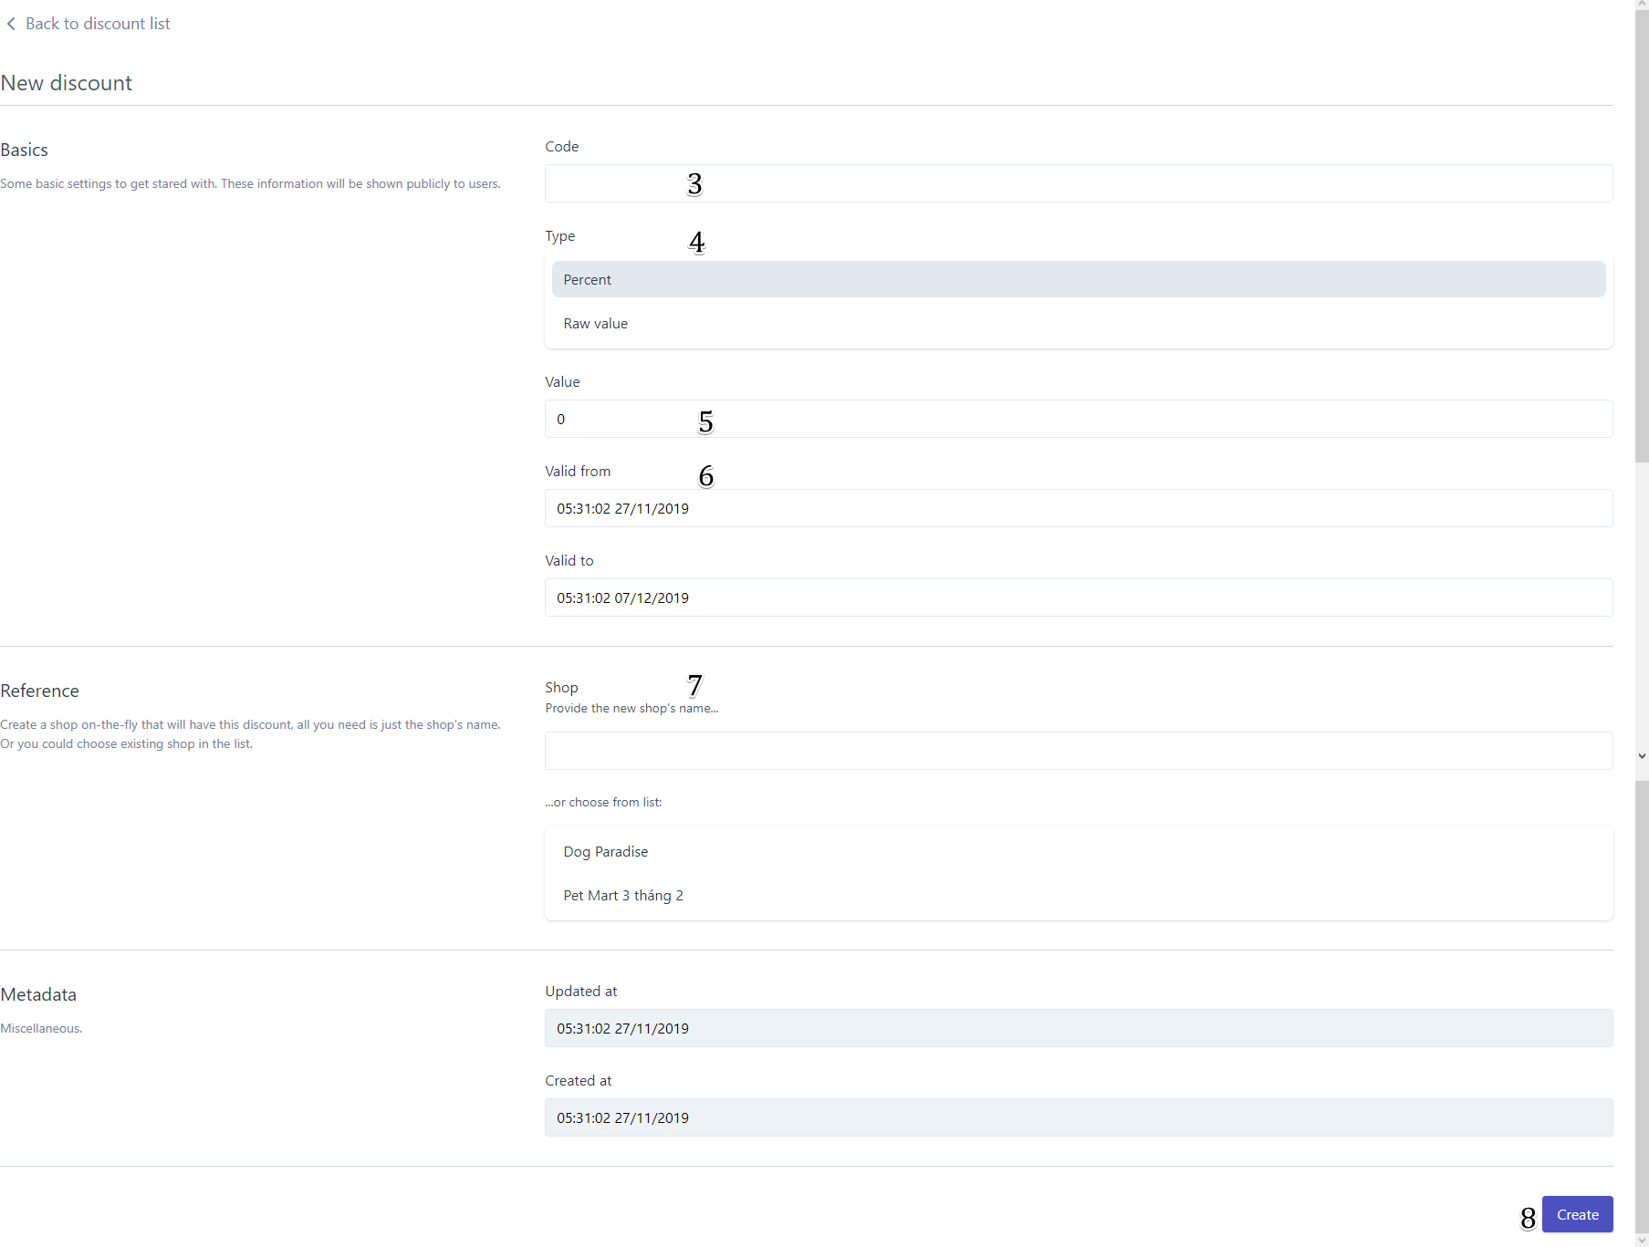

Figure 200 – <User Guide> Create New Discount

|  |  |
| --- | --- |
| Step | Description |
| 1 | Tap “Discounts” tab |
| 2 | Tap “Create new discount” button |
| 3 | Enter code |
| 4 | Choose type |
| 5 | Enter value |
| 6 | Enter valid date |
| 7 | Choose shop |
| 8 | Tap “Create” button |

Table 245 – <User Guide> Create New Discount

##### Edit Discount

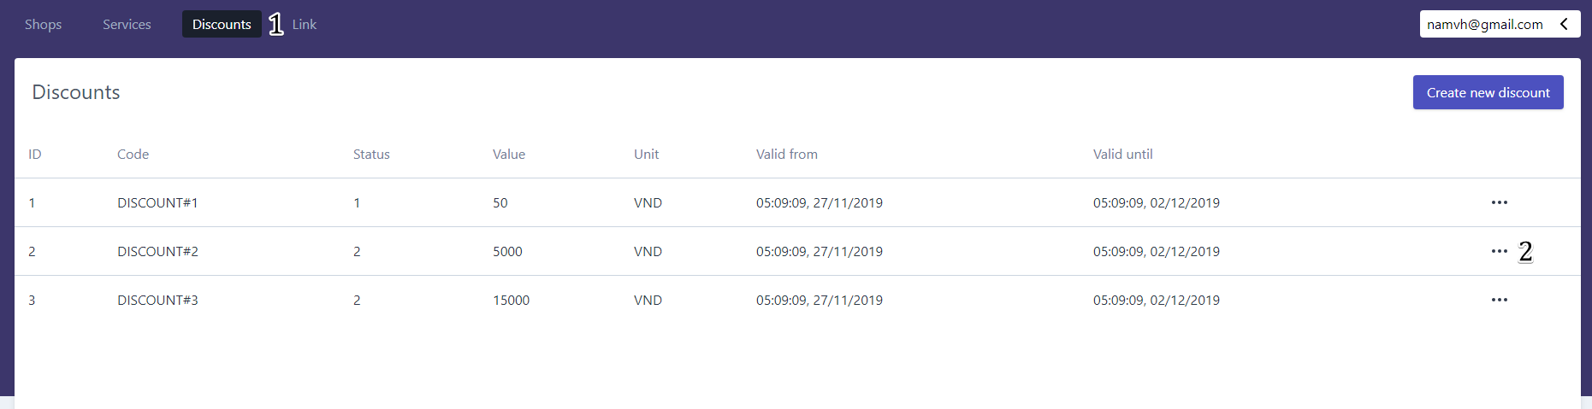

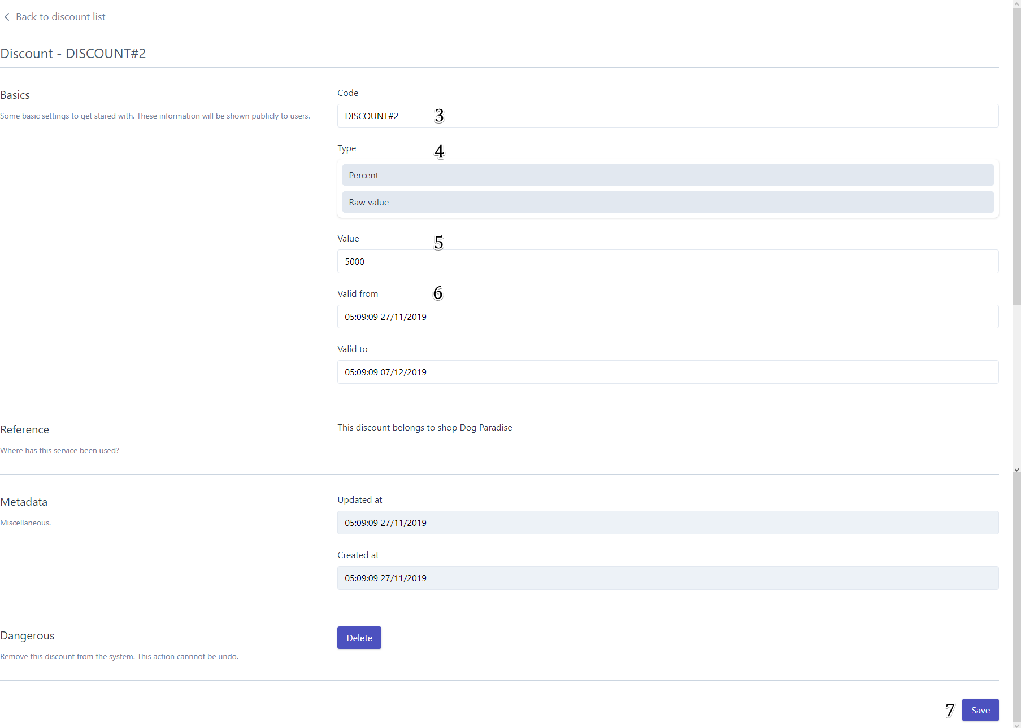

Figure 201 – <User Guide> Edit Discount

|  |  |
| --- | --- |
| Step | Description |
| 1 | Tap “Discounts” tab |
| 2 | Tap “Edit discount” button |
| 3 | Enter code |
| 4 | Choose type |
| 5 | Enter value |
| 6 | Enter valid date |
| 7 | Tap “Save” button |

Table 246 – <User Guide> Edit Discount

##### Create New Link

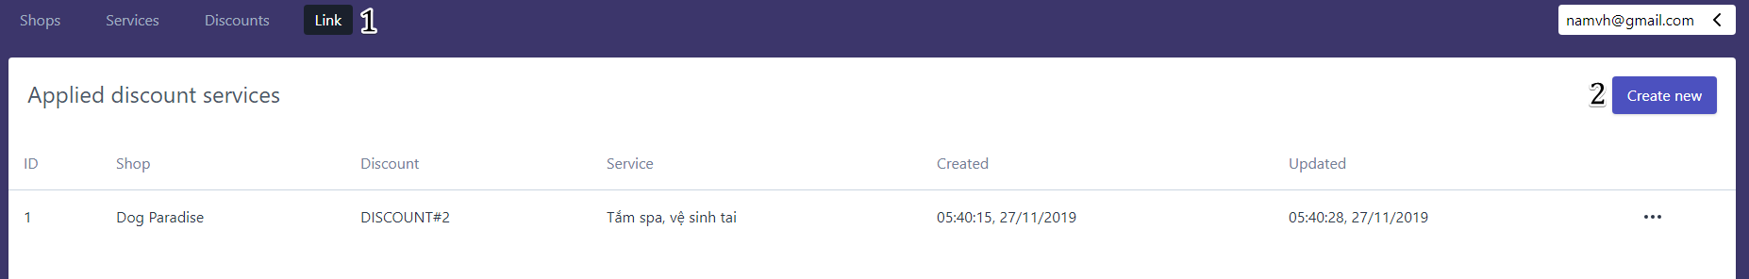

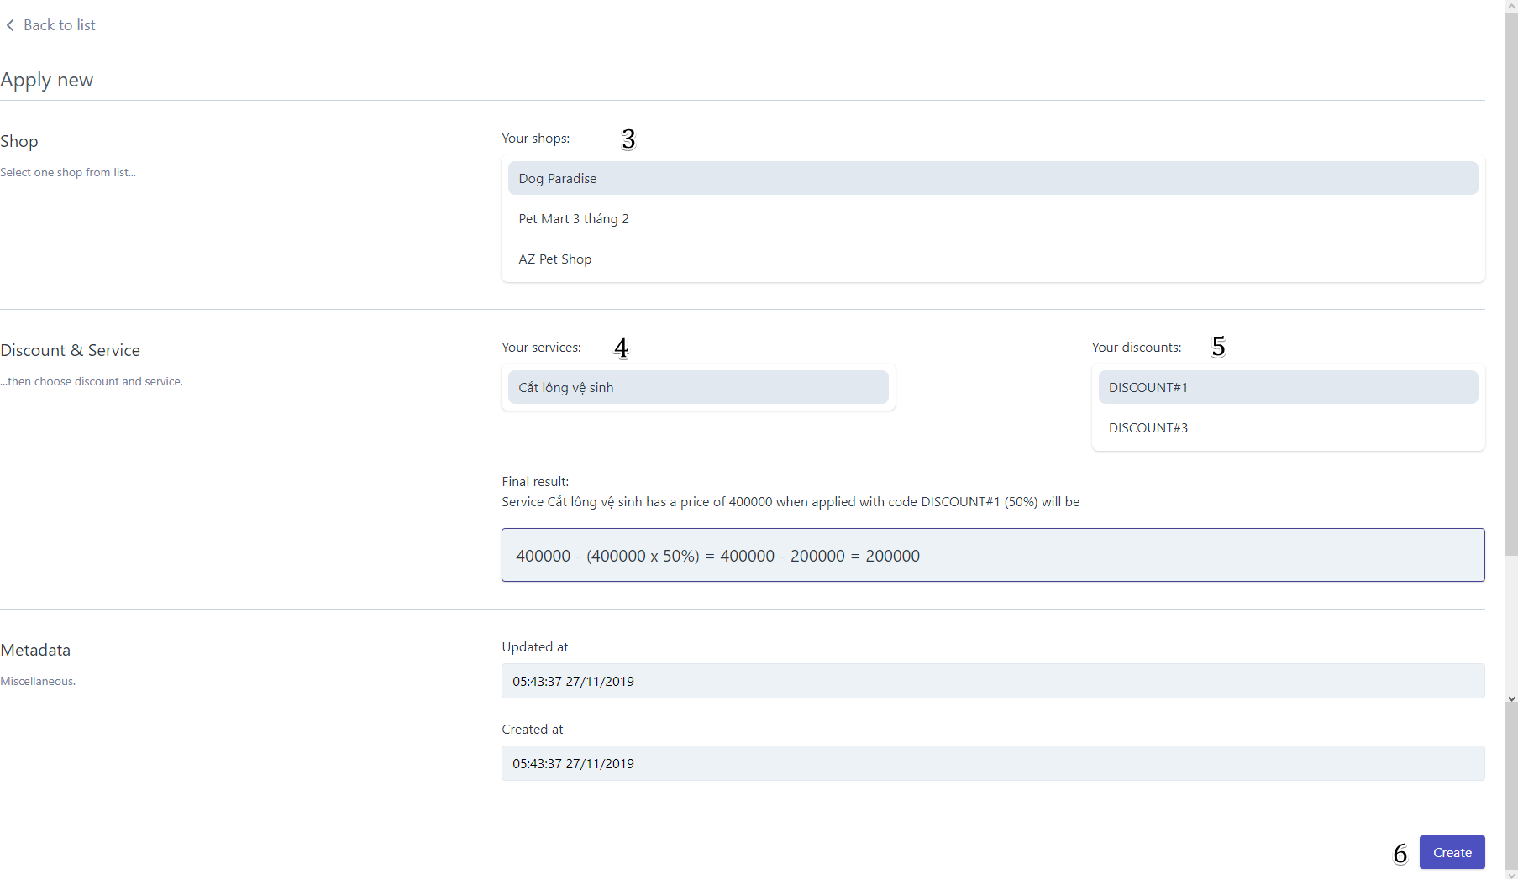

Figure 202 – <User Guide> Create New Link

|  |  |
| --- | --- |
| Step | Description |
| 1 | Tap “Links” tab |
| 2 | Tap “Create new link” button |
| 3 | Choose Your shop |
| 4 | Choose Your services |
| 5 | Choose Your discounts |
| 6 | Tap “Create” button |

Table 247 – <User Guide> Create New Link

##### Edit Link

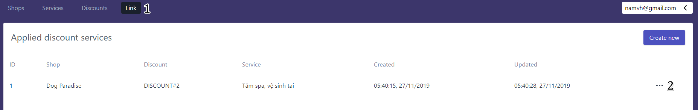

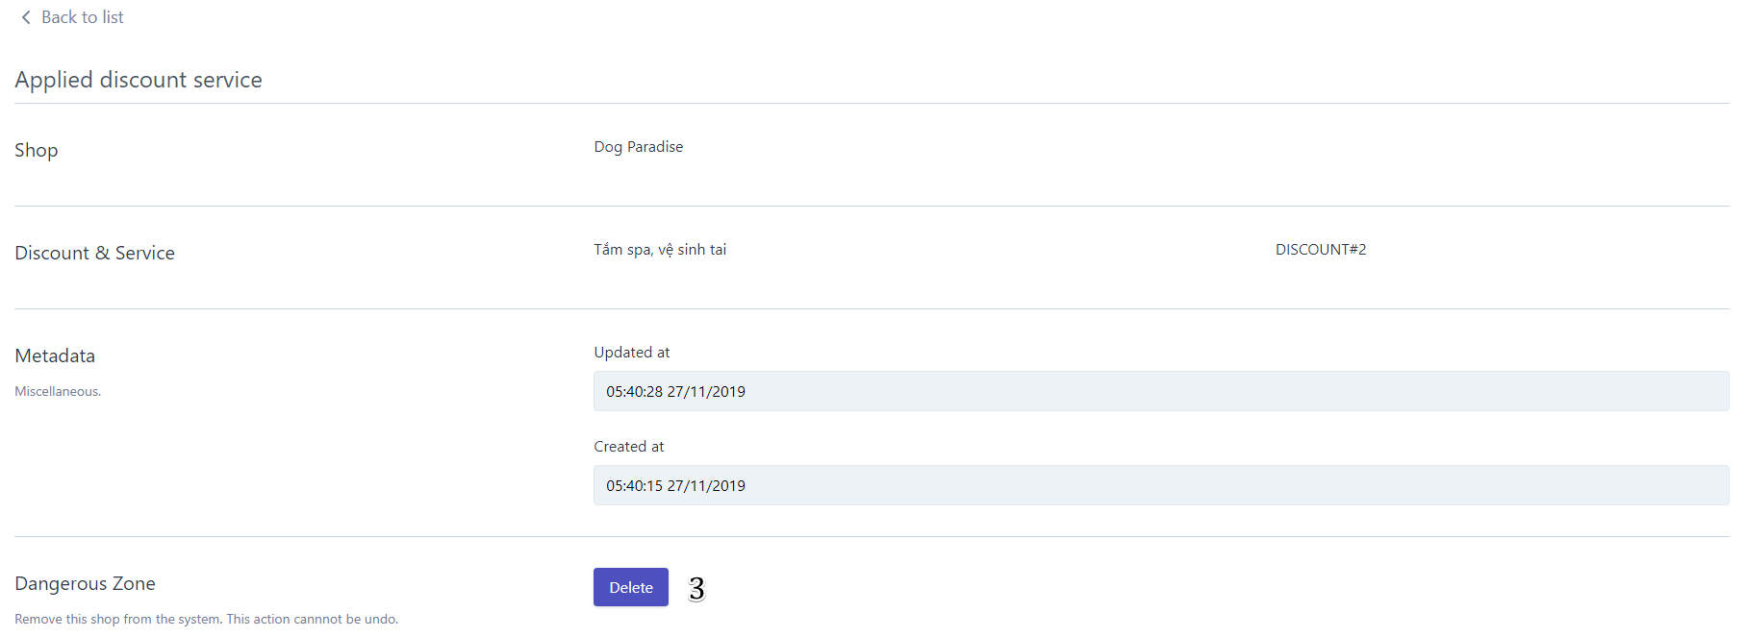

Figure 203 – <User Guide> Edit Link

|  |  |
| --- | --- |
| Step | Description |
| 1 | Tap “Links” tab |
| 2 | Tap “Edit link” button |
| 3 | Tap “Delete” button |

Table 248 – <User Guide> Edit Link

### Mobile Application

#### Login

Figure 204 - <User Guide> Login Mobile

|  |  |
| --- | --- |
| Step | Description |
| 1 | Tap “Please log in to contrinue!" |
| 2 | Fill in field “Email” |
| 3 | Fill in field “Password” |
| 4 | Tap on “SIGN IN” button |
| 5 | Tap on “Sign Up” button to go to Sign Up screen |

Table 249- <User Guide>Login Mobile

#### Add New Pet

**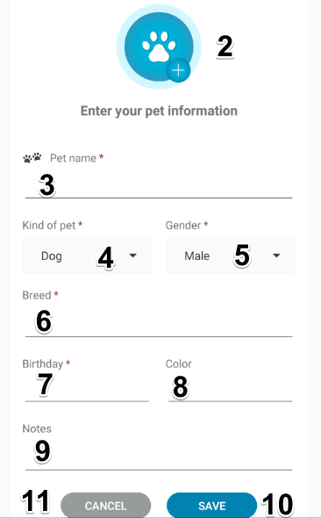**

**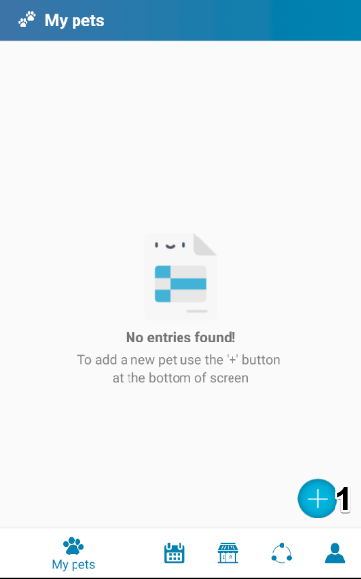**

Figure 205 - <User Guide> Add New Pet

Figure 9- <User Guide>Register Cell

Figure 10- <User Guide>Menu

|  |  |
| --- | --- |
| Step | Description |
| 1 | Tap on “Add New Pet” feature |
| 2 | Choose “Image” |
| 3 | Enter “Pet name” |
| 4 | Choose “Kind of pet” |
| 5 | Choose “Gender” |
| 6 | Choose “Breed” |
| 7 | Choose “Birthday” |
| 8 | Enter “Color” |
| 9 | Enter “Notes” |
| 10 | Tap on “Save” button to add a new pet |
| 11 | Tap on “Cancel” button to exit screen |

Table 250- <User Guide> Add New Pet

#### Add Care Reminder

##### D:\Games\Screenshots\2019-12\food.pngfoodAdd Food Reminder

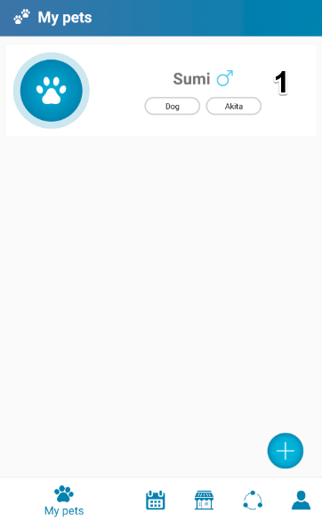

**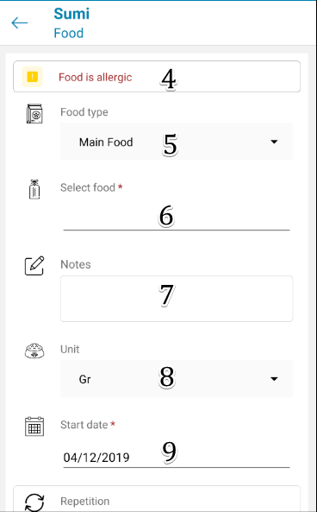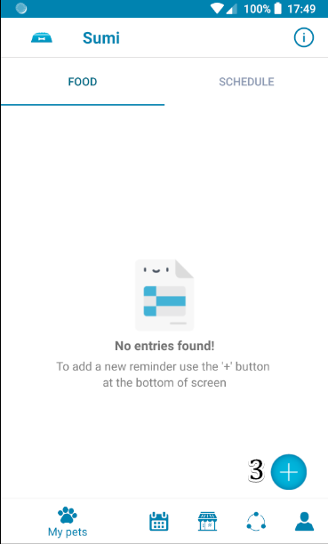**

**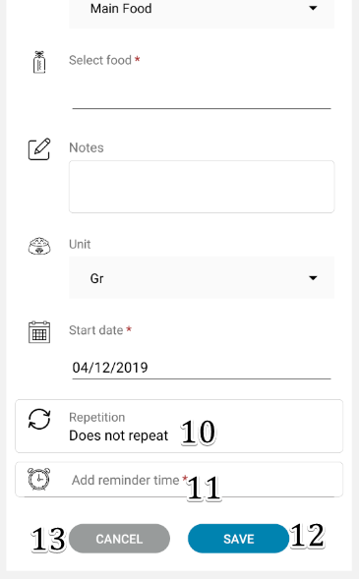**

Figure 208 - <User Guide> Add Food Reminder

|  |  |
| --- | --- |
| Step | Description |
| 1 | Tap on “Pet” |
| 2 | Tap on “Food” |
| 3 | Tap on “Add new reminder” button |
| 4 | Tap “Food is allergic” to see which food is this pet allergic to |
| 5 | Choose “Food type” |
| 6 | Enter “Food name” |
| 7 | Enter “Notes” |
| 8 | Choose “Unit” |
| 9 | Choose “Start date” |
| 10 | Choose “Repetition” |
| 11 | Tap “Add reminder time” |
| 12 | Tap “Save” to add new reminder to the system |
| 13 | Tap “Cancel” to go back to “Food” scree |

Table 251- <User Guide> Add Food Reminder

##### D:\Games\Screenshots\2019-12\bath.pngbathAdd Bath Reminder

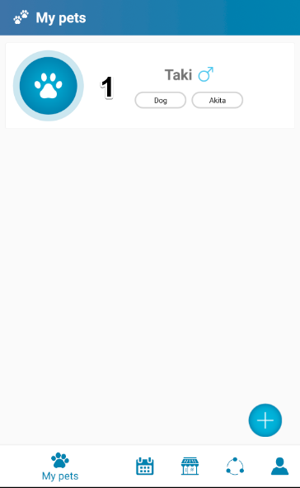

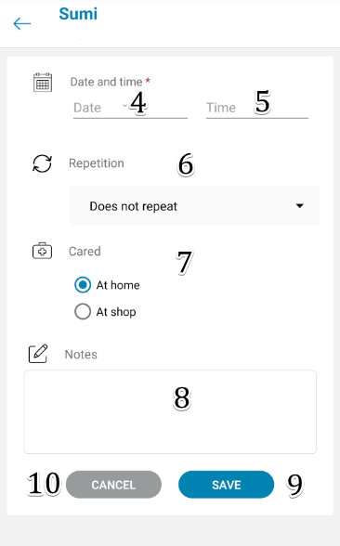

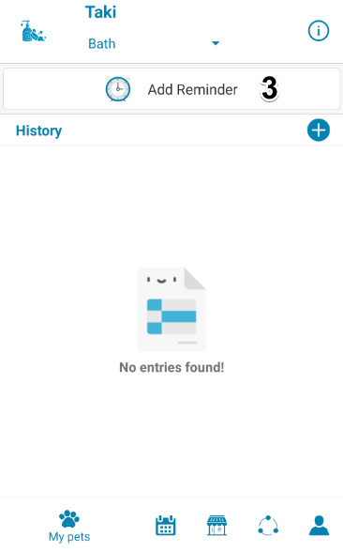

Figure 209 - <User Guide> Add Bath Reminder

|  |  |
| --- | --- |
| Step | Description |
| 1 | Tap on “Pet” |
| 2 | Tap on “Bath” button |
| 3 | Tap on “Add reminder” button |
| 4 | Choose “Date” |
| 5 | Choose “Time” |
| 6 | Choose “Repetition” |
| 7 | Choose “Cared” |
| 8 | Enter “Notes” |
| 9 | Tap on “Save” button to add a new reminder to the system |
| 10 | Tap on “Cancel” to exit screen |

Table 252- <User Guide> Add Bath Reminder

##### Add Hair Reminder

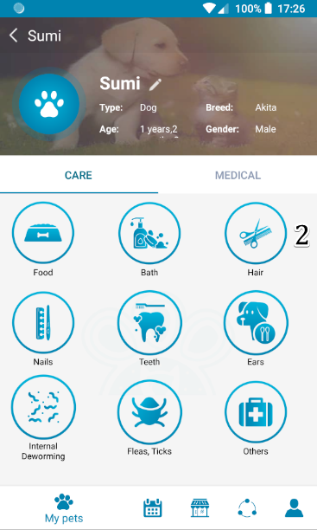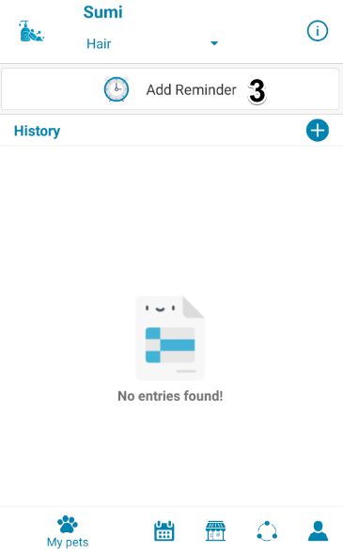

Figure 210 - <User Guide> Add Hair Reminder

|  |  |
| --- | --- |
| Step | Description |
| 1 | Tap on “Pet” |
| 2 | Tap on “Hair” button |
| 3 | Tap on “Add reminder” button |
| 4 | Choose “Date” |
| 5 | Choose “Time” |
| 6 | Choose “Repetition” |
| 7 | Choose “Cared” |
| 8 | Enter “Notes” |
| 9 | Tap on “Save” button to add a new reminder to the system |
| 10 | Tap on “Cancel” to exit screen |

Table 253 - <User Guide> Add Hair Reminder

##### Add Nails Reminder



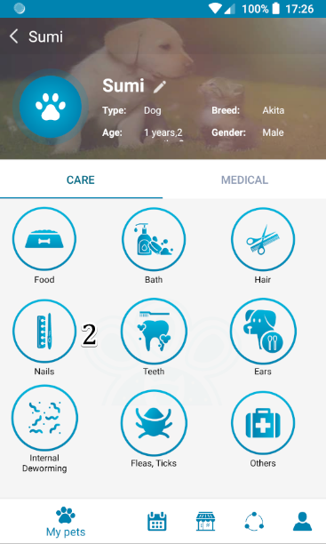

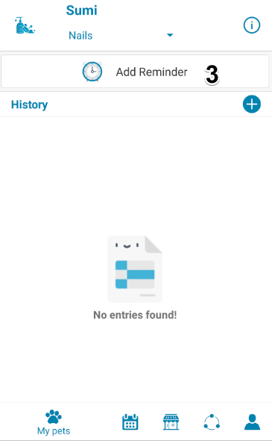

Figure 211 - <User Guide> Add Nail Reminder

|  |  |
| --- | --- |
| Step | Description |
| 1 | Tap on “Pet” |
| 2 | Tap on “Bath” button |
| 3 | Tap on “Add reminder” button |
| 4 | Choose “Date” |
| 5 | Choose “Time” |
| 6 | Choose “Repetition” |
| 7 | Choose “Cared” |
| 8 | Enter “Notes” |
| 9 | Tap on “Save” button to add a new reminder to the system |
| 10 | Tap on “Cancel” to exit screen |

Table 254 - <User Guide> Add Nail Reminder

##### Add Teeth Reminder



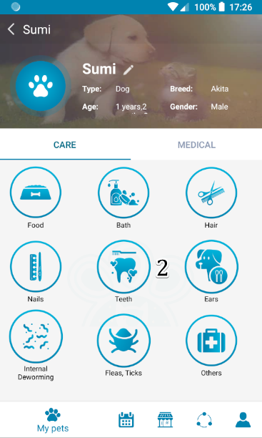

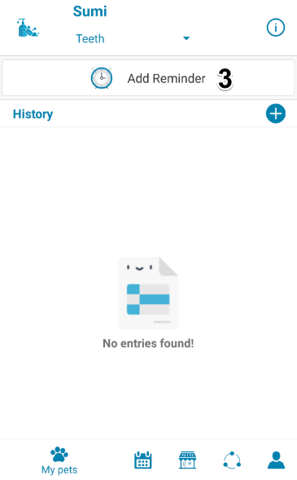



Figure 212 - <User Guide> Add Teeth Reminder

|  |  |
| --- | --- |
| Step | Description |
| 1 | Tap on “Pet” |
| 2 | Tap on “Teeth” button |
| 3 | Tap on “Add reminder” button |
| 4 | Choose “Date” |
| 5 | Choose “Time” |
| 6 | Choose “Repetition” |
| 7 | Choose “Cared” |
| 8 | Enter “Notes” |
| 9 | Tap on “Save” button to add a new reminder to the system |
| 10 | Tap on “Cancel” to exit screen |

Table 255 - <User Guide> Add Teeth Reminder

##### Add Ears Reminder

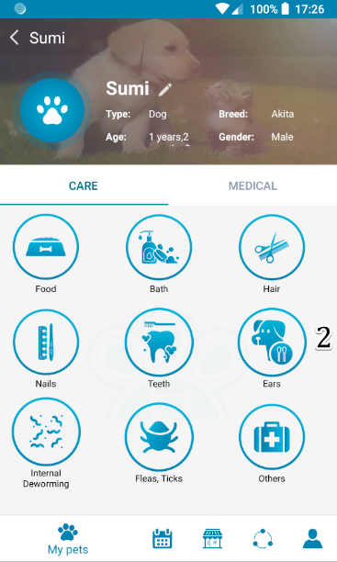



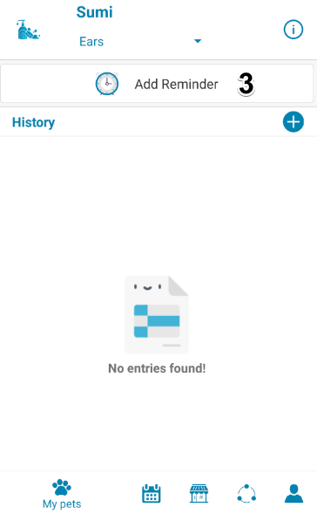

Figure 213 - <User Guide> Add Ears Reminder

|  |  |
| --- | --- |
| Step | Description |
| 1 | Tap on “Pet” |
| 2 | Tap on “Bath” button |
| 3 | Tap on “Add reminder” button |
| 4 | Choose “Date” |
| 5 | Choose “Time” |
| 6 | Choose “Repetition” |
| 7 | Choose “Cared” |
| 8 | Enter “Notes” |
| 9 | Tap on “Save” button to add a new reminder to the system |
| 10 | Tap on “Cancel” to exit screen |

Table 256 - <User Guide> Add Ears Reminder

##### Add Internal Deworming Reminder

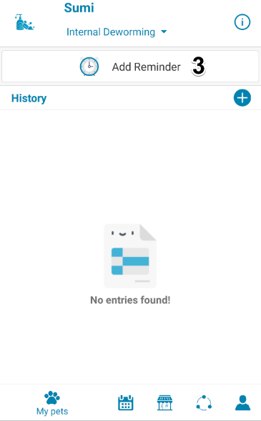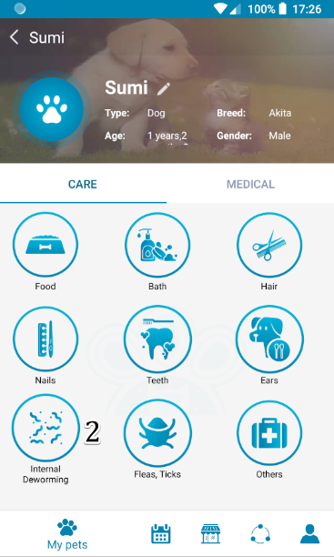Figure 214 - <User Guide> Add Internal Deworming Reminder

|  |  |
| --- | --- |
| Step | Description |
| 1 | Tap on “Pet” |
| 2 | Tap on “Internal Deworming” button |
| 3 | Tap on “Add reminder” button |
| 4 | Choose “Date” |
| 5 | Choose “Time” |
| 6 | Choose “Repetition” |
| 7 | Choose “Cared” |
| 8 | Enter “Notes” |
| 9 | Tap on “Save” button to add a new reminder to the system |
| 10 | Tap on “Cancel” to exit screen |

Table 257 - <User Guide> Add Internal Deworming Reminder

##### Add Fleas, Ticks Reminder

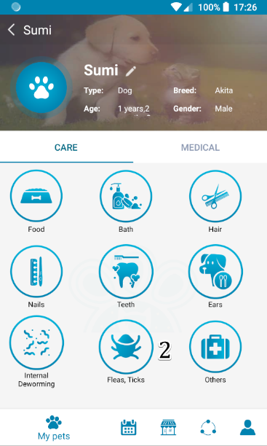

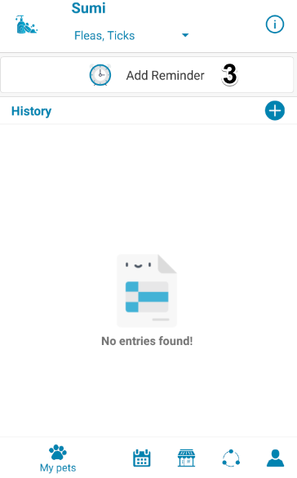

Figure 215 - <User Guide> Add Fleas, Ticks Reminder

|  |  |
| --- | --- |
| Step | Description |
| 1 | Tap on “Pet” |
| 2 | Tap on “Fleas, Ticks” button |
| 3 | Tap on “Add reminder” button |
| 4 | Choose “Date” |
| 5 | Choose “Time” |
| 6 | Choose “Repetition” |
| 7 | Choose “Cared” |
| 8 | Enter “Notes” |
| 9 | Tap on “Save” button to add a new reminder to the system |
| 10 | Tap on “Cancel” to exit screen |

Table 258 - <User Guide> Add Fleas, Ticks Reminder

##### Add Others Reminder

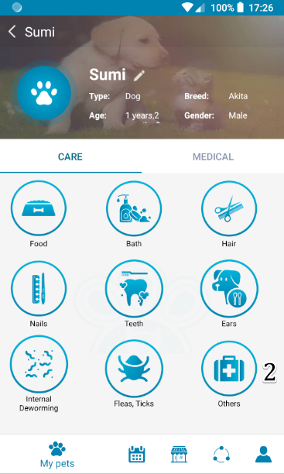

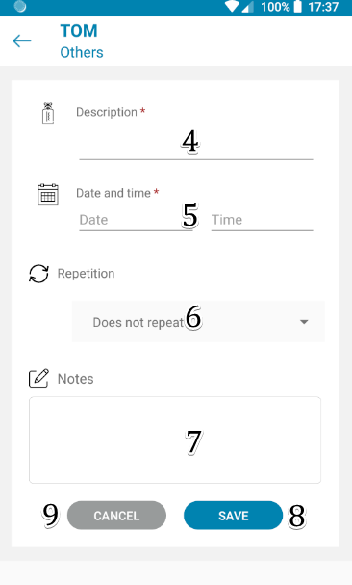

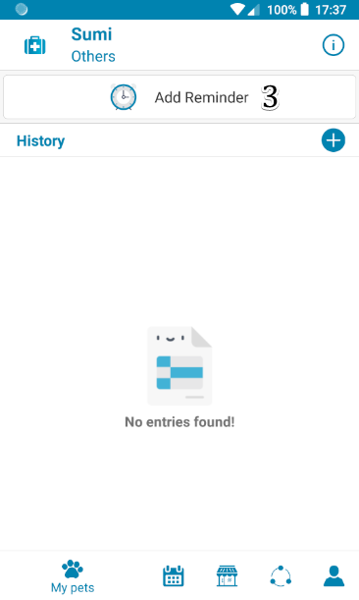

Figure 19 - Add Otherd Reminder

|  |  |
| --- | --- |
| Step | Description |
| 1 | Tap on “Pet” |
| 2 | Tap on “Others” button |
| 3 | Tap on “Add reminder” button |
| 4 | Enter “Description" |
| 5 | Choose “Date” |
| 6 | Choose “Time” |
| 7 | Choose “Repetition” |
| 8 | Tap on “Save” button to add a new reminder to the system |
| 9 | Tap on “Cancel” to exit screen |

Table 259- Add Others Reminder

#### Add Medical Reminder

##### Add Vaccination Reminder

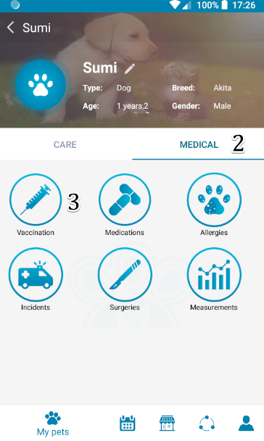



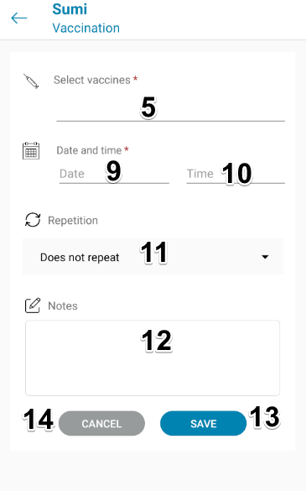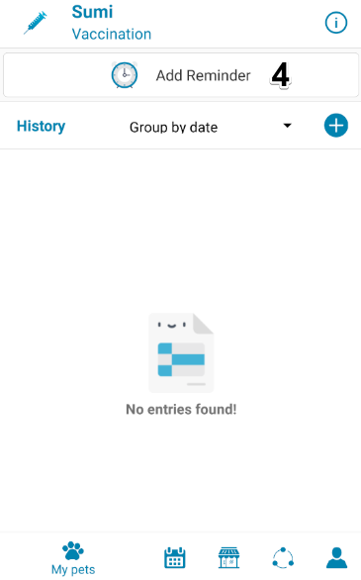

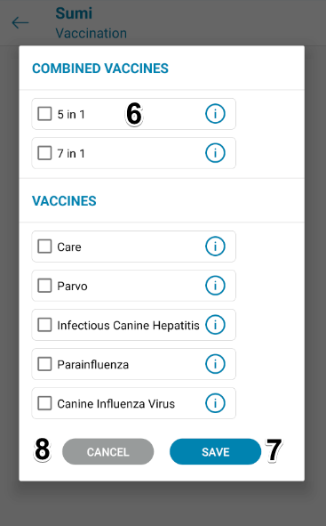

Figure 217 - <User Guide> Add Vaccination Reminder

|  |  |
| --- | --- |
| Step | Description |
| 1 | Tap on “Pet” |
| 2 | Tap on “Medical” |
| 3 | Tap on “Vaccination” |
| 4 | Tap on “Add reminder” button |
| 5 | Tap on “Select vaccines” |
| 6 | Choose “Vaccine” |
| 7 | Tap “Save” to add vaccines |
| 8 | Tap “Cancel” to go back to add reminder screen |
| 9 | Choose “Date” |
| 10 | Choose “Time” |
| 11 | Choose “Repetition” |
| 12 | Enter “Notes” |
| 13 | Tap on “Save” button to add a new reminder to the system |
| 14 | Tap on “Cancel” to exit screen |

Table 260 - <User Guide> Add Vaccination Reminder

##### Add Medication Reminder

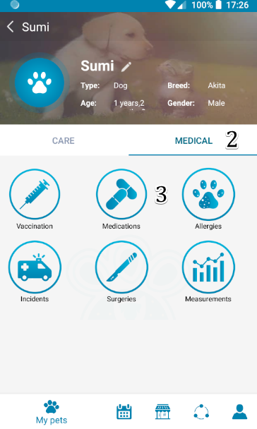

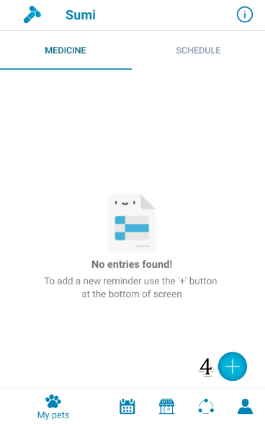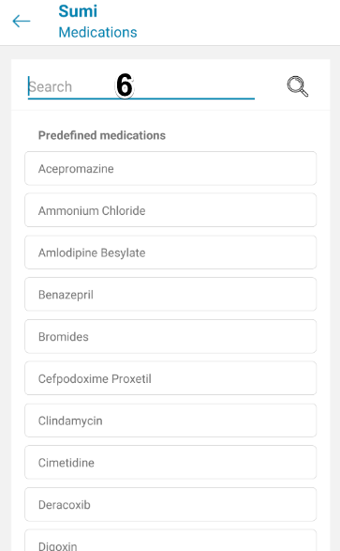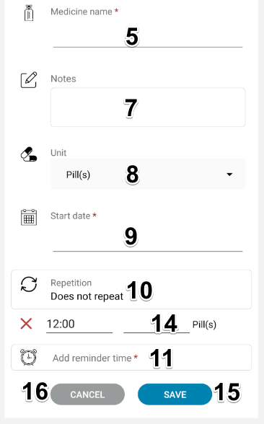

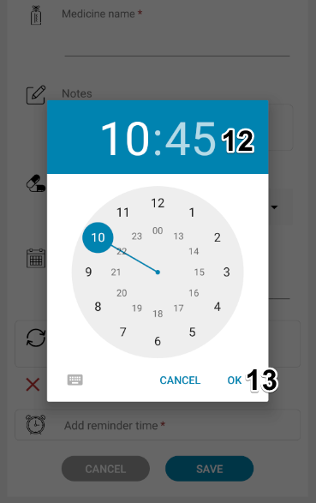

Figure 218 - <User Guide> Add Medication Reminder

|  |  |
| --- | --- |
| Step | Description |
| 1 | Tap on “Pet” |
| 2 | Tap on “Medical” |
| 3 | Tap on “Medications” |
| 4 | Tap on “Add reminder” button |
| 5 | Choose “Medication name” |
| 6 | Choose “Medication” |
| 7 | Enter “Notes” |
| 8 | Choose “Unit” |
| 9 | Choose “Start date” |
| 10 | Choose “Repetition” |
| 11 | Tap “Add reminder time” |
| 12 | Choose “Time” |
| 13 | Tap “OK” to choose time |
| 14 | Enter value of unit |
| 15 | Tap on “Save” button to add a new reminder to the system |
| 16 | Tap on “Cancel” to exit screen |

Table 261 - <User Guide> Add Medication Reminder

##### Add Measurements History

###### Add Weight

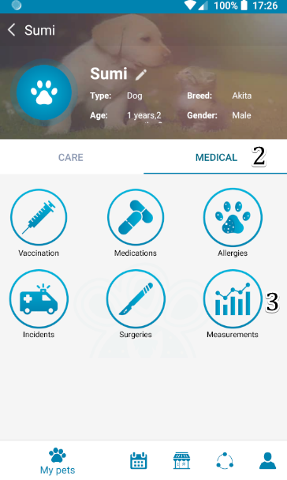

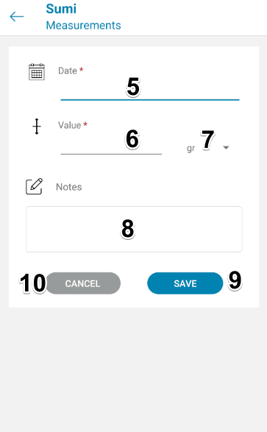

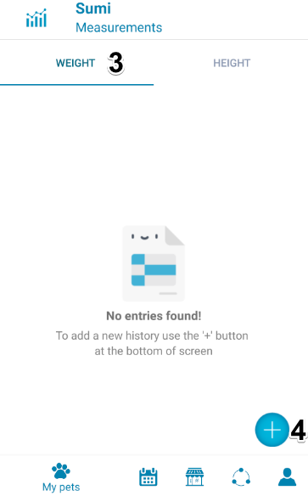

Figure 219 - <User Guide> Add Weight

|  |  |
| --- | --- |
| Step | Description |
| 1 | Tap on “Pet” |
| 2 | Tap on “Measurements” button |
| 3 | Tap “Weight” |
| 4 | Tap on “Add history” button |
| 5 | Choose “Date” |
| 6 | Enter value |
| 7 | Choose unit of weight |
| 8 | Enter “Notes” |
| 9 | Tap on “Save” button to add a new history to the system |
| 10 | Tap on “Cancel” to exit screen |

Table 262 - <User Guide> Add Weight

###### Add Height





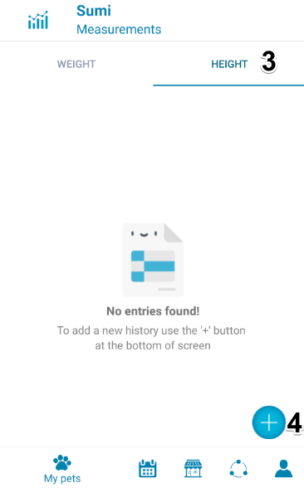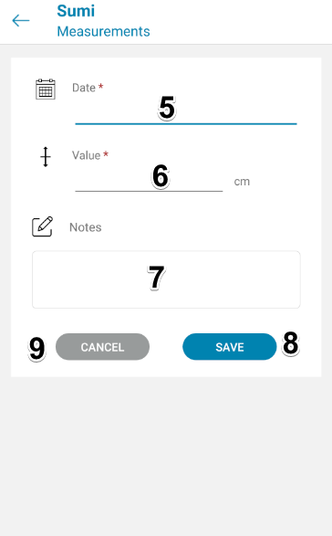

Figure 220 - <User Guide> Add Height

|  |  |
| --- | --- |
| Step | Description |
| 1 | Tap on “Pet” |
| 2 | Tap on “Measurements” button |
| 3 | Tap “Height |
| 4 | Tap on “Add history” button |
| 5 | Choose “Date” |
| 6 | Enter value |
| 7 | Enter “Notes” |
| 8 | Tap on “Save” button to add a new history to the system |
| 9 | Tap on “Cancel” to exit screen |

Table 263 - <User Guide> Add Height

#### Add Medical History

##### Add Vaccination History





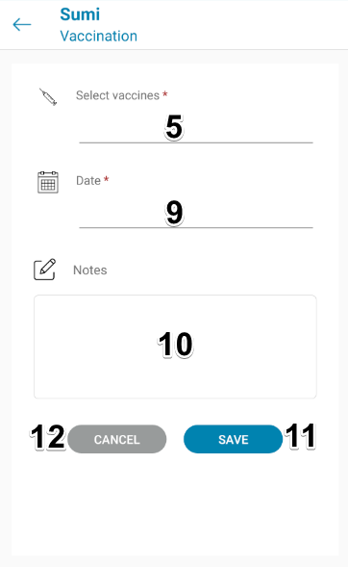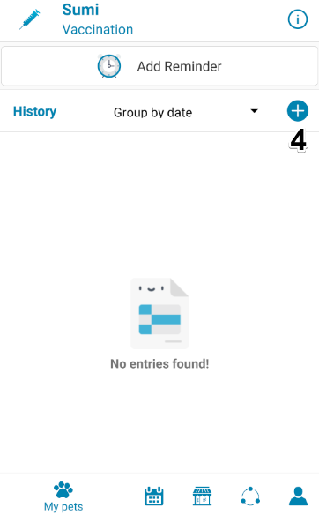

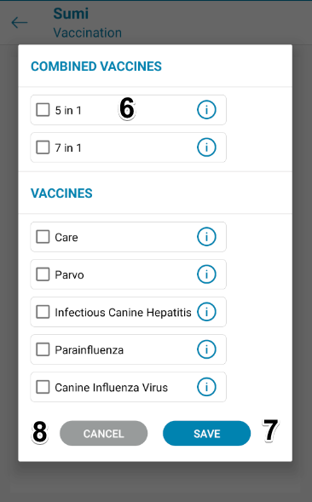

Figure 221 - <User Guide> Add Vaccination History

|  |  |
| --- | --- |
| Step | Description |
| 1 | Tap on “Pet” |
| 2 | Tap on “Medical” |
| 3 | Tap on “Vaccination” |
| 4 | Tap on “Add history” button |
| 5 | Tap on “Select vaccines” |
| 6 | Choose “Vaccine” |
| 7 | Tap “Save” to add vaccines |
| 8 | Tap “Cancel” to go back to add reminder screen |
| 9 | Choose “Date” |
| 10 | Enter “Notes” |
| 11 | Tap on “Save” button to add a new history to the system |
| 12 | Tap on “Cancel” to exit screen |

Table 264 - <User Guide> Add Vaccination History

##### Add Surgery History

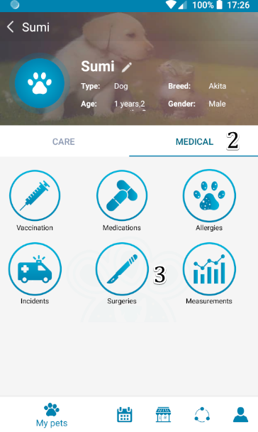

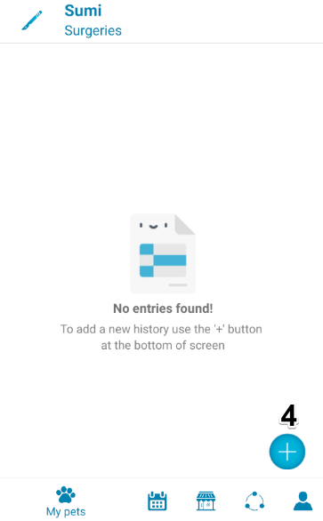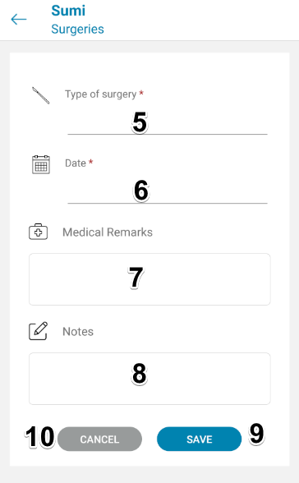

Figure 222 - <User Guide> Add Surgeru History

|  |  |
| --- | --- |
| Step | Description |
| 1 | Tap on “Pet” |
| 2 | Tap on “Medical” |
| 3 | Tap on “Surgeries” button |
| 4 | Tap on “Add history” button |
| 5 | Enter “Type of surgery” |
| 6 | Choose “Date” |
| 7 | Enter “Medical remarks” |
| 8 | Enter “Notes” |
| 9 | Tap on “Save” button to add a new history to the system |
| 10 | Tap on “Cancel” to exit screen |

Table 265 - <User Guide> Add Surgeru History

##### Add Allergy History

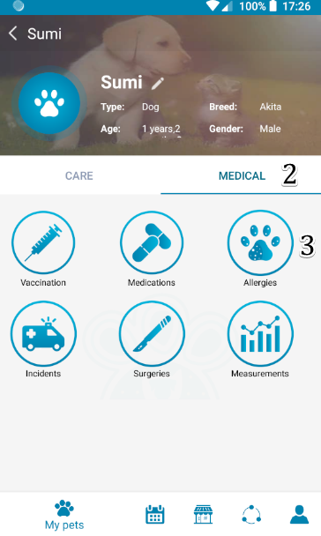

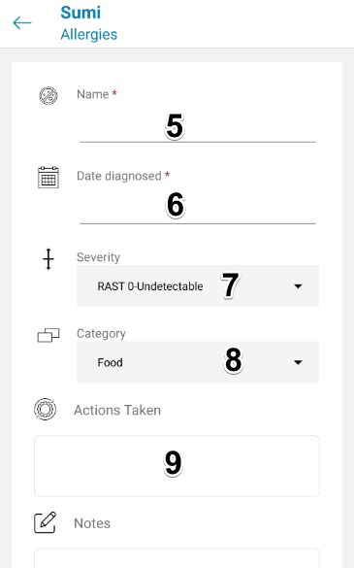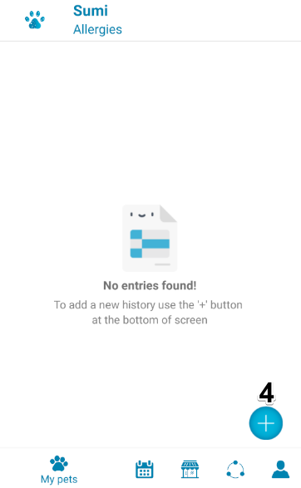

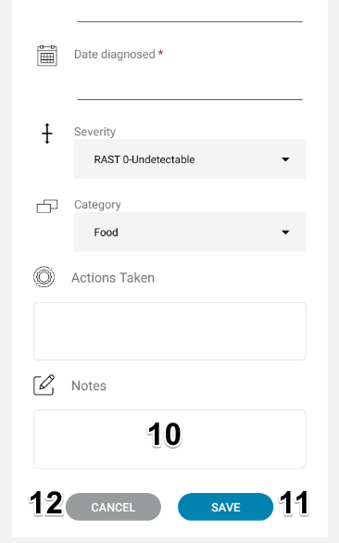

Figure 223 - <User Guide> Add Allergy History

|  |  |
| --- | --- |
| Step | Description |
| 1 | Tap on “Pet” |
| 2 | Tap on “Medical” |
| 3 | Tap on “Allergies” button |
| 4 | Tap on “Add history” button |
| 5 | Enter “Name” |
| 6 | Choose “Date diagnosed” |
| 7 | Choose “Severity” |
| 8 | Choose “Category” |
| 9 | Enter “Actions taken” |
| 10 | Enter “Notes” |
| 11 | Tap on “Save” button to add a new history to the system |
| 12 | Tap on “Cancel” to exit screen |

Table 266 - <User Guide> Add Allergy History

##### Add Incident History

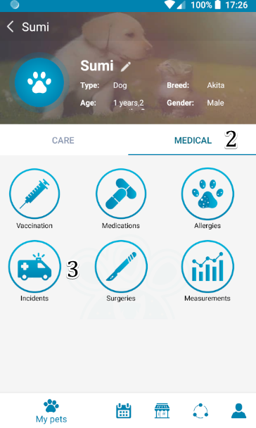



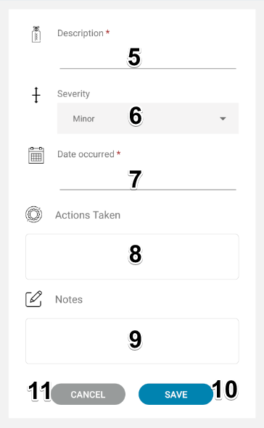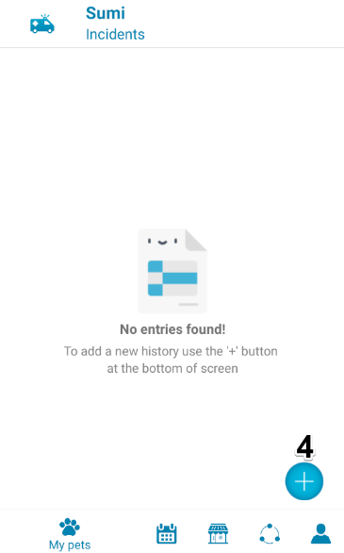

Figure 224 - <User Guide> Add Incidents History

|  |  |
| --- | --- |
| Step | Description |
| 1 | Tap on “Pet” |
| 2 | Tap on “Medical” |
| 3 | Tap on “Incidents” button |
| 4 | Tap on “Add history” button |
| 5 | Enter “Description” |
| 6 | Choose “Severity” |
| 7 | Choose “Date occured” |
| 8 | Enter “Actions taken” |
| 9 | Enter “Notes” |
| 10 | Tap on “Save” button to add a new history to the system |
| 11 | Tap on “Cancel” to exit screen |

Table 267 - <User Guide> Add Incidents History

## 取扱説明書

モバイルアプリ

#### 3.1.1. ログイン

Figure 30<ユーザーガイド> モバイルへのログイン

|  |  |
| --- | --- |
| **ステップ** | **説明** |
| 1 | 「続行するにはログインしてください！」をタップしてください。 |
| 2 | 「メール」フィールドに入力します |
| 3 | 「パスワード」フィールドに入力します |
| 4 | 「サインイン」ボタンをタップします |
| 5 | 「サインアップ」ボタンをタップしてサインアップ画面に移動します |

Table 268- <ユーザーガイド> モバイルへのログイン

#### 3.1.2. 新しいペットを追加

****

****

Figure 226 - <ユーザーガイド>新しいペットの追加

|  |  |
| --- | --- |
| **ステップ** | **説明** |
| 1 | 「新しいペットを追加」機能をタップします |
| 2 | 「画像」を選択 |
| 3 | 「ペット名」を入力してください |
| 4 | 「種類を選択し、ペットのを」 |
| 5 | 「性別」を選択します |
| 6 | 「品種」を選択します |
| 7 | 「誕生日」を選択します |
| 8 | 「色」を入力 |
| **9** | 「メモ」を入力してください |
| **10** | 「保存」ボタンをタップして新しいペットを追加します |
| **11** | 「キャンセル」ボタンをタップして画面を終了します |

Table 269 - <ユーザーガイド>新しいペットの追加

#### 3.1.3. ケアリマインダーを追加

##### フードリマインダーを追加



**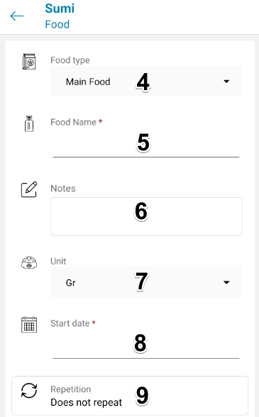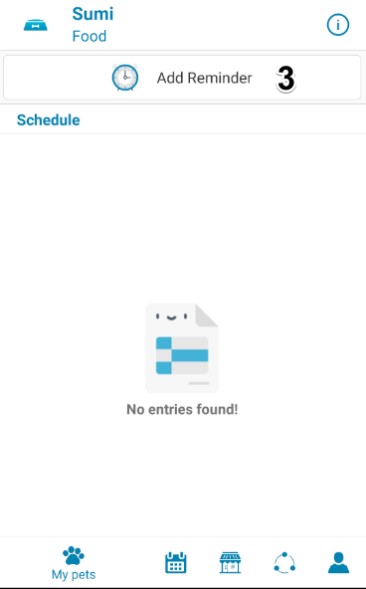**

**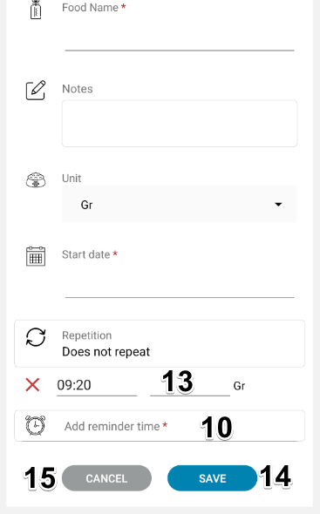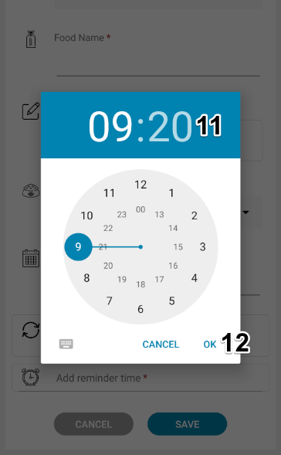**

Figure 227 - <ユーザーガイド>フードリマインダーの追加

|  |  |
| --- | --- |
| **ステップ** | **説明** |
| 1 | 「ペット」をタップします |
| 2 | 「食べ物」をタップします |
| 3 | 「新しいリマインダーを追加」ボタンをタップします |
| 4 | 「食品の種類」を選択します |
| 5 | 「食品名」を入力してください |
| 6 | 「注意事項」入る |
| 7 | 「ユニット」選ぶ |
| 8 | 「開始日」選ぶ |
| 9 | 「繰り返し」選ぶ |
| 10 | 「の追加リマインダ時間」をタップ |
| 11 | 「時間」選ぶ |
| 12 | 「OK」をタップして時間を選択します |
| 13 | 単位の値を入力してください |
| 14 | [保存]をタップして、新しいリマインダーをシステムに追加します |
| 15 | 「キャンセル」をタップして「フード」画面に戻ります |

Table 270 - <ユーザーガイド> フードリマインダーの追加

##### D:\Games\Screenshots\Screenshots\2019-10\qemu-system-i386_2019_10_24_19_22_10.pngqemu-system-i386_2019_10_24_19_22_10バスリマインダーを追加



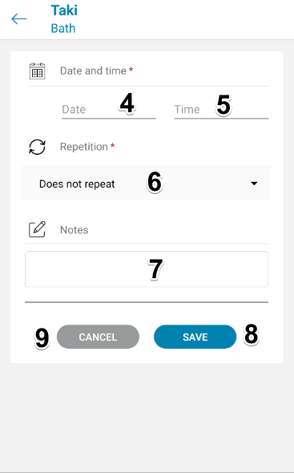

Figure 228 - <ユーザーガイド>バスリマインダーの追加

|  |  |
| --- | --- |
| **ステップ** | **説明** |
| 1 | 「ペット」をタップします |
| 2 | 「お風呂」ボタンをタップします |
| 3 | 「リマインダーを追加」ボタンをタップします |
| 4 | 「日付」を選択 |
| 5 | 「時間」を選択 |
| 6 | 「繰り返し」を選択します |
| 7 | 「メモ」を入力してください |
| 8 | 「保存」ボタンをタップして、システムに新しいリマインダーを追加します |
| 9 | 「キャンセル」をタップして画面を終了します |

Table 271 - <ユーザーガイド> バスリマインダーの追加

##### ヘアリマインダーを追加

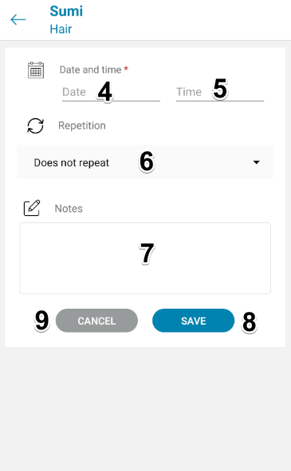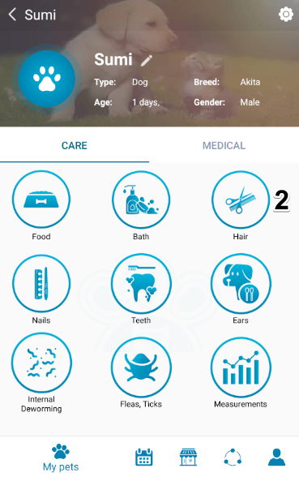

Figure 229 - <ユーザーガイド>ヘアリマインダーの追加

|  |  |
| --- | --- |
| **ステップ** | **説明** |
| 1 | 「ペット」をタップします |
| 2 | 「髪」ボタンをタップします |
| 3 | 「リマインダーを追加」ボタンをタップします |
| 4 | 「日付」を選択 |
| 5 | 「時間」を選択 |
| 6 | 「繰り返し」を選択します |
| 7 | 「メモ」を入力してください |
| 8 | 「保存」ボタンをタップして、システムに新しいリマインダーを追加します |
| 9 | 「キャンセル」をタップして画面を終了します |

Table 272 - <ユーザーガイド>ヘアリマインダーの追加

##### 釘リマインダーを追加

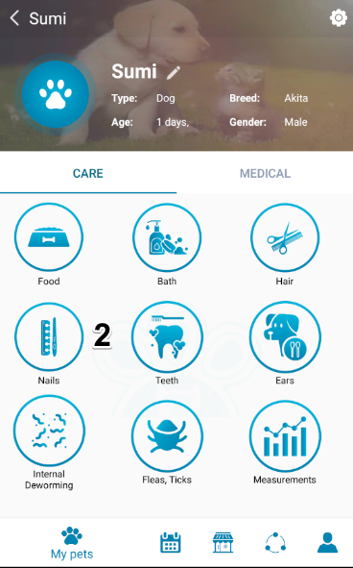

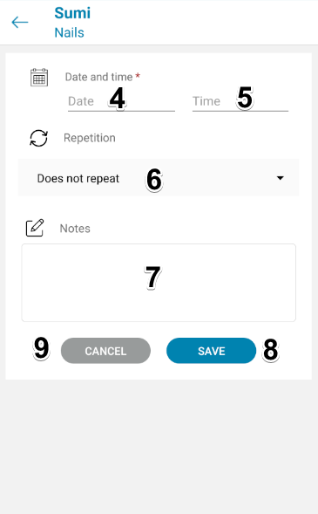

Figure 230- <ユーザーガイド>ネイルリマインダーの追加

|  |  |
| --- | --- |
| **ステップ** | **説明** |
| 1 | 「ペット」をタップします |
| 2 | 「お風呂」ボタンをタップします |
| 3 | 「リマインダーを追加」ボタンをタップします |
| 4 | 「日付」を選択 |
| 5 | 「時間」を選択 |
| 6 | 「繰り返し」を選択します |
| 7 | 「メモ」を入力してください |
| 8 | 「保存」ボタンをタップして、システムに新しいリマインダーを追加します |
| 9 | 「キャンセル」をタップして画面を終了します |

Table 273 - <ユーザーガイド>ネイルリマインダーの追加

##### 歯リマインダーを追加



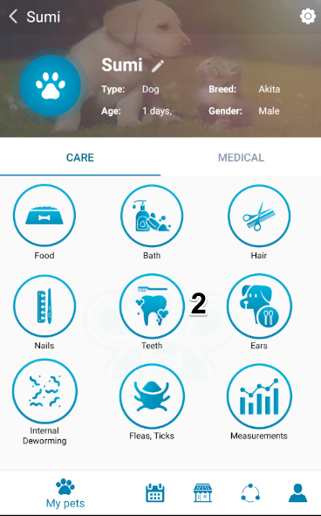

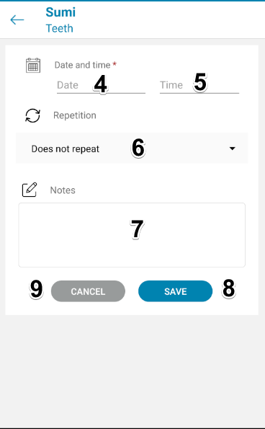

Figure 231 - <ユーザーガイド>歯リマインダーの追加

|  |  |
| --- | --- |
| **ステップ** | **説明** |
| 1 | 「ペット」をタップします |
| 2 | 「歯」ボタンをタップします |
| 3 | 「リマインダーを追加」ボタンをタップします |
| 4 | 「日付」を選択 |
| 5 | 「時間」を選択 |
| 6 | 「繰り返し」を選択します |
| 7 | 「メモ」を入力してください |
| 8 | 「保存」ボタンをタップして、システムに新しいリマインダーを追加します |
| 9 | 「キャンセル」をタップして画面を終了します |

Table 274- <ユーザーガイド>歯リマインダーの追加

##### 耳リマインダーを追加

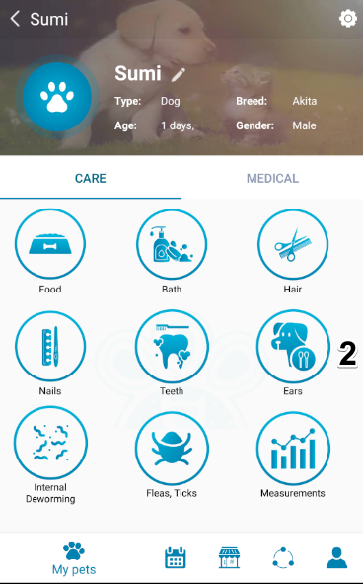

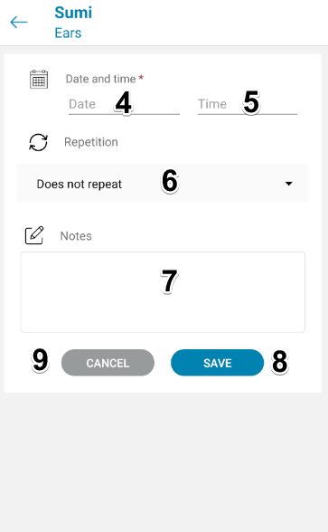

Figure 232 - <ユーザーガイド>耳リマインダーの追加

|  |  |
| --- | --- |
| **ステップ** | **説明** |
| 1 | 「ペット」をタップします |
| 2 | 「お風呂」ボタンをタップします |
| 3 | 「リマインダーを追加」ボタンをタップします |
| 4 | 「日付」を選択 |
| 5 | 「時間」を選択 |
| 6 | 「繰り返し」を選択します |
| 7 | 「メモ」を入力してください |
| 8 | 「保存」ボタンをタップして、システムに新しいリマインダーを追加します |
| 9 | 「キャンセル」をタップして画面を終了します |

Table 275 - <ユーザーガイド>耳リマインダーの追加

##### 内部駆虫リマインダーを追加

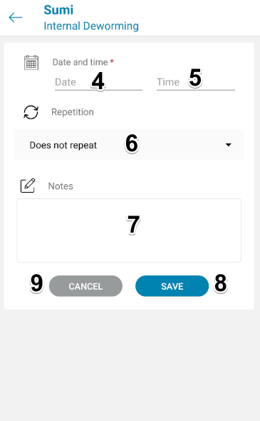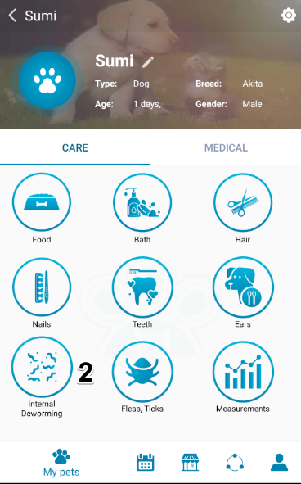Figure 233 - <ユーザガイド>追加の内部駆虫リマインダー

|  |  |
| --- | --- |
| **ステップ** | **説明** |
| 1 | 「ペット」をタップします |
| 2 | 「内部駆虫」ボタンをタップします |
| 3 | 「リマインダーを追加」ボタンをタップします |
| 4 | 「日付」を選択 |
| 5 | 「時間」を選択 |
| 6 | 「繰り返し」を選択します |
| 7 | 「メモ」を入力してください |
| 8 | 「保存」ボタンをタップして、システムに新しいリマインダーを追加します |
| 9 | 「キャンセル」をタップして画面を終了します |

Table 276  - <ユーザガイド>内部駆虫リマインダーを追加

##### ノミ、ダニのリマインダーを追加

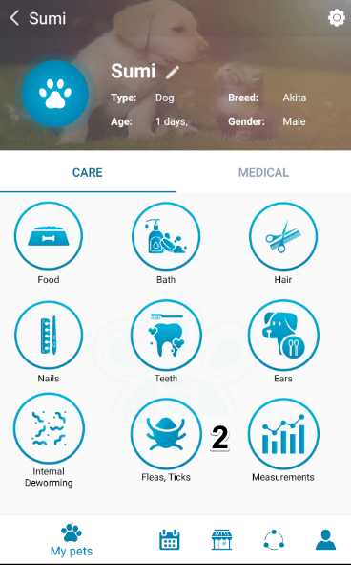

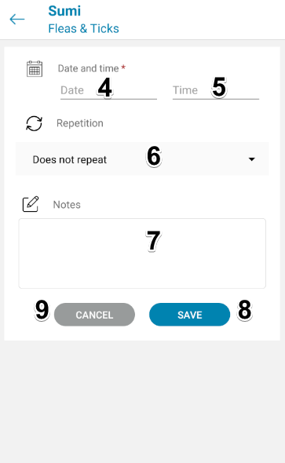

Figure 234 - <ユーザーガイド>ノミの追加、ティックのリマインダー

|  |  |
| --- | --- |
| **ステップ** | **説明** |
| 1 | 「ペット」をタップします |
| 2 | 「ノミ、ダニ」ボタンをタップします |
| 3 | 「リマインダーを追加」ボタンをタップします |
| 4 | 「日付」を選択 |
| 5 | 「時間」を選択 |
| 6 | 「繰り返し」を選択します |
| 7 | 「メモ」を入力してください |
| 8 | 「保存」ボタンをタップして、システムに新しいリマインダーを追加します |
| 9 | 「キャンセル」をタップして画面を終了します |

Table 277 - <ユーザーガイド>ノミ、ダニのリマインダーの追加

#### 3.1.4. 医療リマインダーを追加

##### 予防接種リマインダーを追加

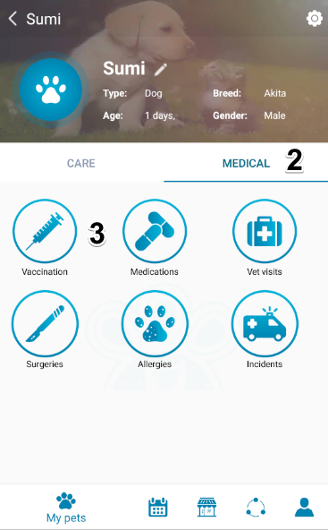





Figure 235 - <ユーザーガイド>予防接種リマインダーの追加

|  |  |
| --- | --- |
| **ステップ** | **説明** |
| 1 | 「ペット」をタップします |
| 2 | 「医療」をタップします |
| 3 | 「予防接種」をタップします |
| 4 | 「リマインダーを追加」ボタンをタップします |
| 5 | 「ワクチンの選択」をタップします |
| 6 | 「ワクチン」を選択 |
| 7 | 「保存」をタップしてワクチンを追加します |
| 8 | 「キャンセル」をタップして戻ってリマインダー画面を追加します |
| 9 | 「日付」を選択します |
| 10 | 「時間」を選択します |
| 1 1 | 「繰り返し」選ぶ |
| 1 2 | 「メモ」を入力してください |
| 13 | 「保存」ボタンをタップして、システムに新しいリマインダーを追加します |
| 14 | 「キャンセル」をタップして画面を終了します |

Table 278 - <ユーザーガイド>予防接種リマインダーの追加

##### 投薬リマインダーを追加



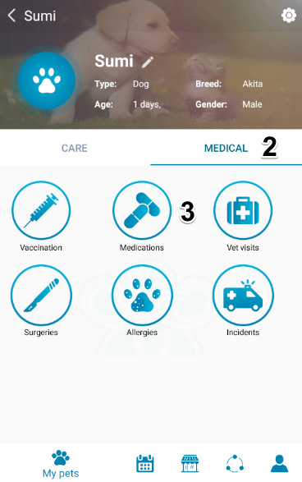

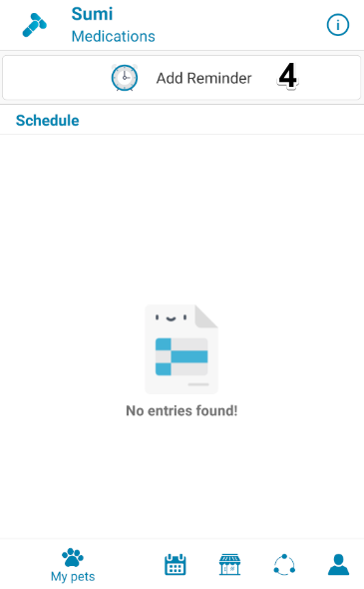



Figure 236 - <ユーザーガイド>投薬リマインダーの追加

|  |  |
| --- | --- |
| **ステップ** | **説明** |
| 1 | 「ペット」をタップします |
| **2** | 「医療」をタップします |
| **3** | 「薬」をタップします |
| **4** | 「リマインダーを追加」ボタンをタップします |
| **5** | 「医薬品名」を選択します |
| 6 | 「薬」選ぶ |
| 7 | 「メモ」を入力してください |
| 8 | 「ユニット」選ぶ |
| 9 | 「開始日」選ぶ |
| 1 0 | 「繰り返し」選ぶ |
| 11 | 「の追加リマインダ時間」をタップ |
| 12 | 「時間」選ぶ |
| 13 | 「OK」をタップして時間を選択します |
| 14 | 単位の値を入力してください |
| 15 | 「保存」ボタンをタップして、システムに新しいリマインダーを追加します |
| 16 | 「キャンセル」をタップして画面を終了します |

Table 279 - <ユーザーガイド>投薬リマインダーの追加

##### 獣医訪問リマインダーを追加

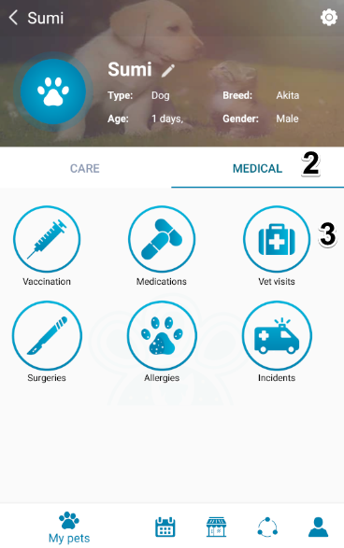

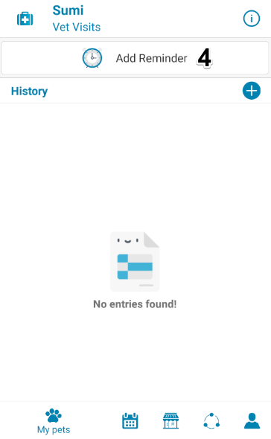

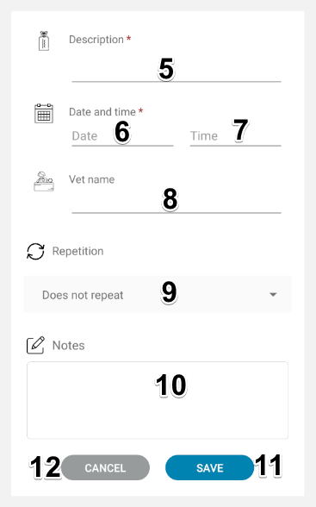

Figure 237 <ユーザーガイド>獣医訪問リマインダーを追加

|  |  |
| --- | --- |
| **ステップ** | **説明** |
| 1 | 「ペット」をタップします |
| **2** | 「医療」をタップします |
| **3** | 「獣医訪問」をタップします |
| **4** | 「リマインダーを追加」ボタンをタップします |
| **5** | 「説明」を入力してください |
| **6** | 「日付」を選択します |
| **7** | 「時間」を選択します |
| **8** | 「獣医名」入る |
| **9** | 「繰り返し」選ぶ |
| 1 0 | 「メモ」を入力してください |
| 1 1 | 「保存」ボタンをタップして、システムに新しいリマインダーを追加します |
| 1 2 | 「キャンセル」をタップして画面を終了します |

Table 280 - <ユーザーガイド>獣医訪問リマインダーを追加

#### 3.1.5. ケア履歴を追加

##### D:\Games\Screenshots\Screenshots\2019-10\qemu-system-i386_2019_10_24_19_22_10.pngqemu-system-i386_2019_10_24_19_22_10バス履歴を追加



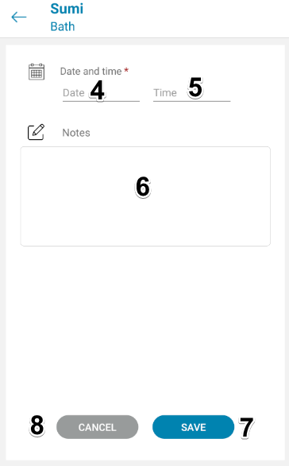

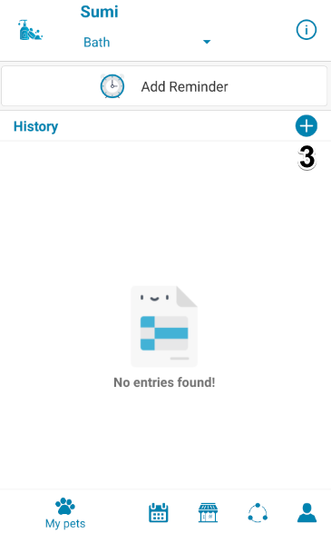Figure 238 - <ユーザーガイド>バス履歴の追加

|  |  |
| --- | --- |
| **ステップ** | **説明** |
| 1 | 「ペット」をタップします |
| 2 | 「お風呂」ボタンをタップします |
| 3 | 「履歴を追加」ボタンをタップします |
| 4 | 「日付」を選択 |
| 5 | 「時間」を選択 |
| 6 | 「メモ」を入力してください |
| 7 | 「保存」ボタンをタップして、システムに新しい履歴を追加します |
| 8 | 「キャンセル」をタップして画面を終了します |

Table 281 - <ユーザーガイド>バス履歴の追加

##### 髪の履歴を追加



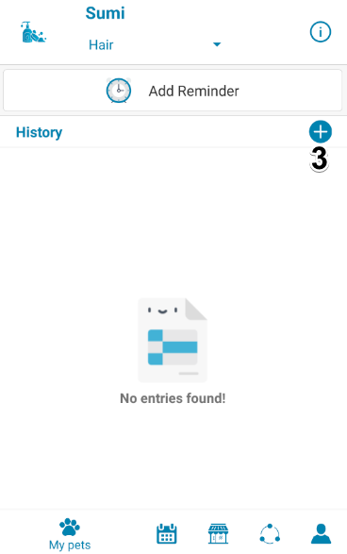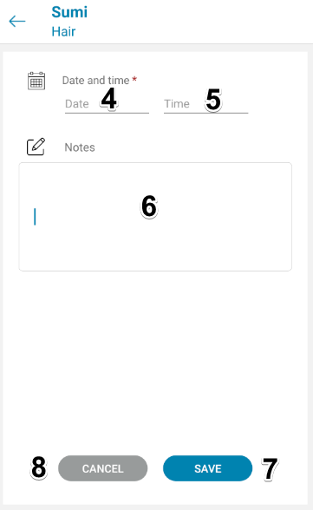

Figure 239 - <ユーザーガイド>ヘア履歴の追加

|  |  |
| --- | --- |
| **ステップ** | **説明** |
| 1 | 「ペット」をタップします |
| 2 | 「髪」ボタンをタップします |
| 3 | 「履歴を追加」ボタンをタップします |
| 4 | 「日付」を選択 |
| 5 | 「時間」を選択 |
| 6 | 「メモ」を入力してください |
| 7 | 「保存」ボタンをタップして、システムに新しい履歴を追加します |
| 8 | 「キャンセル」をタップして画面を終了します |

Table 282 - <ユーザーガイド>ヘア履歴の追加

##### 爪の履歴を追加

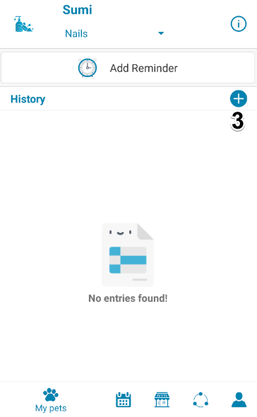

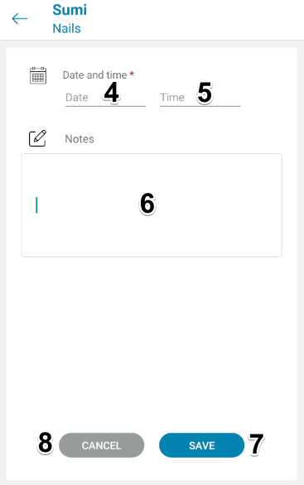

Figure 240 - <ユーザーガイド>ネイル履歴の追加

|  |  |
| --- | --- |
| **ステップ** | **説明** |
| 1 | 「ペット」をタップします |
| 2 | 「釘」ボタンをタップします |
| 3 | 「履歴を追加」ボタンをタップします |
| 4 | 「日付」を選択 |
| 5 | 「時間」を選択 |
| 6 | 「メモ」を入力してください |
| 7 | 「保存」ボタンをタップして、システムに新しい履歴を追加します |
| 8 | 「キャンセル」をタップして画面を終了します |

Table 283 - <ユーザーガイド>ネイル履歴の追加

##### 歯の履歴を追加



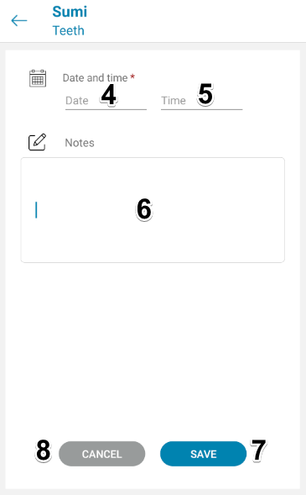

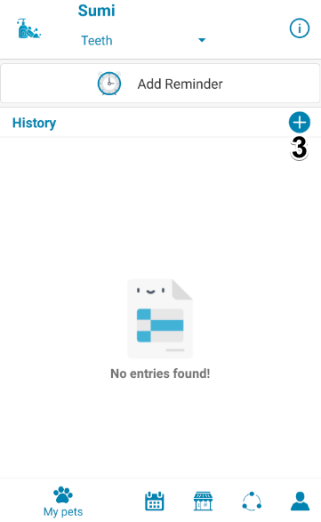

Figure 241 - <ユーザガイド>追加歯の歴史

|  |  |
| --- | --- |
| **ステップ** | **説明** |
| 1 | 「ペット」をタップします |
| 2 | 「歯」ボタンをタップします |
| 3 | 「履歴を追加」ボタンをタップします |
| 4 | 「日付」を選択 |
| 5 | 「時間」を選択 |
| 6 | 「メモ」を入力してください |
| 7 | 「保存」ボタンをタップして、システムに新しい履歴を追加します |
| 8 | 「キャンセル」をタップして画面を終了します |

Table 284 - <ユーザガイド>追加歯の歴史

##### 耳の履歴を追加



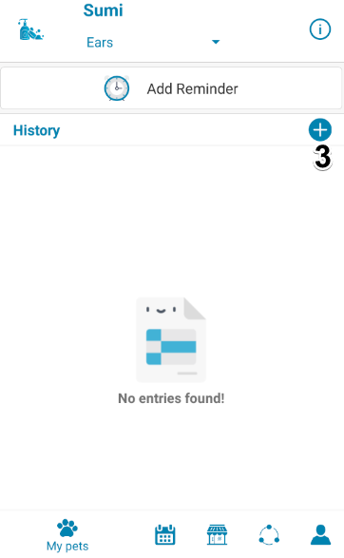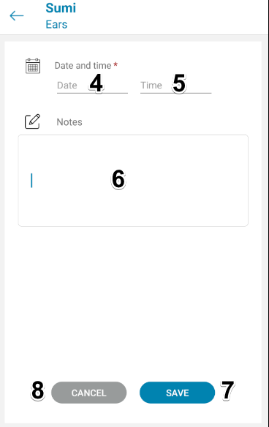

Figure 242 - <ユーザガイド>追加耳の歴史

|  |  |
| --- | --- |
| **ステップ** | **説明** |
| 1 | 「ペット」をタップします |
| 2 | 「耳」ボタンをタップします |
| 3 | 「履歴を追加」ボタンをタップします |
| 4 | 「日付」を選択 |
| 5 | 「時間」を選択 |
| 6 | 「メモ」を入力してください |
| 7 | 「保存」ボタンをタップして、システムに新しい履歴を追加します |
| 8 | 「キャンセル」をタップして画面を終了します |

Table 285  - <ユーザガイド>追加耳の歴史

##### 内部駆除履歴を追加する



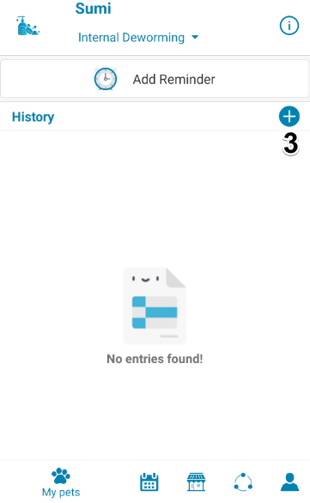

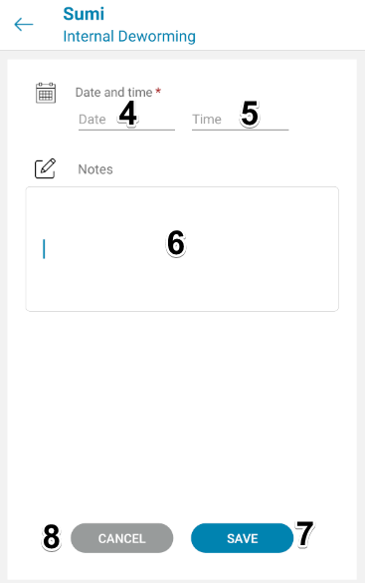

Figure 243 - <ユーザーガイド>内部ワーム駆除履歴の追加

|  |  |
| --- | --- |
| **ステップ** | **説明** |
| 1 | 「ペット」をタップします |
| 2 | 「内部駆虫」ボタンをタップします |
| 3 | 「履歴を追加」ボタンをタップします |
| 4 | 「日付」を選択 |
| 5 | 「時間」を選択 |
| 6 | 「メモ」を入力してください |
| 7 | 「保存」ボタンをタップして、システムに新しい履歴を追加します |
| 8 | 「キャンセル」をタップして画面を終了します |

Table 286 - <ユーザーガイド>内部駆除履歴の追加

##### ノミ、ティックの履歴を追加



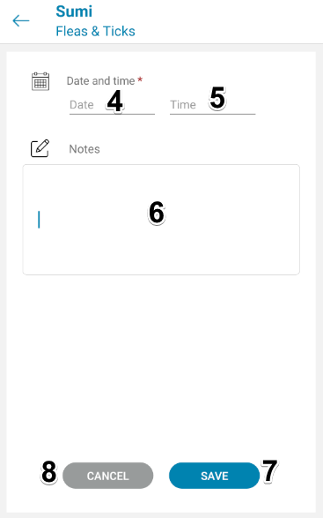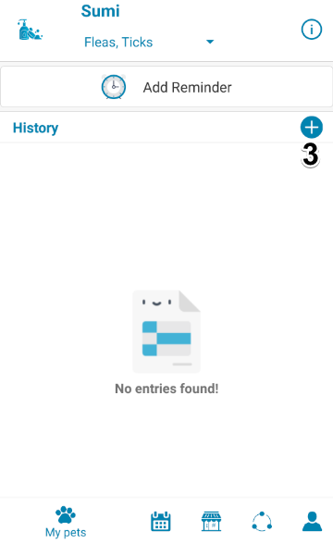

Figure 244 - <ユーザーガイド>ノミ、ティックの履歴の追加

|  |  |
| --- | --- |
| **ステップ** | **説明** |
| 1 | 「ペット」をタップします |
| 2 | 「ノミ、ダニ」ボタンをタップします |
| 3 | 「履歴を追加」ボタンをタップします |
| 4 | 「日付」を選択 |
| 5 | 「時間」を選択 |
| 6 | 「メモ」を入力してください |
| 7 | 「保存」ボタンをタップして、システムに新しい履歴を追加します |
| 8 | 「キャンセル」をタップして画面を終了します |

Table 287 - <ユーザーガイド>ノミの追加、ティックの履歴

##### 測定履歴を追加

###### 重量を追加

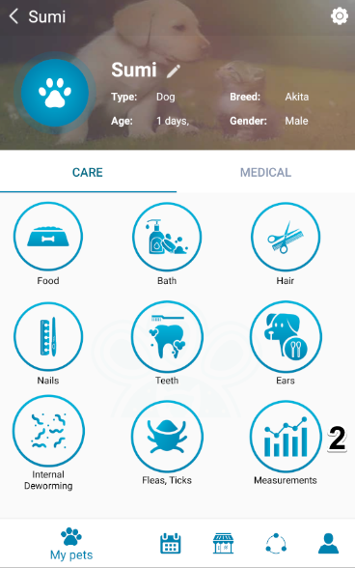





Figure 245 - <ユーザーガイド>重量の追加

|  |  |
| --- | --- |
| **ステップ** | **説明** |
| 1 | 「ペット」をタップします |
| 2 | 「測定」ボタンをタップします |
| 3 | 「重量」をタップします |
| 4 | 「履歴を追加」ボタンをタップします |
| 5 | 「日付」を選択 |
| 6 | 値を入力してください |
| 7 | ユニット選ぶ |
| 8 | 「メモ」を入力してください |
| 9 | 「保存」ボタンをタップして、システムに新しい履歴を追加します |
| 10 | 「キャンセル」をタップして画面を終了します |

Table 288 - <ユーザーガイド>重量の追加

###### 高さを追加





Figure 246 - <ユーザーガイド>高さの追加

|  |  |
| --- | --- |
| **ステップ** | **説明** |
| 1 | 「ペット」をタップします |
| 2 | 「測定」ボタンをタップします |
| 3 | 「高さ」をタップします |
| 4 | 「履歴を追加」ボタンをタップします |
| 5 | 「日付」を選択 |
| 6 | 値を入力してください |
| 7 | 「メモ」を入力してください |
| 8 | 「保存」ボタンをタップして、システムに新しい履歴を追加します |
| 9 | 「キャンセル」をタップして画面を終了します |

Table 289 - <ユーザーガイド>高さの追加

#### 3.1.6. 病歴を追加

##### 予防接種履歴を追加







Figure 247 - <ユーザガイド>予防接種の歴史を追加します

|  |  |
| --- | --- |
| **ステップ** | **説明** |
| 1 | 「ペット」をタップします |
| 2 | 「医療」をタップします |
| 3 | 「予防接種」をタップします |
| 4 | 「履歴を追加」ボタンをタップします |
| 5 | 「ワクチンの選択」をタップします |
| 6 | 「ワクチン」を選択 |
| 7 | 「保存」をタップしてワクチンを追加します |
| 8 | 「キャンセル」をタップして戻ってリマインダー画面を追加します |
| 9 | 「日付」を選択します |
| 10 | 「メモ」を入力してください |
| 11 | 「保存」ボタンをタップして、システムに新しい履歴を追加します |
| 12 | 「キャンセル」をタップして画面を終了します |

Table 290 - <ユーザガイド>予防接種の歴史を追加します

##### 獣医の訪問履歴を追加



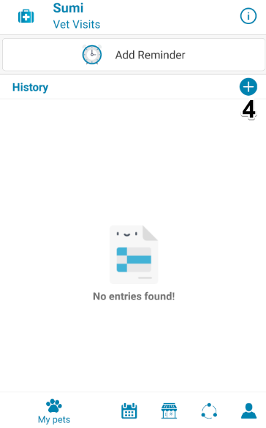

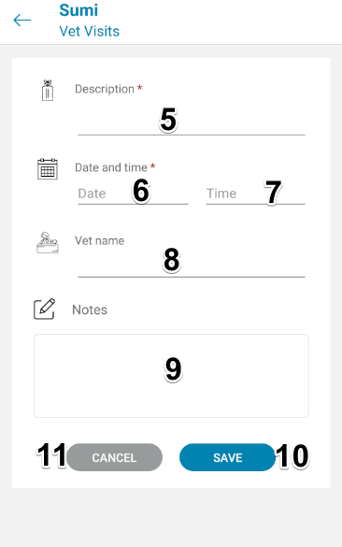

Figure 248 - <ユーザガイド>追加獣医の訪問の歴史

|  |  |
| --- | --- |
| **ステップ** | **説明** |
| 1 | 「ペット」をタップします |
| 2 | 「医療」をタップします |
| 3 | 「獣医訪問」をタップします |
| 4 | 「履歴を追加」ボタンをタップします |
| 5 | 「説明」を入力してください |
| 6 | 「日付」を選択します |
| 7 | 「時間」を選択します |
| 8 | 「獣医名」入る |
| 9 | 「メモ」を入力してください |
| 10 | 「保存」ボタンをタップして、システムに新しい履歴を追加します |
| 11 | 「キャンセル」をタップして画面を終了します |

Table 291 - <ユーザガイド>獣医の訪問の歴史を追加

##### 手術履歴を追加

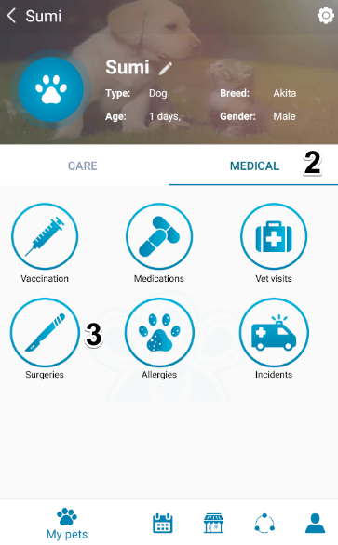



Figure 249 - <ユーザーガイド>手術履歴を追加

|  |  |
| --- | --- |
| **ステップ** | **説明** |
| 1 | 「ペット」をタップします |
| 2 | 「医療」をタップします |
| 3 | 「手術」ボタンをタップします |
| 4 | 「履歴を追加」ボタンをタップします |
| 5 | 「手術の種類」を入力します |
| 6 | 「日付」を選択 |
| 7 | 「医学的発言」を入力してください |
| 8 | 「メモ」を入力してください |
| 9 | 「保存」ボタンをタップして、システムに新しい履歴を追加します |
| 1 0 | 「キャンセル」をタップして画面を終了します |

Table 292 - <ユーザーガイド>手術履歴を追加

##### アレルギー履歴を追加

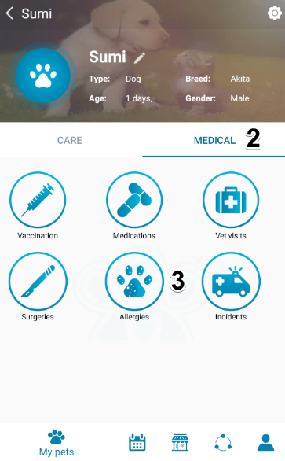





Figure 250 - <ユーザガイド>アレルギーの歴史を追加します

|  |  |
| --- | --- |
| **ステップ** | **説明** |
| 1 | 「ペット」をタップします |
| 2 | 「医療」をタップします |
| 3 | 「アレルギー」ボタンをタップします |
| 4 | 「履歴を追加」ボタンをタップします |
| 5 | 名前を入力" |
| 6 | 「診断日」を選択します |
| 7 | 「重大度」を選択します |
| 8 | 「カテゴリ」を選択します |
| 9 | 「実行されたアクション」を入力します |
| 10 | 「メモ」を入力してください |
| 11 | 「保存」ボタンをタップして、システムに新しい履歴を追加します |
| 1 2 | 「キャンセル」をタップして画面を終了します |

Table 293  - <ユーザガイド>アレルギーの歴史を追加します

##### インシデント履歴を追加

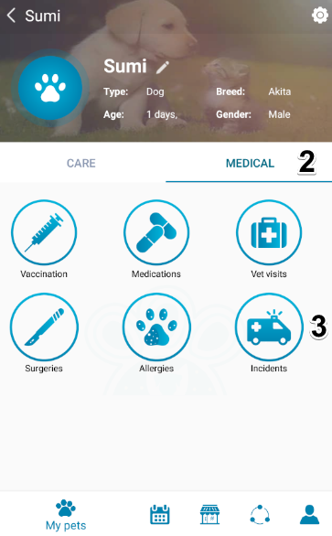





Figure 251 - <ユーザーガイド>インシデント履歴の追加

|  |  |
| --- | --- |
| **ステップ** | **説明** |
| 1 | 「ペット」をタップします |
| 2 | 「医療」をタップします |
| 3 | 「インシデント」ボタンをタップします |
| 4 | 「履歴を追加」ボタンをタップします |
| 5 | 「説明」を入力してください |
| 6 | 「重大度」を選択します |
| 7 | 「発生日」を選択します |
| 8 | 「実行されたアクション」を入力します |
| 9 | 「メモ」を入力してください |
| 10 | 「保存」ボタンをタップして、システムに新しい履歴を追加します |
| 1 1 | 「キャンセル」をタップして画面を終了します |

Table 294 - <ユーザーガイド>インシデント履歴の追加

### Webシステム

#### ログイン



Figure 252 – <ユーザーガイド>ログイン

|  |  |
| --- | --- |
| ステップ | 説明 |
| 1 | 「ユーザー名」フィールドに入力します |
| 2 | 「パスワード」フィールドに入力します |
| 3 | 「ログイン」ボタンをタップします |

Table 295 – <ユーザーガイド>ログイン

#### 管理者

##### 新しいショップを作成する





Figure 253 – <ユーザーガイド>新しいショップの作成

|  |  |
| --- | --- |
| ステップ | 説明 |
| 1 | 「ショップ」タブをタップします |
| 2 | 「新しいショップを作成」ボタンをタップします |
| 3 | ユーザーIDを入力してください |
| 4 | ステータスを選択 |
| 5 | ショップ名を入力してください |
| 6 | 説明を入力（オプション） |
| 7 | 画像のURLを入力（オプション） |
| 8 | 「URLから画像を読み込む」または「デフォルトを使用」ボタンをタップします |
| 9 | 緯度と経度を入力してください（オプション） |
| 10 | 「作成」ボタンをタップします |

Table 296 – <ユーザーガイド>新規ショップの作成

##### ショップを編集





Figure 254 – <ユーザーガイド>編集ショップ

|  |  |
| --- | --- |
| ステップ | 説明 |
| 1 | 「ショップ」タブをタップします |
| 2 | 「ショップを編集」ボタンをタップします |
| 3 | ステータスを選択 |
| 4 | ショップ名を入力してください |
| 5 | 説明を入力（オプション） |
| 6 | 画像のURLを入力（オプション） |
| 7 | 「URLから画像を読み込む」または「デフォルトを使用」ボタンをタップします |
| 8 | 緯度と経度を入力してください（オプション） |
| 9 | 「保存」ボタンをタップします |

Table 297 – <ユーザーガイド>ショップの編集

##### 新しいアカウントを作成する





Figure 255 – <ユーザーガイド>新しいアカウントの作成

|  |  |
| --- | --- |
| ステップ | 説明 |
| 1 | 「アカウント」タブをタップします |
| 2 | 「新しいアカウントを作成」ボタンをタップします |
| 3 | 名前を入力" |
| 4 | 「メール」を入力 |
| 5 | パスワードを入力する" |
| 6 | 「ロール」を選択します |
| 7 | 「作成」ボタンをタップします |

Table 298 – <ユーザーガイド>新しいアカウントの作成

##### 新しい品種を作成





Figure 256 – <ユーザーガイド>新しい品種の作成

|  |  |
| --- | --- |
| ステップ | 説明 |
| 1 | 「種」タブをタップします |
| 2 | 「新しい品種を作成」ボタンをタップします |
| 3 | 名前を入力" |
| 4 | 「メモ」と入力します（オプション） |
| 5 | 「ペットの種類」を選択します |
| 6 | 「作成」ボタンをタップします |

Table 299 – <ユーザーガイド>新しい品種の作成

##### 品種を編集





Figure 257 – <ユーザーガイド>品種の編集

|  |  |
| --- | --- |
| ステップ | 説明 |
| 1 | 「種」タブをタップします |
| 2 | 「品種を編集」ボタンをタップします |
| 3 | 名前を入力" |
| 4 | 「メモ」と入力します（オプション） |
| 5 | 「ペットの種類」を選択します |
| 6 | 「保存」ボタンをタップします |

Table 300 – <ユーザーガイド>品種の編集

##### 新しい薬を作成する





Figure 258- <ユーザーガイド>新薬の作成

|  |  |
| --- | --- |
| ステップ | 説明 |
| 1 | 「医薬品」タブをタップします |
| 2 | 「新薬の作成」ボタンをタップします |
| 3 | 名前を入力" |
| 4 | 「メモ」と入力します（オプション） |
| 5 | 「作成」ボタンをタップします |

Table 301 – <ユーザーガイド>新薬の作成

##### 薬を編集





Figure 259 – <ユーザーガイド>薬の編集

|  |  |
| --- | --- |
| ステップ | 説明 |
| 1 | 「医薬品」タブをタップします |
| 2 | 「薬の編集」ボタンをタップします |
| 3 | 名前を入力" |
| 4 | 「メモ」と入力します（オプション） |
| 5 | 「保存」ボタンをタップします |

Table 302 – <ユーザーガイド>医薬品の編集

##### 新しいウイルスを作成する





Figure 260 – <ユーザーガイド>新しいウイルスの作成

|  |  |
| --- | --- |
| ステップ | 説明 |
| 1 | 「ウイルス」タブをタップします |
| 2 | 「新しいウイルスの作成」ボタンをタップします |
| 3 | 名前を入力 |
| 4 | 「メモ」と入力します（オプション） |
| 5 | 「作成」ボタンをタップします |

Table 303 – <ユーザーガイド>新しいウイルスの作成

##### ウイルスを編集





Figure 261 – <ユーザーガイド>ウイルスの編集

|  |  |
| --- | --- |
| ステップ | 説明 |
| 1 | 「ウイルス」タブをタップします |
| 2 | 「ウイルスの編集」ボタンをタップします |
| 3 | 名前を入力" |
| 4 | 「メモ」と入力します（オプション） |
| 5 | 「保存」ボタンをタップします |

Table 304 – <ユーザーガイド>ウイルスの編集

##### 新しいワクチンを作成する





Figure 262 – <ユーザーガイド>新しいワクチンの作成

|  |  |
| --- | --- |
| ステップ | 説明 |
| 1 | 「ワクチン」タブをタップします |
| 2 | タップし、「編集Dのワクチン」ボタン |
| 3 | 名前を入力" |
| 4 | 「メモ」と入力します（オプション） |
| 5 | 「ペットの種類」を選択します |
| 6 | 「タイプ」を選択 |
| 7 | 「強い反対」ウイルスを選択します |
| 8 | 「編集」ボタンをタップします |

Table 305表14 – <ユーザーガイド>新しいワクチンの作成

##### ワクチンを編集





Figure 263 – <ユーザーガイド>ワクチンの編集

|  |  |
| --- | --- |
| ステップ | 説明 |
| 1 | 「ワクチン」タブをタップします |
| 2 | 「ワクチンの編集」ボタンをタップします |
| 3 | 名前を入力" |
| 4 | 「メモ」と入力します（オプション） |
| 5 | 「ペットの種類」を選択します |
| 6 | 「タイプ」を選択 |
| 7 | 「強い反対」ウイルスを選択します |
| 8 | 「保存」ボタンをタップします |

Table 306 – <ユーザーガイド>ワクチンの編集

#### ショップの所有者

##### 新しいショップを作成





Figure 264 – <ユーザーガイド>新規ショップの作成

|  |  |
| --- | --- |
| ステップ | 説明 |
| 1 | 「ショップ」タブをタップします |
| 2 | 「新しいショップを作成」ボタンをタップします |
| 3 | ショップ名を入力してください |
| 4 | 説明を入力（オプション） |
| 5 | 画像のURLを入力（オプション） |
| 6 | 「URLから画像を読み込む」または「デフォルトを使用」ボタンをタップします |
| 7 | 緯度と経度を入力してください（オプション） |
| 8 | 「作成」ボタンをタップします |

Table 307 – <ユーザーガイド>新規ショップの作成

##### ショップを編集





Figure 265 – <ユーザーガイド>ショップの編集

|  |  |
| --- | --- |
| ステップ | 説明 |
| 1 | 「ショップ」タブをタップします |
| 2 | 「ショップを編集」ボタンをタップします |
| 3 | ショップ名を入力してください |
| 4 | 説明を入力（オプション） |
| 5 | 画像のURLを入力（オプション） |
| 6 | 「URLから画像を読み込む」または「デフォルトを使用」ボタンをタップします |
| 7 | 緯度と経度を入力してください（オプション） |
| 8 | 「保存」ボタンをタップします |

Table 308 – <ユーザーガイド>ショップの編集

##### 新しいサービスを作成





Figure 266 – <ユーザーガイド>新しいサービスの作成

|  |  |
| --- | --- |
| ステップ | 説明 |
| 1 | 「サービス」タブをタップします |
| 2 | 「新しいサービスを作成」ボタンをタップします |
| 3 | サービスの名前を入力してください |
| 4 | 説明を入力（オプション） |
| 5 | 価格を入力してください |
| 6 | ユニットを入力 |
| 7 | ショップを選ぶ |
| 8 | 「作成」ボタンをタップします |

Table 309 – <ユーザーガイド>新しいサービスの作成

##### サービスを編集





Figure 267 – <ユーザーガイド>サービスの編集

|  |  |
| --- | --- |
| ステップ | 説明 |
| 1 | 「サービス」タブをタップします |
| 2 | 「サービスの編集」ボタンをタップします |
| 3 | サービスの名前を入力してください |
| 4 | 説明を入力（オプション） |
| 5 | 価格を入力してください |
| 6 | ユニットを入力 |
| 7 | 「保存」ボタンをタップします |

Table 310 – <ユーザーガイド>サービスの編集

##### 新しい割引を作成





Figure 268 – <ユーザーガイド>新しい割引の作成

|  |  |
| --- | --- |
| ステップ | 説明 |
| 1 | 「割引」タブをタップします |
| 2 | 「新しい割引を作成」ボタンをタップします |
| 3 | コードを入力してください |
| 4 | タイプを選択 |
| 5 | 値を入力してください |
| 6 | 有効な日付を入力してください |
| 7 | ショップを選ぶ |
| 8 | 「作成」ボタンをタップします |

Table 311 – <ユーザーガイド>新しい割引の作成

##### 割引を編集





Figure 269 – <ユーザーガイド>割引の編集

|  |  |
| --- | --- |
| ステップ | 説明 |
| 1 | 「割引」タブをタップします |
| 2 | 「割引を編集」ボタンをタップします |
| 3 | コードを入力してください |
| 4 | タイプを選択 |
| 5 | 値を入力してください |
| 6 | 有効な日付を入力してください |
| 7 | 「保存」ボタンをタップします |

Table 312 – <ユーザーガイド>割引の編集

##### 新しいリンクを作成





Figure 270 – <ユーザーガイド>新しいリンクの作成

|  |  |
| --- | --- |
| ステップ | 説明 |
| 1 | 「リンク」タブをタップします |
| 2 | 「新しいリンクを作成」ボタンをタップします |
| 3 | ショップを選択してください |
| 4 | サービスを選択してください |
| 5 | 割引を選択してください |
| 6 | 「作成」ボタンをタップします |

Table 313 – <ユーザーガイド>新しいリンクの作成

##### リンクを編集





Figure 271 – <ユーザーガイド>リンクの編集

|  |  |
| --- | --- |
| ステップ | 説明 |
| 1 | 「リンク」タブをタップします |
| 2 | 「リンクを編集」ボタンをタップします |
| 3 | 「削除」ボタンをタップします |

Table 314 – <ユーザーガイド>リンクの編集

# G. Appendix

1Firebase <https://firebase.google.com/docs>

2 Ngrok <https://ngrok.com/docs>

3 Android Jetpack <https://developer.android.com/jetpack>

4 ReactJS <https://reactjs.org/>

5 Tailwind CSS <https://tailwindcss.com/docs/installation>

86Feline Vaccine

* 3 in 1 <https://sites.google.com/site/phongdichtecctytg/home/benh-cho-meo/vac-xin-cho-meo>
* 4 in 1<https://www.facebook.com/yeuthucung2909/posts/1510290952355169/>

7 Pet Medication

<https://www.petmd.com/pet-medication>

|  |  |  |
| --- | --- | --- |
|  |  |  |
|  |  |  |
|  |  |  |
|  |  |  |
|  |  |  |
|  |  |  |
|  |  |  |
|  |  |  |
|  |  |  |
|  |  |  |
|  |  |  |
|  |  |  |
|  |  |  |
|  |  |  |
|  |  |  |
|  |  |  |
|  |  |  |
|  |  |  |